182. Cup is to coffee as bowl is to a. dish. b. soup. c. spoon. d. food.
183. Exercise is to gym as eating is to a. food. b. dieting. c. ﬁtness. d. restaurant.
184. Oar is to rowboat as foot is to a. running. b. sneaker. c. skateboard. d. jumping.
185. Window is to pane as book is to a. novel. b. glass. c. cover. d. page.
186. Secretly is to openly as silently is to a. scarcely. b. impolitely. c. noisily. d. quietly.
187. Artist is to painting as senator is to a. attorney. b. law. c. politician. d. constituents.
188. Play is to actor as concert is to a. symphony. b. musician. c. piano. d. percussion.
189. Careful is to cautious as boastful is to a. arrogant. b. humble. c. joyful. d. suspicious.
190. Pride is to lion as school is to a. teacher. b. student. c. self-respect. d. ﬁsh.
191. Guide is to direct as reduce is to a. decrease. b. maintain. c. increase. d. preserve.
192. Yard is to inch as quart is to a. gallon. b. ounce. c. milk. d. liquid.
193. Reptile is to lizard as ﬂower is to a. petal. b. stem. c. daisy. d. alligator.
194. Elated is to despondent as enlightened is to a. aware. b. ignorant. c. miserable. d. tolerant.
195. Marathon is to race as hibernation is to a. winter. b. bear. c. dream. d. sleep.
196. Embarrassed is to humiliated as frightened is to a. terriﬁed. b. agitated. c. courageous. d. reckless.
197. Odometer is to mileage as compass is to a. speed. b. hiking. c. needle. d. direction.
198. Optimist is to cheerful as pessimist is to a. gloomy. b. mean. c. petty. d. helpful.
199. Sponge is to porous as rubber is to a. massive. b. solid. c. elastic. d. inﬂexible.
200. Candid is to indirect as honest is to a. frank. b. wicked. c. truthful. d. untruthful.
201. Pen is to poet as needle is to a. thread. b. button. c. sewing. d. tailor.
202. Choose the picture that would go in the empty box so that the two bottom pictures are related in the same way as the top two are related. 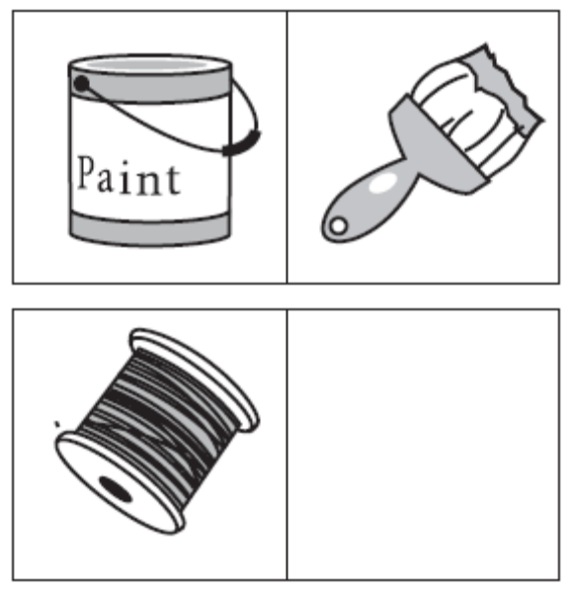a. 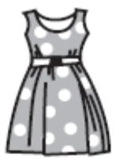 b. 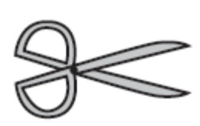 c. 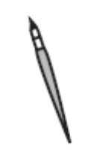 d. 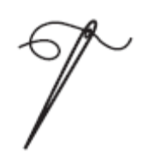
203. Choose the picture that would go in the empty box so that the two bottom pictures are related in the same way as the top two are related. 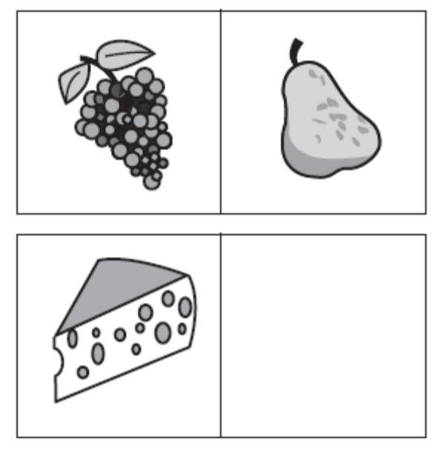a. 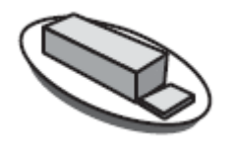 b.  c. 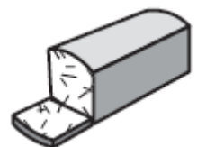 d. 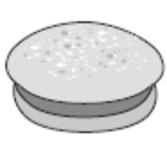
204. Choose the picture that would go in the empty box so that the two bottom pictures are related in the same way as the top two are related. 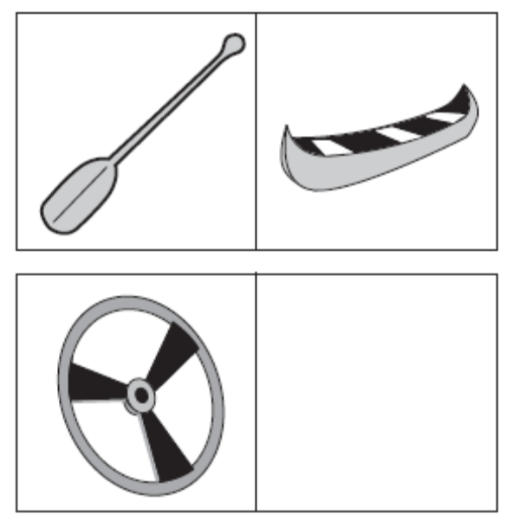 a. 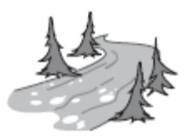 b.  c.  d. 
205. Choose the picture that would go in the empty box so that the two bottom pictures are related in the same way as the top two are related. 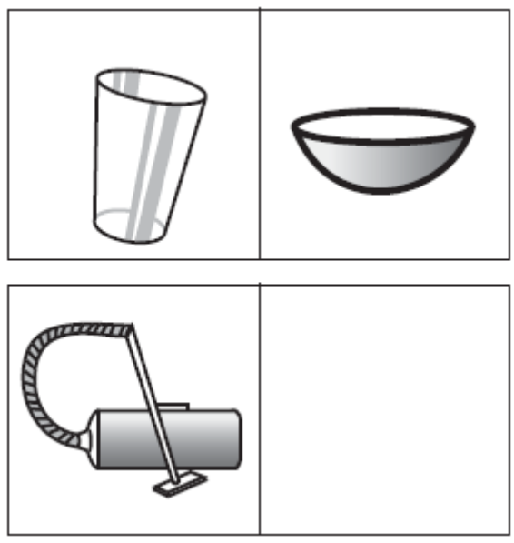 a. 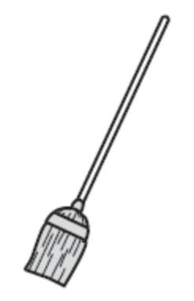 b. 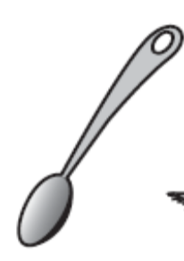 c.  d. 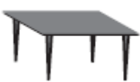
206. Choose the picture that would go in the empty box so that the two bottom pictures are related in the same way as the top two are related. 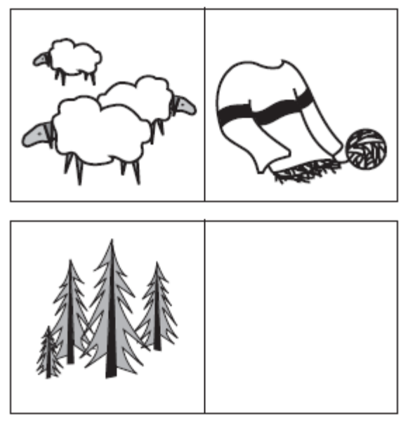 a. 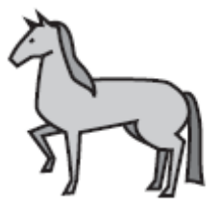 b.  c. 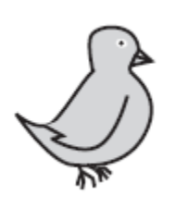 d. 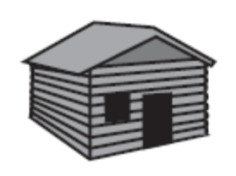
207. Choose the picture that would go in the empty box so that the two bottom pictures are related in the same way as the top two are related. 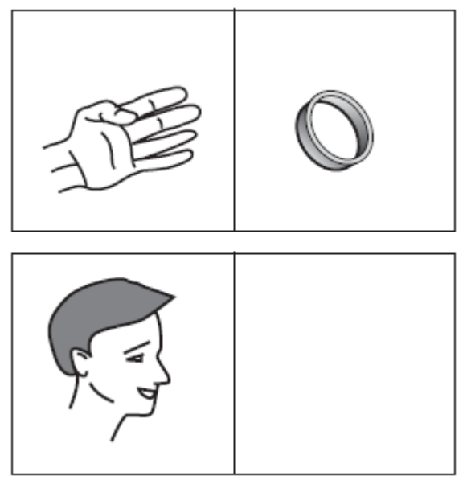 a. 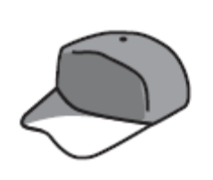 b. 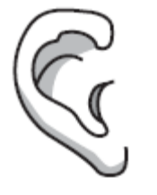 c.  d. 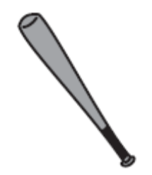
208. Choose the picture that would go in the empty box so that the two bottom pictures are related in the same way as the top two are related. 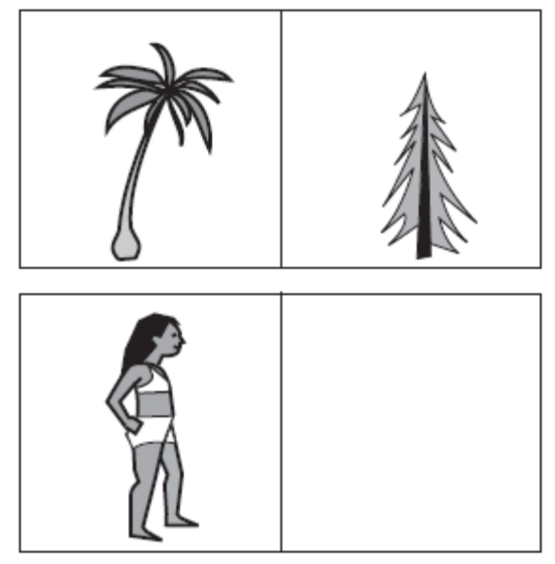 a. 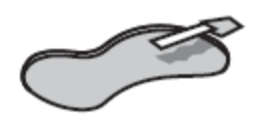 b.  c. 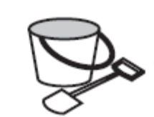 d. 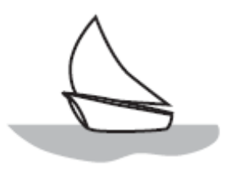
209. Choose the picture that would go in the empty box so that the two bottom pictures are related in the same way as the top two are related. 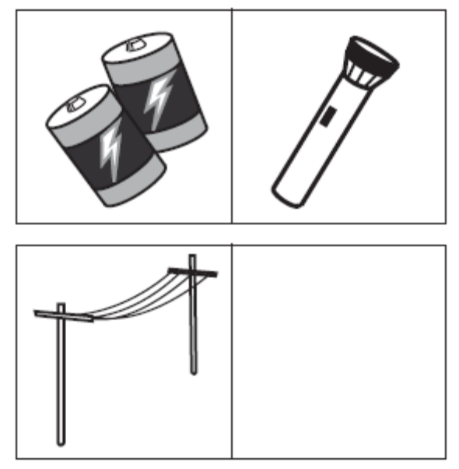 a. 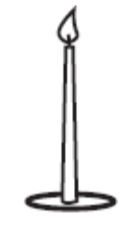 b. 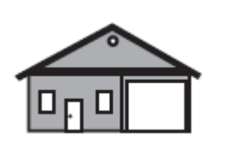 c.  d. 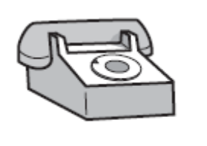
210. Choose the picture that would go in the empty box so that the two bottom pictures are related in the same way as the top two are related. 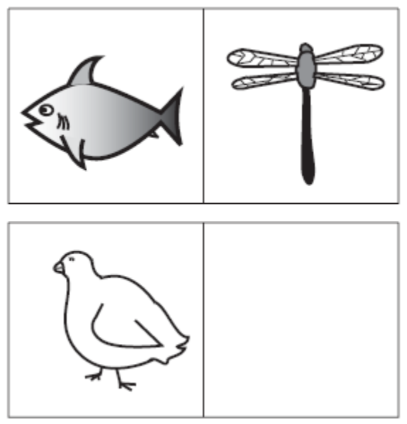 a. 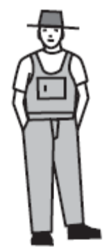 b. 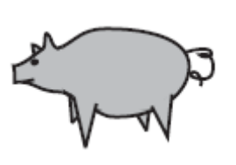 c.  d. 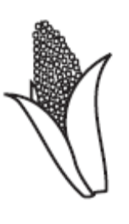
211. Choose the picture that would go in the empty box so that the two bottom pictures are related in the same way as the top two are related. 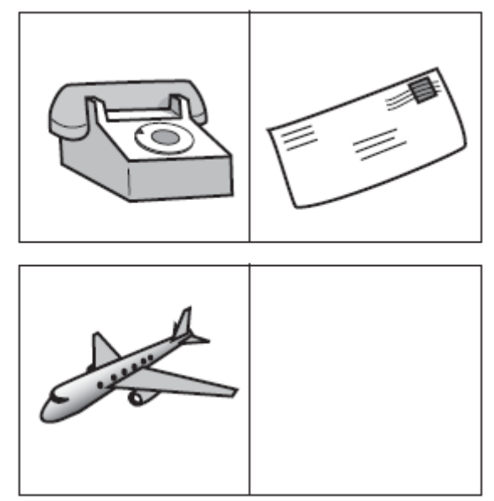 a. 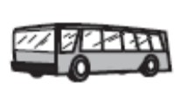 b.  c. 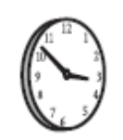 d. 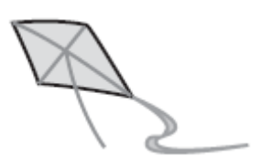
212. Choose the picture that would go in the empty box so that the two bottom pictures are related in the same way as the top two are related. 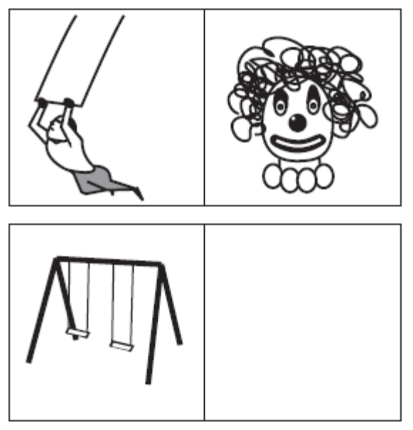 a. 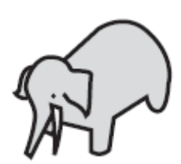 b.  c. 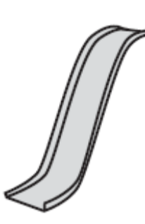 d. 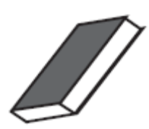
213. Choose the picture that would go in the empty box so that the two bottom pictures are related in the same way as the top two are related. 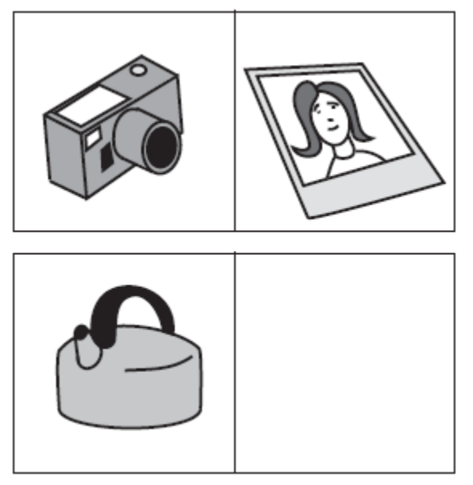 a. 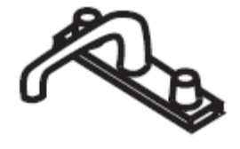 b.  c.  d. 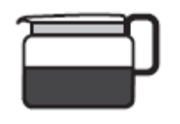
214. Choose the picture that would go in the empty box so that the two bottom pictures are related in the same way as the top two are related. 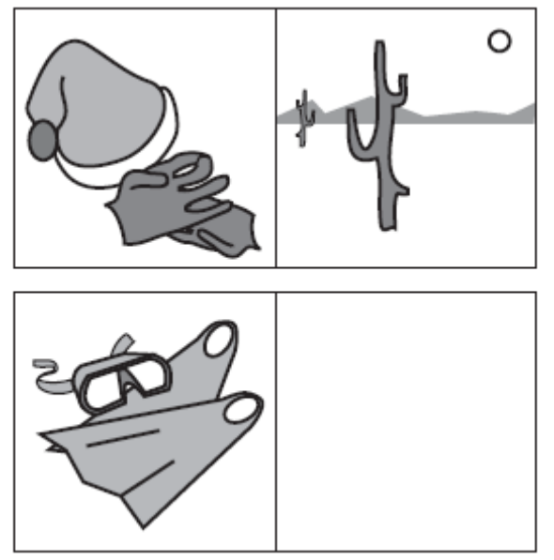 a.  b. 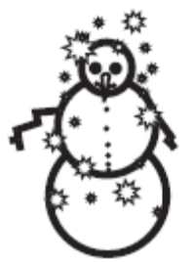 c. 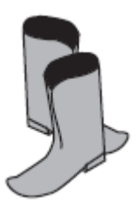 d. 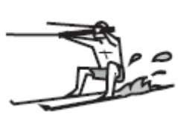
215. Choose the picture that would go in the empty box so that the two bottom pictures are related in the same way as the top two are related. 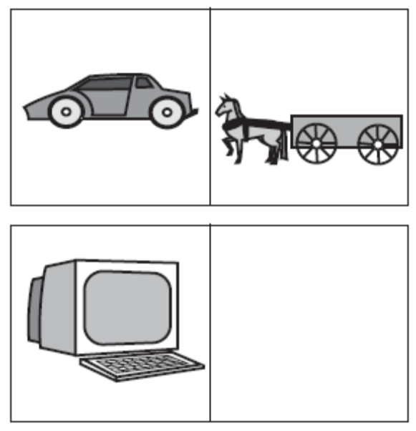 a. 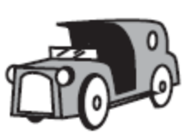 b.  c.  d. 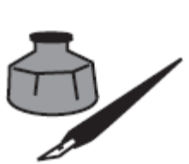
216. Choose the picture that would go in the empty box so that the two bottom pictures are related in the same way as the top two are related. 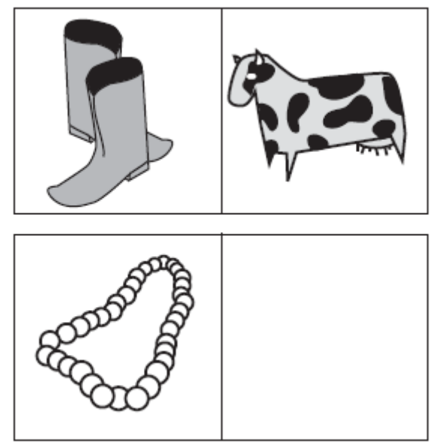 a. 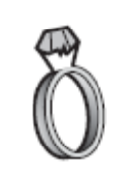 b.  c.  d. 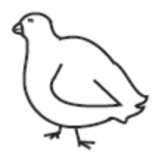
217. Choose the picture that would go in the empty box so that the two bottom pictures are related in the same way as the top two are related. 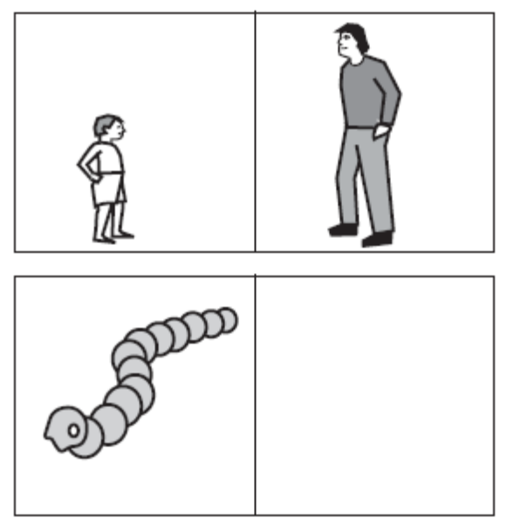 a. 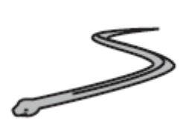 b.  c. 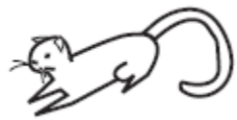 d. 
218. Choose the picture that would go in the empty box so that the two bottom pictures are related in the same way as the top two are related. 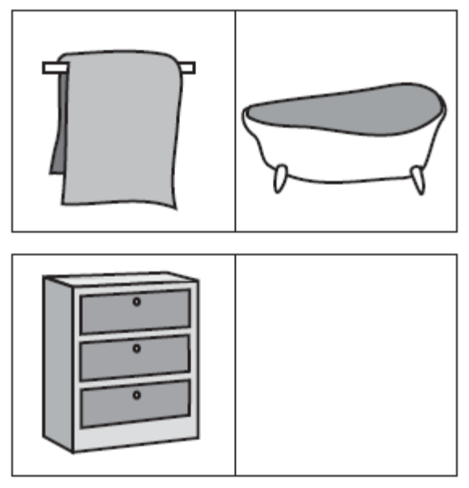 a. 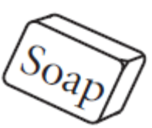 b. 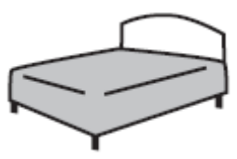 c.  d. 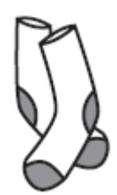
219. Choose the picture that would go in the empty box so that the two bottom pictures are related in the same way as the top two are related. 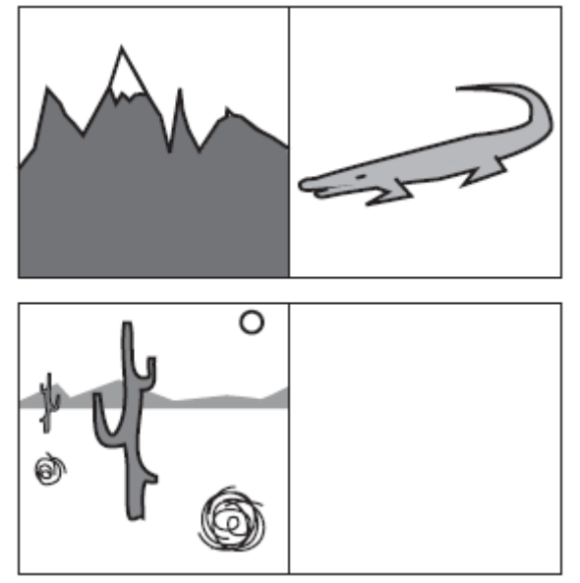 a.  b. 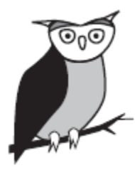 c. 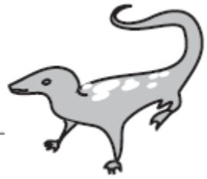 d. 
220. Choose the picture that would go in the empty box so that the two bottom pictures are related in the same way as the top two are related. 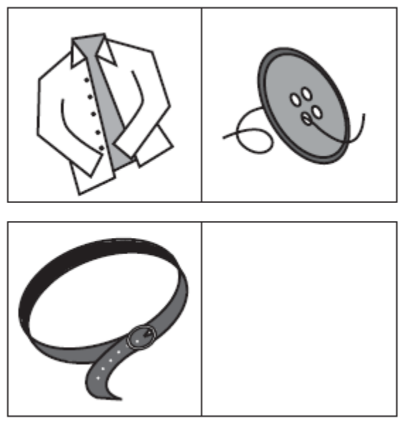 a. 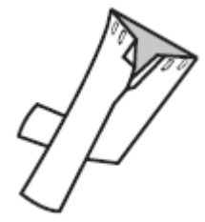 b. 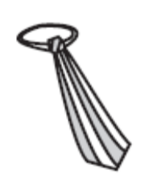 c.  d. 
221. Choose the picture that would go in the empty box so that the two bottom pictures are related in the same way as the top two are related. 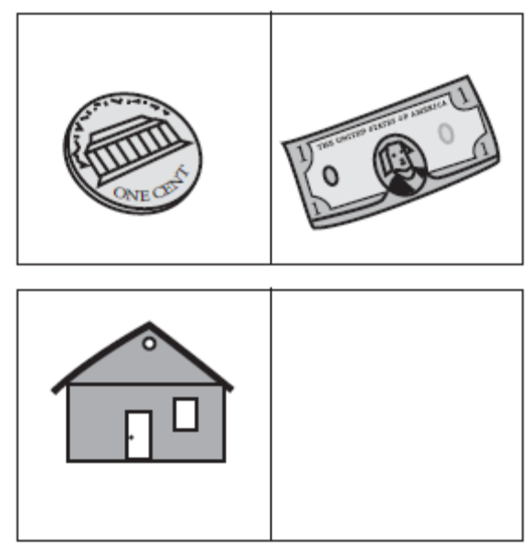 a.  b. 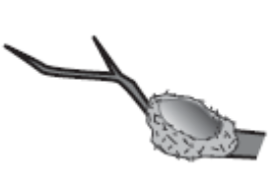 c.  d. 
222. From the four answer choices, choose the picture that would go in the empty box so that the two bottom pictures are related in the same way as the top two are related. 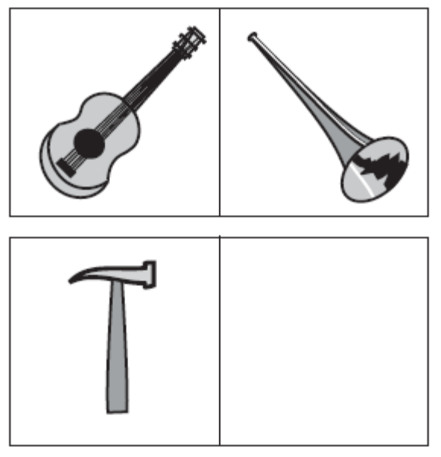 a. 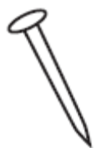 b. 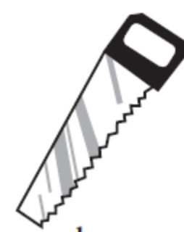 c. 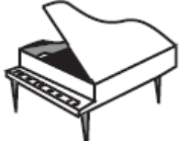 d. 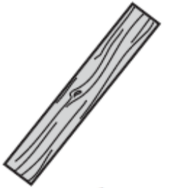
223. From the four answer choices, choose the picture that would go in the empty box so that the two bottom pictures are related in the same way as the top two are related. 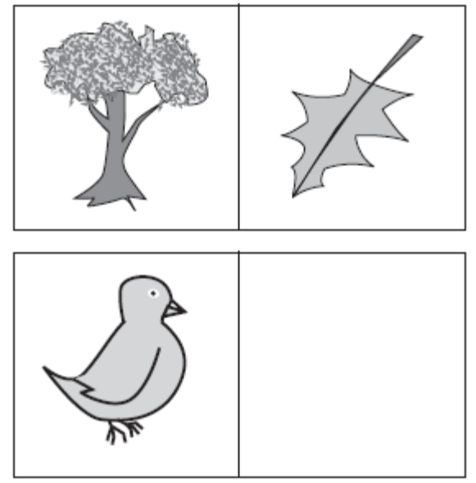 a. 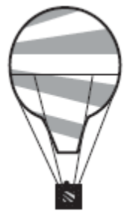 b. 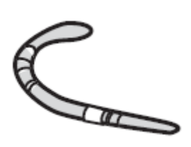 c. 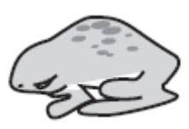 d. 
224. From the four answer choices, choose the picture that would go in the empty box so that the two bottom pictures are related in the same way as the top two are related. 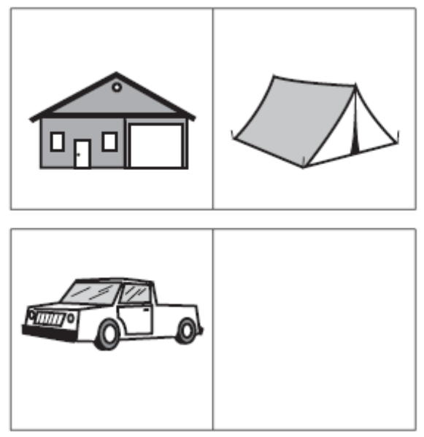 a. 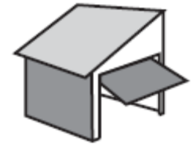 b.  c. 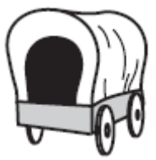 d. 
225. From the four answer choices, choose the picture that would go in the empty box so that the two bottom pictures are related in the same way as the top two are related. 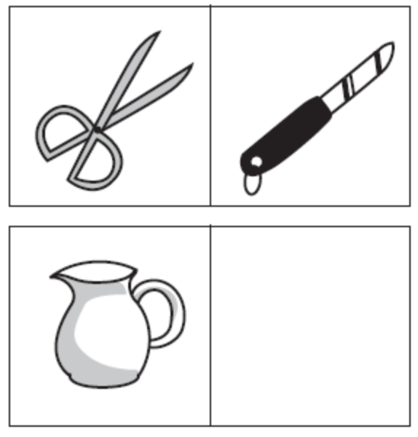 a.  b.  c. 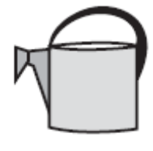 d. 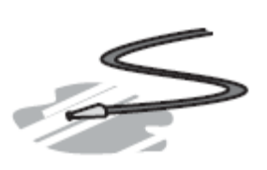
226. From the four answer choices, choose the picture that would go in the empty box so that the two bottom pictures are related in the same way as the top two are related. 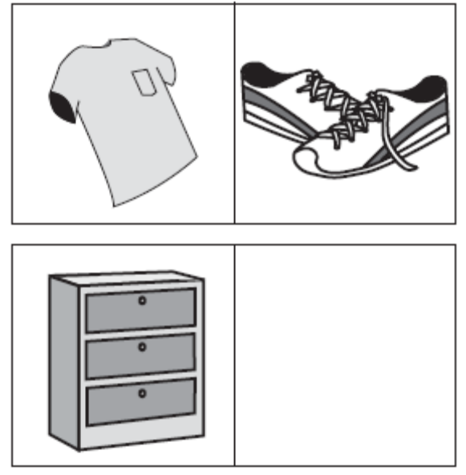 a. 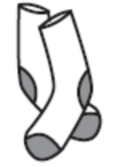 b. 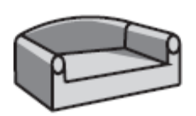 c. 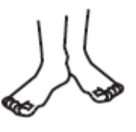 d. 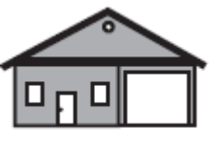
227. From the four answer choices, choose the picture that would go in the empty box so that the two bottom pictures are related in the same way as the top two are related. 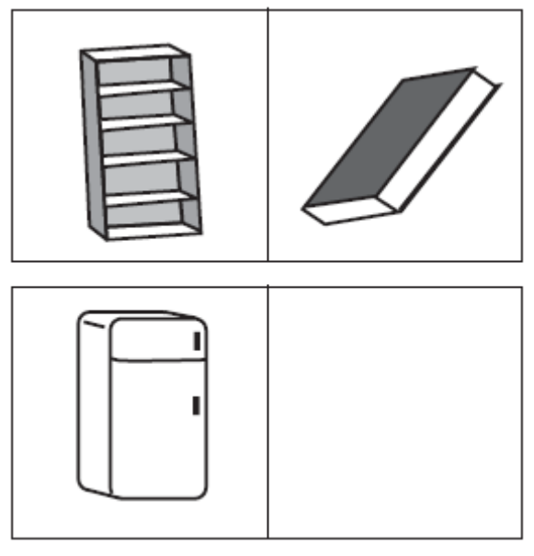 a. 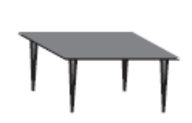 b. 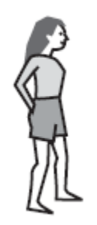 c. 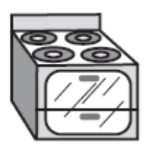 d. 
228. From the four answer choices, choose the picture that would go in the empty box so that the two bottom pictures are related in the same way as the top two are related. 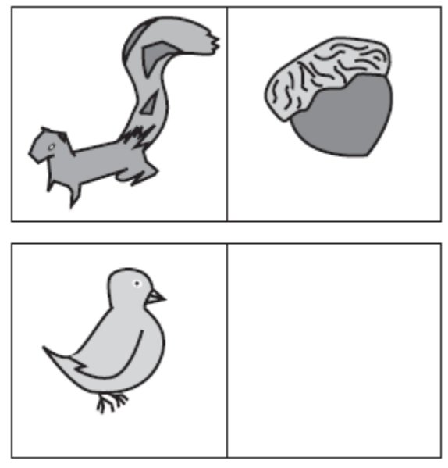 a. 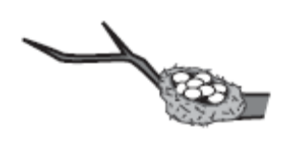 b.  c. 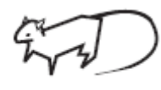 d. 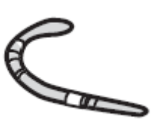
229. From the four answer choices, choose the picture that would go in the empty box so that the two bottom pictures are related in the same way as the top two are related. 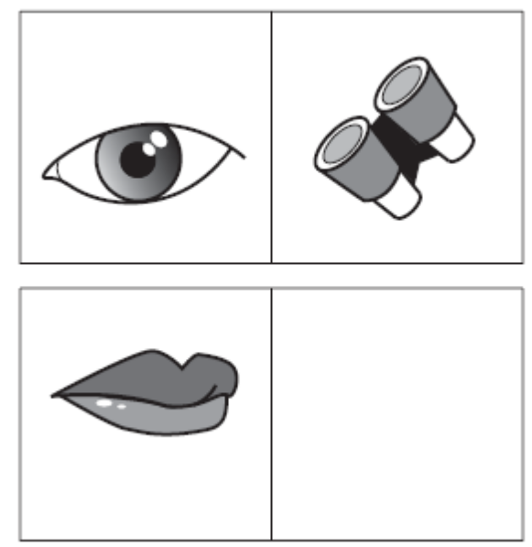 a. 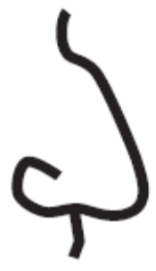 b.  c. 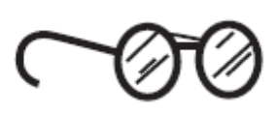 d. 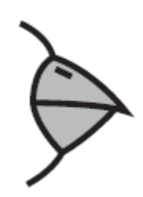
230. From the four answer choices, choose the picture that would go in the empty box so that the two bottom pictures are related in the same way as the top two are related.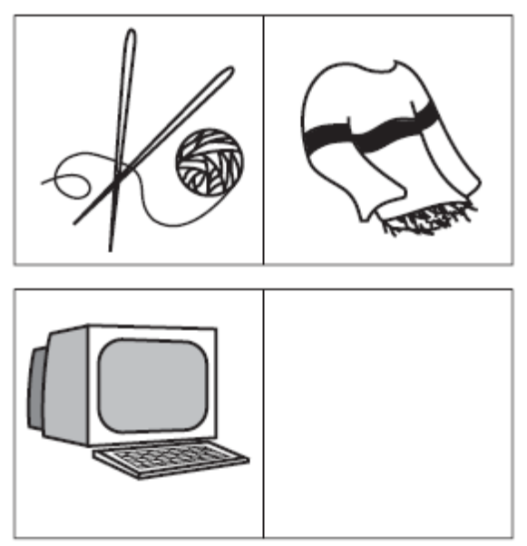 a.  b.  c.  d. 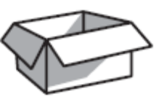
231. From the four answer choices, choose the picture that would go in the empty box so that the two bottom pictures are related in the same way as the top two are related. 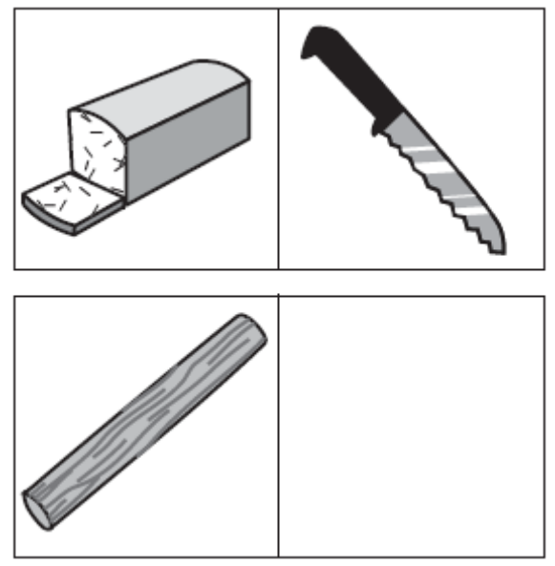 a. 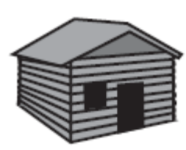 b.  c. 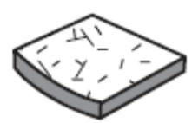 d. 
232. From the four answer choices, choose the picture that would go in the empty box so that the two bottom pictures are related in the same way as the top two are related. 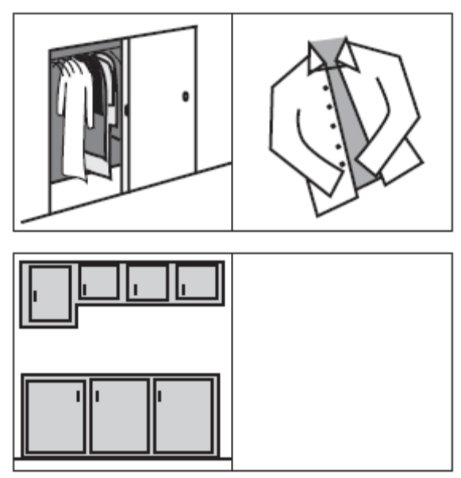 a. 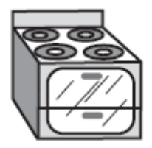 b.  c. 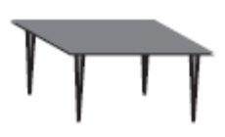 d. 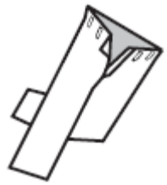
233. From the four answer choices, choose the picture that would go in the empty box so that the two bottom pictures are related in the same way as the top two are related. 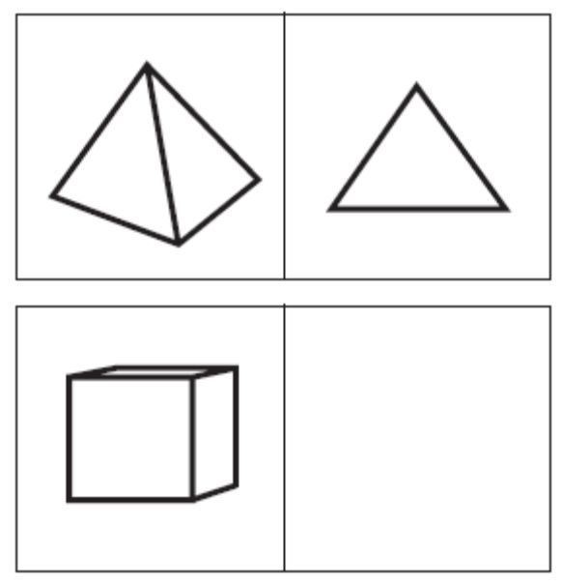 a.  b.  c.  d. 
234. From the four answer choices, choose the picture that would go in the empty box so that the two bottom pictures are related in the same way as the top two are related. 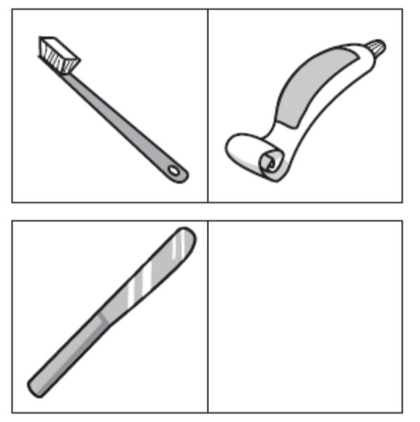 a.  b. 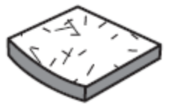 c. 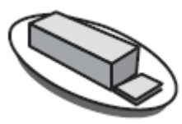 d. 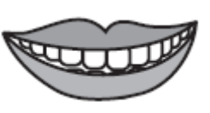
235. From the four answer choices, choose the picture that would go in the empty box so that the two bottom pictures are related in the same way as the top two are related. 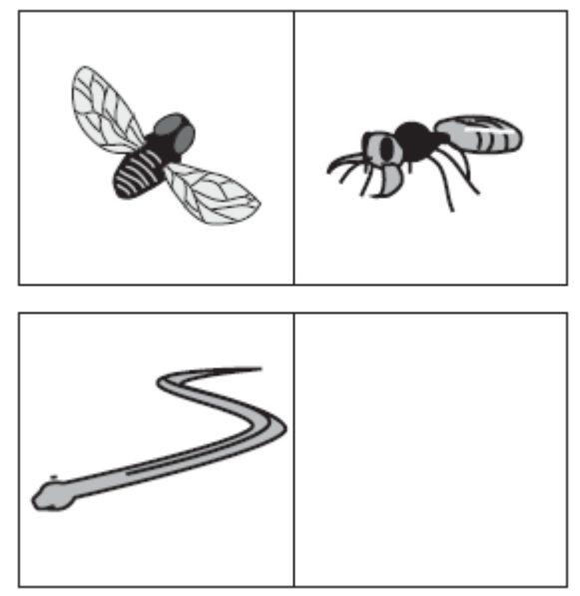 a. 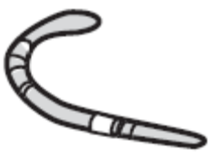 b. 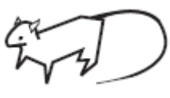 c. 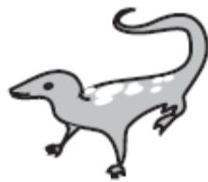 d. 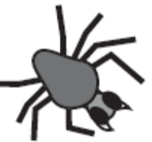
236. From the four answer choices, choose the picture that would go in the empty box so that the two bottom pictures are related in the same way as the top two are related. 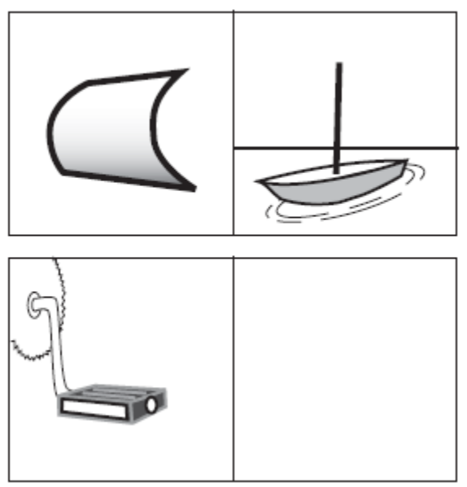 a.  b. 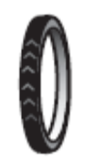 c.  d. 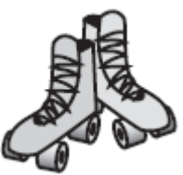
237. From the four answer choices, choose the picture that would go in the empty box so that the two bottom pictures are related in the same way as the top two are related. 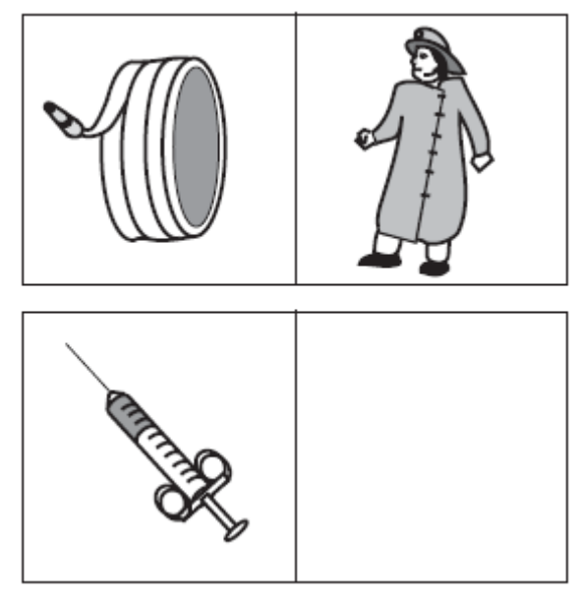 a. 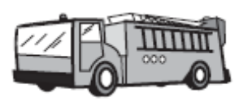 b. 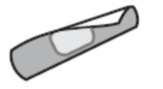 c.  d. 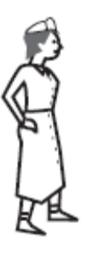
238. From the four answer choices, choose the picture that would go in the empty box so that the two bottom pictures are related in the same way as the top two are related.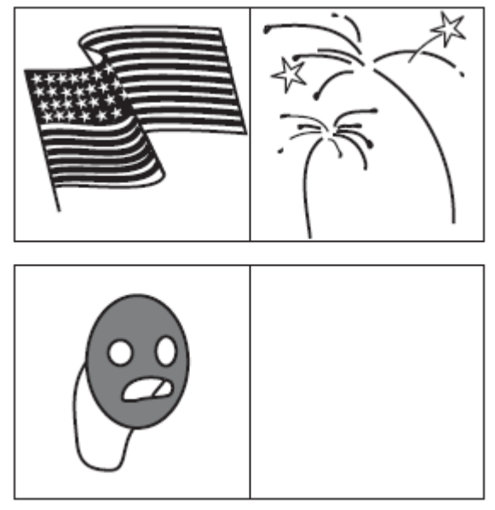 a.  b.  c.  d. 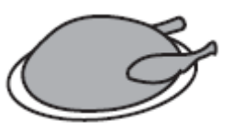
239. From the four answer choices, choose the picture that would go in the empty box so that the two bottom pictures are related in the same way as the top two are related. 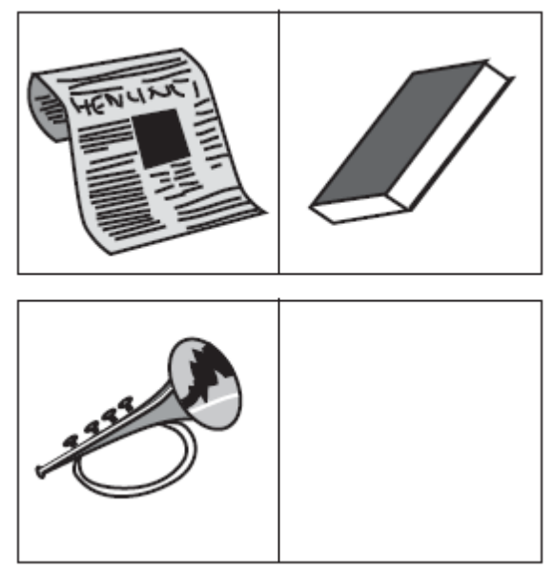 a. 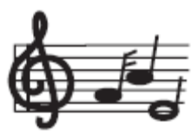 b.  c. 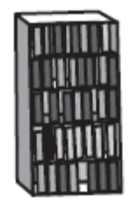 d. 
240. From the four answer choices, choose the picture that would go in the empty box so that the two bottom pictures are related in the same way as the top two are related. 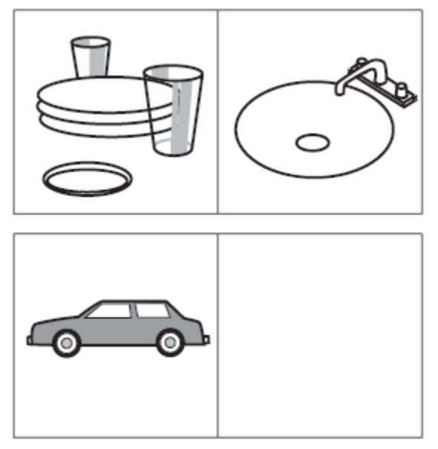 a.  b. 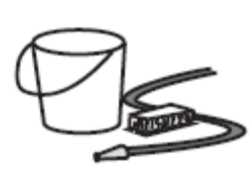 c.  d. 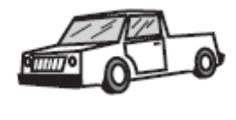
241. From the four answer choices, choose the picture that would go in the empty box so that the two bottom pictures are related in the same way as the top two are related. 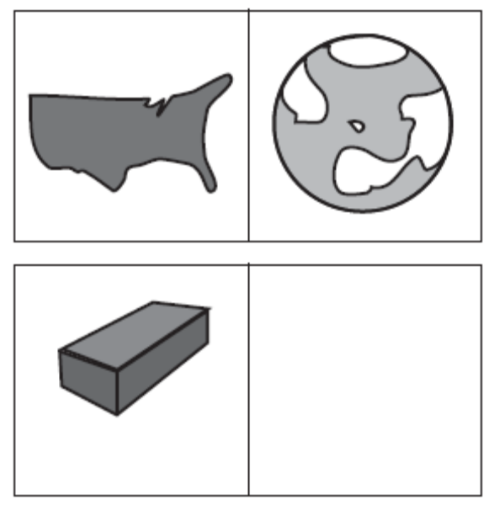 a. 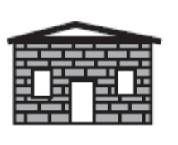 b.  c.  d. 
242. Find the word that completes the row of words. ant ﬂy bee : hamster squirrel _______ a. spider b. mouse c. rodent d. cat
243. Find the word that completes the row of words. carpenter saw nails : pediatrician stethoscope _______ a. thermometer b. baby c. doctor d. illness
244. Find the word that completes the row of words. table wood oak : shirt cloth _______ a. sewing b. dress c. cotton d. tree
245. Find the word that completes the row of words. rule command dictate : doze sleep _______ a. snore b. govern c. awaken d. hibernate
246. Find the word that completes the row of words. meal banquet feast : shelter palace _______ a. mansion b. hallway c. protection d. haven
247. Find the word that completes the row of words. fence wall boundary : path alley _______ a. ramp b. passageway c. airﬁeld d. pedestrian
248. Find the word that completes the row of words. palette easel brush : textbook lesson plan _______ a. artist b. teacher c. report card d. paint
249. Find the word that completes the row of words. snow mountain ski : warmth lake _______ a. sand b. swim c. sunburn d. vacation
250. Find the word that completes the row of words. candle lamp ﬂoodlight : hut cottage _______ a. tent b. city c. dwelling d. house
251. Find the word that completes the row of words. apples fruit supermarket : novel book _______ a. bookstore b. magazine c. vegetable d. shopping
252. Find the word that completes the row of words. tadpole frog amphibian : lamb sheep _______ a. animal b. wool c. farm d. mammal
253. Find the word that completes the row of words. walk skip run : toss pitch _______ a. swerve b. hurl c. jump d. dance
254. Find the word that completes the row of words. honeybee angel bat : kangaroo rabbit _______ a. mermaid b. possum c. grasshopper d. sprinter
255. Find the word that completes the row of words. daisy ﬂower plant : bungalow house _______ a. building b. cottage c. apartment d. city
256. Find the pair that has a similar relationship. PETAL : FLOWER a. salt : pepper b. tire : bicycle c. base : ball d. sandals : shoes e. puppy : dog
257. Find the pair that has a similar relationship. BRISTLE : BRUSH a. arm : leg b. stage : curtain c. recline : chair d. key : piano e. art : sculpture
258. Find the pair that has a similar relationship. FISH : SCHOOL a. wolf : pack b. elephant : jungle c. beagle : clan d. herd : peacock e. cow : farm
259. Find the pair that has a similar relationship. ODOMETER : DISTANCE a. scale : weight b. length : width c. inch : foot d. mileage : speed e. area : size
260. Find the pair that has a similar relationship. SIAMESE : CAT a. type : breed b. dog : puppy c. mark : spot d. romaine : lettuce e. collar : leash
261. Find the pair that has a similar relationship. PEDAL : BICYCLE a. inch : yardstick b. walk : skip c. tire : automobile d. buckle : belt e. oar : canoe
262. Find the pair that has a similar relationship. PULSATE : THROB a. walk : run b. tired : sleep c. examine : scrutinize d. ballet : dancer e. ﬁnd : lose
263. Find the pair that has a similar relationship. ELEPHANT : PACHYDERM a. mantis : rodent b. poodle : feline c. kangaroo : marsupial d. zebra : horse e. tuna : mollusk
264. Find the pair that has a similar relationship. DEPRESSED : SAD a. neat : considerate b. towering : cringing c. rapid : plodding d. progressive : regressive e. exhausted : tired
265. Find the pair that has a similar relationship. PSYCHOLOGIST : NEUROSIS a. ophthalmologist : cataract b. dermatologist : fracture c. infant : pediatrician d. rash : orthopedist e. oncologist : measles
266. Find the pair that has a similar relationship. BINDING : BOOK a. criminal : gang b. display : museum c. artist : carpenter d. nail : hammer e. frame : picture
267. Find the pair that has a similar relationship. EXPLORE : DISCOVER a. read : skim b. research : learn c. write : print d. think : relate e. sleep : wake
268. Find the pair that has a similar relationship. COTTON : BALE a. butter : churn b. wine : ferment c. grain : shock d. curd : cheese e. beef : steak
269. Find the pair that has a similar relationship. DIVISION : SECTION a. layer : tier b. tether : bundle c. chapter : verse d. riser : stage e. dais : speaker
270. Find the pair that has a similar relationship. PASTORAL : RURAL a. metropolitan : urban b. harvest : autumn c. agrarian : benevolent d. sleepy : nocturnal e. wild : agricultural
271. Find the pair that has a similar relationship. WAITRESS : RESTAURANT a. doctor : diagnosis b. actor : role c. driver : truck d. teacher : school e. author : book
272. Find the pair that has a similar relationship. FINCH : BIRD a. frog : toad b. elephant : reptile c. Dalmatian : dog d. collie : marsupial e. ant : ladybug
273. Find the pair that has a similar relationship. RAIN : DRIZZLE a. swim : dive b. hop : shufﬂe c. juggle : bounce d. walk : run e. run : jog
274. Find the pair that has a similar relationship. SKEIN : YARN a. squeeze : lemon b. ﬁre : coal c. ream : paper d. tree : lumber e. plow : acre
275. Find the pair that has a similar relationship. TAILOR : SUIT a. scheme : agent b. edit : manuscript c. revise : writer d. mention : opinion e. implode : building
276. Choose the pair that best represents a similar relationship to the one expressed in the original pair of words. CONDUCTOR : ORCHESTRA a. jockey : mount b. thrasher : hay c. driver : tractor d. skipper : crew e. painter : house
277. Choose the pair that best represents a similar relationship to the one expressed in the original pair of words. JAUNDICE : LIVER a. rash : skin b. dialysis : kidney c. smog : lung d. valentine : heart e. imagination : brain
278. Choose the pair that best represents a similar relationship to the one expressed in the original pair of words. COBBLER : SHOE a. jockey : horse b. contractor : building c. mason : stone d. cowboy : boot e. potter : paint
279. Choose the pair that best represents a similar relationship to the one expressed in the original pair of words. PHOBIC : FEARFUL a. ﬁnicky : thoughtful b. cautious : emotional c. envious : desiring d. shy : familiar e. asinine : silly
280. Choose the pair that best represents a similar relationship to the one expressed in the original pair of words. INTEREST : OBSESSION a. mood : feeling b. weeping : sadness c. dream : fantasy d. plan : negation e. highlight : indication
281. Choose the pair that best represents a similar relationship to the one expressed in the original pair of words. MONK : DEVOTION a. maniac : paciﬁsm b. explorer : contentment c. visionary : complacency d. rover : wanderlust e. philistine : culture
282. Choose the pair that best represents a similar relationship to the one expressed in the original pair of words. SLAPSTICK : LAUGHTER a. fallacy : dismay b. genre : mystery c. satire : anger d. mimicry : tears e. horror : fear
283. Choose the pair that best represents a similar relationship to the one expressed in the original pair of words. VERVE : ENTHUSIASM a. loyalty : duplicity b. devotion : reverence c. intensity : color d. eminence : anonymity e. generosity : elation
284. Choose the pair that best represents a similar relationship to the one expressed in the original pair of words. SOUND : CACOPHONY a. taste : style b. touch : massage c. smell : stench d. sight : panorama e. speech : oration
285. Choose the pair that best represents a similar relationship to the one expressed in the original pair of words. CONVICTION : INCARCERATION a. reduction : diminution b. induction : amelioration c. radicalization : estimation d. marginalization : intimidation e. proliferation : alliteration
286. Choose the pair that best represents a similar relationship to the one expressed in the original pair of words. DELTOID : MUSCLE a. radius : bone b. brain : nerve c. tissue : organ d. blood : vein e. scalpel : incision
287. Choose the pair that best represents a similar relationship to the one expressed in the original pair of words. UMBRAGE : OFFENSE a. confusion : penance b. inﬁnity : meaning c. decorum : decoration d. elation : jubilance e. outrage : consideration
288. Choose the pair that best represents a similar relationship to the one expressed in the original pair of words. PROFESSOR : ERUDITE a. aviator : licensed b. inventor : imaginative c. procrastinator : conscientious d. overseer : wealthy e. moderator : vicious
289. Choose the pair that best represents a similar relationship to the one expressed in the original pair of words. DEPENDABLE : CAPRICIOUS a. fallible : cantankerous b. erasable : obtuse c. malleable : limpid d. capable : inept e. incorrigible : guilty
290. Choose the pair that best represents a similar relationship to the one expressed in the original pair of words. FROND : PALM a. quill : porcupine b. blade : evergreen c. scale : wallaby d. tusk : alligator e. blade : fern
291. Choose the pair that best represents a similar relationship to the one expressed in the original pair of words. METAPHOR : SYMBOL a. pentameter : poem b. rhythm : melody c. nuance : song d. slang : usage e. analogy : comparison
292. Choose the pair that best represents a similar relationship to the one expressed in the original pair of words. DIRGE : FUNERAL a. chain : letter b. bell : church c. telephone : call d. jingle : commercial e. hymn : concerto
293. Choose the pair that best represents a similar relationship to the one expressed in the original pair of words. FERAL : TAME a. rancid : rational b. repetitive : recurrent c. nettlesome : annoying d. repentant : honorable e. ephemeral : immortal
294. Choose the pair that best represents a similar relationship to the one expressed in the original pair of words. SPY : CLANDESTINE a. accountant : meticulous b. furrier : rambunctious c. lawyer : ironic d. shepherd : garrulous e. astronaut : opulent
295. Choose the pair that best represents a similar relationship to the one expressed in the original pair of words. DOMINANCE : HEGEMONY a. romance : sympathy b. furtherance : melancholy c. independence : autonomy d. tolerance : philanthropy e. recompense : hilarity
296. Choose the pair that best represents a similar relationship to the one expressed in the original pair of words. AERIE : EAGLE a. capital : government b. bridge : architect c. unit : apartment d. kennel : veterinarian e. house : person

