376. Charlie wants to know the area of his property, which measures 120 ft by 150 ft. Which formula will he use? a. A = s² b. A = πr² c. A = $\frac{1}{2}$bh d. A = lw
377. Dawn wants to compare the volume of a basketball with the volume of a tennis ball. Which formula will she use? a. V = πr²h b. V = $\frac{3}{4}$ πr³ c. V = $\frac{1}{3}$ πr²h d. V = s³
378. Rick is ordering a new triangular sail for his boat. He needs to know the area of the sail. Which formula will he use? a. A = lw b. A = $\frac{1}{2}$ bh c. A = bh d. A = $\frac{1}{2}$ h(b₁ + b₂)
379. Keith wants to know the surface area of a basketball. Which formula will he use? a. s = 6s² b. s = 4πr² c. s = 2πr² + 2πrh d. s = πr² + 2πrh
380. Aaron is installing a ceiling fan in his bedroom. Once the fan is in motion, he needs to know the area the fan will cover. Which formula will he use? a. A = bh b. A = s² c. A = $\frac{1}{2}$ bh d. A = πr²
381. Mimi is ﬁlling a tennis ball can with water. She wants to know the volume of the cylinder shaped can. What formula will she use? a. V = πr²h b. V = $\frac{3}{4}$ πr³ c. V = $\frac{1}{3}$ πr²h d. V = s³
382. Audrey is creating a raised ﬂowerbed that is 4.5 ft by 4.5 ft. She needs to calculate how much lumber to buy. If she needs to know the distance around the ﬂowerbed, which formula is easiest to use? a. P = a + b + c b. A = lw c. P = 4s d. C = 2πr
383. Al is painting a right cylinder storage tank. In order to purchase the correct amount of paint he needs to know the total surface area to be painted. Which formula will he use if he does not paint the bottom of the tank? a. S = 2πr² + 2πrh b. S = 4πr² c. S = πr² + 2πrh d. S = 6s²
384. Cathy is creating a quilt out of fabric panels that are 6 in by 6 in. She wants to know the total area of her square-shaped quilt. Which formula will she use? a. A = s² b. A = $\frac{1}{2}$ bh c. A = πr² d. A = $\frac{1}{2}$ h(b₁ + b₂)
385. If Lisa wants to know the distance around her circular table, which has a diameter of 42 in, which formula will she use? a. P = 4s b. P = 2l + 2w c. C = πd d. P = a + b + c
386. Danielle needs to know the distance around a basketball court. Which geometry formula will she use? a. P = 2l + 2s b. P = 4s c. P = a + b + c d. P = b₁ + b₂ + h
387. To ﬁnd the volume of a cube that measures 3 cm by 3 cm by 3 cm, which formula would you use? a. V = πr² h b. V = $\frac{4}{3}$ πr³ c. V = $\frac{1}{3}$ πr² h d. V = s³
388. To ﬁnd the perimeter of a triangular region, which formula would you use? a. P = a + b + c b. P = 4s c. P = 2l + 2w d. C = 2πr
389. A racquetball court is 40 ft by 20 ft. What is the area of the court in square feet? a. 60 ft² b. 80 ft² c. 800 ft² d. 120 ft²
390. Allan has been hired to mow the school soccer ﬁeld, which is 180 ft wide by 330 ft long. If his mower mows strips that are 2 feet wide, how many times must he mow across the width of the lawn? a. 90 b. 165 c. 255 d. 60
391. Erin is painting a bathroom with four walls each measuring 8 ft by 5.5 ft. Ignoring the doors or windows, what is the area to be painted? a. 176 ft² b. 88 ft² c. 54 ft² d. 160 ft²
392. The arm of a ceiling fan measures a length of 25 in. What is the area covered by the motion of the fan blades when turned on? (π = 3.14) a. 246.49 in² b. 78.5 in² c. 1,962.5 in² d. 157 in²
393. A building that is 45 ft tall casts a shadow that is 30 ft long. Nearby, Heather is walking her standard poodle, which casts a shadow that is 2.5 ft long. How tall is Heather’s poodle? a. 2.75 ft b. 3.25 ft c. 3.75 ft d. 1.67 ft
394. A circular pool is ﬁlling with water. Assuming the water level will be 4 ft deep and the diameter is 20 ft, what is the volume of the water needed to ﬁll the pool? (π = 3.14) a. 251.2 ft³ b. 1,256 ft³ c. 5,024 ft³ d. 3,140 ft³
395. A cable is attached to a pole 24 ft above ground and fastened to a stake 10 ft from the base of the pole. In order to keep the pole perpendicular to the ground, how long is the cable? a. 22 ft b. 26 ft c. 20 ft d. 18 ft
396. Karen is buying a wallpaper border for her bedroom, which is 12 ft by 13 ft If the border is sold in rolls of 5 yards each, how many rolls will she need to purchase? a. 3 b. 4 c. 5 d. 6
397. The formula for the surface area of a sphere is 4πr² . What is the surface area of a ball with a diameter of 6 inches? Round to the nearest inch. (π = 3.14) a. 452 in² b. 113 in² c. 38 in² d. 28 in²
398. Brittney would like to carpet her bedroom. If her room is 11 ft by 13 ft, what is the area to be carpeted in square feet? a. 121 ft² b. 48 ft² c. 169 ft² d. 143 ft²
399. The scale on a map shows that 1 inch is equal to 14 miles. Shannon measured the distance on the map to be 17 inches. How far will she need to travel? a. 23.8 miles b. 238 miles c. 2,380 miles d. 23,800 miles
400. How far will a bowling ball roll in one rotation if the ball has a diameter of 10 inches? (π = 3.14) a. 31.4 in b. 78.5 in c. 15.7 in d. 62.8 in
401. A water sprinkler sprays in a circular pattern a distance of 10 ft. What is the circumference of the spray? (π = 3.14) a. 31.4 ft b. 314 ft c. 62.8 ft d. 628 ft
402. If a triangular sail has a vertical height of 83 ft and horizontal length of 30 ft, what is the area of the sail? a. 1,245 ft2 b. 1,155 ft2 c. 201 ft2 d. 2,490 ft2
403. What is the volume of a ball whose radius is 4 inches? Round to the nearest inch. (π = 3.14) a. 201 in³ b. 268 in³ c. 804 in³ d. 33 in³
404. If a tabletop has a diameter of 42 in, what is its surface area to the nearest inch? (π = 3.14) a. 1,384 in² b. 1,319 in² c. 1,385 in² d. 5,539 in²
405. An orange has a radius of 1.5 inches. Find the volume of one orange. (π = 3.14) a. 9.42 in³ b. 113.04 in³ c. 28.26 in³ d. 14.13 in³
406. A ﬁre and rescue squad places a 15 ft ladder against a burning building. If the ladder is 9 ft from the base of the building, how far up the building will the ladder reach? a. 8 ft b. 10 ft c. 12 ft d. 14 ft
407. Safe deposit boxes are rented at the bank. The dimensions of a box are 22 in by 5 in by 5 in. What is the volume of the box? a. 220 in³ b. 550 in³ c. 490 in³ d. 360 in³
408. How many degrees does a minute hand move in 20 minutes? a. 20° b. 120° c. 60° d. 100°
409. Two planes leave the airport at the same time. Minutes later, plane A is 70 miles due north of the airport and plane B is 168 miles due east of the airport. How far apart are the two airplanes? a. 182 miles b. 119 miles c. 163.8 miles d. 238 miles
410. If the area of a small pizza is 78.5 in² , what size pizza box would best ﬁt the small pizza? (Note: Pizza boxes are measured according to the length of one side.) a. 12 in b. 11 in c. 9 in d. 10 in
411. Stuckeyburg is a small town in rural America. Use the map to approximate the area of the town. a. 40 miles² b. 104 miles² c. 93.5 miles² d. 92 miles²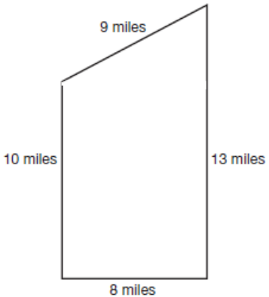
412. A rectangular ﬁeld is to be fenced in completely. The width is 22 yd and the total area is 990 yd² . What is the length of the ﬁeld? a. 968 yd b. 45 yd c. 31 yd d. 473 yd
413. A circular print is being matted in a square frame. If the frame is 18 in by 18 in, and the radius of the print is 7 in, what is the area of the matting? (π = 3.14) a. 477.86 in² b. 170.14 in² c. 280.04 in² d. 288 in²
414. Ribbon is wrapped around a rectangular box that is 10 in by 8 in by 4 in. Using the illustration provided, determine how much ribbon is needed to wrap the box. Assume the amount of ribbon does not include a knot or bow. a. 52 in b. 44 in c. 22 in d. 320 in 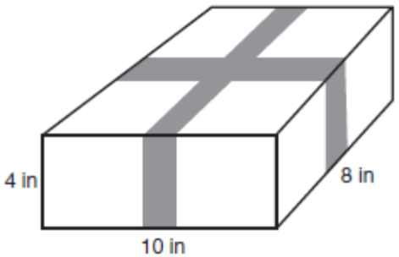
415. Pat is making a Christmas tree skirt. She needs to know how much fabric to buy. Using the illustration provided, determine the area of the skirt to the nearest foot. a. 37.7 ft² b. 27 ft² c. 75 ft² d. 38 ft² 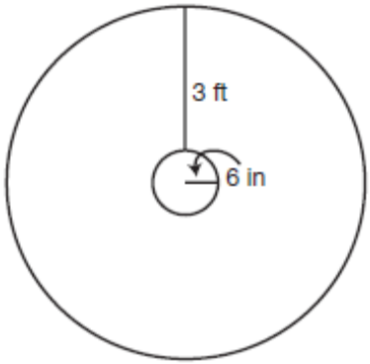
416. Mark intends to tile a kitchen ﬂoor, which is 9 ft by 11 ft. How many 6-inch tiles are needed to tile the ﬂoor? a. 60 b. 99 c. 396 d. 449
417. A framed print measures 36 in by 22 in. If the print is enclosed by a 2-inch matting, what is the length of the diagonal of the print? Round to the nearest tenth. See illustration. a. 36.7 in b. 39.4 in c. 26.5 in d. 50 in 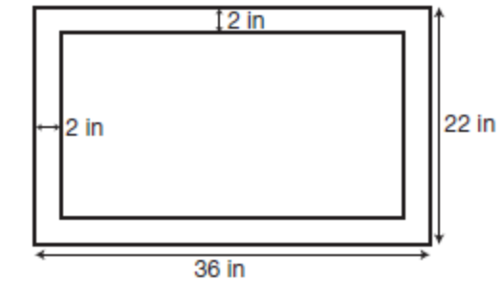
418. A 20-foot light post casts a shadow 25 feet long. At the same time, a building nearby casts a shadow 50 feet long. How tall is the building? a. 40 ft b. 62.5 ft c. 10 ft d. 95 ft
419. Barbara is wrapping a wedding gift that is contained within a rectangular box 20 in by 18 in by 4 in. How much wrapping paper will she need? a. 512 in² b. 1,440 in² c. 1,024 in² d. 92 in²
420. Mark is constructing a walkway around his inground pool. The pool is 20 ft by 40 ft and the walkway is intended to be 4 ft wide. What is the area of the walkway? a. 224 ft² b. 416 ft² c. 256 ft² d. 544 ft²
421. The picture frame shown below has outer dimensions of 8 in by 10 in and inner dimensions of 6 in by 8 in. Find the area of section A of the frame. a. 18 in² b. 14 in² c. 7 in² d. 9 in²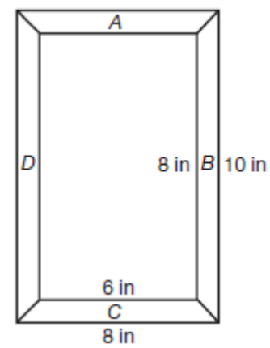
422. John is planning to purchase an irregularly shaped plot of land. Referring to the diagram, ﬁnd the total area of the land. a. 6,400 m² b. 5,200 m² c. 4,500 m² d. 4,600 m² 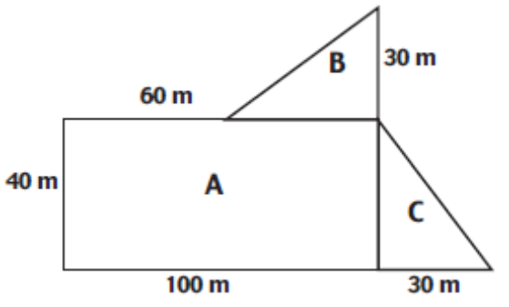
423. Using the illustration, determine the perimeter of the plot of land. a. 260 m b. 340 m c. 360 m d. 320 m
424. A weather vane is mounted on top of an 18 ft pole. If a 20 ft guy wire is staked to the ground to keep the pole perpendicular, how far is the stake from the base of the pole? a. 76 ft b. $\sqrt{724}$ c. 38 d. $\sqrt{76}$or $2\sqrt{19}$
425. A surveyor is hired to measure the width of a river. Using the illustration provided, determine the width of the river. a. 48 ft b. 8 ft c. 35 ft d. 75 ft 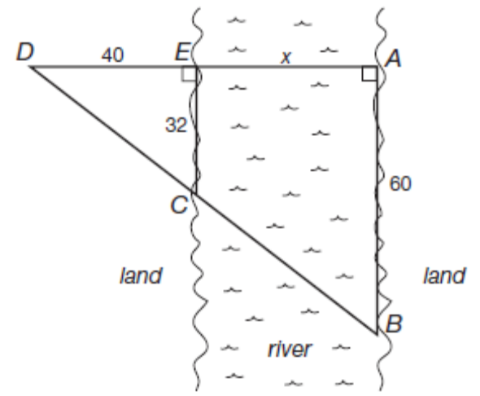
426. A publishing company is designing a book jacket for a newly published textbook. Find the area of the book jacket, given that the front cover is 8 in wide by 11 in high, the binding is 1.5 in by 11 in and the jacket will extend 2 inches inside the front and rear covers. a. 236.5 in² b. 192.5 in² c. 188 in² d. 232 in²
427. A Norman window is to be installed in a new home. Using the dimensions marked on the illustration, ﬁnd the area of the window to the nearest tenth of an inch. (π = 3.14) a. 2,453.3 in² b. 2,806.5 in² c. 147.1 in² d. 2,123.6 in² 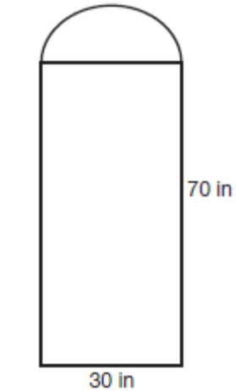
428. A surveyor is hired to measure the distance of the opening of a bay. Using the illustration and various measurements determined on land, ﬁnd the distance of the opening of the bay. a. 272.7 yds b. 82.5 yds c. 27.5 yds d. 205 yds 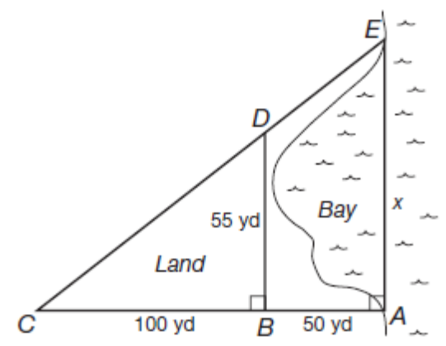
429. A car is initially 200 meters due west of a roundabout (trafﬁc circle). If the car travels to the roundabout, continues halfway around the circle, exits due east, then travels an additional 160 meters, what is the total distance the car has traveled? Refer to diagram. a. 862.4 m b. 611.2 m c. 502.4 m d. 451.2 m 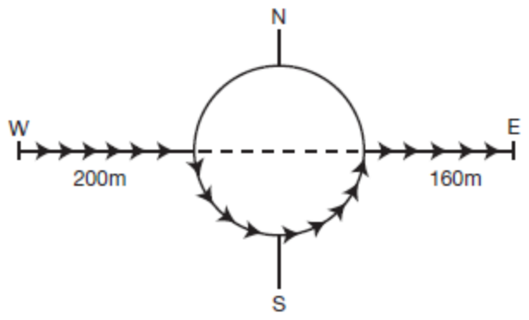
430. Steve Fossett is approaching the shores of Australia on the ﬁrst successful solo hot air balloon ride around the world. His balloon, the Bud Light™ Spirit of Freedom, is being escorted by a boat (directly below him) that is 108 meters away. The boat is 144 meters from the shore. How far is Fossett’s balloon from the shore? a. 252 m b. 95.2 m c. 126 m d. 180 m
431. Computer monitors are measured by their diagonals. If a monitor is advertised to be 19 in, what is the actual viewing area, assuming the screen is square? (Round to the nearest tenth.) a. 361.0 in² b. 90.25 in² c. 144.4 in² d. 180.5 in²
432. An elevated cylindrical shaped water tower is in need of paint. If the radius of the tower is 10 ft and the tower is 40 ft tall, what is the total area to be painted? (π = 3.14) a. 1,570 ft² b. 2,826 ft² c. 2,575 ft² d. 3,140 ft²
433. A sinking ship signals to the shore for help. Three individuals spot the signal from shore. The ﬁrst individual is directly perpendicular to the sinking ship and 20 meters inland. The second individual is also 20 meters inland but 100 meters to the right of the ﬁrst individual. The third is also 20 meters inland but 125 meters to the right of the ﬁrst individual. How far off shore is the sinking ship? See illustration. a. 60 meters b. 136 meters c. 100 meters d. 80 meters 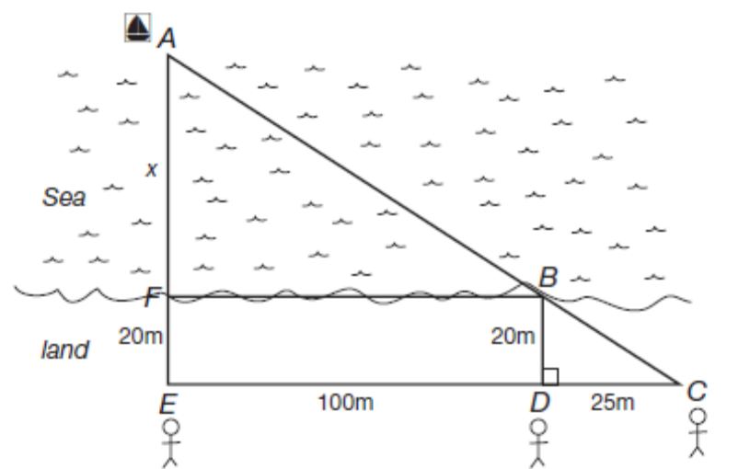
434. You are painting the surface of a silo that has a radius of 8 ft and height of 50 ft. What is the total surface area to be painted? Assume the top of the silo is 1 2 a sphere and sets on the ground. Refer to the illustration. 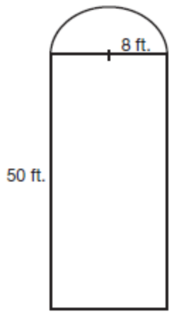 a. 2,913.92 ft2 b. 1,607.68 ft2 c. 2,612.48 ft2 d. 3,315.84 ft2
435. Find the height of the Washington Monument to the nearest tenth of a meter. a. 157.8 m b. 169.3 m c. 170.1 m d. 192.2 m .The Washington Monument is located in Washington D.C. Use the following illustration, which represents one of four identical sides, to answer question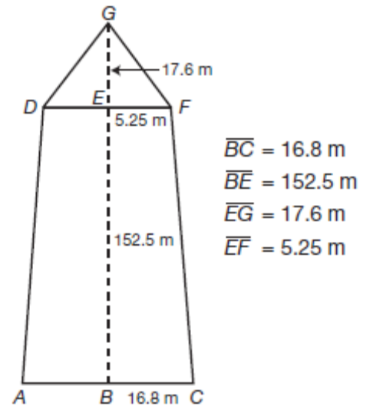
436. Find the surface area of the monument to the nearest meter. a. 13,820 m² b. 13,451 m² c. 3,455 m² d. 13,543 m² .The Washington Monument is located in Washington D.C. Use the following illustration, which represents one of four identical sides, to answer question
437. An inground pool is ﬁlling with water. The shallow end is 3 ft deep and gradually slopes to the deepest end, which is 10 ft deep. The width of the pool is 15 ft and the length is 30 ft. What is the volume of the pool? a. 1,575 ft³ b. 4,500 ft³ c. 2,925 ft³ d. 1,350 ft³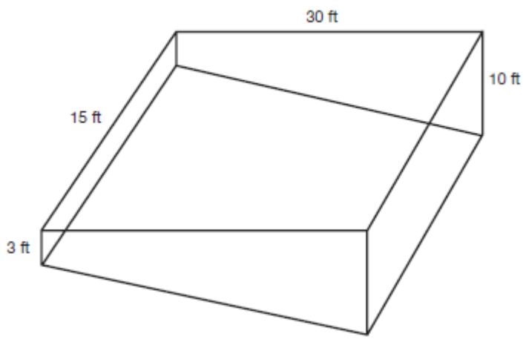
438. In a periscope, a pair of mirrors is mounted parallel to each other as shown. The path of light becomes a transversal. If ∠2 measures 50°, what is the measurement of ∠3? a. 50° b. 40° c. 130° d. 310° 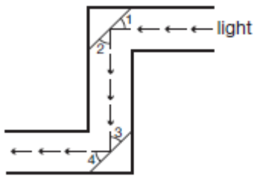
439. Given that ∠2 measures 50°, what is the measurement of ∠4? a. 50° b. 40° c. 130° d. 85°
440. The angle measure of the base angles of an isosceles triangle are represented by x and the vertex angle is 3x + 10. Find the measure of a base angle. a. 112° b. 42.5° c. 34° d. 16°
441. Using the information from question 440, ﬁnd the measure of the vertex angle of the isosceles triangle. a. 34° b. 16° c. 58° d. 112°
442. In parallelogram ABCD, ∠A = 5x + 2 and ∠C = 6x − 4. Find the measure of ∠A. a. 32° b. 6° c. 84.7° d. 44°
443. The longer base of a trapezoid is three times the shorter base. The nonparallel sides are congruent. The nonparallel side is 5 cm more that the shorter base. The perimeter of the trapezoid is 40 cm. What is the length of the longer base? a. 15 cm b. 5 cm c. 10 cm d. 21 cm
444. The measure of the angles of a triangle are represented by 2x + 15, x + 20, and 3x + 25. Find the measure of the smallest angle within the triangle. a. 40° b. 85° c. 25° d. 55°
445. Suppose ABCD is a rectangle. IF AB = 10 and AD = 6, ﬁnd BX to the nearest tenth. 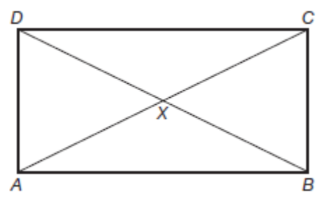 a. 4.0 b. 5.8 c. 11.7 d. 8.0
446. The perimeter of the parallelogram is 32 cm. What is the length of the longer side? 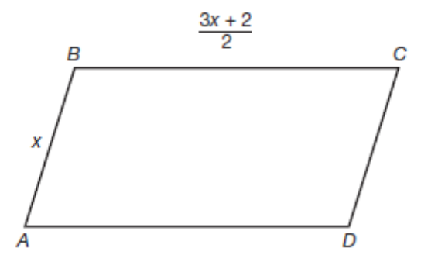 a. 9 cm b. 10 cm c. 6 cm d. 12 cm
447. A door is 6 feet and 6 inches tall and 36 inches wide. What is the widest piece of sheetrock that can ﬁt through the door? Round to the nearest inch. a. 114 in b. 86 in c. 85 in d. 69 in
448. The width of a rectangle is 20 cm. The diagonal is 8 cm more than the length. Find the length of the rectangle. a. 20 b. 23 c. 22 d. 21
449. The measures of two complementary angles are in the ratio of 7:8. Find the measure of the smallest angle. a. 84° b. 42° c. 48° d. 96°
450. In parallelogram ABCD, m∠A = 3x + 10 and m∠D = 2x + 30, ﬁnd the m∠A. a. 70° b. 40° c. 86° d. 94°
451. Using the diagram below and the fact that ∠A + ∠B + ∠C + ∠D = 325, ﬁnd m∠E. 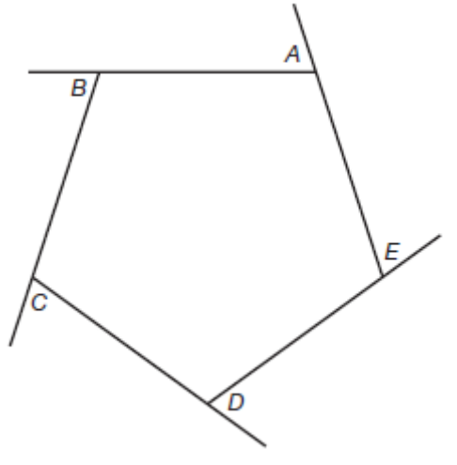 a. 81° b. 35° c. 25° d. 75°
452. The base of a triangle is 4 times as long as its height. If together they measure 95 cm, what is the area of the triangle? a. 1,444 cm² b. 100 cm² c. 722 cm² d. 95 cm²
453. One method of ﬁnding the height of an object is to place a mirror on the ground and then position yourself so that the top of the object can be seen in the mirror. How high is a structure if a person who is 160 cm tall observes the top of a structure when the mirror is 100 m from the structure and the person is 8 m from the mirror? 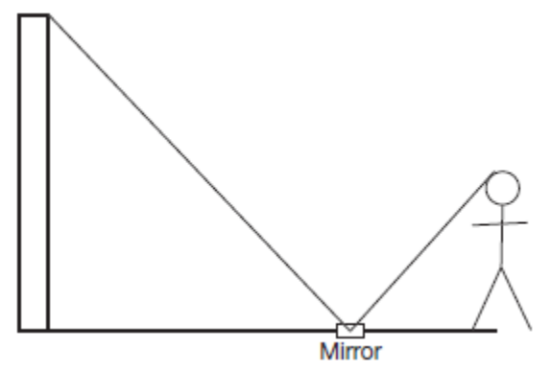 a. 50,000 cm b. 20,000 cm c. 2,000 cm d. 200 cm
454. Suppose ABCD is a parallelogram; ∠B = 120 and ∠2 = 40. Find m∠4. 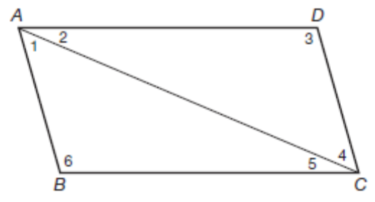 a. 50° b. 40° c. 20° d. 30°
455. The length and width of a rectangle together measure 130 yards. Their difference is 8 yards. What is the area of the rectangle? a. 4,209 yd² b. 130 yd² c. 3,233 yd² d. 4,270 yd²
456. A sphere has a volume of 288π cm³ . Find its radius. a. 9.5 cm b. 7 cm c. 14 cm d. 6 cm
457. Using the illustration provided below, if m∠ABE = 4x + 5 and m∠CBD = 7x − 10, ﬁnd the measure of ∠ABE. 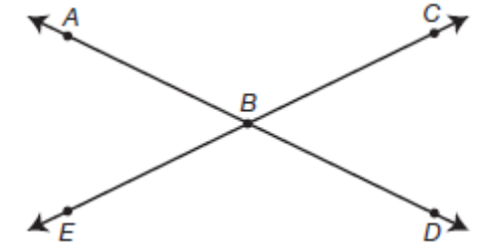 a. 155° b. 73° c. 107° d. 25°
458. Two angles are complementary. The measure of one angle is four times the measure of the other. Find the measure of the larger angle. a. 36° b. 72° c. 144° d. 18°
459. If Gretta’s bicycle has a 25-inch diameter wheel, how far will she travel in two turns of the wheel? (π = 3.14) a. 491 in b. 78.5 in c. 100 in d. 157 in
460. Two angles are supplementary. The measure of one is 30 more than twice the measure of the other. Find the measure of the larger angle. a. 130° b. 20° c. 50° d. 70°
461. Using the illustration provided, ﬁnd the m∠AED. Given m∠BEC = 5x − 36 and m∠AED = 2x + 9. 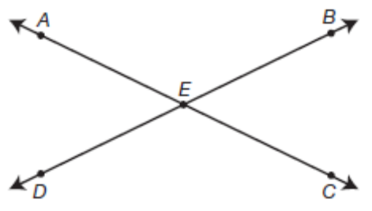 a. 141° b. 69° c. 111° d. 39°
462. The measures of the angles of a triangle are in the ratio of 3:4:5. Find the measure of the largest angle. a. 75° b. 37.5° c. 45° d. 60°
463. A mailbox opening is 4.5 inches high and 5 inches wide. What is the widest piece of mail able to ﬁt in the mailbox without bending? Round answer to the nearest tenth. a. 9.5 inches b. 2.2 inches c. 6.7 inches d. 8.9 inches
464. The ﬁgure below represents the cross section of a pipe 1/2 inch thick that has an inside diameter of 3 inches. Find the area of the shaded region in terms of π. 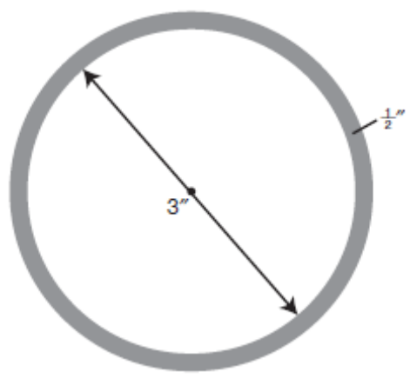 a. 8.75π in² b. 3.25π in² c. 7π in² d. 1.75π in²
465. Using the same cross section of pipe from question 464, answer the following question. If the pipe is 18 inches long, what is the volume of the shaded region in terms of π? a. 31.5π in³ b. 126π in³ c. 157.5 in³ d. 58.5 in³
466. A person travels 10 miles due north, 4 miles due west, 5 miles due north, and 12 miles due east. How far is that person from the starting point? a. 23 miles northeast b. 13 miles northeast c. 17 miles northeast d. 17 miles northwest
467. Using the illustration provided, ﬁnd the area of the shaded region in terms of π. 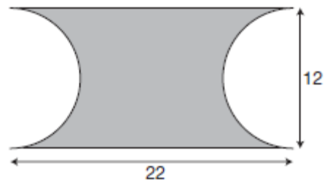 a. 264 − 18π b. 264 − 36π c. 264 − 12π d. 18π−264
468. Find how many square centimeters of paper are needed to create a label on a cylindrical can 45 cm tall with a circular base having diameter of 20 cm. Leave answer in terms of π. a. 450π cm² b. 4,500π cm² c. 900π cm² d. 9,000π cm²
469. Using the illustration provided below, if the measure ∠AEB = 5x + 40 and ∠BEC = x + 20, ﬁnd m∠DEC. 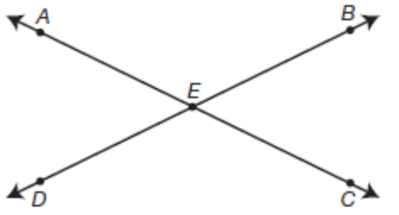 a. 40° b. 25° c. 140° d. 65°
470. The structural support system for a bridge is shown in the illustration provided. AD is parallel to BC , BE is parallel to CD , and AB is parallel to CF . Find ∠CGE. 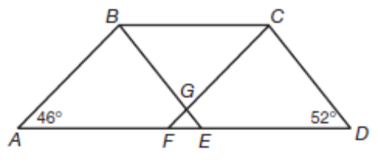 a. 46° b. 52° c. 82° d. 98°
471. Find the area of the shaded portions, where AB = 6 and BC = 10. Leave answer in terms of π. 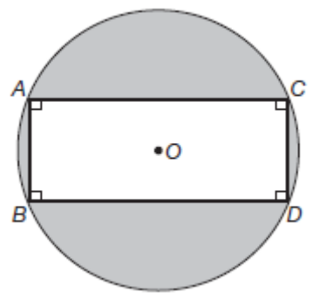 a. 25π−72 b. 25π−48 c. 25π−8 d. 100π−48
472. Find the area of the shaded region in terms of π. 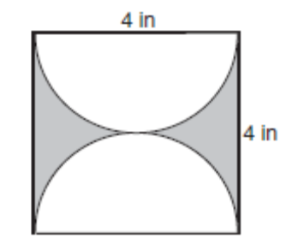 a. 8 − 4π b. 16 − 4π c. 16 − 2π d. 2π−16
473. On a piece of machinery, the centers of two pulleys are 3 feet apart, and the radius of each pulley is 6 inches. How long a belt (in feet) is needed to wrap around both pulleys? 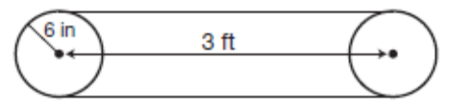 a. (6 + .5π) ft b. (6 + .25π) ft c. (6 + 12π) ft d. (6 + π) ft
474. Find the measure of each angle of a regular 14-sided polygon to the nearest tenth. a. 25.7° b. 12.9° c. 128.6° d. 154.3°
475. A sand pile is shaped like a cone as illustrated below. How many cubic yards of sand are in the pile. Round to the nearest tenth. (π = 3.14) 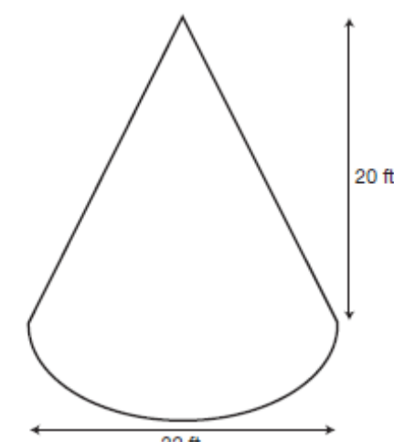 a. 5,358.9 yd³ b. 595.4 yd³ c. 198.5 yd³ d. 793.9 yd³
476. Find the area of the regular octagon with the following measurements. 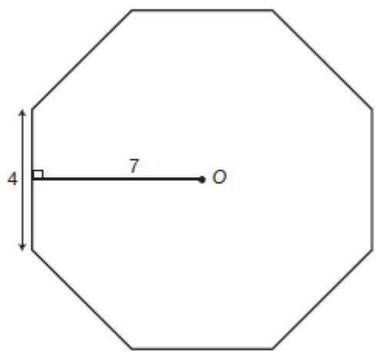 a. 224 square units b. 112 square units c. 84 square units d. 169 square units
477. Two sides of a picture frame are glued together to form a corner. Each side is cut at a 45-degree angle. Using the illustration provided, ﬁnd the measure of ∠A. 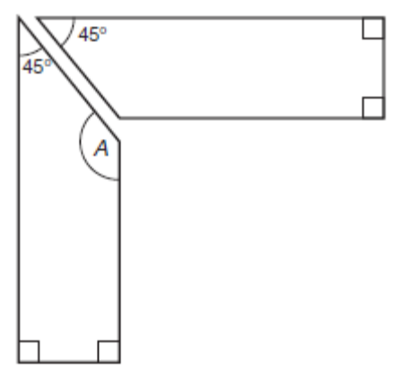 a. 45° b. 90° c. 115° d. 135°
478. Find the total area of the shaded regions, if the radius of each circle is 5 cm. Leave answer in terms of π. 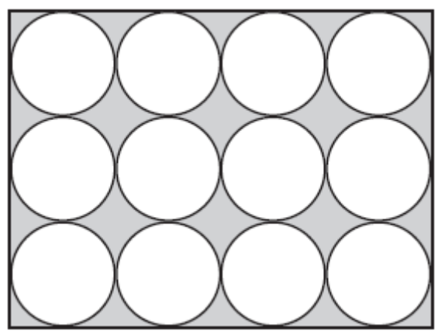 a. 1,200 − 300π cm² b. 300 − 300π cm² c. 300π−1,200 cm² d. 300π−300 cm²
479. The road from town A to town B travels at a direction of N23°E. The road from town C to town D travels at a direction of S48°E. The roads intersect at location E. Find the measure of ∠BED, at the point of intersection. a. 71° b. 23° c. 109° d. 48°
480. The ﬁgure provided below represents a hexagonal-shaped nut. What is the measure of ∠ABC? 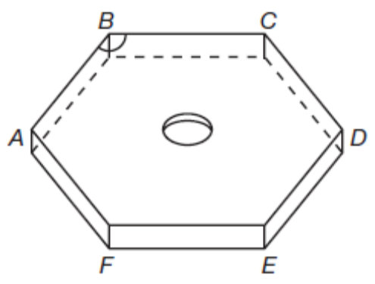 a. 120° b. 135° c. 108° d. 144°
481. If the lengths of all sides of a box are doubled, how much is the volume increased? a. 2 times b. 4 times c. 6 times d. 8 times
482. If the radius of a circle is tripled, the circumference is a. multiplied by 3. b. multiplied by 6. c. multiplied by 9. d. multiplied by 12.
483. If the diameter of a sphere is doubled, the surface area is a. multiplied by 4. b. multiplied by 2. c. multiplied by 3. d. multiplied by 8.
484. If the diameter of a sphere is doubled, the volume is a. multiplied by 2. b. multiplied by 8. c. multiplied by 4. d. multiplied by 3.
485. If the radius of a cone is doubled, the volume is a. multiplied by 2. b. multiplied by 4. c. multiplied by 6. d. multiplied by 8.
486. If the radius of a cone is halved, the volume is a. multiplied by 1/4 . b. multiplied by 1/2 . c. multiplied by 1/8 . d. multiplied by 1/16.
487. If the radius of a right cylinder is doubled and the height is halved, its volume a. remains the same. b. is multiplied by 2. c. is multiplied by 4. d. is multiplied by 1/2 .
488. If the radius of a right cylinder is doubled and the height is tripled, its volume is a. multiplied by 12. b. multiplied by 2. c. multiplied by 6 d. multiplied by 3.
489. If each interior angle of a regular polygon has a measure of 144 degrees, how many sides does it have? a. 8 b. 9 c. 10 d. 11
490. A box is 30 cm long, 8 cm wide and 12 cm high. How long is the diagonal AB ? Round to the nearest tenth. 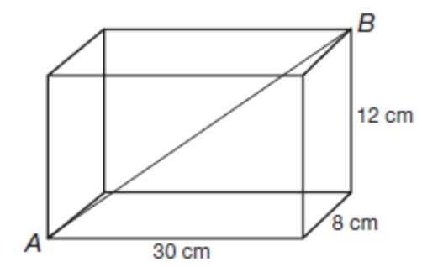 a. 34.5 cm b. 32.1 cm c. 35.2 cm d. 33.3
491. Find the area of the shaded region. Leave answer in terms of π. 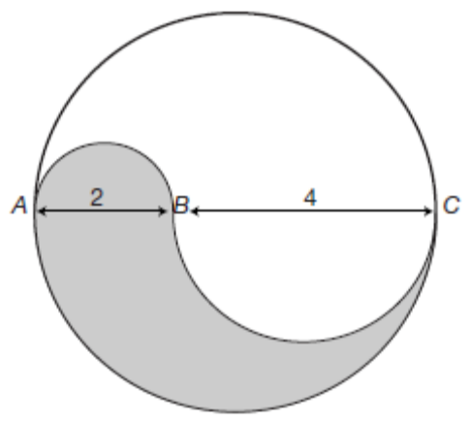 a. 16.5π b. 30π c. 3π d. 7.5π
492. A round tower with a 40 meter circumference is surrounded by a security fence that is 8 meters from the tower. How long is the security fence in terms of π? a. (40 + 16π) meters b. (40 + 8π) meters c. 48π meters d. 56π meters
493. The ﬁgure below is two overlapping rectangles. Find the sum of ∠1 + ∠2 + ∠3 + ∠4. 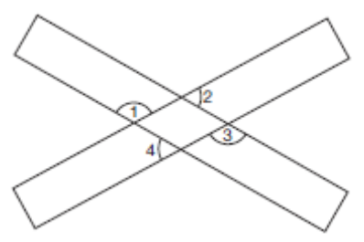 a. 360° b. 90° c. 180° d. 540°
494. A solid is formed by cutting the top off of a cone with a slice parallel to the base, and then cutting a cylindrical hole into the resulting solid. Find the volume of the hollow solid in terms of π. 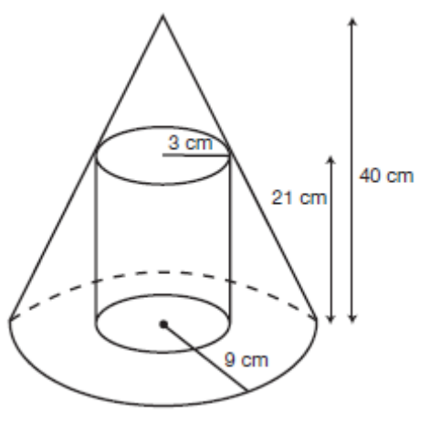 a. 834π cm³ b. 2,880π cm³ c. 891π cm³ d. 1,326π cm³
495. A rectangular container is 5 cm wide and 15 cm long, and contains water to a depth of 8 cm. An object is placed in the water and the water rises 2.3 cm. What is the volume of the object? a. 92 cm3 b. 276 cm³ c. 172.5 cm³ d. 312.5 cm³
496. A concrete retaining wall is 120 feet long with ends shaped as shown. How many cubic yards of concrete are needed to construct the wall? 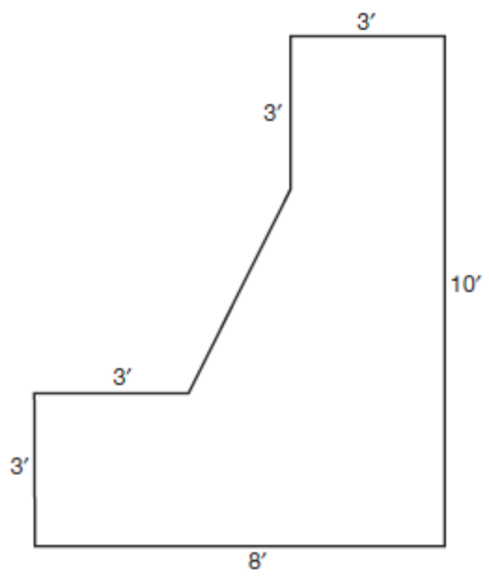 a. 217.8 yd³ b. 5,880 yd³ c. 653.3 yd³ d. 49 yd³
497. A spherical holding tank whose diameter to the outer surface is 20 feet is constructed of steel 1 inch thick. How many cubic feet of steel is needed to construct the holding tank? Round to the nearest integer value. (π = 3.14) 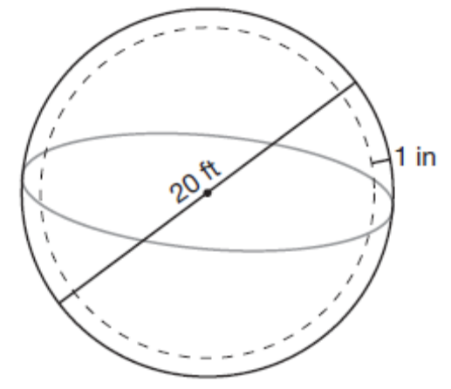 a. 78 ft³ b. 104 ft³ c. 26 ft³ d. 125 ft³
498. How many cubic inches of lead are there in the pencil? Round to the nearest thousandth. (π = 3.14) 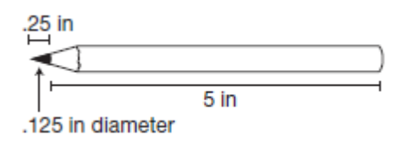 a. 0.061 in³ b. 0.060 in³ c. 0.062 in³ d. 0.063 in³
499. A cylindrical hole with a diameter of 4 inches is cut through a cube. The edge of the cube is 5 inches. Find the volume of the hollowed solid in terms of π. 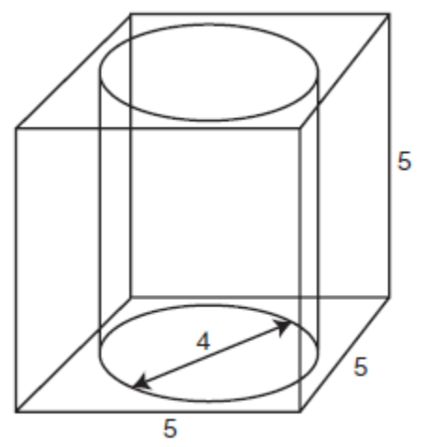 a. 125 − 80π b. 125 − 20π c. 80π−125 d. 20π−125
500. Find the area of the region. 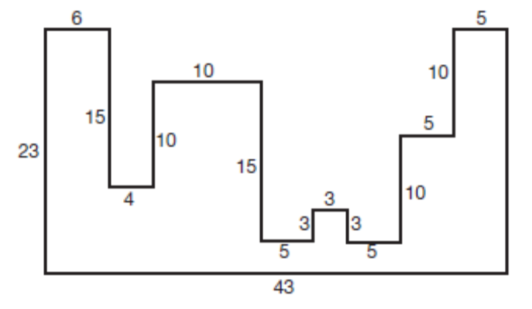 a. 478 units² b. 578 units² c. 528 units² d. 428 units²
501. From a stationary point directly in front of the center of a bull’s eye, Kim aims two arrows at the bull’s eye. The ﬁrst arrow nicks one point on the edge of the bull’s eye; the second strikes the center of the bull’s eye. Kim knows the second arrow traveled 20 meters since she knows how far she is from the target. If the bull’s eye is 4 meters wide, how far did the ﬁrst arrow travel? You may assume that the arrows traveled in straight-line paths and that the bull’s eye is circular. Round answer to the nearest tenth. a. 19.9 meters b. 24 meters c. 22 meters d. 20.1 meters

