# Motor Sports – Technical Design Document

This document will explain the technical design of Motor Sports application

# Events

## Create New Event

### DB Table

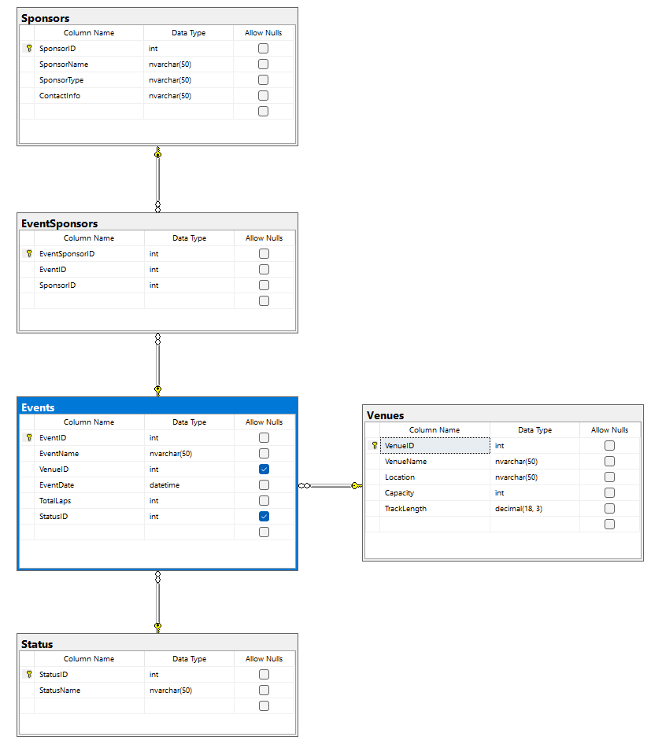

### API End Point

Following Endpoints will be exposed in EventsController

1. GetEvents
   1. This endpoint will return all events available in Database.
   2. Following columns will be returned – *It will return an array of all events*
      * EventID
      * EventName
      * VenueID
      * VenueName
      * EventDate
      * TotalLaps
      * StatusID
      * StatusName
      * EventSponsors – *It will be an array of all sponsors*
        + SponsorID
        + SponsorName
        + SponsorType
        + ContactInfo
2. GetEvent(eventID)
   1. This endpoint will return details of one event matching with eventide
   2. Following columns will be returned – *It will return a single instance of Event*
      * EventID
      * EventName
      * VenueID
      * VenueName
      * EventDate
      * TotalLaps
      * StatusID
      * StatusName
      * EventSponsors – *It will be an array of all sponsors*
        + SponsorID
        + SponsorName
        + SponsorType
        + ContactInfo
3. AddNewEvent
   1. This endpoint will Add a new event in the events table
   2. This endpoint will accept following input parameters
      * EventName
      * VenueID
      * EventDate
      * TotalLaps
      * StatusID
      * EventSponsors – *It will be an arrays*
        + SponsorID
4. UpdateEvent
   1. This endpoint will Update an existing event in the event table
   2. This endpoint will accept following input parameters
      * EventID
      * EventName
      * VenueID
      * EventDate
      * TotalLaps
      * StatusID
      * EventSponsors – *It will be an arrays*
        + SponsorID
5. DeleteEvent
   1. This endpoint will delete an existing event from the events table
   2. This endpoint will accept following input parameters
      * EventID