Table of Contents

Abstract: 2

Current e-commerce: 2

Innovation: The Maall 2

Shopping Mall: 3

Shop: 4

How we can earn through Mall: 4

Integration of Blockchain 4

Basic Shop Token (BST) 4

Access Shop Token (AST) 4

# Abstract:

The core idea is to create Centaurus(a shopping mall here in Islamabad) in VR and put it in browser screen so everyone can perform all those activities in that VR-made shopping mall that they perform in Real-world mall. Such as shopping etc, and we can use promotion and advertisement too.

# Current e-commerce:

We shop from an online ecommerce platform and we go through different items we want to purchase like we are reading a book. In current e-commerce website we enter keyword and visit a single page with different images, Like we search for a word in glossary of book and then we go to its page number and get what we are seeking for. It shows current e-commerce system limitize us to only a book or similar to reading a book.

# Innovation: **The Maall**

Innovation I want to bring in ecommerce is to build a website in VR, where user will feel like he is shopping in real world instead of going through book pages. Everything will be 3d modeled similarly like real world outlet store.

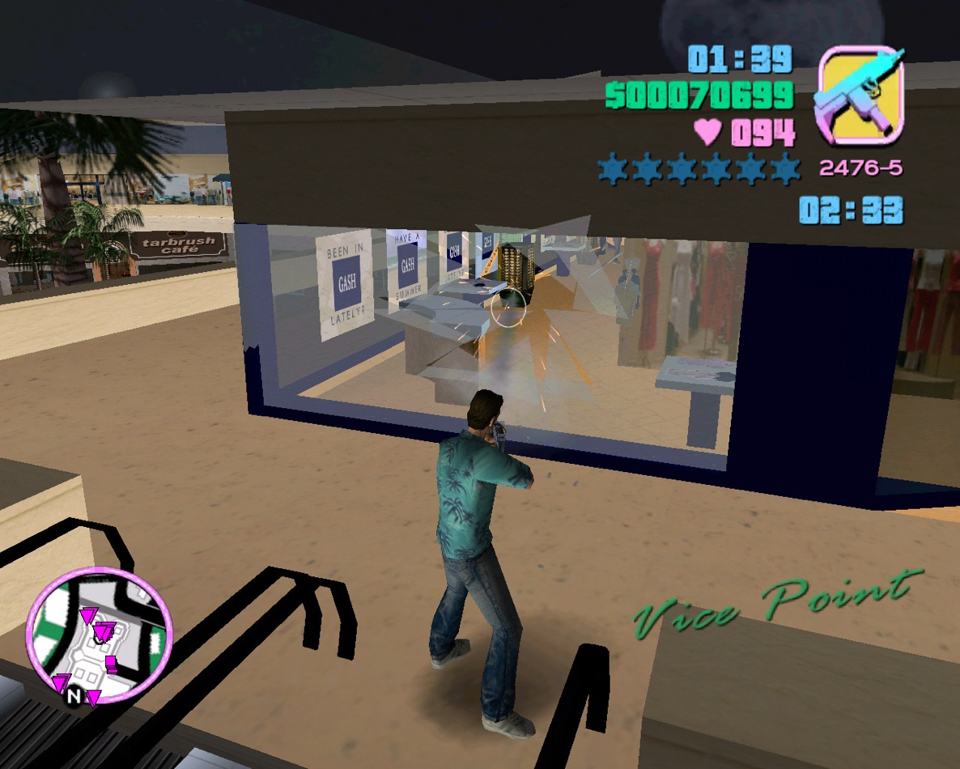A good example if one has played GTA vice city, in that game there was a mission where Tom had to kill some people in a Shopping mall Shopping mall was a VR 3D model people (3d models) were shopping in outlets outlets were stuffed with 3d models dummies etc. Few screenshot from that mission of game

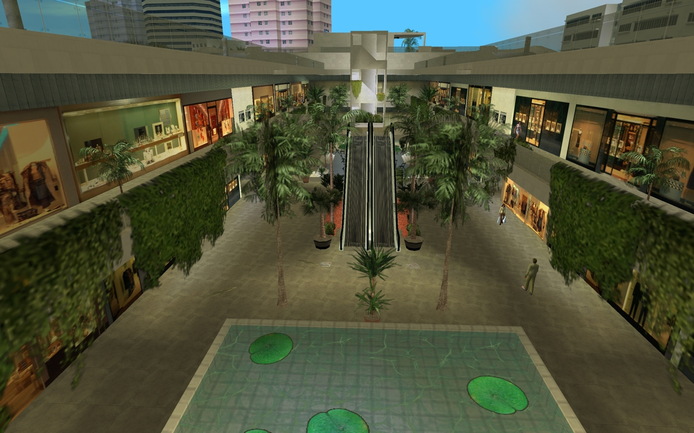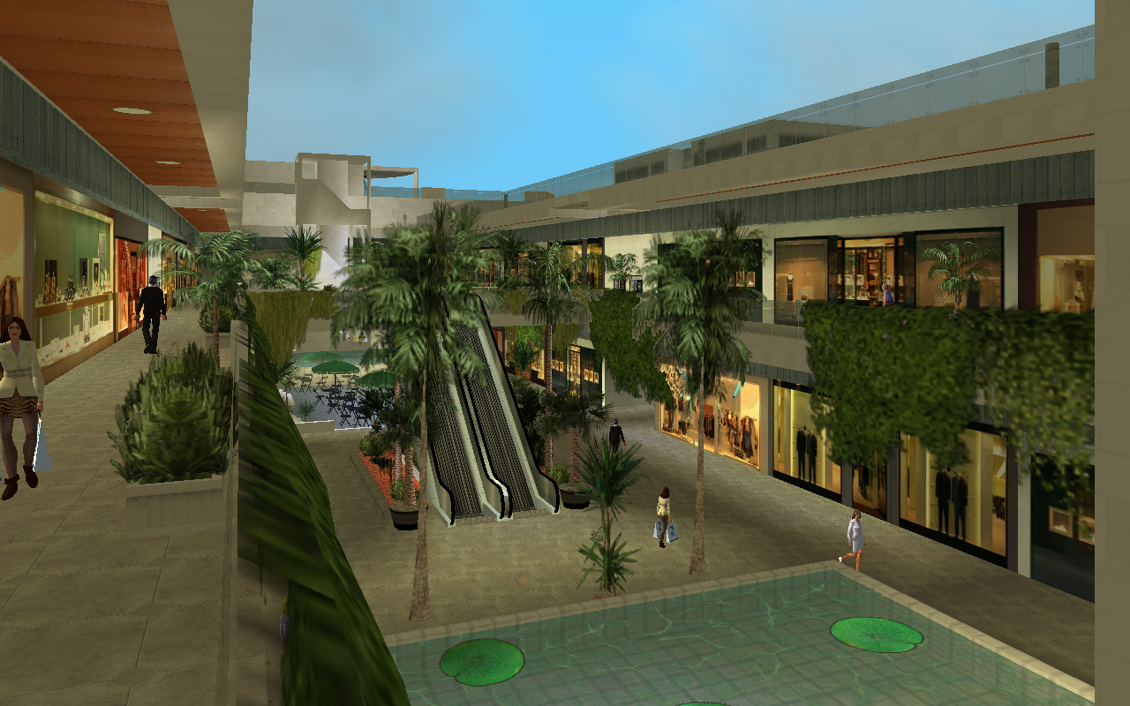

# Shopping Mall:

What my actual idea is to develop a (product) shopping mall (plaza) in VR similar to what is in this game’s screenshots. Where I’ll sale stores(shops) to different buyers, buyers could be outlets live Levis etc, or any other shop can be built in that store similar to real world plaza including store for electrical appliances, clothes, shoes, Apple, Smasung, Car’s showroom, As this would be a VR store so we can even build a showroom for Cars, Helicoptores, Big Airplanes or anything else that comes new in market and we can display it in one of our Stores from our shopping mall for promotions, advertisement purpose that is impossible in real world malls but we can earn a lot from these promotions too.

## Shop:

Each Shop/store will have following properties:

* It’ll have a specific length and width (40*40) feet etc.
* A new Room/Store will be completely empty during its selling time.
* Price of store will vary according to its location in Mall, like corner shop, or 1st floor shop etc will have higher rates.

## How we can earn through Mall:

* By Selling/Renting shops/sores in Mall.
* By advertisement and Promotions for different products and companies.
* By commission in sale and purchase of Asset like (Shop/store).
* By providing different models to stores/shops, designing stores for store owners for their product. Example: Like Levis buys a store in a shopping mall at the time of buying they only get a room completely empty, then they pay interior designers to design their store, similary when we will sell/rent a store we will also provide them option to design their store and we can earn from this aswell.
* By opening meeting rooms for different teams. Example: Suppose A team of some businessmen/developers wants to conduct a meeting, unlike thei conventional way of meeting that is a video conference call we can innovate it by getting their photos from their cameras and then putting them on faces of different models and showing them all the full room where everyone is sitting and to them it’ll be like they are all present in the same room and attending real world meeting.

# Integration of Blockchain

Blockchain technology was basically developed to gain trust of people. We can use Smart Contracts to deal with selling and purchasing in Mall either it is items from a store or Shops/stores themselves.

Currently I’m willing to develop two tokens

* Basic Shop Token (BST)
* Access Shop Token(AST)

## Basic Shop Token (BST)

BST will be used for selling and purchasing purpose of shops and items/accessories they are selling to customer/buyers.

## Access Shop Token (AST)

AST is a unique token for each single shop, Every shop In mall will have it’s own unique identifier Token that can be transferred to any buyer (new owner) of shop.

Area of shop (40*40 feet) will automatically increase as the shop ages. Suppose a shop will be increased from (40*40) to (45*45) after a passing 1 year of its creation. This will be a benefit for customers(shop owners/buyers), and obviously it’ll not affect us anyway because it is built in VR and we can increase its area whenever we want to without paying for area cost like in real-world.

# Initial Investment:

I’m willing to get an initial investment so I can build a good prototype of form maybe 2,3 full functional floors of Mall and to make a better team of developers, advisors, and marketing persons. Because this team matters a lot in ICO.

# ICO

After getting initial investment and creating a good team. Next plan is to Run an ICO with 3-4 phases.

## Why I prefer ICO for our product?

As from start ICOs helped many teams to collect incredible amount of investment for their products.

But there were some cases due to which people usually don’t want to invest/trust in ICOs reasosn are:

* Most of the ICOs didn’t delivered what they promised for before ICO.
* A few of them were scam, with an impressive landing page and fake teams many people looted a lot of investors.
* But that was all due to hype of ICOs that made investors throw their money blindly in greed.

But with all these facts I still want to go for an ICO because.

* 1st thing is it can help gather a lot of investment, if we have some famous and top/ better advisors in our team, because usually investors invest by seeing team and hype