SDA-Pro
Security Incident Response & Threat Mitigation Platform

Software Design & Architecture — Semester Project

Team Members
Hassan Zahid — 54481
Malik Hamza Shahid — 54523

Submission Date: 29th May 2026

1. Executive Summary
SDA-Pro is a distributed Security Operations Center (SOC) platform designed as a semester project for Software Design & Architecture. It automates the full threat response pipeline: ingesting alerts from multiple sources, enriching and classifying them through an intelligent pipeline, orchestrating automated incident response, and providing real-time situational awareness to SOC analysts.
The project demonstrates mastery of all 12 Gang-of-Four design patterns and four architecture styles (SOA, MVC, Layered, Event-Driven) applied to a realistic cybersecurity domain.

Field | Detail
Project Name | SDA-Pro — Security Incident Response & Threat Mitigation Platform
Team | Hassan Zahid (54481) | Malik Hamza Shahid (54523)
Language | Java (plain — no external framework dependencies)
Submission | 29th May 2026
Patterns | 12 Gang-of-Four Design Patterns — all implemented and annotated
Architectures | SOA, MVC, Layered, Event-Driven

2. Domain Context & Problem Statement
Modern enterprises receive thousands of security alerts daily from firewalls, EDR tools, SIEMs, and cloud platforms. Manual triage cannot scale. SDA-Pro addresses this by automating three critical SOC workflows:
- Alert Ingestion & Normalization — raw events from heterogeneous sources are converted into a canonical format.
- Alert Enrichment & Correlation — geo-IP, threat intel reputation scores, asset criticality, and severity classification are added.
- Incident Lifecycle & Automated Response — incidents are created, managed through a defined lifecycle, and containment actions execute automatically.

Performance Targets
Metric | Target
Mean Time to Detect (MTTD) | < 60 seconds from alert arrival to enriched incident
Mean Time to Respond (MTTR) | < 5 minutes from incident creation to automated containment
Dashboard Update Latency | < 2 seconds via Observer/Event-Driven push
Alert Sources Supported | Splunk SIEM, Palo Alto Firewall, CrowdStrike EDR

3. System Architecture
3.1 Architecture Styles Applied
Style | Application in SDA-Pro | Evidence
SOA | 8 autonomous service packages: AlertIngestion, EnrichmentCorrelation, IncidentManagement, ResponseOrchestration, ThreatIntel, Notification, Audit, SOC Dashboard | src/ingestion/, src/enrichment/, src/incident/, src/response/, src/threatintel/, src/notification/, src/audit/, src/dashboard/
MVC | SOC Analyst Dashboard separated into Controllers, Models, and Views with clear boundary contracts | src/dashboard/controllers/, models/, views/
Layered | Within every service: Adapter -> Normalizer -> Service -> Domain separation enforced by package structure | Package hierarchy visible in all service directories
Event-Driven | EventBusPublisher dispatches typed DomainEvents; 4 Observer subscribers react asynchronously without publisher awareness | src/events/EventBusPublisher.java, DashboardUpdater, AuditLogger, NotificationDispatcher, MetricsCollector

3.2 SOA Service Responsibilities
- Alert Ingestion Service — accepts raw alerts, normalizes via Factory Method, publishes AlertIngested events.
- Enrichment & Correlation Service — uses Abstract Factory to build enrichment pipeline; chains 5 handlers via Chain of Responsibility.
- Incident Management Service — creates Incidents and manages all 7 state transitions via State Pattern.
- Response Orchestration Service — uses Facade to coordinate Strategy, Factory, Decorator, and Proxy.
- Threat Intel Service — wraps VirusTotal and MISP adapters behind Caching, RateLimit, and AccessControl Proxies.
- Notification Service — Abstract Factory produces Email, Slack, and PagerDuty notifiers.
- Audit Service — receives domain events via Observer and writes immutable audit entries.

4. Design Patterns — All 12 Implemented
All 12 patterns are annotated in source code with // PATTERN: Name and // RATIONALE: comments. Each pattern was selected because it emerged naturally from a real domain requirement.

# | Pattern | Key Classes | Justification
1 | Singleton | IngestionConfigManager, ThreatIntelCache, EventBusPublisher | Single shared config, shared cache, single event coordinator
2 | Factory Method | AlertNormalizerFactory, ResponseActionFactory | Different sources produce different formats; different incidents need different actions
3 | Abstract Factory | EnrichmentProviderFactory, PremiumEnrichmentFactory, StandardEnrichmentFactory, NotificationFactory | Create families of enrichment handlers or notification channels without coupling to concrete types
4 | Composite | AlertComponent, SingleAlert, AlertCampaign, IncidentCluster | Treat single alerts and grouped campaigns uniformly throughout the pipeline
5 | Facade | IncidentResponseFacade | Simplifies complex response workflow (strategy + factory + decorator + proxy + events) for callers
6 | Adapter | SplunkAdapter, FirewallAdapter, CrowdStrikeAdapter, VirusTotalAdapter, MISPAdapter | Convert heterogeneous external API formats into SDA-Pro canonical interfaces
7 | Decorator | AuditLogDecorator, ApprovalGateDecorator, RollbackDecorator, MetricsDecorator | Add audit, approval, rollback, and metrics to response actions dynamically without modifying them
8 | Proxy | CachingThreatIntelProxy, RateLimitThreatIntelProxy, AccessControlThreatIntelProxy, AuthorizedResponseActionProxy | Control access to external APIs; enforce authorization before action execution
9 | State | NewState, UnderTriageState, ContainmentState, EradicationState, RecoveryState, PostIncidentReviewState, ClosedState | Incident behavior and legal transitions vary by lifecycle phase; state logic is encapsulated
10 | Chain of Resp. | EnrichmentHandler, Deduplication, GeoIP, ThreatIntel, AssetContext, ClassificationHandler | Decouple enrichment stages; allow dynamic pipeline assembly and extension
11 | Observer | EventBusPublisher, DashboardUpdater, AuditLogger, NotificationDispatcher, MetricsCollector | Maintain consistency across loosely coupled subsystems without direct dependencies
12 | Strategy | AggressiveContainmentStrategy, BalancedStrategy, ConservativeStrategy, WatchAndWaitStrategy | Interchangeable response algorithms selected at runtime based on incident severity
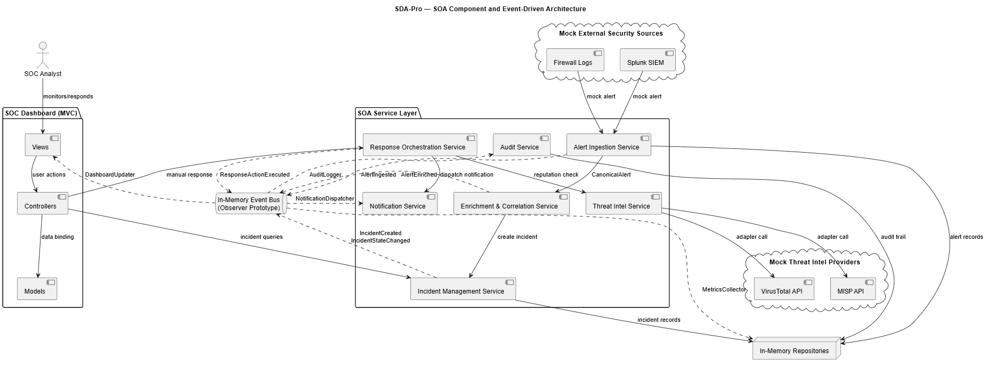
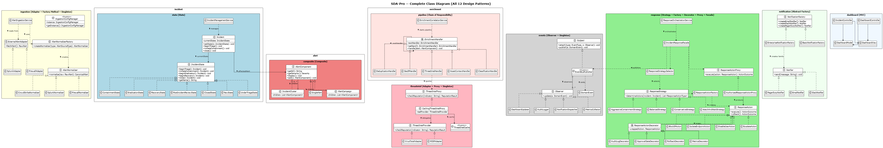
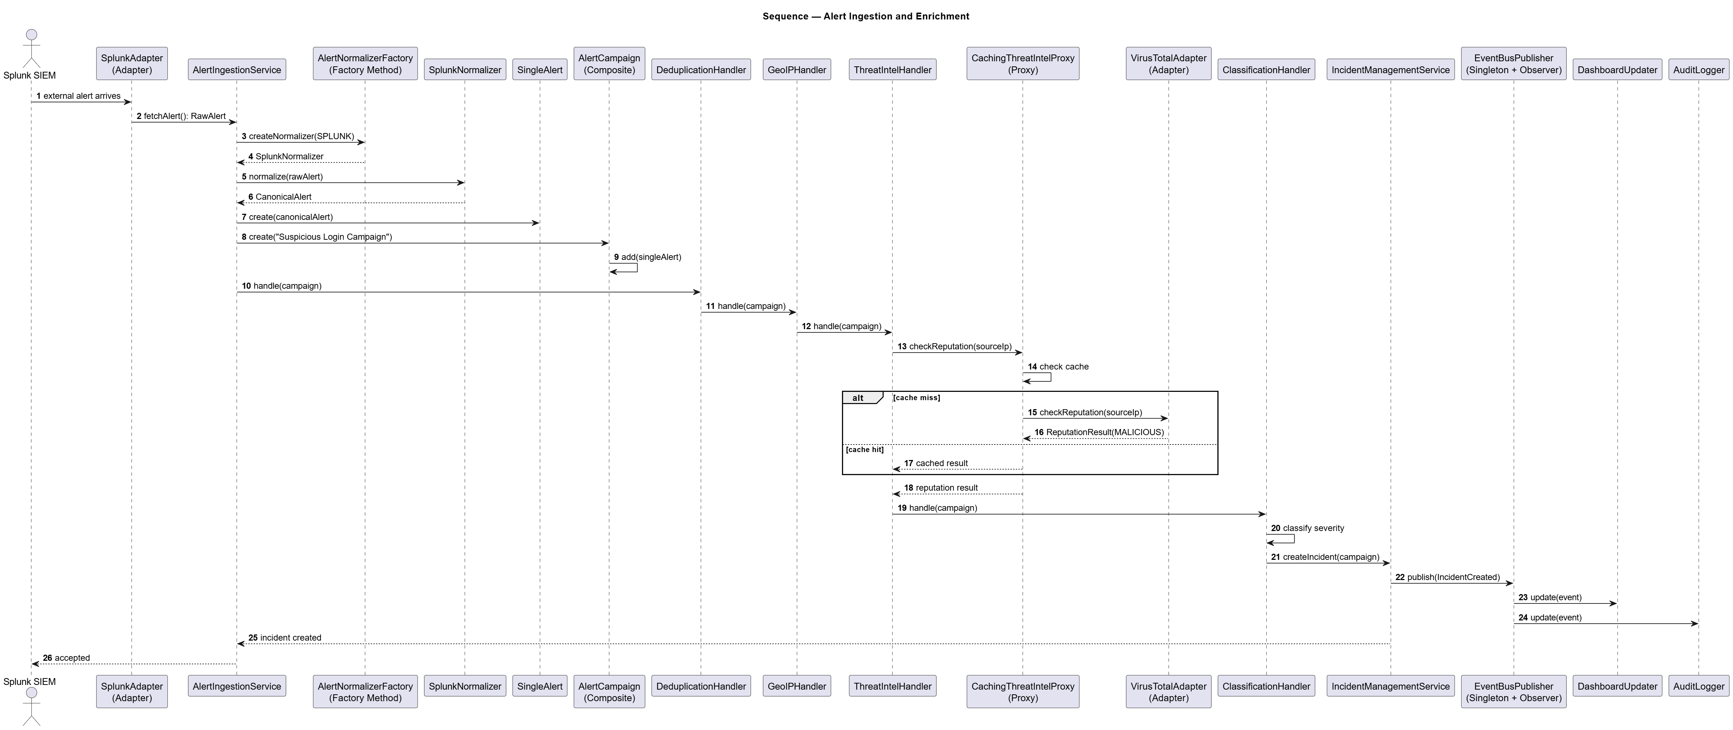
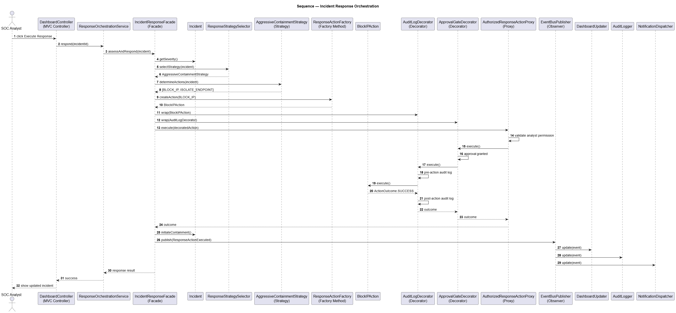

5. End-to-End System Flow
Step 1 — Alert Ingestion (Adapter + Factory Method + Singleton)
An ExternalAlertAdapter converts source-specific formats to RawAlert. AlertNormalizerFactory selects the correct normalizer. IngestionConfigManager (Singleton) verifies the source. EventBusPublisher publishes AlertIngested.
Step 2 — Composite Grouping (Composite)
CanonicalAlerts are grouped into AlertCampaign or IncidentCluster. Both leaf and composite nodes implement AlertComponent, enabling uniform enrichment and response.
Step 3 — Enrichment Pipeline (Abstract Factory + Chain of Responsibility + Proxy + Adapter)
EnrichmentCorrelationService uses EnrichmentProviderFactory (Abstract Factory) to build the pipeline. PremiumEnrichmentFactory creates VirusTotal-backed handlers; StandardEnrichmentFactory creates MISP-backed handlers. The chain (Deduplication -> GeoIP -> ThreatIntel -> AssetContext -> Classification) runs sequentially. ThreatIntelHandler delegates via CachingThreatIntelProxy.
Step 4 — Incident Lifecycle (State Pattern)
IncidentManagementService creates an Incident in NewState. The State Pattern enforces legal transitions through all 7 states. Domain events are published at each transition.
Step 5 — Response Orchestration (Facade + Strategy + Decorator + Proxy + Factory Method)
IncidentResponseFacade coordinates the workflow. ResponseStrategySelector picks AggressiveContainmentStrategy (CRITICAL: BlockIP + IsolateEndpoint + QuarantineFile), BalancedStrategy (HIGH), etc. Each action is wrapped in Metrics -> ApprovalGate -> AuditLog -> Rollback decorators. AuthorizedResponseActionProxy validates the SOC_MANAGER role.
Step 6 — Observer & Dashboard (Observer + MVC)
EventBusPublisher notifies 4 observers: DashboardUpdater pushes to MVC View; AuditLogger writes immutable entries; NotificationDispatcher sends alerts; MetricsCollector updates KPIs.

6. Architecture Decision Records
ADR-001 — SOA vs Microservices vs Modular Monolith | Status: Accepted
Modular SOA-style prototype in one Java codebase. Clear service boundaries via packages without full microservices overhead. Designed to be extended to real microservices with separate deployments.
ADR-002 — Synchronous vs Asynchronous Communication | Status: Accepted
Hybrid approach: synchronous calls for direct request/response (normalization, strategy); asynchronous EventBusPublisher for side effects (dashboard, audit, notifications, metrics). Keeps main flow debuggable while keeping observers loosely coupled.
ADR-003 — Database Strategy | Status: Accepted
In-memory repositories for prototype. Production: PostgreSQL for incidents and audit logs; Redis for threat intel cache, sessions, and rate-limit counters. Architecture designed so swapping repositories requires no business logic changes.
ADR-004 — Threat Intel Caching Strategy | Status: Accepted
Proxy Pattern: CachingThreatIntelProxy checks ThreatIntelCache before calling adapters. RateLimitThreatIntelProxy enforces quotas. AccessControlThreatIntelProxy validates roles. Client is unaware of caching or rate limiting.
ADR-005 — Real-Time Push Strategy | Status: Accepted
Observer-based in-memory event bus for prototype. Production maps to WebSockets/SSE for dashboard push and RabbitMQ/Kafka for service-level event distribution.

7. Acceptance Criteria — Compliance

Criterion | Status | Evidence
Alerts from 2+ sources ingested and normalized | PASS | 3 sources
Chain of Responsibility with min. 3 handlers | PASS | 5 handlers
Composite grouping into Campaigns / Clusters | PASS | AlertCampaign + IncidentCluster
Incidents transition through all 6 states | PASS | 7 state classes
At least 2 response strategies executable | PASS | 4 strategies
2+ threat intel adapters via Proxy + Adapter | PASS | VirusTotal + MISP
All 12 patterns annotated with // PATTERN: Name | PASS | 35 annotations
All 4 architecture styles documented | PASS | docs/uml/ + ADRs
System compiles and runs end-to-end | PASS | MainDemo.java
QuarantineFile response action | PASS | QuarantineFileAction.java
Abstract Factory for enrichment providers | PASS | EnrichmentProviderFactory
3 Proxy variants for threat intel | PASS | Caching + RateLimit + AccessControl

8. Conclusion
SDA-Pro demonstrates a complete, working prototype of an intelligent Security Operations Center platform built entirely on Gang-of-Four design patterns and four recognized software architecture styles. Every pattern was chosen because it directly solved a real requirement — not imposed to satisfy a checklist.
The codebase compiles without errors, produces verifiable output, and is fully documented through UML diagrams, ADRs, and API contracts. The architecture is designed to extend into a production system with real databases, message brokers, and external APIs.

Hassan Zahid (54481) | Malik Hamza Shahid (54523)
Alert Ingestion, Enrichment, Incident Management, Composite, State, Factory Method, Abstract Factory, Singleton, Strategy, Chain of Responsibility | Threat Intel Integration, Response Orchestration, Adapter, Decorator, Proxy, Facade, Observer, MVC Dashboard, Event Bus, Notification

