Formal Model and Experiment Plan
Gym Crowding and the El Farol Bar Problem
SE 4457 / ECE 9710 · Group Myerson · 9 November 2026
1. Question
If gym users are given live information about how crowded the gym is, does this reduce crowding overall, or can it cause people to shift toward the same times and create new periods of congestion?
We will compare three information conditions (none, live, delayed) and how many past days agents remember (1, 5, or 10). We then measure how crowded the busiest slot gets and how often the gym goes over capacity.
2. What we are doing with the data
The NetLogo El Farol model is not trained on any data. “1990s” is just the date of Arthur’s paper (1994) and the Rand and Wilensky model (1997/2007). Attendance history starts as random numbers, and each agent’s strategies are random weight vectors. There is nothing old to replace.
So “update the model with modern data” means three concrete things, not training:
1. Calibrate parameters from real WSRC counts: how many agents, what counts as capacity, which evening slots, and the typical demand curve.
2. Validate the simulation: does the evening shape, the share of half-hours over capacity, and the variance look like the real gym?
3. Seed each agent’s starting memory with real past occupancy instead of random numbers.
The earlier task list said “Train the model with all the data.” That row is now “Calibrate and validate the model with the data.”
3. Data
What we kept
@WesternWeightRm (X). Staff post 3WR / 4WR / CM counts about every 30 minutes. We pulled the timeline from 1 September 2025 to 27 October 2026 (1,174 posts). 321 posts had the numbers in the text. 850 were images, so we ran Tesseract OCR. Only 3 posts (0.26%) could not be parsed. A 30-post OCR spot-check matched the cards for 3WR, 4WR, and CM.
westernusc.ca/wsrc-status. The same numbers on a live page. We started polling it so we still have data if X scraping fails later.
Gazette (2022). Used only as a sanity check on which days and hours are busy. Not used to set parameters.
Fitness centre = 3WR + 4WR (the two weight rooms). Cardio mezz (CM) is stored but left out of capacity, demand, and validation.
What we dropped
@WesternGymBot. These are prediction-vs-observed charts. Digitising charts is extra work, and the observed series is already in @WesternWeightRm.
Mendeley fitness-gym dataset. Six days of pressure and humidity sensors, not attendance.
metaodi/gym-occupancy. Swiss gyms, different setting.
Kaggle UC Berkeley gym (2015–17). We may mention it in one comparison paragraph later. It is not used to set our parameters.
Window and numbers
We model weekday evenings, 16:00–22:00, in 12 half-hour slots. That window is fully open Monday–Thursday (Friday closes at 20:00). Weekends, holidays, reading week, exams, and summer are excluded.
On that window we have 81 evenings and 324 half-hour observations (4 September 2025 – 27 October 2026). Coverage is uneven: staff post more reliably on the hour than on the half-hour.
Quantity | Value
Evenings / half-hour slots | 81 / 324
Mean occupancy (3WR + 4WR) | 173
Median | 170
Peak | 317
95th percentile (capacity fallback) | 239
Peak hour | 17:00 (mean 193)
Share of slots over capacity | 4.6%
Coefficient of variation | 0.24
Lag-1 autocorrelation (adjacent slots) | 0.75

Posted 3WR / 4WR capacities from Rec Services are not in yet, so capacity is the 95th percentile of the same evening window. If we get a posted number we will rerun with capacity ±10%.
NetLogo runs stay small by scaling the same ratios down to 100 agents: unscaled population is 2 × peak (634 people, capacity 239); scaled run uses N = 100 and C = 38. History is seeded from the real per-slot means, not from random 100.
Evening profile
The real curve rises into the 17:00 hour and then falls. That shape is what we will compare the “none” simulation against.
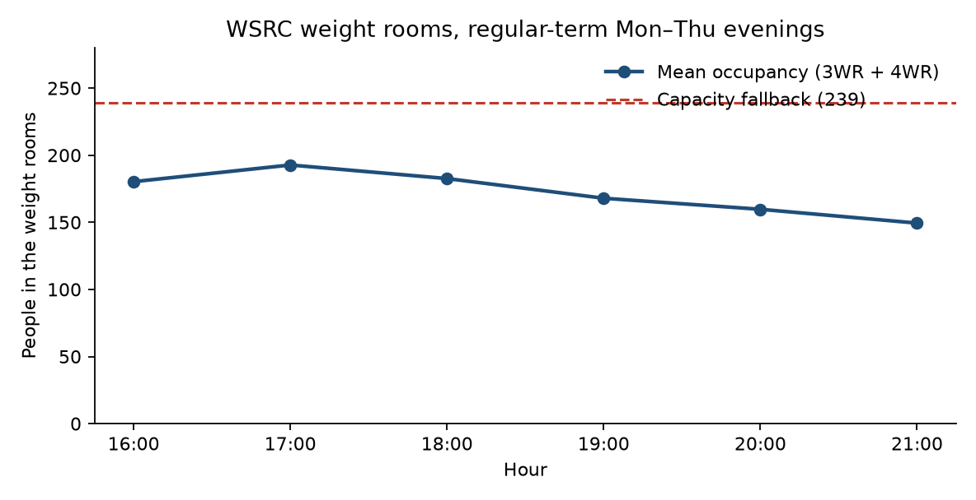
Figure 1. Mean combined 3WR + 4WR occupancy by hour. Regular-term Monday–Thursday evenings, 4 Sept 2025 – 27 Oct 2026 (81 evenings). Dashed line is the 95th-percentile capacity fallback (239).
4. Formal model
We start from the NetLogo El Farol model (Rand and Wilensky, 2007) and leave the strategy code alone. What changes is the decision and the information: one Thursday night becomes twelve evening slots, and agents may see a live or delayed count from earlier tonight.
N agents, K = 12 slots (16:00–22:00). Each agent wants one workout per day. Action a_i is a slot in {1…K} or skip. If the agent goes and the slot ends at or under capacity C, payoff is 1. If the slot is over capacity, payoff is 0. Skip is also 0.
Each agent holds S random linear predictors (default S = 10) over the last M days of that slot, and uses the one with the lowest mean absolute error. That is Arthur’s inductive setup, just one history list per slot instead of one Thursday list.
Agents decide slot by slot. At slot s, anyone who has not gone or skipped yet predicts crowding for s and goes if the prediction is ≤ C; otherwise they wait. Anyone still waiting at 21:30 skips (must-go? is off).
The three information conditions are:
none — only that slot’s past days. This is classic El Farol.
live — also see the actual count from the previous slot tonight.
delayed — also see the count from delay slots ago. Default delay = 2 (one hour), matching a 30-minute page update plus travel time.
In the NetLogo model, live and delayed blend that intra-day count 50/50 with the inductive prediction. The first slot of the evening has no intra-day signal yet, so it uses the inductive prediction only.
In short: a congestion / minority game solved by inductive learning (Arthur 1994; Fogel et al. 1999), with an extra intra-day information switch.
Symbol | Meaning | Default
N | Agents | 100 (scaled)
K | Evening slots | 12
C | Capacity | 38 scaled / 239 unscaled
S | Strategies per agent | 10
M | Memory (days, per slot) | 1, 5, or 10
delay | Slots of lag when info = delayed | 2 (1 hour)

5. Experiment plan
Main grid (BehaviorSpace experiment info-memory-grid):
info-mode: none / live / delayed
memory-size: 1, 5, 10 days
30 random seeds
40 simulated days; first 10 discarded as burn-in
Fixed: N = 100, C = 38, S = 10, delay = 2, must-go? off, history seeded from the data
A secondary run will vary number-strategies (5 vs 10) and, if Rec Services reply, capacity ±10%.
What we will measure
Reporter | What it is
peak-occupancy | Busiest slot after burn-in
pct-slots-over-capacity | Share of slots with attendance > C
occupancy-variance | How much occupancy swings across slots
lag1-autocorr | Correlation between neighbouring slots
good-visit-rate | Share of visits that landed at or under C
skip-rate | Share of agent-days that skipped

Three analyses
1. Main effect of information. Does live lower pct-slots-over-capacity and peak-occupancy relative to none? Does delayed look more oscillatory (higher lag-1 autocorrelation and higher variance)? This is the proposal question.
2. Memory × information. A heatmap of over-capacity % across the 3 × 3 grid.
3. Validation. Compare the none condition to the real evening curve in Figure 1 (shape and % over capacity). We will report mean absolute error between the simulated and real profiles after both are normalised.
Analysis is in Python from the BehaviorSpace CSV. We already ran a 5-seed 3 × 3 pilot. The 12-slot model finished in under a minute, so we are keeping the slot model and not falling back to a single-slot version. The 30-seed grid is the confirmatory run; the pilot is not a result.
6. Limits
Staff counts are noisy and not every half-hour is posted.
Agents are identical. Real gym users are not.
We only model weekday evenings, not mornings, Fridays, or weekends.
Capacity is a percentile fallback until Rec Services send a posted number.
References
Arthur, W. B. (1994). Inductive reasoning and bounded rationality. American Economic Review, 84(2), 406–411.
Fogel, D. B., Chellapilla, K., & Angeline, P. J. (1999). Inductive reasoning and bounded rationality reconsidered. IEEE Transactions on Evolutionary Computation, 3(2), 142–146.
Rand, W., & Wilensky, U. (2007). NetLogo El Farol model. Center for Connected Learning, Northwestern University. https://ccl.northwestern.edu/netlogo/models/ElFarol
Western Gazette. (2022). Using data to plan your trip to the rec centre. https://westerngazette.ca/news/campus/using-data-to-plan-your-trip-to-the-rec-centre/article_a393ead8-70d7-11ed-8fbe-63379a003173.html

