Formal Model and Experiment Plan
Gym Crowding and the El Farol Bar Problem
Group Myerson

1. Question
If gym users are given live information about how crowded the gym is, does this reduce crowding overall, or can it cause people to shift toward the same times and create new periods of congestion?
We will compare three information conditions (none, live, delayed) and how many past days agents remember (1, 5, or 10). We then measure how crowded the busiest slot gets and how often the gym goes over capacity.
To clarify the three information conditions and what they mean:
- None Information
  - Agents predict attendance using only their past memory
- Live Information
  - Agents can see simulated attendance from previous 30-minute slot
- Delayed information
  - Agents can see attendance from 1 hour (may change) ago
For agent’s memory, it will be stored separately for each time slot:
- 1 day: remembers attendance at that time yesterday
- 5 days: remembers attendance at that time over the previous five days.
- 10 days: remembers attendance at that time over the previous ten days.

2. What we are doing with the data
The NetLogo El Farol model is not trained on any data. The model was created based on Arthur’s paper (1994) and the Rand and Wilensky model (1997/2007). Attendance history starts as random numbers, and each agent’s strategies are random weight vectors.
So by using a decade old model along with modern data analytics:
- Calibrate parameters from real WSRC counts: how many agents, what counts as capacity, which evening slots, and the typical demand curve.
- Validate the simulation: does the evening shape, the share of half-hours over capacity, and the variance look like the real gym?
- Seed each agent’s starting memory with real past occupancy instead of random numbers.

3. Data Sources
- @WesternWeightRm (X) Staff post counts about every 30 minutes. We pulled the timeline from 1 September 2025 to 27 October 2026 (1,174 posts). 321 posts had the numbers in the text. 850 were images, so we ran Tesseract OCR. Only 3 posts (0.26%) could not be parsed. A 30-post OCR spot-check matched the cards.
- westernusc.ca/wsrc-status. The same numbers on a live page. We started polling it so we still have data if X scraping fails later.
- Gazette (2022). Used only as a sanity check on which days and hours are busy. Not used to set parameters.
Fitness centre = 3rd + 4th Fl. (the two weight rooms).

Window and numbers
We modeled weekday evenings, 4:00 PM–10:00 PM, in 12 half-hour slots. That window is fully open Monday–Thursday (Friday closes at 8:00 PM). Weekends, holidays, reading week, exams, and summer are excluded.
With that time window we have 81 evenings and 324 half-hour observations (4 September 2025 – 27 October 2026). Coverage is uneven: staff post more reliably every 1 hour than every half-hour.
Quantity | Value
Evenings / half-hour slots | 81 / 324
Mean occupancy (1st + 4th Floors) | 173
Median | 170
Peak | 317
95th percentile (capacity fallback) | 239
Peak hour | 5:00 PM (mean 193)
Share of slots over capacity | 4.6%
Coefficient of variation | 0.24
Lag-1 autocorrelation (adjacent slots) | 0.75

Posted 1st Floor / 4th Floor capacities from Rec Services are not in yet, so capacity is the 95th percentile of the same evening window. If we get a posted number we will rerun with capacity ±10%.
NetLogo runs stay small by scaling the same ratios down to 100 agents: unscaled population is 2 × peak (634 people, capacity 239); scaled run uses N = 100 and C = 38. History is seeded from the real per-slot means, not from random 100.

Evening profile
The real curve rises into the 5:00 PM hour and then falls. That shape is what we will compare the “none” simulation against.
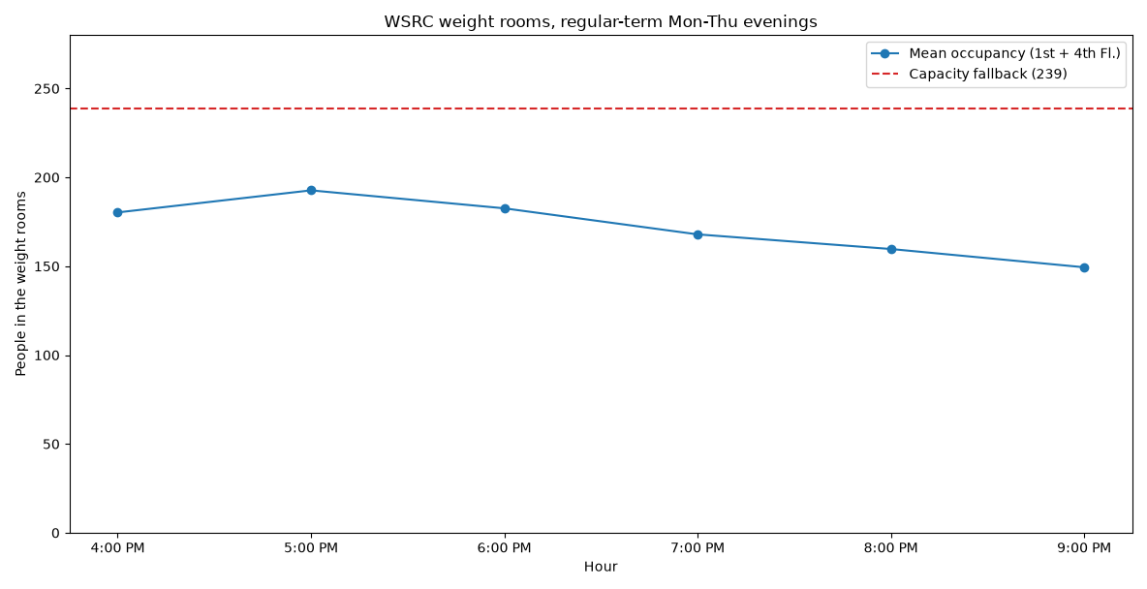
Figure 1. 3rd Floor & 4th Floor combined occupancy by hour. Regular-term Monday–Thursday evenings, 4 Sept 2025 – 27 Oct 2026 (81 evenings). Dashed line is the 95th-percentile capacity fallback (239).

4. Formal model
We start from the NetLogo El Farol model (Rand and Wilensky, 2007) and leave the strategy code alone. What changes is the decision and the information: one Thursday night becomes twelve evening slots, and agents may see a live or delayed count from earlier tonight.
N agents, K = 12 slots (4:00 PM–10:00 PM). Each agent wants one workout per day. Action a_i is a slot in {1…K} or skip. If the agent goes and the slot ends at or under capacity C, payoff is 1. If the slot is over capacity, payoff is 0. Skip is also 0.
Each agent holds S random linear predictors (default S = 10) over the last M days of that slot, and uses the one with the lowest mean absolute error. That is Arthur’s inductive setup, just one history list per slot instead of one Thursday list.
Agents decide slot by slot. At slot s, anyone who has not gone or skipped yet predicts crowding for s and goes if the prediction is ≤ Capacity, otherwise, they wait. Anyone still waiting at 9:30 PM skips (must-go? is off).
The three information conditions are:
- None: only that slot’s past days. This is classic El Farol.
- Live: also see the actual count from the previous slot tonight.
- Delayed: also see the count from delay slots ago. Default delay = 2 (one hour), matching a 30-minute page update plus travel time.
In the NetLogo model, live and delayed blend that intra-day count 50/50 with the inductive prediction. The first slot of the evening has no intra-day signal yet, so it uses the inductive prediction only.
In short: a congestion / minority game solved by inductive learning (Arthur 1994; Fogel et al. 1999), with an extra intra-day information switch.
Symbol | Meaning | Default
N | Agents | 100 (scaled)
K | Evening slots | 12
C | Capacity | 38 scaled / 239 unscaled
S | Strategies per agent | 10
M | Memory (days, per slot) | 1, 5, or 10
delay | Slots of lag when info = delayed | 2 (1 hour)

5. Connection to course theory and theoretical baseline
Lecture 1 defines a rational agent as choosing the action expected to maximize its performance measure given its evidence. In this project, that performance measure is a successful workout, and the evidence is the crowding information available to the agent. The students are self-interested in the course’s technical sense: each has its own ranking of outcomes, but no agent is assumed to be selfish or hostile to others.

Utility and expected utility
A single simulated day can be represented as a finite congestion game G = (𝒩, A, u). There are N agents. Agent i chooses a slot aᵢ ∈ {1, …, K} or skip, and nₛ(a) is the number of agents who choose slot s. The implementation reveals the slots in time order, but the final daily outcome is still a profile of chosen slots and skips.
uᵢ(a) = 1 if aᵢ = s and nₛ(a) ≤ C; uᵢ(a) = 0 if aᵢ = skip or nₛ(a) > C.
These values are normalized utilities, not dollars. A successful uncrowded workout is strictly preferred to the zero-utility outcomes. Crowding and skipping both receive zero in the implemented model; when they tie, the decision rule waits rather than knowingly entering a predicted crowded slot. As in the utility lecture, a positive affine rescaling would preserve the same choices.
Given information Iᵢ, the expected utility of choosing slot s is therefore the probability that the slot finishes at or below capacity:
EUᵢ(s | Iᵢ) = Pr(nₛ ≤ C | Iᵢ).
NetLogo uses a bounded-rational approximation to this calculation. Each agent produces a point prediction n̂ᵢₛ and accepts the slot when n̂ᵢₛ ≤ C. The information condition changes Iᵢ, not uᵢ: none uses only that slot’s M-day history; live adds the preceding 30-minute count; delayed adds the count from two slots (one hour) earlier. The 50/50 blend is an operational belief update, not a claim that agents compute an exact Bayesian posterior. Memory size changes how much historical evidence is used.

Best response, congestion, and bounded rationality
The project connects directly to Lecture 3 because one agent’s payoff depends on the actions of the others. Choosing a slot forecast to be uncrowded is a best response to the agent’s current belief. However, every additional visitor creates a negative congestion externality: the same action can push nₛ above C and reduce all visitors’ utilities in that slot from 1 to 0.
A Nash equilibrium is a useful stability benchmark—a profile where no one can improve by changing slot alone—but the simulation does not assume that agents solve for Nash equilibrium. Following Arthur (1994), they are boundedly rational and choose among inductive predictors that worked well in the past. The model asks whether this learning settles near capacity or keeps producing overshooting and oscillation.
The information treatment creates the main multi-agent tension. A live count can improve one student’s estimate, but if many students receive and react to the same signal, their best responses become correlated. They may herd away from one slot and into another. Thus better individual information need not produce a Pareto improvement or lower total congestion. The good-visit-rate is the operational count of utility-1 outcomes; it is not a claim that utility numbers from different real people can generally be added.

Theoretical baseline
We use a simple analytical null before comparing the three information conditions. Suppose all N = 100 agents independently randomize uniformly across K = 12 slots. Then nₛ follows Binomial(100, 1/12), so E[nₛ] = N/K = 8.33. Its exact central 95% interval is 3–14 agents, far below C = 38, and Pr(nₛ > 38) ≈ 4.2 × 10⁻¹⁷ for any one slot. This is a theoretical mixed-choice baseline, not a prediction of the NetLogo learning model and not a claim that it is the Nash equilibrium.
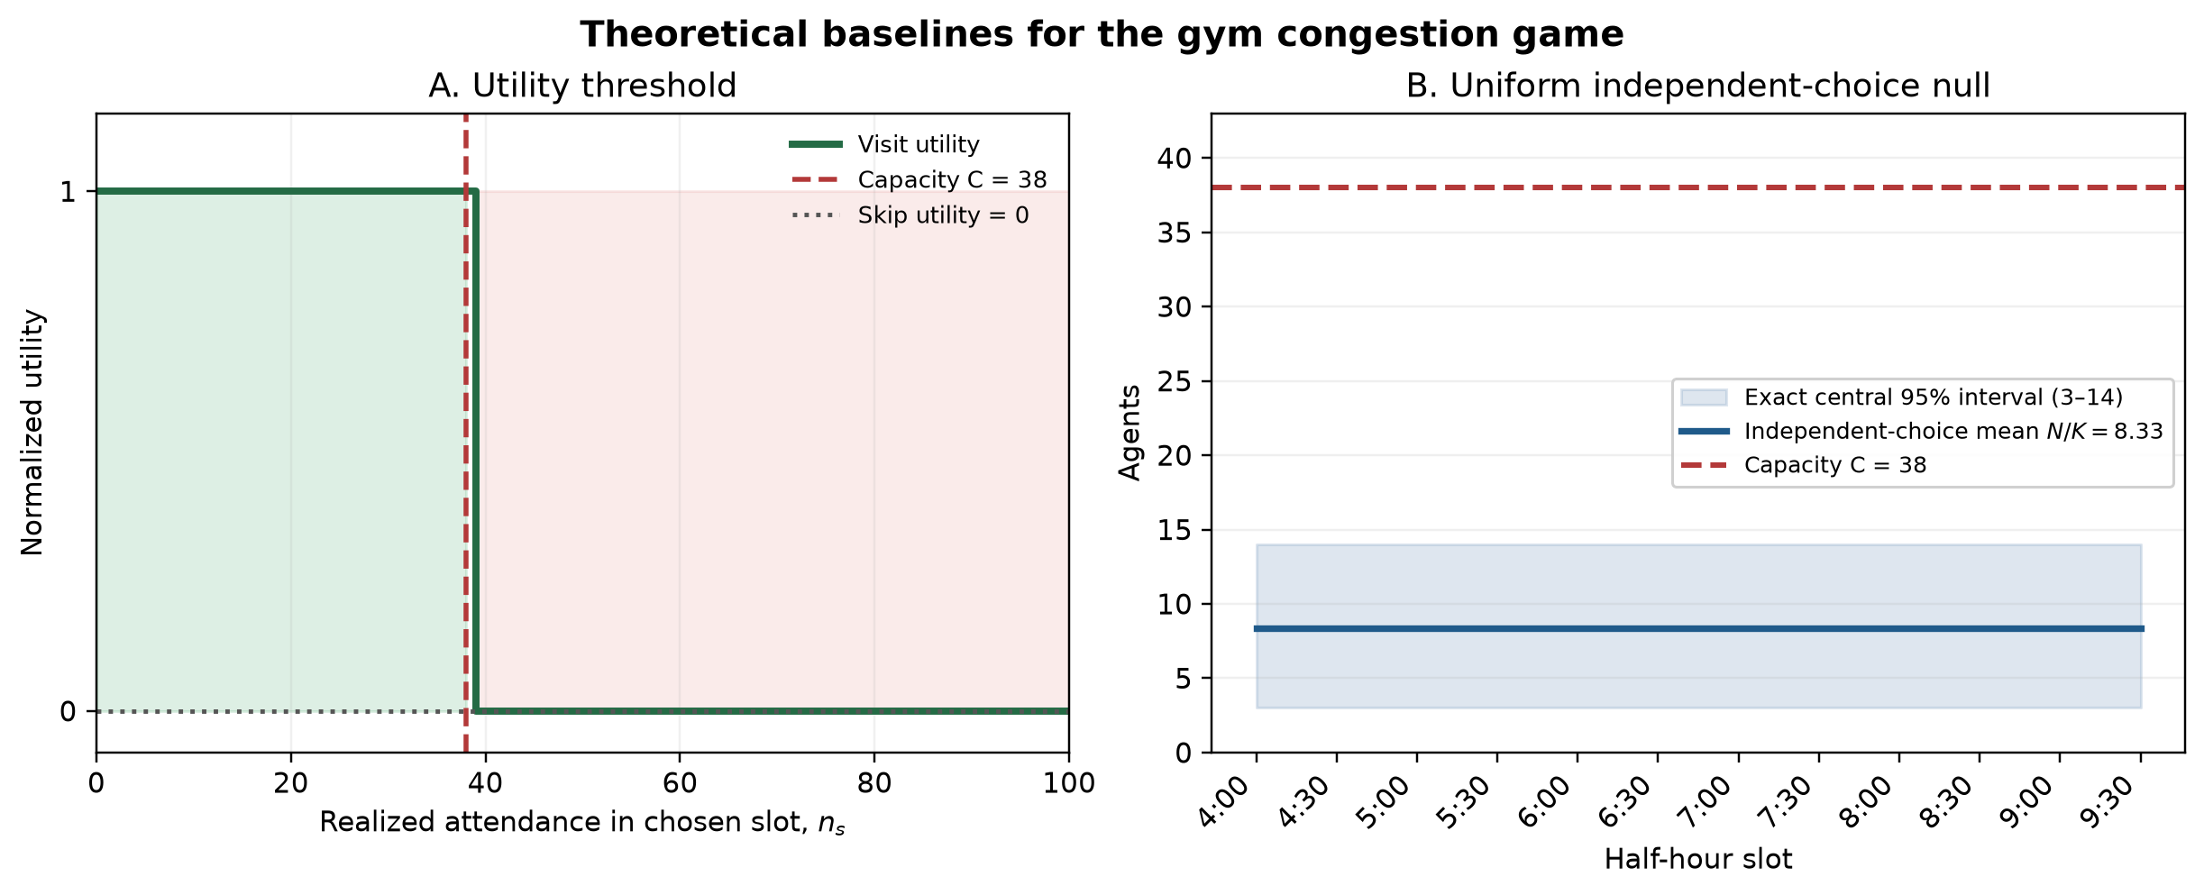
Figure 2. Theoretical baselines. Panel A shows the model’s normalized utility threshold; skipping is the zero-utility baseline. Panel B shows the uniform independent-choice null for 100 agents and 12 slots. The blue band is the exact central 95% binomial interval and the red dashed line is capacity C = 38. This figure is analytical, not an experimental result.
Because total evening capacity K × C = 456 exceeds N = 100, overcrowding is not caused by a shortage of aggregate capacity in the scaled model. It is caused by coordination failure: too many agents choose the same slots. The baseline therefore gives a clear comparison. Large peaks, repeated capacity crossings, or oscillation above this null indicate synchronization created by common histories, common signals, and the sequential decision rule.

Theory-based expectations
- None: inductive learning should move attendance around the capacity threshold, as in El Farol.
- Live: newer information may lower the single highest peak, but a common signal can synchronize agents and move congestion to later slots.
- Delayed: stale information may make agents chase conditions that have already changed, producing lagged crowding or oscillation.
- Memory: short memory should react faster but be noisier; longer memory should smooth predictions but adapt more slowly.
These statements are hypotheses derived from the utility and information structure. The 30-seed BehaviorSpace experiment tests them; the theoretical baseline is not counted as one of the three experimental treatments.

6. Experiment plan
Main grid (BehaviorSpace experiment info-memory-grid):
info-mode: none / live / delayed
memory-size: 1, 5, 10 days
30 random seeds
40 simulated days; first 10 discarded as burn-in
Fixed: N = 100, C = 38, S = 10, delay = 2, must-go? off, history seeded from the data
A secondary run will vary number-strategies (5 vs 10)

What we will measure
Reporter | What it is
peak-occupancy | Busiest slot after burn-in
pct-slots-over-capacity | Share of slots with attendance > C
occupancy-variance | How much occupancy swings across slots
lag1-autocorr | Correlation between neighbouring slots
good-visit-rate | Share of visits that landed at or under C
skip-rate | Share of agent-days that skipped

Three analyses
- Main effect of information. Does live lower pct-slots-over-capacity and peak-occupancy relative to none? Does delayed look more oscillatory (higher lag-1 autocorrelation and higher variance)? This is the proposal question.
- Memory × information. A heatmap of over-capacity % across the 3 × 3 grid.
- Validation. Compare the none condition to the real evening curve in Figure 1 (shape and % over capacity). We will report mean absolute error between the simulated and real profiles after both are normalized.
Analysis is in Python from the BehaviorSpace CSV. We already ran a 5-seed 3 × 3 pilot. The 12-slot model finished in under a minute.

7. Limits
- Staff counts are noisy and not every half-hour is posted.
- Agents are identical. Real gym users are not.
- We only modeled weekday evenings, not mornings, Fridays, or weekends.
- Capacity is a percentile fallback, not an accurate value.

8. References
Arthur, W. B. (1994). Inductive reasoning and bounded rationality. American Economic Review, 84(2), 406–411.
Fogel, D. B., Chellapilla, K., & Angeline, P. J. (1999). Inductive reasoning and bounded rationality reconsidered. IEEE Transactions on Evolutionary Computation, 3(2), 142–146.
Rand, W., & Wilensky, U. (2007). NetLogo El Farol model. Center for Connected Learning, Northwestern University. https://ccl.northwestern.edu/netlogo/models/ElFarol
Western Gazette. (2022). Using data to plan your trip to the rec centre. https://westerngazette.ca/news/campus/using-data-to-plan-your-trip-to-the-rec-centre/article_a393ead8-70d7-11ed-8fbe-63379a003173.html

Nash, J. (1951). Non-cooperative games. Annals of Mathematics, 54(2), 286–295.
von Neumann, J., & Morgenstern, O. (1944). Theory of Games and Economic Behavior. Princeton University Press.

