## First usage charging

Earlier battery types like nickel cadmium had a "memory effect" that meant batteries would maintain a certain capacity based on how they had been charged and discharged. This meant that electronics products often came with advice to charge them fully and keep them plugged in for hours before using them.

However, with modern lithium-ion batteries most people agree that there is no such effect and the batteries are more reliable. A smartphone is fine to run out of the box without "priming" it beforehand.

For the same reason, you don't need to calibrate your smartphone by running the battery all the way down. While this used to be the case, Apple and others no longer recommend it.

## Battery life get worse over time

You're not making it up, your battery deteriorates over time. Modern lithium-ion batteries are designed to withstand a certain number of "cycles" - a full drain of the battery. A cycle is equivalent to a battery fully draining, but this doesn't all have to be from one charge.

As Apple puts it: "You might use 75 per cent of your battery’s capacity one day, then recharge it fully overnight. If you use 25 per cent the next day, you will have discharged a total of 100 per cent, and the two days will add up to one charge cycle.

The lifetime of batteries measure in cycles differs between different devices, but typically have between 300 and 500 full cycles before they reach 70 per cent of their original capacity - equivalent to a couple of years of use, although this graph from [Battery University](http://batteryuniversity.com/learn/article/how_to_prolong_lithium_based_batteries) shows that capacity begins to drop fairly quickly:

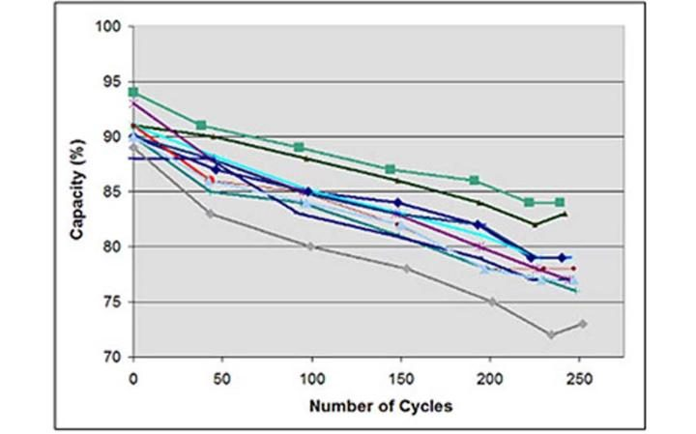

## Leaving my smartphone charging

There have been suggestions that keeping your phone charging overnight or constantly can force the battery to deteriorate, due to it receiving more power than it needs. Modern battery systems, however, know to reduce this to a trickle, so it only tops up a battery with the power you need.

The exception is in very hot conditions. Heat causes lithium-ion batteries to decay slightly, reducing performance. Since charging a phone does heat it up slightly, combining this with hot temperatures (over 30 degrees centigrade) can damage it. Try to keep your phone relatively cool when charging it, by placing it out of the sun for example.

## Let battery draining or charging often

No - in fact, you should do the opposite. Modern lithium-ion batteries gain nothing from being powered down, and long charging cycles are actually worse than short ones.

Partial discharges and charges actually tend to prolong battery life - 50 per cent discharges can happen between 1,200 and 1,500 times (so 600-750 full cycles) before capacity drops to 70 per cent of its original span, compared to 300 to 500 for 0-100 per cent charges. This effectively means running your phone down 50 per cent, charging it up again and running it down to 50 per cent again is better than a full discharge.

## Does turning off Wi-Fi and Bluetooth improve battery life? What about airplane mode?

Wi-Fi and Bluetooth are not nearly as power hungry as they used to be, or as your phone's cellular radio. Keeping them on is not likely to drain a huge amount of battery, although if you really want to completely maximise efficiency, it helps slightly.

Having your cellular radio look for signal in areas where there isn't any, however, is very draining. You can activate airplane mode if you don't need a mobile signal. And if you can connect to Wi-Fi, do it: Using 4G or 3G drains the battery far quicker than Wi-Fi does.

## How else can I save battery?

There are several things that can be done to just reduce how much power the phone is using, which will both keep your battery going for longer and mean it deteriorating more slowly.

* Turning down the screen brightness
* Disabling location and background app refresh for apps that don't need it
* Not closing your apps in multitasking (they are idle - and opening them later actually uses up more battery)
* Disabling push notifications for email, Twitter and Facebook