Citizen AI Project - Detailed Documentation

Project Report

Project Team Members

1. HASSIN FATHIMA N

2. AATHILA RIFAYA A

3. MOHAMEDA SIYANA NAWSIN A

4. FAAZILA T

1. Introduction:

- Briefly explain what **Citizen AI** means.

- Talk about how AI is becoming a responsible digital citizen.

- Importance of building AI systems that are **ethical, transparent, and beneficial to society**

1.1 Project Title: Citizen AI

1.2 Background:

Artificial Intelligence (AI) has become one of the most transformative technologies of the 21st century. From healthcare and education to governance and transportation, AI is reshaping how citizens interact with services and information.

1.3 Objectives:

- To understand the role of AI in modern society.

- To identify challenges of AI adoption in governance, education, healthcare, and public services.

- To propose solutions for **ethical and responsible AI usage**.

2. Project Overview

2.1 Purpose:

The purpose of the Citizen AI project is to empower cities and residents with an AI-powered assistant

capable of providing real-time safety assessments and responding to citizen queries.

2.2 Features:

- Conversational Interface: Natural language interaction.

- City Analysis: Provides statistics about crime index, accident rates, and safety.

- Policy Summarization: Summarizes long policy documents.

- User-Friendly Interface: Uses Gradio for dashboards.

3. Architecture

3.1 Frontend (Gradio): Provides interactive web-based UI with tabs.

3.2 Backend (Hugging Face Transformers + PyTorch): Runs AI model for responses.

3.3 Model Integration: IBM Granite model is used for text generation and analysis.

3.4 Functions:

- generate_response: Generates AI responses.

- city_analysis: Provides city safety analysis.

- citizen interaction: Responds to citizen queries.

4. Setup Instructions

4.1 Prerequisites:

- Python 3.8 or later

- Google Colab (T4 GPU preferred)

- Libraries: transformers, torch, gradio

4.2 Installation Process:

1. Open Google Colab.

2. Change runtime to GPU (T4 preferred).

3. Install libraries with !pip install transformers torch gradio -q.

4. Paste the project code into Colab.

5. Run all cells to launch.

6. Access the public link for interaction.

5. Folder Structure

app/ – Backend logic

app/api/ – API routes

ui/ – Frontend components

smart_dashboard.py – Entry script

granite_llm.py – Model integration

document_embedder.py – Document embeddings

6. Running the Application

6.1 Steps to Run:

➢ Launch Colab notebook.

➢ Run installation and model setup.

➢ Start Gradio interface.

➢ Use City Analysis tab for safety data.

➢ Use Citizen Services tab for queries.

7. API Documentation

7.1 Available Functions:

generate_response(prompt)

city_analysis(city_name)

citizen_interaction(query)

8. Authentication & Security

Future deployments can include:

- Token-based authentication (JWT, API Keys).

- OAuth2 integration.

- Role-based access control (Admin, Citizen, Researcher).

9. User Interface

9.1 City Analysis Tab: Input city name → Safety insights.

9.2 Citizen Services Tab: Input query → Government response.

9.3 Output: Clear textboxes with results.

10. Testing

10.1 Unit Testing: Functions tested independently.

10.2 API Testing: Using test inputs.

10.3 Manual Testing: Validating analysis and queries.

10.4 Edge Case Handling: Empty queries, invalid city names

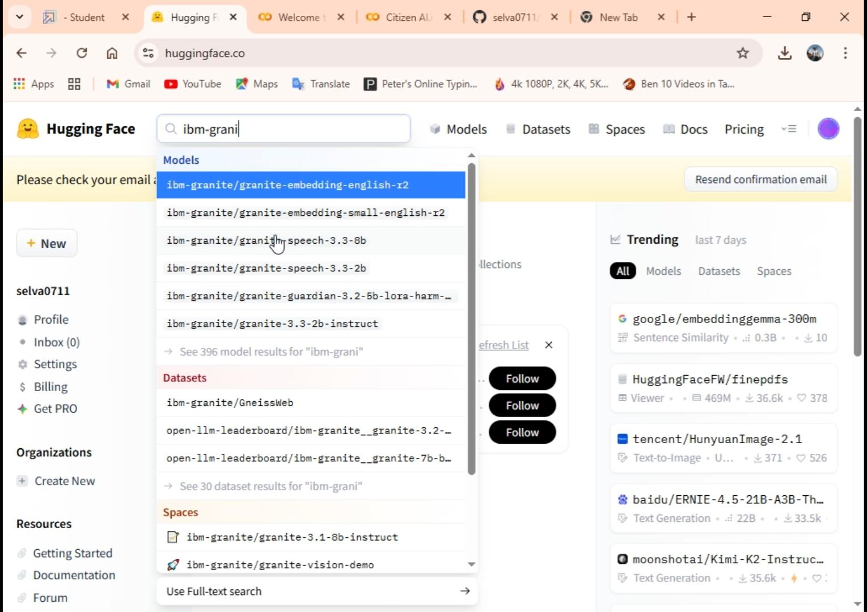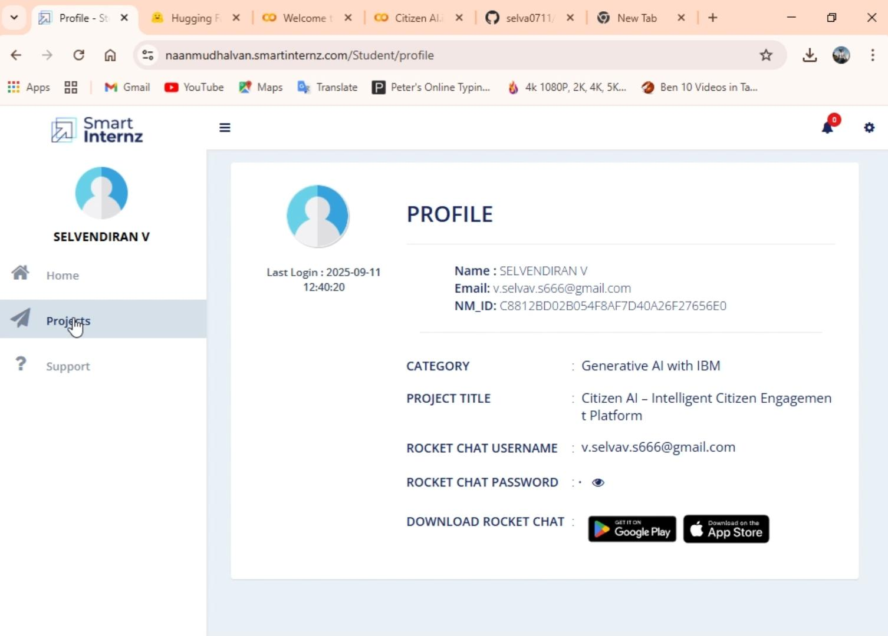11. Screenshots

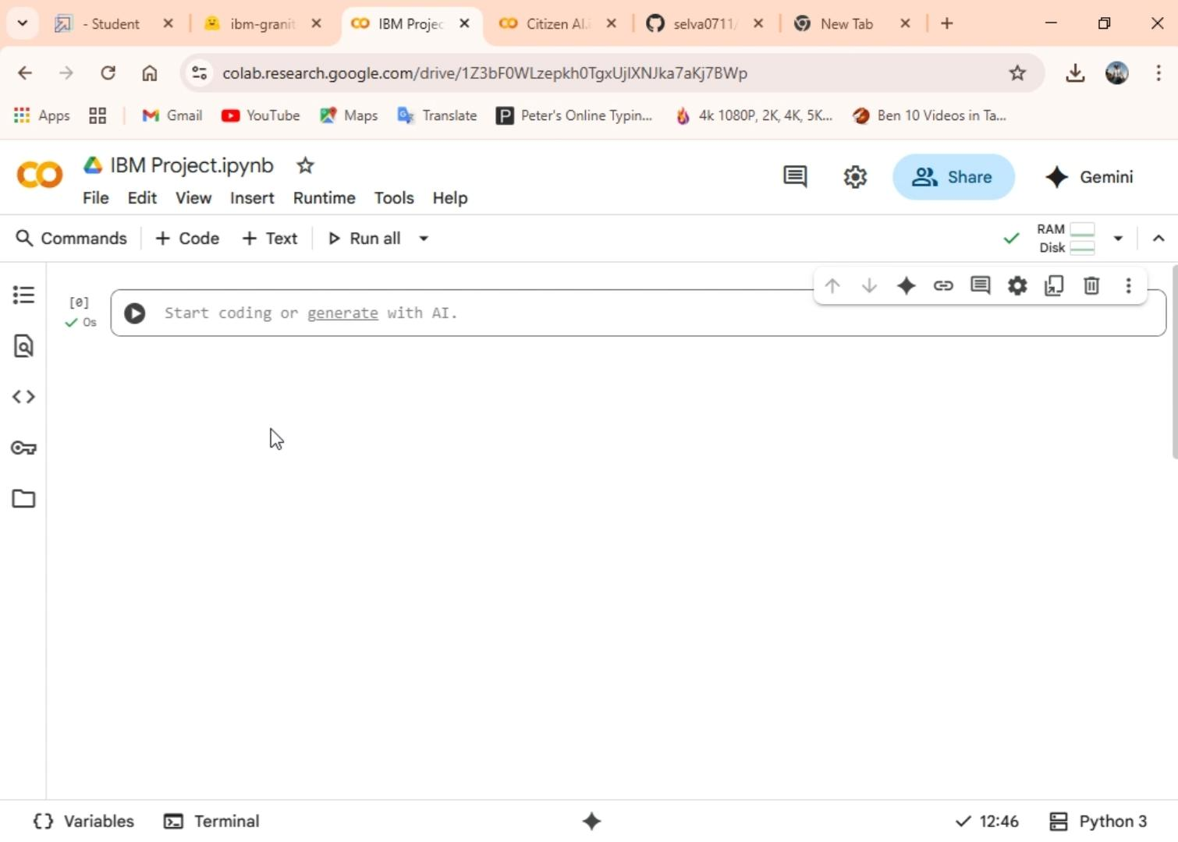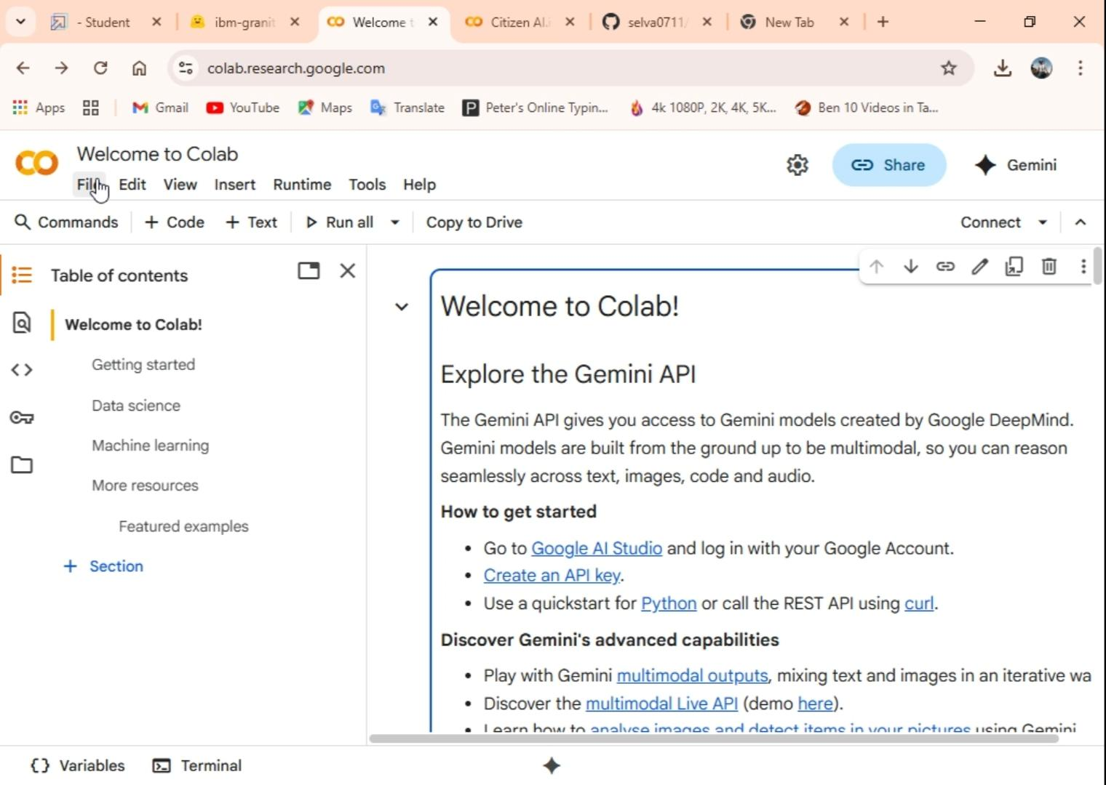

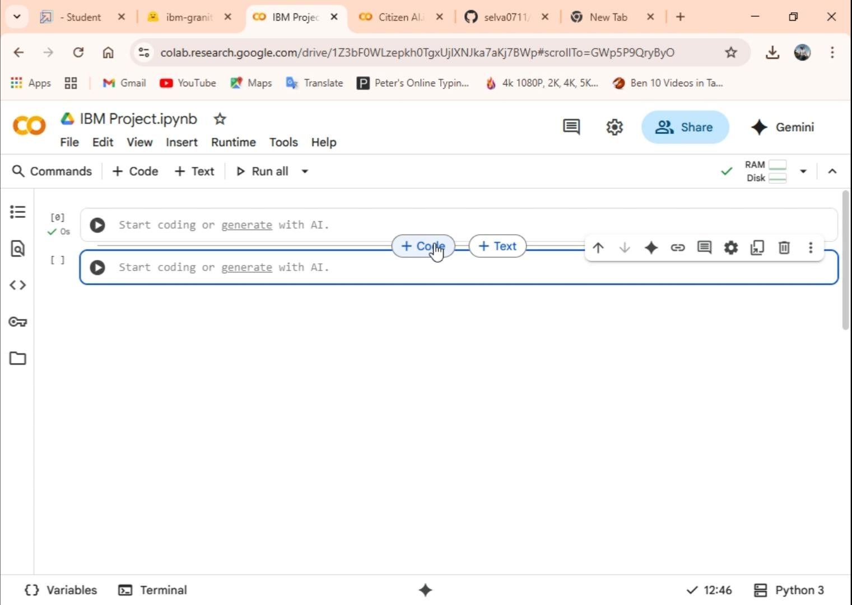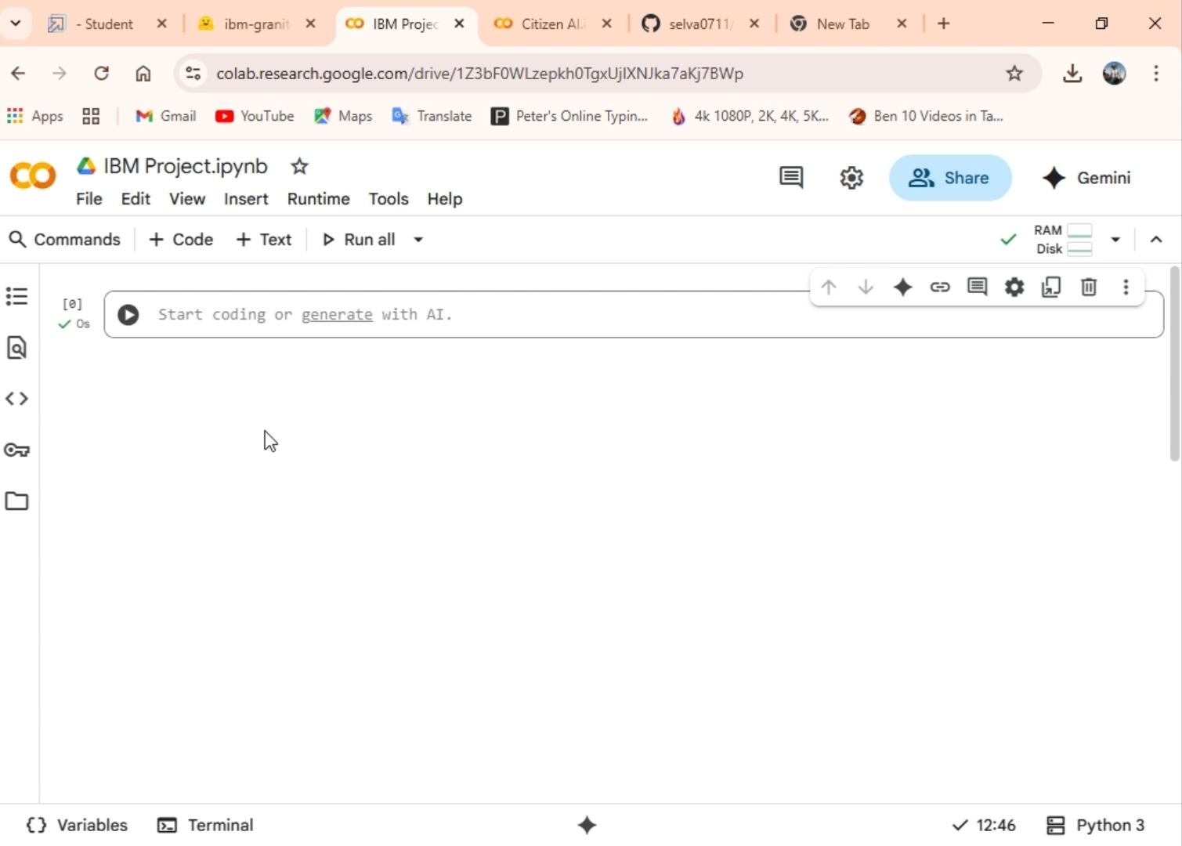

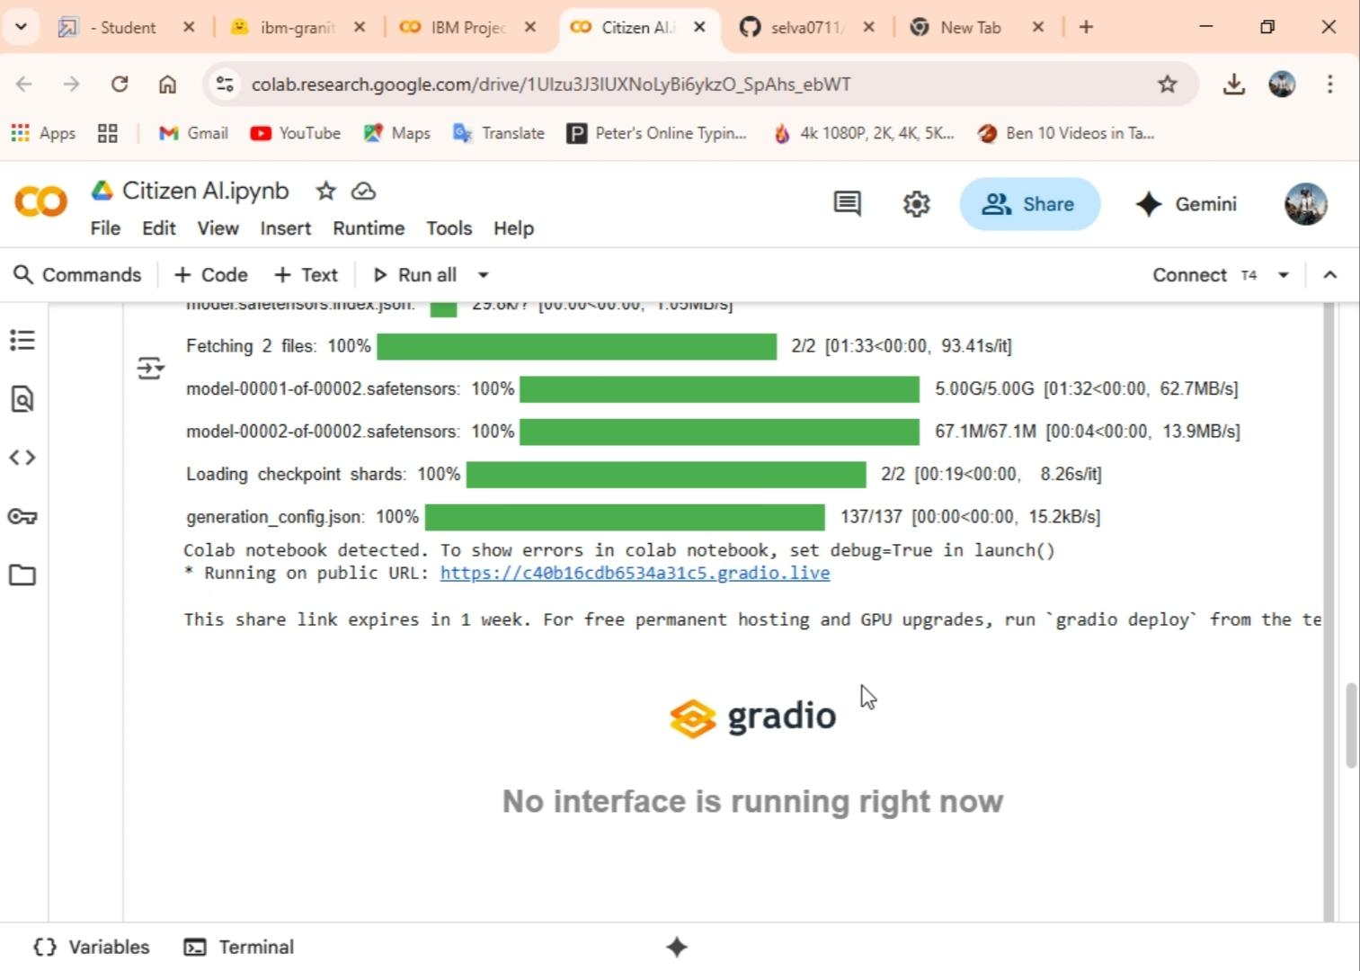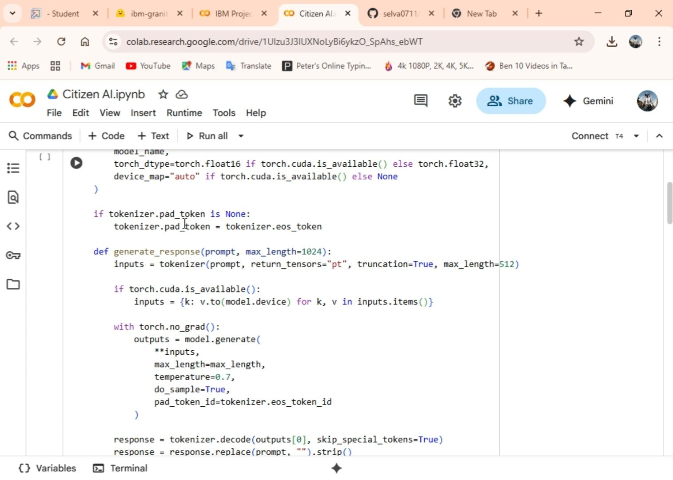

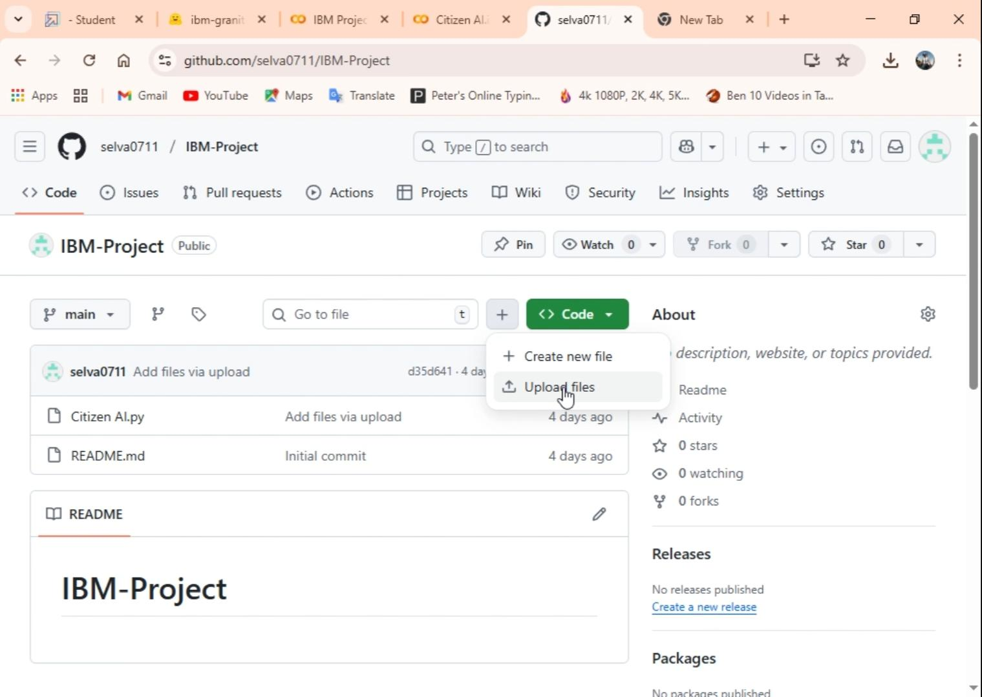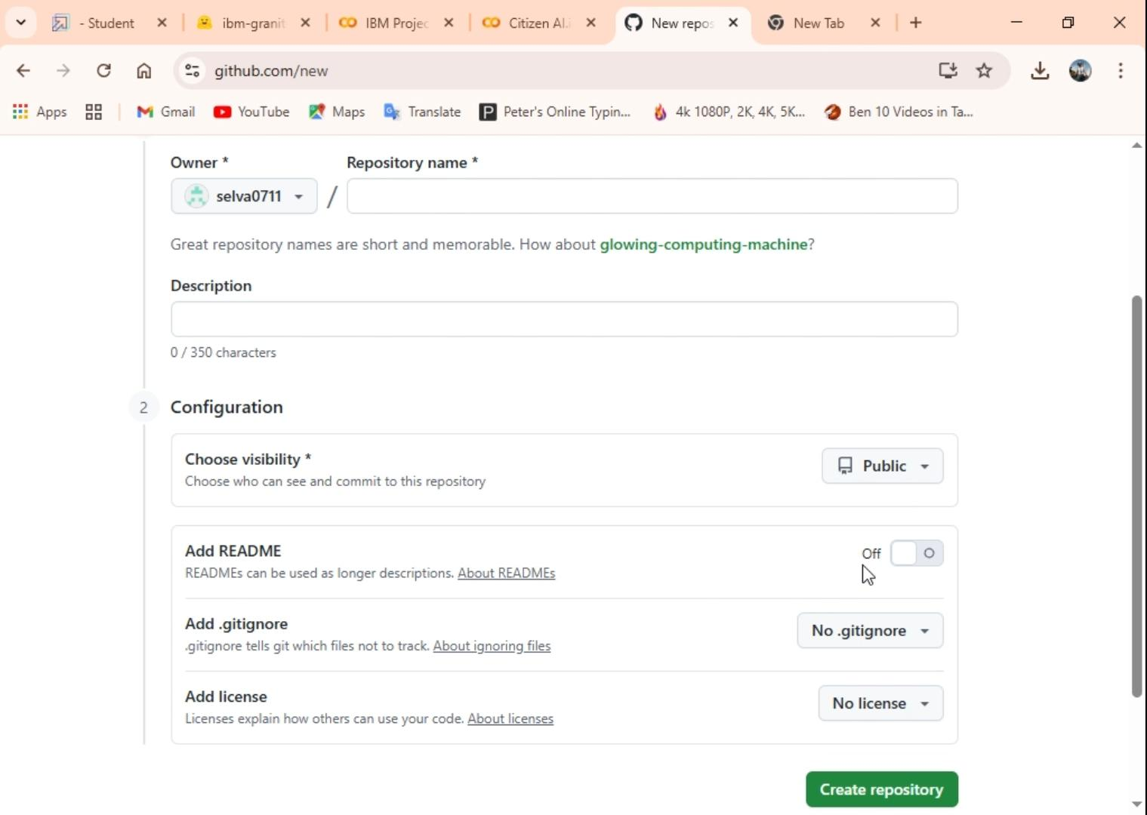

12. Known Issues

- Requires stable internet connection.

- AI-generated outputs may vary.

- Limited accuracy without real-time datasets.

13. Future Enhancements

- Integration with real-time city data.

- Advanced analytics and forecasting.

- Multilingual support.

- Mobile app interface.

14. Conclusion

The Citizen AI Project demonstrates how AI models and user-friendly interfaces can support citizens

and officials in decision-making, safety monitoring, and public service management. It lays the

foundation for future smart city applications.