How to manage code in group project . well git is there for you . using git techniques very good management can be done . so say # developers are going to complete a project how should they start ?

Well the concept is like this:

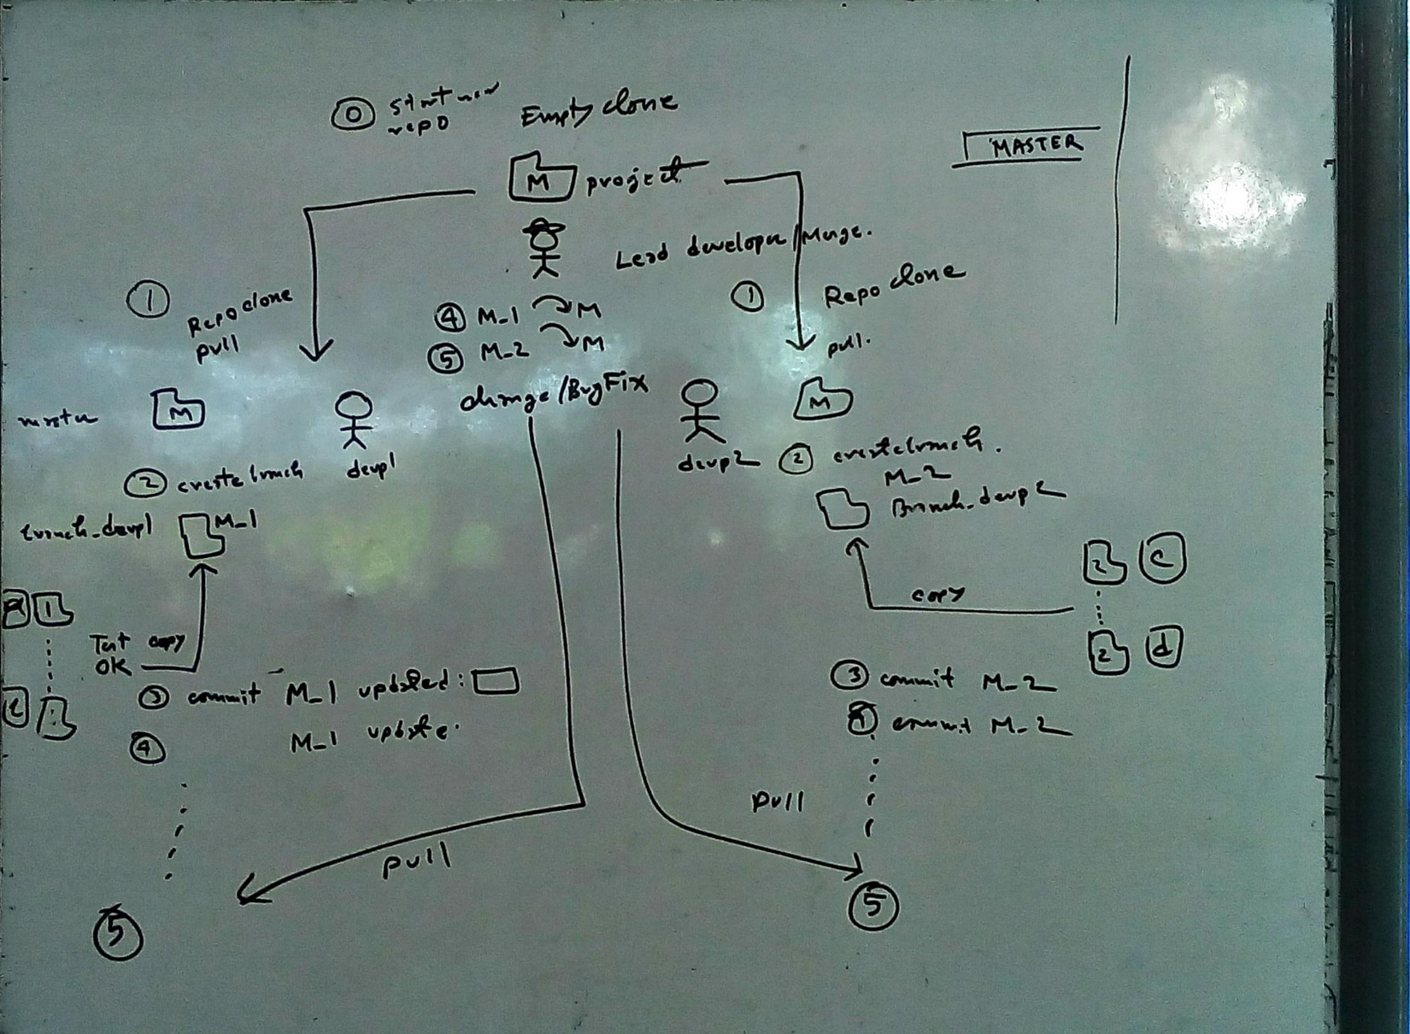

I think explanation would be great if the working way is shown pragmatically. let’s say a group of 3 developers are going to develop an embedded product Smart Bowl which will detect any insertion of extra rice will say “thank you for not wasting” if we think how to manage the source codes and ckt files in folder then I think the following file tree should be used for any embedded product

Hardware

Firmware

ReadMe.md

Now to manage code one simple rule should be followed which is no developer can push to the master. Master will always merge with its hardware & firmware folder copies

Now treat yourself as the lead developer and your branch is

1. Go to github create a new repository “Smart Bowl”
2. Clone it to your

<https://www.youtube.com/watch?v=EWe_qugrUxI>

<http://jasonrudolph.com/blog/2009/02/25/git-tip-how-to-merge-specific-files-from-another-branch/>