The mock object approach to test-driven development

* As embedded applications grow in size they are often broken into subsections that we call modules
* When you get to a point where you need a function, or a module that doesn’t exist, you simply mock it out and continue with the current module.

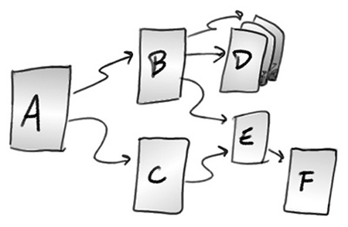

Mock:

A mock is a stand-in for a real module. It doesn’t contain any real functionality but rather imitates a module’s interface .If the function being called has a return value, the mock for that function will also return a value as specified in the test. Additionally, mocks have a special feature that keeps track of the number of times each function is called, and the order of those calls.

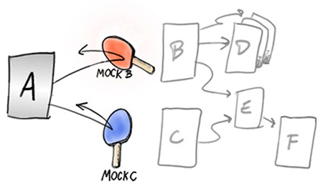

Mocking framework:

A mocking framework is a tool that generates mocks for you. For example:

* cMock for C : To generate a mock, all it needs is a header file. CMock parses the function declarations in the header file and generates mock functions based on the prototypes
* googleMock for c++
* cppUTest for c++
* creedling

Testing frameworks and mocking frameworks are generally used together within a build automation environment.

|  |  |  |  |
| --- | --- | --- | --- |
| // test_LedControl.h #include “LedControl.h” #include “mock_Gpio.h” void test_LedControl_TurnLedOn_should_set_GPIO_pin_1_when_turning_on_ the_red_LED() {    // Setup expected call chain    GPIO_SetPin_Expect(1U);     // Call the function under test    LedControl_TurnLedOn(LED_RED); }  Listing 1 - Unit Test | // Gpio.h void GPIO_SetPin(uint8_t pin_num);  cMock will create a mock_Gpio.h corresponding to it  Listing 2 - GPIO Module Header File | // LedControl.h  #define RED_LED_PIN 1 #define BLUE_LED_PIN 2  typedef enum {    LED_RED,    LED_BLUE } LED_T;  void LedControl_TurnLedOn(LED_T led);  Listing 3 - LedControl Header File | // LedControl.c  #include “LedControl.h” #include “Gpio.h” void LedControl_TurnLedOn(LED_T led) {    if(LED_RED == led)    {       GPIO_SetPin(RED_LED_PIN);    } }  Listing 4 - LedControl Source File |

* In many cases, a given module will make calls into one or more neighboring modules. Those modules, in turn, make calls into other modules and the chain continues all the way down to the lowest-level hardware interactions.