Following adafruit tutorial <http://docs.micropython.org/en/latest/esp8266/esp8266/tutorial/intro.html>

* REPL means read evaluate print loop by which python shell works
* Any esp8266 board will work with micropython
* Minimum requirement for the flash size is 512KB
* At first you have to deploy the microPython firmware on your esp8266 device

1. Put the device in the bootloader mode
2. Upload the firmware

* The board I have is nodeMcu amica at the back with ESP8266MOD chip it’s a popular board

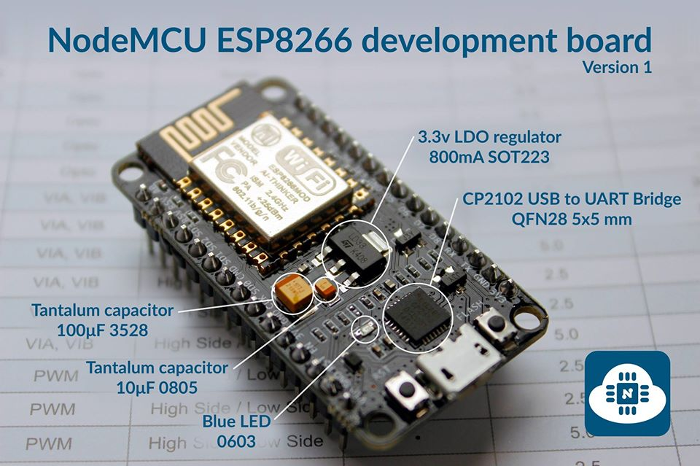

* It has the DTR and RTS pins so at reset it goes to bootloader mode and listen for incoming bytes from the USB serial until a timeout [Ref: /hardware/NODEMCU_DEVKIT_SCH]
* Go to <http://micropython.org/download> and download microPython bin for your esp8266
* Bin file is downloaded at /firmware
* Download ESP8266Flasher.exe from <https://github.com/nodemcu/nodemcu-flasher/raw/master/Win64/Release/ESP8266Flasher.exe> & install it
* It automatically detects esp8266 COM port and burning is easy follow this <https://learn.adafruit.com/building-and-running-micropython-on-the-esp8266/flash-firmware#nodemcu-flasher-tool-windows-only>
* Point the firmware go to operation and flash as nodemcy dev kit has DTR and RTS pins connected so when bin upload starts devkit board will reset esp8266 automatically and bootloader will work
* After upload complete log tab will say program flash success. port disconnected
* Now connect to the COM port by any serial terminal soft @115200 bps and use the REPL