Spotify Recommendation System With Clustering

Daniel Hassler

2023-11-12

Table of contents

**Author: Daniel Hassler**

```{python}  
import pandas as pd  
import numpy as np  
import seaborn as sns  
import matplotlib.pyplot as plt  
from sklearn.cluster import KMeans, DBSCAN  
from sklearn.model_selection import train_test_split, ParameterGrid  
from sklearn.decomposition import PCA  
from sklearn.preprocessing import StandardScaler  
from sklearn.metrics import silhouette_score  
```

## Data Analysis

Clustering algorithms can be applied to many real-world applications, including but not limited to security, anomaly detection, document clustering, stock market analysis, image compression, and so much more. The application I decided to approach with clustering is a song recommendation system. I found a dataset on Kaggle containing almost 114,000 songs from the popular music streaming platform Spotify. Each entry in the dataset consists of many features including artists, track_name, track_genre, popularity, danceability, and many more.

Before I dive into the visualizaitons, I first dropped duplicates in the dataset to minimize problems with recommendations. Now, below are some visualizations showcasing certain features in a scatterplot. This gives me a rough idea what the dataset looks like with all of these features and genres.

```{python}  
original_df = pd.read_csv("./dataset-dedup.csv")  
print(original_df.columns)  
# original_df = original_df.drop_duplicates(subset=["artists", "track_name"], keep="first").reset_index()  
print(original_df.shape)  
# original_df.to_csv("./dataset-dedup.csv")  
features_x = ["loudness", "popularity", "duration_ms"]  
features_y = ["popularity", "energy", "tempo"]  
  
for i, (x,y) in enumerate(zip(features_x, features_y)):  
 scatter = sns.scatterplot(x=x, y=y, hue='track_genre', data=original_df, palette="viridis", alpha=0.25)  
 legend_labels = original_df['track_genre'].unique()# [:3] # Show only the first 3 genres  
 scatter.legend(title='Genre', labels=legend_labels, prop={'size': 1})  
 plt.title(f"Scatter Plot of {x} vs {y} by genre")  
 plt.show()  
  
plt.show()  
```

Index(['Unnamed: 0.1', 'index', 'Unnamed: 0', 'track_id', 'artists',  
 'album_name', 'track_name', 'popularity', 'duration_ms', 'explicit',  
 'danceability', 'energy', 'key', 'loudness', 'mode', 'speechiness',  
 'acousticness', 'instrumentalness', 'liveness', 'valence', 'tempo',  
 'time_signature', 'track_genre'],  
 dtype='object')  
(81344, 23)

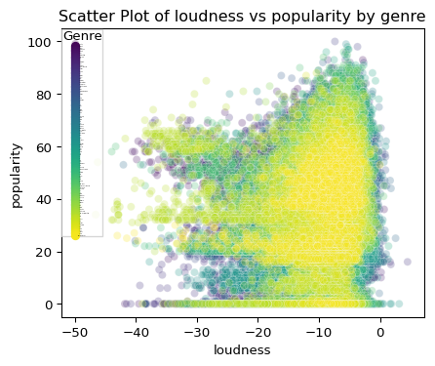

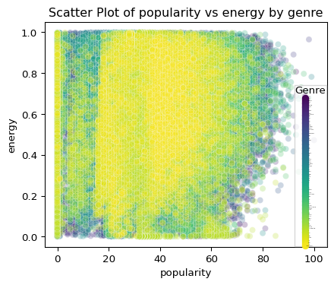

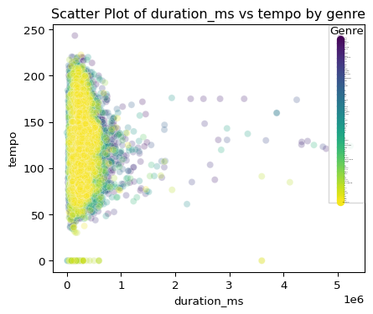

```{python}  
unique_vals = original_df['track_genre'].unique()  
plt.bar(unique_vals, original_df['track_genre'].value_counts())  
plt.title("Occurrence of Genre")  
plt.ylabel("Count")  
plt.xlabel("Genre")  
_ = plt.xticks(rotation="vertical", fontsize=4)  
```

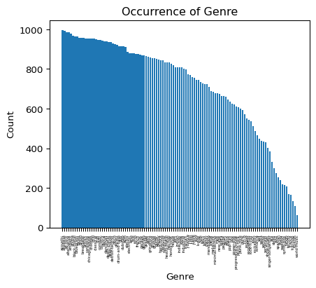

Because a lot of these continuous variables: loudness, popularity, duration_ms overlap by genre significantly, I decided to drop these features during training, as well as many other features like energy, danceability, acousticness, as these metrics are too complex, overlapping, and even subjective. As a Spotify consumer myself, I like when Spotify gives me songs related to the current artist I’m listening to, so I thought important features in this dataset included: artists, track_genre, minimally. Although, I did try other features like key, and tempo on top of that.

## K-Means

The K-Means algorithm clusters data by minimizing a criteria known as intertia, the within-cluster sum-of-squares. The formula for inertia, specified in the K-means documentation for Sklearn, is noted below:

Noting some of the variables in the summation: n is the number of datapoints, mu is the mean of the cluster, also the cluster_centroid of the cluster C, ||x_i - \mu||^2 represents the squared euclidean distance between point x_i and the centroid, and min() takes the min of the calculation

$$\sum_{i=0}^{n}{\min_{μ_{j}∈C}}\left(\left|\right|x_{i}−μ_{j}{\left|\right|}^{2}\right)$$

It is worth noting that the inertia method has some drawbacks. According to Sklearn, intertia makes the assumption that clusters are convex and isotropic, which may not always be the case. The documentation also states that inertia isn’t a “normalized metric”, so running PCA (principal component analysis) before the K-means clustering is beneficial (which is exactly what I did in later steps).

A great benefit to K-means is its scalability to large sample sets, which is good for this problem since there are now 81,344 points.

### Hyperparameter Tuning

The biggest hyperparameter for K-means is the number of clusters n_clusters. This hyperparameter is the amount of clusters to generate for the problem. Because the number of clusters largely effects the results of the model, it is important to tune this. In order to chose the best value, I loop through different values up to 80.

```{python}  
inertia = []  
# train_df is the numeric representation of original_df  
train_df = original_df.drop(columns=['Unnamed: 0.1', 'index', 'Unnamed: 0', 'track_id',  
 'album_name', 'track_name', 'popularity', 'duration_ms', 'explicit',  
 'danceability', 'energy', 'loudness', 'mode', 'speechiness',  
 'acousticness', 'instrumentalness', 'liveness', 'valence', 'tempo',  
 'time_signature'])  
  
for col in train_df.columns:  
 if not pd.api.types.is_numeric_dtype(train_df[col]):  
 train_df[col] = pd.factorize(original_df[col])[0]  
  
scaler = StandardScaler()  
# df_scaled is the scaled version of train_df  
df_scaled = scaler.fit_transform(train_df)  
pca_num_components = 2  
  
# df_pca to reduce dimensionality  
pca = PCA(n_components=pca_num_components).fit_transform(df_scaled)  
df_pca = pd.DataFrame(pca,columns=['pca1','pca2'])  
  
for k in range(1, 80, 10):  
 kmeans = KMeans(n_clusters=k, random_state=42)  
 kmeans.fit_predict(df_pca)  
 inertia.append(kmeans.inertia_)  
```

D:\Users\dwh71\AppData\Local\Programs\Python\Python310\lib\site-packages\sklearn\cluster\_kmeans.py:1416: FutureWarning: The default value of `n_init` will change from 10 to 'auto' in 1.4. Set the value of `n_init` explicitly to suppress the warning  
 super()._check_params_vs_input(X, default_n_init=10)  
D:\Users\dwh71\AppData\Local\Programs\Python\Python310\lib\site-packages\sklearn\cluster\_kmeans.py:1416: FutureWarning: The default value of `n_init` will change from 10 to 'auto' in 1.4. Set the value of `n_init` explicitly to suppress the warning  
 super()._check_params_vs_input(X, default_n_init=10)  
D:\Users\dwh71\AppData\Local\Programs\Python\Python310\lib\site-packages\sklearn\cluster\_kmeans.py:1416: FutureWarning: The default value of `n_init` will change from 10 to 'auto' in 1.4. Set the value of `n_init` explicitly to suppress the warning  
 super()._check_params_vs_input(X, default_n_init=10)  
D:\Users\dwh71\AppData\Local\Programs\Python\Python310\lib\site-packages\sklearn\cluster\_kmeans.py:1416: FutureWarning: The default value of `n_init` will change from 10 to 'auto' in 1.4. Set the value of `n_init` explicitly to suppress the warning  
 super()._check_params_vs_input(X, default_n_init=10)  
D:\Users\dwh71\AppData\Local\Programs\Python\Python310\lib\site-packages\sklearn\cluster\_kmeans.py:1416: FutureWarning: The default value of `n_init` will change from 10 to 'auto' in 1.4. Set the value of `n_init` explicitly to suppress the warning  
 super()._check_params_vs_input(X, default_n_init=10)  
D:\Users\dwh71\AppData\Local\Programs\Python\Python310\lib\site-packages\sklearn\cluster\_kmeans.py:1416: FutureWarning: The default value of `n_init` will change from 10 to 'auto' in 1.4. Set the value of `n_init` explicitly to suppress the warning  
 super()._check_params_vs_input(X, default_n_init=10)  
D:\Users\dwh71\AppData\Local\Programs\Python\Python310\lib\site-packages\sklearn\cluster\_kmeans.py:1416: FutureWarning: The default value of `n_init` will change from 10 to 'auto' in 1.4. Set the value of `n_init` explicitly to suppress the warning  
 super()._check_params_vs_input(X, default_n_init=10)  
D:\Users\dwh71\AppData\Local\Programs\Python\Python310\lib\site-packages\sklearn\cluster\_kmeans.py:1416: FutureWarning: The default value of `n_init` will change from 10 to 'auto' in 1.4. Set the value of `n_init` explicitly to suppress the warning  
 super()._check_params_vs_input(X, default_n_init=10)

```{python}  
plt.plot(range(1, 80, 10), inertia, marker='o')  
plt.title('Elbow Method for Optimal K')  
plt.xlabel('Number of Clusters (K)')  
plt.ylabel('Inertia (Within-Cluster Sum of Squares)')  
plt.show()  
```

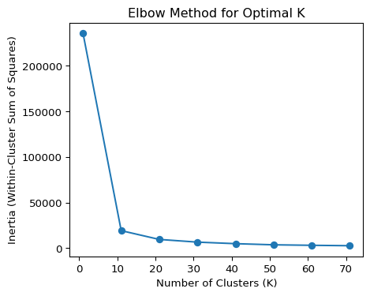

The elbow chart is a great way to visualize intertia vs number of clusters on the dataset. Since our goal is to generalize well, it’s not the best to choose the “lowest” inertia value. It is generally recommended in practice to choose the “elbow point”; I chose 10 as this looks very close to an elbow point for this distribution. Although, one drawback to this approach is its subjectiveness– you might think the elbow point is 12, whereas I think the elbow point is 10.

### K-Means for Spotify

After taking the resulting elbow point, I run that through my own instance of kmeans, utilizing the Sklearn library, and store the predicted results into the original dataframe.

```{python}  
kmeans = KMeans(n_clusters=10, random_state=42)  
original_df['clusters'] = kmeans.fit_predict(df_pca)  
```

D:\Users\dwh71\AppData\Local\Programs\Python\Python310\lib\site-packages\sklearn\cluster\_kmeans.py:1416: FutureWarning: The default value of `n_init` will change from 10 to 'auto' in 1.4. Set the value of `n_init` explicitly to suppress the warning  
 super()._check_params_vs_input(X, default_n_init=10)

```{python}  
sns.scatterplot(x="pca1", y="pca2", hue=original_df['clusters'], data=df_pca)  
plt.title('K-means Clustering PCA of 3 features [track_genre, artists, key]')  
plt.show()  
```

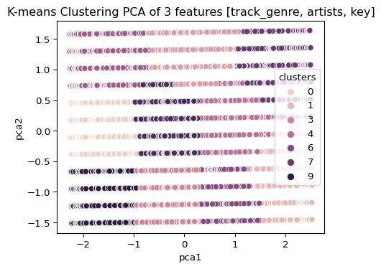

This is a PCA visualization of the clusters on the feature set track_genre, artists and key.

## Evaluating K-Means for Spotify

Below are some sample mini-clusters. Since the goal of this overall problem is to recommend music based on certain songs, I decided to create a function that grabs an entry from the CSV file, finds the cluster it’s in, and computes the k-nearest neighbors of that song. These nearest neighbors would be the “recommendation” songs, in order.

The general idea we should see with these mini-clusters are songs that resemble the query song. In the case of the first example, I ran my function on Daughtry’s song “Home”. The recommended song (top 1) example was another Daughtry song “It’s Not Over”.

When testing out different K-means implementations on different features, I found that simplicity is key. Having a ton of features is great for any dataset, but knowing how they interact with each other and how to simplify the problem makes for better results. I tested many different subsests of features including:

1. all of the original dataset features (n=20)
2. subset of continuous variables
3. subset of just track_genre and artists
4. subset of track_genre, artists, tempo, and key. All of which are discrete, factual features.
5. subset of track_genre, artists, and key.

My final result ended up being the last option, although those did not generate the most similar clusters, especially compared to option 3. Although, I chose the last option as I was trying to find similar songs while spanning across other artists. Option 5 seemed to give me similar options across at least one or more genres with different artists. It is worth noting that some of the results gave me the same artists, which is good since those are similar songs too.

```{python}  
original_df['Distance_to_Centroid'] = kmeans.transform(df_pca).min(axis=1)  
  
def get_nearest_entry(idx, k=5):  
 # print(original_df.iloc[idx])  
 # print(train_df.iloc[idx])  
 cluster = kmeans.predict(df_pca.iloc[idx].to_frame().T)[0]  
 cluster_data = original_df[original_df["clusters"] == cluster]  
 cluster_data["closest_entries_to_idx"] = (cluster_data["Distance_to_Centroid"] - cluster_data.loc[idx]["Distance_to_Centroid"]).abs()  
 cluster_data = cluster_data.sort_values(by="closest_entries_to_idx")  
 # print(cluster_data[["artists", "album_name", "track_name", "track_genre"]])  
  
 cluster_data.drop(columns=["closest_entries_to_idx"])  
 print(f"Top {k} Closest Examples to {cluster_data.loc[idx]['artists']}'s \"{cluster_data.loc[idx]['track_name']}\"")  
 print(cluster_data[:k][["artists", "track_name", "track_genre"]])  
 print("\n\n")  
  
get_nearest_entry(35640) # rock song  
get_nearest_entry(16587) # country song  
get_nearest_entry(41220) # rap song  
```

Top 5 Closest Examples to Daughtry's "September"  
 artists track_name track_genre  
35640 Daughtry September grunge  
35381 Daughtry It's Not Over grunge  
35839 Stone Sour Hesitate grunge  
55666 Mark Broom Five/Four minimal-techno  
40063 TNT;POPR3B3L I'm Raving - Radio Edit hardstyle  
  
  
  
Top 5 Closest Examples to Florida Georgia Line's "Stay"  
 artists \  
16587 Florida Georgia Line   
8395 Datsik;Virtual Riot   
8582 The Prodigy   
8819 The Prodigy   
8529 The Prodigy   
  
 track_name track_genre   
16587 Stay country   
8395 Nasty breakbeat   
8582 Girls breakbeat   
8819 We Are The Ruffest breakbeat   
8529 Out of Space - Techno Underworld Remix Remastered breakbeat   
  
  
  
Top 5 Closest Examples to Future;Lil Uzi Vert's "Tic Tac"  
 artists track_name \  
41220 Future;Lil Uzi Vert Tic Tac   
43994 Pritam;Arijit Singh;Shadab;Altamash Faridi Lambiyaan Si Judaiyaan   
41226 Lil Baby All In   
43981 Pritam;Sukhwinder Singh;Sunidhi Chauhan Marjaani   
41207 Zack Knight;Jasmin Walia Bom Diggy Diggy   
  
 track_genre   
41220 hip-hop   
43994 indian   
41226 hip-hop   
43981 indian   
41207 hip-hop

C:\Users\dwh71\AppData\Local\Temp\ipykernel_15984\3657151199.py:8: SettingWithCopyWarning:   
A value is trying to be set on a copy of a slice from a DataFrame.  
Try using .loc[row_indexer,col_indexer] = value instead  
  
See the caveats in the documentation: https://pandas.pydata.org/pandas-docs/stable/user_guide/indexing.html#returning-a-view-versus-a-copy  
 cluster_data["closest_entries_to_idx"] = (cluster_data["Distance_to_Centroid"] - cluster_data.loc[idx]["Distance_to_Centroid"]).abs()  
C:\Users\dwh71\AppData\Local\Temp\ipykernel_15984\3657151199.py:8: SettingWithCopyWarning:   
A value is trying to be set on a copy of a slice from a DataFrame.  
Try using .loc[row_indexer,col_indexer] = value instead  
  
See the caveats in the documentation: https://pandas.pydata.org/pandas-docs/stable/user_guide/indexing.html#returning-a-view-versus-a-copy  
 cluster_data["closest_entries_to_idx"] = (cluster_data["Distance_to_Centroid"] - cluster_data.loc[idx]["Distance_to_Centroid"]).abs()  
C:\Users\dwh71\AppData\Local\Temp\ipykernel_15984\3657151199.py:8: SettingWithCopyWarning:   
A value is trying to be set on a copy of a slice from a DataFrame.  
Try using .loc[row_indexer,col_indexer] = value instead  
  
See the caveats in the documentation: https://pandas.pydata.org/pandas-docs/stable/user_guide/indexing.html#returning-a-view-versus-a-copy  
 cluster_data["closest_entries_to_idx"] = (cluster_data["Distance_to_Centroid"] - cluster_data.loc[idx]["Distance_to_Centroid"]).abs()

Option 3 on the other hand gave me different songs for the same artists, which is fine for a recommendation system, but not what I was exactly going for. Below is a visualization of the clusters with just two features as well as its predictions.

```{python}  
original_df = pd.read_csv("./dataset-dedup.csv")  
# train_df is the numeric representation of original_df  
train_df = original_df.drop(columns=['Unnamed: 0.1', 'index', 'Unnamed: 0', 'track_id',  
 'album_name', 'track_name', 'popularity', 'duration_ms', 'explicit',  
 'danceability', 'key', 'energy', 'loudness', 'mode', 'speechiness',  
 'acousticness', 'instrumentalness', 'liveness', 'valence', 'tempo',  
 'time_signature'])  
  
for col in train_df.columns:  
 if not pd.api.types.is_numeric_dtype(train_df[col]):  
 train_df[col] = pd.factorize(original_df[col])[0]  
  
scaler = StandardScaler()  
# df_scaled is the scaled version of train_df  
df_scaled = scaler.fit_transform(train_df)  
pca_num_components = 2  
  
# df_pca to reduce dimensionality  
pca = PCA(n_components=pca_num_components).fit_transform(df_scaled)  
df_pca = pd.DataFrame(pca,columns=['pca1','pca2'])  
  
kmeans = KMeans(n_clusters=10, random_state=42)  
original_df['clusters'] = kmeans.fit_predict(df_pca)  
  
sns.scatterplot(x="pca1", y="pca2", hue=original_df['clusters'], data=df_pca)  
plt.title('K-means Clustering PCA of 2 features [track_genre, artists]')  
plt.show()  
original_df['Distance_to_Centroid'] = kmeans.transform(df_pca).min(axis=1)  
get_nearest_entry(35640) # rock song  
get_nearest_entry(16587) # country song  
get_nearest_entry(41220) # rap song  
```

D:\Users\dwh71\AppData\Local\Programs\Python\Python310\lib\site-packages\sklearn\cluster\_kmeans.py:1416: FutureWarning: The default value of `n_init` will change from 10 to 'auto' in 1.4. Set the value of `n_init` explicitly to suppress the warning  
 super()._check_params_vs_input(X, default_n_init=10)  
C:\Users\dwh71\AppData\Local\Temp\ipykernel_15984\3657151199.py:8: SettingWithCopyWarning:   
A value is trying to be set on a copy of a slice from a DataFrame.  
Try using .loc[row_indexer,col_indexer] = value instead  
  
See the caveats in the documentation: https://pandas.pydata.org/pandas-docs/stable/user_guide/indexing.html#returning-a-view-versus-a-copy  
 cluster_data["closest_entries_to_idx"] = (cluster_data["Distance_to_Centroid"] - cluster_data.loc[idx]["Distance_to_Centroid"]).abs()  
C:\Users\dwh71\AppData\Local\Temp\ipykernel_15984\3657151199.py:8: SettingWithCopyWarning:   
A value is trying to be set on a copy of a slice from a DataFrame.  
Try using .loc[row_indexer,col_indexer] = value instead  
  
See the caveats in the documentation: https://pandas.pydata.org/pandas-docs/stable/user_guide/indexing.html#returning-a-view-versus-a-copy  
 cluster_data["closest_entries_to_idx"] = (cluster_data["Distance_to_Centroid"] - cluster_data.loc[idx]["Distance_to_Centroid"]).abs()  
C:\Users\dwh71\AppData\Local\Temp\ipykernel_15984\3657151199.py:8: SettingWithCopyWarning:   
A value is trying to be set on a copy of a slice from a DataFrame.  
Try using .loc[row_indexer,col_indexer] = value instead  
  
See the caveats in the documentation: https://pandas.pydata.org/pandas-docs/stable/user_guide/indexing.html#returning-a-view-versus-a-copy  
 cluster_data["closest_entries_to_idx"] = (cluster_data["Distance_to_Centroid"] - cluster_data.loc[idx]["Distance_to_Centroid"]).abs()

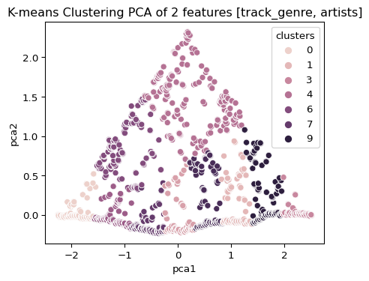

Top 5 Closest Examples to Daughtry's "September"  
 artists track_name track_genre  
35439 Daughtry Waiting for Superman grunge  
35678 Daughtry Gone Too Soon grunge  
35802 Daughtry I'll Fight grunge  
35640 Daughtry September grunge  
35336 Daughtry Home grunge  
  
  
  
Top 5 Closest Examples to Florida Georgia Line's "Stay"  
 artists track_name track_genre  
16592 Florida Georgia Line I Love My Country country  
16587 Florida Georgia Line Stay country  
16938 Florida Georgia Line H.O.L.Y. country  
16598 Florida Georgia Line Sun Daze country  
16975 Florida Georgia Line Life country  
  
  
  
Top 5 Closest Examples to Future;Lil Uzi Vert's "Tic Tac"  
 artists track_name track_genre  
41220 Future;Lil Uzi Vert Tic Tac hip-hop  
39123 Lionheart Cursed hardcore  
39035 Lionheart LHHC '17 hardcore  
39040 Bodyjar A Hazy Shade of Winter hardcore  
39033 Naked Raygun Rat Patrol hardcore

## Conclusion

In this blog post, I used K-means as a clustering algorithm for a song recommendation system. Though K-means does a good job at coming up with clusters and generating similar examples, other clustering algorithms such as DBSCAN may be a suitable option as well. In general, what I like about clustering algorithms for this problem domain, especially K-means, is its free range to determine what logical clusters should look like and its intuitiveness. There’s not only one correct way to do K-means.