FAKE STORE API TEST PLAN

1. DOCUMENT INFORMATION
Project Name: Fake Store API QA Project
Prepared By: Muhammad Hassnain Raza
Testing Type: Manual API Testing
Tool Used: Postman
Bug Tracking Tool: Jira
Date: July 2026

2. PROJECT OVERVIEW
This project focuses on manual API testing of the Fake Store API using Postman.
The objective is to verify API functionality, response accuracy, status codes, input validation, and error handling.

API Base URL:
https://fakestoreapi.com/

3. TEST OBJECTIVES
The objectives of this testing are:
- Verify API endpoints function correctly
- Validate request and response data
- Validate HTTP status codes
- Perform CRUD operation testing
- Perform negative testing with invalid inputs
- Identify and report bugs in Jira

4. TEST SCOPE
In Scope:
- Product API testing
- GET requests
- POST requests
- PUT requests
- DELETE requests
- Positive testing
- Negative testing

Out of Scope:
- Performance testing
- Security testing
- Load testing
- Database validation

5. TEST ENVIRONMENT
Operating System: Windows 10/11
API Testing Tool: Postman
Bug Tracking Tool: Jira
Browser: Google Chrome
Internet Connection: Stable Broadband

6. API ENDPOINTS TESTED
- GET /products
- GET /products/1
- GET /products/999999
- POST /products
- PUT /products/1
- PUT /products/999999
- DELETE /products/1
- DELETE /products/999999

7. TESTING TYPES PERFORMED
- Functional Testing
- API Testing
- Validation Testing
- Negative Testing
- Regression Testing (Basic)

8. ENTRY CRITERIA
- API server accessible
- Postman installed
- Internet available
- Test data prepared

9. EXIT CRITERIA
- Testing will be considered complete when:
- All planned test cases are executed
- Bugs are reported in Jira
- Test execution report is completed

10. RISKS
- Public API may behave inconsistently
- Fake API may not persist actual data changes
- Server downtime may affect testing

11. DEFECT MANAGEMENT PROCESS
Bug lifecycle used in Jira:
To Do → In Progress → Ready for Retest → Done
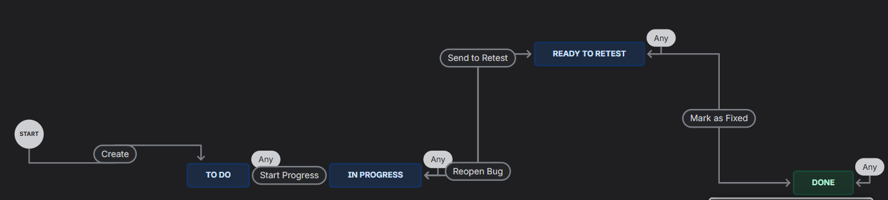

12. BUG SUMMARY
Total Bugs Found: 5
Bug 1:
Invalid product ID returns 200 instead of 404
Bug 2:
POST accepts negative price
Bug 3:
PUT accepts negative price
Bug 4:
DELETE returns success for invalid product ID

13. APPROVAL
Testing Completed By:
Muhammad Hassnain Raza

