**Create Solution**

Added Empty Solution “**SamuraiApp**”

Created Library Project “**SamuraiApp.Domain**”

Created Library Project “**SamuraiApp.Data**”

Created Console Project “**SamuraiApp.UI**”

In “**SamuraiApp.Data**” Added Nuget Package “**Microsoft.EntitiyFrameworkCore.SqlServer**” 5.0.7

PM> Install-Package **Microsoft.EntitiyFrameworkCore.SqlServer**

**Added Project reference of SamuraiApp.Domain** in **SamuraiApp.Data i.e.**

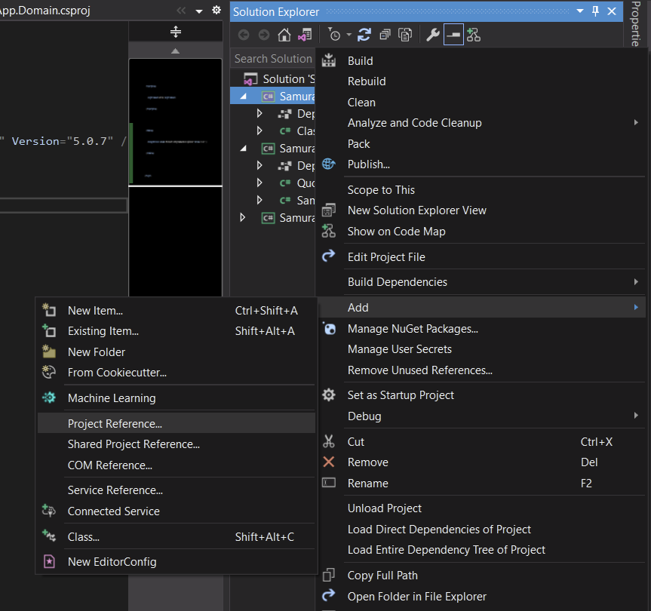

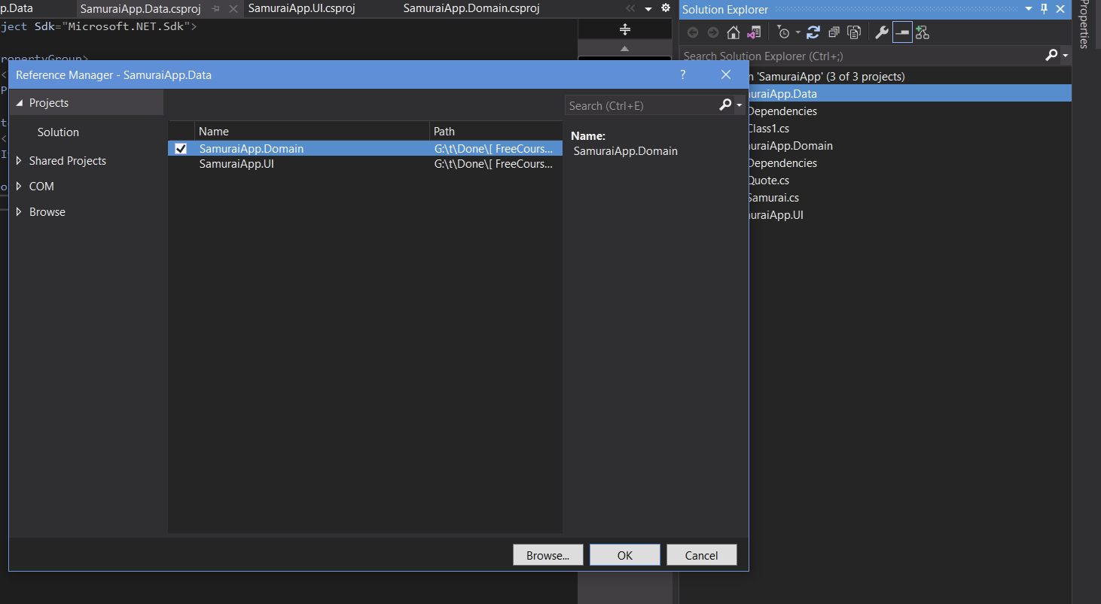

**Add Context Class for EF Core**

in **SamuraiApp.Data** project added **public class SamuraiContext:DbContext i.e** inherited from DbContext of Microsoft.EntityFrameworkCore

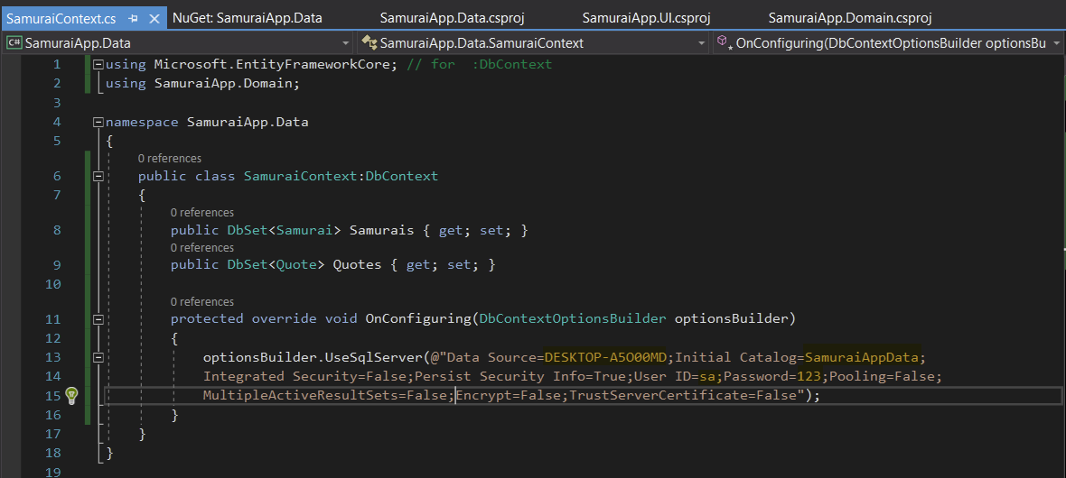

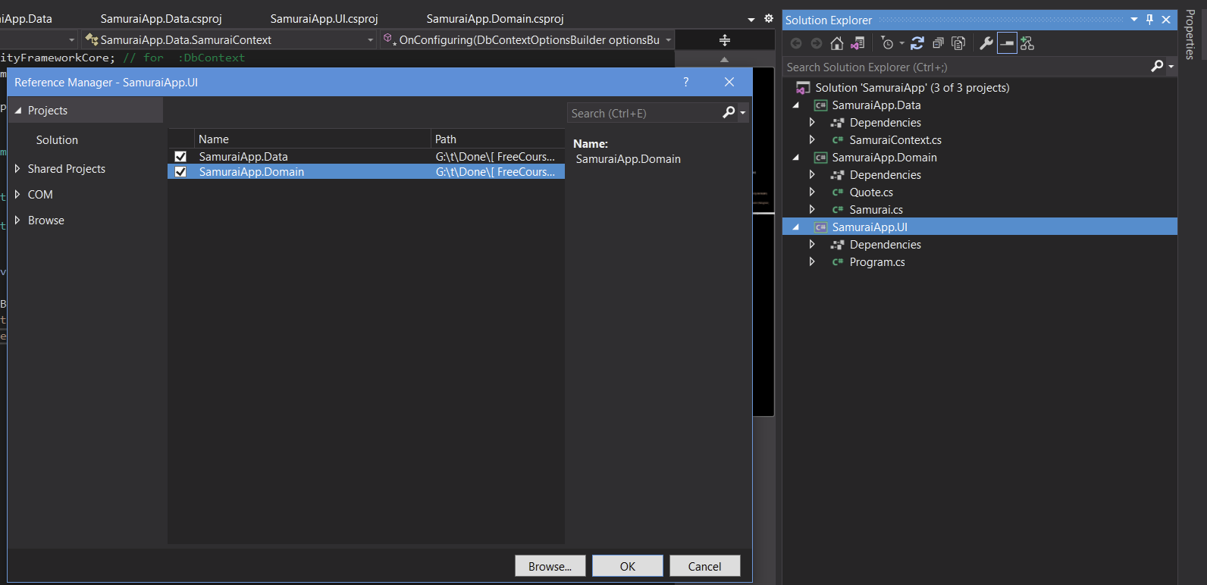

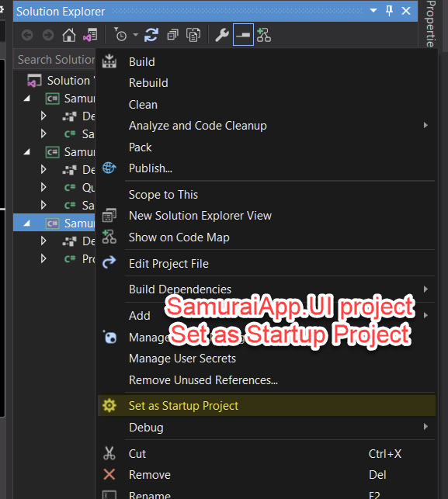

**03. Controlling Database Creation and Schema**

Microsoft.EntityFrameworkCore.Tools

<PackageReference Include="Microsoft.EntityFrameworkCore.Tools" Version="5.0.5">

PM> get-help entityframework

* Add-Migration
* Drop-Database
* Get-DbContext
* Get-Migration
* Remove-Migration
* Scaffold-DbContext
* Script-DbContext
* Script-Migration
* Update-Database

PM> Add-Migration init

PM> update-database

PM> update-database -verbose

PM> script-migration

