Final Project Stat 4043/5543 ODUTOLA ODUNAYO SAMSON

Introduction
The Jaxhouse data contains a random sample of 104 single-family home sales in zip code 32244 on the west side of Jacksonville, Florida, sold during the first half of 2019. This covers a diverse area that includes both older and newer homes. The objective of this analysis is to study the effect of several home characteristics on the sale price using a multiple linear regression model. The response variable is SalePrice, measured in U.S. dollars. The predictors considered are listed below;
Bedrooms: Number of Bedrooms.
Baths: Number of Bathrooms.
GrossSF: Gross Square footage (Sq ft).
HtdSF: Heated square footage (Sq ft).
Age2020: Age of Home as of 2020(years).
LotSF: Lot square footage (Sq ft).
Townhouse: whether the property is a townhouse (Y / N).
Pool: whether the property has a pool (Y / N).
Two variables provided in the original dataset were excluded from the analysis. YearConst was removed because it is a perfect linear function of Age2020 (YearConst + Age2020 = 2020 for every observation), so including both would cause exact collinearity. AppJustVal2018 was removed because it is itself the county appraiser's price estimate from one year before sale rather than a physical characteristic of the home; including it would reduce the analysis to "does last year's appraisal predict this year's sale price?" and would not answer the research question. After these removals, the working dataset contains 104 observations, 6 continuous predictors, and 2 categorical predictors.

Data Visualization
SalePrice ranged from $21,000 to $320,000 with a mean of $162,569, a median of $165,000, and a standard deviation of $51,887. The histogram in Figure 1 shows an approximately symmetric, bell-shaped distribution, and the boxplot in Figure 2 identifies three (3) high outliers above $300,000 and two low outliers near $40,000 and $21,000. Because the distribution is approximately symmetric rather than strongly skewed, no response transformation was applied at this stage. However, my decision will be revisited after examining residual plots from the initial model.
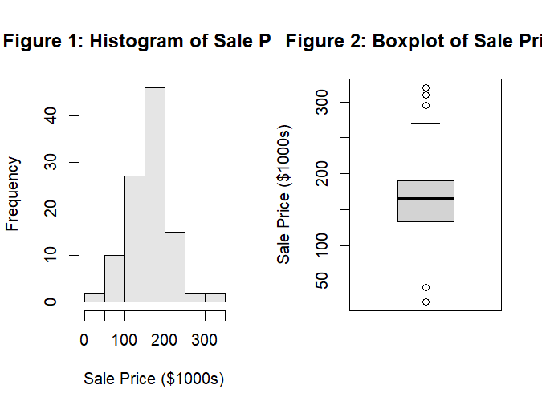
Boxplots of the continuous predictors are shown in Figure 3 below. Bedrooms and Baths are nearly constant across the sample, most homes have exactly 3 bedrooms and 2 bathrooms, with a small number of 2-, 4-, and 5-bedroom homes appearing as outliers. GrossSF and HtdSF show similar distributions and are strongly correlated with one another (r = 0.933), which anticipates a multicollinearity concern to be addressed during model fitting. Age2020 is well-distributed over 0 to 70 years. LotSF contains one extreme observation near 158,000 sq ft, well above the rest of the sample; this observation will be monitored during outlier diagnostics.

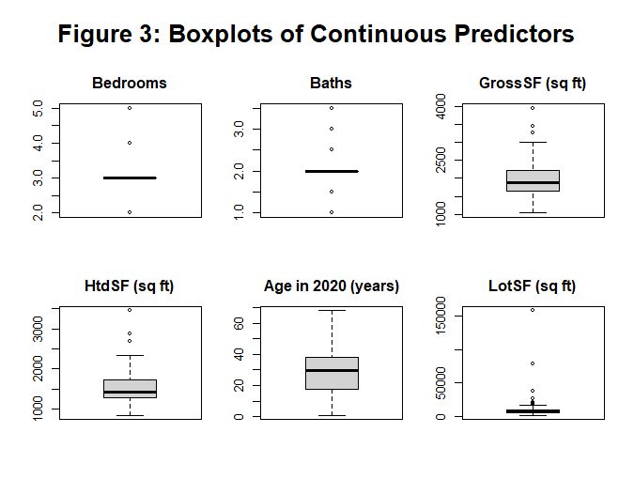
Among the categorical predictors, Townhouse is fairly well balanced (92 non-townhouses, 12 townhouses) but Pool is heavily imbalanced, with only 7 of the 104 homes having a pool. Figure 4 shows that townhouses sell for noticeably less than non-townhouses (median ≈ $110,000 vs ≈ $170,000) and that pool homes appear to sell at a premium (median ≈ $215,000 vs ≈ $160,000). However, because only 7 homes in the sample have a pool, any estimated pool effect will carry considerable uncertainty, and this is a limitation of the study.
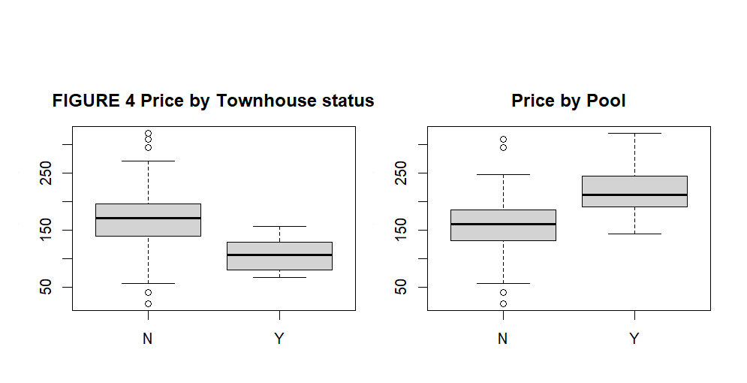
The correlation matrix of the continuous variables Figure 5 shows that SalePrice has strong positive linear relationships with GrossSF (r = 0.766) and HtdSF (r = 0.735), a moderate negative relationship with Age2020 (r = −0.313), and a weak relationship with LotSF (r = 0.183), the last likely attenuated by the single extreme lot-size observation noted above.
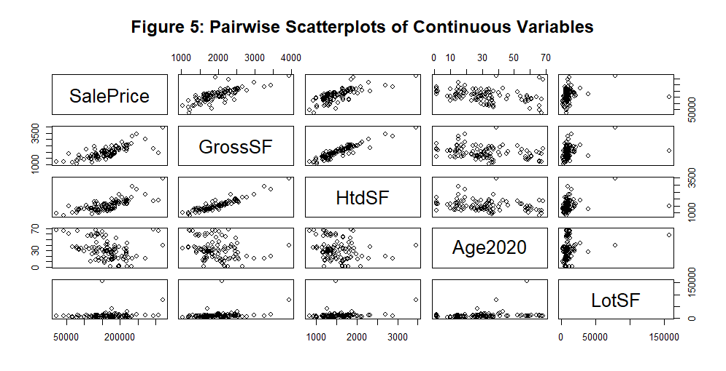

Model Selection and Diagnostics

Full Model:
We began by fitting the full model with all 8 predictors:
$$y=β_{0}+β_{1}.Bedrooms +β_{2}.Baths+β_{3}.GrossSF+β_{4}.HtdSF+β_{5}.Age2020+β_{6}.LotS+β_{7}.TownhouseY +β_{8}PoolY+ϵ$$
where ε ~ N(0, σ²) and errors are independent. The full model produced an R² of 0.666 and an adjusted R² of 0.638, indicating about 66.6% of variation in SalePrice is explained by the eight predictors.
Linearity and constant variance: The residuals-vs-fitted plot showed mostly random scatter, but two extreme positive residuals from rows 103 and 104 lay above the +3 line (Figure 6). This indicates that the homoscedasticity assumption holds and that a transformation of the response was not needed because residual issues are localized to a few specific observations rather than reflecting a systemic distributional problem
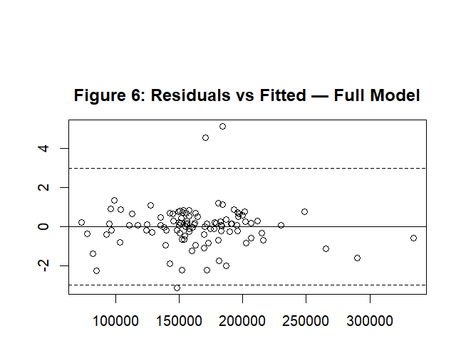
Independence: Data are cross-sectional (each home is a separate sale), so no reason to expect correlated errors.
Normality: QQ correlation = 0.9364 which is below the typical thresholds. The QQ plot showed both tails departing from the line, driven by the same extreme observations Figure 7.
Multicollinearity: VIF for GrossSF showed 10.18, HtdSF 10.13 unfortunately both above the cutoff of 10 but Other VIFs all < 2. This was anticipated from the exploratory data analysis correlation r = 0.933 between these two.
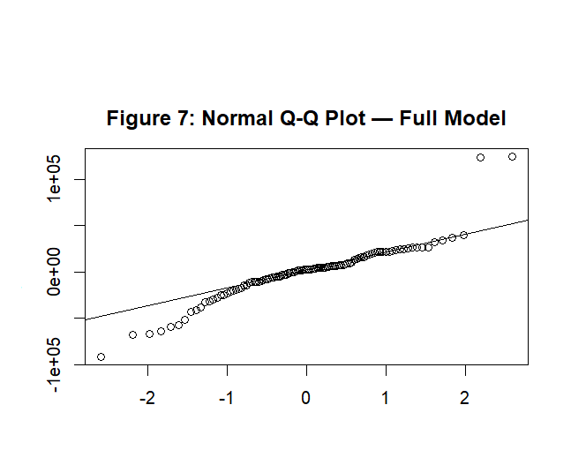

Outlier and Influence
Three observations had studentized residual > 3 (rows 72, 103, 104). Cook's distance values flagged row 104 (D = 0.725) and row 103 (D = 0.198) as substantially exceeding the threshold of 4/n = 0.038. Though row 88 had high leverage (hat= 0.83) due to its 158,000 sq ft lot above 75th percentile of 10,500 sq ft but its low cook’s Distance of 0.04 does not pose any threat to me (Figure 9).
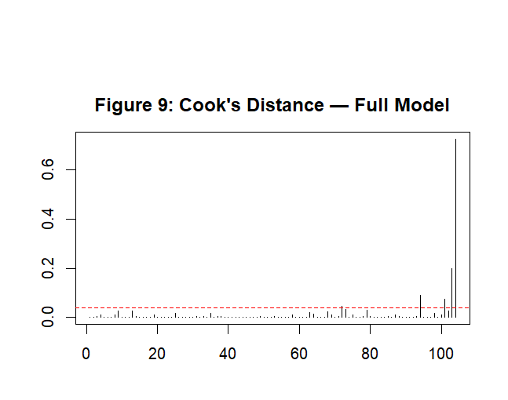

Remedial Action
Rows 103 and 104, both 66 - 68-year-old homes that sold for prices near $300,000, well above what the model predicted for older homes were removed because of their combined high residuals and high Cook's distances in our findings. We retained Row 88 after investigation although with high-leverage, the model's fit and conclusions were not materially affected by its presence. After cleaning, the dataset contains n = 102 observations and is used for all subsequent analysis. The multicollinearity between GrossSF and HtdSF persists and will be addressed during model selection.

The full model was refit on the cleaned dataset and diagnostics were re-examined. The residuals vs fitted-values plot on Figure 10 showed an improved random pattern. The Q-Q plot (Figure 11) and histogram of residuals (Figure 12) revealed the reduced tail deviation, with the Q-Q correlation rising from 0.9364 to 0.9691. Cook's distance values were greatly reduced (Figure 13), with no remaining observation having Cook's D exceeding 0.43, and only one residual (observation 72) still slightly outside the ±3 band. The fit improved noticeably, with R² = 0.779 and adjusted R² = 0.760.
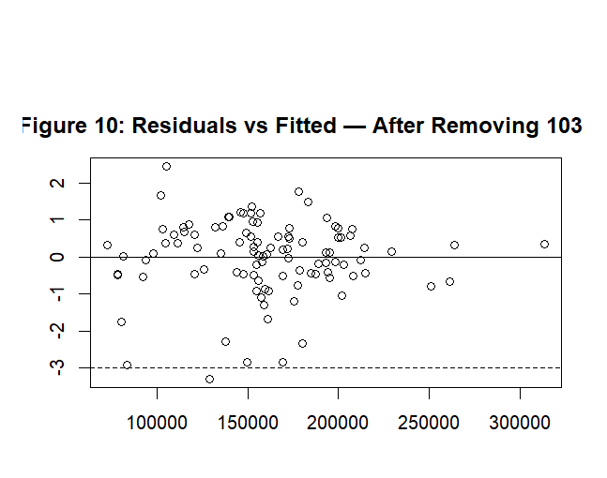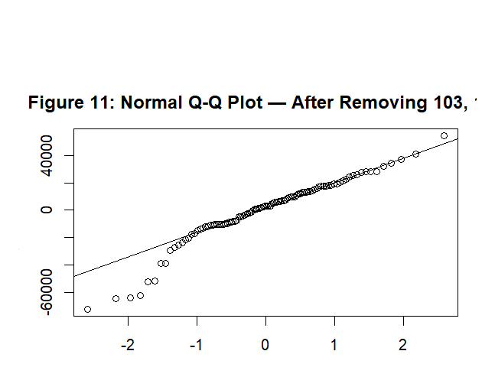
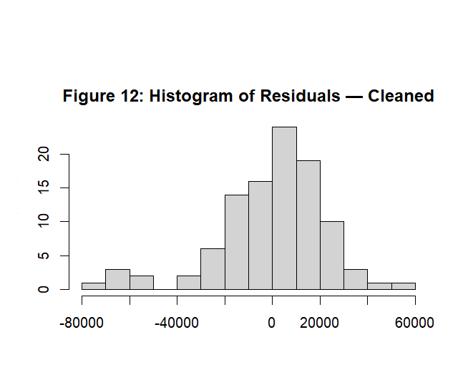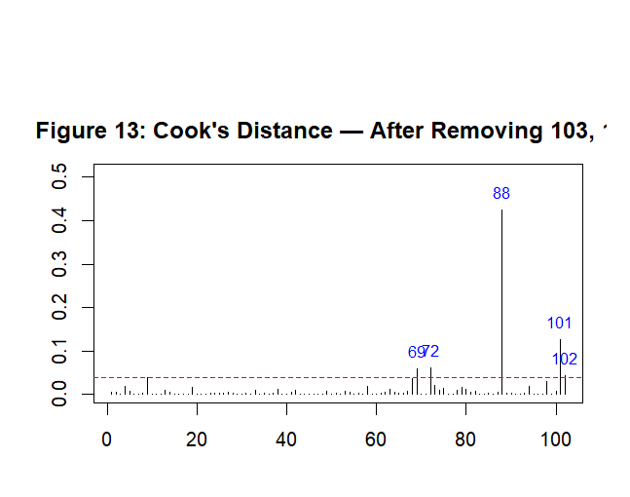

Model Selection
To identify the best model, I used the AIC-based stepwise procedure starting from the intercept-only model and considering all eight predictors, allowing both forward addition and backward removal of variables. This procedure added GrossSF first (AIC dropped from 2202.07 to 2094.13), then Age2020 (AIC = 2079.43), then Townhouse (AIC = 2066.41), and finally Pool (AIC = 2058.50). At that point no further addition or removal improved the AIC, and the algorithm terminated. The selected main-effects model was therefore:
$$Saleprice= β_{0}+β_{1}.GrossSF+β_{2}.Age2020+ β_{3}.TownhouseY+ β_{4}.PoolY+ϵ$$
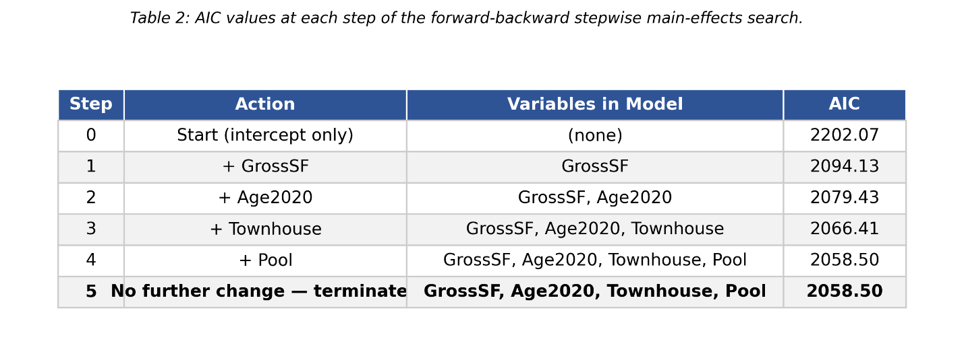
Note that HtdSF was not selected, which automatically resolved the multicollinearity between the two square-footage variables. Bedrooms, Baths, and LotSF were also dropped, consistent with their non-significant t-values in the full model.
I then searched all six possible two-way interactions among the four selected predictors using the same stepwise AIC procedure. The procedure terminated immediately at the starting model, as every candidate interaction increased AIC, and removing any of the four main effects increased AIC substantially. The closest candidate, GrossSF × Age2020, would have raised AIC by only 0.3, but stepwise AIC adds a term only if it strictly lowers AIC. The additive main-effects model was therefore maintained as the final model.
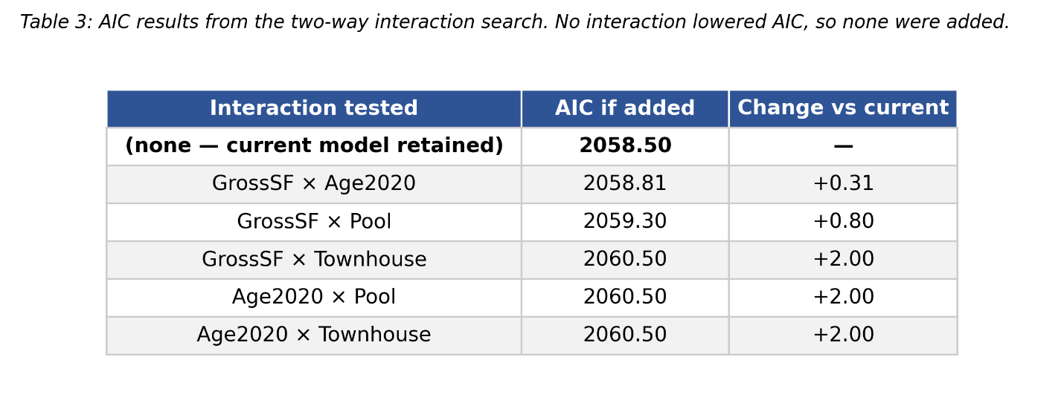

Final Model Diagnostics
All the assumptions on the final selected model were rechecked. The residuals vs fitted-values plot (Figure 14) shows a random scatter centered on zero with no funneling pattern, supporting both linearity and constant variance. Residuals plotted against each predictor individually (Figure 15) show no systematic curvature for GrossSF or Age2020 and similar spreads across the levels of Townhouse and Pool. Therefore, Independence is justified by the cross-sectional structure of the data as in the full model.

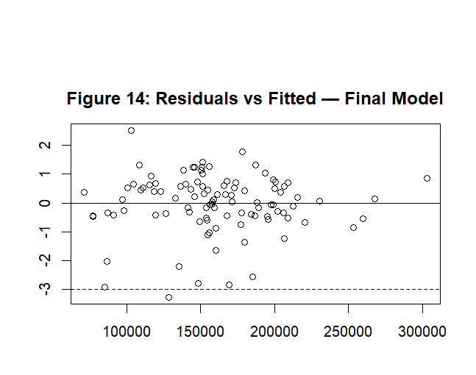
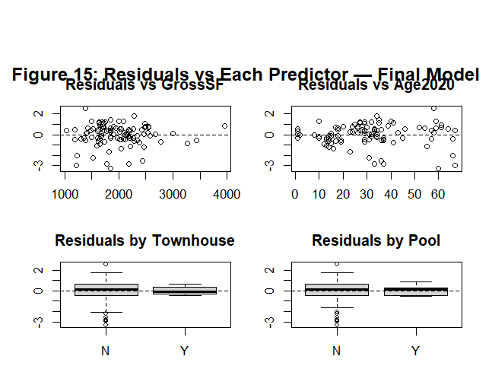
The Q-Q plot (Figure 16) shows that most of the residuals lie close to the reference line, with some deviation in the lower tail driven primarily by observation 72, the home that sold for $56,300, well below its appraised value of $86,603, possibly showing non-physical factors such as a distress sale that the model cannot capture from physical home characteristics. The Q-Q correlation is 0.9656, only marginally below the typical threshold; given the limited number of points causing the deviation, this is accepted with the caveat that one observation creates a mild lower-tail departure. The Cook's distance plot on Figure 17 shows no observation exceeding 0.113, well below the conventional thresholds of 0.5 and 1.0 for serious concern. Five observations slightly exceeded the 4/n threshold (rows 13, 69, 72, 101, 102), but their absolute Cook's D values are small, and removing them would not be necessary. All variance inflation factors are between 1.12 and 1.43 indicating that multicollinearity is no longer present. Therefore, with all assumptions sufficiently met, the selected model is appropriate for interpretation and inference.
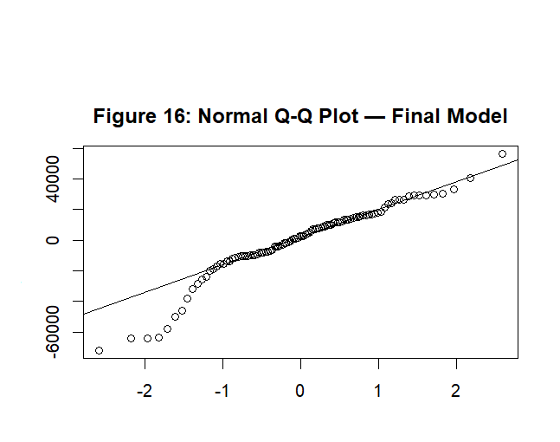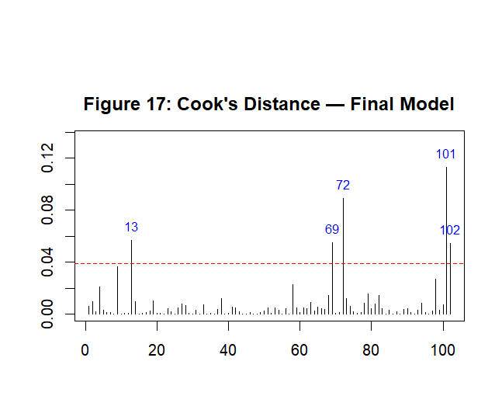
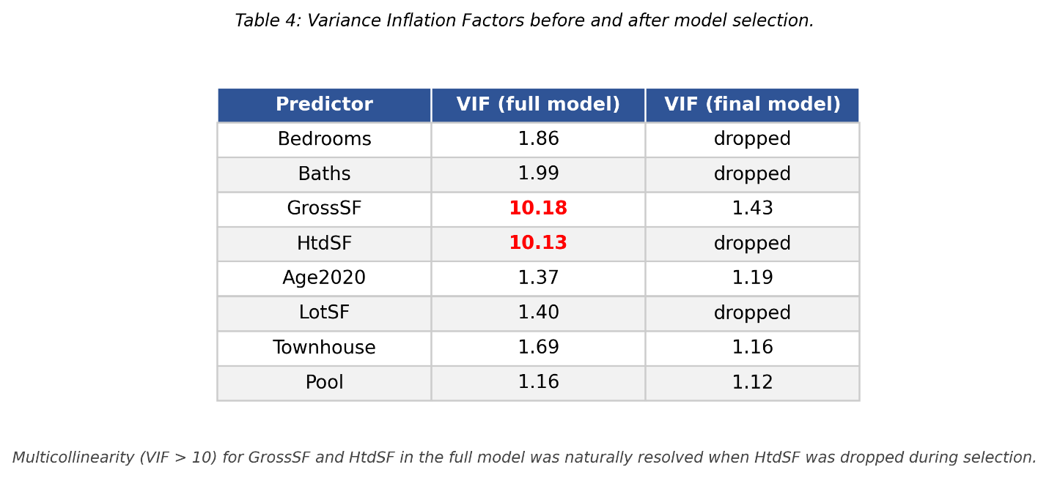

Final Model and Results

Final Estimated Model
After all the diagnostics and selection, the final fitted regression equation gives:
$$Saleprice= 73,170.62 +59.09.GrossSF- 888.16Age2020- 32,722.34.TownhouseY+ 30,754.69.PoolY+ϵ$$

where GrossSF is measured in sq ft, Age2020 in years, and TownhouseY and PoolY are indicator variables taking the value 1 if the home is a townhouse / has a pool, respectively, and 0 otherwise. The reference category for both indicators is "N." All coefficients are reported in U.S. dollars.

Coefficient Estimates and Hypothesis Tests
The coefficient estimates, standard errors, t-statistics, p-values, and 95% confidence intervals are summarized in Table 1. For each coefficient the null hypothesis is $H_{0} :β_{j}=0, against H_{1} : β_{j} ≠0$
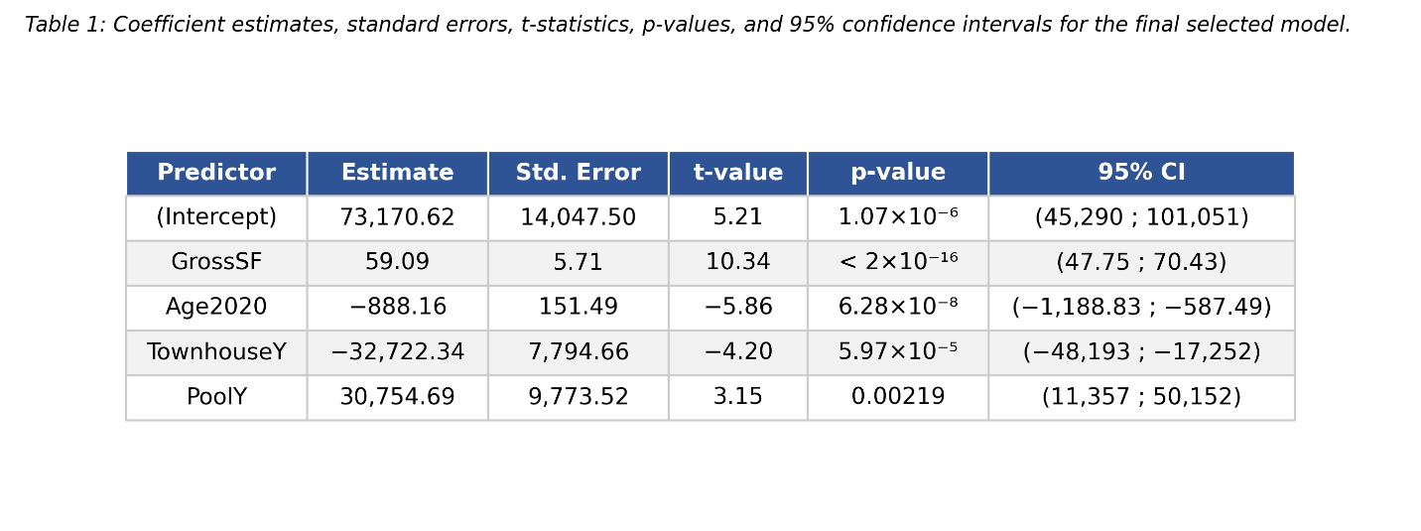
All the four predictors are highly significant. The intercept and the GrossSF, Age2020, and Townhouse coefficients all show p-values below 0.001, providing very strong evidence that each variable has a non-zero effect on SalePrice. The Pool coefficient is significant at the 1% level (p = 0.0022), although the wide 95% confidence interval ($11,357 to $50,152) reflects the small number of pool homes (n = 7) in the sample.

Goodness of Fit
The model has R² = 0.7737 and adjusted R² = 0.7644, indicating that approximately 77% of the variation in sale price is explained by the four predictors. The residual standard error is $23,550 on 97 degrees of freedom, which gives an indication of how far typical predictions are from observed sale prices. The F-statistic of 82.92 on 4 and 97 degrees of freedom ($p<2.2 ×{10}^{-16})$ decisively rejects the null hypothesis that all slope coefficients are simultaneously zero (0), confirming the overall significance of the model.

Interpretation of Coefficients
Each coefficient is interpreted holding the other predictors constant.
- GrossSF $( β=59.09$: Each additional square foot of gross floor area is associated with an estimated increase of $59.09 in sale price (95% CI: $47.75 to $70.43). For a typical 100 sq ft increase in size, this corresponds to an expected increase of approximately $5,909.
- Age2020 $\left( β=-888.16\right)$ Each additional year of age (i.e., older homes) is associated with an estimated decrease of $888.16 in sale price (95% CI: −$1,188.83 to −$587.49). For a 10-year difference in age, this corresponds to an expected difference of approximately $8,882.
- TownhouseY $\left( β=-32,722.34\right)$: Townhouses sell for an estimated $32,722 less than non-townhouses with the same gross floor area, age, and pool status (95% CI: −$48,193 to −$17,252).
- PoolY $\left( β=30,754.69\right):$Homes with a pool sell for an estimated $30,755 more than otherwise comparable homes without a pool (95% CI: $11,357 to $50,152). The wider confidence interval reflects the small number of pool homes in the sample.

Worked-Example Predictions
To illustrate the model’s practical usefulness, predicted sale prices were generated for a baseline home with average characteristics: GrossSF = 1,956.89 sq ft, Age2020 = 30.66 years, no townhouse status, no pool.
- Baseline home: estimated mean SalePrice = $161,579, with 95% confidence interval ($156,444; $166,715). The 95% prediction interval for an individual home with the same characteristics is wider, ($114,562; $208,597), reflecting the additional uncertainty in predicting a single observation rather than the mean.
- Baseline home with a pool: estimated mean SalePrice = $192,334, 95% CI ($173,550; $211,118). The pool is associated with a roughly 19% increase over the baseline.
- Average-sized townhouse: estimated mean SalePrice = $128,857, 95% CI ($114,350; $143,364). The townhouse status is associated with a roughly 20% decrease from the baseline.

Findings and Conclusion
The analysis identifies four key characteristics that together explain about 77% of the variation in single-family home sale prices during the first half of 2019: gross square footage, age, townhouse status, and pool presence. Number of bedrooms, number of bathrooms, heated square footage, and lot size were not retained by the AIC-based stepwise procedure that I did because they did not provide additional predictive value once the four selected predictors were included. The strong correlation between gross and heated square footage was responsible for excluding heated square footage in particular.
The model results indicate clear and intuitive relationships between several home characteristics and sale price. Larger homes tend to sell for more, with sale price increasing by about $59 for each additional square foot. In contrast, older homes sell for less, with prices decreasing by roughly $888 for every additional year of age. Holding size and age constant, townhouses sell for substantially less than non-townhouse homes, with an average difference of about $32,722. Homes with a pool, on the other hand, sell for noticeably more, with an estimated price increase of about $30,755.
The magnitude of the pool effect should be interpreted with caution, however, since only 7 homes in the sample had a pool, which introduces additional uncertainty into this estimate. Within these limitations, our model provides a useful tool for estimating expected sale prices based on observable physical characteristics. For example, a typical 1,957 sq ft, 30-year-old non-townhouse home without a pool would be expected to sell for approximately $161,600, which is consistent with the predictions generated earlier for the baseline home.

For a non-statistician reader, the key takeaway is straightforward; In this part of west Jacksonville, sale price is driven primarily by how big the home is, how old it is, whether it is a townhouse, and whether it has a pool but each of these factors makes a real and measurable difference in price, with size being the strongest single predictor. Other often discussed features such as the number of bedrooms or the size of the lot did not, in this sample, add further explanation once size, age, and home type were accounted for.

Appendix

# ---- Libraries ----
library(car)
library(MASS)

# ---- Read data ----
setwd("C:/Users/HP/Desktop/MSQF/Data1/Data pack 1")
jax <- read.csv("Jaxhouse.csv", header = TRUE)

# ---- Convert categorical variables to factors ----
jax$Townhouse <- factor(jax$Townhouse)
jax$Pool <- factor(jax$Pool)

# ---- Drop YearConst (perfectly collinear with Age2020) ----
jax$YearConst <- NULL

# ==============================================================
# Step 1: Descriptive Analysis
# ==============================================================

# Response summary
summary(jax$SalePrice)
sd(jax$SalePrice)

# Figure 1 & 2: Histogram and Boxplot of SalePrice
par(mfrow = c(1, 2))
hist(jax$SalePrice/1000, main = "Figure 1: Histogram of Sale Price",
xlab = "Sale Price ($1000s)", col = "grey90")
boxplot(jax$SalePrice/1000, main = "Figure 2: Boxplot of Sale Price",
ylab = "Sale Price ($1000s)")
par(mfrow = c(1, 1))

# Figure 3: Boxplots of continuous predictors
par(mfrow = c(2, 3), oma = c(1, 1, 4, 1), mar = c(3, 3, 3, 1))
boxplot(jax$Bedrooms, main = "Bedrooms")
boxplot(jax$Baths, main = "Baths")
boxplot(jax$GrossSF, main = "GrossSF (sq ft)")
boxplot(jax$HtdSF, main = "HtdSF (sq ft)")
boxplot(jax$Age2020, main = "Age in 2020 (years)")
boxplot(jax$LotSF, main = "LotSF (sq ft)")
mtext("Figure 3: Boxplots of Continuous Predictors",
side = 3, outer = TRUE, line = 1, cex = 1.3, font = 2)
par(mfrow = c(1, 1))

# Categorical predictors
table(jax$Townhouse)
table(jax$Pool)

# Figure 4: Price by categorical predictors
par(mfrow = c(1, 2))
boxplot(SalePrice/1000 ~ Townhouse, data = jax,
main = "Price by Townhouse status", ylab = "Price ($1000s)")
boxplot(SalePrice/1000 ~ Pool, data = jax,
main = "Price by Pool", ylab = "Price ($1000s)")
par(mfrow = c(1, 1))

# Correlation matrix
cont_vars <- c("Bedrooms","Baths","GrossSF","HtdSF","Age2020",
"LotSF","SalePrice")
round(cor(jax[, cont_vars]), 3)

# Figure 5: Pairs plot
pairs(jax[, c("SalePrice","GrossSF","HtdSF","Age2020","LotSF")],
main = "Figure 5: Pairwise Scatterplots of Continuous Variables")

# ==============================================================
# Step 2: Initial Full Model and Diagnostics
# ==============================================================

fullfit <- lm(SalePrice ~ Bedrooms + Baths + GrossSF + HtdSF +
Age2020 + LotSF + Townhouse + Pool,
data = jax)
summary(fullfit)

# Figure 6: Residuals vs Fitted
plot(fullfit$fitted.values, studres(fullfit),
xlab = "Fitted Values", ylab = "Studentized Residuals",
main = "Figure 6: Residuals vs Fitted — Full Model")
abline(h = c(-3, 0, 3), lty = c(2, 1, 2))

# Figure 7: QQ plot
qqnorm(fullfit$residuals, main = "Figure 7: Normal Q-Q Plot — Full Model")
qqline(fullfit$residuals)

# Quantify normality
norm_check <- qqnorm(fullfit$residuals, plot.it = FALSE)
cat("QQ correlation:", cor(norm_check$x, norm_check$y), "\n")

# Figure 8: Histogram of residuals
hist(fullfit$residuals, breaks = 15,
main = "Figure 8: Histogram of Residuals — Full Model",
xlab = "Residuals")

# VIFs
vif(fullfit)

# Figure 9: Cook's Distance
plot(cooks.distance(fullfit), type = "h",
main = "Figure 9: Cook's Distance — Full Model",
ylab = "Cook's Distance", xlab = "Observation Index")
abline(h = 4/nrow(jax), lty = 2, col = "red")

# Identify outliers and influential observations
cd <- cooks.distance(fullfit)
head(sort(cd, decreasing = TRUE), 10)
hv <- hatvalues(fullfit)
head(sort(hv, decreasing = TRUE), 10)
sr <- studres(fullfit)
which(abs(sr) > 3)
jax[c(72, 88, 103, 104), ]

# ==============================================================
# Step 3: Remedial Measures — Remove Influential Observations
# ==============================================================

jax_clean <- jax[-c(103, 104), ]
nrow(jax_clean)

# Refit on cleaned data
fullfit2 <- lm(SalePrice ~ Bedrooms + Baths + GrossSF + HtdSF +
Age2020 + LotSF + Townhouse + Pool,
data = jax_clean)
summary(fullfit2)

# Figure 10: Residuals vs Fitted (cleaned data)
plot(fullfit2$fitted.values, studres(fullfit2),
xlab = "Fitted Values", ylab = "Studentized Residuals",
main = "Figure 10: Residuals vs Fitted — After Removing 103, 104")
abline(h = c(-3, 0, 3), lty = c(2, 1, 2))

# Figure 11: QQ plot (cleaned)
qqnorm(fullfit2$residuals,
main = "Figure 11: Normal Q-Q Plot — After Removing 103, 104")
qqline(fullfit2$residuals)
norm_check2 <- qqnorm(fullfit2$residuals, plot.it = FALSE)
cat("QQ correlation after removal:", cor(norm_check2$x, norm_check2$y), "\n")

# Figure 12: Histogram of residuals (cleaned)
hist(fullfit2$residuals, breaks = 15,
main = "Figure 12: Histogram of Residuals — Cleaned",
xlab = "Residuals")

# VIFs (cleaned)
vif(fullfit2)

# Figure 13: Cook's Distance (cleaned)
cd2 <- cooks.distance(fullfit2)
threshold2 <- 4 / nrow(jax_clean)
plot(cd2, type = "h",
main = "Figure 13: Cook's Distance — After Removing 103, 104",
ylab = "Cook's Distance", xlab = "Observation Index",
ylim = c(0, max(cd2) * 1.2))
abline(h = threshold2, lty = 2, col = "red")
high_idx2 <- which(cd2 > threshold2)
text(x = high_idx2, y = cd2[high_idx2], labels = high_idx2,
pos = 3, cex = 0.8, col = "blue")

which(abs(studres(fullfit2)) > 3)
head(sort(cd2, decreasing = TRUE), 5)

# ==============================================================
# Step 4: Model Selection — AIC Stepwise (per Lecture 19)
# ==============================================================

# Main effects: stepwise AIC, both directions, from null model
fit0 <- lm(SalePrice ~ 1, data = jax_clean)
step_main <- step(fit0,
SalePrice ~ Bedrooms + Baths + GrossSF + HtdSF +
Age2020 + LotSF + Townhouse + Pool,
direction = "both", trace = 1)
summary(step_main)

# Refit chosen main-effects model
fitmain <- lm(SalePrice ~ GrossSF + Age2020 + Townhouse + Pool,
data = jax_clean)
summary(fitmain)

# Two-way interactions: stepwise AIC from main-effects model
step_int <- step(fitmain, scope = . ~ .^2,
direction = "both", trace = 1)
summary(step_int)

# Final model
final_fit <- step_int

# ==============================================================
# Step 5: Final Model Diagnostics
# ==============================================================

# Figure 14: Residuals vs Fitted (final model)
plot(final_fit$fitted.values, studres(final_fit),
xlab = "Fitted Values", ylab = "Studentized Residuals",
main = "Figure 14: Residuals vs Fitted — Final Model")
abline(h = c(-3, 0, 3), lty = c(2, 1, 2))

# Figure 15: Residuals vs each predictor
par(mfrow = c(2, 2))
plot(jax_clean$GrossSF, studres(final_fit),
xlab = "GrossSF", ylab = "Studentized Residuals",
main = "Residuals vs GrossSF")
abline(h = 0, lty = 2)
plot(jax_clean$Age2020, studres(final_fit),
xlab = "Age2020", ylab = "Studentized Residuals",
main = "Residuals vs Age2020")
abline(h = 0, lty = 2)
boxplot(studres(final_fit) ~ jax_clean$Townhouse,
xlab = "Townhouse", ylab = "Studentized Residuals",
main = "Residuals by Townhouse")
abline(h = 0, lty = 2)
boxplot(studres(final_fit) ~ jax_clean$Pool,
xlab = "Pool", ylab = "Studentized Residuals",
main = "Residuals by Pool")
abline(h = 0, lty = 2)
mtext("Figure 15: Residuals vs Each Predictor — Final Model",
side = 3, outer = TRUE, line = -1.5, cex = 1.2, font = 2)
par(mfrow = c(1, 1))

# Figure 16: QQ plot (final model)
qqnorm(final_fit$residuals,
main = "Figure 16: Normal Q-Q Plot — Final Model")
qqline(final_fit$residuals)
norm_check_final <- qqnorm(final_fit$residuals, plot.it = FALSE)
cat("QQ correlation, final model:",
cor(norm_check_final$x, norm_check_final$y), "\n")

# Figure 17: Cook's Distance (final model)
cd_final <- cooks.distance(final_fit)
threshold_final <- 4 / nrow(jax_clean)
plot(cd_final, type = "h",
main = "Figure 17: Cook's Distance — Final Model",
ylab = "Cook's Distance", xlab = "Observation Index",
ylim = c(0, max(cd_final) * 1.2))
abline(h = threshold_final, lty = 2, col = "red")
high_idx_final <- which(cd_final > threshold_final)
text(x = high_idx_final, y = cd_final[high_idx_final],
labels = high_idx_final, pos = 3, cex = 0.8, col = "blue")

vif(final_fit)
which(abs(studres(final_fit)) > 3)
head(sort(cd_final, decreasing = TRUE), 5)

# ==============================================================
# Step 6: Results — Confidence Intervals and Predictions
# ==============================================================

# 95% confidence intervals for coefficients
confint(final_fit, level = 0.95)

# Mean values for the worked example
mean(jax_clean$GrossSF)
mean(jax_clean$Age2020)

# Baseline home prediction
baseline <- data.frame(
GrossSF = mean(jax_clean$GrossSF),
Age2020 = mean(jax_clean$Age2020),
Townhouse = factor("N", levels = c("N","Y")),
Pool = factor("N", levels = c("N","Y"))
)
predict(final_fit, newdata = baseline, interval = "confidence", level = 0.95)
predict(final_fit, newdata = baseline, interval = "prediction", level = 0.95)

# Baseline + pool
baseline_pool <- baseline
baseline_pool$Pool <- factor("Y", levels = c("N","Y"))
predict(final_fit, newdata = baseline_pool, interval = "confidence", level = 0.95)

# Average-sized townhouse
baseline_th <- baseline
baseline_th$Townhouse <- factor("Y", levels = c("N","Y"))
predict(final_fit, newdata = baseline_th, interval = "confidence", level = 0.95)

# Final summary
summary(final_fit)

