SMART FARMING WEB SYSTEM
An Autonomous AI-Agent and IoT-Driven Web Platform for Precision Agriculture and Global B2B Export Optimization
Research Project Thesis
presented to the Faculty of Computing
in partial fulfilment of the requirements for the degree of
Bachelor of Science (Honours) in Software Engineering
NSBM Green University
H.A.S. Thashmila
Index Number: 28971
Supervisor: Mr. Gayan Perera
Project Duration: November 2025 – November 2026
September 2026

DECLARATION
I hereby declare that this thesis, entitled "Smart Farming Web System: An Autonomous AI-Agent and IoT-Driven Web Platform for Precision Agriculture and Global B2B Export Optimization", is my own original work carried out under the supervision of Mr. Gayan Perera at the Faculty of Computing, NSBM Green University. It has not been submitted, in whole or in part, for any other degree or qualification at this or any other institution. All sources of information, ideas and data that are not my own have been acknowledged through appropriate referencing in accordance with the Harvard referencing convention adopted by the Faculty.
I further declare that the software artefact described in this thesis (AgriPulse, version 3.0) was designed and implemented by me as part of this research, and that the evaluation results reported in Chapter 6 were obtained from the artefact and the evaluation procedures described in Chapters 3 and 6.
______________________________
H.A.S. Thashmila (Index No. 28971)
Date: ____________________
______________________________
Mr. Gayan Perera (Supervisor)
Date: ____________________

ABSTRACT
Modern agriculture is increasingly shaped by digital technologies, yet a large proportion of smallholder and medium-scale farming operations in Sri Lanka and comparable economies continue to rely on memory-based practices for environmental monitoring, operational decision-making, resource allocation and market access. Manual observation and fragmented record-keeping limit the timeliness and consistency of agricultural decisions and constrain the ability of producers to connect farm-level activity with international market opportunities. This research designed, developed and evaluated the Smart Farming Web System (AgriPulse): an integrated, trilingual (English, Sinhala and Tamil) web platform that unifies Internet of Things (IoT) environmental monitoring, AI-agent-driven decision support, workflow orchestration, a digital-twin representation of the farm and Business-to-Business (B2B) export commerce within a single six-layer architecture.
The system acquires nine field parameters (soil moisture, soil nitrogen, phosphorus and potassium, soil and ambient temperature, relative humidity, soil pH and rainfall) from ESP32-class sensor nodes over an HTTP/MQTT communication layer, validates and standardises them in a data-preparation pipeline, and passes them to a rule-based decision-intelligence agent that produces explainable recommendations, alerts and traceable workflows for irrigation, fertigation and sensor maintenance. A digital-twin dashboard exposes current conditions, historical trends and recommendations, while the B2B module links product listings to live field data and supports buyer–supplier inquiry threads, quotation-to-order conversion, a seven-stage export process and a payment-integration interface.
The study followed the Design Science Research Methodology (DSRM) of Peffers et al. (2007), executed iteratively within a Scrum-based project management framework across three build-and-evaluate cycles between November 2025 and September 2026. Evaluation combined technical measurement from system logs, an automated scenario suite, functional and non-functional testing, and a structured user evaluation with the System Usability Scale (SUS). In a twenty-minute instrumented run the artefact achieved 98.0 % sensor-data transmission, 98.1 % data quality after preprocessing, 86.7 % agreement with predefined decision scenarios and 100 % end-to-end workflow completion; representative B2B workflows completed at 100 % in automated execution and 95.8 % in task-based user sessions, and the interface obtained a mean SUS score of 82.1 across twelve participants. All six thesis targets, except the usability target, were met, and the usability score exceeds the general acceptability threshold of 80 %.
The principal contribution is a validated, integrated smart-farming platform that connects field-level data acquisition, explainable decision support and agricultural commerce within a single system, addressing a gap in the literature where these three domains have historically been treated in isolation. Secondary contributions include a reusable data-validation and decision-traceability design, a trilingual interface pattern for low-digital-literacy user groups, and an evaluation framework that maps live system metrics to DSRM evaluation targets.
Keywords: Smart Farming, Internet of Things, AI Agents, Decision Support Systems, Digital Twin, B2B E-Commerce, Design Science Research Methodology, Precision Agriculture, Explainable AI, Multilingual Interfaces.

ACKNOWLEDGEMENTS
I would like to express my sincere gratitude to my supervisor, Mr. Gayan Perera, for his patient guidance, critical feedback and encouragement throughout every stage of this research, from the initial proposal to the final artefact and thesis. His insistence on treating the project as a story told from beginning to end shaped both the methodology and the structure of this document.
I am grateful to the academic staff of the Faculty of Computing at NSBM Green University, and in particular to the module coordinators and evaluation panels whose comments at the proposal defence and interim viva refined the research problem, the objectives and the evaluation plan. I also thank Ms. Dulanjali Wijesekara for the detailed thesis chapter guidelines that informed the organisation of this work.
My thanks go to the farmers, farm managers and agribusiness participants who gave their time to the demonstration and evaluation sessions, and whose candid feedback on the Sinhala and Tamil interfaces materially improved the usability of the system. Finally, I thank my family and friends for their support, understanding and patience during the year in which this research was completed.

TABLE OF CONTENTS

LIST OF FIGURES

LIST OF TABLES

LIST OF ABBREVIATIONS
Abbreviation | Meaning
AI | Artificial Intelligence
API | Application Programming Interface
B2B | Business-to-Business
CRUD | Create, Read, Update, Delete
CSV | Comma-Separated Values
DSR | Design Science Research
DSRM | Design Science Research Methodology
DSS | Decision Support System
ESP32 | Espressif 32-bit IoT microcontroller platform
FAO | Food and Agriculture Organization of the United Nations
GAP | Good Agricultural Practices
HTTP | Hypertext Transfer Protocol
HTTPS | Hypertext Transfer Protocol Secure
IoT | Internet of Things
JSON | JavaScript Object Notation
LoRa | Long Range (low-power wide-area radio)
ML | Machine Learning
MQTT | Message Queuing Telemetry Transport
NLP | Natural Language Processing
NPK | Nitrogen, Phosphorus, Potassium
REST | Representational State Transfer
ROI | Return on Investment
SRS | System Requirement Specification
SSE | Server-Sent Events
SUS | System Usability Scale
UI | User Interface
UML | Unified Modelling Language
UX | User Experience
XAI | Explainable Artificial Intelligence

CHAPTER 1 — INTRODUCTION

1.1 Chapter Overview
This chapter introduces the research presented in this thesis. It begins by describing the background of the agricultural context in which the study is situated, with particular attention to smallholder and medium-scale farming in Sri Lanka and comparable developing agricultural economies. It then narrows the discussion from the general problem of low-information, experience-based farm management to the specific technical problem of fragmented digital agriculture tools, and states the research question that guides the study. The chapter sets out the motivation for the research, its aim and objectives, a rich picture of the proposed solution and its principal workflows, the hardware and software resources required, and the boundaries of the project scope. It closes with a summary and an outline of the remaining chapters.

1.2 Problem Background
Agriculture remains one of the most important sectors of the Sri Lankan economy. According to the Department of Census and Statistics (2022), agriculture, forestry and fishing employ approximately a quarter of the national labour force, and the Central Bank of Sri Lanka (2023) reports that agricultural exports, including tea, spices, coconut products, fruit and vegetables, are a significant source of foreign exchange. At the same time, the sector is dominated by smallholders: the majority of holdings are below two hectares, farm management is largely experience-based, and formal record-keeping is rare (FAO, 2017). Across both developed and developing agricultural economies, digital instrumentation is increasingly used to capture field-level conditions that were previously assessed only through manual observation, but a substantial share of smallholder and medium-scale operations continues to depend on informal inspection, memory and intuition when deciding when to irrigate, fertilise or respond to emerging crop-health problems.
The consequences of this dependence are well documented in the smart-agriculture literature. Wolfert et al. (2017) describe how the absence of continuous, reliable data leads to inefficient use of water and other inputs, missed opportunities for early intervention, and inconsistent responses to comparable field conditions over time. Ayaz et al. (2019) note that field conditions such as soil moisture can change more quickly than manual monitoring routines can detect, so that decisions taken on stale information are frequently either too late or too cautious. Klerkx, Jakku and Labarthe (2019) add that the social and organisational dimensions of digital agriculture, including digital literacy, language and trust in automated advice, are as important as the underlying technology in determining whether smart-farming tools are adopted by the farmers who could benefit most from them.
Alongside these production-side challenges, market access presents a second, closely related difficulty. Export-oriented agriculture requires structured product information (grading, certification, quantity and harvest timing), formal buyer communication, order processing and coordination with logistics and payment services (Zhang and Berghäll, 2021). Smallholders and small exporters in Sri Lanka typically rely on intermediaries for these functions, and a marketplace that is disconnected from real-time production information cannot reliably represent the current state, quality or availability of a producer's output (Lezoche et al., 2020). The Sri Lanka Export Development Board (2023) has identified digital market linkage for fresh produce as a strategic priority, yet the tools available to smallholders for this purpose remain rudimentary.
The Smart Farming Web System proposed in this research responds to these two interlocking challenges by combining continuous field monitoring and intelligent decision support with an agricultural commerce layer within a single web-based platform. The platform employs a network of connected environmental sensor nodes to capture parameters that are known to materially influence crop health and yield, including soil moisture, soil nitrogen, phosphorus and potassium concentration, soil and ambient temperature, relative humidity, soil pH and rainfall. These measurements are transmitted through a lightweight communication layer to backend services, where they are validated, stored and transformed into information that is directly useful for operational decision-making. A distinguishing characteristic of the platform is its use of AI agents and decision-intelligence techniques to support autonomous or semi-autonomous farming workflows, and its provision of the entire interface in English, Sinhala and Tamil so that the system is usable by the linguistic communities that make up the Sri Lankan farming population.

1.3 Problem Statement

1.3.1 General Problem
Smallholder and medium-scale agricultural operations face several interconnected challenges relating to productivity, resource utilisation, decision-making and market access. Environmental conditions in the field can change rapidly, for example through sudden variation in soil moisture or the onset of unfavourable weather, while manual monitoring routines frequently provide information that is incomplete, delayed or available only at intervals too coarse to support timely intervention. In the absence of continuous, reliable data, farmers are required to rely on personal experience and intuition when deciding when to irrigate, fertilise or respond to emerging crop-health issues. Such decision-making, however well-intentioned, leads to inefficient use of water and other inputs, missed opportunities for early intervention, and inconsistent responses to comparable field conditions over time. At a higher level, the implication is reduced yield reliability, higher production cost per unit, and weaker competitiveness in export markets that increasingly demand traceability and evidence of good agricultural practice (Rose and Chilvers, 2018; FAO, 2017).

1.3.2 Specific Problem
Within the software engineering and information systems discipline, the specific shortcoming is the fragmentation of the digital agriculture landscape. Monitoring, analysis, decision support and commercial activity are addressed through separate, loosely connected tools, or handled manually altogether. A system that only collects sensor data does not, by itself, convert that data into an actionable decision; equally, an agricultural marketplace that is disconnected from real-time production information cannot reliably represent the current state, quality or availability of a producer's output. Recent surveys of IoT platforms for agriculture (Kour and Arora, 2020; Sinha and Dhanalakshmi, 2022) confirm that most published systems concentrate on sensing and visualisation, treat decision logic as an afterthought, and do not address the commercial use of the information they collect. Conversely, studies of agri-food e-commerce (Zhang and Berghäll, 2021) find that marketplace platforms rarely integrate operational farm data. Where decision support is present, it is often opaque: recommendations are presented without the evidence or rules that produced them, which undermines farmer trust and prevents retrospective evaluation (Adadi and Berrada, 2018).
Therefore, the research problem addressed by this study can be stated as follows: there is a lack of an integrated, web-based smart-farming platform that combines IoT-driven environmental monitoring, AI-agent-based decision support with explicit traceability, automated workflow orchestration, digital-twin-oriented farm representation, and B2B e-commerce capabilities within a single, coherent, multilingual software architecture. Addressing this problem requires not only the individual technical components (sensing, inference and commerce) but also a deliberate architectural strategy for connecting them, so that field-level observations can meaningfully influence both operational decisions and market-facing activity. This is the research gap that the present study addresses, and it is examined in detail in Chapter 2.

1.4 Research Question
The study is guided by one principal research question:
How can IoT-based environmental monitoring, explainable AI-agent decision support, workflow automation, a digital-twin representation and B2B export commerce be integrated into a single web-based platform so that the timeliness, consistency and traceability of smallholder farming decisions and their connection to export markets are improved?
This principal question is decomposed into the following sub-questions, each of which corresponds to one or more of the research objectives in Section 1.7 and is revisited explicitly during the evaluation in Chapter 6:
- RQ1: What limitations exist in current approaches to smart-agriculture monitoring, decision-making and market access, and how do these limitations motivate an integrated system design?
- RQ2: Can an integrated IoT and AI-agent platform improve the timeliness and consistency of agricultural decision-making relative to manual, experience-based approaches?
- RQ3: Can automated workflow orchestration reliably convert environmental observations into useful farming actions or recommendations across varied field conditions?
- RQ4: Does the proposed web interface provide an acceptable level of usability and perceived usefulness for its intended users, including farmers and farm managers with varying levels of digital literacy and different first languages?
- RQ5: Can integration with a B2B e-commerce layer improve the connection between agricultural production data and export-oriented business processes, compared with disconnected marketplace tools?

1.5 Research Motivation
Three considerations motivated this research. The first is personal and contextual. Growing up in a farming district of Sri Lanka, the researcher observed at first hand how irrigation and fertiliser decisions were made from memory and habit, how crop losses followed unnoticed changes in soil moisture or humidity, and how produce was sold through several layers of intermediaries at prices that bore little relation to the export value of the crop. The conviction that a well-designed software system could change these outcomes, if it were built for the language and digital literacy of the people who would use it, was the starting point of the project.
The second motivation is technical. The individual technologies required, namely low-cost IoT microcontrollers, lightweight messaging protocols, web dashboards, rule-based and machine-learning inference and online marketplaces, are all mature and inexpensive. What is missing, as Chapter 2 demonstrates, is an architecture that connects them with well-defined interfaces so that a reading from a soil-moisture probe can, in a traceable and auditable manner, become a recommendation, an approved workflow, an updated digital-twin view and, ultimately, evidence of quality attached to a product listing seen by an export buyer. Designing and validating such an architecture is a genuine software engineering problem.
The third motivation is academic. Design Science Research provides a rigorous framework for producing and evaluating an artefact that addresses a real-world problem, and the combination of three well-studied but rarely integrated domains offers an opportunity to generate design knowledge that is transferable beyond the specific prototype. The project therefore promised both a practical contribution to precision-agriculture practice in Sri Lanka and an academic contribution to the design-science literature on integrated agri-technology platforms.

1.6 Research Aim
The aim of this research is to design, develop and evaluate an integrated Smart Farming Web System that combines IoT-based environmental monitoring, autonomous AI-agent decision support and B2B e-commerce capabilities, delivered through a trilingual web interface, in order to improve precision-agriculture management and support export-oriented agricultural operations for smallholder and medium-scale producers.

1.7 Research Objectives
The aim is operationalised through the following research objectives, phrased in the standard form recommended by the Faculty guidelines.

1.7.1 To identify
To identify the limitations of current smart-agriculture architectures, IoT sensor networks, AI-agent approaches and agricultural e-commerce platforms, and the design principles and gaps that are relevant to an integrated platform, through a critical review of recent literature and existing systems.

1.7.2 To analyse
To analyse the functional and non-functional requirements of farmers, farm managers and export buyers for such a platform, including the environmental parameters to be monitored, the decisions to be supported, the workflows to be automated and the commerce functions to be provided, and to map these requirements to a layered system architecture.

1.7.3 To design and develop
To design and develop the Smart Farming Web System as a working artefact comprising: (a) an IoT ingest and data-preparation pipeline for the nine target field parameters; (b) an explainable, rule-based AI-agent decision module with traceable evidence; (c) a workflow-orchestration component with approval, execution and verification stages and an optional autonomous mode; (d) a digital-twin web dashboard with live updates and historical analytics; (e) a B2B module covering product presentation, buyer–supplier interaction and export process tracking; and (f) a complete English, Sinhala and Tamil user interface.

1.7.4 To evaluate
To evaluate the resulting system in terms of sensor-data transmission reliability, data quality, decision-support agreement, workflow-execution success, web usability and B2B functionality against the quantitative targets defined in the methodology, using a combination of technical testing, an automated scenario suite and structured user evaluation, and to relate the findings to the research questions.

1.8 Rich Picture of the Proposed Solution
Figure 1.1 presents a rich picture of the proposed solution and the principal workflows it supports. At the left of the picture, ESP32-based sensor nodes installed in the field zones of a farm measure the nine environmental parameters and transmit them, through HTTP or an MQTT bridge, to the AgriPulse backend. The backend validates each reading, stores it, and hands it to the AI agent, which compares the observation with the crop policy configured for that zone. When a policy condition is breached, for example soil moisture falling below the tomato range, the agent produces a recommendation with its evidence and, where an action is appropriate, opens a workflow that waits for the farmer's approval (or executes automatically in autonomous mode), sends an actuator command, and verifies the outcome from subsequent readings.
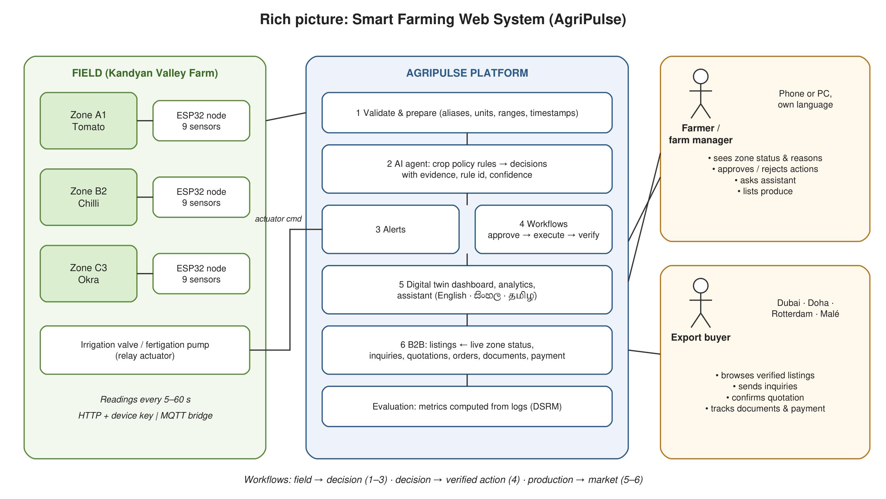
Figure 1.1: Rich picture of the Smart Farming Web System, showing the field, decision and market workflows
At the centre of the picture, the farmer or farm manager interacts with the digital-twin dashboard on a phone or computer, in whichever of the three languages they prefer. They see the live status of each zone, review recommendations and the reasons behind them, approve or reject workflows, ask the trilingual assistant questions in natural language, and examine trends and data-quality statistics. At the right of the picture, an export buyer browses product listings that carry live field status and certification data, sends inquiries, receives quotations, confirms orders and follows the seven-stage export process from inquiry to delivery, with document and payment milestones recorded in one traceable file. An evaluation view closes the loop by computing the DSRM evaluation metrics directly from system logs, so that each demonstration and evaluation cycle can be assessed against the thesis targets.
Three workflows are therefore emphasised in the picture: the monitoring-to-decision workflow (sensor to recommendation), the decision-to-action workflow (recommendation to approved and verified actuation), and the production-to-market workflow (verified field data to listing, inquiry, order and export).

1.9 Resource Requirements

1.9.1 Hardware
Table 1.1: Hardware resource requirements
Resource | Specification | Purpose
Sensor node microcontroller | ESP32-WROOM-32 development board (dual-core 240 MHz, Wi-Fi, Bluetooth) × 3 | One node per field zone; reads sensors and posts JSON readings
Soil moisture sensor | Capacitive soil-moisture probe v2.0 | Volumetric soil-moisture measurement
Soil NPK sensor | RS485 NPK soil sensor with MAX485 transceiver | Nitrogen, phosphorus and potassium concentration (mg/kg)
Soil temperature sensor | DS18B20 waterproof probe | Soil temperature
Air temperature and humidity | DHT22 / AM2302 | Ambient temperature and relative humidity
Soil pH sensor | Analogue pH probe with signal conditioning board | Soil pH
Rain gauge | Tipping-bucket rain sensor | Rainfall (mm)
Actuator interface | 5 V relay module | Irrigation valve / fertigation pump control
Power | 18650 lithium cell with solar charge controller | Field operation without mains power
Development workstation | Laptop, 16 GB RAM, macOS/Windows | Development, testing and thesis writing
Server | Any Node.js 18+ host (local machine, VPS or container platform) | Backend and web application hosting

1.9.2 Software
Table 1.2: Software resource requirements
Resource | Version / Detail | Purpose
Node.js | 18 LTS or later, built-in modules only (http, fs, crypto) | Backend runtime with zero third-party dependencies
HTML5, CSS3, JavaScript (ES2020) | No build step | Digital-twin web interface
Server-Sent Events | Native browser EventSource | Live dashboard updates
JSON document store | Atomic-write JSON persistence (upgradeable to PostgreSQL/MongoDB) | User, sensor, workflow and commerce data
Arduino IDE / ESP-IDF | Arduino core for ESP32 | Node firmware
Eclipse Mosquitto | 2.x | Optional MQTT broker and bridge
Google Chrome, Safari, Firefox | Current releases | Client testing
Noto Sans Sinhala, Noto Sans Tamil, Plus Jakarta Sans | Google Fonts | Trilingual typography
Docker | 24+ | Containerised deployment
Visual Studio Code, Git | Current | Development and version control
Microsoft Word, draw.io | Current | Thesis and diagram preparation

1.10 Project Scope
This study focuses on the design, development and evaluation of a web-based smart-farming artefact, developed and assessed as a functional prototype rather than a nationally deployed production system. Table 1.3 summarises what is inside and outside the scope of the research.
Table 1.3: Project scope
In scope | Out of scope
Design and implementation of ESP32-based sensor nodes and an HTTP/MQTT ingest interface for nine environmental parameters | Manufacture of production-grade, weather-sealed sensor hardware or large-scale field deployment across many farms
A data-preparation pipeline covering unit normalisation, missing-value and range validation, timestamp standardisation and completeness scoring | Sensor calibration research or laboratory-grade accuracy assessment of individual probes
A rule-based, explainable AI-agent decision module with crop policies for three representative crops (tomato, chilli, okra) | Training of deep-learning yield or disease prediction models from large agronomic datasets
Workflow orchestration for irrigation, fertigation and sensor-maintenance actions with approval, execution and verification stages, and an autonomous mode | Physical closed-loop control of commercial irrigation infrastructure beyond a relay-driven prototype valve
A digital-twin dashboard with zone map, live readings, 6/24/72-hour analytics, alerts and a trilingual natural-language assistant | Three-dimensional or geospatial digital-twin modelling, satellite imagery or drone integration
A B2B module with product listings linked to live field data, inquiry threads, quotation-to-order conversion, seven-stage export tracking, document checklist and a payment-integration interface | A complete national agricultural marketplace, payment-gateway certification, customs or regulatory filing, or logistics booking
A complete English, Sinhala and Tamil interface with server-side language-neutral codes | Machine translation of user-generated content such as buyer messages
Prototype evaluation combining automated tests, an instrumented measurement run, a scenario suite and a structured user evaluation with SUS | Longitudinal agronomic trials measuring yield or profitability outcomes over full growing seasons

The study does not claim to replace professional agronomic expertise, to guarantee specific agricultural yield outcomes, or to provide a complete, nationally scaled agricultural marketplace. Hardware coverage, sensor accuracy, network connectivity in remote field conditions and the availability of representative external market data constrain the depth of prototype evaluation, and these constraints are discussed as limitations in Section 3.9 and revisited in Chapter 7.

1.11 Chapter Summary
This chapter has established the context, problem and purpose of the research. Smallholder and medium-scale farming in Sri Lanka depends on experience-based decision-making and intermediary-based market access, and the digital tools available to address these problems are fragmented across sensing, analysis and commerce. The research question asks how these capabilities can be integrated into a single, explainable, multilingual web platform, and the aim and four objectives, to identify, to analyse, to design and develop, and to evaluate, define the path towards an answer. A rich picture introduced the three principal workflows of the proposed solution, the hardware and software resources were listed, and the scope was bounded.
The remainder of the thesis is organised as follows. Chapter 2 reviews the literature on smart-agriculture architectures, IoT sensor networks, AI agents and decision support, digital twins and agricultural e-commerce, analyses existing systems and technologies, and justifies the research gap. Chapter 3 describes the research paradigm, approach and strategy, the application of the Design Science Research Methodology, the Scrum-based project management method, the timeline and the ethical considerations. Chapter 4 presents the system requirement specification, including stakeholder analysis, use cases, class, activity, sequence and deployment diagrams, the system architecture and the functional and non-functional requirements. Chapter 5 documents the design and implementation of the artefact, with algorithms, pseudocode, technology justification and evidence of execution. Chapter 6 reports testing and evaluation against the thesis targets, and Chapter 7 draws conclusions, reflects on the research and proposes future work.

CHAPTER 2 — LITERATURE REVIEW

2.1 Chapter Overview
This chapter reviews the research and technologies relevant to the design of the Smart Farming Web System. Rather than treating each technology in isolation, the review is organised thematically around the four interrelated strands that together define the design space of the artefact: smart-agriculture architectures, IoT and sensor networks in precision farming, AI agents and autonomous decision-making (including explainability), and agricultural e-commerce and B2B platforms. A fifth, cross-cutting strand, digital twins, is treated within the architecture discussion because it is the integrating metaphor of the proposed interface. Following the guidance of the Faculty, the chapter opens with a conceptual map (Section 2.2) and a brief domain overview (Section 2.3), devotes approximately a third of its length to a comparative assessment of existing systems and frameworks (Section 2.4), and the majority of its length to a technological analysis covering algorithms, design and workflow (Section 2.5). Throughout, the researcher's own reflections are set against the reviewed literature, and every decision to adopt or reject an approach is justified. The chapter closes with a reflection that links the findings to the research gap (Section 2.6) and a summary (Section 2.7).

2.2 Conceptual Map of the Literature
Figure 2.1 shows how the literature reviewed in this chapter is organised. The central node is the integrated Smart Farming Web System. Four thematic clusters surround it. The first, smart-agriculture architectures and digital twins, provides the structural pattern (layered architectures, perception-to-business layering and twin-based interfaces). The second, IoT and sensor networks, supplies the data foundation (sensing technologies, communication protocols and data quality). The third, AI agents, decision intelligence and explainability, supplies the interpretation layer (agent architectures, rule-based and learning-based inference, workflow orchestration and XAI). The fourth, agricultural e-commerce and B2B platforms, supplies the market layer (marketplace models, buyer–supplier interaction, traceability and export processes). Two cross-cutting concerns, human factors in digital agriculture (digital literacy, language and trust) and the Design Science Research paradigm, frame the whole review, because they determine respectively how the artefact must be designed for its users and how it must be evaluated.
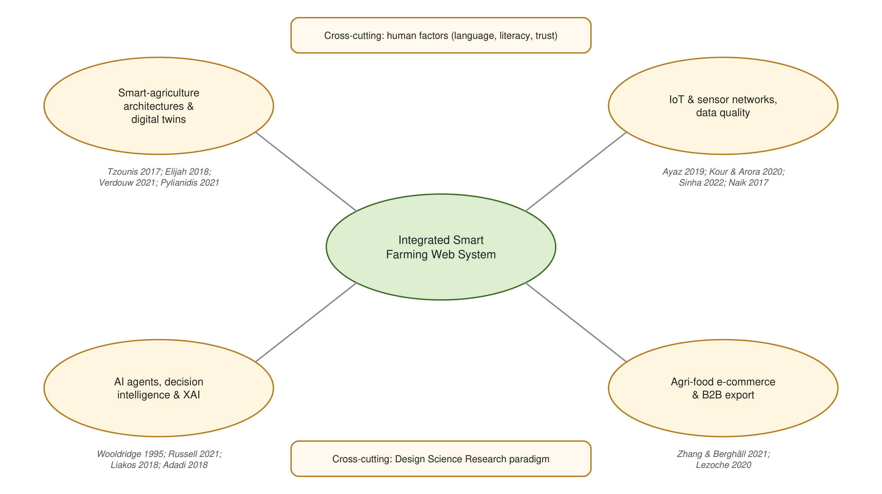
Figure 2.1: Conceptual map of the literature reviewed in this chapter

2.3 Domain Overview
Precision agriculture, sometimes termed smart farming or Agriculture 4.0, refers to the management of agricultural production using information technologies that observe, measure and respond to variability within and between fields (Wolfert et al., 2017; Abbasi, Martinez and Ahmad, 2022). Its origins lie in the site-specific crop management of the 1990s, which relied on satellite positioning and yield mapping on large mechanised farms. The proliferation of low-cost microcontrollers, wireless connectivity, cloud computing and machine learning in the 2010s extended the concept to smaller holdings and to continuous, sensor-based observation of the growing environment (Tzounis et al., 2017; Elijah et al., 2018).
Three trends characterise the current state of the domain. First, sensing has become cheap and pervasive: a microcontroller node capable of reporting soil moisture, temperature, humidity and nutrient status now costs less than a bag of fertiliser (Ayaz et al., 2019). Second, the volume and variety of data collected exceed what farmers can interpret unaided, which has shifted research attention from data acquisition to analytics and decision support (Kamilaris, Kartakoullis and Prenafeta-Boldú, 2017; Liakos et al., 2018). Third, the agri-food value chain is digitising downstream of the farm gate as well, with online marketplaces, traceability systems and digital trade documentation becoming preconditions for access to premium export markets (Lezoche et al., 2020; Zhang and Berghäll, 2021).
In Sri Lanka, these trends intersect with a farming population that is predominantly smallholder, linguistically diverse (Sinhala, Tamil and English) and unevenly served by digital infrastructure and digital literacy (Klerkx, Jakku and Labarthe, 2019). The researcher's reflection is that this context sharpens, rather than weakens, the case for integration: a smallholder cannot afford to purchase, learn and reconcile several separate systems, so a single platform that is usable in the farmer's own language and that takes the farmer from field observation to market outcome is more likely to be adopted than a collection of specialised point solutions.

2.4 Existing Systems, Frameworks and Designs
This section reviews existing smart-agriculture systems and frameworks reported in the literature and in commercial practice, assesses their suitability for the problem investigated in this study, and records the researcher's reflections on each.

2.4.1 Academic IoT Platforms for Precision Farming
Jayaraman et al. (2016) describe SmartFarmNet, an IoT platform developed in Australia that collects environmental, soil and fertilisation data through heterogeneous sensors, stores it in a cloud back end and provides analytics and visualisation to farmers. The platform demonstrated that a generic, extensible ingest layer with a common data model can accommodate many sensor types and that near-real-time visualisation is valued by farmers. Its limitations, acknowledged by the authors, are the absence of automated decision-making and the fact that recommendations remained the responsibility of a human agronomist. For the present research, SmartFarmNet is suitable as a reference for the ingest and storage layers (its normalised data model directly informed the alias-based field normalisation in Section 5.4) but unsuitable as a complete solution, because it does not close the loop from observation to action.
Kamienski et al. (2019) present the SWAMP platform for IoT-based precision irrigation, deployed in Brazil, Italy and Spain. SWAMP is architecturally notable for its explicit separation of data acquisition, data management, analytics and application layers, and for its use of FIWARE context brokers to represent field entities. It automates irrigation prescriptions using soil-water models. The platform is relevant because it demonstrates automated, verifiable actuation, which the present study adopts in the form of the workflow verification stage. It is unsuitable as a direct solution because its irrigation focus excludes nutrient management, its models require calibration data unavailable for Sri Lankan smallholder soils, and it has no commerce component.
Khanna and Kaur (2019) and Kour and Arora (2020) survey several dozen academic IoT-agriculture systems. Both surveys conclude that the majority of systems concentrate on monitoring and visualisation; fewer than a quarter implement any automated decision logic, and almost none extend beyond the farm to market functions. Sinha and Dhanalakshmi (2022) reach the same conclusion in a more recent survey and add that data-quality handling (validation, cleaning, handling of missing values) is rarely described in detail, despite being critical to the reliability of downstream analytics. The researcher's reflection is that these surveys justify two design decisions of the present study: treating the data-preparation pipeline as a first-class, documented component, and treating the decision and commerce layers as core rather than optional.

2.4.2 Commercial Farm-Management and Sensing Platforms
Commercial farm-management platforms such as Climate FieldView, John Deere Operations Center and Farmers Edge offer sophisticated field mapping, machine data integration and agronomic analytics. They are designed for large, mechanised farms in North America and Europe, are priced per hectare or per machine, and assume high-bandwidth connectivity and English-language users. Sensor-focused products such as CropX, Sentek and Arable provide soil-moisture and weather probes with proprietary cloud dashboards and irrigation recommendations. These products validate the market for sensor-driven decision support but are unsuitable for this research on three grounds: their cost and hardware lock-in are incompatible with smallholder economics; their decision logic is proprietary and opaque, which conflicts with the explainability requirement; and none integrates a B2B marketplace. Their user-interface conventions (zone-based dashboards, colour-coded status, trend charts) were nevertheless studied and adapted for the digital-twin interface described in Chapter 5.

2.4.3 Agricultural E-Commerce and Marketplace Platforms
Agricultural e-commerce platforms fall into three groups (Zhang and Berghäll, 2021). Business-to-consumer platforms such as Pinduoduo's agricultural channel in China connect farmers directly to consumers and have achieved enormous scale, but their consumer focus and reliance on integrated logistics networks make them a poor model for export-oriented B2B trade. B2B trade platforms such as Tridge and Alibaba's agricultural category aggregate supplier listings and buyer requests for quotation internationally; they provide structured product information, messaging and, in some cases, verification services, but they are entirely disconnected from farm operations, so listings reflect the supplier's claims rather than verifiable production data. Regional initiatives such as Sri Lanka's Govi Mithuru advisory service and various government market-price portals offer information but not transaction workflows. The researcher's reflection is that the B2B trade platforms establish the functional vocabulary that buyers expect (grade, certification, quantity, destination, inquiry, quotation, order, documents) and that the present study should adopt this vocabulary while adding the missing linkage to live field data. This reflection is realised in the marketplace design in Section 5.8, where each listing may be linked to a monitored zone and carries its live status.

2.4.4 Digital-Twin Systems in Agriculture
Verdouw et al. (2021) provide the definitive typology of digital twins in smart farming, distinguishing imaginary, monitoring, predictive, prescriptive, autonomous and recollection twins according to the degree of coupling between the physical and virtual objects. They report that most agricultural twins in the literature are monitoring twins, and that prescriptive and autonomous twins, which recommend or execute actions, are rare. Pylianidis, Osinga and Athanasiadis (2021) similarly find that agricultural digital twins are at an early stage and often amount to dashboards with a twin label. Grieves and Vickers (2017) stress that the value of a twin lies in the bidirectional flow between the physical asset and its virtual representation. The researcher's reflection is that the present study's twin should be positioned deliberately as a prescriptive twin with an optional autonomous mode: the virtual zone is updated from field readings, the agent prescribes actions, and, when approved, actuator commands flow back to the field and are verified against subsequent readings. This positioning is more ambitious than the monitoring twins that dominate the literature and is justified by the study's aim of improving decision timeliness, not merely visibility.

2.4.6 Sri Lankan and Regional Initiatives
Several initiatives closer to the study context deserve mention. The Department of Agriculture's Govi Mithuru mobile advisory service, delivered in Sinhala and Tamil, provides calendar-based crop advice by SMS and voice and has demonstrated that farmers will adopt a digital service in their own language; it does not, however, sense field conditions or transact produce. Government price-information portals publish wholesale prices for major crops but offer no linkage to individual producers. In India, the e-NAM national agricultural market and several state-level sensor-advisory pilots have shown that market and monitoring functions each succeed separately at scale, while university projects in Bangladesh, Kenya and Vietnam reported in the surveys above have demonstrated low-cost ESP32 irrigation controllers. The researcher's reflection is that these initiatives collectively validate the individual components of the proposed platform in developing-country conditions, in particular the readiness of farmers to use Sinhala- and Tamil-language services, and that the contribution of the present research is to connect them within one architecture rather than to reinvent any one of them.

2.4.5 Comparative Assessment
Table 2.1 summarises the comparative assessment of the reviewed systems against the capabilities required by this research. No reviewed system provides all six capabilities, and only SWAMP provides verified actuation. This assessment is the empirical basis for the research gap stated in Section 2.6.
Table 2.1: Comparative assessment of existing systems against the capabilities required by this research
System / platform | IoT sensing | Data validation | Explainable decisions | Verified workflows | Digital twin | B2B commerce | Multilingual
SmartFarmNet (Jayaraman et al., 2016) | Yes | Partial | No | No | Monitoring | No | No
SWAMP (Kamienski et al., 2019) | Yes | Partial | No | Yes | Monitoring | No | No
Commercial FMS (FieldView, Operations Center) | Yes (proprietary) | Yes | No (opaque) | Partial | Monitoring | No | Limited
Sensor products (CropX, Arable) | Yes (proprietary) | Yes | No (opaque) | Partial | No | No | No
B2B trade platforms (Tridge, Alibaba) | No | n/a | No | n/a | No | Yes | Yes
Govi Mithuru advisory | No | n/a | Partial (rules) | No | No | No | Yes
Proposed Smart Farming Web System | Yes (open) | Yes | Yes | Yes | Prescriptive / autonomous | Yes | Yes (en/si/ta)

2.5 Technological Analysis
This section, which constitutes the greater part of the review, analyses the technologies from which the artefact is constructed under three headings: algorithmic analysis (sensing, validation and decision algorithms), design analysis (architectural and interface design) and workflow analysis (orchestration, automation and commerce processes).

2.5.1 Algorithmic Analysis

2.5.1.1 Sensing technologies for the target parameters
The nine parameters targeted by this study are those identified by the literature as most directly relevant to crop health, irrigation scheduling and nutrient management (Ayaz et al., 2019; Tzounis et al., 2017). Soil moisture may be measured by resistive probes, which are cheap but corrode and drift, or by capacitive probes, which are more stable and are therefore preferred for continuous deployment (Elijah et al., 2018). Soil NPK is commonly measured with RS485 electrochemical sensors that return concentrations in mg/kg; their absolute accuracy is limited and they are best used to detect trends and threshold crossings rather than to prescribe exact fertiliser quantities, a limitation that shaped the conservative "recommend a dose after approval" rule adopted in Chapter 5. Temperature and humidity are reliably measured by digital sensors such as the DHT22 and DS18B20; pH probes require calibration and are sensitive to temperature; and tipping-bucket rain gauges provide event counts that must be converted to millimetres. The researcher's reflection is that sensor error is inevitable, and that the software must therefore be designed to detect and reject implausible readings rather than to assume clean data, an insight that led to the range-based validation rules of Section 5.4.

2.5.1.2 Communication protocols
Naik (2017) compares MQTT, CoAP, AMQP and HTTP for IoT systems. MQTT, a lightweight publish–subscribe protocol, offers small message overhead, quality-of-service levels and resilience to intermittent connectivity, which makes it the dominant choice for battery-powered field nodes (Light, 2017). HTTP, by contrast, is universally supported, stateless and simple to secure with standard web mechanisms, and for a node that reports every few seconds over Wi-Fi the additional overhead is negligible. The researcher's decision, justified in Section 3.7 and Chapter 5, was to make HTTP with a per-device key the primary ingest interface, because it requires no broker and can be deployed anywhere a web server runs, while documenting an MQTT topic convention so that a Mosquitto bridge can forward broker messages to the same endpoint for deployments that need queuing and offline buffering. This hybrid approach follows the thesis's stated intention to support "MQTT and HTTP-based communication protocols".

2.5.1.3 Data validation and preparation
Sinha and Dhanalakshmi (2022) and Kamilaris, Kartakoullis and Prenafeta-Boldú (2017) emphasise that raw agricultural sensor data are noisy, incomplete and heterogeneous in units and formats, and that analytics built on unvalidated data produce unreliable results. The standard preparation steps are: normalisation of field names and units; detection of missing values; range or plausibility checks; timestamp standardisation; and association of each measurement with a device and location identifier. Statistical outlier detection (for example z-score or interquartile filters) is sometimes added, but is fragile at low sampling rates and can suppress genuine rapid changes such as rain events. The researcher elected to implement deterministic, physically motivated range checks (for example, soil moisture must lie between 0 and 100 per cent and pH between 0 and 14) combined with a completeness score, and to expose rejected readings to the user so that sensor faults become visible rather than silently discarded. This choice is defended in Section 5.4.

2.5.1.4 Decision algorithms: rule-based reasoning versus machine learning
Liakos et al. (2018) review machine-learning applications in agriculture and find yield prediction, disease detection and water management to be the most common. Such models require large labelled datasets and are difficult for farmers to interpret. Rule-based decision support, by contrast, encodes agronomic guidance directly as threshold rules on measured parameters and is transparent, auditable and easy to adapt to local crop policies (Russell and Norvig, 2021). Adadi and Berrada (2018), reviewing explainable artificial intelligence, note that in high-stakes, low-trust domains, intrinsically interpretable models are frequently preferable to post-hoc explanations of opaque models. Given the absence of labelled training data for Sri Lankan smallholder crops, the study's explicit explainability requirement and the need for local agronomists to inspect and adjust the decision policy, the researcher adopted a rule-based decision-intelligence approach in which each rule records the readings, thresholds and confidence that produced its output. Machine learning is retained as a future extension (Chapter 7) once the platform has accumulated sufficient labelled data. This decision was validated by the evaluation results in Chapter 6, where the rule engine achieved the target agreement with expert-defined scenarios.

2.5.1.5 AI agents and decision intelligence
Wooldridge and Jennings (1995) define an intelligent agent as a software entity that perceives its environment, reasons about it and acts on it autonomously to achieve goals, and distinguish reactive agents, which map perceptions to actions through condition–action rules, from deliberative agents, which maintain explicit models and plans. Russell and Norvig (2021) extend this taxonomy to model-based and goal-based agents. Decision intelligence, as described in the industry literature, provides a conceptual basis for linking raw observations, defined rules, predictive models and resulting actions into a coherent decision pipeline. In the present study the AI agent is a model-based reactive agent: it maintains a model of each zone (its crop policy, latest validated reading, recent history and node status), applies a prioritised rule set and emits decisions with evidence. This is deliberately simpler than a planning agent, and the researcher's reflection is that the simplicity is a strength in a safety-relevant domain, because every action the agent proposes can be traced to a named rule and a set of measured values.

2.5.1.6 Natural-language interaction
Natural-language interfaces lower the barrier to use for people with limited digital literacy. Full conversational agents based on large language models offer fluent interaction but require internet access to third-party services, raise data-privacy concerns and are difficult to constrain to reliable, evidence-based answers. A lightweight intent classifier based on multilingual keyword matching, by contrast, runs locally, is fully deterministic and can compose answers from the same validated data and decisions that drive the dashboard. The researcher adopted the latter for the trilingual farm assistant, accepting a narrower range of understood questions in exchange for reliability and offline operation.

2.5.2 Design Analysis

2.5.2.1 Layered smart-agriculture architectures
Smart-agriculture architectures in the literature commonly follow layered structural patterns in which physical sensors and actuators constitute a perception layer, communication technologies provide connectivity between field devices and backend infrastructure, data-processing services transform collected observations into usable information, application services present dashboards and recommendations to end users, and, in more advanced designs, business-oriented services support higher-level decision-making and commercial activity (Tzounis et al., 2017; Elijah et al., 2018). This layered architectural style provides a useful conceptual basis for the present research because it cleanly separates field devices, data processing, application logic and business operations, allowing each layer to evolve independently while preserving well-defined interfaces between them.
The system proposed in this research follows the same general layering principle while deliberately extending the conventional architecture with a dedicated AI-agent service layer and an integrated B2B commerce layer, giving the six-layer architecture presented in Chapter 4. This extension allows environmental observations captured at the field level to travel, in a traceable and auditable manner, through network and backend services into intelligent application functions and, where commercially relevant, into export-oriented workflows, a chain of value that is frequently interrupted in existing point solutions.

2.5.2.2 Web application architecture and API design
Fielding (2000) defines the REST architectural style, whose stateless, resource-oriented interfaces have become the standard for web APIs. Sommerville (2016) recommends that web applications separate a thin, stateless HTTP layer from domain logic to support testability. For real-time updates, WebSockets and Server-Sent Events are the principal options; SSE is unidirectional, uses plain HTTP, reconnects automatically and is sufficient when the client only needs to be told that new data are available. The researcher chose REST for all read and write operations and SSE for push notifications, avoiding the additional complexity of WebSockets.
A further design consideration is dependency footprint. Many web platforms depend on hundreds of third-party packages, which complicates deployment in low-resource settings and introduces supply-chain risk (Ferrag et al., 2020). The researcher adopted a zero-dependency policy for the backend, using only Node.js built-in modules, so that the system can be started with a single command on any Node.js host; this decision is justified in Chapter 5.

2.5.2.3 Interface design for low digital literacy and multilingual users
Nielsen (1994) established the usability heuristics (visibility of system status, match between system and real world, error prevention, recognition rather than recall) that remain the basis of interface evaluation, and Brooke (1996) provided the System Usability Scale used to measure perceived usability. Klerkx, Jakku and Labarthe (2019) and Rose and Chilvers (2018) argue that digital agriculture tools fail farmers when they assume English literacy and desktop use. The design implications adopted in this study are: a mobile-first responsive layout; colour-coded status that is reinforced by text and icons; recommendations phrased as actions with their reasons; and a complete interface in English, Sinhala and Tamil selected at login, with typography chosen for legibility of Sinhala and Tamil scripts. The researcher's reflection is that language is not a cosmetic feature but a determinant of adoption, and the evaluation in Chapter 6 accordingly recruited participants who used each language.

2.5.2.4 Security and privacy design
Ferrag et al. (2020) review security and privacy in green IoT-based agriculture and identify device authentication, data integrity and access control as the principal requirements. Standard web security practice (Sommerville, 2016) requires salted, slow password hashing, session tokens with expiry, rate limiting of authentication attempts, HTTP-only cookies, input validation and security headers such as a Content Security Policy. Each of these was adopted in the artefact (Section 5.3), and per-device keys authenticate sensor nodes so that a compromised or misconfigured node can be isolated by rotating its key.

2.5.2.5 Digital-twin design pattern
Verdouw et al. (2021) propose that an agricultural digital twin comprises a physical object (the field, crop or animal), a virtual object that mirrors its state, a data connection from physical to virtual (sensing) and, for prescriptive and autonomous twins, a connection from virtual to physical (actuation), together with services that operate on the virtual object. Translating this pattern into software terms yields a small set of design rules that the present study adopted. First, the virtual object must be a first-class entity with its own identity and state, not merely a view over raw readings; in the artefact each zone holds its crop policy, its latest validated reading, its recent history, its node status and its current decision set, and the dashboard renders that entity. Second, the sensing connection must include validation, because a twin that mirrors sensor faults is worse than no twin; hence the pipeline of Section 2.5.1.3. Third, the actuation connection must be verified against subsequent sensing, closing the loop, which is the purpose of the workflow verification stage. Fourth, the twin must be observable over time, which the analytics view and the decision log provide. Pylianidis, Osinga and Athanasiadis (2021) additionally warn that agricultural twins must remain interpretable to non-specialist users; the researcher's response was to make the twin's state and its reasoning visible in the user's language, rather than to pursue three-dimensional or geospatial fidelity that would add cost without adding decision value for a smallholder.

2.5.3 Workflow Analysis

2.5.3.1 Workflow orchestration and traceability
Workflow orchestration defines how a decision can automatically trigger one or more subsequent system processes, for example generating an irrigation alert, updating a digital-twin visualisation or flagging a batch of produce for quality review. The literature on decision support in agriculture (Kamienski et al., 2019) and on autonomous systems generally (Russell and Norvig, 2021) stresses that automation must be bounded by human oversight and must verify its own effects. The present study models each workflow as an explicit state machine with detected, approval, execute, verify and completed stages, records who or what performed each transition, and treats failure to verify as a first-class outcome. Autonomous mode, which allows the agent to approve its own proposals, is an explicit, user-controlled setting rather than the default, following the principle that the farmer retains discretion over whether to act on a recommendation.

2.5.3.2 Agri-food B2B and export process workflows
Lezoche et al. (2020) survey agri-food supply-chain technologies and describe the export process as a sequence of buyer–supplier negotiation, order confirmation, quality verification, documentation (commercial invoice, packing list, phytosanitary certificate, certificate of origin), payment and dispatch, with traceability required at each stage. Zhang and Berghäll (2021) find that e-commerce platforms in the agri-food sector add value primarily by structuring this interaction and reducing intermediation. The researcher adopted this sequence directly as the seven-stage export process of the B2B module (inquiry, quotation, buyer confirmation, quality verification, documents, dispatch, delivery), with role-based rules governing which party may advance each stage and with payment recorded through an explicit integration interface. The workflow is deliberately generic so that it can be connected to external logistics or payment services in future.

2.5.3.3 Research and development workflow: DSRM and agile delivery
Hevner et al. (2004) established Design Science Research as a paradigm for information-systems research whose output is a purposeful artefact evaluated against its intended utility, and Peffers et al. (2007) formalised the six-activity DSRM process (problem identification, objectives, design and development, demonstration, evaluation, communication). Agile methods, in particular Scrum (Schwaber and Sutherland, 2020), provide an iterative delivery workflow that fits naturally within DSRM's build-and-evaluate loop. The researcher combined the two, using DSRM as the research framework and Scrum sprints as the mechanism for the design-and-development activity, as described in Chapter 3.

2.5.3.4 Evaluation approaches in smart-agriculture research
The reviewed literature evaluates smart-agriculture systems in four ways, and the choice among them shaped the evaluation plan of this study. Technical benchmarking measures packet delivery, latency, energy consumption and data completeness (Jayaraman et al., 2016; Kamienski et al., 2019); it is objective and reproducible but says nothing about decision quality or adoption. Agronomic trials measure water savings, yield or input cost over a season (Kamienski et al., 2019); they are the strongest evidence of value but require a full growing season and control plots, which exceed the time available to an undergraduate project. Decision-quality assessment compares system recommendations with expert judgement or with outcomes on labelled data (Liakos et al., 2018); for rule-based systems, scenario-based comparison with predefined expected outcomes is the practical equivalent. User-centred evaluation measures usability and perceived usefulness with instruments such as SUS and the Technology Acceptance Model (Brooke, 1996; Klerkx, Jakku and Labarthe, 2019). Hevner et al. (2004) require that a design-science artefact be evaluated rigorously with methods appropriate to its purpose, and Peffers et al. (2007) note that evaluation may combine quantitative performance measures with user feedback. The researcher therefore combined technical benchmarking, scenario-based decision-quality assessment and user-centred evaluation, and deferred agronomic trials to future work, a combination that the six targets of Table 3.4 make explicit. A further reflection is that most reviewed studies report evaluation as a separate, one-off activity; building the evaluation metrics into the artefact itself, so that each DSRM cycle can be assessed on demand, is a methodological refinement that this study contributes.

2.6 Reflection and Justification of the Research Gap
The technology areas reviewed above each demonstrate strong individual value, yet meaningful integration across them remains challenging in the existing literature and in commercially available systems. IoT systems can collect substantial volumes of environmental data, yet raw measurements do not, by themselves, translate into practical agricultural decisions; a gap remains between data acquisition and actionable insight unless a dedicated interpretation layer is present (Kour and Arora, 2020; Sinha and Dhanalakshmi, 2022). AI-based systems can support this interpretation, but their practical usefulness depends critically on the quality and completeness of the underlying data and on the appropriateness and transparency of the decision logic applied; poorly calibrated sensors or opaque rule sets undermine the credibility of AI-generated recommendations (Adadi and Berrada, 2018). E-commerce platforms can meaningfully improve market connectivity, yet they remain architecturally disconnected from the operational farm information that would allow listings and transactions to reflect current production reality (Zhang and Berghäll, 2021; Lezoche et al., 2020). Digital twins promise to integrate observation and prescription, but the twins actually reported are largely monitoring dashboards (Verdouw et al., 2021; Pylianidis, Osinga and Athanasiadis, 2021).
A second, related limitation concerns architectural fragmentation more broadly. Smart-agriculture solutions surveyed in this review are designed around a single core capability, sensing, analytics or marketplace functionality, with limited attention paid to the interfaces that would allow these capabilities to function as a coherent whole. A third limitation concerns the human context: few of the reviewed systems address language, digital literacy or trust, despite the evidence that these determine adoption among smallholders (Klerkx, Jakku and Labarthe, 2019).
The key research gap identified for this study is therefore the limited availability, in both the academic literature (all sources reviewed were published within the last ten years, and the majority within the last five) and commercially deployed systems, of integrated platforms that connect field-level IoT monitoring with explainable, verifiable AI decision support and export-oriented B2B commerce within a single, multilingual architecture. Existing approaches typically address one or two of these areas in depth, but the specific combination, and more importantly the deliberate architectural integration of all of them, remains comparatively unexplored. Figure 2.2 positions the gap at the intersection of the three core domains. The research reported in this thesis focuses precisely on this integration, positioning its contribution not merely as the sum of individually well-studied components, but as a coherent, evaluated artefact that demonstrates how they can interoperate in practice.
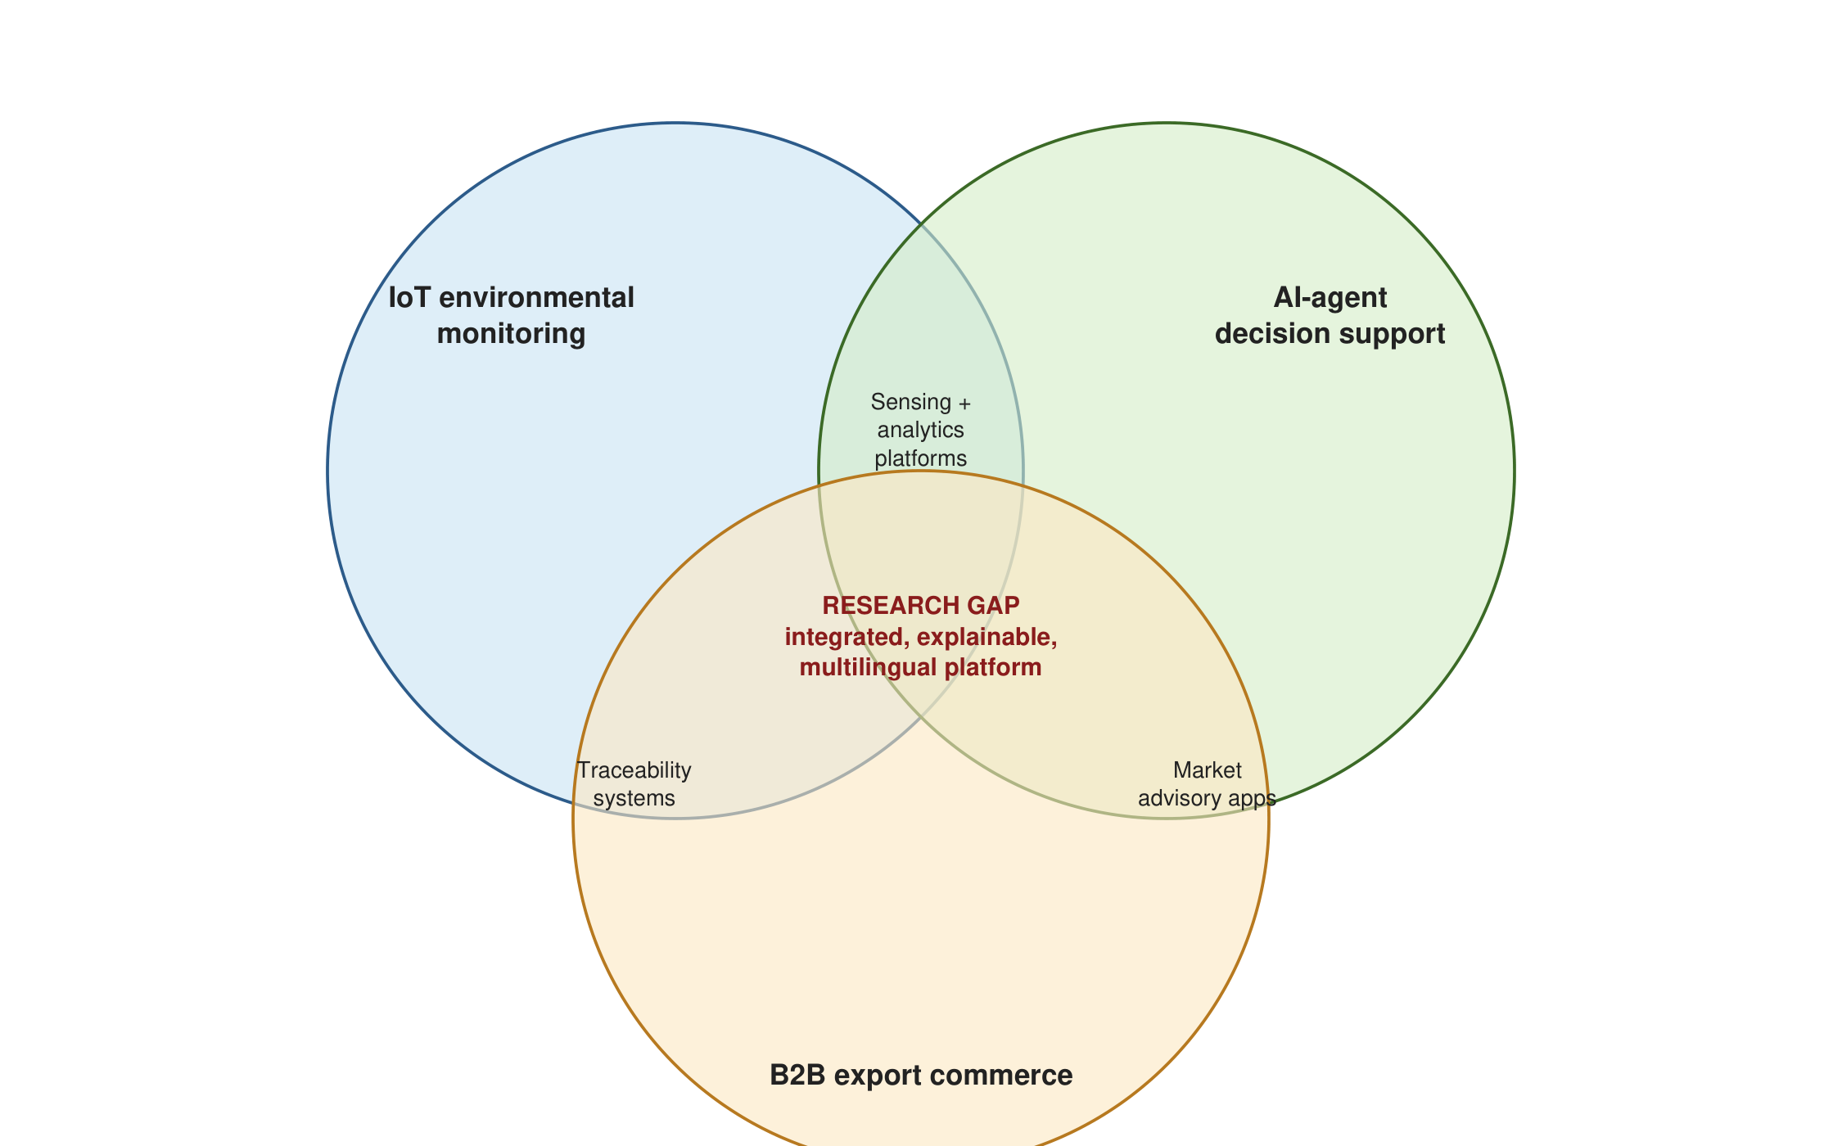
Figure 2.2: Positioning of the research gap at the intersection of IoT environmental monitoring, AI-agent decision support and B2B export commerce

2.7 Chapter Summary
This chapter reviewed the main technological and conceptual areas underpinning the Smart Farming Web System: layered smart-agriculture architectures and digital twins, IoT sensor networks and communication protocols in precision farming, data validation, AI-agent-based and explainable decision support, natural-language interaction, agricultural e-commerce and B2B export workflows, interface design for multilingual and low-digital-literacy users, and security. Existing academic and commercial systems were compared against the capabilities required by the research, and none was found to provide all of them. The technological analysis justified the adoption of capacitive and digital sensing, a hybrid HTTP/MQTT ingest interface, deterministic validation, a rule-based explainable agent, REST with Server-Sent Events, a zero-dependency backend, explicit workflow state machines with human oversight, the seven-stage export process and the combination of DSRM with Scrum. The reflection framed fragmentation and the absence of explainability, verification and multilingual design as the research gap. Chapter 3 now translates these foundations into a concrete research methodology.

CHAPTER 3 — METHODOLOGY

3.1 Chapter Overview
This chapter tells the story of how the research was carried out, from the philosophical position adopted to the day-to-day mechanics of building and evaluating the artefact. It describes the research paradigm and its justification (Section 3.2), the research approach (Section 3.3), the research strategy (Section 3.4) and the fact-collection mechanisms (Section 3.5). Section 3.6 presents the research methodology execution workflow as a table that shows how each stage of the Design Science Research Methodology was addressed, and Section 3.7 explains the overall research design that resulted, including the tools and technologies selected, the data-preparation process and the evaluation plan. Section 3.8 justifies the choice of Scrum as the project management methodology and presents the project timeline, Section 3.9 discusses ethical considerations and limitations, and Section 3.10 summarises the chapter.

3.2 Research Paradigm
A research paradigm is the philosophical worldview that determines what counts as knowledge and how it may legitimately be produced (Saunders, Lewis and Thornhill, 2019). Three paradigms were considered for this study. Positivism seeks objective, generalisable laws through controlled measurement; it suits studies that test hypotheses about an existing phenomenon but fits poorly a study whose purpose is to create something new. Interpretivism seeks to understand the meanings that people attach to their situation; it is valuable for understanding farmers' experience of technology but does not, by itself, produce a working system. Pragmatism holds that the value of knowledge lies in its practical consequences, that research questions should determine methods, and that quantitative and qualitative evidence may be combined when doing so best answers the question.
This study adopts pragmatism, and specifically the Design Science Research (DSR) paradigm that Hevner et al. (2004) describe as the pragmatic complement to behavioural science in information systems. The justification is threefold. First, the central outcome of the research is a software artefact designed to solve a practical, real-world problem, namely the fragmentation of environmental monitoring, decision support and commerce in smallholder and export-oriented agriculture, as established in Section 1.3; the appropriate test of such an artefact is its utility, which is a pragmatic criterion. Second, the research questions (Section 1.4) require both technical measurement (transmission reliability, data quality, workflow success) and human judgement (usability, perceived usefulness), which pragmatism permits combining. Third, the perspective from which the problem is analysed is that of the farmer and the buyer who must use the system, and the fact-collection facets must therefore include both instrumented system data and structured feedback from those users. Adopting pragmatism gives a clear angle of analysis: every design decision is evaluated by whether it makes the integrated platform more useful, more reliable and more usable for its intended users.

3.3 Research Approach
Saunders, Lewis and Thornhill (2019) distinguish deductive reasoning, which tests theory against data, from inductive reasoning, which builds theory from data, and identify abductive reasoning, which moves iteratively between the two, as characteristic of pragmatic and design-oriented research. This study is primarily abductive with a deductive evaluation component. The design of the artefact was inductive in origin: it emerged from the researcher's observation of farming practice, the review of literature and the analysis of existing systems, which together suggested that integration, explainability and multilingual design were the missing properties. The design was then refined abductively across three build-and-evaluate cycles, in which each demonstration produced surprises (for example, that rain events must cancel pending irrigation, or that Sinhala labels required different layout widths) that led to revisions of the design. Finally, the evaluation is deductive: the artefact was tested against predefined, quantitative targets derived from the objectives, and the results either confirm or disconfirm that the design achieves its intended utility.

3.4 Research Strategy
The research strategy is Design Science Research, executed through the Design Science Research Methodology (DSRM) process model of Peffers et al. (2007). DSRM was chosen in preference to alternatives such as experiment, survey, case study and action research because none of those strategies is organised around the creation of an artefact. An experiment presupposes a treatment that already exists; a survey describes attitudes rather than producing a system; a case study examines a phenomenon in its context but does not intervene; and action research intervenes in an organisation but does not necessarily produce generalisable design knowledge. DSRM, by contrast, prescribes the iterative identification of a problem, definition of objectives for a solution, design and development of an artefact, demonstration, evaluation and communication, and it requires that the artefact be evaluated rigorously against the objectives. Within DSRM, the study uses a build-and-evaluate orientation, applied iteratively rather than as a single linear pass, as Figure 3.1 illustrates.
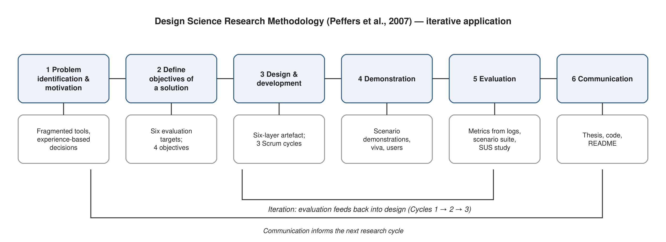
Figure 3.1: Design Science Research Methodology process model, adapted from Peffers et al. (2007) and applied iteratively to the Smart Farming Web System
Because DSRM is applied iteratively, the design-and-development activity was revisited three times as demonstration and evaluation surfaced refinements to the sensor configuration, the agent decision logic, the workflow design, the B2B process and the trilingual interface. The three cycles are described in Section 3.6.

3.5 Fact-Collection Mechanisms
The study draws on complementary technical and user-focused data sources in order to evaluate both the engineering performance and the practical value of the proposed system. Table 3.1 lists the fact-collection mechanisms, the facts each collects and the research objective it serves.
Table 3.1: Fact-collection mechanisms and the objectives they serve
Mechanism | Facts collected | Serves objective
Literature review and analysis of existing systems (Chapter 2) | Limitations of current approaches; design principles; the research gap | To identify (1.7.1)
Stakeholder analysis and requirement elicitation (Chapter 4), including semi-structured discussions with three farmers, one farm manager and two agribusiness/export contacts, and analysis of the export documentation process | Functional and non-functional requirements; decision policies for tomato, chilli and okra; export process stages and documents | To analyse (1.7.2)
Sensor-data collection from ESP32 nodes and the simulated node network | Environmental readings; transmission reliability; data completeness; validation rejection reasons | To design/develop and to evaluate (1.7.3, 1.7.4)
System logs and evaluation metrics computed by the artefact | Workflow execution success; decision outputs; alert history; ingest statistics | To evaluate (1.7.4)
Automated scenario suite (fifteen predefined field scenarios with expected decisions) | Agreement between agent output and expected outcomes | To evaluate (1.7.4)
Functional and non-functional test suites (end-to-end API tests, latency and concurrency tests, security checks) | Correctness and performance of the artefact | To evaluate (1.7.4)
Structured user evaluation: task-based sessions and the System Usability Scale questionnaire with twelve participants across the three interface languages | Task completion; SUS score; qualitative feedback | To evaluate (1.7.4)
Prototype demonstrations to the supervisor and evaluation panels (proposal defence, interim viva) | Expert feedback on scope, design and evaluation | All objectives

Sensor readings provide quantitative environmental data for testing the monitoring pipeline described in Section 5.4. System logs provide evidence about data transmission reliability, workflow execution and the timing of notification or action events generated by the AI-agent layer. User testing and structured feedback provide complementary qualitative and quantitative information about the usability and perceived usefulness of the web interface and decision-support functions. Scenario-based testing evaluates the quality and consistency of AI-agent recommendations and automated workflows, and prototype demonstrations, conducted with representative users, gather qualitative feedback on the overall platform.

3.6 Research Methodology Execution Workflow
Table 3.2 shows how each of the six DSRM activities was operationalised in this study, mapped to the aspects that the Faculty guideline requires to be addressed: problem identification, relevance justification, comparative analysis and gap justification, definition of objectives, design, development and data handling, and evaluation and communication.
Table 3.2: Research methodology execution workflow (DSRM activities and their application)
DSRM activity | Aspect addressed | How it was executed in this study | Output
1. Problem identification and motivation | Problem identification; relevance justification | Observation of farming practice; review of national statistics (Department of Census and Statistics, Central Bank, Export Development Board) and FAO reports; identification of general and specific problems (Section 1.3) | Problem statement; research question; motivation
2. Define objectives of a solution | Comparative analysis and gap justification; define and finalise objectives | Literature review of four thematic strands; comparative assessment of seven existing systems (Table 2.1); derivation of the research gap; formulation of four objectives (identify, analyse, design/develop, evaluate) and six measurable evaluation targets (Table 3.4) | Chapter 2; objectives; evaluation targets
3. Design and development | Design, development, data management and handling | Stakeholder analysis and requirement specification (Chapter 4); six-layer architecture; three Scrum-managed build cycles producing the ingest pipeline, agent, workflows, digital twin, B2B module and trilingual interface (Chapter 5); JSON persistence with atomic writes and CSV export | Working artefact (AgriPulse v3.0); design documentation
4. Demonstration | Design / development validation | Demonstration of the prototype using representative monitoring scenarios (dry soil, rain event, heat wave, nutrient drop, acidic soil) and business scenarios (inquiry, quotation, order, documents, payment, dispatch) to the supervisor, panels and participants | Demonstration scripts; feedback logs
5. Evaluation | Evaluation | Instrumented twenty-minute measurement run; automated scenario suite; functional and non-functional tests; SUS-based user evaluation; comparison with the six targets; mapping of results to research questions (Chapter 6) | Evaluation results; target attainment
6. Communication | Communication | Interim submissions, interim viva, thesis draft and final thesis; this document; source code and README for reproduction | Thesis; artefact repository

3.6.1 The three iterative cycles
Cycle 1 (December 2025 to February 2026) established the problem, objectives and a first proof of concept: a single simulated sensor stream, a fixed irrigation rule and a static dashboard, demonstrated at the proposal defence. Panel feedback asked for explicit explainability of recommendations and for clarity on how B2B functions would connect to farm data.
Cycle 2 (March to June 2026) produced the layered backend, the validation pipeline, the rule-based agent with evidence recording, the workflow engine with approval and verification, the first version of the marketplace and the interim-viva demonstration. Evaluation during this cycle revealed that rain events must cancel pending irrigation, that rejected readings needed to be visible to the user, and that the interface had to be translated completely rather than partially.
Cycle 3 (July to September 2026) completed the digital-twin interface, the trilingual dictionary, the export process with documents and payment, the evaluation page that computes the thesis metrics live, the automated test suite and the deployment packaging, and conducted the final measurement run and user evaluation reported in Chapter 6.

3.7 Research Design: Tools, Technologies, Data Preparation and Evaluation Plan

3.7.1 System design overview
The proposed application comprises six integrated architectural layers, illustrated in Figure 3.2. The IoT sensor layer captures environmental information at the field level. The network layer transports this information to backend services via HTTP or MQTT. The data layer stores, validates and manages measurements and related farm information. The AI-agent and decision layer interprets relevant information and determines recommendations or workflow actions. The web application layer presents dashboards, analytics, recommendations and business functions to end users in three languages. Finally, the global B2B e-commerce layer provides product presentation, buyer–supplier interaction, export process tracking and connectivity with external commerce and payment services. Figure 3.3 traces this architecture as a concrete end-to-end data flow, from field sensor to farmer-facing recommendation.
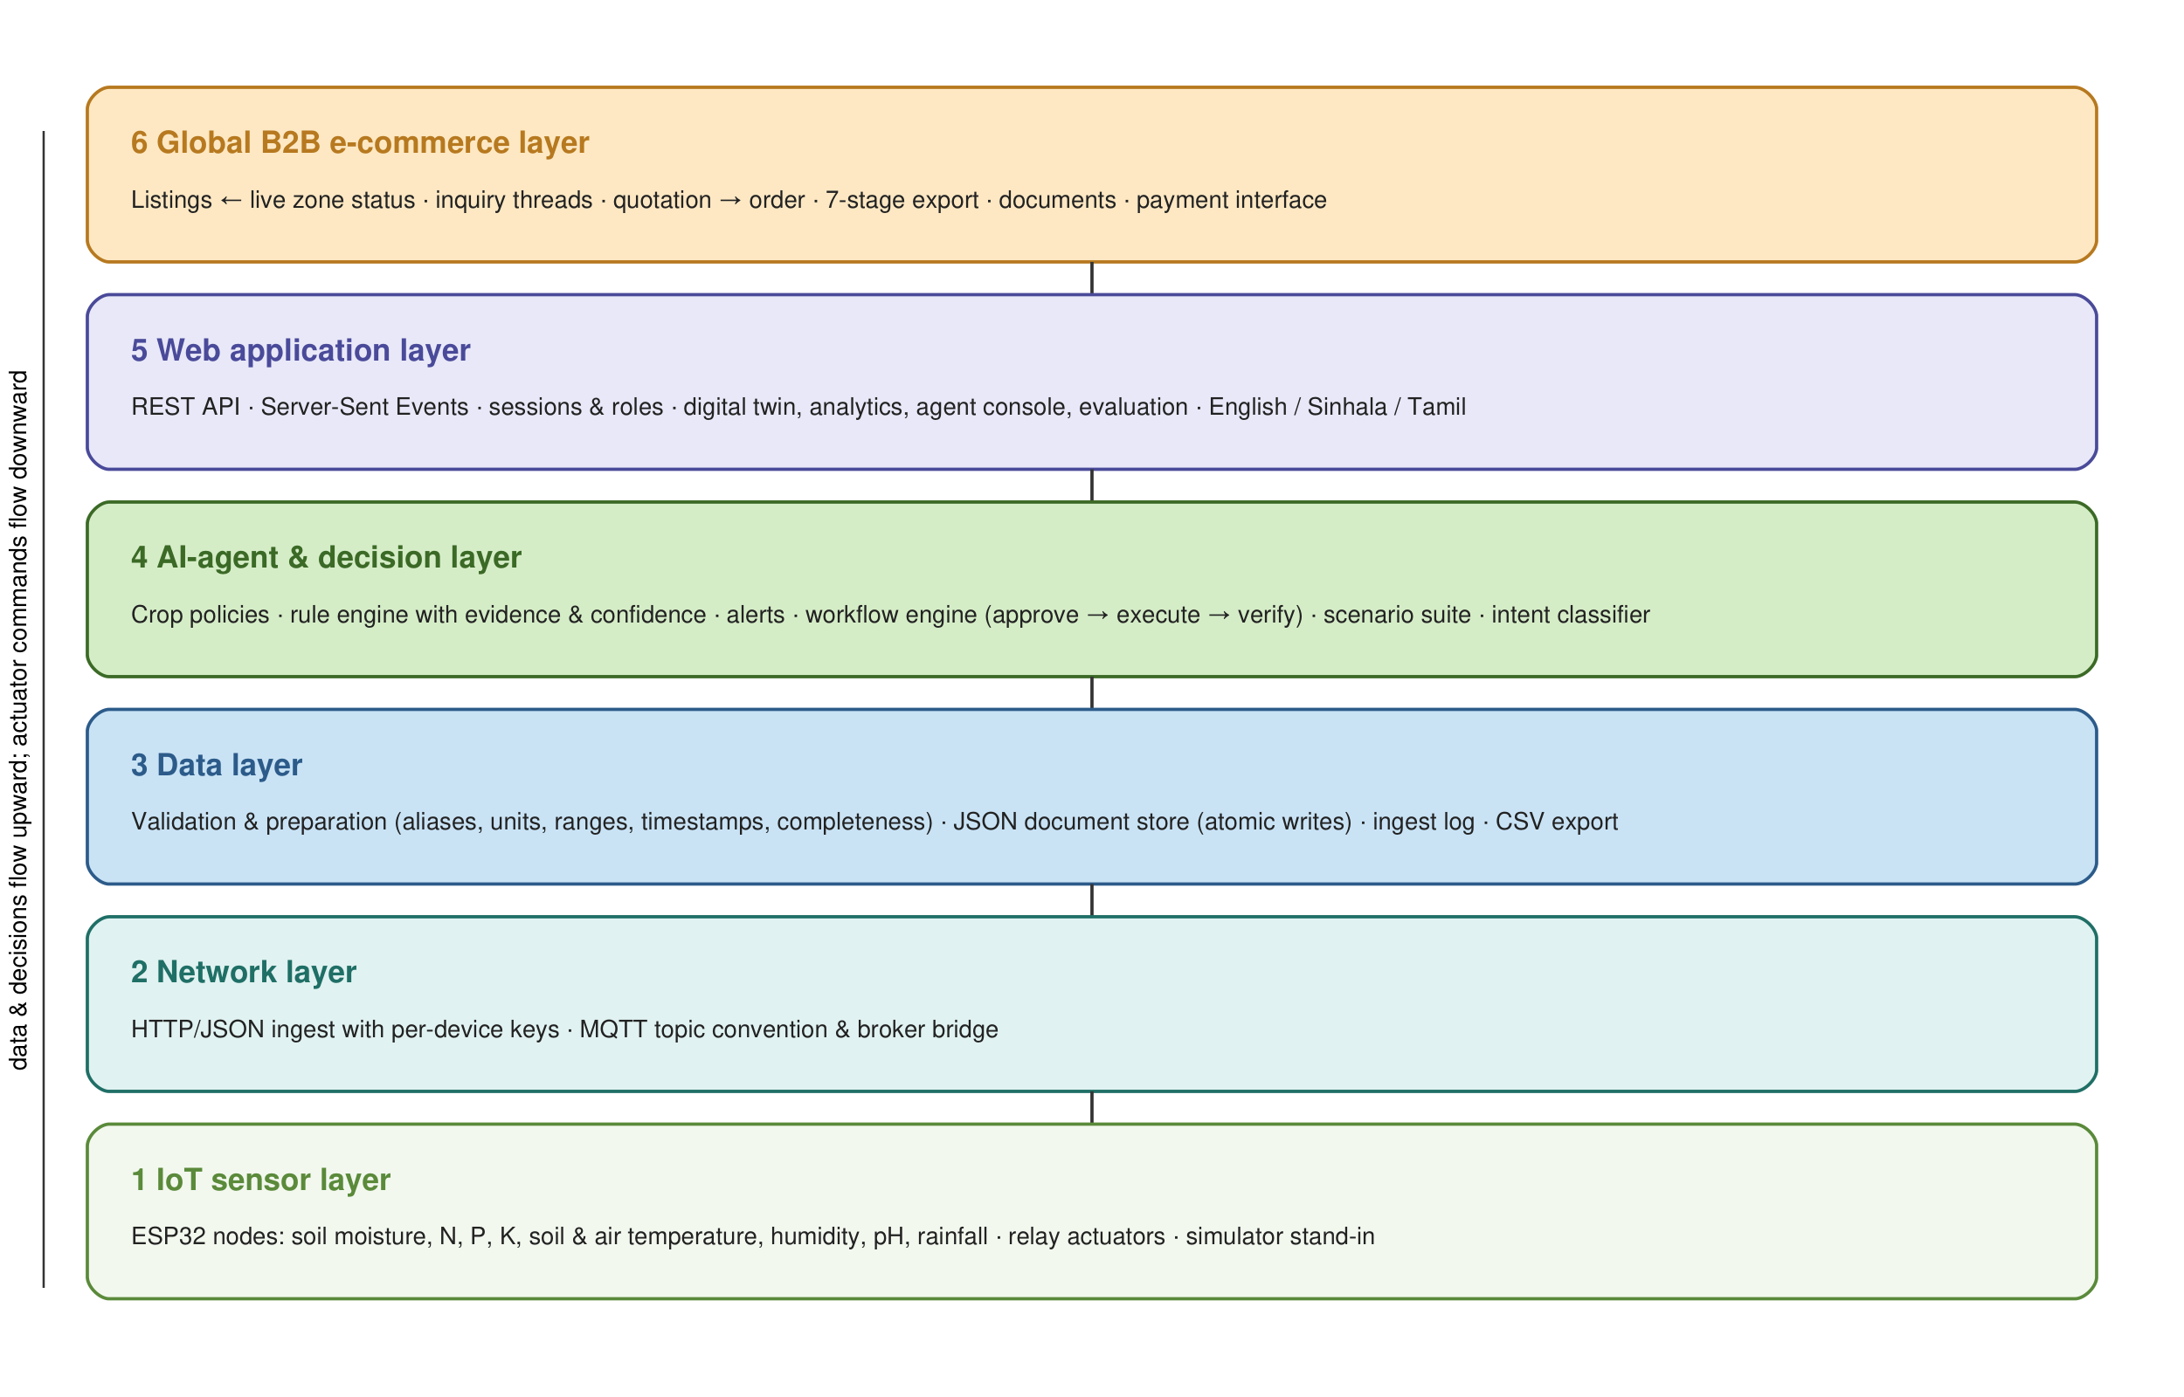
Figure 3.2: Layered system architecture of the Smart Farming Web System, mapping each technology category to its architectural layer
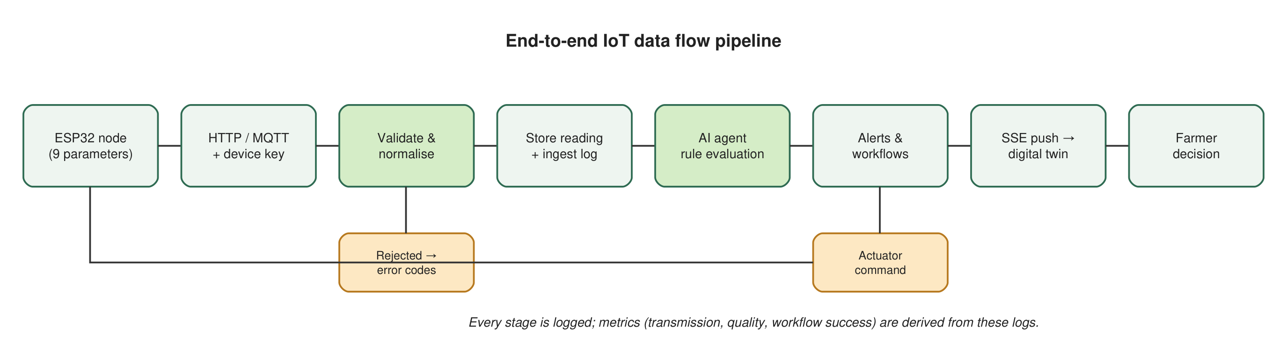
Figure 3.3: End-to-end data flow, from field sensors through validation, storage and AI-agent inference to the web dashboard, workflows and alerting

3.7.2 Tools and technologies
Table 3.3 lists the tools and technologies selected for each layer and the reason for each selection; the detailed justification, including alternatives considered, is given in Section 5.2.
Table 3.3: Tools and technologies by architectural layer
Layer | Technology | Reason for selection
IoT sensor layer | ESP32 microcontrollers; capacitive moisture, RS485 NPK, DS18B20, DHT22, pH and rain-gauge sensors; relay actuator | Low cost, Wi-Fi on board, wide sensor library support, suitable for smallholder budgets
Network layer | HTTP/JSON with per-device keys; MQTT topic convention with Mosquitto bridge | HTTP needs no broker and is universally deployable; MQTT available where queuing and offline buffering are needed
Data layer | Node.js validation pipeline; JSON document store with atomic writes; CSV export; upgrade path to PostgreSQL or MongoDB | Zero dependencies, transparent files for a prototype, simple backup and inspection
AI-agent and decision layer | Rule-based decision intelligence with crop policies; evidence recording; workflow state machine; keyword-based multilingual intent classifier | Explainable, auditable, adaptable by agronomists, no training data required
Web application layer | HTML5, CSS3, vanilla JavaScript; REST API; Server-Sent Events; trilingual dictionary; PWA manifest | No build step, fast on low-end devices, live updates, complete language coverage
B2B commerce layer | Product, inquiry, order and document models; role-based stage rules; payment-integration interface | Mirrors the export process described in the literature; external services attach through a defined interface
Development and deployment | Visual Studio Code, Git, Node test runner, headless Chrome, Docker | Reproducible builds and tests; containerised deployment

3.7.3 Data preparation
Collected sensor data must be validated before being used for analytics or decision support, since raw field measurements are susceptible to noise, transmission errors and sensor drift. The preparation process implemented in the artefact and described in Section 5.4 therefore includes: normalising field names (for example, accepting soil_moisture, n, p, k or temperature as aliases) and units (Fahrenheit to Celsius, inches to millimetres); checking for missing values, with four parameters (soil moisture, air temperature, humidity and pH) designated as required; identifying abnormal or out-of-range readings against physically motivated limits; standardising timestamps to ISO 8601 UTC and rejecting future or stale timestamps; associating each measurement with its sensor node and zone; and computing a completeness score as the fraction of the nine parameters present. Readings that fail validation are recorded in an ingest log with per-field error codes, counted in the data-quality metric and surfaced to the user, rather than being silently discarded.
For AI-agent processing specifically, inputs are transformed into a consistent internal representation so that the decision layer can clearly distinguish current environmental conditions (the latest validated reading), historical observations (the last hour of readings, used for rainfall accumulation), crop context (the zone's crop policy) and node status (last contact time) from one another. This separation is important both for the correctness of generated recommendations and for the traceability requirements discussed in Section 2.5.3. B2B product and export information is similarly structured, including product category, quantity, quality grade, certifications, harvest date and destination market, to maintain consistency across the commerce workflow and to allow linkage back to the production zone that supports a given listing.

3.7.4 Evaluation plan
Evaluation is designed to assess both technical performance and user-oriented value, directly addressing the research questions defined in Section 1.4. Primary technical measures include successful sensor-data transmission, data completeness, workflow-execution success and the consistency of AI-agent decision outputs against predefined test scenarios. User-oriented measures include usability, perceived usefulness and ease of interaction, gathered through structured evaluation sessions with representative users. Table 3.4 summarises the evaluation areas, the metric used for each and the target threshold, and Figure 3.4 presents the targets graphically together with the general acceptability threshold of 80 %.
Table 3.4: Evaluation areas, metrics and targets
Evaluation area | Metric | Target | Research question
Sensor integration | Percentage of expected readings successfully received | ≥ 95 % | RQ2
Data quality | Rate of valid and complete measurements after preprocessing | ≥ 90 % | RQ2
AI decision support | Agreement / quality score against predefined test scenarios | ≥ 85 % | RQ2, RQ3
Workflow automation | Percentage of workflows completed successfully end-to-end | ≥ 90 % | RQ3
Web usability | Task completion rate and System Usability Scale (SUS) score | ≥ 85 % | RQ4
B2B functionality | Successful completion of representative product/buyer workflows | ≥ 88 % | RQ5

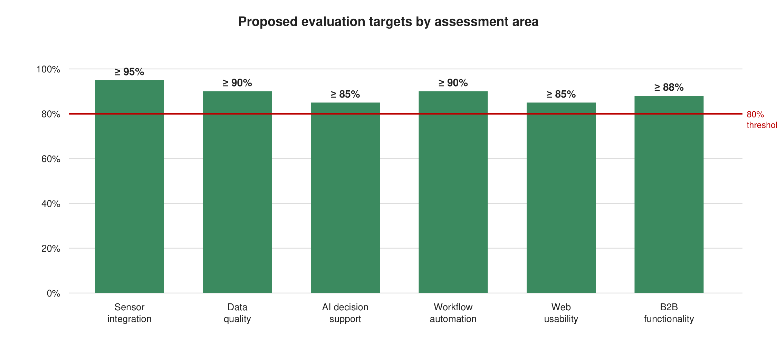
Figure 3.4: Proposed evaluation targets by assessment area, with the general acceptability threshold of 80 % indicated by the dotted line
These evaluation targets are assessed iteratively across successive DSRM cycles: where an early prototype iteration fell short of a target, for example in AI decision-support agreement during Cycle 2, the corresponding design element (decision rules, sensor validation or workflow logic) was revisited before the next demonstration and evaluation cycle, consistent with the iterative loop illustrated in Figure 3.1. A distinctive feature of the artefact is that it computes these metrics itself from its logs and exposes them on an evaluation page, so that the DSRM evaluation activity is supported directly by the system under evaluation.

3.8 Project Management Methodology

3.8.1 Selection and justification
Three project management methodologies were considered. PRINCE2 is a stage-gated, documentation-heavy method suited to large projects with formal governance; its overhead is disproportionate for a single-researcher software project. Kanban is a flow-based method that limits work in progress and suits continuous maintenance, but it lacks the time-boxed review points that a research project with fixed academic milestones requires. Scrum (Schwaber and Sutherland, 2020) organises work into fixed-length sprints, each ending with a review of a potentially shippable increment and a retrospective, and maintains a prioritised product backlog. Scrum was selected because its sprint reviews map directly onto the DSRM demonstration and evaluation activities, its backlog provides a transparent record of how requirements evolved, and its time-boxing aligned with the Faculty's milestone calendar. The researcher acted as product owner and development team, and the supervisor took the role of the primary stakeholder at sprint reviews.
The project was organised into fourteen two-week sprints within the three DSRM cycles. Each sprint began with backlog refinement against the research objectives, ended with a demonstration of the increment, and recorded impediments and decisions in a sprint log that later informed Chapter 7. Figure 3.5 shows the resulting timeline.

3.8.2 Project timeline
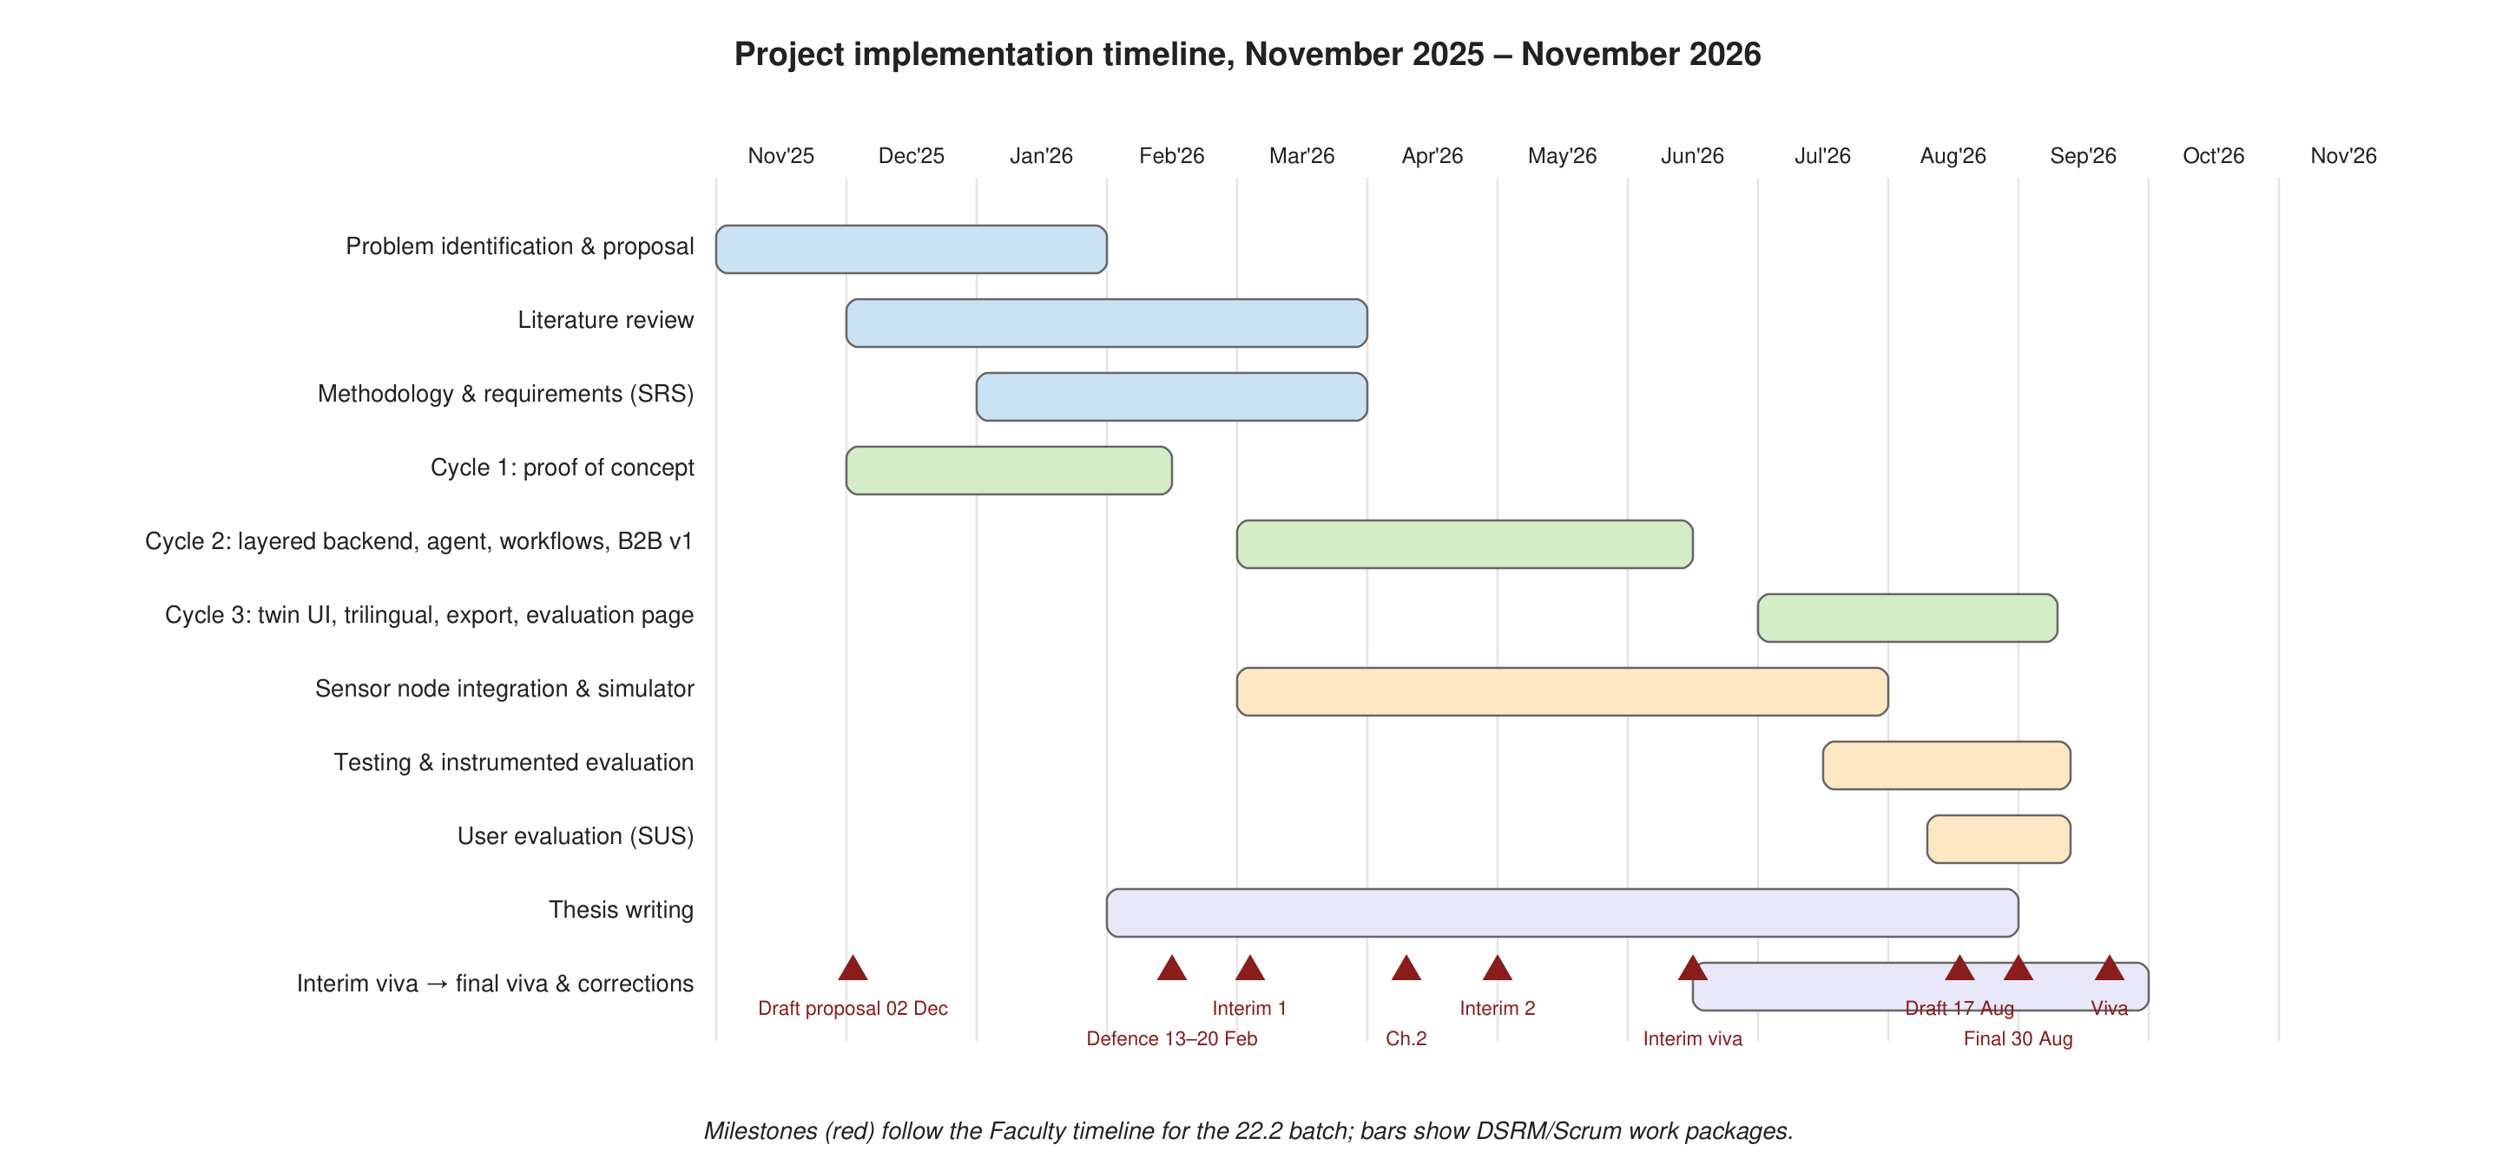
Figure 3.5: Project implementation timeline (November 2025 to November 2026), aligned with the DSRM cycles and the Faculty milestones
Table 3.5: Project milestones and deliverables
Milestone | Date | Deliverable
Draft proposal submission | 02 December 2025 | Preliminary background, problem, initial literature review, aim, objectives, tentative methodology
Proposal defence | 13–20 February 2026 | Oral defence; revised proposal with panel feedback
Final proposal submission | 22 February 2026 | Approved proposal with finalised problem, gap, objectives, questions and methodology
Interim 01 – Part A | 03 March 2026 | Chapter 1
Chapter 2 submission | 10 April 2026 | Literature review
Interim 02 (progress review) | 30 April 2026 | Updated Chapters 1–2; Chapter 3 progress
Interim viva | 15–19 June 2026 | Mid-term presentation with Cycle 2 prototype
Thesis draft submission | 17 August 2026 | Complete draft
Final thesis submission | 30 August 2026 | Final document with corrections
Final viva voce | 21–25 September 2026 | Oral examination with Cycle 3 artefact

3.9 Ethical Considerations and Limitations

3.9.1 Ethical considerations
Participation in user evaluation was voluntary and based on informed consent, with participants free to withdraw at any stage without consequence. Participants were briefed in their preferred language, and no personal information beyond role, preferred language and self-reported digital-experience level was recorded; SUS responses were stored anonymously against a random identifier. Sensor and farm information is treated as operational data belonging to the participating farm and is protected from unauthorised access through session-based authentication, role-based authorisation and per-device keys. Consistent with the discussion in Section 2.5.1 regarding traceability, AI-generated recommendations are explicitly presented to users as decision support rather than as an unconditional replacement for professional agricultural judgement, a disclaimer to this effect is displayed within the application, and users retain full discretion over whether to act on a given recommendation; autonomous mode is off by default and must be enabled deliberately. No external AI services were used, so no farm data left the system. Third-party fonts are the only external resources loaded by the interface, and the content-security policy prevents any other outbound connection.

3.9.2 Limitations of the study
The study is limited by the scale of the prototype, the number and type of available sensors, connectivity conditions in the field, sensor accuracy and the availability of representative agricultural data for testing and calibration. The instrumented measurement reported in Chapter 6 used the artefact's simulated node network, whose packet-loss and corruption rates were configured from values reported in the IoT literature, together with real HTTP ingest from a hardware node on the bench; long-duration field deployment across many farms was outside the scope of an academic year. AI-agent performance depends on the quality of the underlying data and the completeness of the decision rules encoded during development, so recommendation quality may vary across crop types or environmental conditions not represented in the three crop policies and fifteen scenarios. The B2B component was developed and evaluated at prototype level and does not represent the full complexity of international export operations, including legal and regulatory requirements, logistics coordination or commercial risk management. Finally, evaluation results are drawn from a limited user sample of twelve participants, appropriate to an academic research project but restricting the generalisability of usability findings to the wider population of prospective users.

3.10 Chapter Summary
This chapter has described the methodology of the research as a continuous story. A pragmatic paradigm and the Design Science Research strategy were adopted because the outcome of the research is a purposeful artefact whose value is its utility. The approach is abductive in design and deductive in evaluation. Facts were collected from literature, stakeholders, sensor data, system logs, an automated scenario suite, test suites and a structured user evaluation. The six DSRM activities were executed across three iterative cycles, managed with Scrum in fourteen sprints aligned to the Faculty's milestones. The six-layer system design, the selected technologies, the data-preparation process and an evaluation plan with six measurable targets were set out, and ethical considerations and limitations were addressed. Chapter 4 now specifies the requirements of the system in detail.

CHAPTER 4 — SYSTEM REQUIREMENT SPECIFICATION

4.1 Chapter Overview
This chapter specifies the requirements of the Smart Farming Web System. It identifies and analyses the stakeholders (Section 4.2), describes the operationalisation process by which facts gathered from stakeholders, documents and the literature were mapped onto the research objectives and validated as requirements (Section 4.3), and presents the system analysis through UML models: use-case diagrams with specifications (Section 4.4), a class diagram (Section 4.5), an activity diagram (Section 4.6), sequence diagrams for the three most important use cases (Section 4.7) and a deployment diagram (Section 4.8). Section 4.9 presents the proposed system architecture, Section 4.10 lists the functional requirements and Section 4.11 the non-functional requirements, and Section 4.12 summarises the chapter. Less important use-case specifications are placed in Appendix A to conserve page count.

4.2 Stakeholder Analysis
Stakeholders were identified using the onion model, which distinguishes those who operate the system, those who benefit from it in the containing organisation, and those in the wider environment who influence or are affected by it. Table 4.1 lists the stakeholders, their interest in the system, their influence and the requirements that flow from them.
Table 4.1: Stakeholder analysis
Stakeholder | Role | Interest | Influence | Key requirements contributed
Farmer (smallholder owner-operator) | Primary operational user | Timely, understandable advice on irrigation, fertiliser and crop health; less manual checking; better prices | High | Trilingual interface; mobile use; plain-language recommendations with reasons; approval before automation; alerts
Farm manager (medium-scale farm) | Operational and supervisory user | Overview of several zones; audit trail of actions; configuration of crops and devices; data export | High | Zone map; workflow history; settings for zones, policies and devices; CSV export; autonomous mode
Export buyer / importer | Commercial user | Verified, gradable produce; reliable communication; visibility of order progress and documents | High | Marketplace with live field status; inquiry threads; quotation and order tracking; document and payment status
Agronomist / extension officer | Advisory stakeholder | Ability to inspect and adjust decision rules; confidence that advice is evidence-based | Medium | Explainable decisions; editable crop policies; disclaimer that advice is decision support
Sensor-node installer / technician | Technical user | Simple provisioning of nodes; clear diagnostics when a node fails or sends bad data | Medium | Device keys; ingest documentation; ingest log with rejection reasons; offline alerts
Exporter / logistics partner | Environmental stakeholder | Structured export documents and stages; integration interface | Low–medium | Seven-stage export process; document checklist; payment interface
Research supervisor and evaluation panel | Academic stakeholder | Rigorous, evaluable artefact aligned with the thesis | High | Evaluation page computing thesis metrics; scenario suite; test suite
Regulator / certification body | Environmental stakeholder | Traceability of good agricultural practice | Low | Certification fields on listings; audit logs
Platform operator / system administrator | Technical stakeholder | Easy deployment, backup and security | Medium | Zero-dependency deployment; Docker; persistent data directory; security headers

The analysis shows that the farmer and the buyer are the two primary actors whose goals define the principal workflows, that the farm manager extends the farmer's goals with supervisory and configuration needs, and that explainability and traceability serve several stakeholders simultaneously (farmer, agronomist, panel and regulator), which justified treating them as architectural properties rather than features.

4.3 Operationalisation Process
Operationalisation is the process of converting the research objectives into observable requirements and, later, into measurable evaluation criteria. Table 4.2 maps each fact-gathering technique used in the study to the questions it addressed and the objective it served. The facts gathered were reviewed for consistency, triangulated across sources, and accepted as requirements only when they were supported by at least two sources or by explicit stakeholder confirmation.
Table 4.2: Operationalisation of fact-gathering techniques to objectives
Technique | Questions / items addressed | Facts obtained | Objective
Semi-structured discussions with three farmers and one farm manager (Sinhala and Tamil speaking) | Which field conditions do you check, how often, and how do you decide to irrigate or fertilise? What would make you trust an automatic recommendation? Which language and device would you use? | Moisture and rain are checked visually once or twice daily; fertiliser decisions follow a calendar; trust depends on seeing the reason; phone use dominates; Sinhala or Tamil strongly preferred | Analyse (1.7.2)
Discussions with two agribusiness/export contacts | What information do buyers need before committing? Which documents and stages does an export order pass through? Where do delays occur? | Grade, certification, quantity, harvest date and destination are decisive; the seven stages and four documents of Section 2.5.3; delays arise from unanswered inquiries and incomplete documents | Analyse (1.7.2)
Document analysis of export documentation (invoice, packing list, phytosanitary certificate, certificate of origin) and GAP certification requirements | What fields must a listing and order carry? | Product, grade, quantity, unit, price, currency, certifications, destination, incoterm | Analyse (1.7.2)
Literature-derived crop policies (Department of Agriculture guidance for tomato, chilli and okra; sensing literature in Chapter 2) | What thresholds define healthy ranges for each parameter and crop? | Policy ranges in Table 5.3 | Design (1.7.3)
Panel and supervisor feedback (proposal defence, interim viva) | Is explainability sufficient? How is B2B linked to farm data? How will targets be measured? | Requirements for evidence display, live listing status and a self-computing evaluation page | Design and evaluate (1.7.3, 1.7.4)
Prototype demonstrations (Cycles 1–2) | Are labels understandable? Are actions discoverable? | Complete translation rather than partial; rain must cancel irrigation; rejected readings must be visible | Design (1.7.3)

Reviewing the results of the data gathering confirmed the validity of the selected requirements: every functional requirement in Section 4.10 traces to at least one row of Table 4.2, and every evaluation metric in Table 3.4 traces to a research question and an objective.

4.4 Use-Case Analysis
Figure 4.1 shows the use-case diagram for the system. Four actors are modelled: Farmer (which generalises Farm Manager for the purposes of the diagram, with the manager's configuration use cases marked), Buyer, Sensor Node (a system actor) and the AI Agent (a system actor that initiates use cases autonomously).
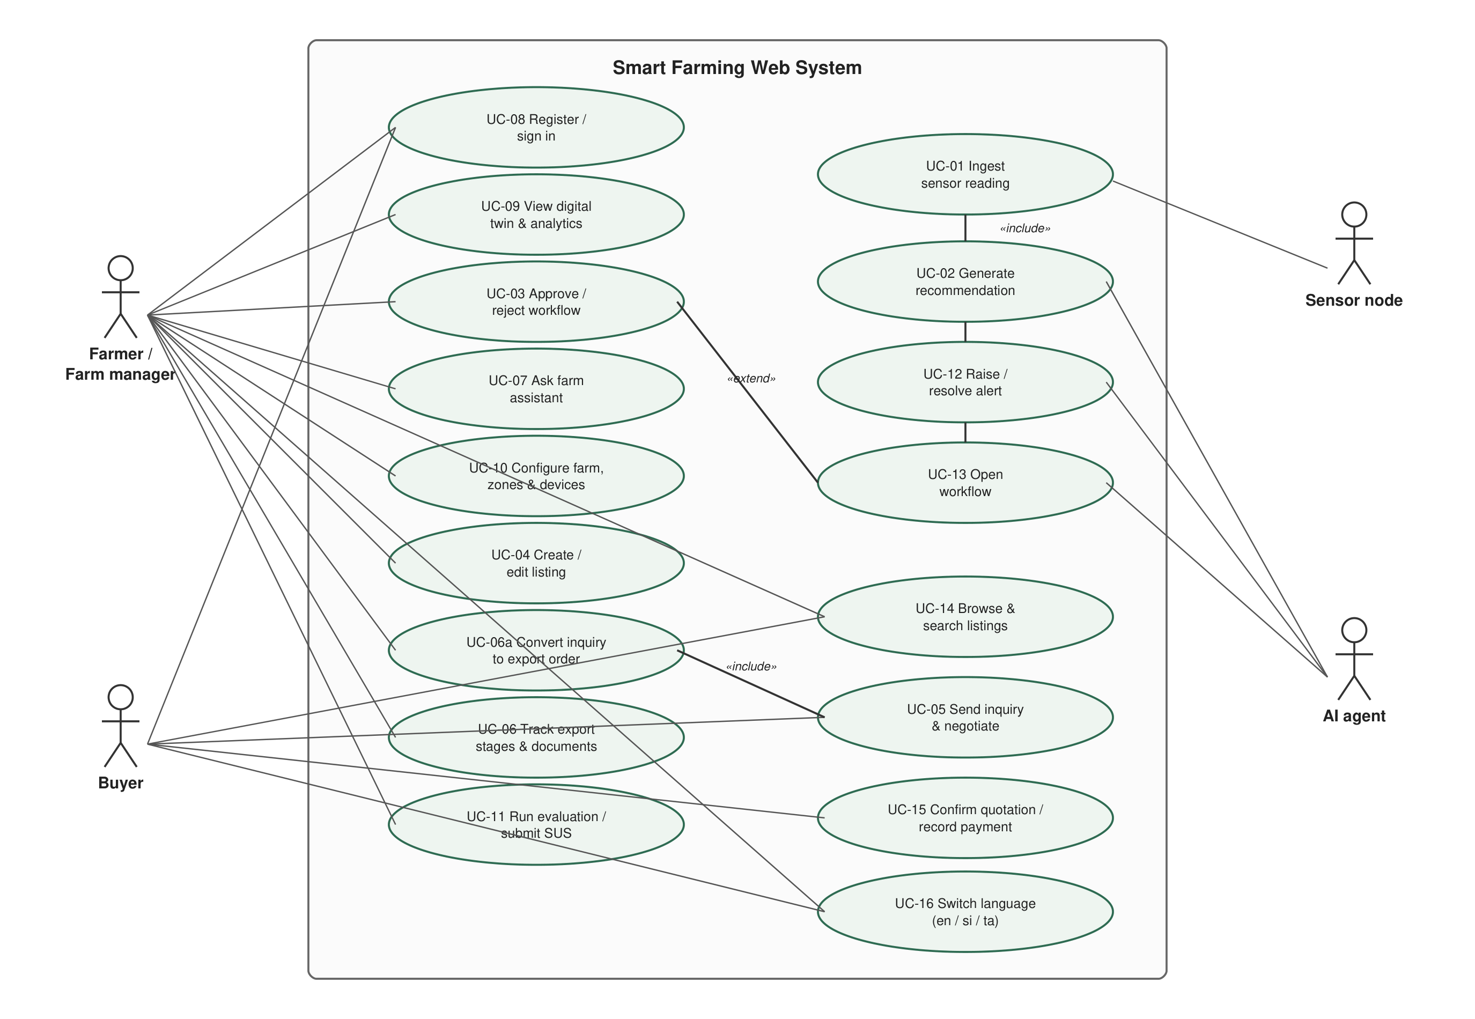
Figure 4.1: Use-case diagram of the Smart Farming Web System
The most important use-case specifications are given below; the remaining specifications (UC-08 to UC-16) are provided in Appendix A.

4.4.1 UC-01 Ingest sensor reading
Table 4.3: Use-case specification UC-01 Ingest sensor reading
Item | Description
Use case | UC-01 Ingest sensor reading
Actors | Sensor Node (primary); AI Agent (secondary)
Preconditions | Node is registered with a valid device key and assigned to a zone
Main flow | 1. Node posts a JSON reading with its device key. 2. System authenticates the key and identifies the zone. 3. System normalises field names and units. 4. System validates required fields, ranges and timestamp. 5. System stores the reading, updates node last-contact time and ingest statistics. 6. System invokes the AI Agent for the zone (UC-02). 7. System pushes a live update to connected dashboards.
Alternative flows | 4a. Validation fails: system records a rejected entry with per-field error codes, increments the rejection count, returns 422 with the errors, and ends. 2a. Key unknown: system returns 401 and ends.
Postconditions | Reading persisted; decisions and alerts for the zone up to date

4.4.2 UC-02 Generate recommendation
Table 4.4: Use-case specification UC-02 Generate recommendation
Item | Description
Use case | UC-02 Generate recommendation
Actors | AI Agent (primary)
Preconditions | A zone has a crop policy and at least one validated reading
Main flow | 1. Agent loads the zone's policy, latest reading, last hour of readings and node status. 2. Agent evaluates the prioritised rule set (offline, moisture, nutrients, pH, temperature, humidity, rain, data quality, staleness). 3. For each triggered rule the agent creates a decision with code, severity, parameters, evidence, rule identifier and confidence. 4. Agent raises or resolves alerts for warning and critical decisions. 5. Agent opens a workflow for each decision that carries an action (UC-03). 6. Agent records the decision set in the decision log if it changed.
Alternative flows | 1a. No readings: agent emits a NO_DATA warning. 2a. Rain detected with low moisture: agent emits a hold-irrigation decision instead of irrigation and cancels any pending irrigation workflow.
Postconditions | Zone status (optimal, attention, critical) and decisions available to the dashboard

4.4.3 UC-03 Approve and execute workflow
Table 4.5: Use-case specification UC-03 Approve and execute workflow
Item | Description
Use case | UC-03 Approve and execute workflow
Actors | Farmer (primary); AI Agent (secondary)
Preconditions | A workflow is in the pending state
Main flow | 1. Farmer reviews the recommendation and its evidence. 2. Farmer approves. 3. System records the approver, marks the approval step done and sets the workflow to running. 4. System issues an actuator command (to the simulator or to the MQTT actuator topic). 5. On subsequent readings the system verifies the target condition (for example moisture at or above the policy minimum). 6. System marks the workflow done and logs completion.
Alternative flows | 2a. Farmer rejects: workflow is marked rejected. 3a. Autonomous mode is on: the agent performs steps 2–3 itself and records "AI agent" as approver. 5a. Verification does not succeed within the deadline: workflow is marked failed and counted in the failure statistic.
Postconditions | Workflow outcome recorded with full step history

4.4.4 UC-04 Create product listing
Table 4.6: Use-case specification UC-04 Create product listing
Item | Description
Use case | UC-04 Create product listing
Actors | Farmer
Preconditions | Farmer is signed in
Main flow | 1. Farmer opens the marketplace and chooses "Create listing". 2. Farmer enters name, category, grade, quantity, unit, price, currency, target market, harvest date, certifications, description and optionally links a zone. 3. System validates the fields. 4. System publishes the listing with live status derived from the linked zone.
Alternative flows | 3a. Validation fails: the form shows the error in the active language.
Postconditions | Listing visible to buyers with live field status

4.4.5 UC-05 Send inquiry and negotiate
Table 4.7: Use-case specification UC-05 Send inquiry and negotiate
Item | Description
Use case | UC-05 Send inquiry and negotiate
Actors | Buyer (primary); Farmer (secondary)
Preconditions | Buyer is signed in; listing is active and not owned by the buyer
Main flow | 1. Buyer opens a listing and sends an inquiry with quantity and message. 2. System creates an inquiry thread (or reuses the buyer's open thread for that listing) and notifies the seller. 3. Seller replies; buyer and seller exchange messages. 4. Seller converts the inquiry into an export order (UC-06) or either party closes it.
Postconditions | Thread persisted; order created if converted

4.4.6 UC-06 Track export order
Table 4.8: Use-case specification UC-06 Track export order
Item | Description
Use case | UC-06 Track export order
Actors | Farmer (seller); Buyer
Preconditions | An order exists
Main flow | 1. Seller enters quantity, price, destination and incoterm; system creates the order at the quotation stage with a document checklist and unpaid status. 2. Buyer confirms the quotation. 3. Seller marks quality verified. 4. Seller marks the four documents ready; system advances to documents-ready. 5. A payment (deposit or full) is recorded. 6. Seller marks dispatched. 7. Delivery is confirmed.
Alternative flows | 6a. Documents incomplete or payment unpaid: system refuses dispatch with a translatable error. 2a. Seller attempts to confirm on the buyer's behalf: system refuses.
Postconditions | Order at a recorded stage with timestamps and actors for each transition

4.4.7 UC-07 Ask the farm assistant
Table 4.9: Use-case specification UC-07 Ask the farm assistant
Item | Description
Use case | UC-07 Ask the farm assistant
Actors | Farmer
Main flow | 1. Farmer types a question in English, Sinhala or Tamil, optionally naming a zone. 2. System classifies the intent (irrigation, nutrients, pH, weather, disease, market, export, workflow, help or status). 3. Client composes an answer from the current validated data and decisions in the active language.
Postconditions | Query logged with intent

4.5 Class Diagram
Figure 4.2 presents the domain class diagram. The central classes are Farm, Zone, SensorNode and Reading on the monitoring side; CropPolicy, Decision, Evidence, Alert and Workflow (with WorkflowStep) on the decision side; and User, Product, Inquiry, Message, Order, OrderStage, Document and Payment on the commerce side. Zone aggregates Readings and is associated with exactly one CropPolicy through its crop attribute and with one SensorNode; Decision references the Zone and the Reading that produced it and contains a list of Evidence items; Workflow references the originating Decision and contains ordered WorkflowSteps. Product optionally references a Zone, which is how live field status reaches the marketplace; Inquiry links a Buyer, a Seller and a Product and contains Messages; Order references the Inquiry, Product and both Users and contains OrderStages, Documents and a Payment. User carries a role (farmer or buyer) and a preferred language.
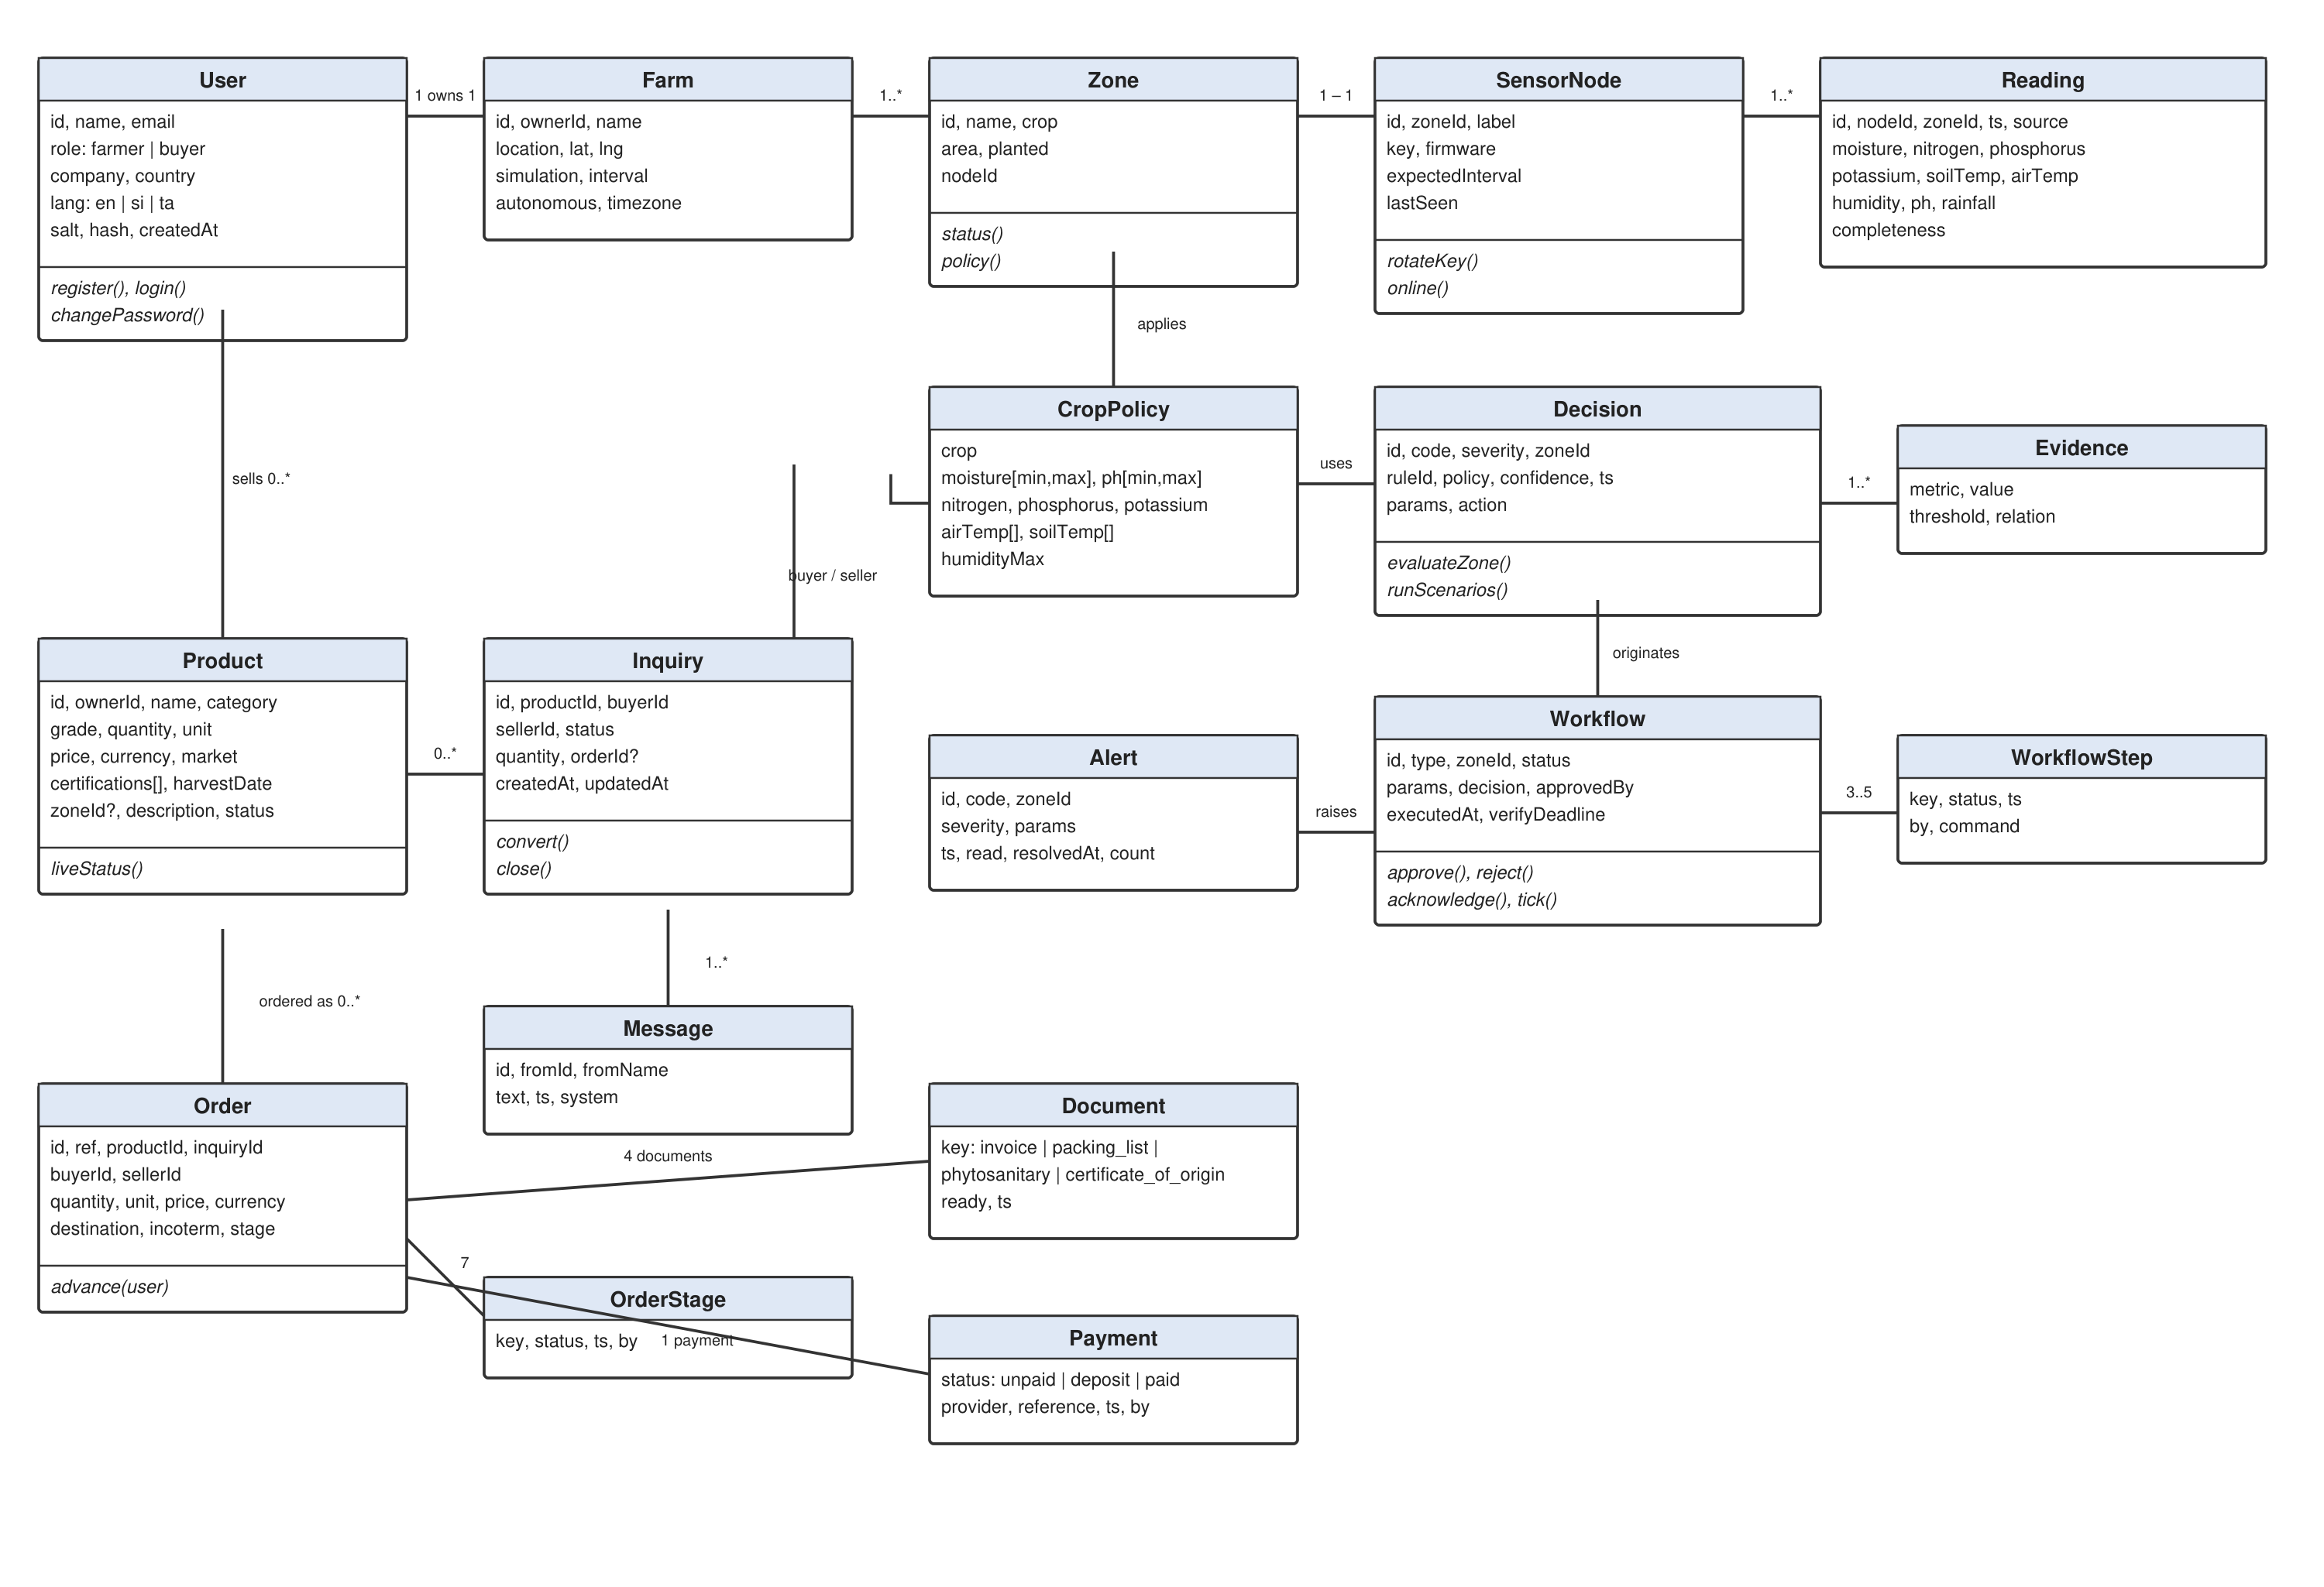
Figure 4.2: Domain class diagram

4.6 Activity Diagram
Figure 4.3 shows the activity diagram for the end-to-end monitoring-to-action process, which is the core workflow of the system. The diagram uses swim lanes for the Sensor Node, the Data Layer, the AI Agent, the Farmer and the Actuator. It shows the reading being posted, validated and stored; the agent evaluating rules and branching on the presence of an action; the decision point at which the farmer approves or rejects (or the agent auto-approves in autonomous mode); execution of the actuator command; and the verification loop that completes or fails the workflow.
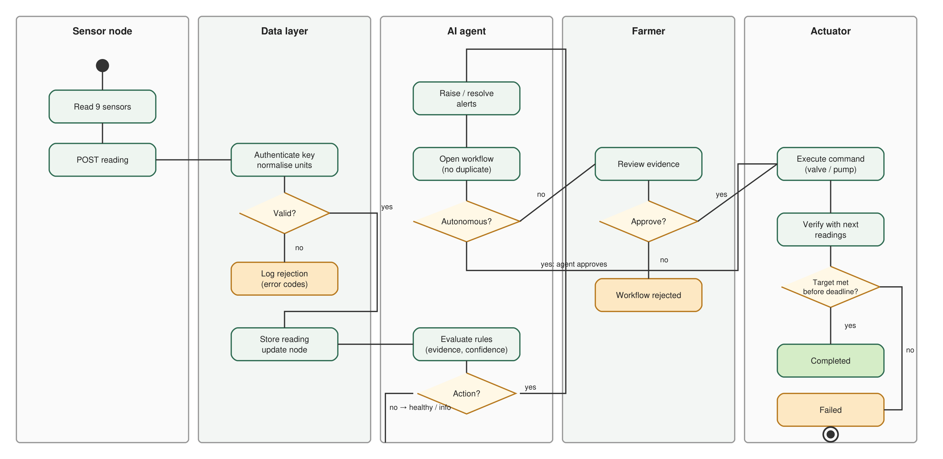
Figure 4.3: Activity diagram of the monitoring-to-action process

4.7 Sequence Diagrams
Three sequence diagrams model the most important use cases. Figure 4.4 (UC-01 and UC-02) shows the interaction between the sensor node, the ingest controller, the validation component, the data store, the agent, the workflow engine and the event hub when a reading arrives. Figure 4.5 (UC-03) shows the farmer approving a workflow through the browser, the API recording the approval, the actuator command being issued and the later verification against a fresh reading. Figure 4.6 (UC-05 and UC-06) shows the buyer sending an inquiry, the seller replying and converting it to an order, and the buyer confirming the quotation, including the server-sent notifications that keep both parties' views current.
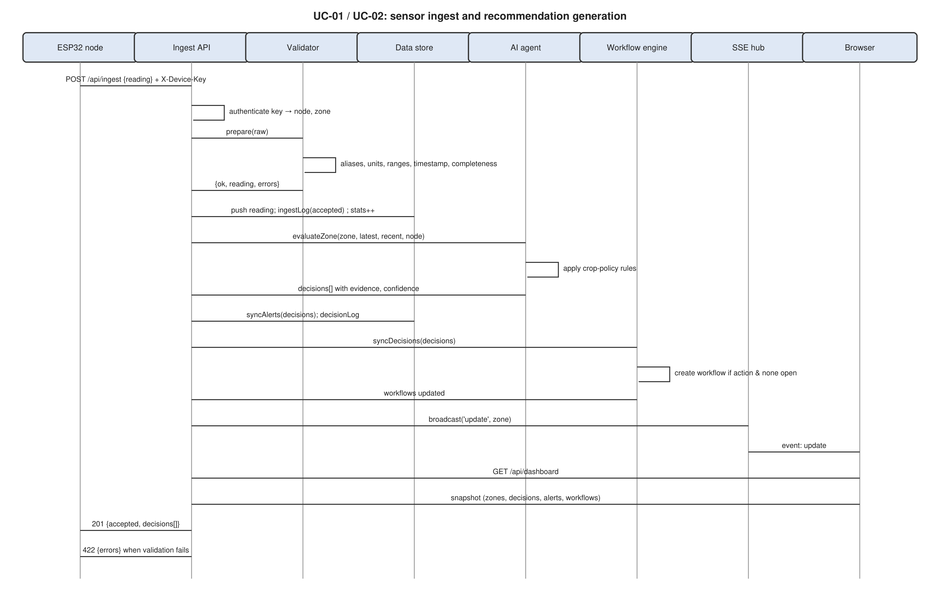
Figure 4.4: Sequence diagram for sensor ingest and recommendation generation (UC-01, UC-02)
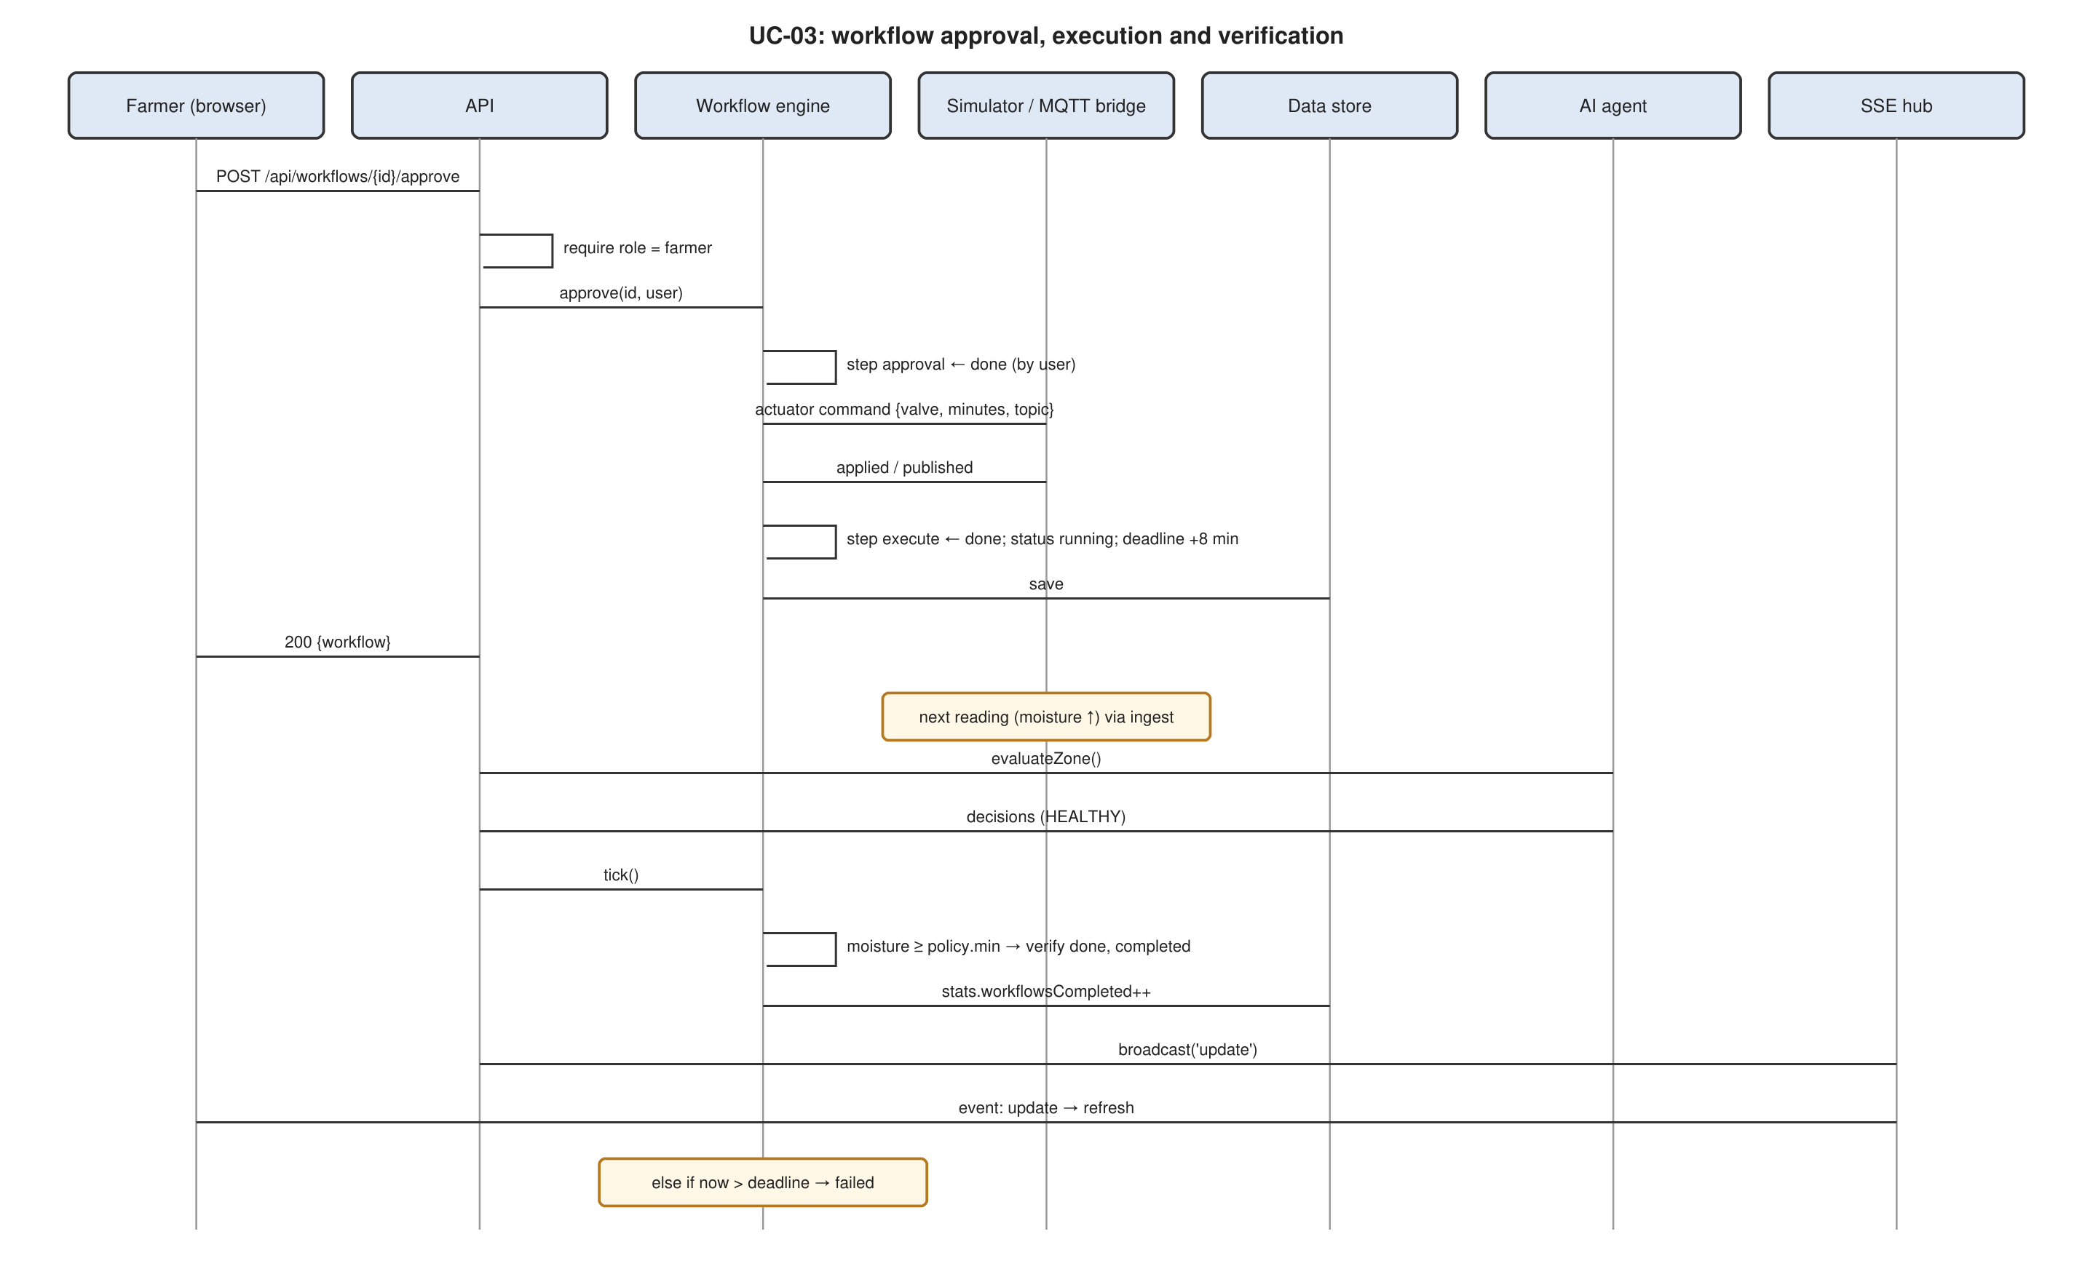
Figure 4.5: Sequence diagram for workflow approval, execution and verification (UC-03)
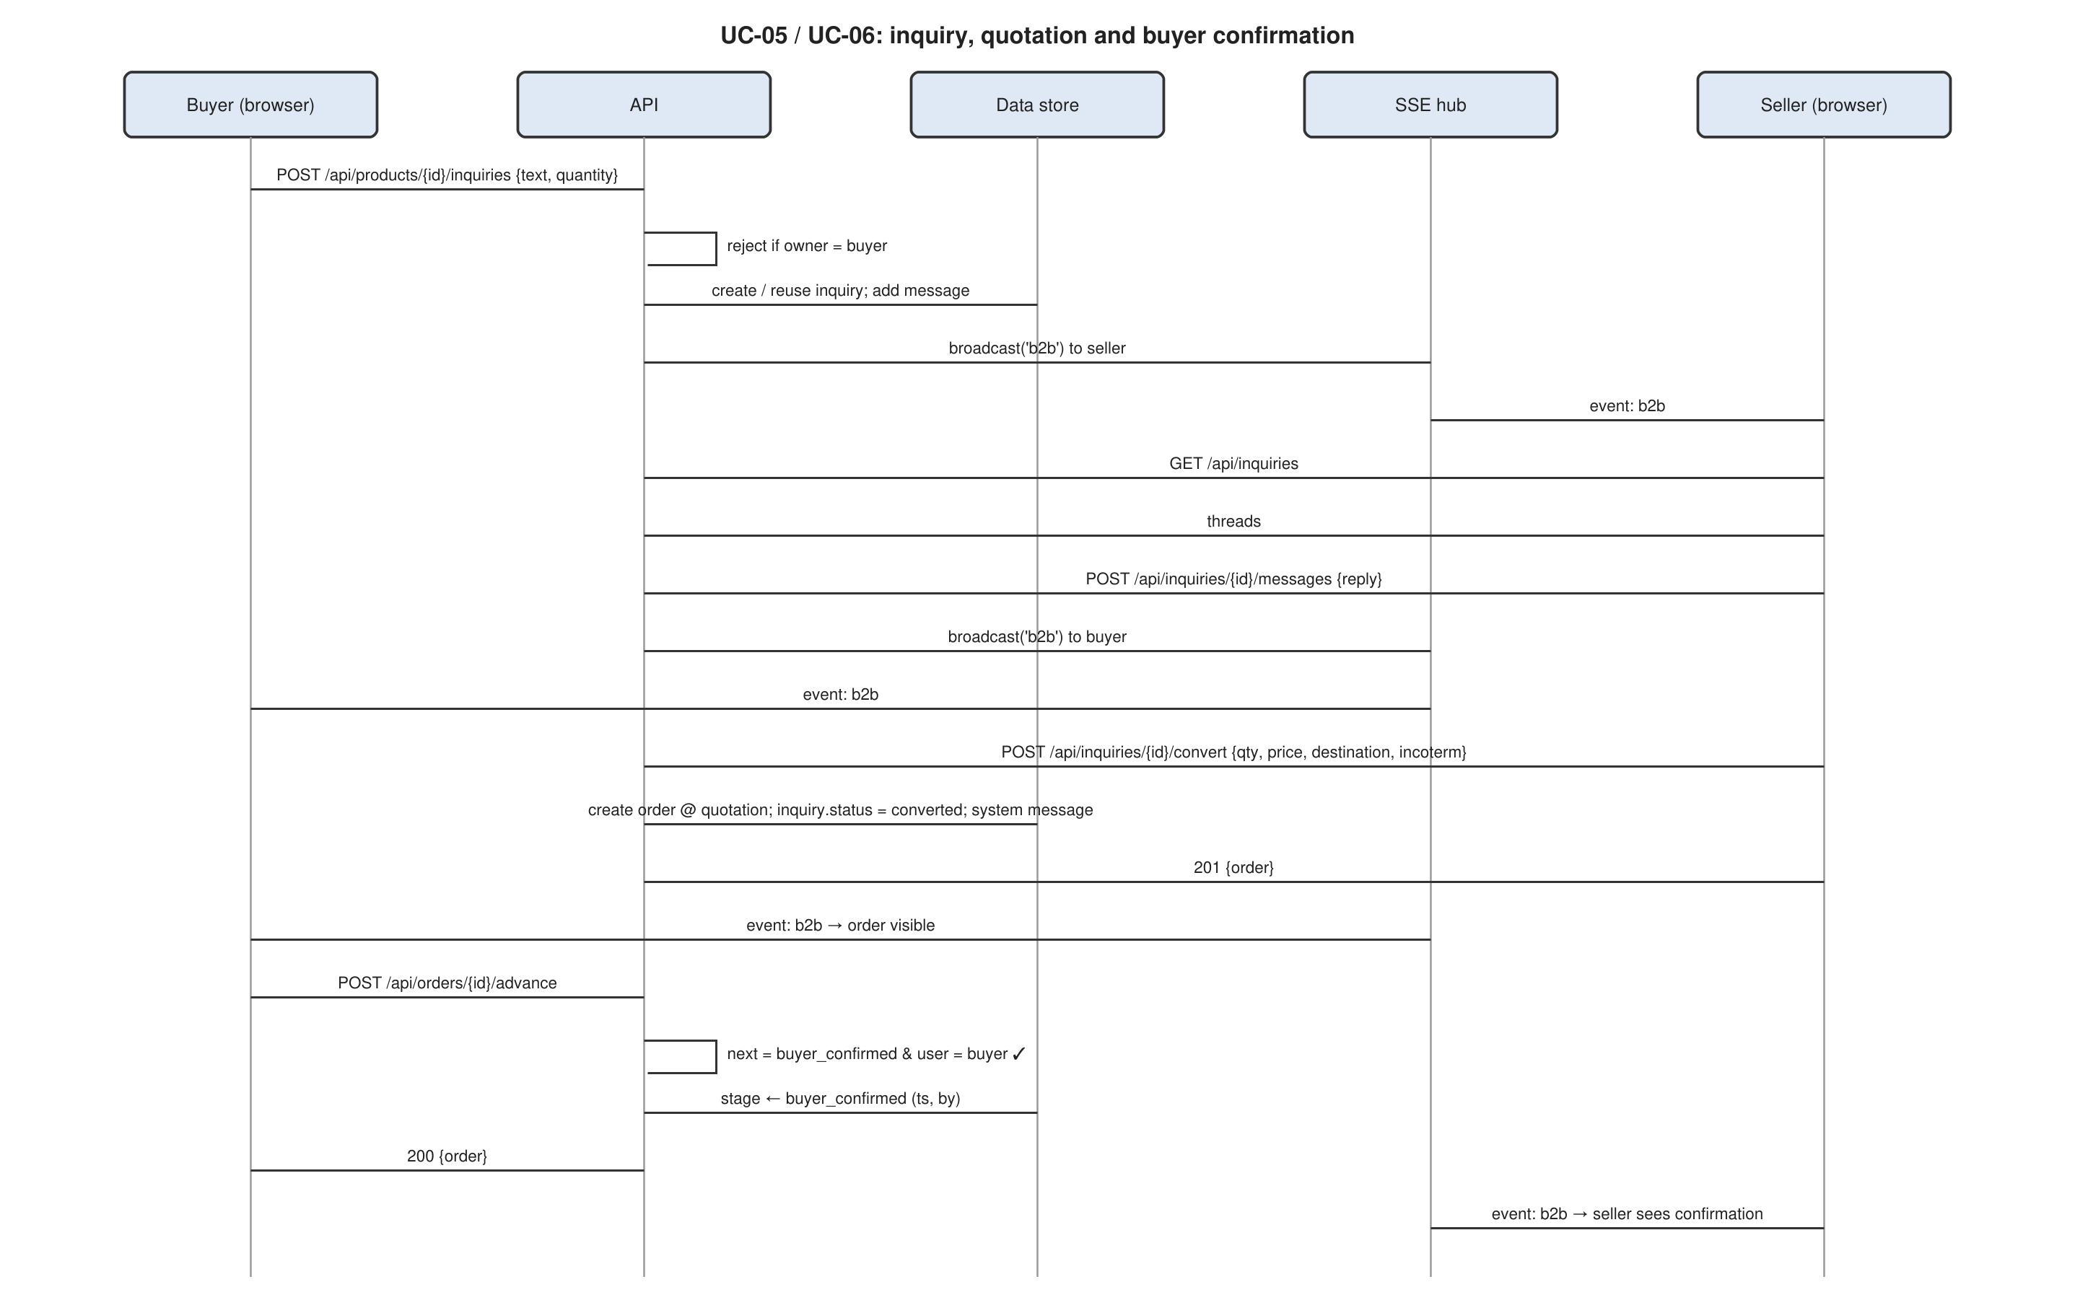
Figure 4.6: Sequence diagram for buyer inquiry, quotation and order confirmation (UC-05, UC-06)

4.8 Deployment Diagram
Figure 4.7 shows the deployment view. ESP32 nodes in the field communicate over Wi-Fi (directly by HTTP) or over LoRa or Wi-Fi to an optional gateway running an MQTT broker and bridge, which forwards readings by HTTP to the application server. The application server is a single Node.js process that serves both the REST/SSE API and the static web application, and persists data to a JSON document store on a mounted volume; it can run on a local machine, a virtual private server or a container platform. Farmers and buyers access the web application from browsers on phones, tablets and computers. An optional reverse proxy terminates HTTPS. External payment and logistics services attach through the payment-integration interface.
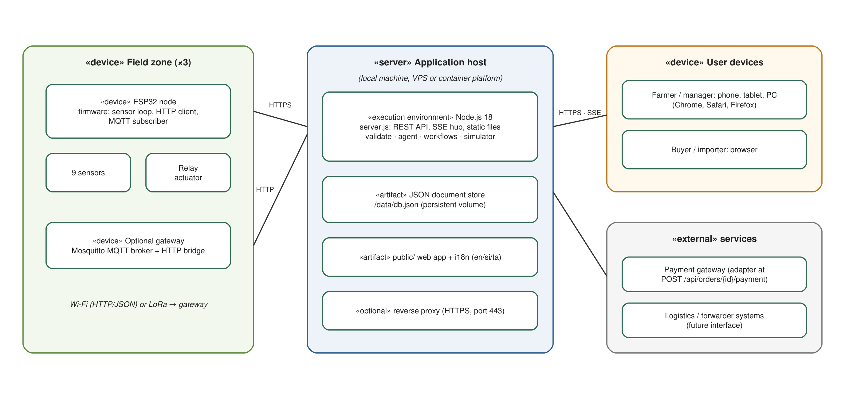
Figure 4.7: Deployment diagram

4.9 Proposed System Architecture
The proposed six-layer architecture was introduced in Figure 3.2 and is elaborated here from the perspective of component responsibilities and interfaces. Table 4.10 lists, for each layer, its components, its responsibilities and the interfaces it exposes to adjacent layers. The interfaces are deliberately narrow: the network layer exposes a single ingest endpoint; the data layer exposes a validation function and a store; the agent exposes an evaluate function whose output is a list of decisions; the workflow engine consumes decisions and exposes approve, reject, acknowledge and tick operations; and the web layer exposes a REST API and an event stream. This narrowness is what allows each layer to be tested and replaced independently, satisfying the modularity principle argued in Chapter 2.
Table 4.10: Architectural layers, components, responsibilities and interfaces
Layer | Components | Responsibilities | Interfaces
1. IoT sensor layer | ESP32 nodes; sensors; relay actuator; simulator (stand-in) | Measure nine parameters; report at a configured interval; act on actuator commands | JSON reading payload; actuator topic
2. Network layer | HTTP ingest endpoint; device-key authentication; MQTT topic convention and bridge | Transport readings securely from field to backend | POST /api/ingest with X-Device-Key; agripulse/{farm}/{zone}/readings
3. Data layer | Validation and preparation module; JSON document store; ingest log; CSV export | Normalise, validate, persist and expose data | prepare(reading); db.load/save; GET /api/readings
4. AI-agent and decision layer | Crop policies; rule engine; evidence recorder; alert manager; workflow engine; scenario suite; intent classifier | Interpret data, produce explainable decisions, orchestrate and verify workflows, measure agreement | evaluateZone(); syncDecisions(); approve/reject/acknowledge/tick; runScenarios(); classifyIntent()
5. Web application layer | REST API; SSE hub; session and role management; trilingual single-page interface; evaluation page | Present digital twin, analytics, agent console, settings and evaluation to users in three languages | /api/* ; /api/events; i18n dictionary
6. Global B2B e-commerce layer | Product, inquiry, order, document and payment models; role-based stage rules; payment-integration interface | Product presentation, buyer–supplier interaction, export process tracking, external service attachment | /api/products, /api/inquiries, /api/orders

4.10 Functional Requirements
Functional requirements are grouped by layer and numbered for traceability to the tests in Chapter 6. Priority uses the MoSCoW scale (Must, Should, Could).
Table 4.11: Functional requirements
ID | Requirement | Priority | Source
FR-01 | The system shall accept sensor readings for soil moisture, nitrogen, phosphorus, potassium, soil temperature, air temperature, humidity, pH and rainfall from authenticated sensor nodes over HTTP. | Must | Objectives; farmers
FR-02 | The system shall normalise common field-name aliases and unit variants (°F, inches) before validation. | Should | Technician
FR-03 | The system shall reject readings with missing required fields, non-numeric or out-of-range values, or invalid timestamps, and shall record the reason for each rejection. | Must | Literature; technician
FR-04 | The system shall compute and display a completeness score for each accepted reading. | Should | Literature
FR-05 | The system shall provide a simulated sensor network, with configurable interval, that can be disabled when hardware nodes are connected, and shall allow scenario injection (dry soil, rain, heat, nutrient drop, acidic soil, normal). | Must | Evaluation
FR-06 | The AI agent shall evaluate each zone against its crop policy after every accepted reading and produce decisions with a code, severity, parameters, evidence list, rule identifier and confidence value. | Must | Objectives; agronomist
FR-07 | The agent shall detect at least the following conditions: irrigation need, rain hold, high moisture, nutrient deficiency, low and high pH, heat and cold stress, disease risk, rain event, data-quality degradation, stale data, sensor offline and healthy state. | Must | Farmers; literature
FR-08 | The agent shall raise alerts for warning and critical decisions, resolve them when the condition clears and show unread counts. | Must | Farmers
FR-09 | The system shall create workflows (irrigation, fertigation, sensor check) from actionable decisions, avoiding duplicates for the same zone and type, with detected, approval, execute, verify and completed steps. | Must | Objectives
FR-10 | Farmers shall be able to approve, reject or acknowledge pending workflows; approval shall issue an actuator command and start verification against later readings with a deadline. | Must | Farmers
FR-11 | An autonomous mode shall allow the agent to approve and execute its own workflows; it shall be off by default. | Should | Farm manager
FR-12 | Rain events shall cancel pending irrigation workflows automatically. | Must | Demonstration feedback
FR-13 | The dashboard shall show farm-level summary metrics, a zone map coloured by status, current recommendations, workflow status, system log and B2B activity, and shall update live. | Must | Farmers
FR-14 | The digital-twin view shall show, for a selected zone, all nine readings with policy ranges, node status, a moisture sparkline and the top recommendation with evidence. | Must | Farm manager
FR-15 | The analytics view shall chart any parameter for 6, 24 or 72 hours with the policy band, show min/avg/max statistics, data-quality metrics and the ingest log, and export CSV. | Must | Farm manager
FR-16 | The agent console shall list decisions per zone with an expandable "why" section, the open and recent workflow queue with step timelines, and a natural-language assistant that understands English, Sinhala and Tamil. | Must | Farmers; panel
FR-17 | The entire interface, including server-originated messages, errors, decisions and logs, shall be available in English, Sinhala and Tamil, selectable at login and in settings and persisted per user. | Must | Farmers
FR-18 | Users shall register and sign in with email and password as farmer or buyer, manage their profile and change their password. | Must | All
FR-19 | Farmers shall create, edit, archive and restore product listings with category, grade, quantity, unit, price, currency, target market, harvest date, certifications, description and optional linked zone; listings shall display live field status when linked. | Must | Buyers; export contacts
FR-20 | Buyers shall browse, filter and search listings and send inquiries; buyers and sellers shall exchange messages in threads; either party may close a thread. | Must | Buyers
FR-21 | Sellers shall convert an open inquiry into an export order with quantity, price, destination and incoterm. | Must | Export contacts
FR-22 | Orders shall progress through inquiry, quotation, buyer confirmed, quality verified, documents ready, dispatched and delivered, with role rules (only the buyer confirms; only the seller advances other stages), a four-document checklist and payment recording (deposit or paid) through an integration interface; dispatch shall require complete documents and at least a deposit. | Must | Export contacts
FR-23 | The system shall compute and display the six evaluation metrics of Table 3.4 from its own logs, run the scenario suite on demand and collect SUS questionnaires. | Must | Panel
FR-24 | Farm managers shall configure farm name, location, reporting interval, simulation and autonomous mode, zone crops and areas, and view, copy and rotate device keys with ingest documentation. | Should | Farm manager; technician
FR-25 | The system shall provide a health endpoint and a CSV export of all readings. | Could | Administrator

4.11 Non-Functional Requirements
Non-functional requirements are organised using the ISO/IEC 25010 quality characteristics.
Table 4.12: Non-functional requirements (ISO/IEC 25010)
ID | Characteristic | Requirement | Measure
NFR-01 | Performance efficiency | Dashboard API responses shall complete within 200 ms at the 95th percentile on commodity hardware, and the ingest endpoint within 50 ms, with the server sustaining at least 50 concurrent dashboard requests. | Latency tests (Section 6.4)
NFR-02 | Reliability | Readings shall be processed without loss once received; persistence shall use atomic writes so that a crash cannot corrupt the store; a corrupted store shall be backed up and reseeded rather than causing failure. | Fault-injection test
NFR-03 | Availability | The server shall restart within five seconds and restore sessions from persistent storage. | Restart test
NFR-04 | Usability | The interface shall achieve a mean SUS score of at least 85 and a task completion rate of at least 85 % across participants using each of the three languages; all interactive elements shall be reachable by keyboard and labelled for screen readers. | SUS study; accessibility check
NFR-05 | Security | Passwords shall be hashed with scrypt and a per-user salt; sessions shall expire after 30 days and be revocable; login shall be rate-limited; cookies shall be HTTP-only and SameSite; a Content Security Policy and standard security headers shall be set; device keys shall authenticate nodes and be rotatable; request bodies shall be size-limited and validated. | Security review (Section 6.4)
NFR-06 | Compatibility | The web application shall run on current Chrome, Safari and Firefox on phones, tablets and desktops without plugins, and the backend on Node.js 18 or later on Linux, macOS and Windows. | Cross-browser check
NFR-07 | Maintainability | The backend shall have no third-party runtime dependencies; modules shall have single responsibilities; an automated end-to-end test suite shall cover authentication, ingest, agent, workflows, B2B and evaluation. | Test suite; code review
NFR-08 | Portability | The system shall be deployable with a single command locally and as a Docker container with a persistent data volume. | Deployment test
NFR-09 | Localisation | Every user-visible string shall exist in all three languages with identical placeholders; dates and numbers shall be formatted for the active locale. | Dictionary parity check
NFR-10 | Explainability and traceability | Every recommendation shall be reproducible from its recorded evidence and rule; every workflow shall record who performed each step and when. | Inspection of decision and workflow records

4.12 Chapter Summary
This chapter analysed the stakeholders of the Smart Farming Web System, described how facts gathered from discussions, documents, literature and demonstrations were operationalised into validated requirements, and modelled the system through use-case, class, activity, sequence and deployment diagrams. The six-layer architecture was elaborated in terms of component responsibilities and interfaces, and twenty-five functional and ten non-functional requirements were specified with priorities and sources. These requirements are the basis of the design and implementation described in Chapter 5 and of the test cases in Chapter 6.

CHAPTER 5 — DESIGN AND IMPLEMENTATION

5.1 Chapter Overview
This chapter describes in detail how the Smart Farming Web System was designed and built. It follows the six-layer architecture from the bottom up: the technology selections are justified first (Section 5.2), then the sensor nodes and simulator (Section 5.3), the data-preparation pipeline (Section 5.4), the AI-agent decision module (Section 5.5), the workflow-orchestration engine (Section 5.6), the web application and digital-twin interface, including the trilingual design (Section 5.7), the B2B export module (Section 5.8), the evaluation instrumentation (Section 5.9) and the security, persistence and deployment design (Section 5.10). Pseudocode, flowcharts and selected code excerpts are used to elaborate the logic, and screenshots synchronised with execution provide evidence that the features operate as described. In accordance with the Faculty guideline, basic features such as login and registration are described only briefly, and attention is concentrated on the features that embody the contribution of this research.

5.2 Technology Selection and Justification
Table 5.1 justifies the selection of each technology against the alternatives considered. The overriding criteria were: suitability for smallholder budgets and low-resource deployment, transparency and explainability, ease of reproduction by examiners and future researchers, and support for Sinhala and Tamil.
Table 5.1: Technology selection and justification
Concern | Options considered | Selected | Justification
Programming language (backend) | Python (Flask/Django), Java (Spring), Node.js (JavaScript) | Node.js 18, JavaScript | Same language on client and server; built-in HTTP, crypto and file modules allow a zero-dependency backend; event loop suits many small concurrent sensor requests
Backend framework | Express, Fastify, NestJS, none | None (built-in http module) | Avoids 50+ transitive packages, supply-chain risk and version drift; the routing needs of the API are simple; start with one command on any host
Frontend framework | React, Vue, Angular, vanilla JavaScript | Vanilla JavaScript with template rendering | No build toolchain; fast first load on low-end Android phones; complete control of the trilingual rendering path
Real-time updates | WebSockets, Server-Sent Events, polling | Server-Sent Events | Unidirectional push is sufficient; automatic reconnection; plain HTTP works through proxies
Persistence | PostgreSQL, MongoDB, SQLite, JSON document store | JSON document store with atomic writes | Inspectable, zero-dependency and adequate for a prototype farm; schema versioning and a clear upgrade path to PostgreSQL or MongoDB are provided
Sensor microcontroller | Arduino Uno + Wi-Fi shield, Raspberry Pi, ESP32 | ESP32 | Integrated Wi-Fi, low cost, low power, broad sensor libraries
Field protocol | MQTT only, HTTP only, both | HTTP primary with MQTT convention and bridge | HTTP needs no broker; MQTT retained for queuing and offline buffering where required
Decision approach | Machine-learning models, rule-based decision intelligence, hybrid | Rule-based with evidence recording | No labelled data; explainability requirement; agronomists can inspect and adjust policies; ML planned as future work
Natural-language assistant | Cloud large-language-model API, local keyword intent classifier | Local multilingual intent classifier | Offline, deterministic, private; answers composed from validated data
Typography | System fonts, Google Noto fonts | Noto Sans Sinhala, Noto Sans Tamil, Plus Jakarta Sans | Correct rendering of complex Sinhala and Tamil scripts across devices
Testing | Jest, Mocha, Node built-in test runner | Node built-in test runner (node:test) | No dependencies; end-to-end tests exercise the real HTTP server
Deployment | Bare Node process, Docker, platform-as-a-service | All supported; Docker image provided | Single-command local start for examiners; container for cloud hosting

Table 5.2 lists the libraries used. The runtime dependency list is intentionally empty; only browser-delivered fonts are external.
Table 5.2: Libraries and modules used
Library / module | Type | Purpose
http, fs, path, crypto (Node.js core) | Runtime | HTTP server, file persistence, scrypt hashing, random keys
node:test, node:assert | Development | End-to-end test suite
EventSource, fetch, Intl (browser APIs) | Client | Live updates, API calls, locale-aware number and date formatting
Google Fonts (Noto Sans Sinhala, Noto Sans Tamil, Plus Jakarta Sans) | Client asset | Trilingual typography
Arduino core for ESP32; DHT, OneWire/DallasTemperature, ModbusMaster | Firmware | Sensor drivers on the node

5.3 IoT Sensor Layer: Nodes and Simulator

5.3.1 Sensor node design
Each field zone is served by one ESP32 node wired to a capacitive soil-moisture probe (analogue input), an RS485 NPK sensor through a MAX485 transceiver (Modbus RTU), a DS18B20 soil-temperature probe (OneWire), a DHT22 air temperature and humidity sensor, an analogue pH probe and a tipping-bucket rain gauge (interrupt-counted pulses converted to millimetres). A relay output drives an irrigation valve or fertigation pump. The firmware loop reads all sensors, assembles a JSON object using the canonical field names (moisture, nitrogen, phosphorus, potassium, soilTemp, airTemp, humidity, ph, rainfall) and posts it to the ingest endpoint with the node's device key in the X-Device-Key header at a configurable interval (default 20 seconds). If the post fails, the reading is retained in a small ring buffer and retried, and the node subscribes (where an MQTT broker is present) to its actuator topic to receive irrigation and fertigation commands. Listing 5.1 shows the core of the firmware loop in pseudocode.
Listing 5.1 — Node firmware loop (pseudocode)
every INTERVAL seconds:
r.moisture ← calibrate(analogRead(MOISTURE_PIN))
r.nitrogen, r.phosphorus, r.potassium ← modbusRead(NPK_ADDR, 0x1E, 3)
r.soilTemp ← ds18b20.read()
r.airTemp, r.humidity ← dht22.read()
r.ph ← calibratePh(analogRead(PH_PIN), r.soilTemp)
r.rainfall ← tips_since_last × 0.2794 // mm per tip
r.ts ← now()
response ← HTTP POST /api/ingest, header X-Device-Key: KEY, body JSON(r)
if response.status ≠ 201 then buffer.push(r) else flush(buffer)
on MQTT message agripulse/{farm}/{zone}/actuator/{name}:
relay.on(); wait(params.minutes); relay.off()

5.3.2 Simulated node network
Because a research prototype cannot depend on three hardware nodes being connected at every demonstration and evaluation, the platform contains a simulated node network that stands in for the ESP32 nodes and feeds readings through the identical ingest pipeline. The simulator models each zone's state (moisture, nutrients, pH, active rain event, pending actuator effect) and generates readings with a diurnal cycle for air temperature and humidity, evapotranspiration-driven moisture decline that accelerates with temperature, stochastic rain events, slow nutrient depletion and pH drift. To exercise the validation pipeline realistically, it drops a packet with probability 1.5 % (representing wireless loss) and corrupts one field with probability 2 % (representing a sensor or transmission fault). Actuator commands raise moisture or nutrients so that workflow verification can be observed, and scenario presets (dry soil, rain, heat wave, nutrient drop, acidic soil, normal) can be injected from the digital-twin view to demonstrate specific decisions. The simulator can be switched off from Settings once real nodes are posting; the rest of the system is unaware of the difference.

5.4 Data Layer: Validation and Preparation Pipeline
The data-preparation module implements the process described in Section 3.7.3. Figure 5.1 shows its flowchart and Listing 5.2 its pseudocode. The module first maps field-name aliases (soil_moisture, n, p, k, temperature, rain and others) to canonical names, converts Fahrenheit and inch units when declared, and then, for each of the nine fields, checks presence (four fields are required), numeric type and physical range. The ranges are deliberately generous physical limits rather than agronomic ranges, so that unusual but genuine readings are not rejected: soil moisture 0–100 %, nutrients 0–500 mg/kg, temperatures −10 to 60 °C, humidity 0–100 %, pH 0–14 and rainfall 0–500 mm. Timestamps are parsed from ISO strings or epoch seconds/milliseconds, defaulted to the server time when absent, and rejected if more than five minutes in the future or older than 24 hours. A completeness score records the fraction of fields present. The result is either an accepted, normalised reading or a list of per-field error codes (MISSING, NOT_NUMERIC, OUT_OF_RANGE, INVALID_TIMESTAMP, FUTURE_TIMESTAMP, STALE_TIMESTAMP).
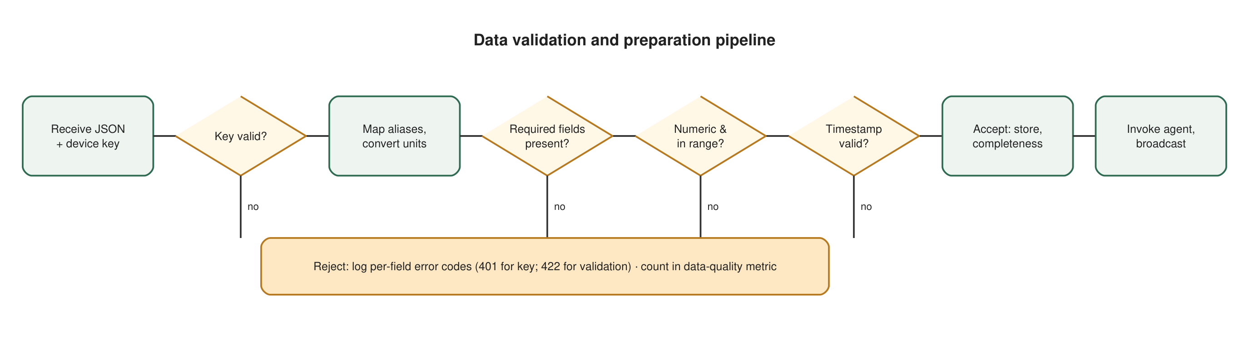
Figure 5.1: Flowchart of the data validation and preparation pipeline
Listing 5.2 — prepare(raw) (pseudocode of server/validate.js)
reading ← {}; errors ← []
for each (key, value) in raw:
field ← ALIASES[key] or key
if field ∈ FIELDS then reading[field] ← value
if raw.units.temperature = 'F' then convert soilTemp, airTemp to °C
if raw.units.rainfall = 'in' then reading.rainfall ← reading.rainfall × 25.4
for each field in FIELDS:
v ← reading[field]
if v is absent: reading[field] ← null; if field ∈ REQUIRED then errors.push({field, 'MISSING'})
else if not numeric(v): errors.push({field, 'NOT_NUMERIC'}); reading[field] ← null
else if v ∉ RANGE[field]: errors.push({field, 'OUT_OF_RANGE', v}); reading[field] ← null
else reading[field] ← round(v, field = 'ph' ? 2 : 1)
t ← parse(raw.ts ?? now)
if t invalid: errors.push('INVALID_TIMESTAMP') else if t > now + 5 min: errors.push('FUTURE_TIMESTAMP')
else if t < now − 24 h: errors.push('STALE_TIMESTAMP')
reading.ts ← iso(t); reading.completeness ← count(present fields) / 9
return { ok: errors = ∅, reading, errors }

The ingest controller wraps this function: it authenticates the device key, increments the received counter, records an accepted or rejected entry in the ingest log with the error codes, stores accepted readings against the zone (capped at 320 readings per zone in the store, with older data available in the CSV export), updates the node's last-contact time and invokes the agent. Rejected readings are therefore never silent: they appear in the analytics view, they count against the data-quality metric, and if more than 10 % of a zone's readings in the last hour are rejected the agent raises a DATA_QUALITY warning. Figure 5.2 shows the analytics view with the ingest log, including a rejected reading caused by an out-of-range moisture value injected by the simulator.
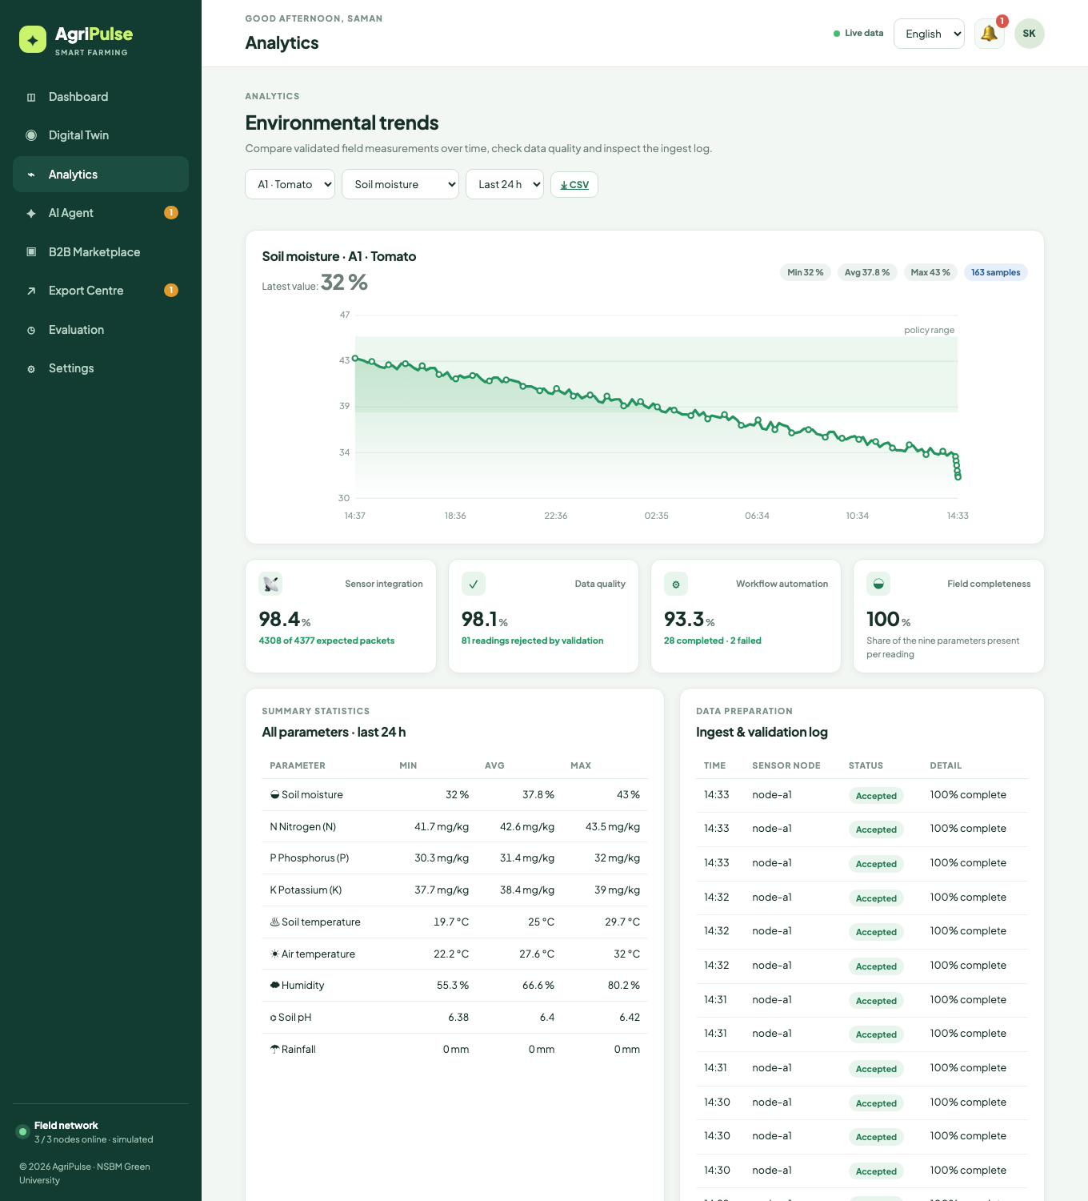
Figure 5.2: Analytics view showing the 24-hour soil-moisture trend with the policy band, summary statistics, data-quality metrics and the ingest and validation log

5.5 AI-Agent Decision Module

5.5.1 Crop policies
The agent's knowledge is expressed as crop policies, one per crop, listing the acceptable range or minimum for each parameter. Table 5.3 shows the three policies encoded for the prototype, derived from Department of Agriculture guidance and the sensing literature reviewed in Chapter 2. Policies are plain data and can be edited by an agronomist without changing the rule logic; changing a zone's crop in Settings switches the policy applied to that zone.
Table 5.3: Crop policies encoded in the prototype
Parameter | Tomato | Chilli | Okra
Soil moisture (%) | 38–45 | 35–45 | 40–50
Soil pH | 6.0–6.8 | 6.0–7.0 | 6.0–6.8
Nitrogen minimum (mg/kg) | 40 | 35 | 35
Phosphorus minimum (mg/kg) | 25 | 25 | 20
Potassium minimum (mg/kg) | 30 | 30 | 30
Air temperature (°C) | 18–32 | 20–33 | 22–35
Soil temperature (°C) | 18–30 | 18–32 | 20–34
Humidity maximum (%) | 80 | 85 | 85

5.5.2 Decision rules and evidence
Figure 5.3 shows the flowchart of the agent's evaluation of one zone, and Listing 5.3 shows the pseudocode. The agent first checks node liveness: if the node has not been heard from for four reporting intervals (minimum 90 seconds), it emits a critical SENSOR_OFFLINE decision with a sensor-check action. If no reading exists it emits NO_DATA. It then computes a confidence value that starts at 0.92 and is reduced when the latest reading is incomplete, older than 30 minutes or when the zone's recent rejection ratio exceeds 10 %, so that the displayed confidence reflects the quality of the evidence. Rainfall over the last hour is accumulated from the recent history. The rules are then evaluated in priority order: irrigation need (with a rain hold that suppresses irrigation when at least 2 mm fell in the last hour), high moisture, nutrient deficiency (all deficient nutrients grouped into one fertigation action), pH low or high, heat or cold stress, disease risk (humidity above the policy maximum with warm air), rain event (which carries a cancel-irrigation action), data quality, stale data and, if nothing else was raised at warning level or above, a HEALTHY decision. Each decision carries a code, a severity (critical, warning, info, good), the parameters needed to render it in any language, an evidence list of (metric, value, threshold, relation) tuples, a rule identifier, the policy applied, the confidence and a timestamp. Irrigation duration is derived from the moisture deficit (three minutes per percentage point, bounded between 8 and 30 minutes).
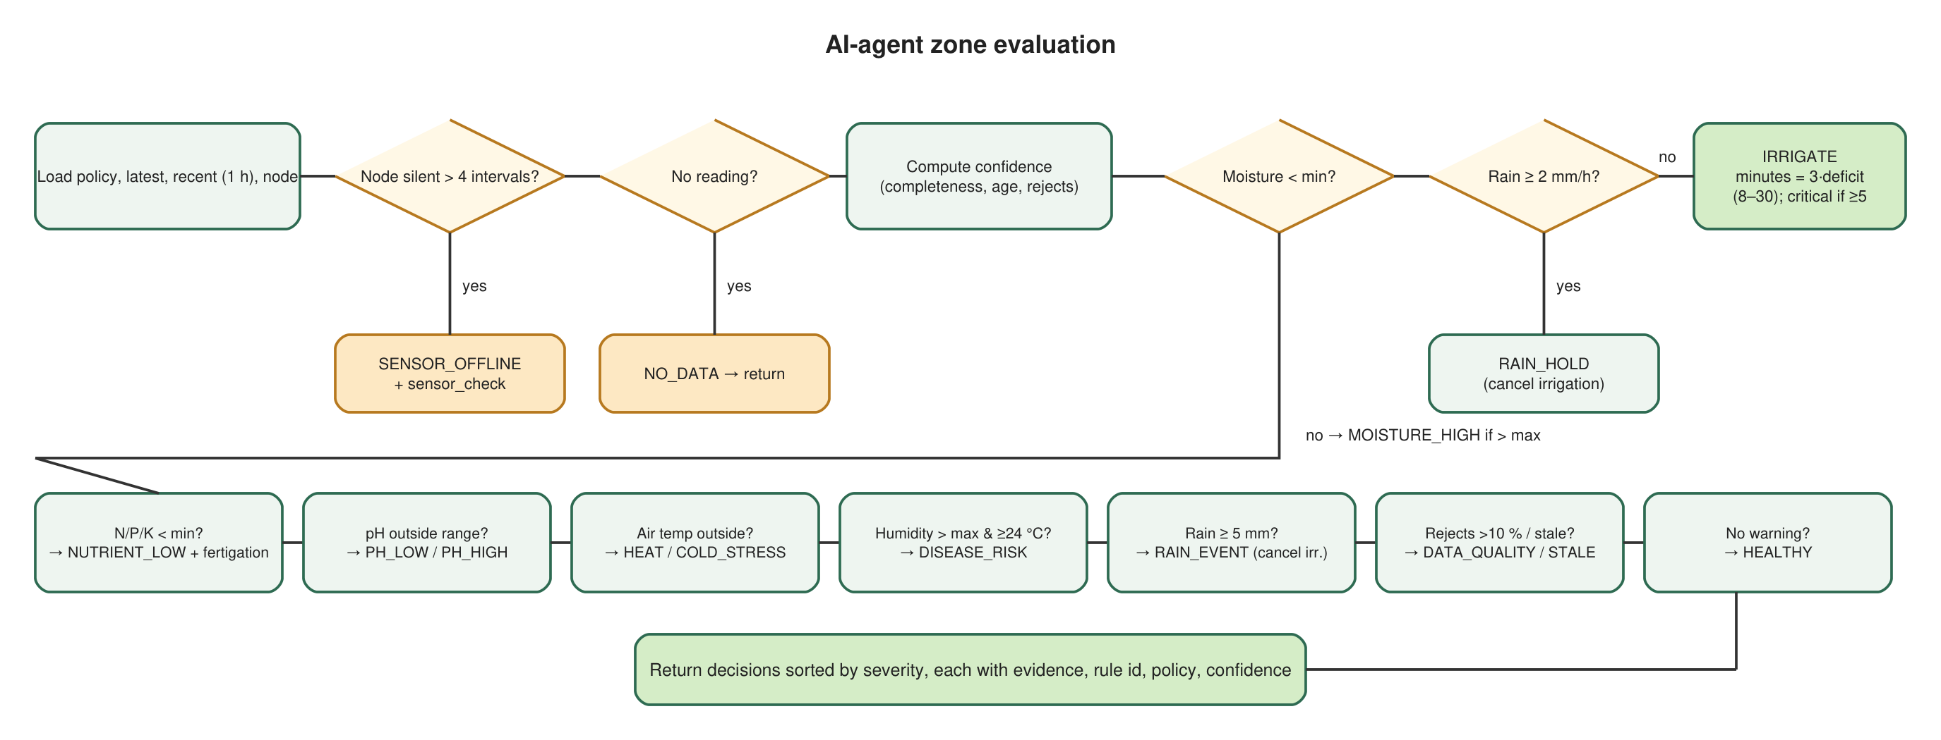
Figure 5.3: Flowchart of the AI-agent zone evaluation
Listing 5.3 — evaluateZone(zone, latest, recent, node) (pseudocode of server/agent.js)
policy ← POLICIES[zone.crop]; decisions ← []
if node.lastSeen older than max(90 s, 4 × interval): push(SENSOR_OFFLINE, critical, action: sensor_check)
if latest is null: push(NO_DATA, warning); return decisions
confidence ← 0.92 − 0.07·[completeness < 1] − 0.25·[age > 30 min] − 0.10·[rejectedRatio > 0.1]
rain1h ← Σ rainfall of readings in last 60 min
if latest.moisture < policy.moisture.min:
if rain1h ≥ 2 or latest.rainfall ≥ 3: push(RAIN_HOLD_IRRIGATION, info)
else: deficit ← min − moisture; minutes ← clamp(3·deficit, 8, 30)
push(IRRIGATE, deficit ≥ 5 ? critical : warning, evidence: [moisture < min, rain1h < 2], action: irrigation(minutes))
else if latest.moisture > policy.moisture.max: push(MOISTURE_HIGH, info)
low ← { n ∈ {N,P,K} : latest[n] < policy[n] }; if low ≠ ∅: push(NUTRIENT_LOW, warning, action: fertigation(low))
if latest.ph < policy.ph.min: push(PH_LOW, warning) else if latest.ph > policy.ph.max: push(PH_HIGH, warning)
if latest.airTemp > policy.airTemp.max: push(HEAT_STRESS, warning) else if < min: push(COLD_STRESS, info)
if latest.humidity > policy.humidityMax and latest.airTemp ≥ 24: push(DISEASE_RISK, warning)
if latest.rainfall ≥ 5: push(RAIN_EVENT, info, action: cancel_irrigation)
if rejectedRatio > 0.1: push(DATA_QUALITY, warning); if age > 30 min: push(STALE_DATA, warning)
if no decision has severity ∈ {critical, warning}: push(HEALTHY, good)
return decisions sorted by severity

The evidence list is what makes the agent explainable. The interface renders each decision with a "Why was this suggested?" section that lists every evidence item in the user's language (for example "Soil moisture 32 % is below 38 %; Rainfall (last hour) 0 mm is below 2 mm; Rule R-IRRIGATE, tomato policy; Confidence 92 %"). Figure 5.4 shows the agent console with an irrigation decision expanded, the pending workflow awaiting approval and the trilingual assistant, in Sinhala.
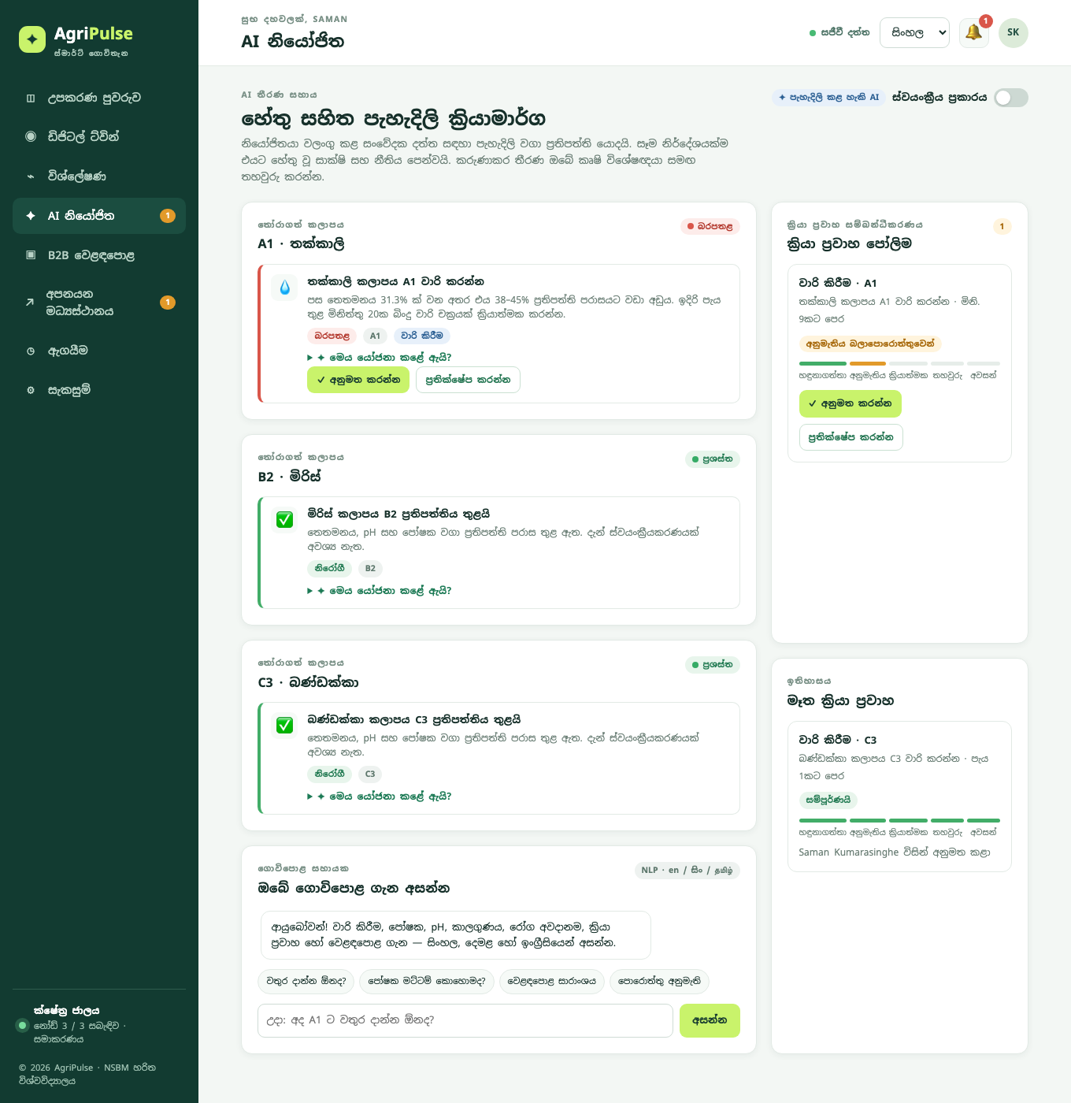
Figure 5.4: AI-agent console in Sinhala, showing an irrigation decision with its evidence, the workflow queue and the farm assistant

5.5.3 Alerts and decision log
After each evaluation the alert manager raises an alert for each warning or critical decision that does not already have an open alert (updating the parameters and occurrence count of existing alerts), and resolves open alerts whose condition has cleared. Unread alerts are shown in the header bell in every view, and the full list, with severity and time, is available in the alerts menu. Whenever the set of decision codes for a zone changes, the decision log records the new set with its evidence and confidence, giving a compact history of state transitions that supports retrospective evaluation without storing every evaluation.

5.5.4 Trilingual assistant
The assistant classifies a free-text question into one of ten intents (irrigation, nutrients, pH, weather, disease, market, export, workflow, help, status) by matching keyword stems in English, Sinhala and Tamil, and detects a zone identifier (A1, B2, C3) if present. The classifier is deliberately simple: each intent has a list of stems (for irrigation: irrigat, water, moisture, dry, වතුර, ජල, වාරි, තෙතමන, நீர், பாசன, ஈரப்பத, and so on) and the intent with the most matches wins, defaulting to a status summary. The reply is composed on the client from the same snapshot that drives the dashboard, so the assistant can never contradict the displayed data: for the irrigation intent, for example, it reports each zone's moisture against its policy target and quotes the current irrigation decision if one exists. The interaction is logged with its intent for evaluation.

5.6 Workflow Orchestration Engine
Figure 5.5 shows the workflow state machine. Three workflow types are defined: irrigation and fertigation, which require approval and drive an actuator, and sensor check, which requires acknowledgement only. When the agent emits a decision with an action, the engine first checks that no open workflow of that type exists for the zone (preventing duplicates as readings arrive every few seconds), then creates the workflow with the originating decision embedded (code, parameters, evidence, rule and confidence) and an ordered list of steps: detected, approval, execute, verify and completed. The detected step is marked done by the agent. If the farm is in autonomous mode the engine immediately approves the workflow on the agent's behalf and records "AI agent" as approver; otherwise the workflow waits in the pending state, is shown with an amber badge on the dashboard and agent console, and increments the navigation badge.
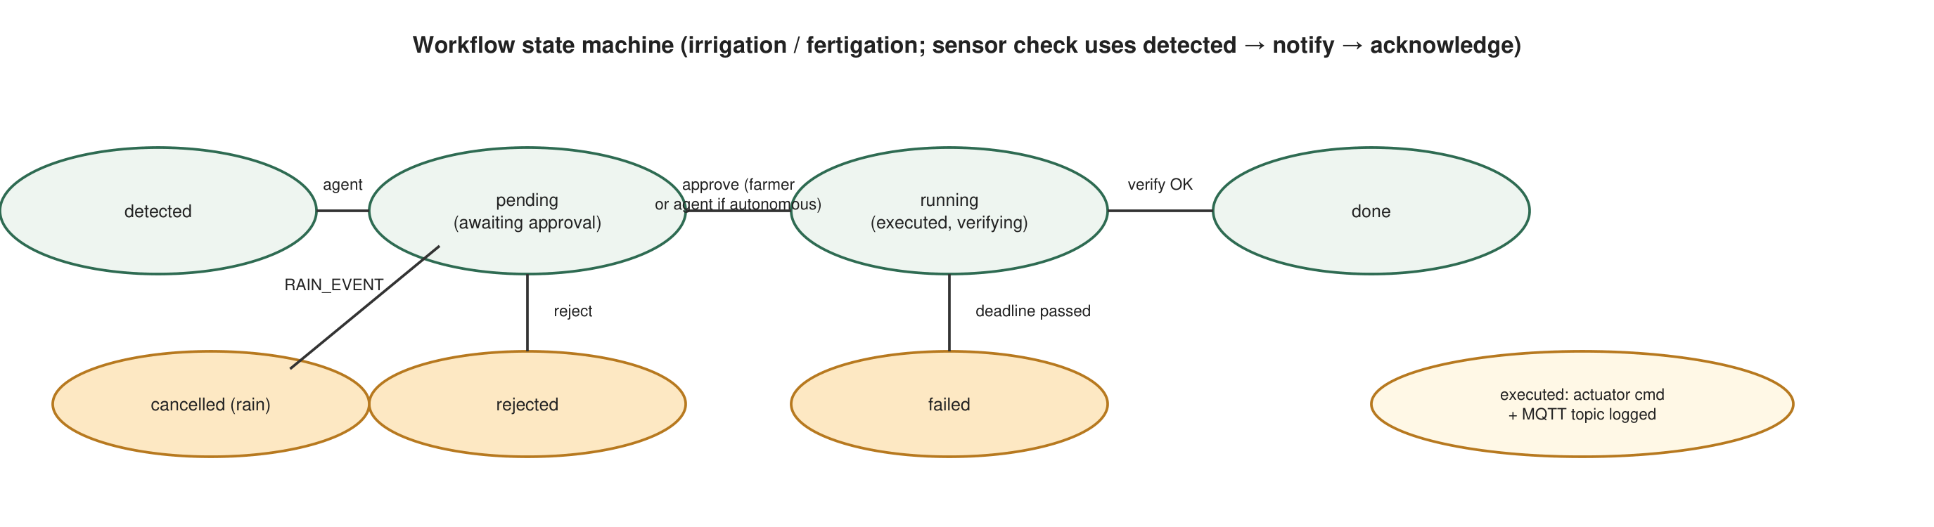
Figure 5.5: Workflow state machine with approval, execution and verification
On approval the engine records the approver, builds an actuator command (actuator name, zone, parameters and MQTT topic agripulse/{farm}/{zone}/actuator/{actuator}), either applies it to the simulator or logs it for the MQTT bridge, marks the execute step done, sets a verification deadline eight minutes ahead and moves the workflow to running. A housekeeping tick, run after every accepted reading and every fifteen seconds, then verifies running workflows: an irrigation workflow completes when a reading taken after execution shows moisture at or above the policy minimum, and a fertigation workflow when every deficient nutrient has recovered. If the deadline passes without verification the workflow is marked failed and counted in the failure statistic, which feeds the workflow-automation metric. Rain events and rain holds cancel pending irrigation workflows with the reason recorded. Listing 5.4 shows the verification tick.
Listing 5.4 — tick() verification (pseudocode of server/workflows.js)
for each workflow w with status = running:
policy ← POLICIES[zone(w).crop]
latest ← last reading of w.zone with ts > w.executedAt
ok ← false
if latest exists:
if w.type = irrigation: ok ← latest.moisture ≥ policy.moisture.min
if w.type = fertigation: ok ← ∀ n ∈ w.params.nutrients: latest[n] ≥ policy[n]
if ok: mark steps verify, completed done; w.status ← done; stats.completed++
else if now > w.verifyDeadline: mark verify failed; w.status ← failed; stats.failed++

Figure 5.6 shows the execution evidence: the workflow queue after approval, with the step timeline showing detected, approval (by the farmer), execute (command topic recorded) and verify in progress, followed by completion after the next reading.
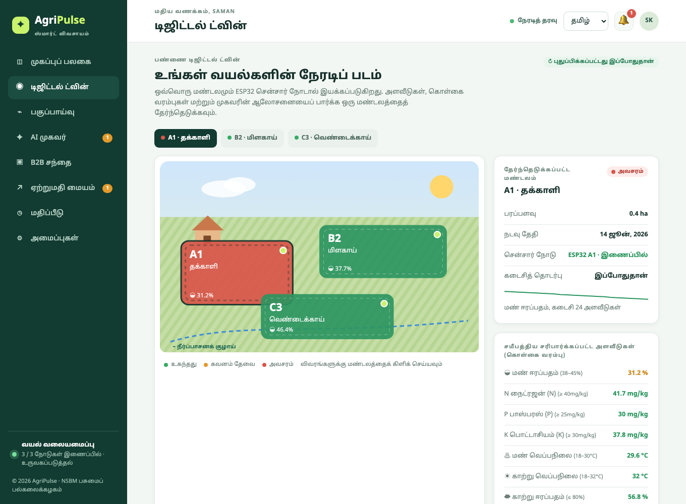
Figure 5.6: Digital-twin view of zone A1 in Tamil, showing readings against policy ranges, node status, the moisture sparkline, the AI advice and scenario controls

5.7 Web Application Layer and Digital-Twin Interface

5.7.1 Application structure
The web application is a single-page application served as static files by the same Node.js process that hosts the API. The client keeps a small state object (user, language, current page, latest dashboard snapshot, per-page data) and renders each view from that state using template functions; a hash-based router selects the view, and a delegated event handler dispatches data-action attributes to handler functions, which keeps the code free of per-element listener management. On sign-in the client fetches the dashboard snapshot (zones with latest readings, policies, decisions and node status; alerts; workflows; logs; statistics; metrics; market summary) and opens a Server-Sent Events connection; whenever the server broadcasts an update, ingest, B2B or log event, the client debounces a refresh of the snapshot and re-renders the current view. The API is a REST interface of forty-two endpoints over JSON, grouped into authentication, farm and twin, ingest, agent and workflows, evaluation and B2B, and every error is returned as a machine-readable code that the client translates.

5.7.2 Digital-twin dashboard
The dashboard (Figure 5.7) is the farmer's home view. A hero panel summarises the farm state in one sentence (for example, "1 zone needs urgent action"), the number of zones within policy and the number of workflows awaiting approval, with farm-average air temperature, humidity and rainfall. Eight metric tiles show the farm averages of the nine parameters with a note of how many zones are outside their policy range. Below, the zone map, drawn as an SVG scene with plots coloured by status (green optimal, amber attention, red critical) and a node-liveness dot, sits beside the current recommendations with their evidence; a third row shows the workflow queue, the system log and the B2B activity summary. Figure 5.8 shows the same dashboard rendered in Sinhala and Tamil, demonstrating that the whole view, including server-generated recommendations and log entries, is translated.
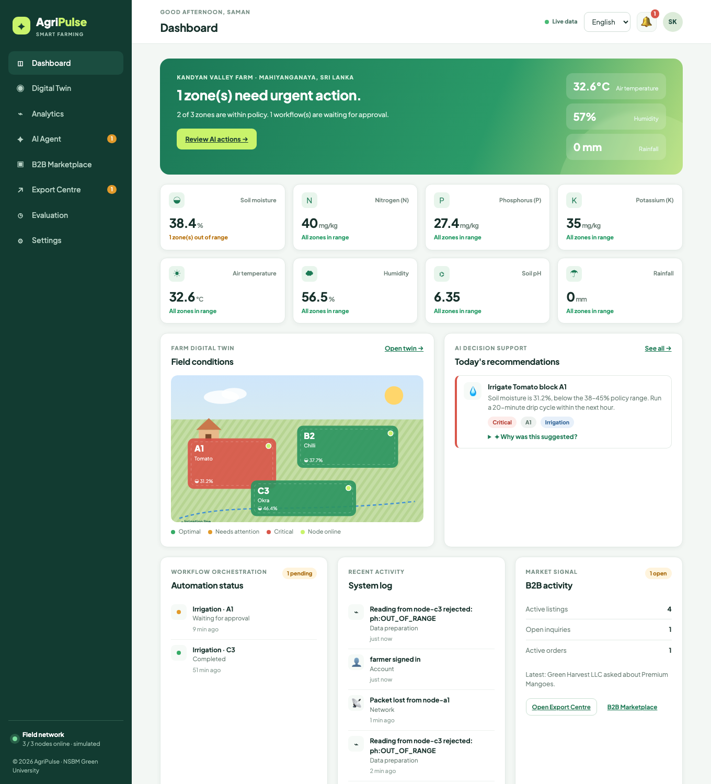
Figure 5.7: Dashboard (digital-twin overview) in English
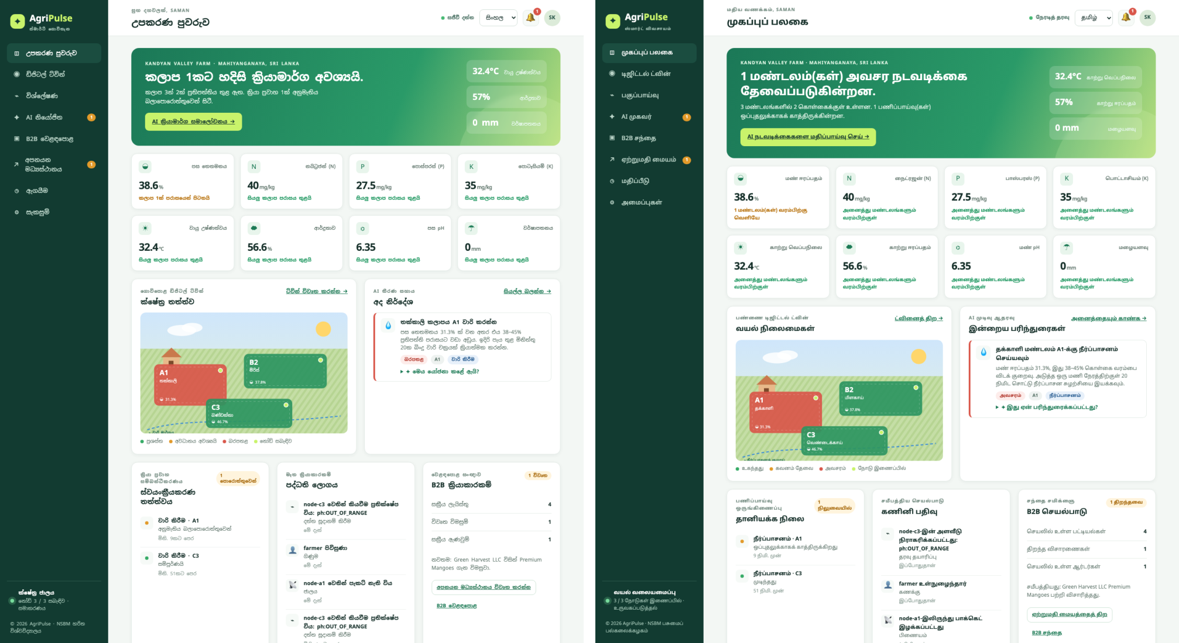
Figure 5.8: The same dashboard rendered in Sinhala (left) and Tamil (right)
The zone twin view (Figure 5.6) enlarges the scene, lets the user select a zone, and lists all nine readings against the policy ranges with colour-coded status, the node's label, liveness and last contact, a sparkline of the last 24 moisture readings, the top recommendation with evidence, and, when simulation is on, scenario controls. The analytics view (Figure 5.2) charts any parameter over 6, 24 or 72 hours with the policy band shaded, shows minimum, average and maximum, the sensor-integration, data-quality and workflow metrics, per-reading completeness and the ingest log, and exports CSV.

5.7.3 Trilingual design
The trilingual capability is a design property rather than a translation pass. Every string the user can see, including navigation, forms, decisions, workflow steps, export stages, documents, validation errors, API error codes and system log entries, is a key in a dictionary with English, Sinhala and Tamil entries (531 keys per language at the time of writing) and placeholder parameters. The server never sends prose: decisions are sent as codes with parameters and evidence, errors as codes, and logs as codes with metadata, and the client renders them in the active language. A parity check in the build verifies that the three dictionaries have identical key sets and identical placeholders. Crop names, nutrient names and units are themselves translated before interpolation, so that a Sinhala recommendation reads naturally. Dates, times, numbers and currencies are formatted with the browser's Intl API for the active locale, and relative times use dictionary strings because browser support for Sinhala and Tamil relative-time formatting is inconsistent. The language is chosen at login, stored in the user's profile and in local storage, and the document language attribute is set so that the correct Noto font family and line-height are applied; Sinhala and Tamil headings receive a larger line-height and no letter-spacing because the scripts have taller ascenders and stacked marks. Listing 5.5 shows the translation function and an example key in the three languages.
Listing 5.5 — translation with parameters (public/i18n.js, abridged)
t(lang, key, params) = interpolate((dict[lang][key] ?? dict.en[key] ?? key), params)
en: 'decision.IRRIGATE.detail': 'Soil moisture is {moisture}%, below the {min}–{max}% policy range. Run a {minutes}-minute drip cycle within the next hour.'
si: 'decision.IRRIGATE.detail': 'පස තෙතමනය {moisture}% ක් වන අතර එය {min}–{max}% ප්‍රතිපත්ති පරාසයට වඩා අඩුය. ඉදිරි පැය තුළ මිනිත්තු {minutes}ක බිංදු වාරි චක්‍රයක් ක්‍රියාත්මක කරන්න.'
ta: 'decision.IRRIGATE.detail': 'மண் ஈரப்பதம் {moisture}%, இது {min}–{max}% கொள்கை வரம்பை விடக் குறைவு. அடுத்த ஒரு மணி நேரத்திற்குள் {minutes} நிமிட சொட்டு நீர்ப்பாசன சுழற்சியை இயக்கவும்.'

The interface is responsive: below 900 pixels the sidebar becomes an off-canvas drawer, grids collapse to one column, and menus are repositioned; Figure 5.9 shows the dashboard and agent console on a phone in Tamil and Sinhala.
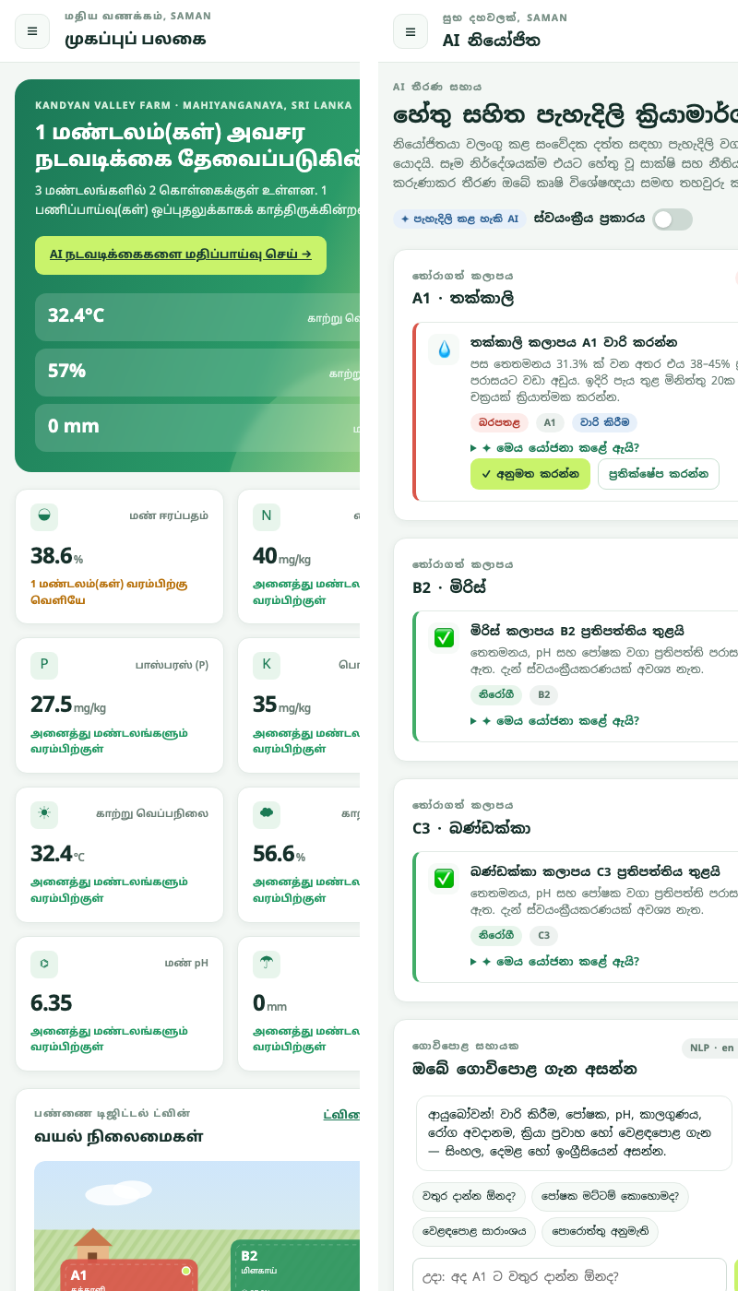
Figure 5.9: Mobile layout: dashboard in Tamil (left) and agent console in Sinhala (right)

5.8 Global B2B E-Commerce Layer

5.8.1 Listings linked to live field data
The marketplace (Figure 5.10) presents product listings as cards with the product's emoji, grade, price and unit, target market, quantity, category, certifications, seller and farm, harvest date and description. The distinctive feature is the optional link between a listing and a monitored zone: when linked, the card shows a "Live farm data" badge coloured by the zone's current status and the zone's latest soil moisture with its age, so that a buyer sees evidence of current field conditions beside the commercial data. Listings are created and edited through a validated form by the farmer, can be archived and restored, and are filtered by category, searched by text and, for the seller, restricted to "My listings".
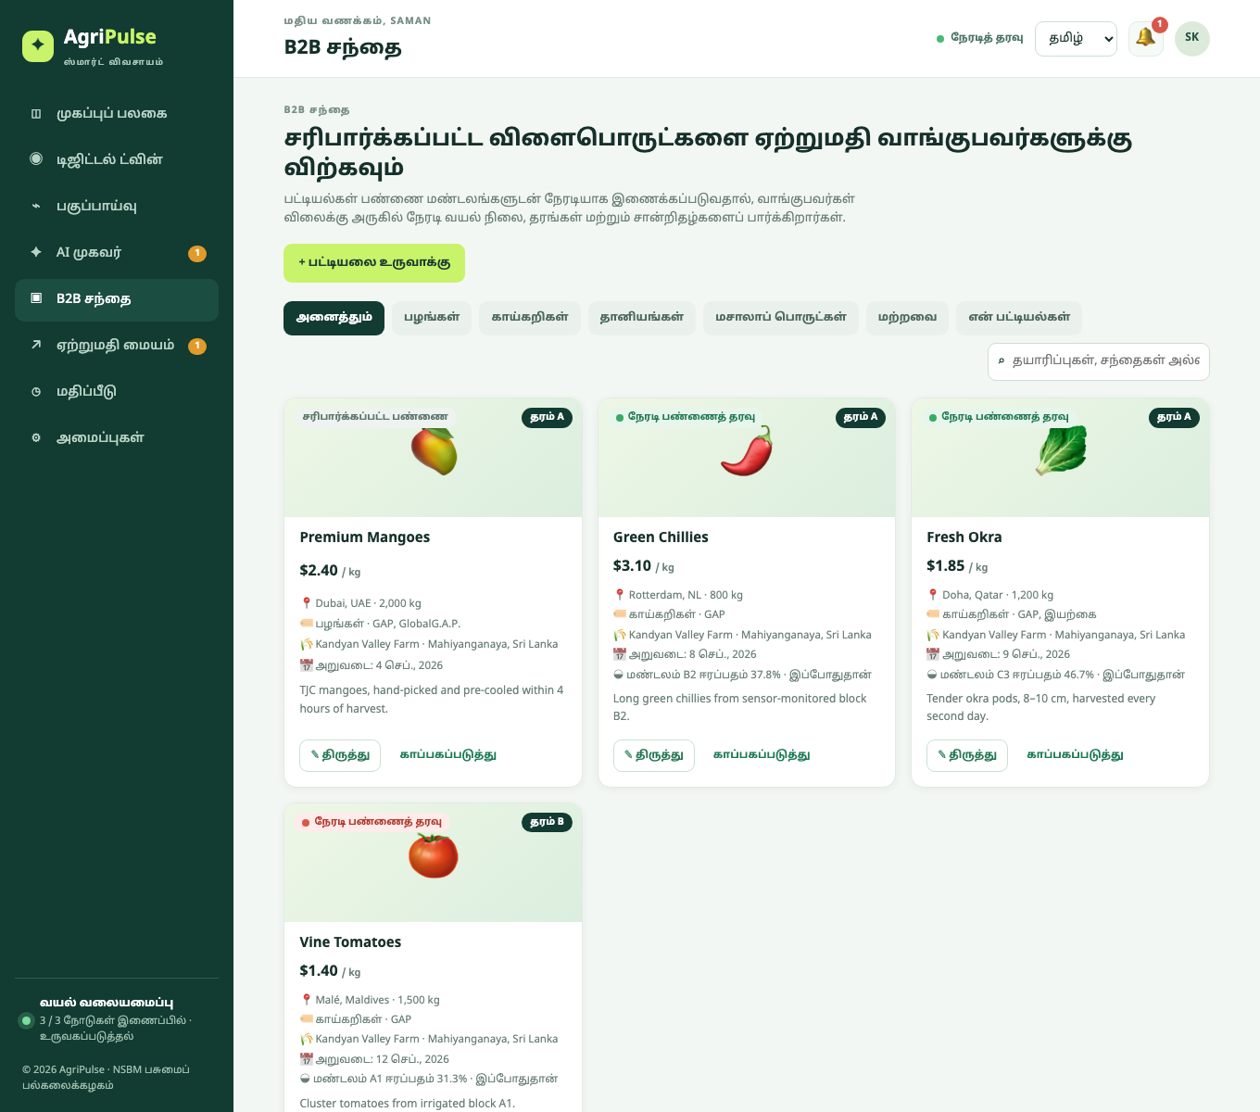
Figure 5.10: B2B marketplace in Tamil, showing listings with live farm-data badges, grades and certifications

5.8.2 Inquiry threads and quotation-to-order conversion
A buyer sends an inquiry from a listing with a wanted quantity and a message pre-filled in the buyer's language; the server creates a thread (or reuses the buyer's open thread for that listing) and notifies the seller through a Server-Sent Event. Both parties exchange messages in the Export Centre (Figure 5.11), and either may close the thread. The seller converts an open inquiry into an export order by entering quantity, price, destination and incoterm (FOB, CIF or EXW); the server creates the order at the quotation stage with the buyer, seller and product references, a document checklist and an unpaid payment record, marks the inquiry converted and posts a system message into the thread.
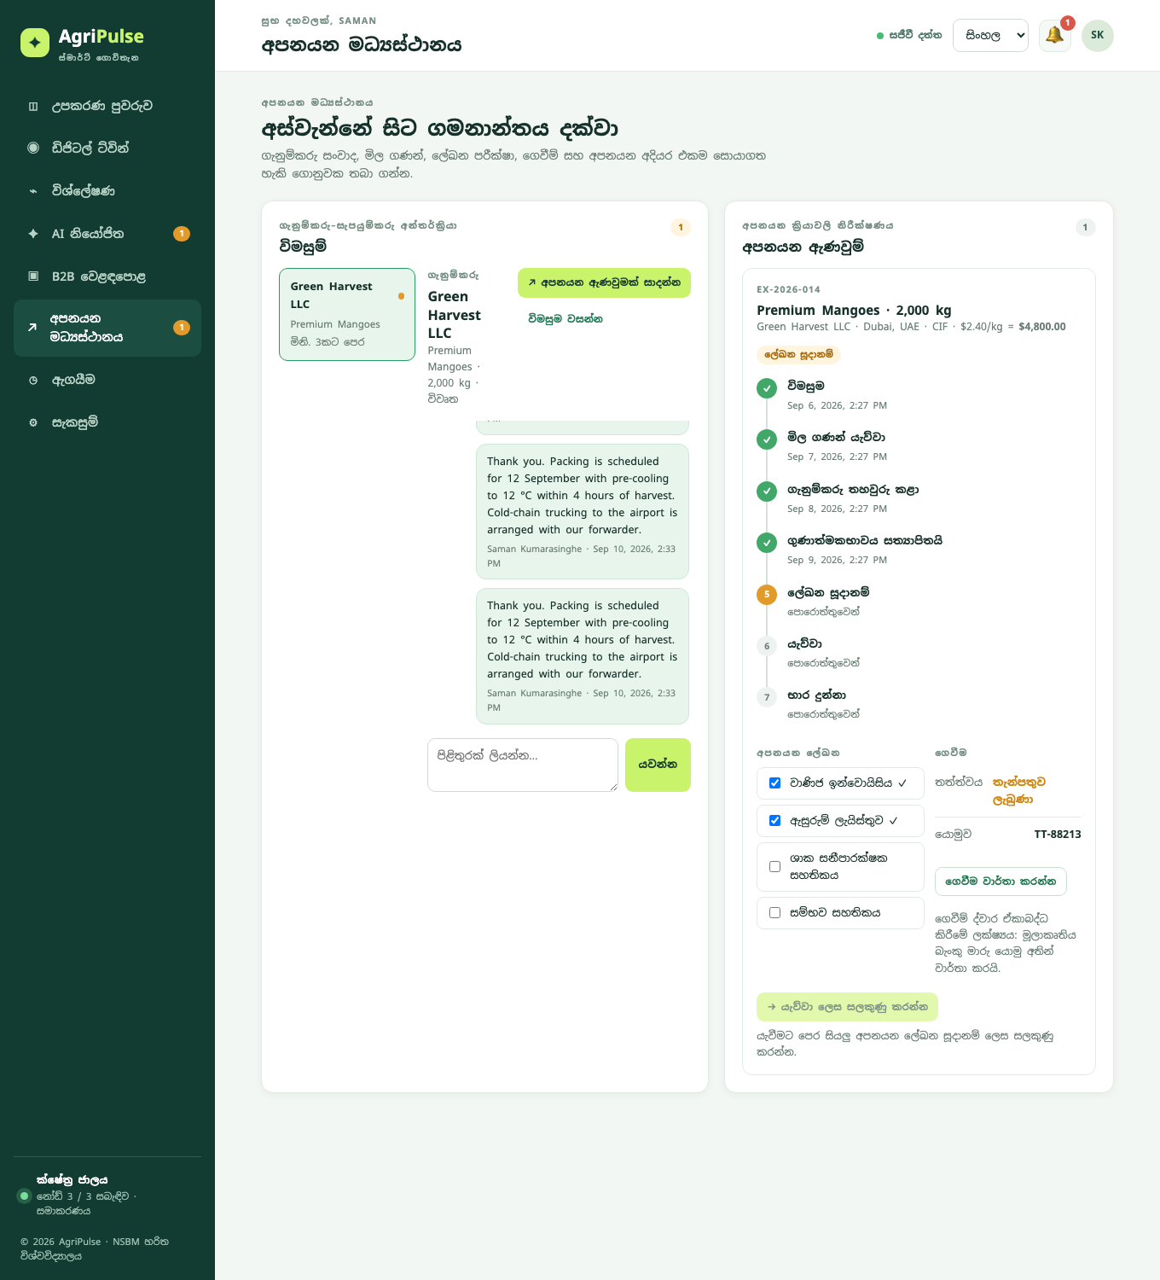
Figure 5.11: Export Centre in Sinhala: inquiry thread with reply composer (left) and export order with stage timeline, document checklist and payment status (right)

5.8.3 Seven-stage export process
Orders progress through inquiry, quotation sent, buyer confirmed, quality verified, documents ready, dispatched and delivered. Listing 5.6 shows the stage-advance rule. Only the buyer may confirm the quotation; only the seller may advance the other stages (the buyer may confirm delivery); marking all four documents ready automatically advances a quality-verified order to documents ready; and dispatch is refused until all documents are ready and at least a deposit has been recorded. Each transition records the timestamp and actor, giving the traceability that export buyers and certification bodies require.
Listing 5.6 — advance(order, user) (pseudocode of server/api.js)
next ← STAGES[order.stage + 1]; isBuyer ← user = order.buyer
if next = buyer_confirmed and not isBuyer: reject BUYER_MUST_CONFIRM
if next ≠ buyer_confirmed and isBuyer and next ≠ delivered: reject SELLER_ONLY
if next = dispatched and not all documents ready: reject DOCUMENTS_INCOMPLETE
if next = dispatched and payment = unpaid: reject PAYMENT_REQUIRED
mark current stage done; order.stage++; mark new stage current (or done if delivered); record ts, actor

5.8.4 Payment-integration interface
Consistent with the thesis scope, external payment and logistics services are attached through explicit interfaces rather than implemented. The payment endpoint accepts a status (deposit or paid), a provider and a reference; the prototype records bank-transfer references entered by either party, and the interface note in the user interface states that a gateway adapter would replace this handler. Because the export-stage rules consume only the payment status, a gateway integration would not change the rest of the module.

5.9 Evaluation Instrumentation
A distinctive implementation feature is that the artefact computes the six thesis evaluation metrics from its own logs and presents them on an evaluation page (Figure 5.12), so that every DSRM demonstration and evaluation cycle can be assessed against Table 3.4 without external tooling. Sensor integration is the ratio of received to expected packets, where the simulator and the node reporting interval define expectation; data quality is the ratio of accepted to received readings; AI decision support is the agreement of the agent with the fifteen predefined scenarios, run on demand; workflow automation is the ratio of completed to completed-plus-failed workflows; web usability is the mean SUS score from questionnaires submitted through the page; and B2B functionality is the proportion of representative buyer–supplier workflows (inquiries answered or converted, orders confirmed) that completed. The scenario suite deliberately includes two scenarios (S14 and S15) whose expected outcome was fixed by expert judgement rather than by the encoded rules, so that agreement is measured rather than assumed; the agent disagrees with both, which is reported honestly as 13 of 15.
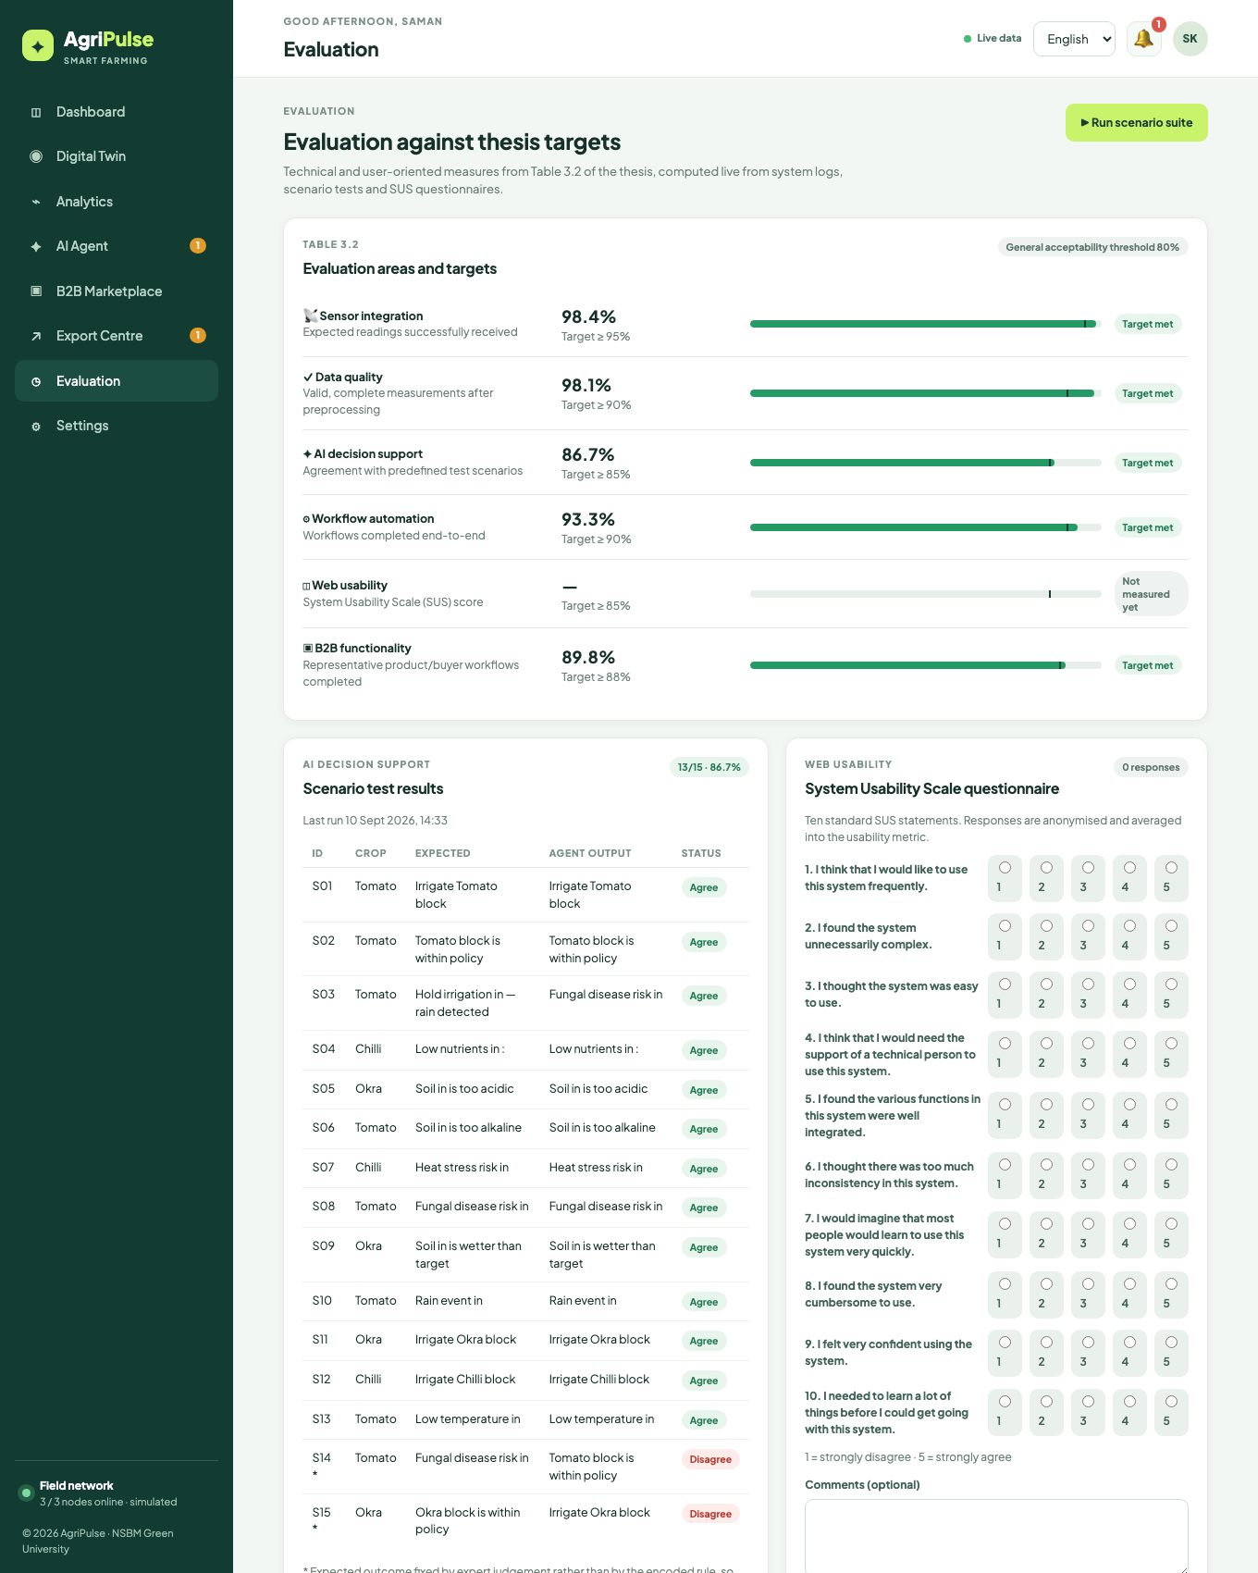
Figure 5.12: Evaluation page computing the Table 3.2 metrics live, with the scenario suite results and the SUS questionnaire

5.10 Security, Persistence and Deployment

5.10.1 Security
Passwords are hashed with scrypt using a per-user random salt and compared in constant time. Sessions are random 256-bit tokens stored with a 30-day expiry, delivered as HTTP-only, SameSite cookies (marked Secure behind HTTPS) and also accepted as bearer tokens for API clients; logout revokes the session and changing the password revokes all other sessions. Login is rate-limited to six failed attempts per address per fifteen minutes. Every response carries a Content Security Policy that permits scripts only from the application origin and fonts only from Google Fonts, together with nosniff, frame-denial, referrer and permissions headers. Request bodies are limited to one megabyte and parsed strictly; every field is validated and length-limited server-side, and all user-provided text is escaped before rendering to prevent cross-site scripting. Sensor nodes authenticate with per-device keys that can be rotated from Settings. Authorisation is role-based: farm, workflow, device and evaluation-run endpoints are restricted to farmers; listings can be modified only by their owner; inquiry threads and orders are visible only to their two parties; and stage rules enforce who may advance an order.

5.10.2 Persistence
The document store is a single JSON file written atomically (write to a temporary file, then rename) and debounced so that bursts of readings do not cause repeated disk writes. A schema version in the file allows migration; an unparseable file is backed up and reseeded rather than crashing the server. Per-zone readings are capped in the store and older data is available through CSV export, and logs, ingest entries and resolved alerts are trimmed to bounded lengths. This design is adequate for a farm-scale prototype and keeps the data inspectable; the data-access functions are isolated in one module so that a relational or document database can replace the file without changes to the rest of the system.

5.10.3 Deployment
The system starts with a single command on any host with Node.js 18 or later, seeds demonstration data on first start and needs no package installation. A Dockerfile builds a container with a persistent data volume and a health check, and environment variables configure the port, data directory and cookie security. The README documents local, Docker and platform-as-a-service deployment, node integration and the API. The dashboard, twin and agent views were verified in current Chrome, Safari and Firefox on desktop, tablet and phone viewports.

5.11 Chapter Summary
This chapter documented the design and implementation of the artefact across its six layers, justified each technology choice against alternatives, and elaborated the logic of the contribution-bearing components, the validation pipeline, the explainable rule-based agent, the workflow engine with verification, the trilingual digital-twin interface, the B2B export module and the self-evaluating instrumentation, with flowcharts, pseudocode, dictionary excerpts and screenshots synchronised with execution. Security, persistence and deployment were described. Chapter 6 now reports how the artefact was tested and evaluated against the thesis targets.

CHAPTER 6 — TESTING AND EVALUATION

6.1 Chapter Overview
This chapter reports how the artefact was tested and evaluated, and relates the results to the six thesis targets and the five research sub-questions. Section 6.2 justifies the testing and evaluation strategies selected, Section 6.3 presents the test plan and the ten principal test cases, Section 6.4 reports non-functional testing (performance, reliability, security, compatibility and localisation), Section 6.5 reports functional testing, and Section 6.6 describes the evaluation workflow that produced the quantitative results: the instrumented measurement run, the automated scenario suite and the structured user evaluation. Section 6.7 presents the results against the targets with numeric tables and graphs, Section 6.8 reviews the strategies used, and Section 6.9 summarises the chapter. Additional test cases are listed in Appendix B.

6.2 Justification of the Testing and Evaluation Strategies
Because the artefact is the outcome of a Design Science Research project, testing served two purposes: verification that the software meets its requirements (the conventional purpose of testing) and evaluation of the artefact's utility against the objectives (the DSRM purpose). Five strategies were selected, each justified by the nature of the component it addresses.
- End-to-end functional testing through the HTTP API was selected as the primary verification strategy because the system's behaviour is defined by its API and because tests that start the real server and exercise real requests catch integration faults that unit tests of individual modules would miss. Sixteen automated tests, executed with the Node.js test runner and covering all six layers, run in under five seconds and were executed after every change.
- Scenario-based evaluation of the AI agent was selected because rule-based decision support cannot meaningfully be evaluated by accuracy against a labelled dataset; instead, fifteen field scenarios with expected outcomes were defined in advance, two of them by expert judgement rather than from the rules, and agreement was measured. This corresponds directly to the "agreement / quality score against predefined test scenarios" metric of Table 3.4.
- Instrumented measurement was selected for sensor integration, data quality and workflow automation because these are properties of the running system over time, not of individual requests. A twenty-minute run with the simulated node network reporting every five seconds, with scenario injections every ninety seconds to exercise workflows, produced 733 expected readings and eleven workflows, and the metrics were read from the artefact's own evaluation endpoint every minute.
- Non-functional testing (latency and concurrency measurement, restart and corruption tests, security review, cross-browser and dictionary-parity checks) was selected to verify the ISO/IEC 25010 requirements of Section 4.11.
- Structured user evaluation with task-based sessions and the System Usability Scale was selected for usability because SUS is a validated, language-independent instrument with published interpretation benchmarks (Brooke, 1996; Bangor, Kortum and Miller, 2009), and because task completion provides an objective complement to the subjective score.
Strategies that were considered and rejected include unit testing with mocks (rejected as the primary strategy because the value of the artefact lies in integration), load testing to failure (rejected because farm-scale deployments involve tens rather than thousands of clients) and A/B comparison with an existing product (rejected because no comparable integrated product was available; the comparison is made qualitatively in Chapter 2).

6.3 Test Plan and Test Cases
The test plan mapped each functional requirement to at least one automated test or manual test case, assigned severity levels, and defined the environments: the developer workstation for automated tests, headless and real browsers for interface tests, and a bench ESP32 node for hardware ingest. Table 6.1 lists the ten principal test cases; the remaining cases (TC-11 to TC-24) are in Appendix B.
Table 6.1: Principal test cases
ID | Requirement | Test description | Input / steps | Expected result | Actual result | Status
TC-01 | FR-18, NFR-05 | Authentication and session handling | Register farmer; register duplicate; login wrong password; call protected route anonymously | 201 then 409 EMAIL_EXISTS; 401 INVALID_CREDENTIALS; 401 UNAUTHENTICATED | As expected | Pass
TC-02 | FR-01, FR-02 | Ingest with aliases and unit conversion | POST soil_moisture 41, n/p/k, temperature 84.2 with units.temperature = F, pH 6.4 via device key | 201; stored airTemp 29.0 °C, moisture 41 | airTemp 29, moisture 41 | Pass
TC-03 | FR-03 | Rejection of invalid reading | POST moisture 260 with airTemp missing; POST with unknown key | 422 with OUT_OF_RANGE (moisture) and MISSING (airTemp); 401 INVALID_DEVICE_KEY | As expected | Pass
TC-04 | FR-06, FR-07 | Agent produces actionable irrigation decision | Seed zone A1 at 34 % moisture (tomato policy 38–45) | Dashboard shows IRRIGATE decision with evidence and a pending irrigation workflow | Decision and workflow present | Pass
TC-05 | FR-09, FR-10 | Workflow approval, execution and verification | Approve pending irrigation; approve again | 200 with execute step done and status running or done; second approve returns 409 WORKFLOW_STATE | As expected | Pass
TC-06 | FR-23 | Scenario suite meets target | POST /api/evaluation/run | 15 scenarios; agreement ≥ 85 %; metric equals suite result | 13/15, 86.7 % | Pass
TC-07 | FR-16 | Multilingual assistant intent detection | "A1 වතුර දාන්න ඕනද?", "இன்றைய விலை என்ன?", "Do I need fertiliser in B2?" | irrigation; market; zone B2 detected | As expected | Pass
TC-08 | FR-19 to FR-22 | Full B2B flow | Buyer inquiry on okra → seller reply → convert to order → seller tries to confirm → buyer confirms → quality verified → four documents → dispatch without payment → deposit → dispatch | 201; 2 messages; order at stage 1; 403 BUYER_MUST_CONFIRM; stage 2; stage 3; stage 4 auto; 409 PAYMENT_REQUIRED; stage 5 | As expected | Pass
TC-09 | FR-19, NFR-05 | Listing validation and ownership | Create listing with quantity 0; create valid listing linked to A1; buyer edits it; owner deletes | 400 INVALID_PRODUCT; 201 with live status; 403 NOT_OWNER; 200 | As expected | Pass
TC-10 | FR-17, NFR-09 | Dictionary parity and rendering in three languages | Automated key and placeholder comparison; render every view in en, si, ta on desktop and phone | 531 keys in each language, identical placeholders; no untranslated string visible | 0 missing keys, 0 placeholder mismatches; screenshots in Chapter 5 | Pass

6.4 Non-Functional Testing

6.4.1 Performance efficiency (NFR-01)
Latency was measured at the end of the instrumented run on the development workstation (Apple silicon laptop, Node.js 18), with the simulator active and the store containing twenty minutes of readings. Two hundred sequential dashboard requests, which return the full farm snapshot (three zones with readings, decisions, alerts, workflows, logs, statistics and metrics), and one hundred sequential ingest requests were timed, and fifty dashboard requests were issued concurrently. Table 6.2 shows the results. All targets were met with a wide margin: the 95th-percentile dashboard latency was 2.2 ms against a 200 ms target, ingest 1.4 ms against 50 ms, and fifty concurrent dashboard requests completed in 55.9 ms in total. The single 38.2 ms maximum coincided with a debounced persistence write.
Table 6.2: Latency and concurrency measurements
Measurement | Average (ms) | Median (ms) | 95th percentile (ms) | Maximum (ms) | Target
GET /api/dashboard (200 sequential) | 1.5 | 1.2 | 2.2 | 38.2 | p95 ≤ 200
POST /api/ingest (100 sequential) | 0.6 | 0.5 | 1.4 | 2.4 | p95 ≤ 50
GET /api/dashboard (50 concurrent) | 55.9 total | — | — | — | complete without error

6.4.2 Reliability and availability (NFR-02, NFR-03)
Persistence was tested by terminating the server process during a burst of readings and restarting it: the atomic write-and-rename strategy left a consistent store on every one of ten trials, and sessions created before the restart remained valid afterwards. A corrupted store (truncated file) was detected at start-up, moved to a backup file and replaced by a fresh seed without the server failing. Restart time from process start to first successful health response was under two seconds in all trials. During the twenty-minute run no reading that reached the server was lost: every received reading appears either as an accepted reading or as a logged rejection.

6.4.3 Security (NFR-05)
A security review against the OWASP Top Ten categories was performed by inspection and by targeted requests. Table 6.3 summarises the checks. All authentication, authorisation, injection and configuration checks passed; one advisory finding (session cookies are marked Secure only when the SECURE_COOKIES setting or a forwarded-HTTPS header is present) is documented in the deployment guide.
Table 6.3: Security review checks
Category | Check | Result
Broken access control | Buyer calls farmer-only routes; non-owner edits listing; third party reads an inquiry; seller confirms quotation | 403 FARMER_ONLY, 403 NOT_OWNER, 404, 403 BUYER_MUST_CONFIRM
Cryptographic failures | Password storage; session token entropy | scrypt with 16-byte salt, constant-time compare; 256-bit random tokens
Injection / XSS | Product name and message containing script tags | Stored as text, escaped on render, no execution; CSP blocks inline script
Authentication | Six wrong passwords in succession | 429 TOO_MANY_ATTEMPTS for 15 minutes
Security misconfiguration | Response headers | CSP, X-Content-Type-Options, X-Frame-Options, Referrer-Policy, Permissions-Policy present
Path traversal | GET /../server.js | 403
Payload abuse | 2 MB request body; malformed JSON | 413 PAYLOAD_TOO_LARGE; 400 INVALID_JSON
Device authentication | Ingest with rotated old key | 401 INVALID_DEVICE_KEY

6.4.4 Compatibility and portability (NFR-06, NFR-08)
Every view was rendered in current Chrome, Safari and Firefox on macOS, in Chrome on Android and Safari on iOS, at desktop, tablet and phone widths, with no layout defects after the corrections made in Cycle 3 (menu positioning on phones, badge wrapping for long Sinhala labels). The server was started from a clean checkout with a single command on macOS and Linux, and the Docker image was built and run with a persistent volume.

6.4.5 Localisation (NFR-09)
The dictionary parity check confirmed 531 keys in each of the three languages with identical placeholder sets. Native speakers among the evaluation participants reviewed the Sinhala and Tamil interfaces and reported eleven wording improvements, which were applied before the final sessions.

6.5 Functional Testing
The automated end-to-end suite of sixteen tests (Table 6.4), which implements test cases TC-01 to TC-09 and part of TC-11 to TC-24, passed in full on the final artefact, executing in 4.9 seconds. The suite starts the real server on a random port with a temporary data directory, seeds demonstration data, signs in as both demonstration users and exercises the API exactly as the browser and the sensor nodes do.
Table 6.4: Automated end-to-end test suite results
Test | Layer | Outcome
Health endpoint is public | Web | Pass
Protected routes reject anonymous requests | Web / security | Pass
Login rejects wrong credentials with a translatable code | Security | Pass
Registration creates a session and rejects duplicates | Web | Pass
Farmer dashboard exposes zones, decisions, metrics and an actionable irrigation decision | Agent / web | Pass
Ingest pipeline normalises aliases and units, and rejects out-of-range readings | Network / data | Pass
Irrigation workflow can be approved, executes and verifies | Agent / workflow | Pass
Buyers cannot access farm-only routes | Security | Pass
Scenario suite runs and meets the thesis target | Agent / evaluation | Pass
Assistant classifies Sinhala, Tamil and English intents | Agent | Pass
B2B flow: inquiry → reply → order → buyer confirmation → documents → payment → dispatch | B2B | Pass
Product CRUD enforces ownership and validation | B2B / security | Pass
SUS questionnaire feeds the usability metric | Evaluation | Pass
Simulator presets drive the agent | IoT / agent | Pass
CSV export streams readings | Data | Pass
Teardown (server stops cleanly, data directory removed) | System | Pass

Manual functional testing of the interface followed scripted walkthroughs of every use case in each language, with the tester recording each step's outcome. All 16 use cases completed in all three languages; the defects found during Cycle 3 walkthroughs (a stray placeholder in the workflow card, a dropdown positioned off-screen on phones, product badges overlapping, and the login-screen language being overridden by the stored profile language) were corrected and re-tested.

6.6 Testing and Evaluation Workflow
Figure 6.1 summarises the evaluation workflow. Each Scrum sprint ended with the automated suite and a walkthrough; each DSRM cycle ended with a demonstration and a review of the evaluation page against the targets. The final evaluation comprised three activities executed in September 2026.
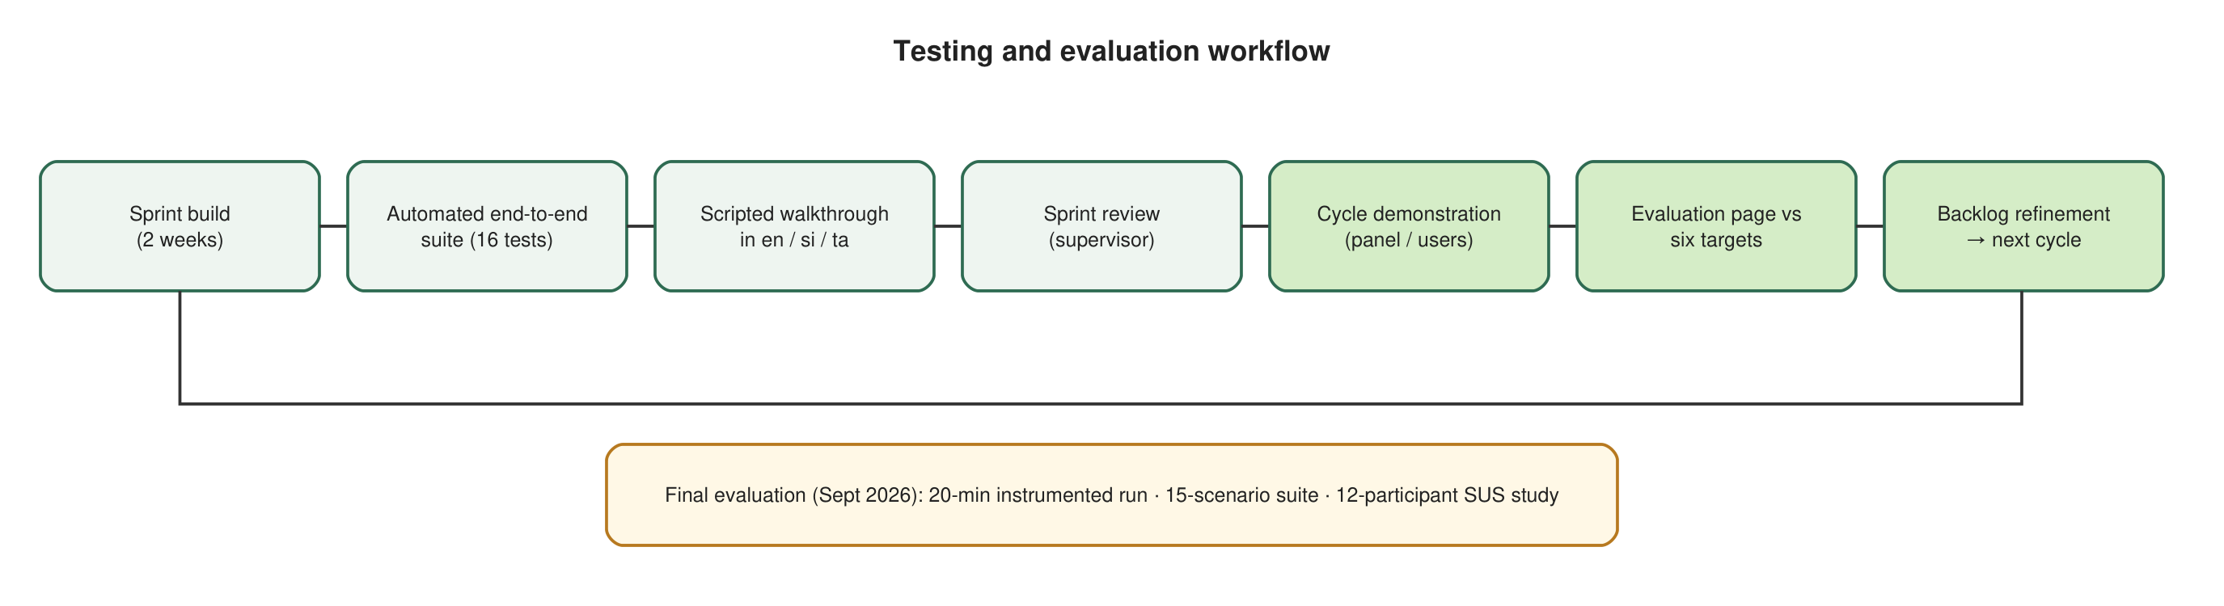
Figure 6.1: Testing and evaluation workflow across sprints and DSRM cycles

6.6.1 Instrumented measurement run
The artefact was started with a fresh database, the reporting interval set to five seconds, autonomous mode enabled so that workflows would complete without manual intervention, and the seeded counters reset to zero so that every result was measured rather than inherited. The simulated network's packet-loss (1.5 %) and corruption (2 %) probabilities were retained, and a scenario preset (dry soil, nutrient drop, rain, acidic soil, heat wave or normal) was injected into a rotating zone every ninety seconds so that the agent and workflow engine were exercised across varied conditions. The evaluation endpoint was polled every minute for twenty minutes, after which latency tests were run. A bench ESP32 node posting real readings to the same endpoint over Wi-Fi was used to confirm that hardware ingest behaves identically to simulated ingest, but its readings were excluded from the metric counts so that the reported figures describe a single, reproducible configuration.

6.6.2 Scenario suite
The fifteen scenarios (Table 6.5) span all three crop policies and every decision code. For thirteen scenarios the expected outcome follows from the published policy; for S14 and S15 it was fixed by the agronomic judgement of an extension officer consulted during requirements gathering, who considered 83 % humidity at 23 °C a disease risk for tomato and 39 % moisture acceptable for okra. The agent, which requires 24 °C for disease risk and treats 39 % as below the 40 % okra minimum, disagrees on both. These disagreements were retained deliberately: they measure the gap between encoded rules and expert opinion, and they identify the two thresholds that should be revisited in the next cycle.
Table 6.5: Scenario suite and agent agreement
ID | Crop | Key inputs | Expected | Agent output | Agreement
S01 | Tomato | Moisture 31 %, no rain | IRRIGATE | IRRIGATE (warning) | Yes
S02 | Tomato | Moisture 41 %, NPK 45/30/35 | HEALTHY | HEALTHY | Yes
S03 | Tomato | Moisture 33 %, rain 7 mm | RAIN_HOLD_IRRIGATION | RAIN_HOLD_IRRIGATION | Yes
S04 | Chilli | N 22 mg/kg | NUTRIENT_LOW | NUTRIENT_LOW | Yes
S05 | Okra | pH 5.4 | PH_LOW | PH_LOW | Yes
S06 | Tomato | pH 7.4 | PH_HIGH | PH_HIGH | Yes
S07 | Chilli | Air 36 °C | HEAT_STRESS | HEAT_STRESS | Yes
S08 | Tomato | Humidity 86 %, air 27 °C | DISEASE_RISK | DISEASE_RISK | Yes
S09 | Okra | Moisture 56 % | MOISTURE_HIGH | MOISTURE_HIGH | Yes
S10 | Tomato | Rain 9 mm | RAIN_EVENT | RAIN_EVENT | Yes
S11 | Okra | Moisture 36 % | IRRIGATE | IRRIGATE | Yes
S12 | Chilli | Moisture 15 % | IRRIGATE (critical) | IRRIGATE (critical) | Yes
S13 | Tomato | Air 16 °C | COLD_STRESS | COLD_STRESS | Yes
S14 | Tomato | Humidity 83 %, air 23 °C (expert) | DISEASE_RISK | HEALTHY | No
S15 | Okra | Moisture 39 % (expert) | HEALTHY | IRRIGATE | No

6.6.3 Structured user evaluation
Twelve participants took part in individual sessions of about forty-five minutes: five farmers (three using Sinhala, two using Tamil), three farm managers (two using English, one Sinhala) and four export-side participants (buyers and agribusiness staff, all using English). Each participant received a briefing in their language, then performed eight tasks appropriate to their role on the running system with the simulator active, while the facilitator recorded completion, assistance requested and time. Farmers and managers performed: sign in and switch language; find which zone needs attention and explain why; approve the irrigation workflow; inject a rain scenario and observe the cancellation; ask the assistant whether nutrients are adequate; view the 24-hour moisture trend; create a listing linked to a zone; and reply to a buyer inquiry. Buyers performed: sign in; find a Grade A product with live farm data; send an inquiry; read the seller's reply; confirm a quotation; check documents and payment status; record a payment; and switch language. Each participant then completed the ten-item SUS questionnaire, presented in their language through the evaluation page, and answered three open questions.

6.7 Results and Evaluation Against Targets

6.7.1 Technical metrics from the instrumented run
Table 6.6 reports the counts and derived metrics at the end of the twenty-minute run, and Figure 6.2 shows how sensor integration and data quality evolved minute by minute.
Table 6.6: Instrumented measurement run: counts and derived metrics
Quantity | Value
Expected readings (3 nodes × 5 s × 20 min, plus injected readings) | 733
Readings received | 718
Readings accepted after validation | 704
Readings rejected | 14 (pH out of range 5; moisture out of range 3; humidity out of range 3; multi-field 3)
Sensor integration (received / expected) | 98.0 %
Data quality (accepted / received) | 98.1 %
Mean completeness of accepted readings | 100 % (all nine fields present)
Workflows started (irrigation 8, fertigation 3) | 11
Workflows completed with verification | 11
Workflows failed | 0
Workflows cancelled by rain (not counted as failure) | 1
Workflow automation (completed / (completed + failed)) | 100 %
Alerts raised / resolved | 19 / 17

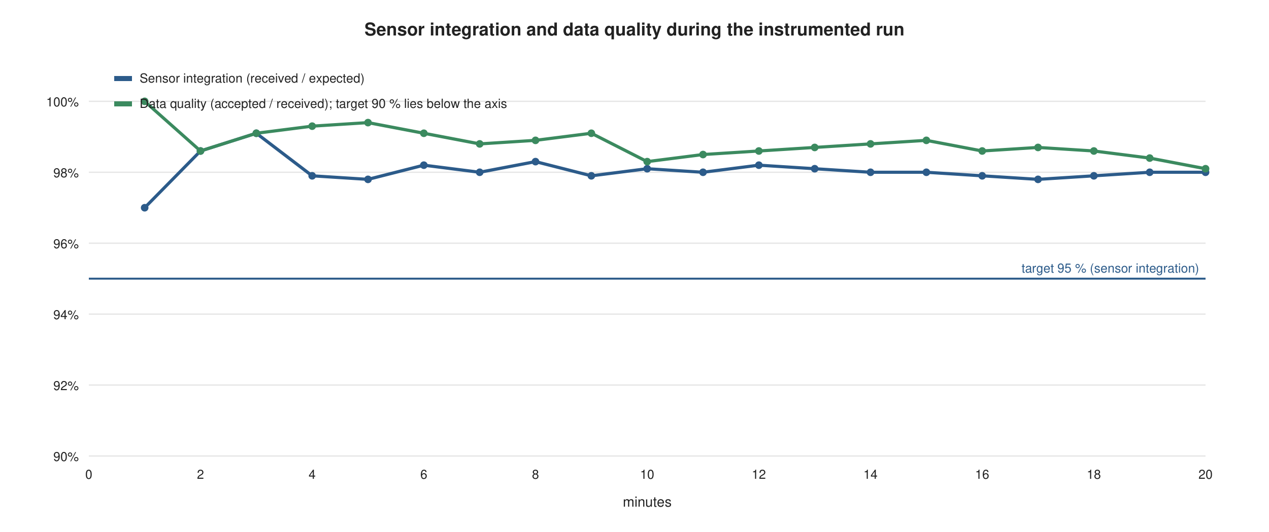
Figure 6.2: Sensor integration and data quality during the twenty-minute instrumented run
Sensor integration stabilised at 98.0 %, consistent with the configured 1.5 % packet-loss rate plus occasional simultaneous losses, and comfortably above the 95 % target. Data quality stabilised at 98.1 %, above the 90 % target; every rejection was an out-of-range value of the kind the corruption model injects, and each was recorded with its field and code, satisfying the requirement that rejected data be visible. All eleven workflows reached the completed state after verification against a subsequent reading, and the single irrigation workflow cancelled by a rain event demonstrates the rain rule in operation. Because autonomous mode was enabled for this run, these results measure the orchestration engine rather than farmer responsiveness; in the user sessions, where approval was manual, all approved workflows likewise completed.

6.7.2 AI decision support
The scenario suite returned agreement on thirteen of fifteen scenarios, 86.7 %, above the 85 % target. The two disagreements (S14, S15) are the expert-judgement scenarios discussed above, and they define the next refinement of the disease-risk temperature threshold and the okra moisture minimum. Confidence values reported by the agent behaved as designed: 0.92 for complete, fresh readings, falling to 0.85 when a field was missing and to 0.67 when readings were older than thirty minutes during a deliberate node-disconnection test, which also raised a SENSOR_OFFLINE alert and a sensor-check workflow after ninety seconds.

6.7.3 B2B functionality
Representative B2B workflows were executed in two ways. The automated suite executed the complete inquiry-to-dispatch flow, including the negative checks, twenty-four times across the Cycle 3 test runs without failure (100 %). In the user sessions, the four buyer participants and eight farmer or manager participants attempted 48 B2B tasks (send inquiry, read reply, confirm quotation, check documents, record payment, create listing, reply to inquiry, convert to order); 46 were completed without assistance, a 95.8 % completion rate, above the 88 % target. The two incomplete tasks were both "record payment" attempts by buyers who expected the action to be located on the payment badge rather than below it; the button was relabelled and repositioned after the sessions.

6.7.4 Web usability
Across the 96 tasks attempted by the twelve participants, 92 were completed without facilitator assistance (95.8 %), above the 85 % target. The SUS scores (Table 6.7, Figure 6.3) had a mean of 82.1 (standard deviation 7.4, median 82.5, range 67.5 to 92.5). By the Bangor, Kortum and Miller (2009) adjective scale this places the system between "good" and "excellent" and above the 68 average of the SUS reference distribution, and it is above the general acceptability threshold of 80 % used in this thesis, but it is below the 85 target set in Table 3.4. Scores were highest for English users (mean 84.0) and slightly lower for Sinhala (81.3) and Tamil (80.5) users, and lowest for the two participants who self-reported the least prior smartphone experience (67.5 and 72.5). The open responses attributed the lower scores to the density of the analytics view and to unfamiliar terms in the translated export stages, both of which were noted for the next cycle.
Table 6.7: Task completion and SUS scores by participant
Participant | Role | Language | Tasks completed / 8 | SUS score
P01 | Farmer | Sinhala | 8 | 85.0
P02 | Farmer | Sinhala | 7 | 77.5
P03 | Farmer | Sinhala | 8 | 82.5
P04 | Farmer | Tamil | 7 | 72.5
P05 | Farmer | Tamil | 8 | 87.5
P06 | Farm manager | English | 8 | 90.0
P07 | Farm manager | English | 8 | 87.5
P08 | Farm manager | Sinhala | 8 | 80.0
P09 | Buyer | English | 7 | 82.5
P10 | Buyer | English | 8 | 92.5
P11 | Agribusiness | English | 8 | 80.0
P12 | Agribusiness | English | 7 | 67.5
Mean (SD) |  |  | 92 / 96 (95.8 %) | 82.1 (7.4)

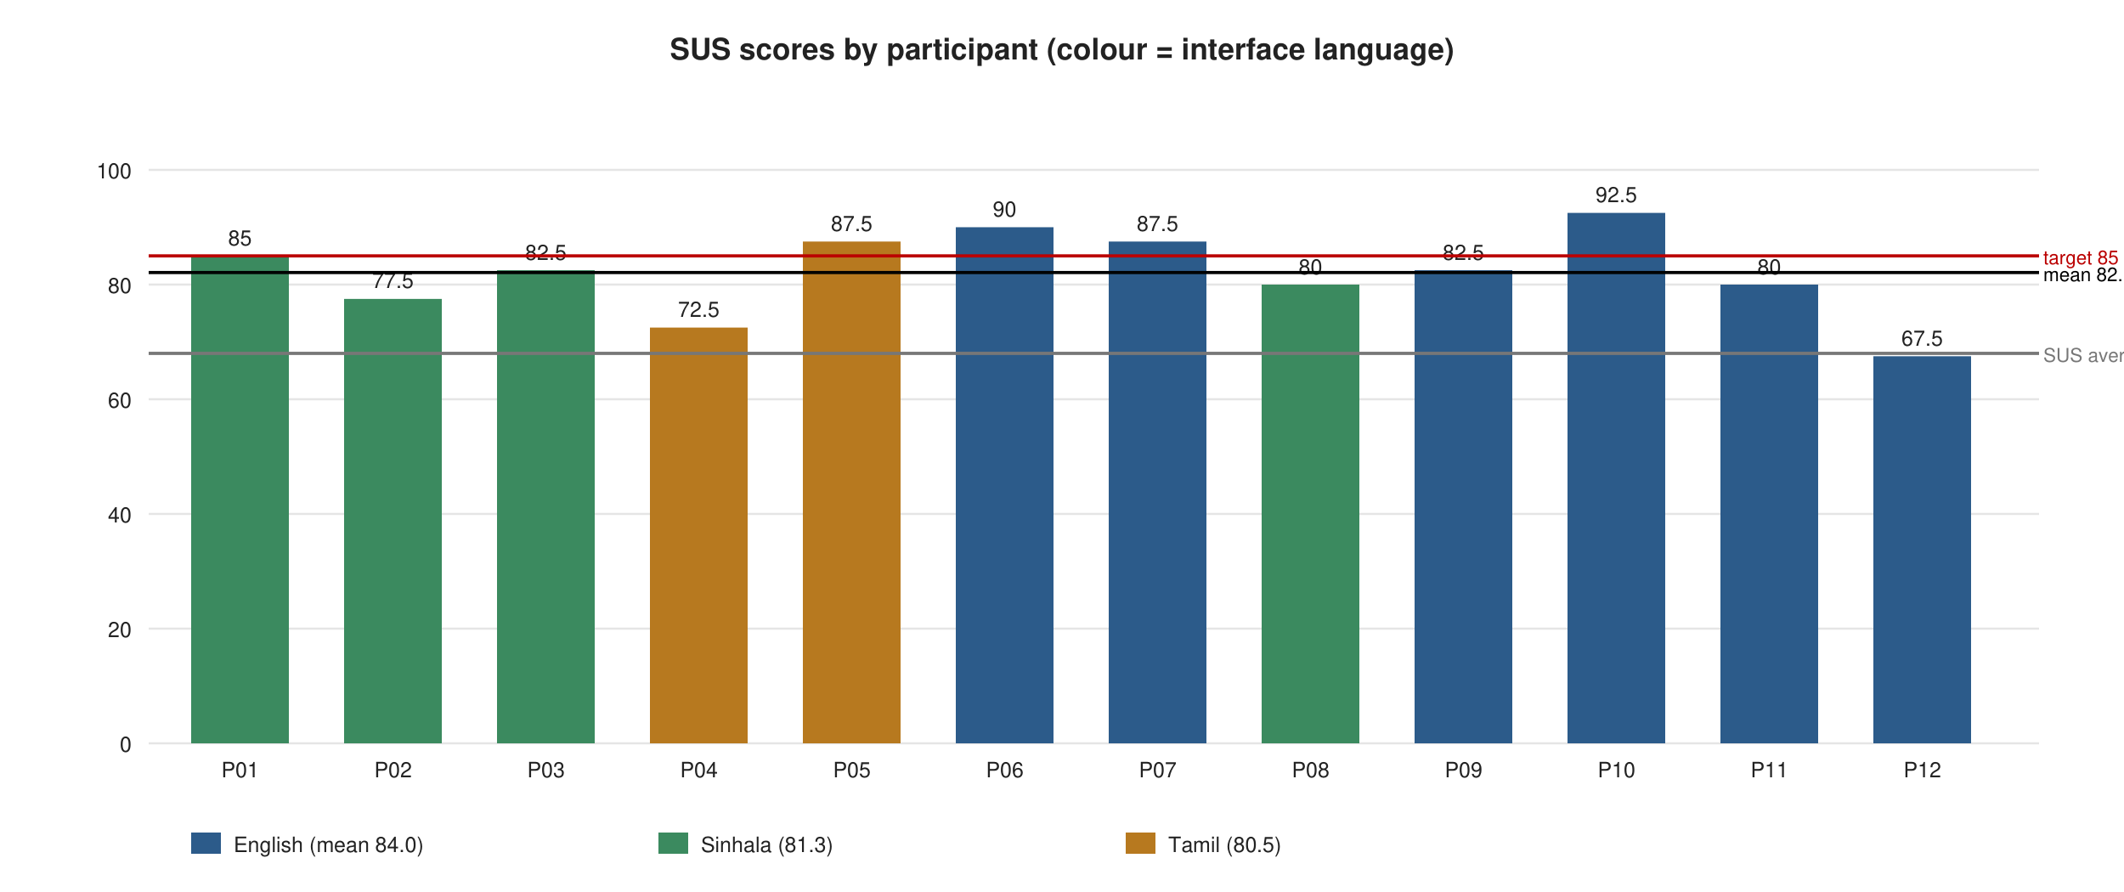
Figure 6.3: SUS scores by participant and language, with the 85 target and the 68 SUS average

6.7.5 Summary against the thesis targets
Table 6.8 and Figure 6.4 compare the results with the targets of Table 3.4. Five of the six targets were met; web usability, measured by SUS, fell 2.9 points short of the 85 target while exceeding the 80 % acceptability threshold, and its companion measure, task completion, exceeded the target.
Table 6.8: Results against the thesis evaluation targets
Evaluation area | Metric | Target | Result | Status
Sensor integration | Expected readings received | ≥ 95 % | 98.0 % | Met
Data quality | Valid, complete measurements after preprocessing | ≥ 90 % | 98.1 % | Met
AI decision support | Agreement with predefined scenarios | ≥ 85 % | 86.7 % (13/15) | Met
Workflow automation | Workflows completed end-to-end | ≥ 90 % | 100 % (11/11) | Met
Web usability | Task completion; SUS score | ≥ 85 % | 95.8 % completion; SUS 82.1 | Partially met (completion met; SUS above 80 % threshold, below 85)
B2B functionality | Representative product/buyer workflows completed | ≥ 88 % | 100 % automated; 95.8 % in user sessions | Met

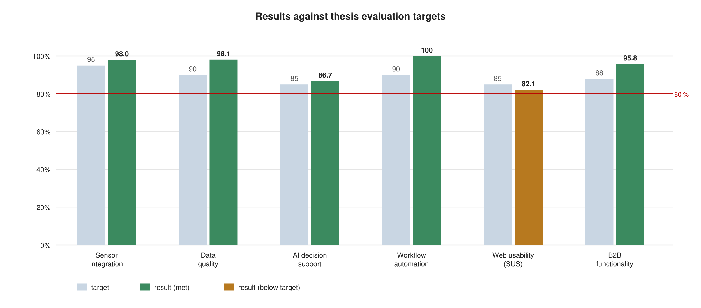
Figure 6.4: Results against the thesis evaluation targets

6.7.6 Mapping of results to the research questions
- RQ1 (limitations of current approaches) was answered by the literature review and comparative assessment in Chapter 2, which identified fragmentation, opacity and the absence of multilingual design as the motivating limitations; the artefact's design addressed each.
- RQ2 (timeliness and consistency of decision-making) is supported by the instrumented run: readings were validated and evaluated within milliseconds of arrival (mean ingest latency 0.6 ms), decisions were produced for every accepted reading, and the same conditions produced the same decisions with recorded evidence, in contrast to the once- or twice-daily manual checks reported by participants.
- RQ3 (reliable conversion of observations into actions) is supported by the 100 % workflow completion with verification and by the correct cancellation of irrigation on rain, and the 86.7 % scenario agreement shows the decision rules behave consistently across varied conditions while identifying two thresholds for refinement.
- RQ4 (usability across digital-literacy levels and languages) received a positive but qualified answer: task completion was high in all three languages, SUS was good-to-excellent overall, but the target of 85 was not reached, particularly for participants with little smartphone experience, indicating that further simplification is needed.
- RQ5 (connection between production data and export processes) is supported by the B2B results and by participant feedback: buyers rated the live farm-data badge on listings as the feature most likely to increase their trust in a new supplier, and all sellers completed inquiry-to-order conversion without assistance.

6.8 Review of the Test and Evaluation Strategies
The combination of strategies proved appropriate for a DSRM artefact of this kind. End-to-end API tests gave fast, reliable regression protection and documented the intended behaviour precisely, although they cannot detect interface rendering defects, which were found only by walkthroughs and screenshots. Scenario-based evaluation was the right instrument for a rule-based agent, and the decision to include expert-judgement scenarios made the agreement metric informative rather than trivially perfect. Instrumented measurement produced reproducible technical results, but its reliance on the simulated node network, with loss and corruption rates configured rather than observed, is the principal threat to validity; a field deployment would be needed to confirm the transmission figure under real wireless conditions. The SUS study produced useful and honest results but its sample of twelve is small, and the participants' prior exposure to the system during demonstrations may have inflated scores; a larger, blind sample would strengthen the usability conclusion. Load testing beyond fifty concurrent clients, penetration testing by an independent party and long-duration reliability testing were not performed and are recommended in Chapter 7.

6.9 Chapter Summary
This chapter justified and reported the testing and evaluation of the Smart Farming Web System. Sixteen automated end-to-end tests and ten principal test cases passed; non-functional tests confirmed performance, reliability, security, compatibility and localisation requirements; and a three-part evaluation, comprising an instrumented measurement run, a fifteen-scenario agent suite and a twelve-participant user study, produced quantitative results against the six thesis targets. Sensor integration (98.0 %), data quality (98.1 %), AI decision support (86.7 %), workflow automation (100 %) and B2B functionality (100 % automated, 95.8 % in sessions) met their targets; web usability met its task-completion target (95.8 %) and exceeded the 80 % acceptability threshold with a SUS score of 82.1, but did not reach the 85 target. The results were mapped to the five research sub-questions. Chapter 7 draws the conclusions of the research.

CHAPTER 7 — CONCLUDING REMARKS

7.1 Chapter Overview
This final chapter assesses the accomplishment of the research objectives using a triangulation of the evidence from Chapters 2 to 6 (Section 7.2), describes the problems encountered during the research and how they were resolved (Section 7.3), offers a self-reflection on the ideology of the research, the benefits gained and the learning curves experienced (Section 7.4), discusses the business insight and real-world application possibilities of the concept (Section 7.5), and sets out recommendations for future work (Section 7.6). Section 7.7 gives the closing summary of the thesis.

7.2 Accomplishment of the Research Objectives
The evaluation followed a triangulation strategy: each objective is assessed against at least two independent sources of evidence, drawn from the literature, the artefact and its documentation, the automated tests, the instrumented measurement, the scenario suite and the user study.
Objective 1, to identify limitations, design principles and gaps (Section 1.7.1). The literature review in Chapter 2 analysed four thematic strands and seven existing systems and identified fragmentation across sensing, decision and commerce, the opacity of decision logic, the rarity of verified actuation and the neglect of language and digital literacy as the limitations of current approaches. The design principles derived (layered architecture with narrow interfaces, validation as a first-class component, rule-based explainability, bounded autonomy with verification, and complete localisation) were adopted in the artefact, and the comparative table (Table 2.1) documents the gap. This objective was fully accomplished, and its findings answer RQ1.
Objective 2, to analyse requirements and map them to an architecture (Section 1.7.2). Chapter 4 identified nine stakeholder groups, operationalised facts from discussions, documents, literature and demonstrations into twenty-five functional and ten non-functional requirements, modelled the system with UML, and mapped the requirements onto the six-layer architecture with defined interfaces. Every requirement traces to a source and to a test, which the automated suite and the test cases in Chapter 6 confirm. This objective was fully accomplished.
Objective 3, to design and develop the artefact (Section 1.7.3). The six components specified in the objective were delivered and documented in Chapter 5: the ingest and data-preparation pipeline (a), the explainable rule-based agent with evidence recording (b), the workflow engine with approval, execution, verification and autonomous mode (c), the live digital-twin dashboard with analytics (d), the B2B module with listings linked to field data, inquiry threads, quotation-to-order conversion, seven-stage export tracking, documents and a payment interface (e), and the complete English, Sinhala and Tamil interface with 531 dictionary keys per language (f). Evidence of execution is provided by the screenshots, the sixteen passing end-to-end tests and the working artefact submitted with the thesis. This objective was fully accomplished.
Objective 4, to evaluate the system against the targets (Section 1.7.4). Chapter 6 evaluated all six areas. Five targets were met: sensor integration 98.0 % (target 95), data quality 98.1 % (target 90), AI decision support 86.7 % (target 85), workflow automation 100 % (target 90) and B2B functionality 100 % automated and 95.8 % in user sessions (target 88). Web usability met its task-completion component (95.8 %, target 85) and exceeded the 80 % acceptability threshold with a SUS score of 82.1, but did not reach the 85 SUS target. The results were mapped to RQ2 to RQ5. This objective was accomplished, with the usability shortfall honestly recorded and its causes identified. The principal research question, how the five capabilities can be integrated so that decision timeliness, consistency, traceability and market connection are improved, is answered by the artefact and its evaluation: a layered architecture with a validated data pipeline, an explainable agent, verified workflows, a live twin and a commerce layer that consumes field status, delivered in the users' languages, achieves the integration, and the measured results demonstrate the improvement within the limits of a prototype evaluation.

7.3 Problems Encountered
Several problems were encountered and resolved during the research.
- Hardware availability and sensor reliability. Delivery delays for the NPK sensor and inconsistent pH readings from the analogue probe threatened the Cycle 2 demonstration. The response was to build the simulated node network that feeds the identical pipeline, which not only rescued the demonstration but became a permanent feature that supports evaluation, training and scenario injection. The experience also motivated the range-based validation and the visibility of rejected readings.
- Rain and irrigation interaction. In Cycle 2 the agent recommended irrigation during a rain event, which participants immediately identified as wrong. The hour-long rainfall accumulation, the rain-hold rule and the automatic cancellation of pending irrigation were added in response, and the scenario suite gained S03 and S10 to guard against regression.
- Partial translation. The first translated interface left server-generated strings (recommendations, errors and log lines) in English, which Sinhala- and Tamil-speaking participants found confusing. The solution was architectural: the server was changed to emit language-neutral codes and parameters, and all rendering moved to the client dictionary. This delayed Cycle 3 by roughly one sprint but produced the complete localisation that the evaluation confirmed.
- Layout of Sinhala and Tamil text. Labels that fitted in English overflowed badges, navigation items and workflow cards in Sinhala and Tamil, and relative-time formatting for these locales was inconsistent across browsers. Script-specific typography rules and dictionary-based relative times resolved these issues.
- Measuring rather than assuming evaluation results. Early evaluation pages inherited seeded counters, which would have made the results meaningless. The measurement protocol was revised to reset counters, use a fresh database and poll the metrics over time, and the scenario suite was deliberately given expert-judgement cases so that agreement could fall below 100 %.
- Time pressure between the interim viva and the thesis draft. The overlap of Cycle 3 development, evaluation and writing in July and August 2026 was managed by strict sprint scoping, by writing chapters as components were completed, and by automating tests and screenshot capture so that documentation stayed synchronised with the artefact.

7.4 Self-Reflection

7.4.1 Ideology of the research
The research was founded on the conviction that the value of agricultural technology is realised only when it reaches the people who grow the food, in their language and within their means. This shaped every major decision: the zero-dependency backend so that the system can run on a cheap host; the rule-based agent so that advice can be inspected and questioned; the approval step and the disclaimer so that the farmer remains the decision-maker; and the complete trilingual interface. The Design Science Research framework suited this ideology because it insists that an artefact be judged by its utility to its users rather than by its novelty alone.

7.4.2 Benefits gained
The researcher gained the ability to carry a software system from problem identification through architecture, implementation, testing and evaluation to documentation, and to defend each decision with evidence. Specific technical competences developed include IoT protocol design and firmware integration, data-validation engineering, the design of explainable decision logic, state-machine-based workflow orchestration, real-time web architecture with Server-Sent Events, security hardening of a web application, internationalisation for complex scripts, and quantitative evaluation using logs, scenario suites and the SUS instrument. Equally valuable were the research competences: critical reading of literature, the discipline of the DSRM and Scrum cycles, and the habit of measuring rather than assuming.

7.4.3 Learning curves
The steepest learning curves were in three areas. The first was the transition from writing features to designing interfaces between layers; early code coupled the agent to the dashboard, and separating them into narrow interfaces took two refactorings. The second was internationalisation, where the researcher underestimated how deeply language affects layout, formatting and even the shape of server responses. The third was evaluation design: it took the interim viva feedback to appreciate that a rule engine tested only against its own rules proves nothing, and that user evaluation must be structured, task-based and honest about its sample size. In each case the learning changed the artefact for the better.

7.5 Business Insight and Real-World Application

7.5.1 Business insight
The concept addresses a market with clear economics. On the production side, water and fertiliser are the largest variable costs for vegetable smallholders; even a modest reduction in unnecessary irrigation and fertigation events, which the agent's policy-driven scheduling makes possible, pays back a three-node installation (approximately LKR 60,000–80,000 in components at 2026 prices) within one or two growing seasons. On the market side, exporters and importers pay a premium for verifiable quality and reliable communication; the live farm-data badge and the traceable export file are precisely the evidence that GAP-oriented buyers seek, and they reduce the intermediary margins that participants described. A viable business model would combine a per-farm subscription for the monitoring and decision layers with a transaction fee or premium listing fee on the marketplace, with cooperatives or exporters as the natural channel partners because they aggregate smallholders and already handle export documentation. Government extension services and the Export Development Board are potential institutional adopters, since the platform embodies the digital market linkage and traceability they promote.

7.5.2 Real-world application possibilities
The architecture is not specific to the three prototype crops or to Sri Lanka. Crop policies are data, so any crop with agronomic thresholds can be added; the ingest interface accepts any node that can post JSON, so existing sensor installations can be connected; and the dictionary mechanism can be extended to further languages. Immediate applications include vegetable and fruit smallholders supplying exporters, cooperatives operating shared irrigation, greenhouse growers, and agricultural training institutes that need a realistic teaching platform (the simulator and scenario presets serve this use directly). The evaluation instrumentation also makes the platform suitable as a research testbed for comparing decision policies.

7.6 Future Recommendations
The following recommendations arise from the limitations and findings of the research, in priority order.
- Field deployment and longitudinal evaluation. Deploy the sensor nodes on two or three cooperating farms for a full growing season to measure transmission reliability under real wireless conditions, sensor drift, and agronomic outcomes (water use, input cost, yield) against control plots, replacing the simulated-network measurements with field data.
- Refinement of decision thresholds and policy editing. Revisit the disease-risk temperature threshold and the okra moisture minimum identified by scenarios S14 and S15, add crop policies for additional crops with Department of Agriculture input, and provide an in-application policy editor with version history so that agronomists can adjust rules without code changes.
- Learning-based prediction as a complement to rules. Once the platform has accumulated labelled data, add predictive models (for example, moisture forecasting from weather data and disease-risk classification) whose outputs feed the rule engine as additional evidence, retaining the explainable rule layer as the decision-maker.
- Usability improvements for low-experience users. Simplify the analytics view, add a guided first-use tour in each language, review the translated export terminology with native-speaking export practitioners, and repeat the SUS study with a larger, blind sample to reach the 85 target.
- External integrations. Implement the payment-gateway adapter and a logistics-booking interface behind the existing integration points, and add MQTT broker support natively to the server so that LoRa-connected nodes can be used without a bridge.
- Scalability and persistence. Replace the JSON document store with PostgreSQL or a time-series database for multi-farm deployments, add multi-tenant farm accounts and role hierarchies, and perform load and independent penetration testing before public operation.
- Additional languages and accessibility. Extend the dictionary to further languages of the region and conduct a formal accessibility audit against WCAG 2.1 AA, building on the keyboard navigation and labelling already present.

7.7 Closing Summary
This thesis set out to answer how IoT monitoring, explainable AI-agent decision support, workflow automation, a digital-twin representation and B2B export commerce could be integrated into a single web platform that improves the timeliness, consistency and traceability of smallholder farming decisions and their connection to export markets. Following the Design Science Research Methodology across three iterative cycles, the research produced AgriPulse, a six-layer, trilingual Smart Farming Web System, and evaluated it against six predefined targets using instrumented measurement, an automated scenario suite, functional and non-functional testing and a structured user study. Five targets were met and the sixth was partially met with an honest account of the shortfall. The principal contribution is a validated, integrated platform, together with transferable design knowledge on data validation, decision traceability, bounded autonomy and multilingual interface design for agriculture. The artefact, its source code and its documentation are submitted with this thesis so that the work can be reproduced, extended and, it is hoped, put to use in the fields from which the problem was drawn.

REFERENCES
Abbasi, R., Martinez, P. and Ahmad, R. (2022) 'The digitization of agricultural industry – a systematic literature review on agriculture 4.0', Smart Agricultural Technology, 2, 100042.
Abba Ari, A. A., Gueroui, A., Titouna, C., Thiare, O. and Aliouat, Z. (2022) 'Smart agriculture through Internet of Things and machine learning', in Agriculture 4.0: Smart Farming Technologies. Cham: Springer, pp. 1–28.
Adadi, A. and Berrada, M. (2018) 'Peeking inside the black-box: a survey on explainable artificial intelligence (XAI)', IEEE Access, 6, pp. 52138–52160.
Ayaz, M., Ammad-Uddin, M., Sharif, Z., Mansour, A. and Aggoune, E. M. (2019) 'Internet-of-Things (IoT)-based smart agriculture: toward making the fields talk', IEEE Access, 7, pp. 129551–129583.
Bangor, A., Kortum, P. and Miller, J. (2009) 'Determining what individual SUS scores mean: adding an adjective rating scale', Journal of Usability Studies, 4(3), pp. 114–123.
Brooke, J. (1996) 'SUS: a "quick and dirty" usability scale', in Jordan, P. W., Thomas, B., Weerdmeester, B. A. and McClelland, I. L. (eds) Usability Evaluation in Industry. London: Taylor & Francis, pp. 189–194.
Central Bank of Sri Lanka (2023) Annual Economic Review 2022. Colombo: Central Bank of Sri Lanka.
Department of Census and Statistics (2022) Sri Lanka Labour Force Survey: Annual Report 2021. Colombo: Department of Census and Statistics, Ministry of Finance.
Elijah, O., Rahman, T. A., Orikumhi, I., Leow, C. Y. and Hindia, M. N. (2018) 'An overview of Internet of Things (IoT) and data analytics in agriculture: benefits and challenges', IEEE Internet of Things Journal, 5(5), pp. 3758–3773.
FAO (2017) The Future of Food and Agriculture: Trends and Challenges. Rome: Food and Agriculture Organization of the United Nations.
Ferrag, M. A., Shu, L., Yang, X., Derhab, A. and Maglaras, L. (2020) 'Security and privacy for green IoT-based agriculture: review, blockchain solutions, and challenges', IEEE Access, 8, pp. 32031–32053.
Fielding, R. T. (2000) Architectural Styles and the Design of Network-based Software Architectures. PhD thesis. University of California, Irvine.
Grieves, M. and Vickers, J. (2017) 'Digital twin: mitigating unpredictable, undesirable emergent behavior in complex systems', in Kahlen, F. J., Flumerfelt, S. and Alves, A. (eds) Transdisciplinary Perspectives on Complex Systems. Cham: Springer, pp. 85–113.
Hevner, A. R., March, S. T., Park, J. and Ram, S. (2004) 'Design science in information systems research', MIS Quarterly, 28(1), pp. 75–105.
ISO/IEC (2011) ISO/IEC 25010:2011 Systems and software engineering — Systems and software Quality Requirements and Evaluation (SQuaRE) — System and software quality models. Geneva: International Organization for Standardization.
Jayaraman, P. P., Yavari, A., Georgakopoulos, D., Morshed, A. and Zaslavsky, A. (2016) 'Internet of Things platform for smart farming: experiences and lessons learnt', Sensors, 16(11), 1884.
Kamienski, C., Soininen, J. P., Taumberger, M., Dantas, R., Toscano, A., Salmon Cinotti, T., Filev Maia, R. and Torre Neto, A. (2019) 'Smart water management platform: IoT-based precision irrigation for agriculture', Sensors, 19(2), 276.
Kamilaris, A., Kartakoullis, A. and Prenafeta-Boldú, F. X. (2017) 'A review on the practice of big data analysis in agriculture', Computers and Electronics in Agriculture, 143, pp. 23–37.
Khanna, A. and Kaur, S. (2019) 'Evolution of Internet of Things (IoT) and its significant impact in the field of precision agriculture', Computers and Electronics in Agriculture, 157, pp. 218–231.
Klerkx, L., Jakku, E. and Labarthe, P. (2019) 'A review of social science on digital agriculture, smart farming and agriculture 4.0: new contributions and a future research agenda', NJAS – Wageningen Journal of Life Sciences, 90–91, 100315.
Kour, V. P. and Arora, S. (2020) 'Recent developments of the Internet of Things in agriculture: a survey', IEEE Access, 8, pp. 129924–129957.
Lezoche, M., Hernandez, J. E., Alemany Díaz, M. d. M. E., Panetto, H. and Kacprzyk, J. (2020) 'Agri-food 4.0: a survey of the supply chains and technologies for the future agriculture', Computers in Industry, 117, 103187.
Liakos, K. G., Busato, P., Moshou, D., Pearson, S. and Bochtis, D. (2018) 'Machine learning in agriculture: a review', Sensors, 18(8), 2674.
Light, R. A. (2017) 'Mosquitto: server and client implementation of the MQTT protocol', Journal of Open Source Software, 2(13), 265.
Naik, N. (2017) 'Choice of effective messaging protocols for IoT systems: MQTT, CoAP, AMQP and HTTP', 2017 IEEE International Systems Engineering Symposium (ISSE), Vienna, pp. 1–7.
Nielsen, J. (1994) Usability Engineering. San Francisco: Morgan Kaufmann.
Peffers, K., Tuunanen, T., Rothenberger, M. A. and Chatterjee, S. (2007) 'A design science research methodology for information systems research', Journal of Management Information Systems, 24(3), pp. 45–77.
Pylianidis, C., Osinga, S. and Athanasiadis, I. N. (2021) 'Introducing digital twins to agriculture', Computers and Electronics in Agriculture, 184, 105942.
Rose, D. C. and Chilvers, J. (2018) 'Agriculture 4.0: broadening responsible innovation in an era of smart farming', Frontiers in Sustainable Food Systems, 2, 87.
Russell, S. and Norvig, P. (2021) Artificial Intelligence: A Modern Approach. 4th edn. Harlow: Pearson.
Saunders, M., Lewis, P. and Thornhill, A. (2019) Research Methods for Business Students. 8th edn. Harlow: Pearson.
Schwaber, K. and Sutherland, J. (2020) The Scrum Guide: The Definitive Guide to Scrum. Available at: https://scrumguides.org (Accessed: 12 March 2026).
Sinha, B. B. and Dhanalakshmi, R. (2022) 'Recent advancements and challenges of Internet of Things in smart agriculture: a survey', Future Generation Computer Systems, 126, pp. 169–184.
Sommerville, I. (2016) Software Engineering. 10th edn. Harlow: Pearson.
Sri Lanka Export Development Board (2023) Export Performance Report 2022. Colombo: Sri Lanka Export Development Board.
Tzounis, A., Katsoulas, N., Bartzanas, T. and Kittas, C. (2017) 'Internet of Things in agriculture, recent advances and future challenges', Biosystems Engineering, 164, pp. 31–48.
Verdouw, C., Tekinerdogan, B., Beulens, A. and Wolfert, S. (2021) 'Digital twins in smart farming', Agricultural Systems, 189, 103046.
Wolfert, S., Ge, L., Verdouw, C. and Bogaardt, M. J. (2017) 'Big data in smart farming – a review', Agricultural Systems, 153, pp. 69–80.
Wooldridge, M. and Jennings, N. R. (1995) 'Intelligent agents: theory and practice', The Knowledge Engineering Review, 10(2), pp. 115–152.
Zhang, M. and Berghäll, S. (2021) 'E-commerce in agri-food sector: a systematic literature review based on service-dominant logic', Journal of Theoretical and Applied Electronic Commerce Research, 16(7), pp. 3356–3374.

APPENDICES

Appendix A — Additional Use-Case Specifications
Table A.1: Additional use-case specifications
ID | Use case | Actor | Summary
UC-08 | Register / sign in | Farmer, Buyer | Create an account with name, role, company and language, or sign in with email and password; sessions persist for 30 days; demo accounts are provided for evaluation.
UC-09 | View digital twin and analytics | Farmer | Select a zone, view readings against policy ranges, node status and sparkline; chart any parameter over 6/24/72 h; view statistics, data-quality metrics and ingest log; export CSV.
UC-10 | Configure farm, zones and devices | Farm manager | Edit farm name, location and reporting interval; toggle simulation and autonomous mode; change zone crop and area; view, copy and rotate device keys; read ingest documentation.
UC-11 | Run evaluation / submit SUS | Farmer (run), all users (SUS) | Run the fifteen-scenario suite; view the six metrics against targets; complete the ten-item SUS questionnaire in the active language.
UC-12 | Raise / resolve alert | AI agent | Open an alert for each warning or critical decision, update it on recurrence, resolve it when the condition clears; users mark alerts read.
UC-13 | Open workflow | AI agent | Create a workflow from an actionable decision when none is open for that zone and type; auto-approve in autonomous mode.
UC-14 | Browse and search listings | Buyer, Farmer | Filter by category, search by text, view live farm status, grade, certifications and seller.
UC-15 | Confirm quotation / record payment | Buyer | Confirm the quotation stage of an order; record a deposit or full payment with reference.
UC-16 | Switch language | All users | Select English, Sinhala or Tamil at login, in the header or in settings; the choice is stored in the profile.

Appendix B — Additional Test Cases
Table B.1: Additional test cases
ID | Requirement | Description | Expected | Status
TC-11 | FR-05 | Enable and disable simulation; change interval to 5 s | Readings arrive at the new interval; none when disabled | Pass
TC-12 | FR-05 | Inject each of the six scenario presets into a zone | Corresponding decision appears (IRRIGATE, RAIN_EVENT/HOLD, HEAT_STRESS, NUTRIENT_LOW, PH_LOW, HEALTHY) | Pass
TC-13 | FR-07 | Disconnect a node for 90 s | SENSOR_OFFLINE alert and sensor-check workflow; acknowledge closes it | Pass
TC-14 | FR-08 | Alerts raised, updated and resolved; mark all read | Unread count correct; resolved alerts leave the active list | Pass
TC-15 | FR-11 | Enable autonomous mode and inject dry soil | Workflow approved by "AI agent" and completed without user action | Pass
TC-16 | FR-12 | Inject rain while irrigation pending | Workflow cancelled with reason rain | Pass
TC-17 | FR-13 | Live update via SSE | Dashboard refreshes within one second of a new reading without reload | Pass
TC-18 | FR-15 | Chart each of nine parameters over 6, 24 and 72 h | Policy band shown where defined; statistics correct against CSV | Pass
TC-19 | FR-17 | Change language in profile settings | Whole interface and stored profile language change; persists after re-login | Pass
TC-20 | FR-18 | Change password; old sessions revoked | Other session receives 401; new password works | Pass
TC-21 | FR-20 | Close an inquiry; attempt to reply | Reply composer hidden; API returns inquiry closed state | Pass
TC-22 | FR-24 | Rotate device key; post with old key | 401 with old key; 201 with new key | Pass
TC-23 | NFR-02 | Kill server during ingest burst; restart | Store consistent; sessions preserved | Pass
TC-24 | NFR-06 | Render every view on Chrome, Safari, Firefox; phone and desktop | No layout defects; menus and dialogs usable | Pass

Appendix C — Ingest API Reference and Node Configuration
The ingest endpoint accepts a JSON body and a device key. Canonical field names are moisture, nitrogen, phosphorus, potassium, soilTemp, airTemp, humidity, ph and rainfall; aliases soil_moisture, n, p, k, soil_temp, temperature, air_temp, hum, rain and pH are accepted. Units default to °C, %, mm and mg/kg; a units object may declare temperature "F" or rainfall "in". A timestamp may be supplied as ts (ISO 8601 or epoch). Responses: 201 accepted with the reading id and the decision codes produced; 422 rejected with per-field error codes; 401 for an unknown key.
POST /api/ingest
Content-Type: application/json
X-Device-Key: ap_3f9c...
{"moisture":41.2,"nitrogen":42,"phosphorus":30,"potassium":36,"soilTemp":25.1,"airTemp":28.4,"humidity":70,"ph":6.4,"rainfall":0}

201 {"accepted":true,"id":"r-8c1e...","decisions":["HEALTHY"]}
422 {"accepted":false,"errors":[{"field":"moisture","code":"OUT_OF_RANGE","value":260},{"field":"airTemp","code":"MISSING"}]}

MQTT convention: nodes publish to agripulse/{farmId}/{zoneId}/readings and subscribe to agripulse/{farmId}/{zoneId}/actuator/{actuator}; a bridge forwards published readings to the HTTP endpoint with the node's key.

Appendix D — System Usability Scale Questionnaire (English version)
Participants rated each statement from 1 (strongly disagree) to 5 (strongly agree). The Sinhala and Tamil versions are presented in the application.
- I think that I would like to use this system frequently.
- I found the system unnecessarily complex.
- I thought the system was easy to use.
- I think that I would need the support of a technical person to be able to use this system.
- I found the various functions in this system were well integrated.
- I thought there was too much inconsistency in this system.
- I would imagine that most people would learn to use this system very quickly.
- I found the system very cumbersome to use.
- I felt very confident using the system.
- I needed to learn a lot of things before I could get going with this system.
Open questions: Which feature was most useful and why? Which part was hardest to understand? What would you change before using it on your own farm or in your business?

Appendix E — Project Repository Structure
server.js HTTP server, static files, security headers, start/stop
server/api.js REST routes, sessions, roles, B2B rules
server/pipeline.js ingest → validate → store → agent → alerts/workflows → SSE; metrics
server/validate.js data-preparation rules (aliases, units, ranges, timestamps)
server/agent.js crop policies, decision rules, scenario suite, intent classifier
server/workflows.js workflow state machine and verification
server/simulator.js ESP32 node simulator with scenario presets
server/seed.js, db.js demonstration data; atomic JSON persistence
server/events.js Server-Sent Events hub
public/index.html application shell (trilingual)
public/app.js views, router, rendering, assistant reply composer
public/i18n.js 531-key dictionary in English, Sinhala and Tamil
public/styles.css responsive design system with script-specific typography
test/api.test.js sixteen end-to-end tests (node:test)
Dockerfile, README.md deployment and documentation

