MedAssist AI
Turning Clinical Data into Human Understanding

CS 595 — Medical Informatics & AI


Illinois Institute of Technology



Team: Alpha

Members:
Siddharth Bhamare, A20582786
Vaishnav Bhujbhal, A20579636
Gayatri Gaikwad, A20598464
Jeevan Singh, A20581464

Submission: May 2026
Guidance: Dr. Frank Naeymi-Rad

Abstract
MedAssist AI is a full-stack medical informatics platform that transforms blood test reports into comprehensive, patient-friendly health insights. A healthcare patient's lab report — dense with abbreviations, reference ranges, and clinical codes — is opaque to most non-clinical readers. MedAssist bridges this gap by combining Google Gemini Vision OCR, a multi-provider LLM ensemble with consensus judging, and evidence-based clinical risk scoring to convert raw lab values into plain-language summaries, personalized diet and lifestyle plans, FDA-verified medication suggestions, and structured follow-up schedules. Built as the capstone project for CS 595 — Medical Informatics & AI at Illinois Institute of Technology, the platform demonstrates responsible AI design in healthcare: explainable outputs, HIPAA-compliant audit logging, role-based access control, and conservative risk-first decision merging across all AI agents.
1. Introduction
Routine blood tests are among the most information-dense documents a patient receives, yet they are rarely explained in language a non-clinical reader can act on. A CBC panel or metabolic profile can reveal early signs of kidney disease, cardiovascular risk, or nutritional deficiency — but only if the reader understands what the numbers mean. Clinicians rarely have time to walk patients through every value during a short appointment, leaving patients to interpret results on their own.
MedAssist AI addresses this problem by acting as an intelligent intermediary between the raw clinical data and the patient. The system accepts a scanned or photographed blood report, extracts all measurable parameters using computer vision, analyzes them through a multi-LLM ensemble, calculates validated clinical risk scores, and presents everything in plain English — with audio narration, trend charts, and a downloadable PDF summary. The goal is not to replace physicians, but to ensure patients arrive at their next appointment informed, with meaningful questions and a clear picture of their health trajectory.
2. Problem Statement & Motivation
2.1 The Gap in Medical Data Literacy
A 2022 survey by the American Board of Internal Medicine found that over 60% of patients who received lab results could not correctly identify which values were abnormal. When abnormal values are identified, fewer than half of patients understand the clinical significance or know what action to take. This data literacy gap is widest among patients with limited healthcare experience, low health literacy, or language barriers.
2.2 The Scope of MedAssist AI
MedAssist AI focuses on the patient-side of the data literacy problem:
- Convert scanned or photographed blood reports into structured, searchable data
- Explain each abnormal value in plain language with clinical significance
- Generate personalized diet, lifestyle, and supplement recommendations
- Compute evidence-based clinical risk scores across four body systems
- Schedule follow-up tests with email reminders based on severity
- Provide audio narration and full English/Spanish language support
3. System Architecture — High-Level Design (HLD)
3.1 Architecture Overview
MedAssist AI follows a three-tier architecture: a React 19 SPA on the frontend (Vercel), an Express.js REST API on the backend (Render), and a PostgreSQL database on Supabase. All AI processing runs server-side through a multi-provider LLM ensemble. The frontend communicates with the backend via Axios with a JWT interceptor. Long-running agent jobs execute as fire-and-forget background processes, and the client polls an agent status endpoint to stream progress.
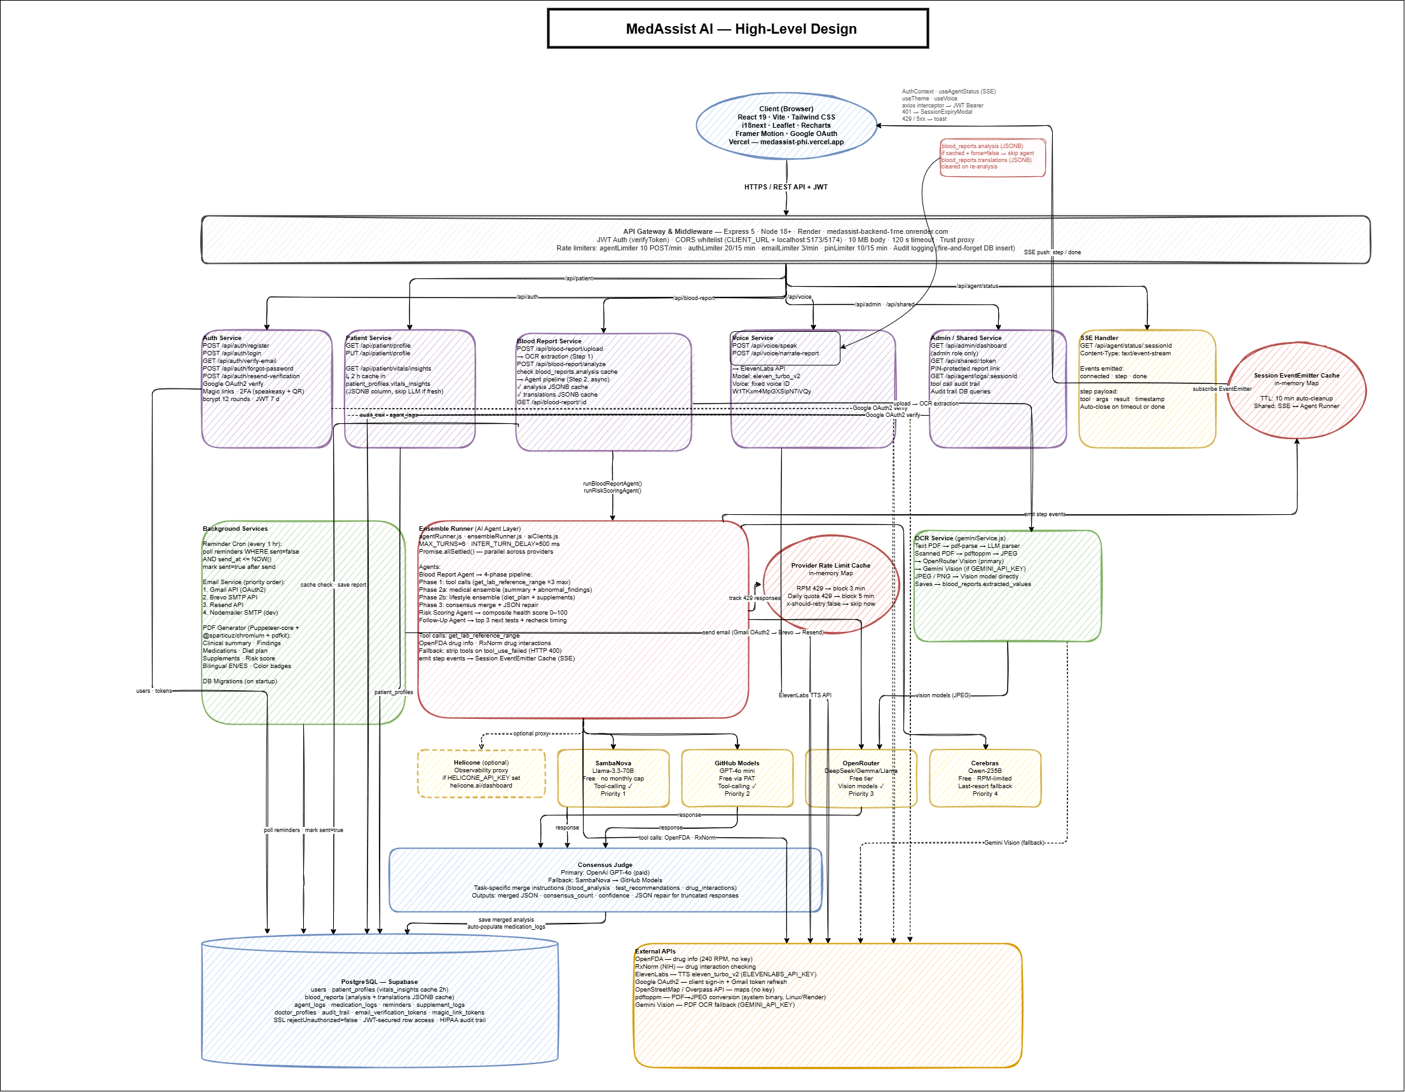
Figure 1 — MedAssist AI System Architecture (HLD)
3.2 Blood Report Processing Flow
When a patient uploads a blood report, the system executes a 4-phase pipeline. The result is stored in the database and the patient can immediately view, narrate, export, or share the full analysis.
Patient uploads PDF / Image
│
▼
┌─────────────────────┐
│ Gemini Vision OCR │ ← extracts 40+ blood parameters
└──────────┬──────────┘
│
▼
┌─────────────────────────────────────────────────────────┐
│ PHASE 1 — Tool Calls │
│ OpenAI GPT-4o → Fetch reference ranges from │
│ OpenFDA & RxNorm for top 3 abnormal parameters │
└──────────────────────────┬──────────────────────────────┘
│
┌───────────────┴──────────────┐
▼ ▼
┌─────────────────────────┐ ┌─────────────────────────┐
│ PHASE 2a — Medical │ │ PHASE 2b — Lifestyle │
│ Ensemble (parallel) │ │ Ensemble (parallel) │
│ SambaNova + GitHub + │ │ SambaNova + GitHub + │
│ OpenRouter │ │ OpenRouter │
│ → Judge: GPT-4o │ │ → Judge: GPT-4o │
│ Output: summary, │ │ Output: diet_plan, │
│ abnormal_findings, │ │ recovery_ingredients │
│ complexity_flag │ │ │
└──────────┬──────────────┘ └──────────┬──────────────┘
└──────────────┬──────────────┘
▼
┌──────────────────────────────┐
│ Merge → blood_reports DB │
│ status: analyzed │
└──────────┬───────────────────┘
│
┌──────────────┼──────────────┐
▼ ▼ ▼
┌─────────────┐ ┌──────────┐ ┌─────────────────┐
│ Risk Scoring│ │ Follow-Up│ │ PDF / Summary │
│ Agent │ │ Agent │ │ Card Export │
│ Framingham │ │ recheck │ │ (Puppeteer) │
│ FINDRISC │ │ schedule │ │ │
│ CKD-EPI │ │ + email │ │ │
│ Child-Pugh │ │ reminders│ │ │
└─────────────┘ └──────────┘ └─────────────────┘
4. Technology Stack
4.1 Frontend
Technology | Purpose
React 19 + Vite | SPA framework and build tool
Tailwind CSS 3.4 | Utility-first styling with dark mode
React Router v7 | Client-side routing
Recharts 3.8 | Trend charts and sparkline visualizations
Leaflet + React Leaflet | Interactive nearby-clinic map
Framer Motion 12 | Page transitions and animations
react-hook-form 7 | Form state management
i18next + react-i18next | Full English / Spanish internationalization
Axios 1.13 | HTTP client with JWT Bearer interceptor
@react-oauth/google | Google OAuth federated login

4.2 Backend
Technology | Purpose
Node.js 18 + Express 5 | REST API server
PostgreSQL via Supabase | Primary relational database
jsonwebtoken | Stateless JWT authentication (7-day tokens)
bcryptjs | Password hashing
Speakeasy + QRCode | TOTP 2-factor authentication
Multer 2.1 | File upload handling (10 MB limit)
PDFKit 0.18 + Puppeteer Core | PDF report generation and export
pdf-parse 1.1 | Text extraction from digital PDFs
Nodemailer 8 | Multi-provider email (Gmail OAuth2, Brevo, Resend)
express-rate-limit 8.3 | 4-layer rate limiting (auth, email, agent, PIN)

4.3 AI Providers & External APIs
Provider / API | Cost | Role
OpenAI GPT-4o | Paid | Consensus judge + Phase 1 tool calling
SambaNova Llama 3.3 70B | Free | Ensemble agent (parallel inference)
GitHub Models GPT-4o mini | Free* | Ensemble agent (parallel inference)
OpenRouter (multi-chain) | Free | Ensemble fallback agent
Google Gemini 1.5 Vision | Free tier | Blood report OCR — 40+ parameters
ElevenLabs TTS | Paid | Audio narration of findings
OpenFDA | Free | Drug info, adverse events, recall data
RxNorm (NIH) | Free | Drug name normalization and interaction checking
OpenStreetMap Overpass | Free | Nearby clinic/lab/hospital search (10 km)
Google OAuth 2.0 | Free | Federated patient authentication

5. Key Features Implemented
5.1 Blood Report Upload
- Upload blood reports as PDF, JPG, or PNG (up to 10 MB)
- Live camera capture mode with guide-frame overlay, front/rear flip, and 2× resolution crop for mobile users
- Google Gemini 1.5 Vision extracts 40+ parameters: name, value, unit, normal range, status
- Graceful handling of multi-page PDFs, handwritten values, and non-standard column layouts
5.2 AI Blood Report Analysis (4-Phase Ensemble)
Output Section | Description
Overall Assessment | 2–3 sentence summary with root cause identification
Abnormal Findings | Value, normal range, status (normal/low/high/critical), plain-English interpretation
Complexity Flag | Low / Medium / High with physician referral decision
Diet Plan | Meal schedule, foods to eat/avoid, personalized to the patient's conditions
Recovery Ingredients | Natural supplements with targets and adherence tracking
Tablet Recommendations | FDA-verified medication suggestions with RxNorm normalization

5.3 Clinical Risk Scoring
Four validated clinical models applied to extracted blood values:
- Framingham Risk Score — 10-year cardiovascular disease risk
- FINDRISC — Type 2 diabetes risk (Finnish Diabetes Risk Score)
- CKD-EPI — Estimated GFR for chronic kidney disease staging
- Child-Pugh Score — Liver function and cirrhosis severity
- Composite 0–100 health index with urgency levels: routine / follow-up soon / urgent / emergency
5.4 Follow-Up Scheduling
- Top 3 recommended follow-up tests derived from abnormal finding severity
- Evidence-based recheck timeframes: Critical (1–2 weeks), Significant (1–3 months), Mild (3–6 months)
- Automated background email reminders sent 1 day before each scheduled recheck
5.5 Report History & Trend Analysis
- Full report history with interactive month-by-month timeline
- Recharts trend charts for 10 key parameters across all historical visits
- Side-by-side comparison of any 2 reports with delta badges (↑/↓/→)
5.6 Patient Dashboard
- Composite health score gauge (0–100) with AI summary and risk sparkline
- Daily AI-generated personalized health tips (refreshable, cached 24 hours)
- Recent report cards showing status, parameter count, and abnormal findings
- Achievement badges (first report, analysis complete, streaks)
5.7 Vitals Tracker
Vital | Unit / Notes
Blood Pressure | mmHg — systolic / diastolic
Glucose | mg/dL — fasting or random
Weight | kg
Heart Rate | bpm
SpO₂ | % oxygen saturation
Temperature | °F

30-day trend sparklines per vital type. AI-generated insights correlate vitals to blood report parameters (e.g., elevated glucose correlated with HbA1c result).
5.8 Audio Narration
- Doctor-style full report narration via ElevenLabs TTS (eleven_turbo_v2)
- Plain-English on-demand explanation of any single abnormal finding
- Native Spanish audio narration when language is set to Spanish
5.9 Multi-Language Support (EN / ES)
- Full English / Spanish UI powered by i18next
- Smart translation caching — translations stored in PostgreSQL, incremental key-level updates
- Poisoned-cache detection prevents caching of failed or incomplete translations
- One-click sidebar toggle, persists across sessions
5.10 Report Sharing & PDF Export
- PIN-protected shareable links with 7-day expiry — recipients view the full analysis without an account
- Full analysis PDF export with Puppeteer (headless browser rendering)
- One-page summary card PDF via PDFKit
- Both exports support multi-language output
5.11 Medical ID Card (Emergency)
- Emergency contact name and phone, blood type, organ donor status, critical medical notes
- PIN-protected public lookup by patient ID — accessible to first responders without login
- Brute-force protection: 10 failed PIN attempts triggers 15-minute IP lockout
5.12 Nearby Clinics & Labs
- Searches clinics, labs, hospitals, pharmacies, and blood banks within 10 km of the patient
- Powered by OpenStreetMap Overpass API with 3-mirror parallel fallback (14-second timeout each)
- Results: name, specialization, address, phone, website, and Haversine-calculated distance
- 1-hour in-memory cache per location bucket (up to 200 buckets) — cache hits bypass Overpass entirely
- Circuit breaker: 10-minute cooldown if all mirrors fail simultaneously
5.13 Admin Panel
- System statistics: total users, blood reports uploaded, AI analyses generated
- Paginated user list with search and suspend/unsuspend controls
- HIPAA audit trail: every sensitive action logged with user, action, resource, IP, timestamp
6. AI Agents & Multi-LLM Ensemble
6.1 Blood Report Agent
The primary agent runs a 4-phase pipeline as a fire-and-forget background process. The client polls GET /api/agent/status/:sessionId for real-time progress. Results are persisted to the database immediately as each phase completes.
Phase | Description
Phase 1 — Tool Calls | OpenAI GPT-4o fetches lab reference ranges from OpenFDA and RxNorm for the top 3 abnormal parameters
Phase 2a — Medical Ensemble | SambaNova + GitHub Models run in parallel → GPT-4o merges → summary, abnormal findings, complexity flag, referral decision
Phase 2b — Lifestyle Ensemble | SambaNova + GitHub Models run in parallel → GPT-4o merges → diet plan, recovery ingredients, tablet recommendations
Phase 3 — Persist | Merged JSON written to blood_reports table; status set to 'analyzed'

6.2 Risk Scoring Agent
A single-turn agent that applies four validated clinical scoring algorithms to the extracted blood parameter set combined with the patient's age, weight, BMI, and medical history from their profile.
Model | Measures
Framingham | 10-year cardiovascular disease probability
FINDRISC | Type 2 diabetes risk (validated in 10+ European cohorts)
CKD-EPI | eGFR estimation for chronic kidney disease staging
Child-Pugh | Liver function and cirrhosis prognosis scoring

6.3 Follow-Up Agent
Takes the abnormal findings list and the patient's current medications as input. Returns the top 3 recommended follow-up tests with recheck timeframes and urgency levels. Automatically creates a reminder record in the database; the background reminder service sends the email 1 day before each scheduled recheck date.
6.4 Ensemble Runner Architecture
Incoming request
│
▼
Dispatch to available providers (Promise.allSettled)
┌─────────────┬─────────────┬───────────────┐
▼ ▼ ▼ ▼
SambaNova GitHub Models OpenRouter (skip if
Llama 3.3 GPT-4o mini DeepSeek/ rate-limited)
70B Gemma/Llama
└─────────────┴─────────────┴───────────────┘
│
▼
Consensus Judge
OpenAI GPT-4o
(task-specific merge strategy)
│
▼
Final merged result
Merge strategies per task type:
Task | Merge Strategy
blood_analysis | Conservative — prefer lower/safer values; flag abnormal if ANY agent raises concern
drug_interactions | Use the MORE SEVERE rating when agents disagree (patient safety priority)
treatment_plan | Prefer safer/lower doses; flag all drug interactions

7. Database Design
MedAssist AI uses PostgreSQL hosted on Supabase. The schema is applied via a base schema.sql file and 4 incremental migrations. Key design choices include JSONB columns for flexible AI output storage and a dedicated audit_trail table for HIPAA compliance.
Table | Purpose & Key Columns
users | Patient and admin accounts — email, password_hash, role, name, 2FA secret
patient_profiles | Health demographics — age, gender, weight, height, conditions, allergies, medications, insurance
blood_reports | Upload + full AI analysis — extracted_values JSONB, analysis JSONB, risk_scores JSONB, follow_up JSONB, translations JSONB
vitals_logs | Daily vital signs — BP systolic/diastolic, glucose, weight, HR, SpO₂, temperature
medication_logs | Medication adherence timestamps
supplement_logs | Recovery ingredient adherence and streak counters
medical_id | Emergency card — blood type, organ donor flag, PIN hash, emergency contacts
email_verification_tokens | 24-hour registration verification links
password_reset_tokens | 24-hour one-time-use password reset tokens
report_shares | PIN-protected 7-day shareable links — token, pin_hash, access_count, expiry
agent_logs | AI agent execution audit — steps JSONB, total_turns, provider, created_at
audit_trail | HIPAA action log — user_id, action, resource, ip_address, user_agent, created_at
reminders | Scheduled follow-up email reminders — send_at, status, test_name, report_id

8. Security & HIPAA Compliance
8.1 Authentication
Mechanism | Details
JWT (7-day tokens) | Stateless auth — payload: userId, role, name; auto-attached by Axios interceptor
Email Verification | Required on registration — 24-hour time-limited link
Password Reset | 24-hour time-limited token, one-time use, invalidated after use
Google OAuth 2.0 | Federated login — no password stored
TOTP 2FA | Google Authenticator / Authy compatible; QR code setup flow

8.2 Rate Limiting (4 Layers)
Layer | Limit
Auth endpoints | 20 requests / 15 min / IP
Email endpoints | 3 requests / 60 sec / IP
AI agent endpoints | 10 requests / 60 sec / IP
Medical ID PIN lookup | 10 attempts / 15 min / IP — brute-force lockout

8.3 HIPAA Audit Trail
Every sensitive action is logged to the audit_trail table with: user_id, action type, resource identifier, IP address, user-agent string, and timestamp. The admin panel exposes this log with filtering by user, action type, and date range.
9. API Reference
Route Group | Endpoints
/api/auth | register, login, google, forgot-password, verify-email, reset-password, 2fa/setup, 2fa/verify
/api/patient | profile (GET/PUT), vitals (POST/GET), vitals/insights, medical-id, badges, sessions
/api/blood-report | upload, analyze, history, /:id, risk-scores, follow-up, export-pdf, export-summary
/api/voice | speak, narrate-report, explain-finding, translate
/api/shared | share-report, shared/:token, medical-id/:patientId (public PIN lookup)
/api/admin | stats, users (paginated), users/:id/suspend, audit-log
/api/agent | status/:sessionId (polling endpoint for real-time progress)

10. Deployment
Component | Platform | Notes
Frontend | Vercel | React SPA — continuous deploy from main branch
Backend API | Render | Node.js Express server — free tier (ephemeral filesystem)
Database | Supabase | PostgreSQL — SSL required (rejectUnauthorized: false)
CI/CD | GitHub Actions | Lint + build check on every push to main

Live URLs:
Service | URL
Frontend (Vercel) | https://medassist-phi.vercel.app/
Backend API (Render) | https://medassist-backend-1rne.onrender.com

11. Local Setup Guide
11.1 Prerequisites
- Node.js 18+
- PostgreSQL database or a Supabase project
- API keys: OpenAI (required — consensus judge), Gemini (required — OCR), SambaNova + GitHub PAT + OpenRouter (free ensemble agents), ElevenLabs (optional — TTS)
- Google OAuth Client ID and Secret (for federated login)
11.2 Install & Configure
# Clone and install
git clone https://github.com/SiddharthBhamare01/medassist-ai.git
cd medassist-ai
cd server && npm install
cd ../client && npm install
# Copy environment files
cp server/.env.example server/.env # fill in your API keys
cp client/.env.example client/.env # fill in VITE_API_URL and VITE_GOOGLE_CLIENT_ID
11.3 Database Setup
Run the following SQL files in order in your Supabase SQL editor:
server/db/schema.sql
server/db/migrations/001_recommended_tests_jsonb.sql
server/db/migrations/002_session_status.sql
server/db/migrations/003_all_features.sql
server/db/migrations/004_persist_cached_llm_outputs.sql
server/db/seed.sql # optional demo data
11.4 Run Locally
# Terminal 1 — backend (http://localhost:5000)
cd server && npm run dev
# Terminal 2 — frontend (http://localhost:5173)
cd client && npm run dev
12. Key Design Decisions
Why Multi-Provider Ensemble Instead of a Single Model?
Medical AI requires higher accuracy than general text generation. A single LLM can hallucinate drug names, misstate reference ranges, or produce overconfident risk assessments. By dispatching the same prompt to multiple free-tier providers in parallel and using GPT-4o as a consensus judge, MedAssist achieves higher reliability — similar to the clinical practice of seeking a second opinion. The conservative merge strategy (flag abnormal if any agent raises concern) prioritizes patient safety over false reassurance.
Why Tool Calling Instead of Pure LLM Generation?
Drug names, interaction data, and adverse events must come from authoritative sources — not from LLM training data which can be stale or incorrect. Tool calling in Phase 1 forces the agent to query OpenFDA and RxNorm for real-time, source-verified data before generating any recommendations. This grounds the AI output in facts rather than inference.
Why Fire-and-Forget with Polling Instead of SSE?
The 4-phase blood report pipeline can take 30–90 seconds. Keeping an HTTP connection open that long is unreliable on serverless/free-tier hosting (Render sleeps idle connections). Fire-and-forget stores the job, and the client polls GET /api/agent/status/:sessionId every 3 seconds. The AgentStatusPanel renders real-time progress bars so the wait feels transparent and trustworthy.
Why Gemini Vision for OCR?
Blood reports come in dozens of formats — scanned images, photographed pages, multi-column PDFs, handwritten annotations. Traditional pdf-parse works for digital PDFs but fails on images. Gemini 1.5 Vision handles both with a structured JSON prompt describing the 40+ expected parameters, gracefully returning null for any value it cannot confidently extract rather than hallucinating a value.
13. Educational Disclaimer
MedAssist AI is an educational CS 595 project developed at Illinois Institute of Technology. It is not a licensed medical device and must not be used for actual clinical decisions. All AI-generated outputs are labeled as educational information only. The system never prescribes medications — it suggests informational references. Complex or critical findings are flagged for physician consultation. All system prompts explicitly include the disclaimer: "Educational use only — not a substitute for professional medical advice."

Screenshots

Authentication & Onboarding
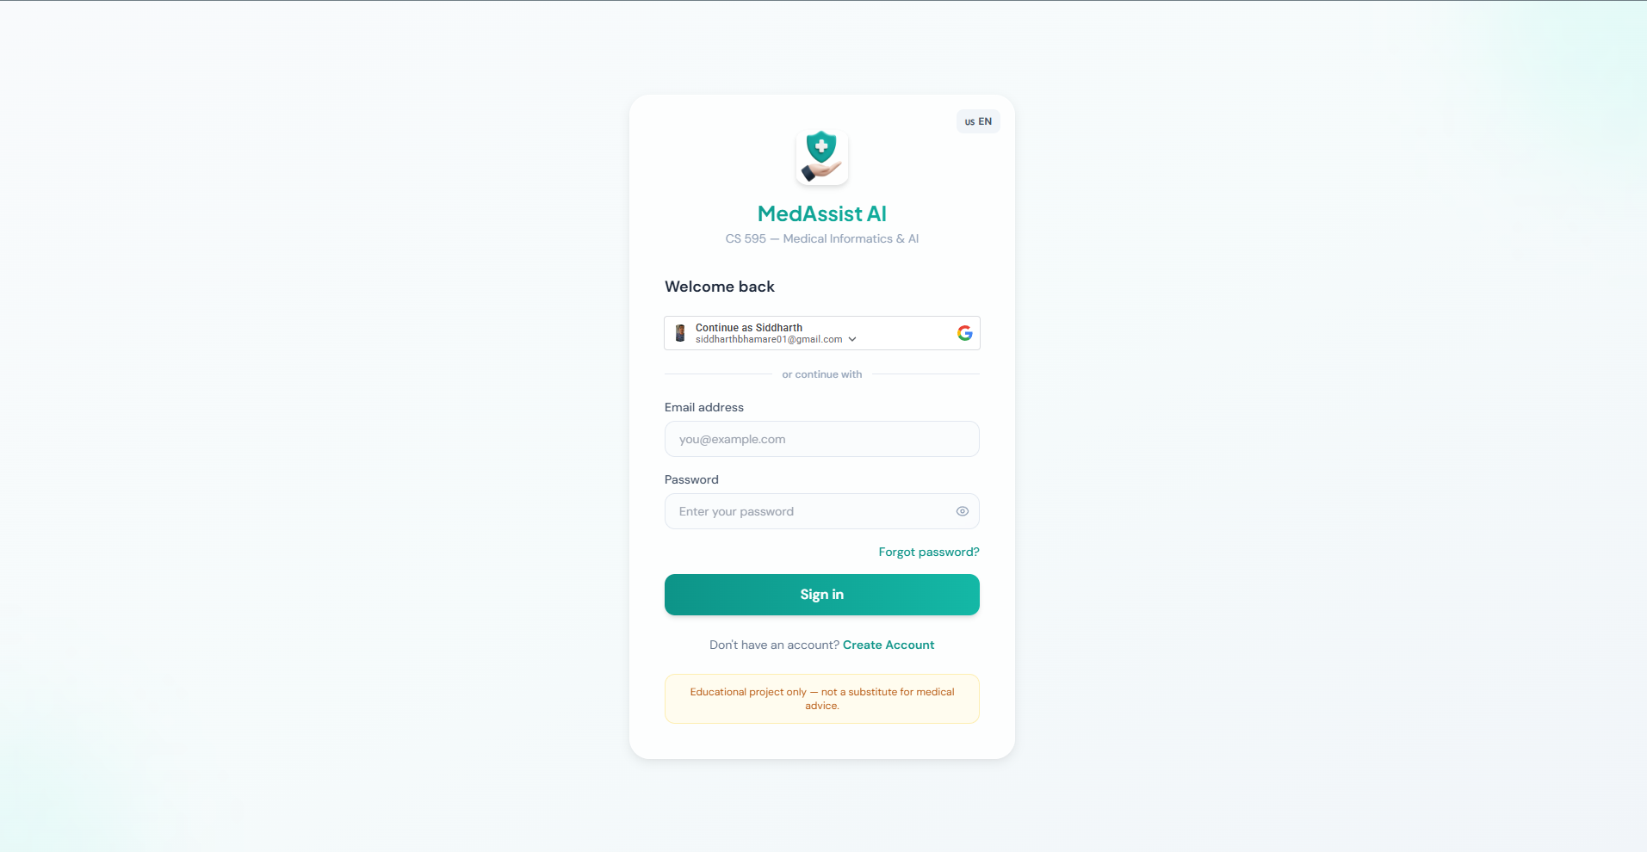
Login Page with Google OAuth

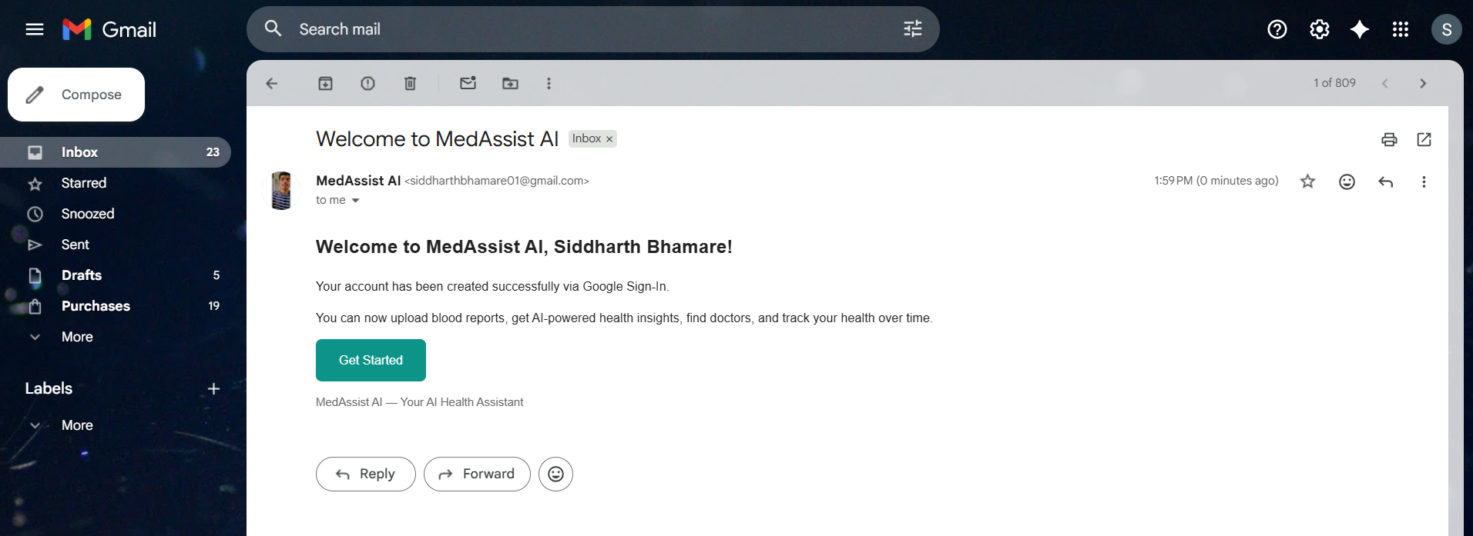
Welcome Email on New Account Creation

Patient Dashboard
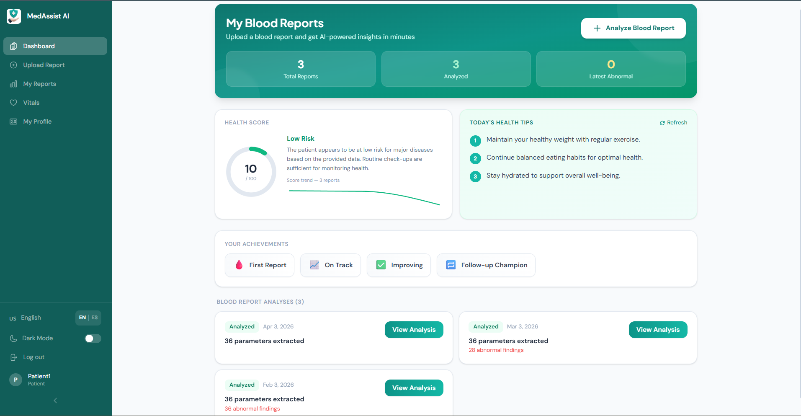
Patient Dashboard — Health Score, Tips & Report Cards

Blood Report Upload
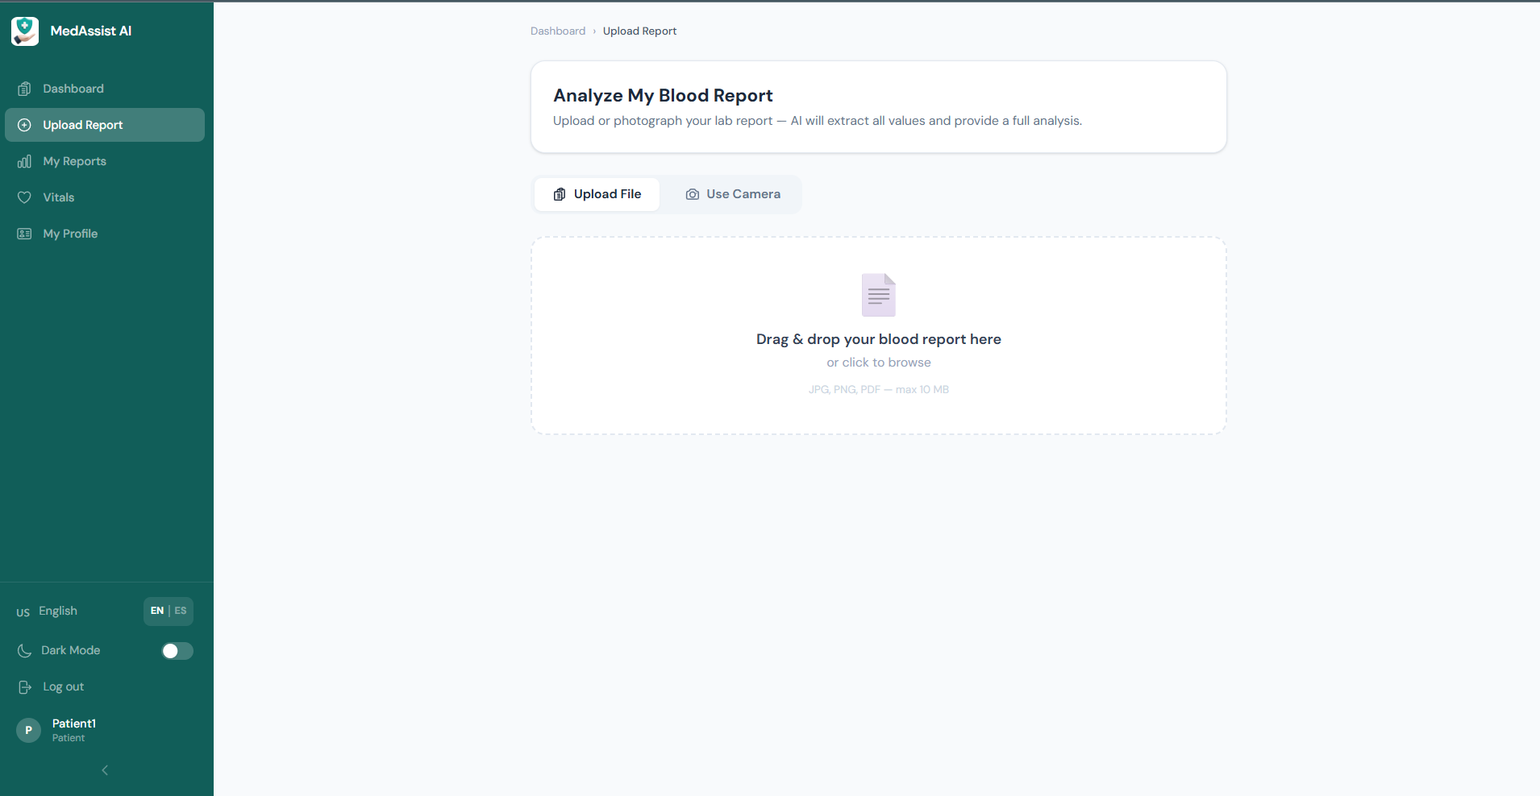
Blood Report Upload (File or Camera)

AI Blood Report Analysis
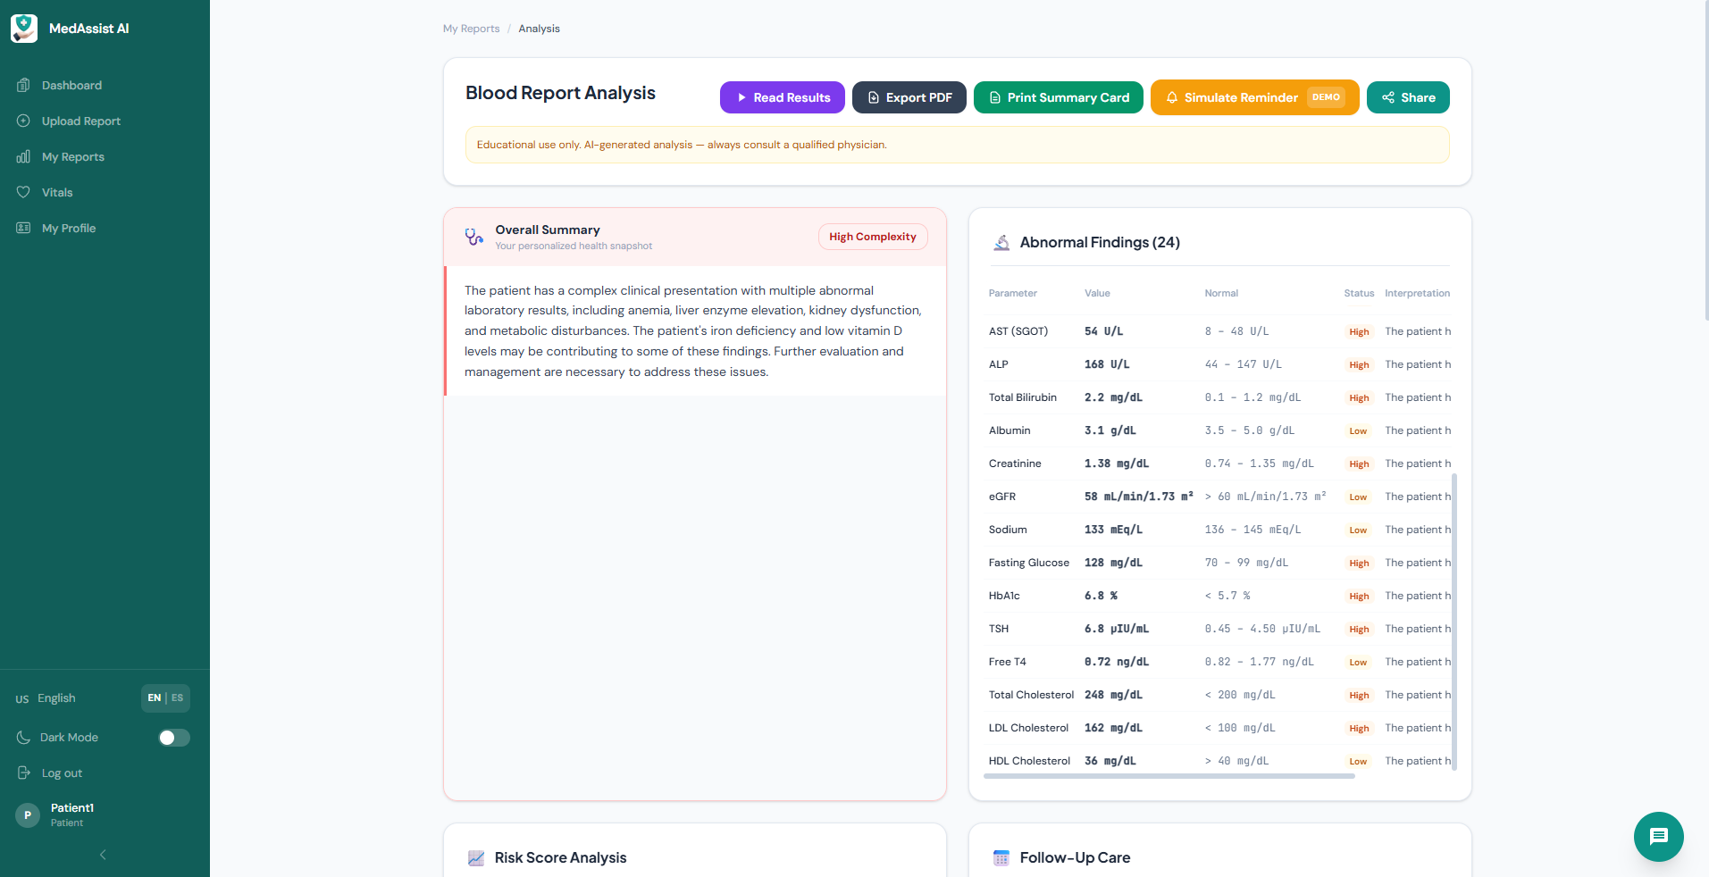
Analysis — Overall Summary & Abnormal Findings

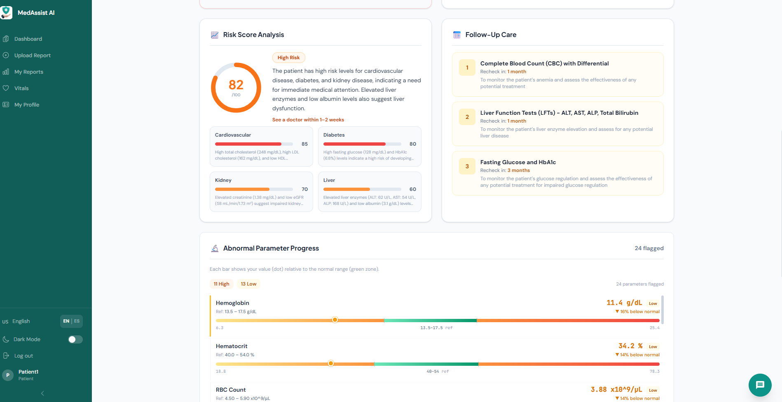
Analysis — Risk Score Breakdown & Follow-Up Care

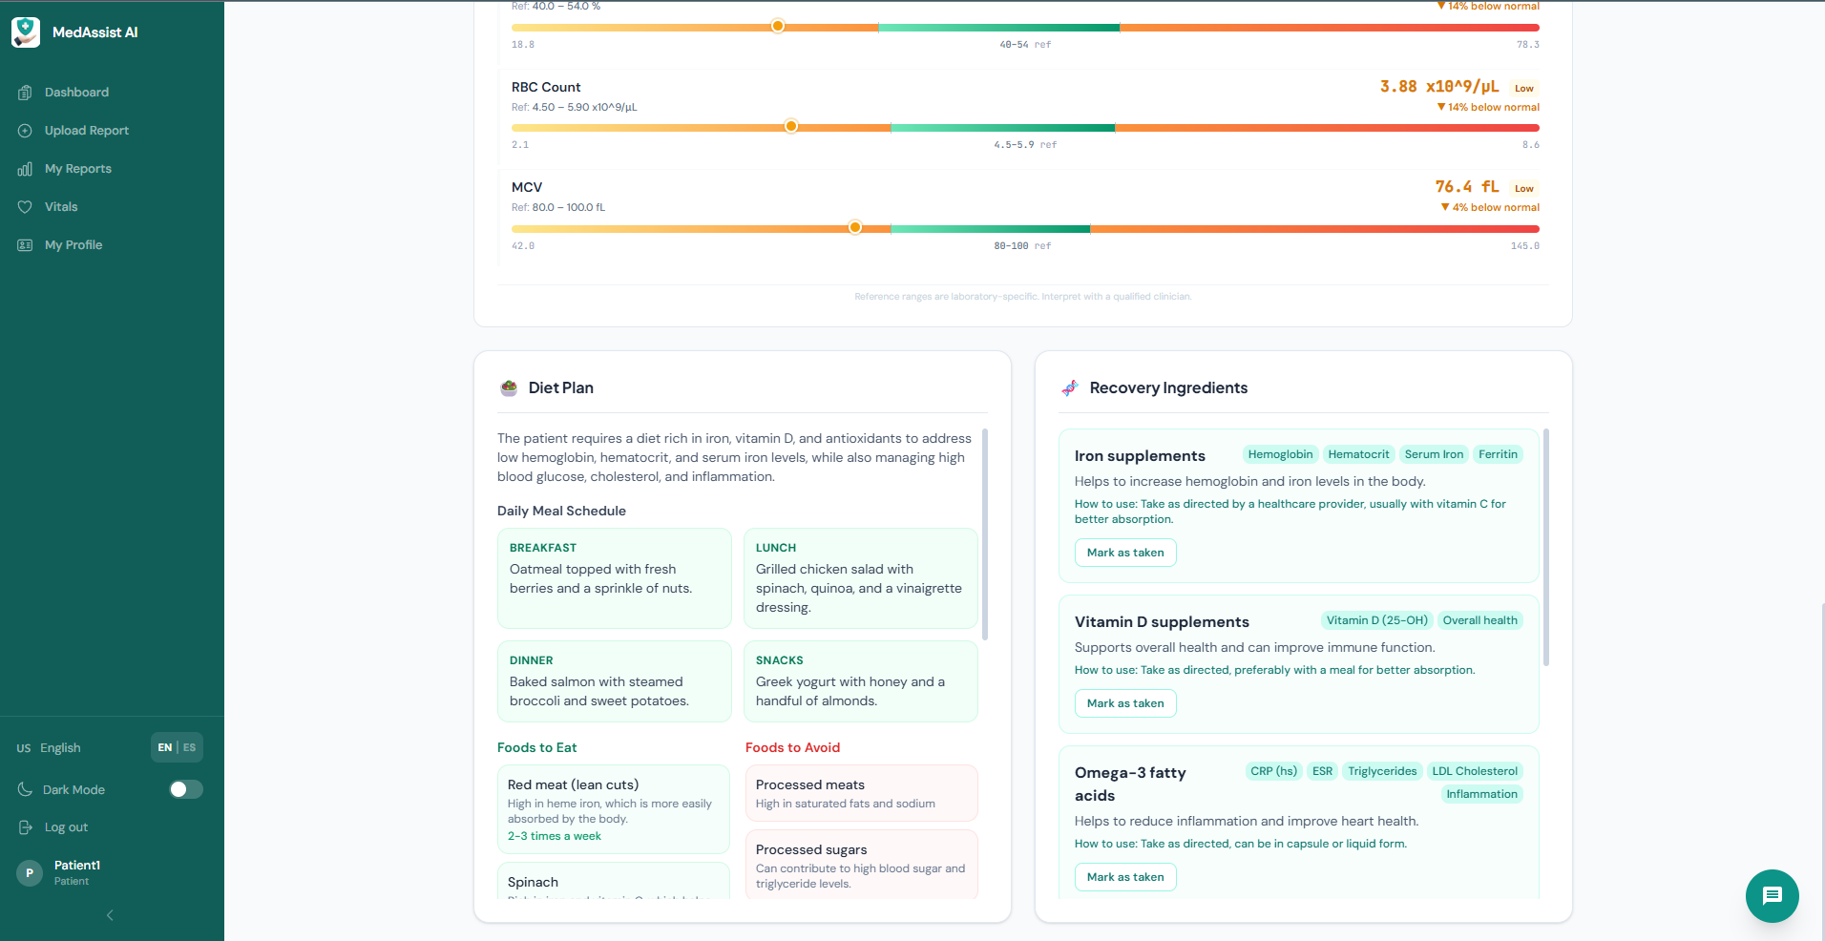
Analysis — Diet Plan & Recovery Ingredients

Report History & Comparison
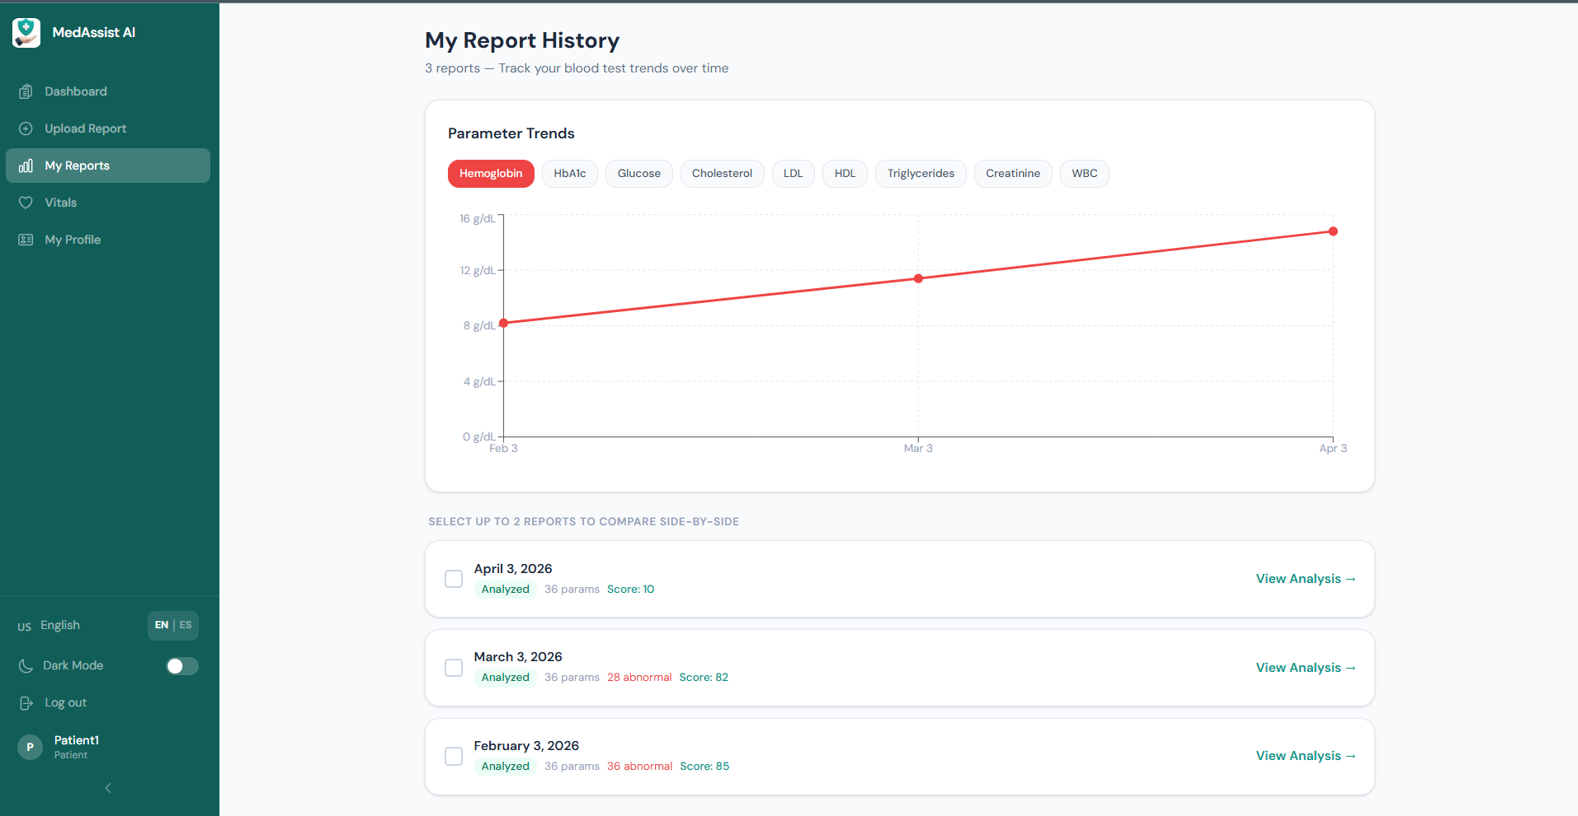
My Report History with Parameter Trend Charts

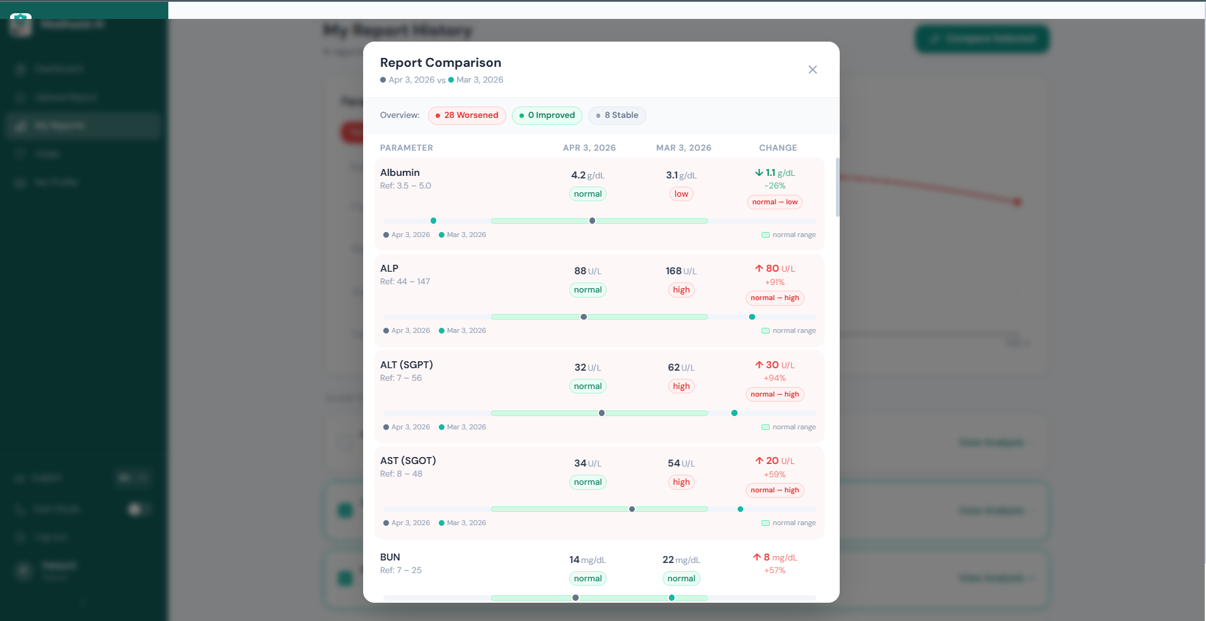
Side-by-Side Report Comparison with Delta Badges

Vitals Tracker
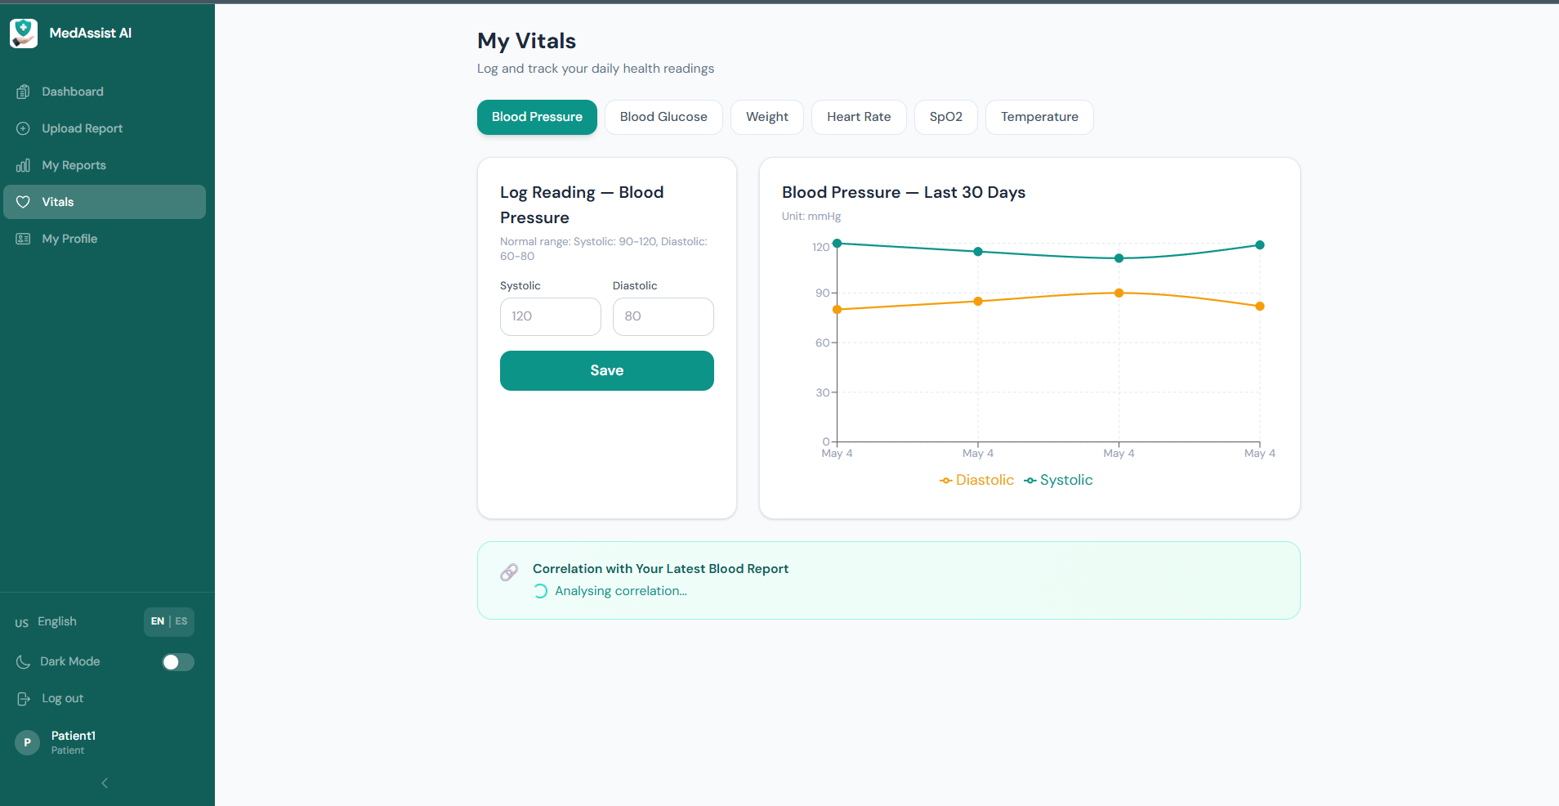
Vitals Tracker — Blood Pressure 30-Day Trend

Multi-Language Support
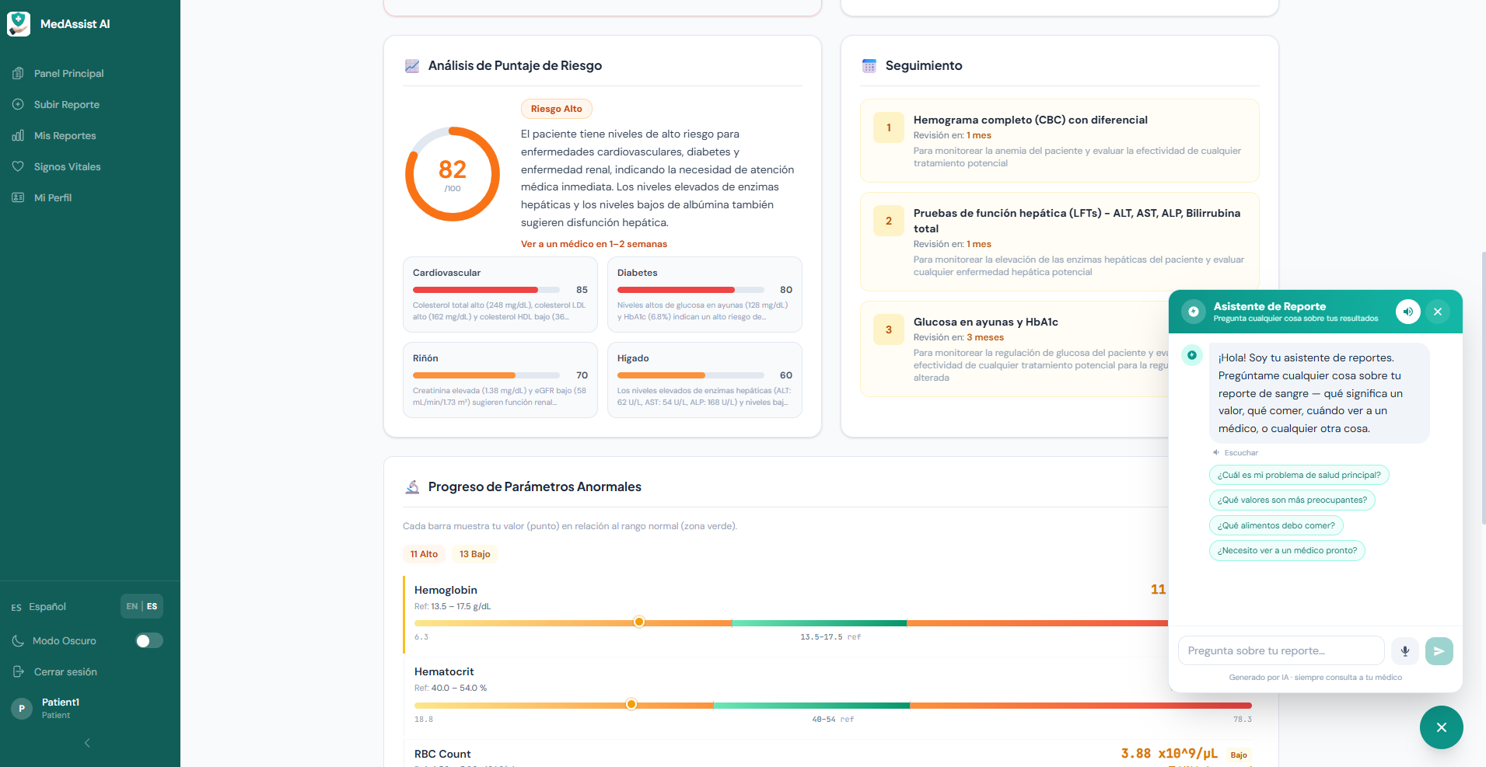
Full Spanish UI with AI Chatbot Assistant

AI Chatbot Assistant
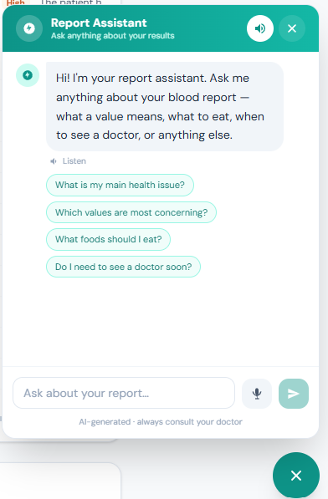
Report Assistant Chatbot (English)

Follow-Up Email Reminder
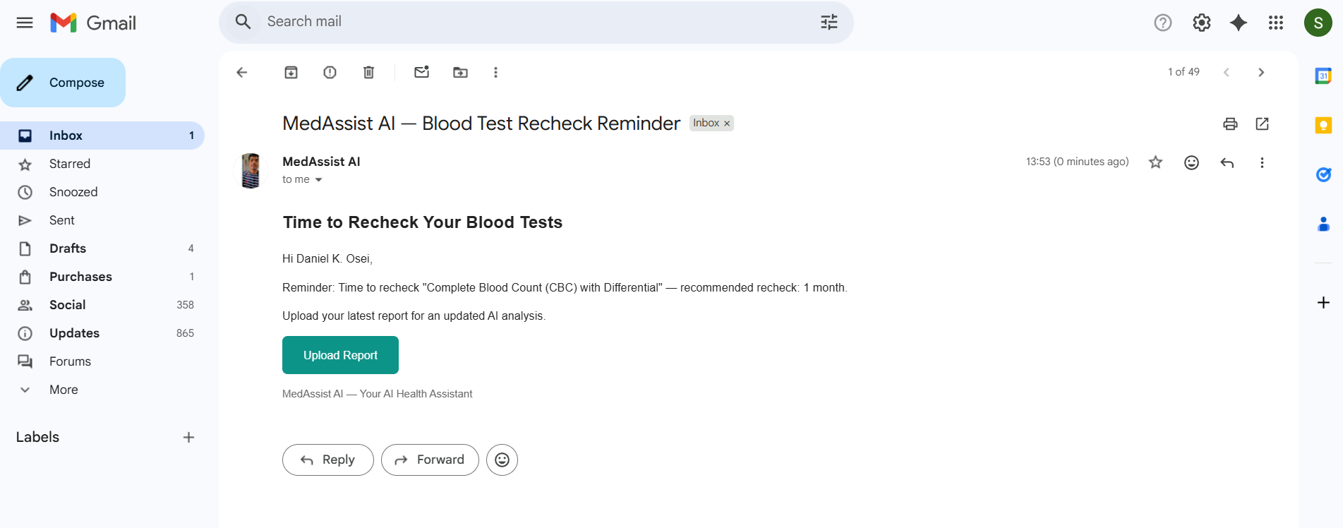
Automated Blood Test Recheck Reminder Email

Suggestion of Clinics/lab as per location of Patient
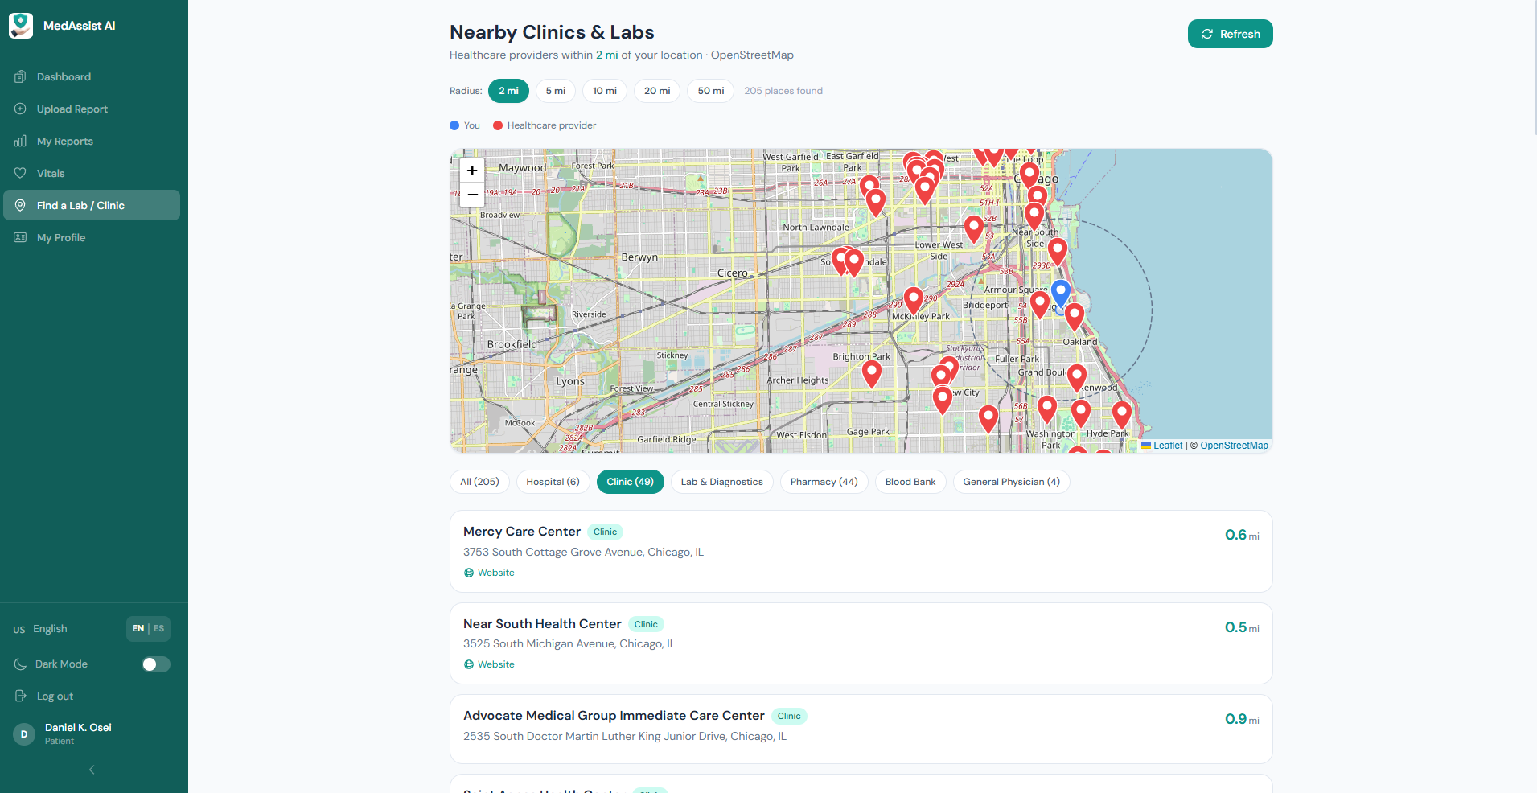
Location based clinic/lab recommendation

Live Agent Tracking & Backend Logs
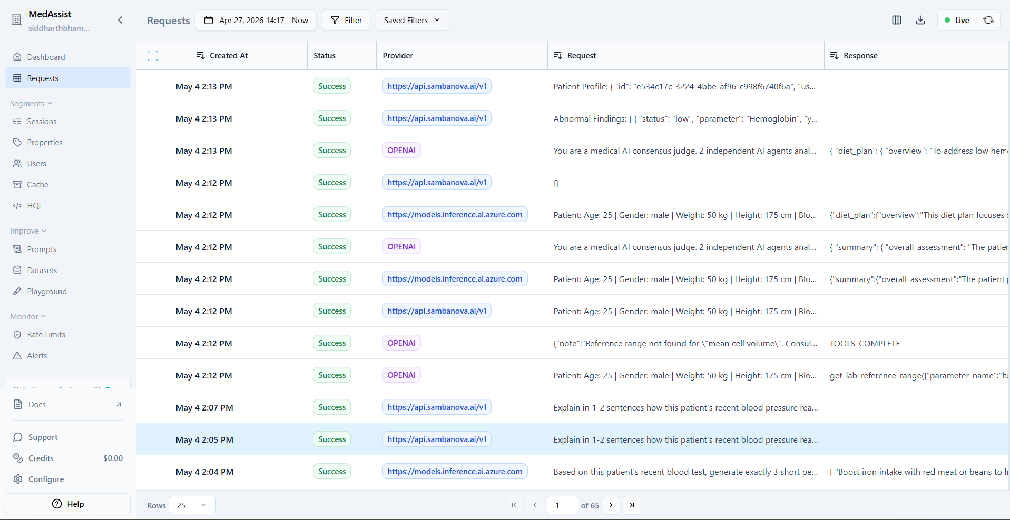
Live Agent API Call Tracking (Langfuse)

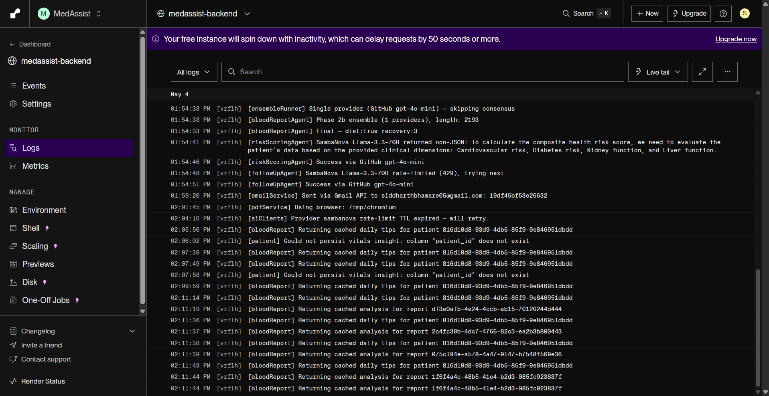
Live Backend Server Logs on Render

