5. ECONOMIC FEASIBILITY OF THE ASYNCHRONOUS MESH
Deployment cost is a binding constraint on quantum fraud detection that the QML literature rarely quantifies. A model that improves detection while costing more to operate than the fraud it recovers is not deployable, irrespective of its reported accuracy. This section prices the Aegis mesh against the fraud value it arbitrates, using Amazon Braket and Amazon EC2 list prices [11], [12].

5.1 Cost Model
For an authorization volume N, the asynchronous path incurs quantum cost only on the routed fraction ρ. Each adjudication requires c circuit executions, and Amazon Braket bills a fixed per-task fee τ together with a per-shot price σ across s shots:
C_{Q} = N · ρ · c · (τ + sσ)
The circuit count is governed by explainability rather than classification. A verdict requires two executions, one for the VQC and one for the QAE of Section 3.2. Exact Quantum SHAP over k features, as defined in Section 3.3, evaluates all 2ᵏ coalitions, each scored by both circuits:
c = 2 + 2^{(k+1)}
For the deployed configuration (k = 4), c = 34, of which 32 executions — 94.1% of quantum expenditure — serve attribution rather than detection. Trained on the ULB European Cardholder dataset [5], the calibrated sieve routes ρ = 0.604% of traffic to adjudication, with s = 1000 shots per circuit.

5.2 Cost by Adjudication Backend
Table 1 prices one million authorizations under this model. The spread across backends exceeds seven orders of magnitude.
Adjudicator backend | Per adjudication | Per 10⁶ authorizations
CPU simulation (c6i.xlarge) | $0.00007 | $0.44
GPU simulation (g5.xlarge) | $0.00055 | $3.30
Amazon Braket DM1 (managed) | $0.13 | $770
Rigetti Cepheus | $24.65 | $148,864
IQM Garnet | $59.50 | $359,327
IonQ Forte | $2,730.20 | $16,487,988
Fraud value arbitrated (ceiling) | — | $137,313
Table 1. Adjudicator cost per 10⁶ authorizations at ρ = 0.604%, with exact Quantum SHAP. List prices, September 2026.
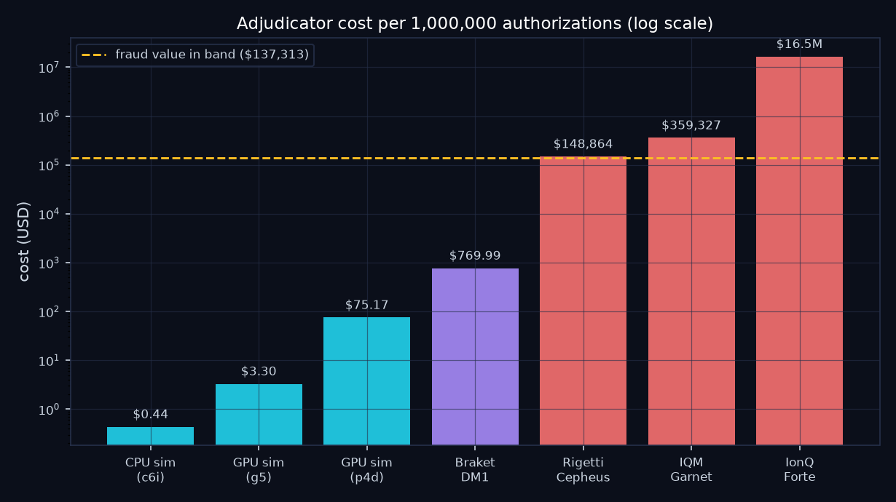
Figure 1. Adjudicator cost by backend (logarithmic scale). The dashed line marks the fraud value arbitrated by the ambiguity band.

5.3 The Economic Ceiling
The value adjudication can recover is bounded above by the fraud flowing through the ambiguity band:
V = N · φ · β · ā
where φ = 0.1727% is the dataset fraud rate, β = 65.3% the measured share of fraud falling within the band, and ā = $122.21 the mean fraudulent amount. At N = 10⁶ this yields V = $137,313, or $0.137 per authorization. The bound is optimistic: realizing it would require detecting every fraud the synchronous sieve missed while declining no legitimate transaction.
Measured against this ceiling, adjudication on IonQ Forte costs $16.49 per authorization, approximately 120 times the entire value at stake. Lower-priced superconducting devices narrow the margin to order unity without clearing it. Simulating the identical circuits on rented compute costs $3.30 per 10⁶ authorizations, or roughly 1/40,000 of the ceiling.

5.4 Implications for the Hardware Strategy
Three conclusions follow. First, the asynchronous mesh is economically deployable at present, but with its circuits simulated rather than executed on quantum hardware. At k = 4 the statevector comprises sixteen amplitudes, so classical simulation is exact and its marginal cost negligible. Quantum hardware becomes the cheaper option only once circuit width exceeds classical simulability, beyond approximately forty qubits; the backend abstraction of Section 4 renders that transition a configuration change rather than a redesign.
Second, selective routing is what makes quantum adjudication tractable at all. Adjudicating ρ = 0.604% of traffic rather than the full stream reduces quantum expenditure by a factor of 166. The contribution of the mesh is therefore economic as much as operational.
Third, exact attribution dominates the quantum bill. Should expenditure require reduction, restricting Quantum SHAP to declined transactions, or sampling coalitions rather than enumerating them, addresses 94% of the cost — at the expense of the exactness that makes the attribution defensible under enterprise model governance.

5.5 Basis of Estimate and Hardware Availability
IonQ Aria, targeted in Section 4, is no longer offered on Amazon Braket. IonQ's currently available devices are Forte-1 and Forte-Enterprise-1, priced at $0.08000 per shot against the $0.03 previously assumed; Section 4 and reference [10] are updated accordingly.
All figures use list prices verified on 14 September 2026, exclusive of promotional credits, committed-use discounts, and hourly reservation pricing, which is offered from $2,500 to $7,000 per device-hour and may prove cheaper at sustained volume. The model assumes one Braket task per circuit execution; batching circuits into fewer tasks would reduce the per-task component. Queue latency, data transfer, and the engineering cost of production operation are excluded.

Additional References
[11] Amazon Web Services. Amazon Braket Pricing. Accessed 14 September 2026.
[12] Amazon Web Services. Amazon EC2 On-Demand Instance Pricing. Accessed 14 September 2026.

