ASSIGNMENT – 3

Develop a Shopping card in PHP

- Shopping Cart – Admin Site :-

- Admin_Login:

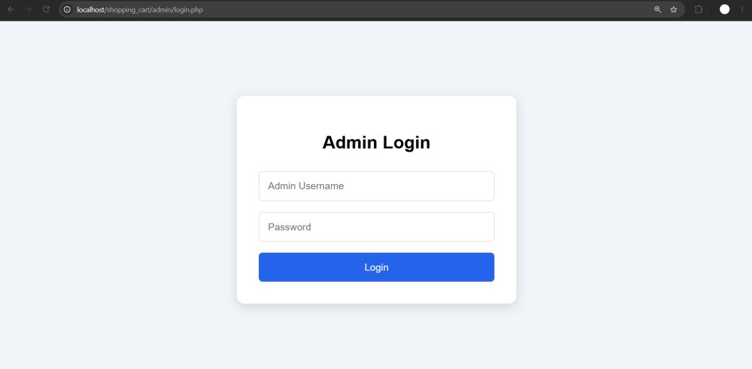

- Admin_dashboard:

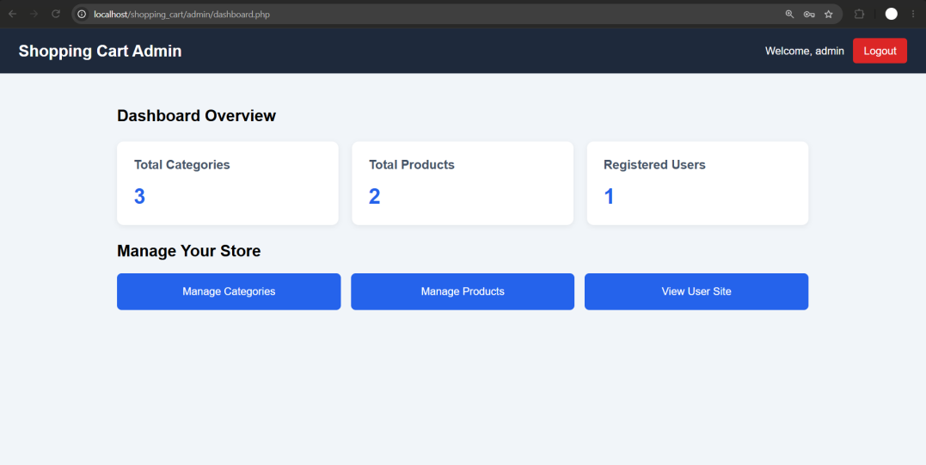

- Manage_Categories:

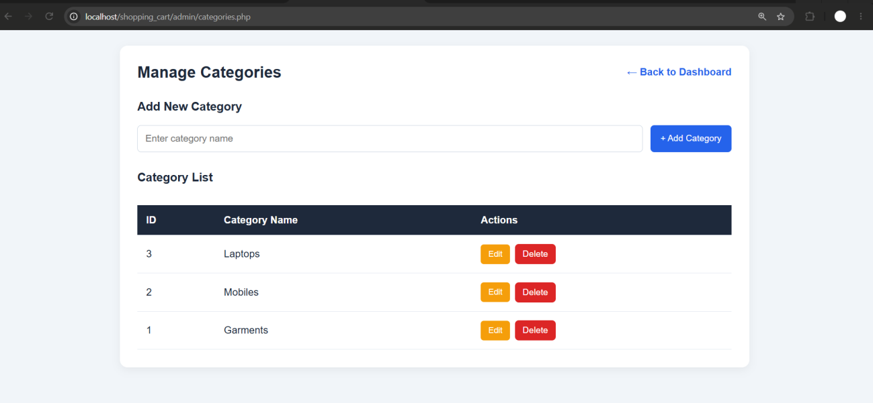

- Add_Product_With_Image:

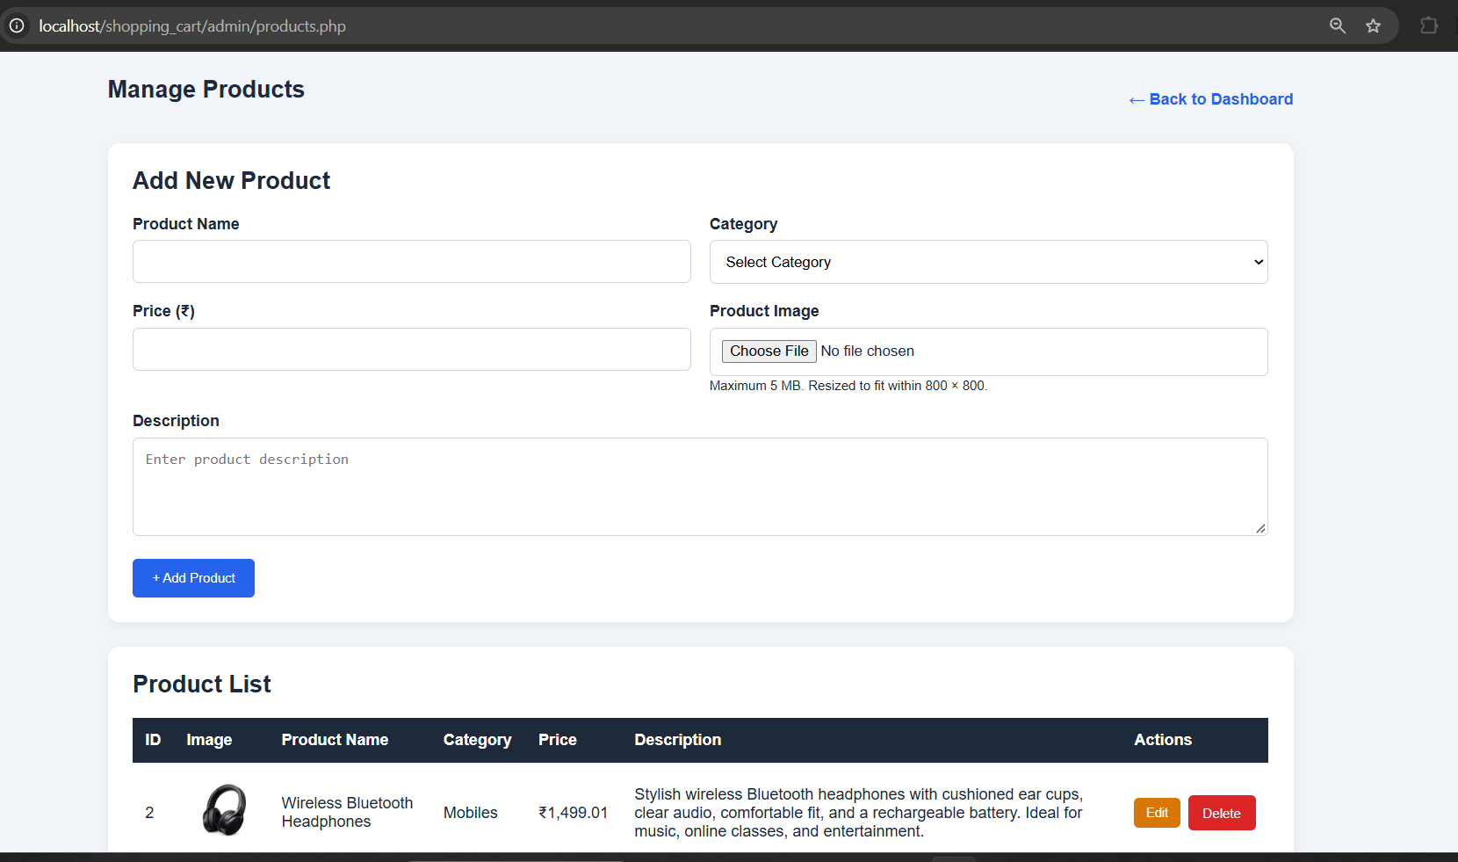

- Manage_Product:

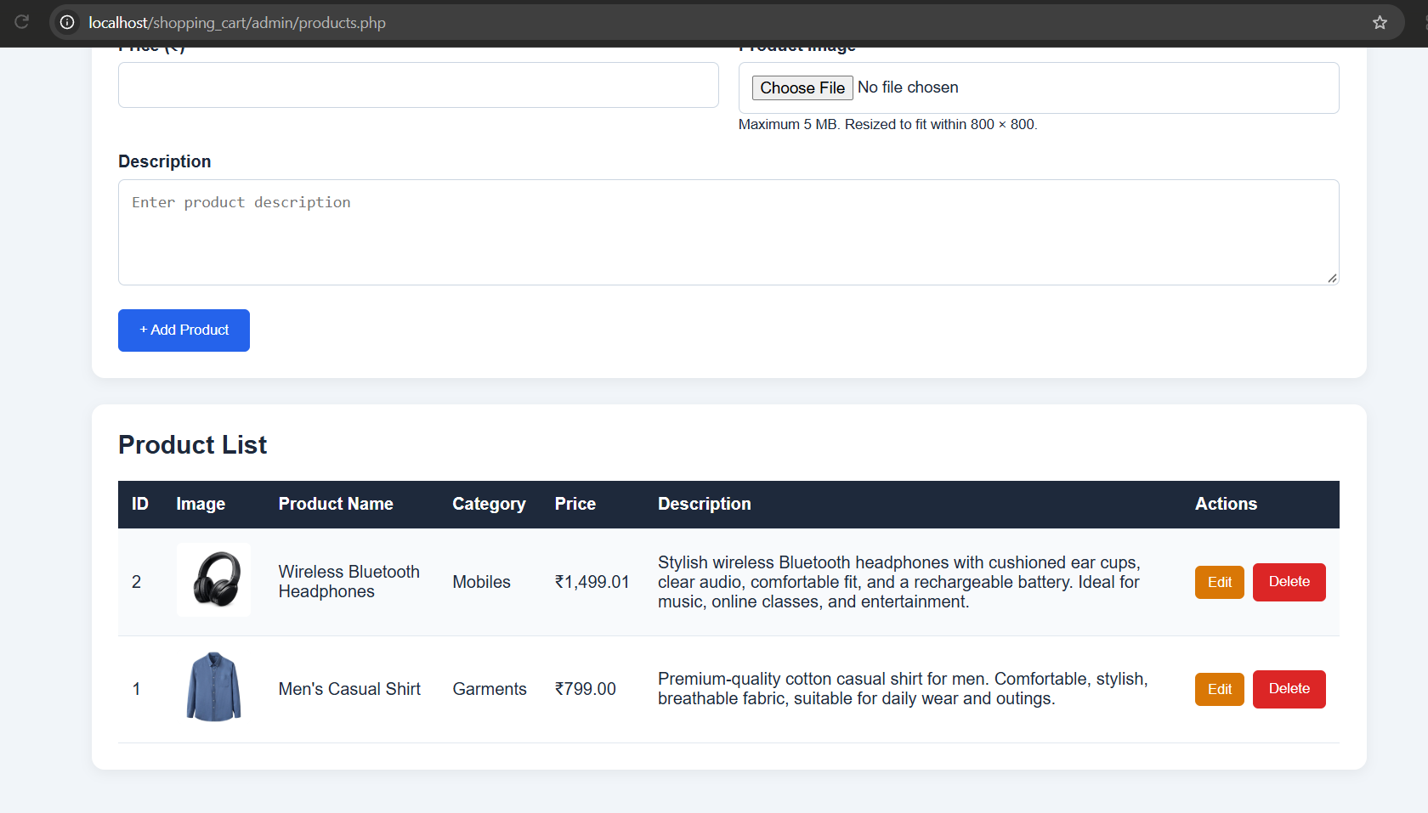

- Admin_Logout:

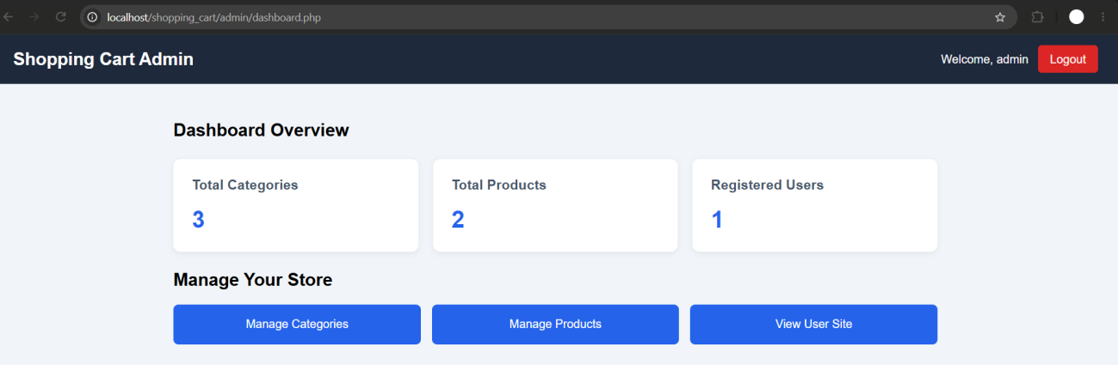

- Shopping Cart – User Site:-

- List_Categories

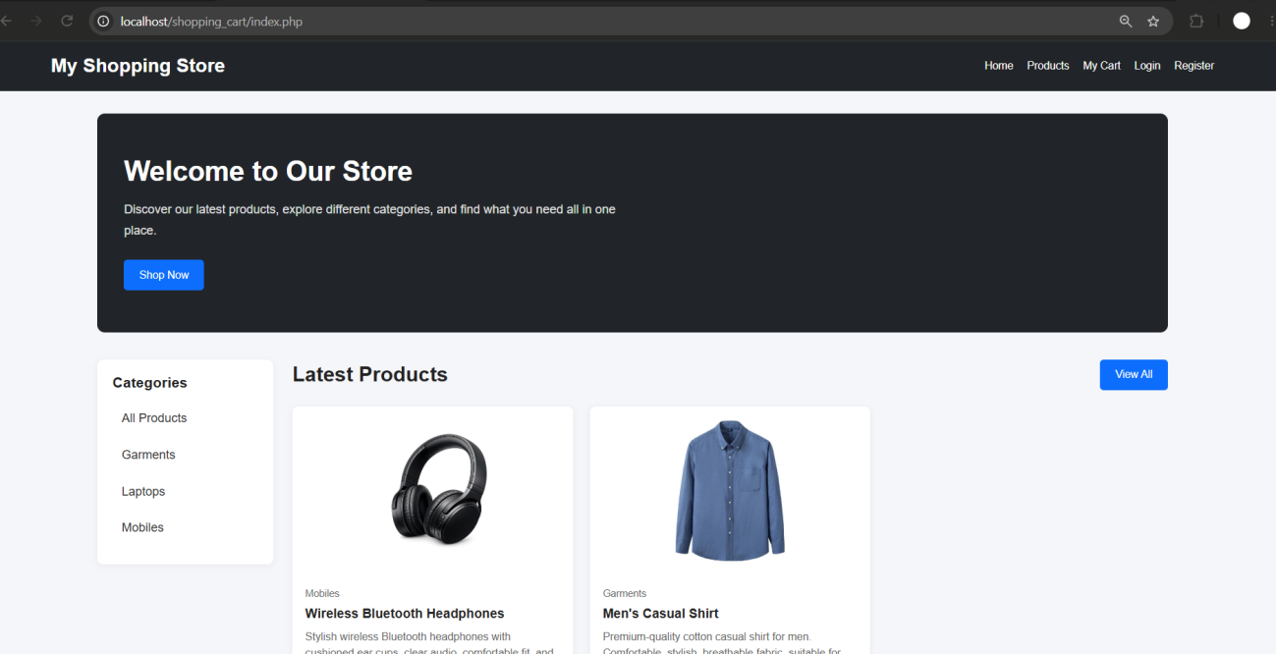

- Product_By_Category:

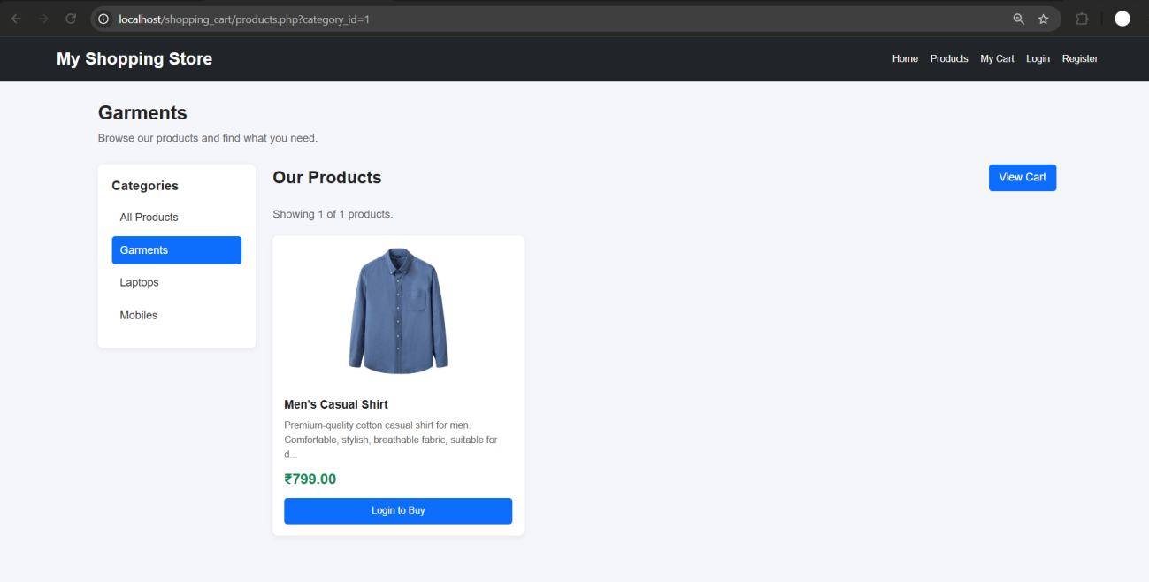

- User_Registration_Captch:

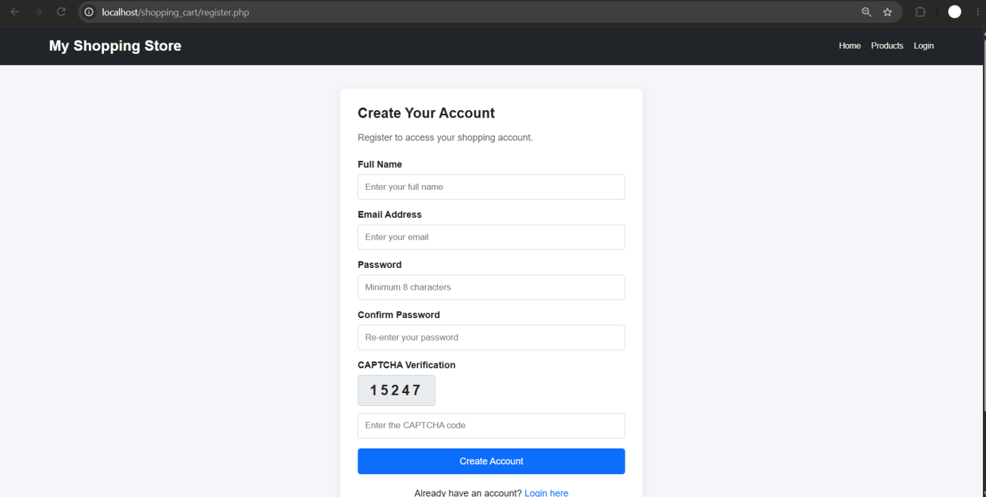

- User_Login:

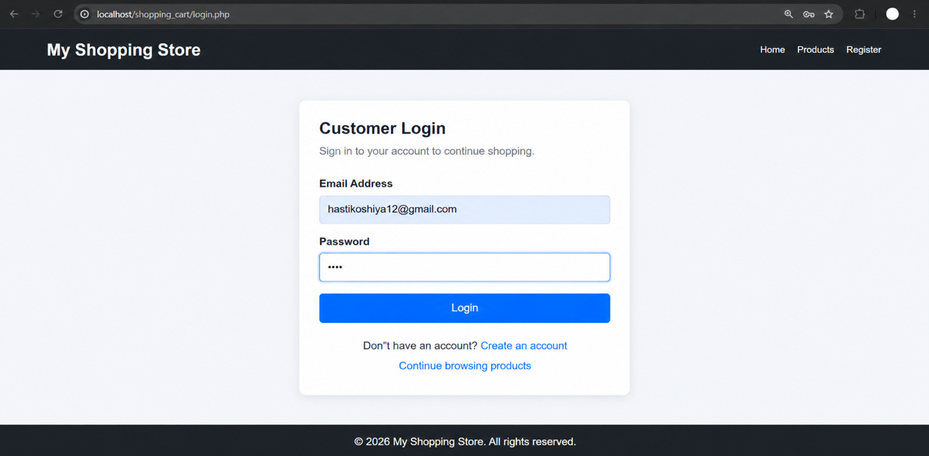

- Add_to_Cart:

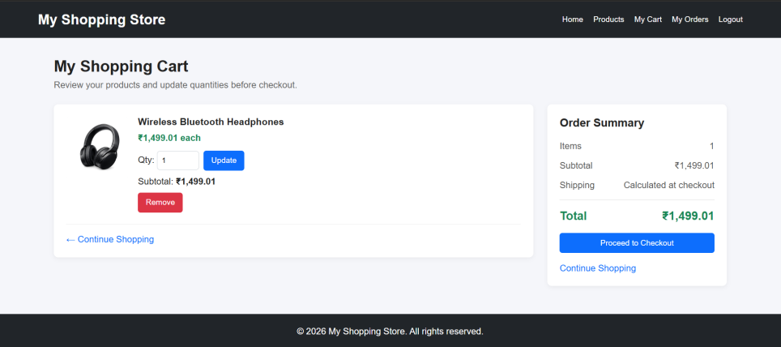

- Place_Order:

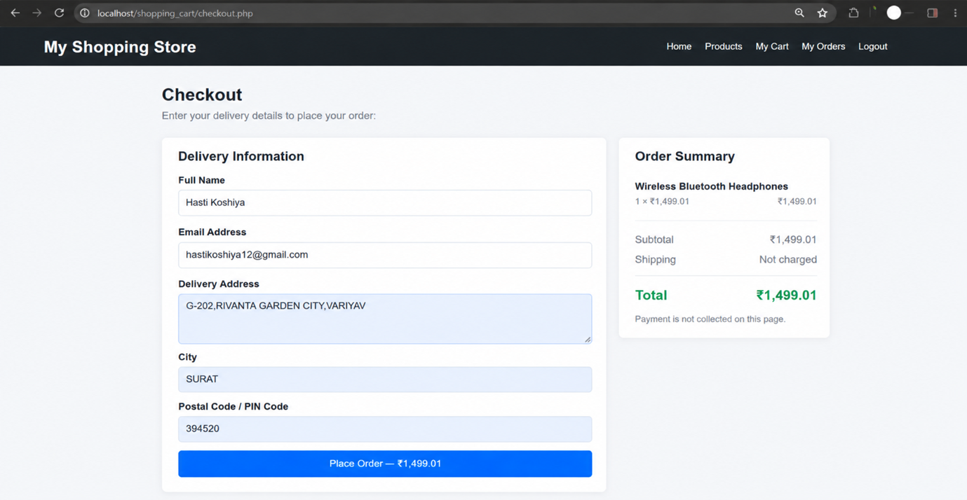

- Order_Placed:

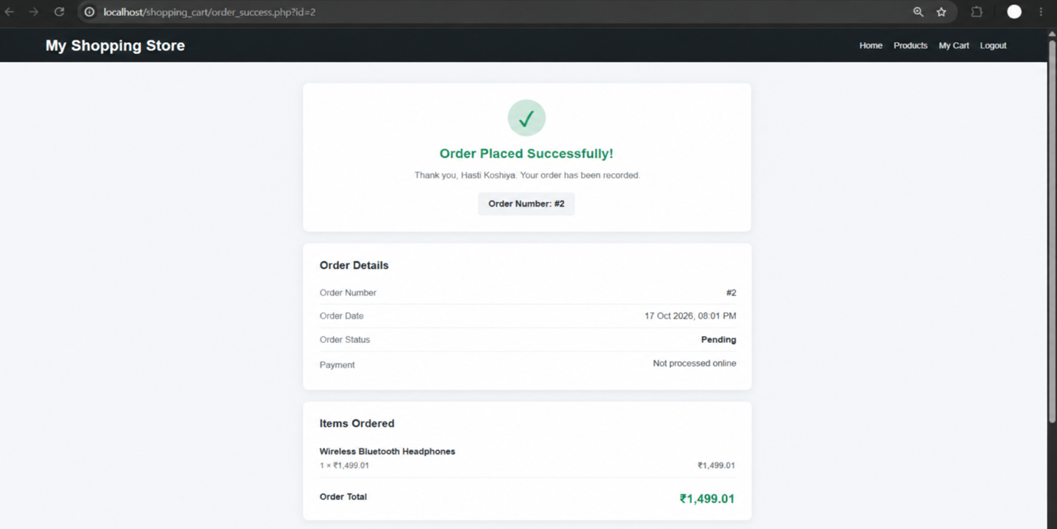

- Shopping Cart – XML and MySQL :-

- Students_XML_File:

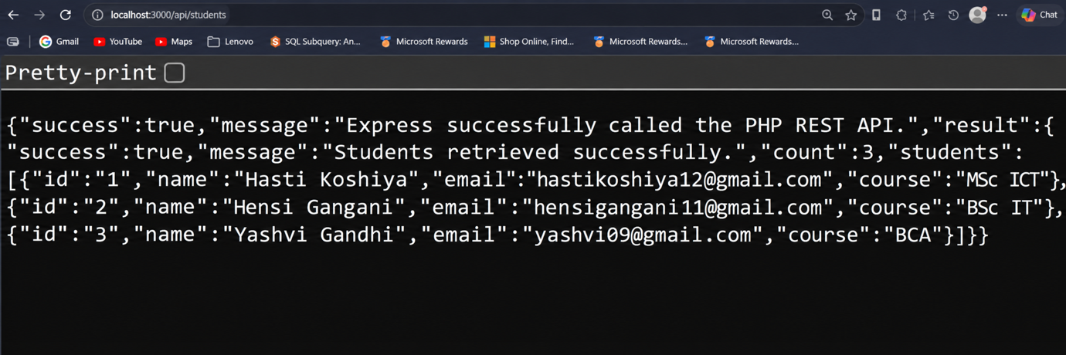

- Import_XML_To_MySQL :-

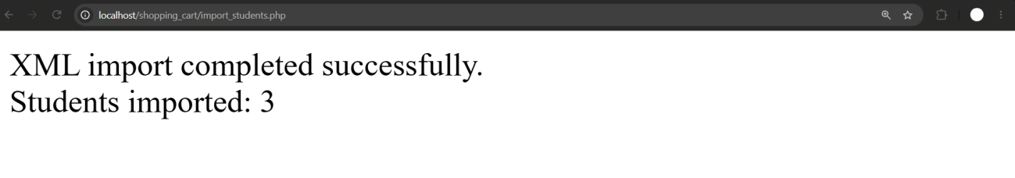
- Export_MySQL_To_XML :

