./**tea.run** bam **tea ra** **–c** hg19 **–p** 10 **–f –K**

-c : hg19, -p : # of CPU, -K : Starting from Meerkat

**Example**

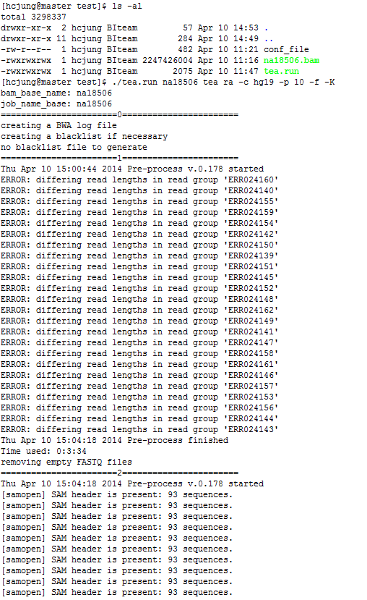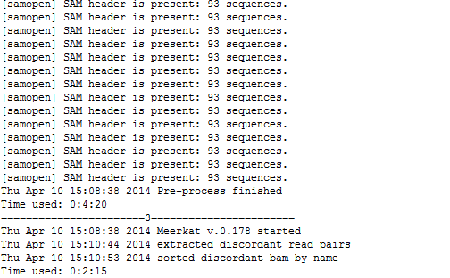

**Meerkat finished and TEA start running**

