Better SISU

By Aleksi Hasu, Leo Mandara, Jyri Hakala

User manual

At the start of the program a login screen "SISU LOGIN" is displayed. The login screen asks the user to enter a first and last name of a student and a student ID. The user can also choose a saved student from the drop-down menu. If invalid information is given, clicking the "Continue" button displays an error message on the bottom of the window telling what input needs to be changed. When valid inputs are given, clicking the "Continue" button closes the login screen and a loading screen is displayed.

The loading screen is displayed while data is being read from SISU and the main window "SISU" hasn't been created yet. After the data had been read and saved and main window is created, the loading screen is closed, and the main window is displayed.

The "SISU" window consists of two tabs: “STUDENT INFORMATION” and “DEGREE STRUCTURE” and the user can go between these two just by clicking on the tabs:

On the "STUDENT INFORMATION" tab the user can choose a degree program and a possible field from the drop-down menus. When a degree program is selected, a Loading... text is displayed while the program is getting the whole corresponding module from SISU. Choosing a degree programme or field automatically updates the “DEGREE STRUCTURE” tab to match the chosen degree.

On the “DEGREE STRUCTURE” tab the user can view the degree programme as a tree on the left side of the tab. By selecting a study module on the tree and if the module contains courses, the user can add or remove courses by selecting the checkboxes appearing on the right side of the tab. User can view the course name, code and credits by holding mouse cursor on top of a checkbox. On top right of the tab is a text field where the user can search from the visible courses by typing.

On the bottom right corner of the main window is "SAVE" button. The saved degree can be accessed the next time SISU is opened by choosing the applicable student’s name from the drop-down menu on the login screen.

Extra features

Thorough testing of logic classes. All logic-centred classes were implemented using test-driven development. An interface was agreed on for each class, and tests were implemented first to make sure the class to be implemented worked according to what was agreed.

Student settings window. At the start of the program a window is shown for entering a student’s information.

Program saving. A planned degree can be saved by pressing the “SAVE” button in the bottom right corner of the “STUDENT INFORMATION” or the “DEGREE STRUCTURE” tab. The saved degree can be accessed the next time SISU is opened by choosing the applicable student’s name from the drop-down menu on the login screen. The top right Close button also saves the planned degree.

Class diagram

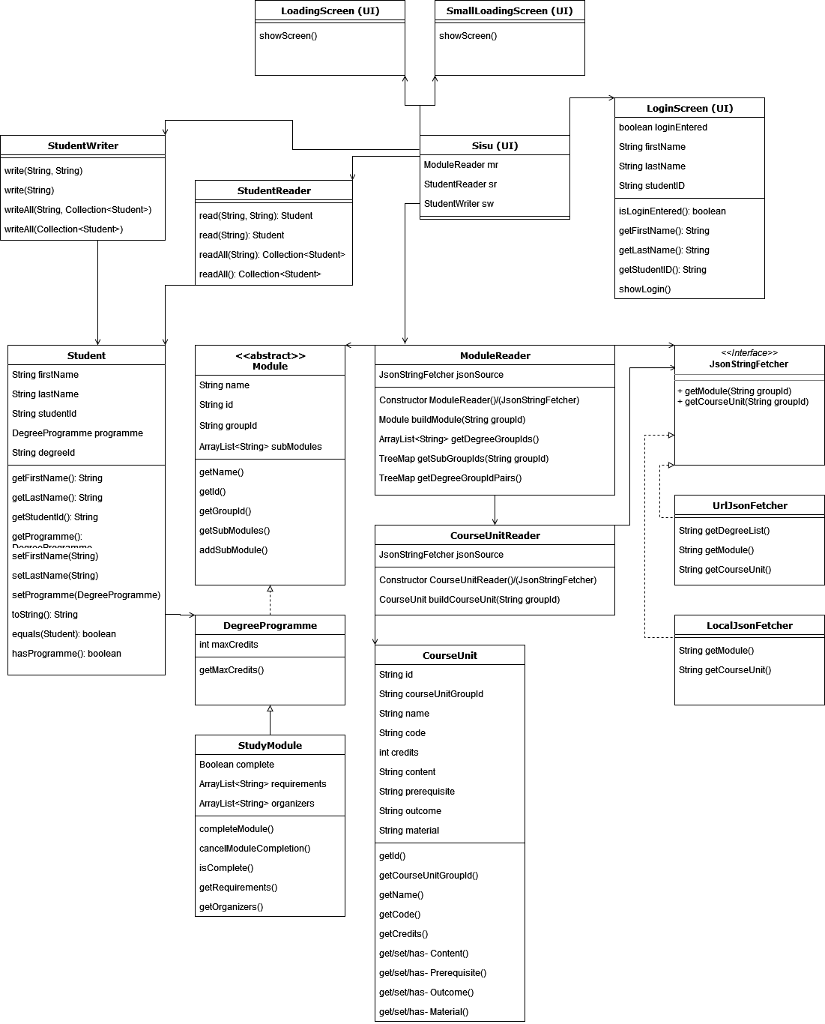

Responsibilities, pre and post conditions of logic classes

The Better SISU implementation stores data in three different module classes stemming from one abstract base class, and one course unit class. Due to the varying nature of data stored, the responsibility of these classes is just to store any data given to them. These classes are as follows:

Module

Stores common data for Modules such as their name, id, groupId, and sub modules and sub course units.

GroupingModule

Adds no functionality to module as such but distinguishes grouping modules from other module types.

DegreeProgramme

Adds maximum credits to module.

StudyModule

Adds completion status, module requirements, and organizers to module.

CourseUnit

Stores all information about a course unit, including id, groupId, name, code, and minimum and maximum credits.

Reading data from a source into modules and course units is done by the classes ModuleReader and CourseUnitReader. Both rely on a class implementing the JsonStringFetcher interface to get their respective data. Two different classes implementing JsonStringFetcher were designed, one for reading data from the remote SISU and the other for reading data from a local JSON directory. In the final UI only the SISU source was used.

JsonStringFetcher

Defines a method for reading Module data and a method for reading CourseUnit data from a source. The classes implementing JsonStringFetcher are LocalJsonFetcher and UrlJsonFetcher. Both implemented fetchers take into account missing data by returning a default “unavailable” string of the correct format.

ModuleReader

Reads data from JsonStringFetcher into modules. Assumes that all data given is in the same format as in the SISU remote data.

CourseUnitReader

Reads data from JsonStringFetcher into course units. Assumes that all data given is in the same format as in the SISU remote data.

Student

Stores a student’s basic information and their chosen DegreeProgramme.

StudentWriter

Writes JSON files representing Students to local storage. Common use is calling write(Student) for a single student, but other methods are included to ensure usability.

StudentReader

Reads JSON files, as saved by StudentWriter, from local storage into Student objects. Common use is calling readAll() to fetch all saved students.

ModuleAdapter

Is used by StudentWriter and StudentReader to differentiate types of Module when writing/reading JSON files. Adds fields “type” and “properties” to each, where type is self-explanatory, and properties holds the actual attributes of the class.

UI Classes

The main window and all it's functions are implemented inside the Sisu class. LoginScreen collects Student information and other GUI classes are displayed while the program is loading to make the user experience more pleasant.

Sisu

Main JavaFX Application class. "SISU" window implemented in this class.

LoginScreen

"SISU LOGIN" window at the start of the program

LoadingScreen

GUI, extends java.awt.Window. Displayed when LoginScreen is closed, and the program is loading. Consists of welcome text and loading gif

SmallLoadingScreen

GUI, extends java.awt.Window. Displayed while the program is loading a module from Sisu. Consists of Loading... text

Division of work

The division of work was agreed on in weekly meetings. The different Module and CourseUnit classes were implemented as a group in order to get the group up to speed. After the basic data classes, the team mostly worked on their own responsibilities. Aleksi’s responsibility was the user interface, Leo’s responsibility was reading data from the Kori API into the defined data structure, and Jyri’s responsibility was classes for storing and reading student data. Though everyone had their own part, the group gave feedback on each other’s completed modules. Larger git merges were also discussed in the weekly meetings, so that everyone knew what would be merged into main.

Bugs and missing features

* When marking courses as complete in the “DEGREE STRUCTURE” tab, the changes are only reflected in the “STUDENT INFORMATION” tab on program restart.
* UI was only tested manually