# User manual

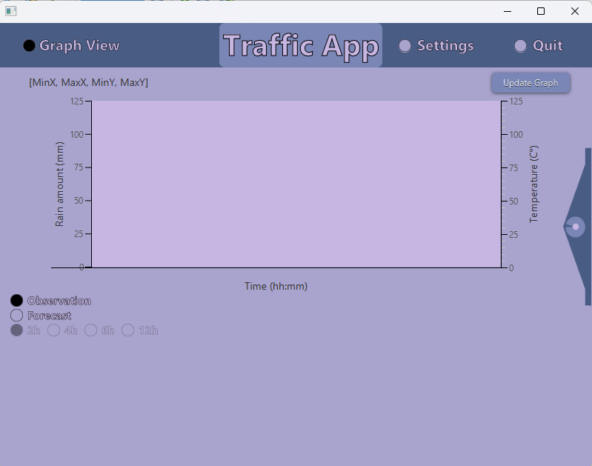

In the graph view user can view the data. Rain amounts are presented in a blue bar chart and temperature in a red line chart.

User can also select whether they want to view observation or forecast data.

Program can be close by clicking the quit button and setting can be changed from the settings tab.

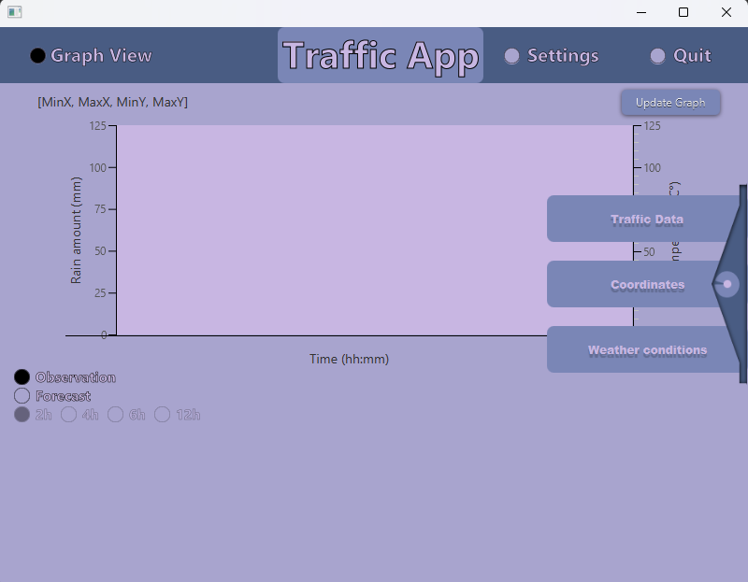

When side bar is clicked a menu opens.

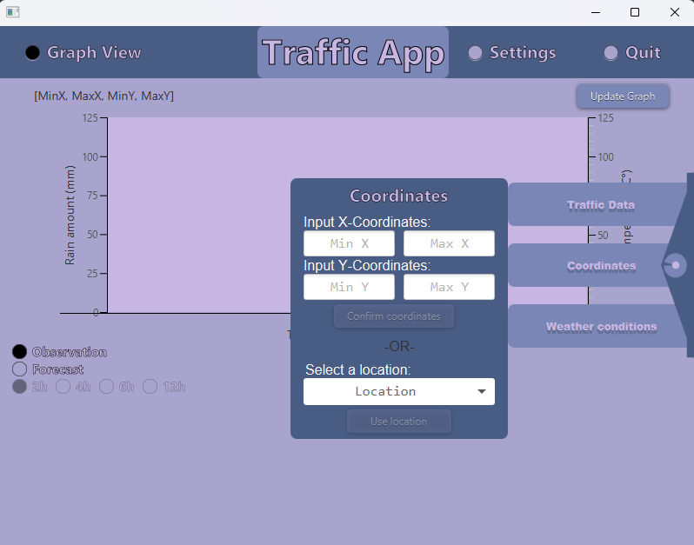

In the coordinates menu user can input the coordinates of their choosing or select a pre-set location.

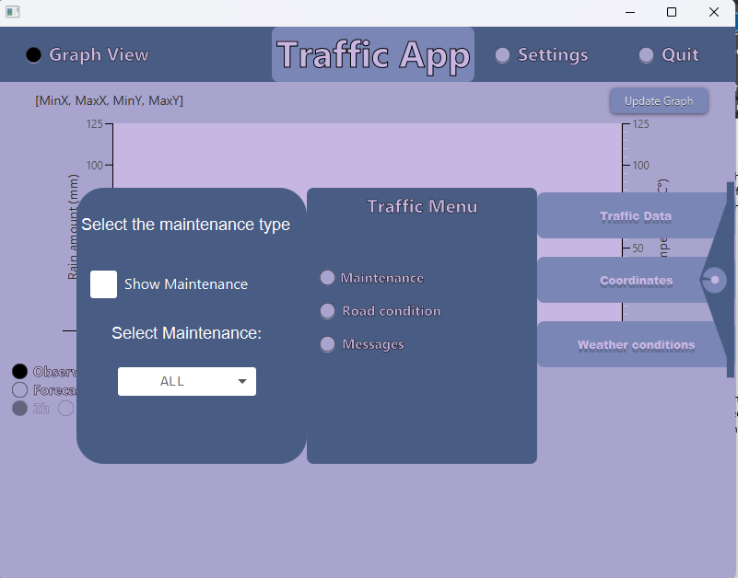

In the traffic menu user can select which traffic data related items they want to display in the UI.

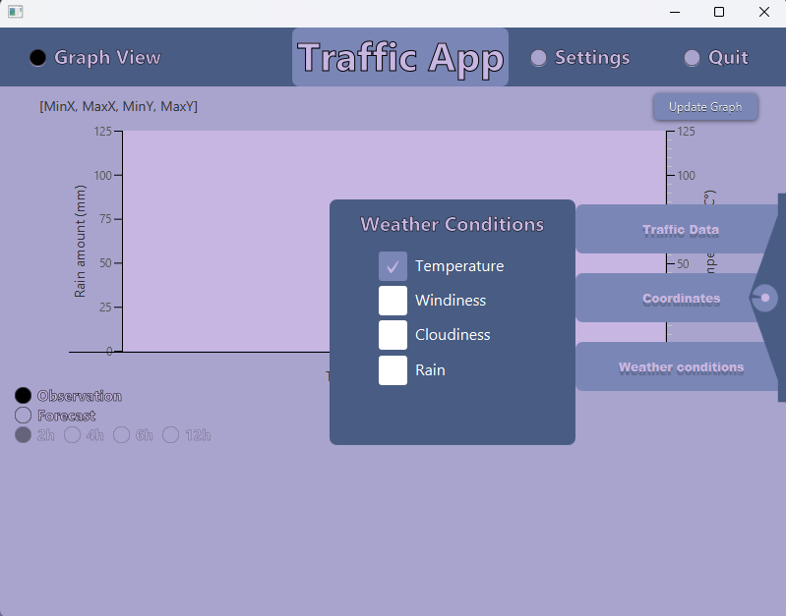

In the weather conditions menu user can select which weather-related items they want to display in the UI.

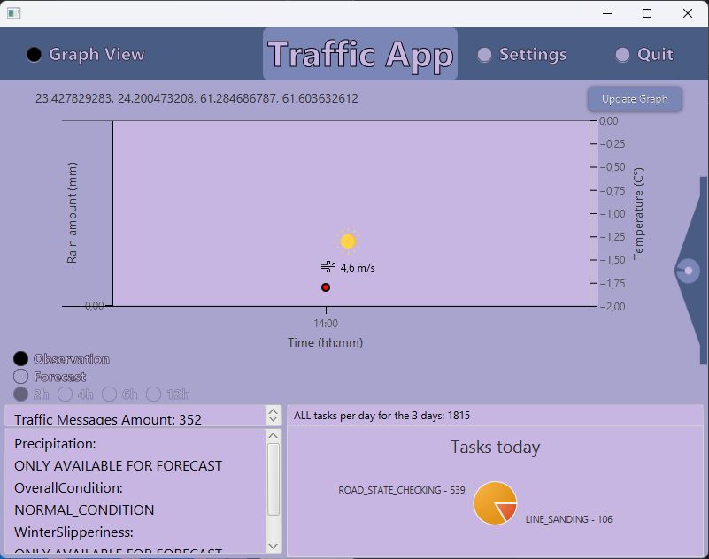

Once all wanted items are selected the graph view needs to be updated by clicking the Update graph button

Graph view needs to be updated every time some changes are made for the changes to appear in the UI.

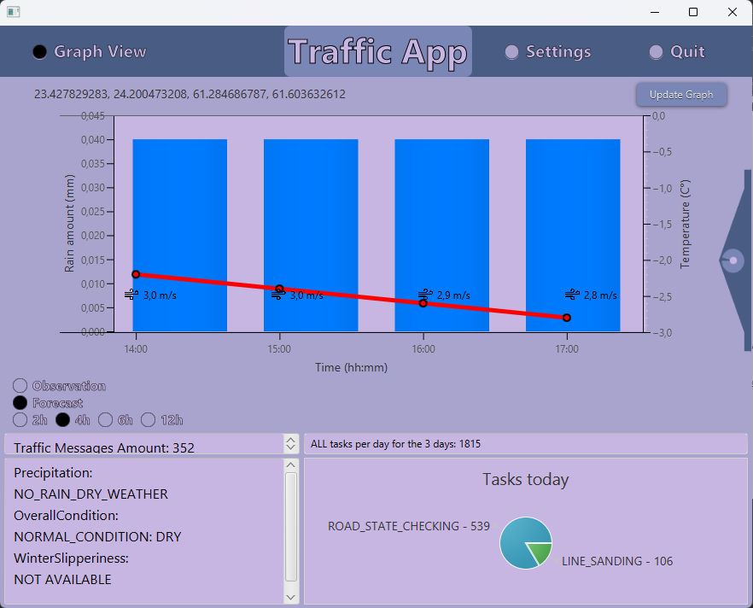

Forecast shows the rain amount of the whole day in each column.

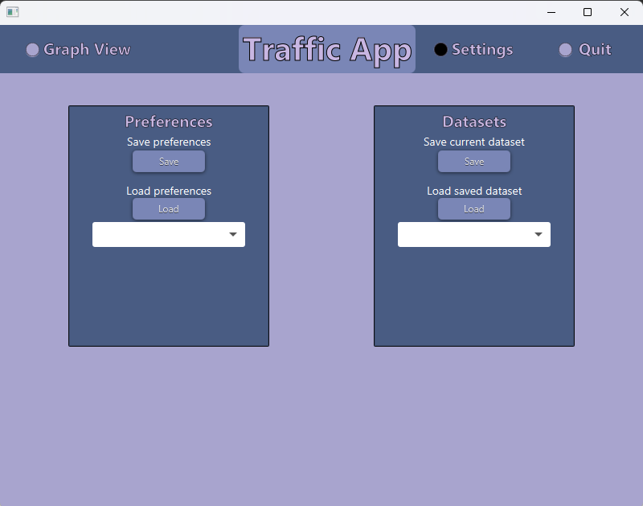

In the setting tab user can save their preferences and datasets as well as load previously saved ones.