**Aagnia - Online Assessment for Full Stack Development**

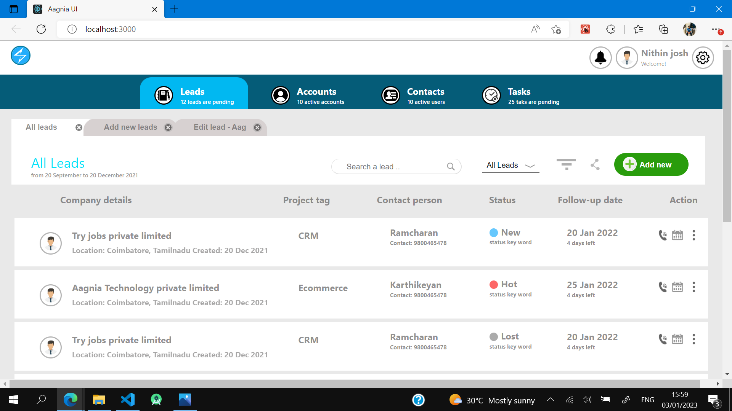

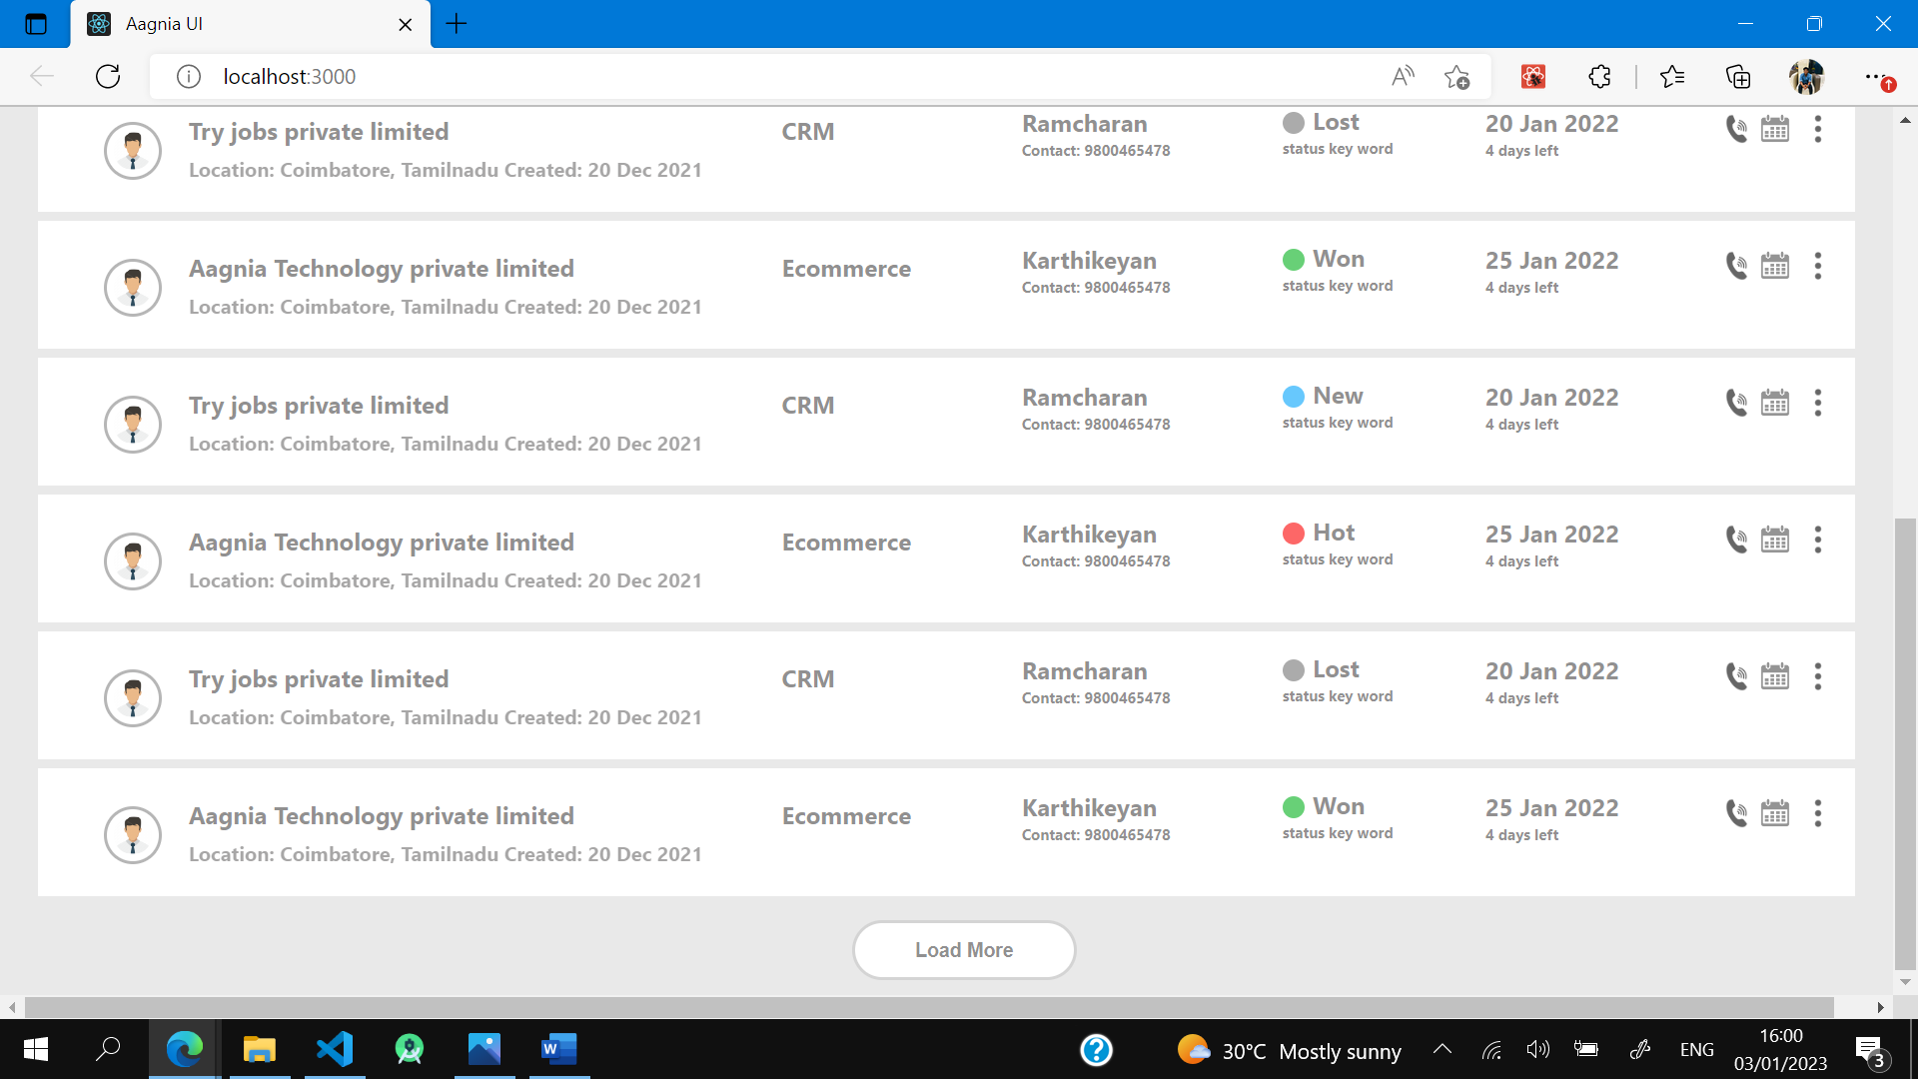

Hariharasudhan SP

9788196753

[harihasu.16@gmail.com](mailto:harihasu.16@gmail.com)