**PROJECT TITLE:**  **Media Streaming using Cloud**

**INOVATION**

The project involves creating a virtual cinema platform using IBM Cloud Video Streaming. The objective is to build a platform where users can upload and stream movies and videos on-demand. This project encompasses defining the virtual cinema platform, designing the user interface, integrating IBM Cloud Video Streaming services, enabling on-demand video playback, and ensuring a seamless and immersive cinematic experience.

In a world where physical gatherings are often challenging, there is a growing need for a virtual cinema platform that can recreate the joy of shared movie experiences. Traditional streaming services lack the communal aspect of watching movies together, especially when loved ones are separated by distance. Moreover, existing platforms might not offer the level of seamless streaming and high-quality playback necessary for an immersive cinematic experience.

The absence of a virtual cinema platform has created a void in shared movie experiences among friends and family, particularly when geographically separated. Existing streaming services may lack the necessary seamless streaming and high-quality playback for an immersive cinematic experience. The challenge is to create a platform using IBM Cloud Video Streaming that allows users to effortlessly upload, stream, and share their favourite movies, fostering joyous movie nights with loved ones, regardless of location. The objective is to elevate the overall movie-watching experience through a user-friendly interface and robust streaming capabilities.

IBM Cloud Video Streaming is also highly secure and reliable, making it a perfect choice for streaming sensitive content or delivering video to large audiences.

**STEPS**

***Step 1:*** ***creation******of platform***

1. Concept and Purpose:

- Clearly define the purpose of your platform. Is it for video streaming, user-generated content, or a combination of both?

- Understand your target audience and their preferences.

2. Content Strategy:

- Determine the type of content you'll offer, whether it's original content, user-generated content, or licensed content from third parties.

- Develop a content acquisition and curation strategy to build a diverse and engaging library.

3. User Experience (UX) and User Interface (UI):

- Create intuitive and visually appealing UI/UX designs that are easy to navigate and use.

- Design user-friendly interfaces for web, mobile, and other platforms.

- Focus on personalization by recommending content based on user behavior and preferences.

4. Platform Development:

- Choose the right technology stack for your platform. This may include web development frameworks, video encoding tools, and content management systems.

- Build both the front-end and back-end of the platform to ensure seamless user interactions and content management.

5. Video Streaming Infrastructure:

- Set up a reliable and scalable video streaming infrastructure.

- Implement content delivery networks (CDNs) to ensure fast and efficient content distribution to users globally.

- Optimize video encoding and streaming protocols for various devices and network conditions.

6. Content Management and catalogue:

- Develop a content management system (CMS) to organize and categorize your content.

- Implement effective search and recommendation algorithms to help users discover new content.

7. User Registration and Accounts:

- Create user registration and account management systems, including features for profiles, playlists, and preferences.

- Implement secure authentication and data storage practices.

8. Monetization Strategy:

- Decide on your platform's revenue model, such as subscription-based, ad-supported, or a combination of both.

- Integrate payment gateways for processing subscriptions and transactions.

9. Content Licensing and Rights Management:

- Establish partnerships and licensing agreements with content providers.

- Implement digital rights management (DRM) to protect copyrighted content.

10. Security and Privacy:

- Ensure user data privacy and compliance with relevant data protection regulations.

- Implement security measures to protect against unauthorized access and piracy.

11. User Generated Content (If Applicable):

- If allowing user-generated content, implement moderation and content guidelines to maintain quality and safety.

12. Analytics and Data Insights:

- Utilize analytics tools to gather data on user behavior, content performance, and engagement.

- Use this data to make informed decisions and optimize the platform.

13. Marketing and Promotion:

- Develop a marketing strategy to attract users.

- Utilize social media, content marketing, and advertising to promote your platform.

14. Launch and Testing:

- Conduct thorough testing to identify and fix issues.

- Launch the platform in stages or with a beta version to gather user feedback and refine the platform.

15. Maintenance and Updates:

- Continuously update and improve the platform with new features and enhancements.

- Stay current with evolving technology and industry trends.

16. Legal Compliance:

- Ensure that your platform complies with all relevant laws and regulations, including copyright and content licensing agreements.

17. Scaling and Performance:

- Plan for scalability to accommodate increasing user numbers and content volume



***Step 2: Integration***

Integration in the context of software and technology refers to the process of combining or connecting different systems, applications, or components to work together seamlessly. Integration is essential for streamlining processes, improving efficiency, and enhancing the functionality of software and hardware systems. Here are some key aspects and types of integration:

1. API Integration:

- Application Programming Interface (API) integration involves connecting different software applications or systems to communicate and share data. This is commonly used to enable third-party services to interact with your platform or to integrate various components of your own system.

2. Data Integration:

- Data integration involves combining data from multiple sources into a unified view or database. This is crucial for making informed decisions and ensuring data consistency. ETL (Extract, Transform, Load) processes are often used in data integration.

3.*Cloud Integration:

- Cloud integration refers to connecting on-premises systems or applications to cloud-based services and resources. This allows for flexibility and scalability in managing data and workloads.

4. Enterprise Application Integration (EAI):

- EAI focuses on connecting different software applications within an organization to improve information flow and automate business processes.

5. Middleware Integration:

- Middleware acts as a bridge between different software components, allowing them to communicate. This is common in complex systems with multiple software applications.

6. IoT (Internet of Things) Integration:

- IoT integration connects devices, sensors, and data sources to a central platform or network. This enables the collection and analysis of data from various IoT devices.

7.*Payment Gateway Integration:

- For e-commerce platforms, integrating payment gateways allows users to make online transactions securely.

8. Social Media Integration:

- Integrating with social media platforms enables users to log in with their social media accounts or share content directly to social networks.

9. Single Sign-On (SSO) Integration:

- SSO integration allows users to access multiple applications or systems with a single set of login credentials.

10. Content Management System (CMS) Integration:

- Integrating a CMS with other systems, like e-commerce or CRM platforms, allows for streamlined content publication and management.

11. Customer Relationship Management (CRM) Integration:

- CRM integration connects customer data and interactions across various departments and touchpoints, improving customer service and marketing efforts.

12. Supply Chain Integration:

- Supply chain integration connects various stakeholders in the supply chain, such as suppliers, manufacturers, and distributors, to optimize the flow of goods and information.

13. Real-time Integration:

- Real-time integration enables the immediate exchange of data between systems, which is essential for applications like instant messaging, live data feeds, and financial trading systems.

14. Legacy System Integration:

- Integrating with older legacy systems, which might use outdated technology, is a common challenge in modernizing and streamlining operations.

***Step 3:*** *Testing*

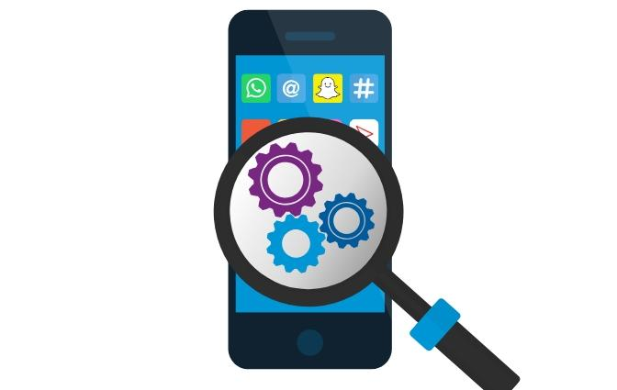

1. Usability Testing:

- Conduct usability testing to ensure a smooth and intuitive user experience.

- Use the video streaming platform again and again with all the options which are present and try to stream a video.

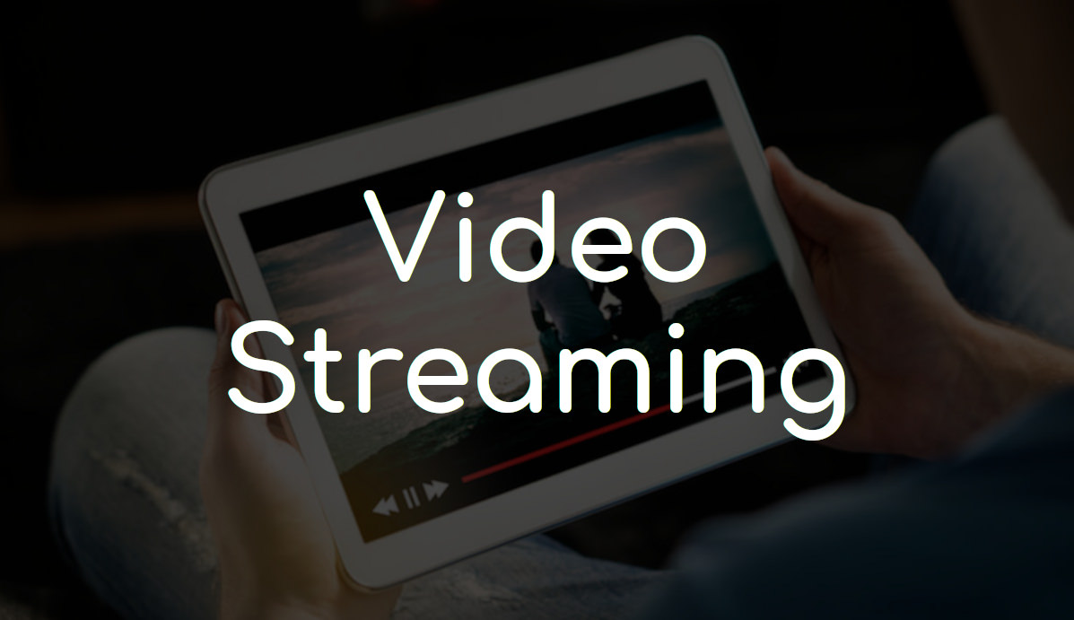

2. Performance Optimization:

- Optimize the platform's performance to reduce loading times and ensure smooth streaming.

* Checking whether any bugs are present and resolve those issues for Optimization.

1. Introduction to the Project:

* The video streaming platform project aims to deliver high-quality video content to users over the internet. It caters to a diverse audience and plays a crucial role in today’s digital landscape.

2. Testing Objectives:

* The primary objectives of the testing phase are to ensure a seamless user experience. This involves validating video playback quality, optimizing performance, fortifying security, and enhancing overall user satisfaction.

3. Testing Types and Methodologies:

* Functional Testing: The testing team is rigorously checking each feature of the platform to ensure it works as intended. This encompasses video upload and playback, user registration, and content management.
* Compatibility Testing: Comprehensive testing is ongoing across various platforms, including different devices (computers, smartphones, smart TVs), browsers, and operating systems to guarantee consistent performance.
* Performance Testing: Load testing, stress testing, and scalability testing are being conducted to evaluate how the platform performs under different levels of concurrent users and to identify performance bottlenecks.
* Security Testing: Security assessments include penetration testing to discover vulnerabilities, privacy assessments to ensure data protection, and encryption checks to secure sensitive information.
* Usability Testing: The team is engaging with real users to collect feedback on the user interface, navigation, and overall user experience, which will inform design enhancements.

4. Test Environment Setup:

- The test environments have been meticulously established:

- Development Environment: The initial testing and development stages take place here.

- Staging Environment: A replica of the production environment is used for pre-launch testing.

- Production Environment: This is where the platform is accessed by users.

5. Test Scenarios and Data:

- Specific test scenarios have been created, simulating common user journeys like user registration, video upload, and content discovery.

- Realistic test data, including sample videos, user profiles, and various content types, is employed to replicate real-world conditions.

6. Test Automation:

* Automation tools and scripts play a crucial role in executing repetitive test cases, ensuring efficiency and maintaining consistency across multiple test cycles.

7. Performance Metrics:

* The team is tracking various performance metrics, including video load times, response times, and server resource utilization, to assess the platform’s performance and identify areas for improvement.

8. Security Findings and Remediation:

* Security vulnerabilities are identified during security testing. Remediation steps, such as encryption implementation, access control enhancements, and data protection measures, are being actively executed.

9. Usability Feedback and Enhancements:

- Usability testing with actual users is ongoing to collect feedback on user preferences, pain points, and suggestions.

- User feedback is directly influencing the platform’s design and user experience enhancements.

10. Regression Testing:

- Regression testing is conducted to ensure that new features or bug fixes do not introduce new issues.

- A comprehensive suite of regression tests is in place to maintain the platform’s stability.

11. Test Coverage and Traceability:

* The testing team maintains a high level of test coverage, ensuring that all features are thoroughly examined and aligning test cases with project requirements.

12. Challenges Faced and Solutions:

* Challenges such as unexpected performance bottlenecks and compatibility issues are addressed with innovative solutions and strategies to ensure a smooth testing process.

13. Lessons Learned and Best Practices:

* Ongoing reflection on lessons learned during the testing phase informs best practices that can be applied to future projects or testing phases.

14. Conclusion and Impact:

* The testing phase is making a significant impact on the project, leading to improved video quality, enhanced performance, and a more satisfying user experience.



***Step 4:*** **Launch**

1.Launch the Platform:

- Deploy the video streaming platform and make it accessible to users.

- check whether the users can access the platform easily.



Launch Phase Overview:

* The launch phase marks a pivotal moment in the video streaming platform project. The platform has undergone rigorous testing, and it’s now ready to be introduced to the public.

Final Testing and Quality Assurance:

* Prior to the launch, the team is conducting a final round of testing to ensure that any last-minute issues are addressed. This includes thorough checks of video playback, performance, and security.

Deployment Planning: Deployment planning is underway, with detailed strategies for rolling out the platform to users. This includes selecting the optimal hosting infrastructure, content delivery networks (CDNs), and scaling mechanisms.

User Onboarding and Registration:

* The platform is preparing for user onboarding and registration. The registration process is made user-friendly, with robust authentication and security measures in place.

User Support and Help Center:

* A comprehensive user support system and help center have been established. Users can easily find solutions to common issues and receive assistance when needed.

Marketing and Promotion:

* The marketing team is gearing up for promotions and advertising campaigns to create awareness about the platform. Social media, online advertising, and partnerships play a key role in promotion.

User Feedback and Continuous Improvement:

* After the launch, user feedback mechanisms are active. The platform is committed to continuous improvement based on user suggestions and needs.

Monitoring and Analytics:

* Real-time monitoring and analytics are in place to track the platform’s performance, user behavior, and content popularity. Data-driven decisions will guide future enhancements.

Post-launch Support:

* Post-launch support and maintenance are a priority. The team is prepared to address any issues, roll out updates, and ensure the platform’s stability.

Growth and User Acquisition:

* Strategies for growth and user acquisition are being implemented. These include user referral programs, social sharing features, and partnerships with influencers.

2. Marketing Strategies:

- Implement marketing strategies to attract users and promote the platform.

By following these steps, you can create a virtual cinema platform using IBM Cloud Video Streaming, offering users a seamless and enjoyable movie-watching experience with on-demand streaming and high-quality playback.