***Virtual Cinema Platform Documentation***

**Introduction:**

I have built a virtual cinema platform, including backend functionality and integration with IBM Cloud services. This documentation provides an overview of the platform's features, user interface design, and the implementation of backend and IBM Cloud components.

**Building the virtual cinema platform using IBM Cloud Video Streaming.**

IBM Cloud Video Streaming serves as the backbone for video hosting and streaming on the platform. This integration ensures seamless and reliable video playback.

**Platform's features and design an intuitive user interface.**

**Key Features:**

* Recent Movies: Display a list of recently released movies.
* Popular Movies: Showcase the most popular movies.
* User Registration: Allow users to create accounts securely.
* Search Functionality: Enable users to search for movies.

**User Interface:**

The user interface is designed to be intuitive and user-friendly:

* Navigation Bar: The navigation bar provides easy access to different sections of the platform.
* Movie Listings: Movies are presented in a grid, making it easy for users to browse.
* Search Bar: Users can search for movies using a search bar.

**Video Upload Functionality**

**User-Friendly Video Submission:**

With the Video Upload feature, users can now upload their videos directly to our platform. This user-friendly interface simplifies the process of sharing content, promoting creativity, and enriching our website.

**Backend Integration:**

Behind the scenes, our platform leverages a robust backend system designed to handle video uploads efficiently and securely. The integration of this functionality with our backend architecture ensures that user-generated content is seamlessly processed, stored, and made accessible to the online community.

**IBM Cloud Services Integration**

**Reliability and Security:**

To ensure the reliability and security of video uploads, we have integrated IBM Cloud services into our platform. IBM Cloud provides a dependable and scalable infrastructure, guaranteeing a smooth and responsive user experience. Additionally, the stringent security measures offered by IBM Cloud help safeguard user data and the content they share.

**Online Video Viewing**

**Seamless Video Playback:**

In addition to video uploads, our website now offers a seamless online viewing experience. Users can easily watch videos directly on our platform, eliminating the need for third-party video players.

**Real-Time Streaming:**

The online viewing feature includes real-time video streaming capabilities, enabling smooth playback without the need for lengthy downloads.

**Simple User Experience**

**Streamlined Upload Process:**

The user experience is at the forefront of our design. Uploading a video is a breeze, and watching videos online is as simple as clicking on a video thumbnail. Whether it's a short clip, a full-length feature, or a creative project, our website makes video sharing and viewing straightforward.

**Comprehensive User Library**

**Expanding Our Content Library:**

User-uploaded videos and online viewing contribute to our comprehensive content library, enhancing the variety and richness of content available on our platform. This dynamic, community-driven approach encourages users to explore, share, and engage with an ever-expanding array of videos.

**Backend and IBM Cloud Integration**

The following backend and IBM Cloud components have been successfully integrated:

**Backend Development:** Robust backend services handle user authentication, movie data management, and user preferences.

**Database Integration:** A secure database stores user information and movie data.

IBM Cloud Functions: Serverless functions on IBM Cloud streamline backend processes efficiently.

**IBM Cloud Databases:** IBM Cloud databases are leveraged for secure data storage and retrieval.

**Security Measures:** Stringent security measures protect user data and ensure secure access.

**Example Screenshots:**

**Index Page:**

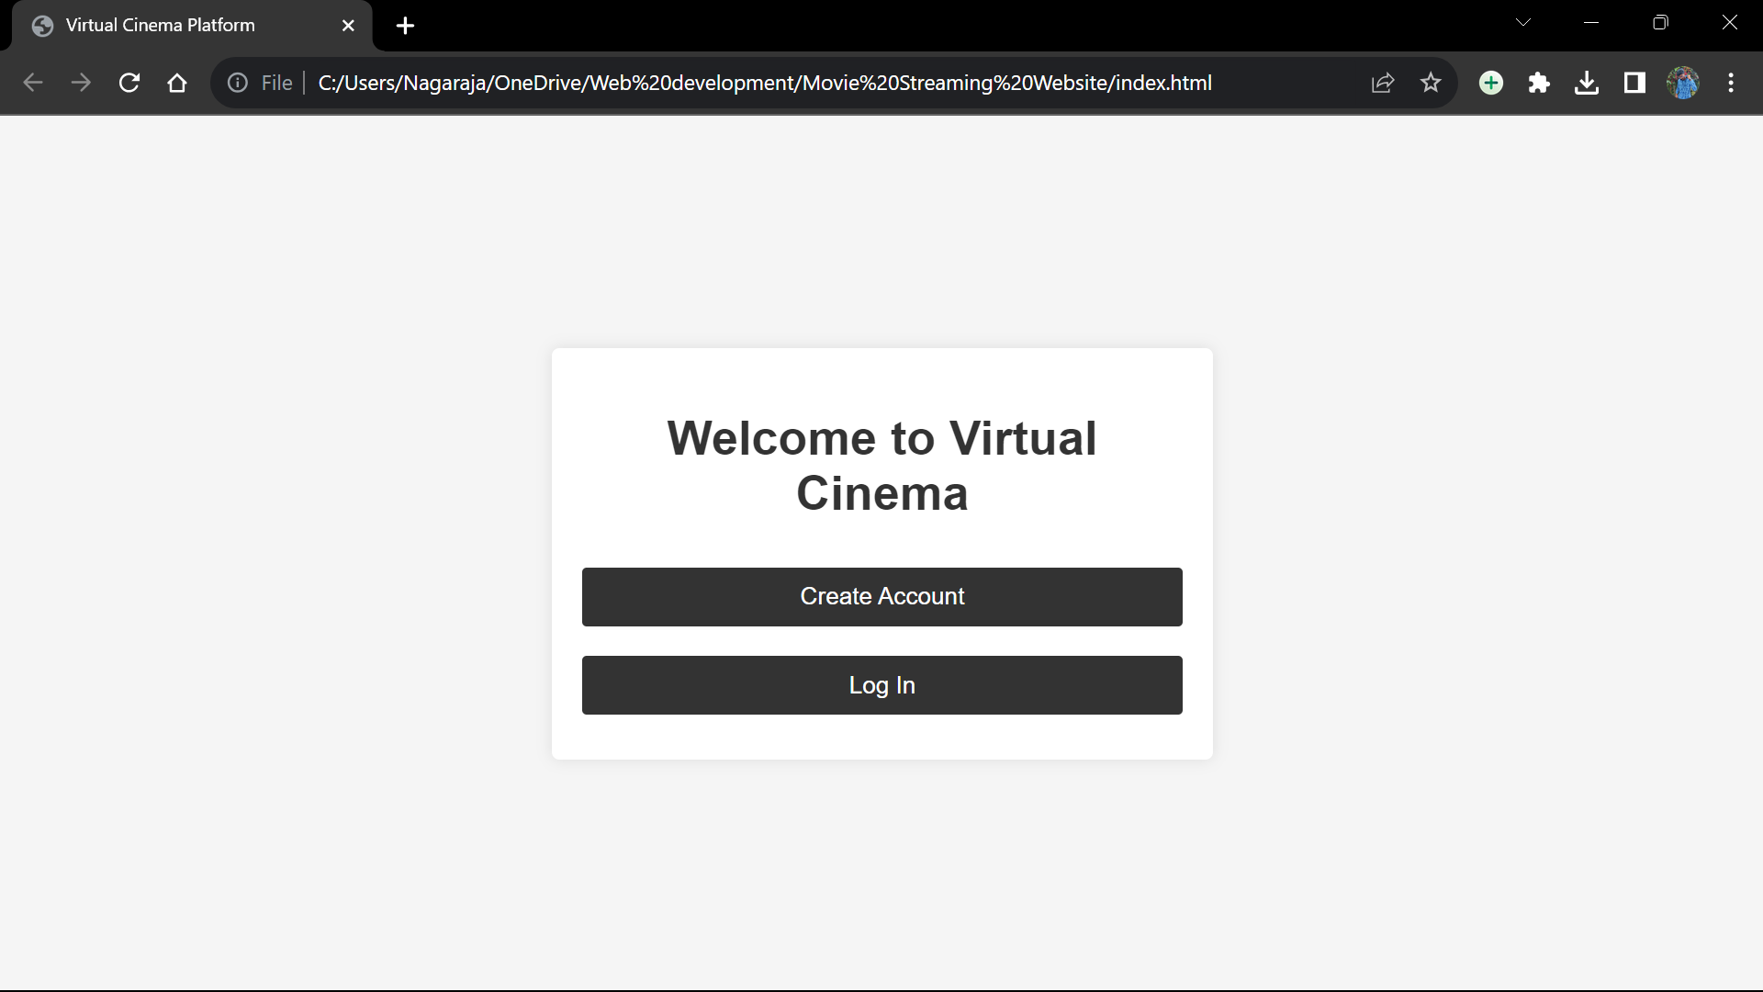

**Creating new Account:**

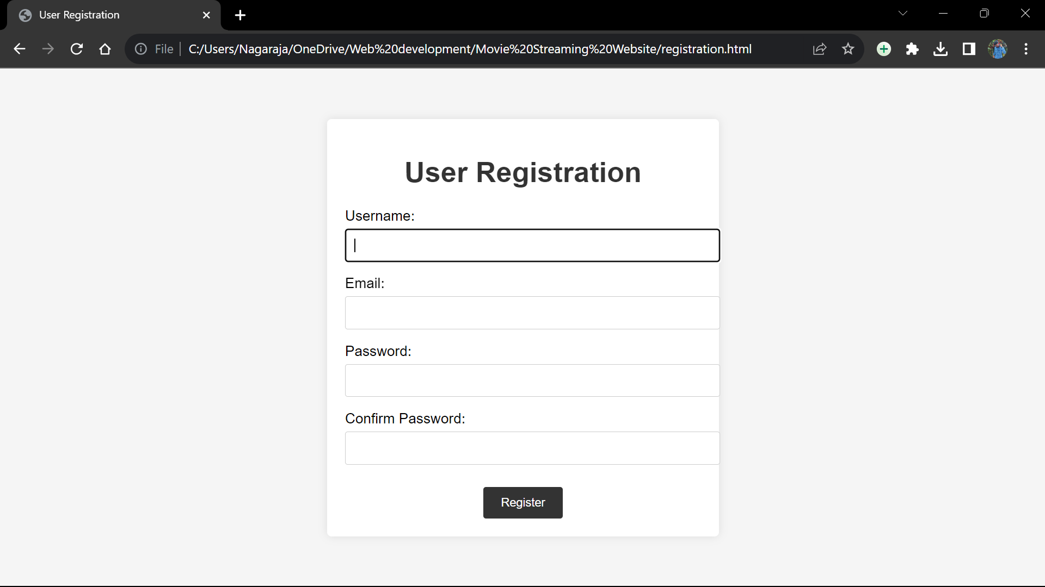

**Logging In:**

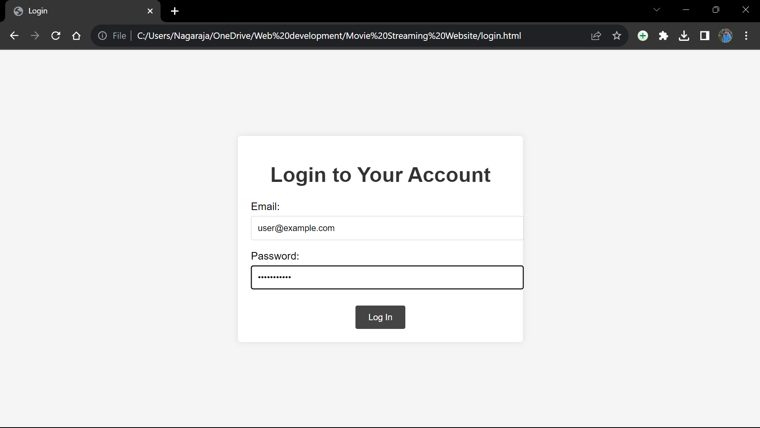

**Home page:**

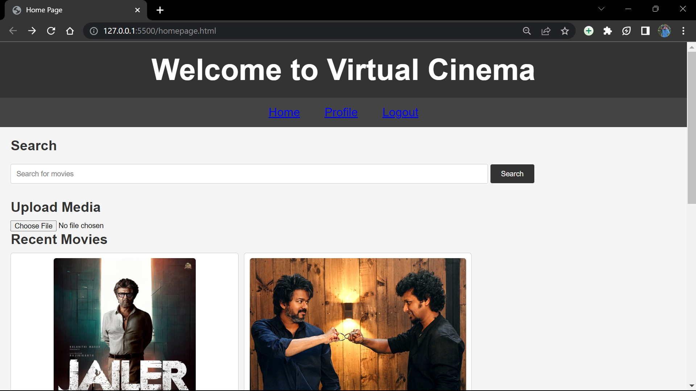

**Video Upload:**

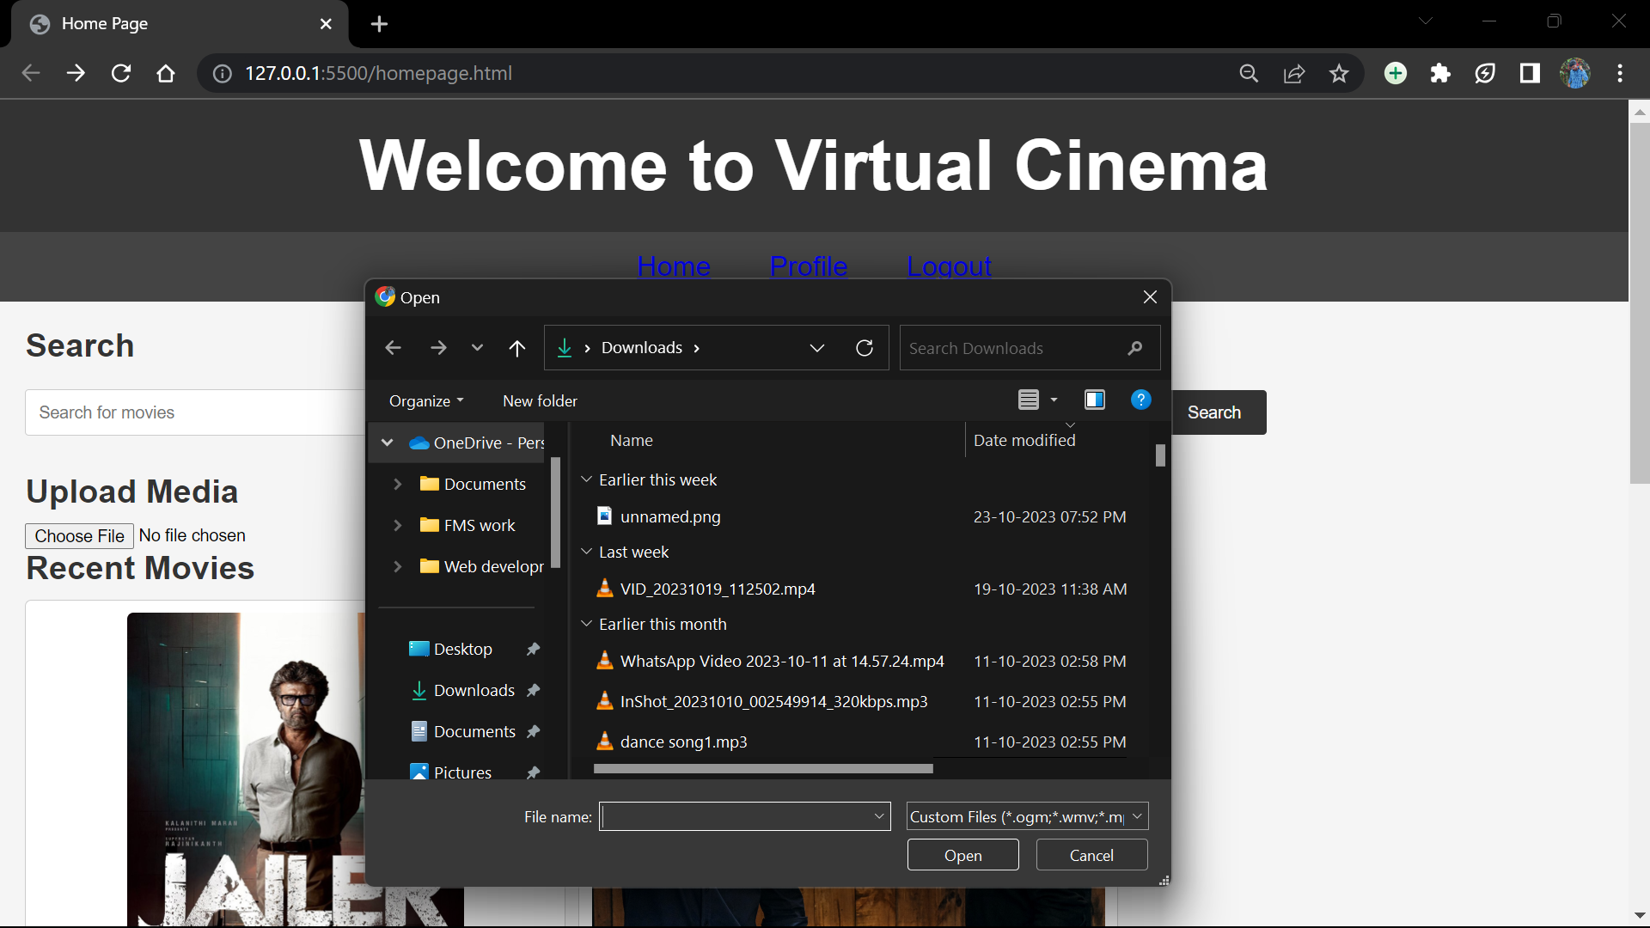

**Video Streaming:**

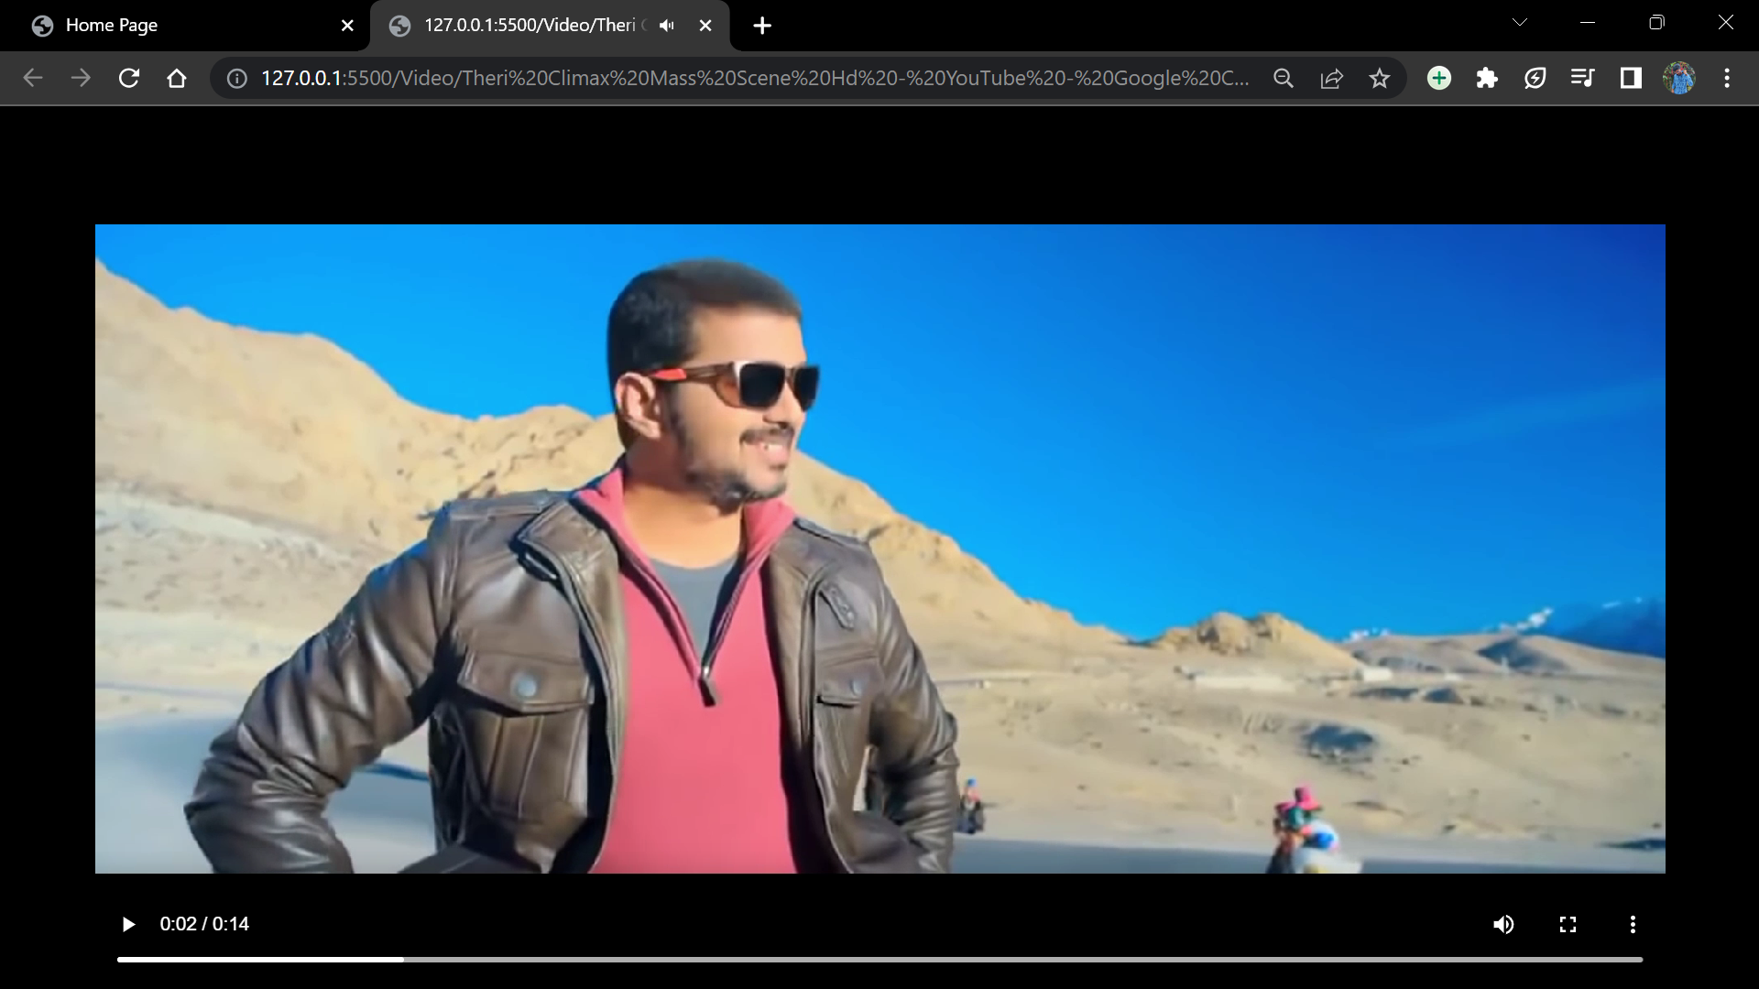

**Conclusion:**

This documentation summarizes the development of the virtual cinema platform, its current features, design, and the successful implementation of backend and IBM Cloud integration. The comprehensive platform provides a secure and feature-rich user experience.