PSD_RS-Pertemuan-6.R
LENOVO
2026-10-05
#Tipe Data
#Numeric
print("Numeric")
## [1] "Numeric"
a <- 21.2
class(a)
## [1] "numeric"
print ("integer")
## [1] "integer"
b = 1000L
class(b)
## [1] "integer"
print("character")
## [1] "character"
c = "Nama saya adalah Qintara"
class(c)
## [1] "character"
print("Complex")
## [1] "Complex"
d = 2i + 8
class(d)
## [1] "complex"
print("Boolean")
## [1] "Boolean"
e = TRUE
class (e)
## [1] "logical"
#Struktur Data
buah = c("apel", "jeruk", "alpukat")
buah #vektor
## [1] "apel" "jeruk" "alpukat"
list_buah = list("Durian", "Mangga", 10, 20)
list_buah #Data List
## [[1]]
## [1] "Durian"
##
## [[2]]
## [1] "Mangga"
##
## [[3]]
## [1] 10
##
## [[4]]
## [1] 20
matrix_angka = matrix(c(1,2,3,4,5,6), nrow = 3, ncol = 2)
matrix_angka
## [,1] [,2]
## [1,] 1 4
## [2,] 2 5
## [3,] 3 6
#Data Frame (DF)
Statistik_Game_RPG = data.frame(
stat = c("Power", "Mana", "Exp"),
Marksman = c(100, 21, 75),
Fighter = c(85, 30, 90)
)
Statistik_Game_RPG
## stat Marksman Fighter
## 1 Power 100 85
## 2 Mana 21 30
## 3 Exp 75 90
#Vector Numeric
angka = c(1,2,3)
angka
## [1] 1 2 3
urutan = 1:20
urutan
## [1] 1 2 3 4 5 6 7 8 9 10 11 12 13 14 15 16 17 18 19 20
urutan_desimal = 1.5:7.5
urutan_desimal
## [1] 1.5 2.5 3.5 4.5 5.5 6.5 7.5
urutan_desimal = 1.5:4.3
urutan_desimal #Angka terakhir tidak masuk
## [1] 1.5 2.5 3.5
#Panjang Vektor
length(urutan_desimal)
## [1] 3
length(buah)
## [1] 3
#Mengurutkan vektor
fruits = c("banana", "apple", "mango", "lemon")
sort(fruits)
## [1] "apple" "banana" "lemon" "mango"
#Mengakses Vektor
fruits[1]
## [1] "banana"
fruits[-1]
## [1] "apple" "mango" "lemon"
#Mengganti item
fruits[1] = "pear"
fruits
## [1] "pear" "apple" "mango" "lemon"
#Data Frame
Statistik_Game_RPG
## stat Marksman Fighter
## 1 Power 100 85
## 2 Mana 21 30
## 3 Exp 75 90
summary(Statistik_Game_RPG)
## stat Marksman Fighter
## Length :3 Min. : 21.00 Min. :30.00
## N.unique :3 1st Qu.: 48.00 1st Qu.:57.50
## N.blank :0 Median : 75.00 Median :85.00
## Min.nchar:3 Mean : 65.33 Mean :68.33
## Max.nchar:5 3rd Qu.: 87.50 3rd Qu.:87.50
## Max. :100.00 Max. :90.00
#Mengakses Data Frame
Statistik_Game_RPG[1]
## stat
## 1 Power
## 2 Mana
## 3 Exp
Statistik_Game_RPG$Marksman
## [1] 100 21 75
#Menambahkan Baris di DF
Statistik_Game_RPG
## stat Marksman Fighter
## 1 Power 100 85
## 2 Mana 21 30
## 3 Exp 75 90
Statistik_Game_RPG = rbind(Statistik_Game_RPG, c("Gold", 70, 50))
Statistik_Game_RPG
## stat Marksman Fighter
## 1 Power 100 85
## 2 Mana 21 30
## 3 Exp 75 90
## 4 Gold 70 50
ML = Statistik_Game_RPG
ML
## stat Marksman Fighter
## 1 Power 100 85
## 2 Mana 21 30
## 3 Exp 75 90
## 4 Gold 70 50
#Menambahkan Kolom di DF
ML = cbind(ML, Assassin = c(100, 21, 88, 65))
ML
## stat Marksman Fighter Assassin
## 1 Power 100 85 100
## 2 Mana 21 30 21
## 3 Exp 75 90 88
## 4 Gold 70 50 65
#Menghapus Baris dan Kolom di DF
ML_HapusBarisKolom = ML[-c(1), -c(1)]
ML_HapusBarisKolom
## Marksman Fighter Assassin
## 2 21 30 21
## 3 75 90 88
## 4 70 50 65
#Mencari Dimensi
dim(ML)
## [1] 4 4
dim(ML_HapusBarisKolom)
## [1] 3 3
#Melihat Data Frame
View(ML)
View(ML_HapusBarisKolom)
#menggabungkan Dua DF
Data_Frame1 = data.frame(
Senjata = c("M4", "AK47", "MP5"),
Skin = c("Dragon", "Alok", "JB"),
Damage = c(100,57,35)
)
Data_Frame2 = data.frame (
Senjata = c("SG", "Glock", "Riffle"),
Skin = c("Justin", "Wowok", "Teddy"),
Damage = c(99,76,69)
)
FF = rbind(Data_Frame1, Data_Frame2)
View(FF)
#Grafik
#Plot
plot(1, 3)
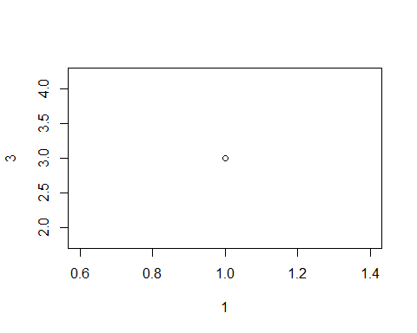
plot(c(1.7), c(7.9))
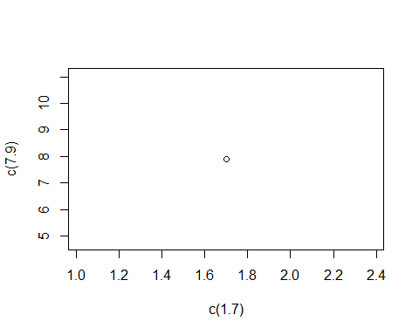
x = c(1,2,3,4,5)
y = c(7,2,4,2,1)
plot(x,y)
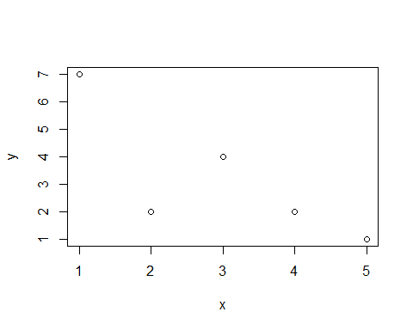
plot(3:10) #Urutan
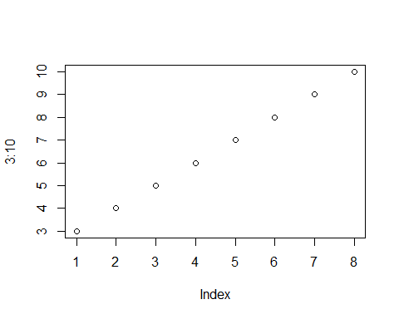
plot (3:10, type = "l")
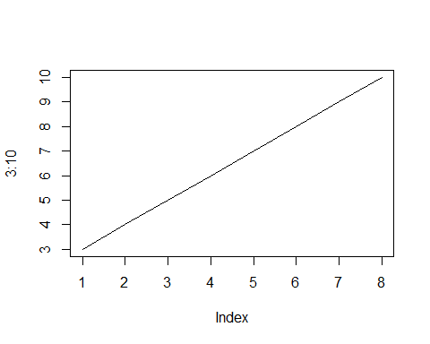
#lot(3:10, main = "Grafik Lurus", xlab = "Ini adalah sumbu x", ylab = "Ini adalah sumbu y" type = "l", col = "red")
plot (1:10)
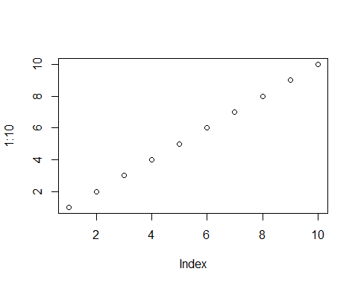
plot(1:10, pch = 2)
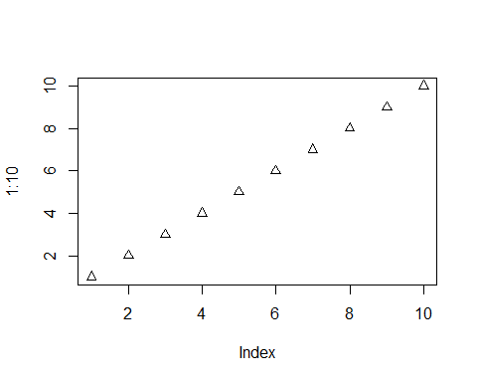
plot(1:10, pch = 2, type = "l")
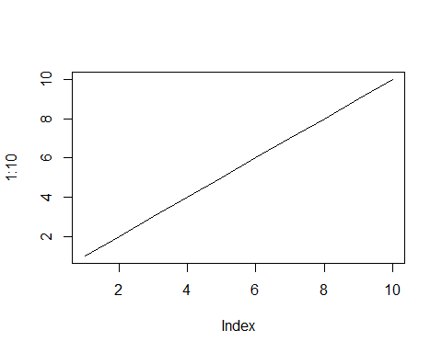
plot(1:10, pch = 2, type = "l", lwd = 2) #Mempertebal garis pakai lwd
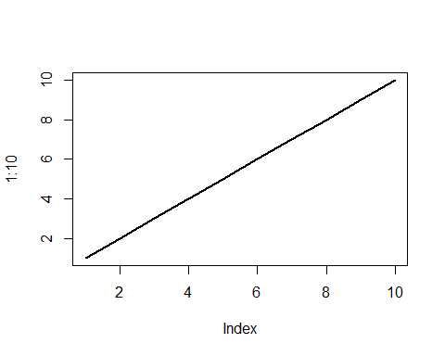
x = c(1,2,3,4,5)
y = c(7,2,4,2,5)
plot (x, type = "l", col = "blue")
lines(y, type = "l", col = "red")
