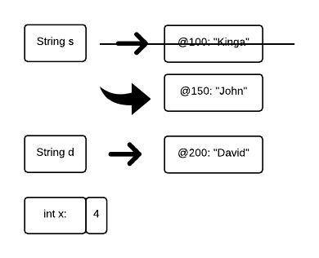

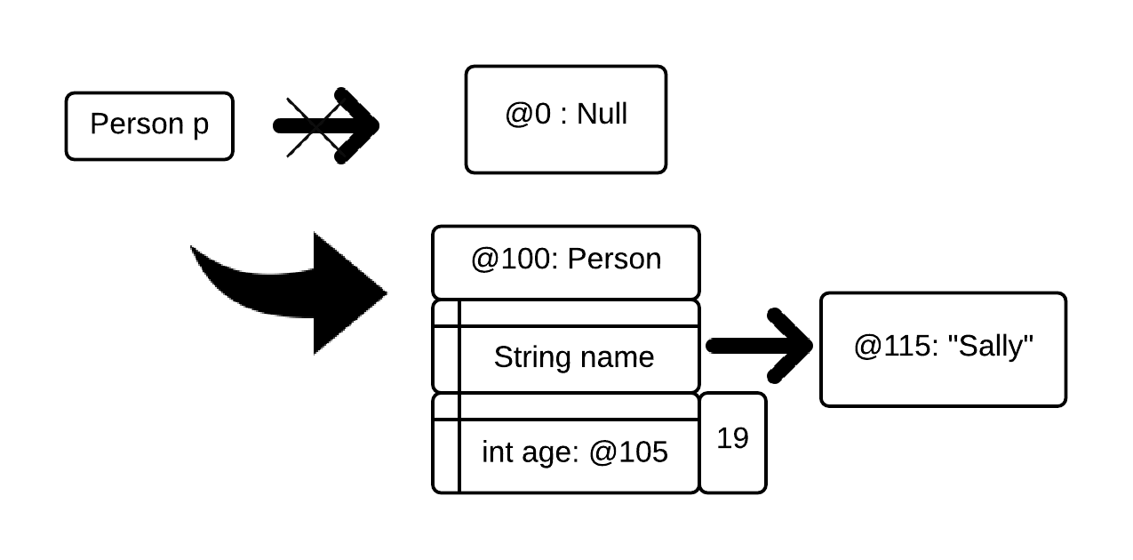

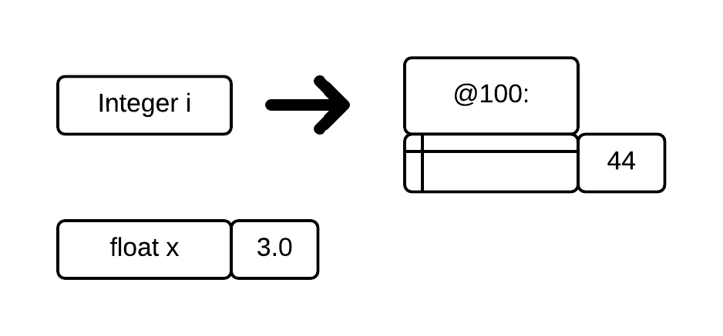
- Results of expressions:
Part | Expression | Type | Value
a | 1 == 2; | boolean | false
b | 3 / ((float 2); | float | 1.5
c | x = false;  “3” + x; | String | “3false”
d | x = 4;  x++;  x / 4 + 3; | int | 4
e | true && p1==p1 | boolean | true
f | String s1 = “ki”;  s1.charAt[1] | char | i
g | “1” + 3; | String | 13

- Using a modified source code, which includes the original code + the Person class, you can plug this into Java Visualizer to guide your thinking. The source code, Driver.java, is also in this folder.
public class Driver{
public static class Person{
String name;
int age;
public Person(){}
public Person(String name, int age){
this.name = name;
this.age = age;
}
public String toString(){
return this.name + " " + this.age;
}
}

private static Person person = new Person("n", 0);

public static void main(String[] args){
int x = 2;
String name = "John";
Person p1 = new Person(name, 11);
Person p2 = p1;
Person p3 = new Person(name, 11);

System.out.println(x);
System.out.println(name.toString());
System.out.println(p1);
System.out.println(p2);
System.out.println(p3);
System.out.println(person);
System.out.println(p1 == p3);
System.out.println(p1 == p2);

p3 = change(name, x, p1);

System.out.println(x);
System.out.println(name.toString());
System.out.println(p1);
System.out.println(p2);
System.out.println(p3);
System.out.println(person);
}

public static Person change(String name, int y, Person p){
person.name = name;
name = "Bob";
p.name = name;
y++;
p.age = y;
p = new Person("Liz", 10);
return p;
}
}

Output:
2
John
John 11
John 11
John 11
n 0
false
true
2
John
Bob 3
Bob 3
Liz 10
John 0

- The below code is available in Animal.java.
// Part g.
public class Animal{
// Part a fulfilled below
private String species; // Private is optional, but good practice.
private int weight;
public Animal(){ // Part b
this.species = "Arbitrary Animal";
this.weight = 0; // Arbitrary weight;
}

public Animal(String species, int weight){ // Part c
int len = species.length();
if(len >= 1 && len < 20){ // Part f
this.species = species; // Whatever you like.
this.weight = weight;
} else { // Of course, what if they fail Part f?
/*
* Specs don't say what to do.
* In this case, you choose.
* Since I won't probably won't see this class again
* outside of this class... I'll just throw an
* exception.
*/

throw new Exception("Species length failed :" + len);
}
}

public void setSpecies(String species){ // Part e
int len = species.length(); // Strings have a... size method?
if(len >= 1 && len < 20){ // Part f
this.species = species;
} else { // In case the species name wasn't good...
System.out.println("Species length failed :" + len);
}
/*
* You know when you've typed a word too many times...
* It doesn't look like the word anymore?
* "species" looks like such a weird word.
*/
}

public String toString(){ // Part d. Anyway you like it.
return "Species: "+this.species+"\nWeight: "+this.weight;
}
}

Question | Answer and Justification
A public static method of Person can be called on p1 | True. Though discouraged, you can do it.
A public static method of Person can be called on Person (the class) in main | True. This is allowed.
A static method can update both static and non-static attributes of the same class | False. A Static method can only update static attributes of the same class.
A public static method can call other public static methods within its body, but not private static ones | Ambiguous. A public static method can call other public static methods and private static methods within the same class.
A private method can only access private attributes within the same class | False. Private methods have access to all attributes in the same class.
The main method can call a private method of Person on p2 | False. Private methods can only called within the classes they were written in.
The equals method can be called on p1 with p2 as an argument | True. This is appropriate.
I must import java.util.Scanner before using a Scanner object | True. To use objects not included in java.lang, you need to import it.

