1.
a)
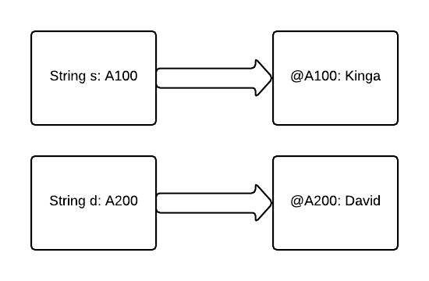
b)
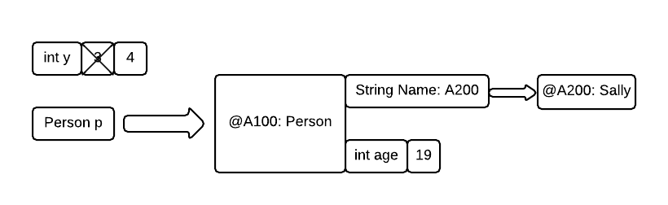
c)
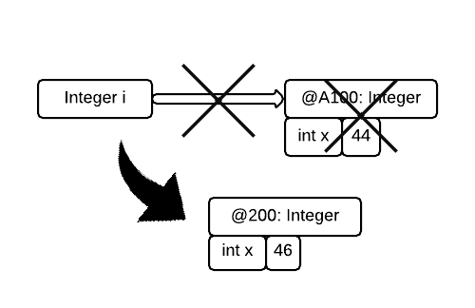

2.

public class Animal{
// Part a
String species;
int weight;

// Part b
public Animal(){
this.species = "Arbitrary animal"; // Values in compliance to d
this.weight = 1;
}

// Part c
public void setSpecies(String newAlien){
// In compliance to d
if(newAlien.length >= 1 && newAlien.length < 20){
this.species = newAlien;
}
}
// Notice there isn't any error checking for weight
// Since specs don't specify other ways to change weight--
// You never -have- to worry about it
}

