EEM211 FINALEXAMINATION 18.01.2007

1 ) Answer The Following Questions

- Convert (257.0554)₈ to base 16 and base 2

( 257.0554 )₈ = ( 010 101 111.000 101 101 100 )₂ =( 1010 1111.0001 0110 1100 )₂ = (AF.16C)₁₆

- Implement a 4-bit Gray to Binary code conversion circuit by using three 2-input XOR gates only.
B_{n} = G_{n} (MSB)
B_{i} = G_{i} ⊕ B_{i+1} i=0, n-1
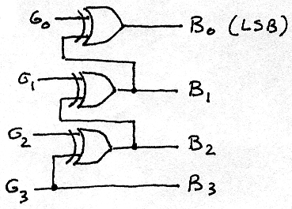
c) A 7-bit Hamming Code word 0010011 of 4 data bits and 3 parity bits is received through a transmission channel. Check this word for a possible 1-bit error and find out the original 4-bit data word put into the channel.

C₁ =XOR of bits (1, 3, 5, 7 ) = 0
C₂= XOR of bits (2, 3, 6, 7) = 1
C₄= XOR of bits (4, 5, 6, 7) = 0
error bit position C₄ C₂ C₁ = 010 = 2
corrected code = 0110011 Data =1011

d) Implement a 2-input OR function with use of minimum number of INVERTERs and NAND gates. (Complements of inputs are not available)

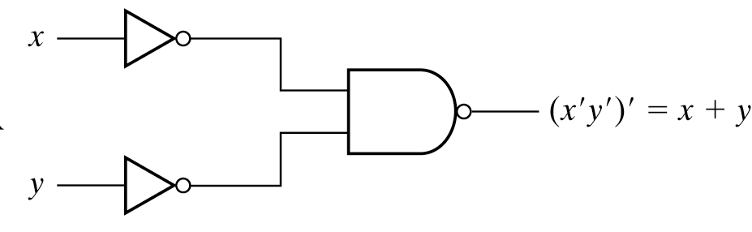

e) How many 32K × 8 RAM chips are needed to provide a total memory capacity of 512 K bytes?

512 k byte / 32 K byte = 16 memory chip

f) Convert the following function to canonical SOP form.

F (A,B,C) = AB + AC + AC

A | B | C | F
0 | 0 | 0 | 0
0 | 0 | 1 | 1
0 | 1 | 0 | 0
0 | 1 | 1 | 1
1 | 0 | 0 | 1
1 | 0 | 1 | 0
1 | 1 | 0 | 1
1 | 1 | 1 | 1

F (A,B,C) = ∑ (1, 3, 4, 6, 7)

2) Answer The Following Questions

a) Binary information is shifted and distributed through 4-bit shift registers A and B, when shift control is high (1). Write the contents of each shift register, after the application of 3 clock pulses. (Initial values of shift registers are A = 1100 and B = 1110)
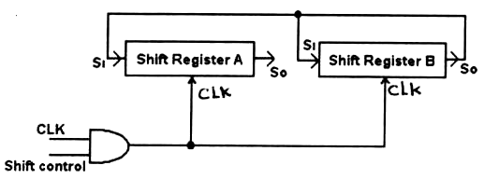

3 clock darbesinden sonra A = 1101 ve B = 1101 olur
A = 1100 | B= 1110
0110 | 0111
1011 | 1011
1101 | 1101

b) A 2-bit binary counter is shown in the figure.

Redraw this counter by using D type flip flop’s
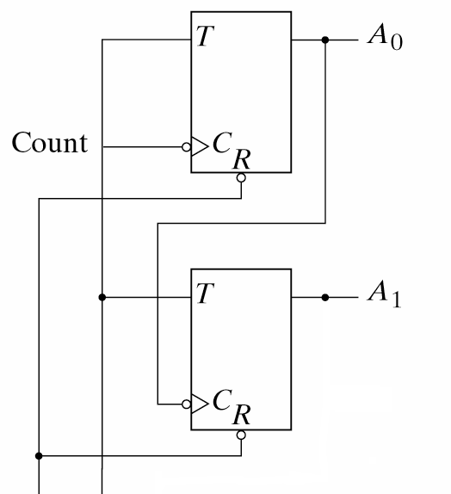
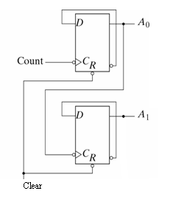
Clear High

3) Implement the following two functions
simultaneously with the given PLA:
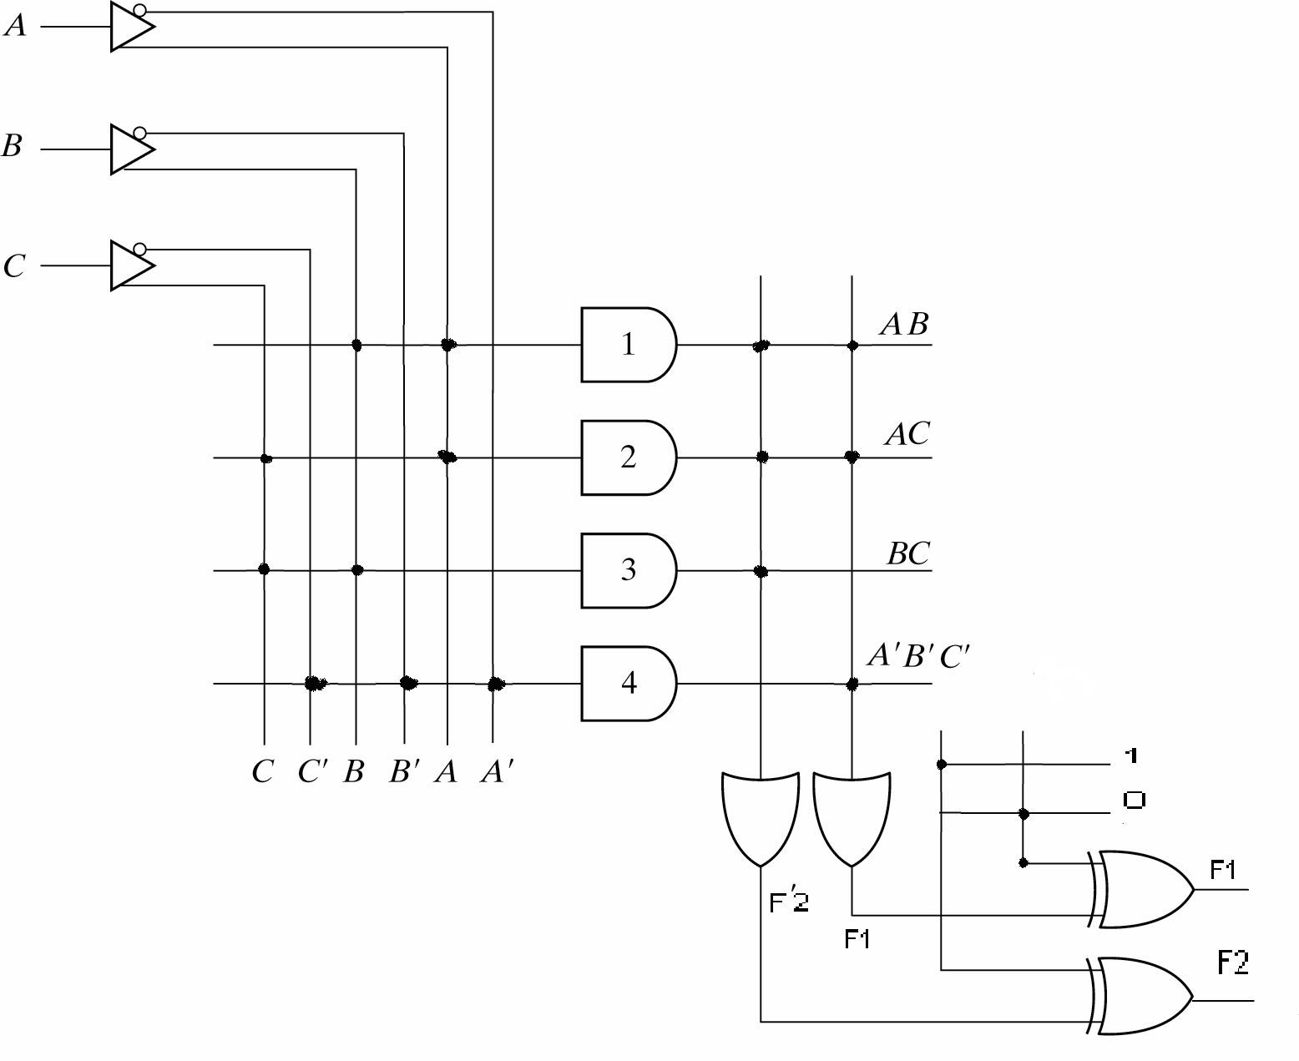
F₁ (A,B,C) = ∑ ( 0,5 ,6 ,7)

F₂ (A,B,C) = ∑ ( 0,1,2,4)

A/BC | 00 | 01 | 11 | 10
0 | 1 | 0 | 0 | 0
1 | 0 | 1 | 1 | 1

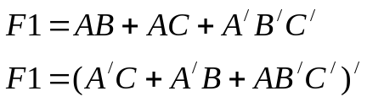

A\BC | 00 | 01 | 11 | 10
0 | 1 | 1 | 0 | 1
1 | 1 | 0 | 0 | 0

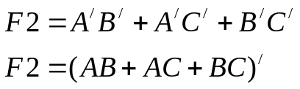

4) Reduce the number of states in the following state table and find the reduced state table.
ŞimdikiGelecek DurumÇıktı
Durumx = 0 x = 1 x = 0 x = 1
afb00
bdc00
cfe00
dga10
edc00
ffb11
ggh01
hga10

Verilen çizelgedeki durumları, aynı girdi dizilerine karşın, aynı çıktı dizileri üretip üretmediklerine bakarak denklik kümeleri içinde toparlarsak:
P₀ = (abcdefgh)
P₁ = (abce)(dh)(f)(g)
P₂ = (ac)(be)(dh)(f)(g)
Buluruz. Bu da verilen “sequential” devrenin kendisine denk olan 5 durumlu bir devreye indirgenebileceğini gösterir. Her küme içinden bir durum seçer ve gelecek durumlarla çıktıları buna göre yeniden düzenleyerek indirgenmiş çizelgeyi oluştururuz:
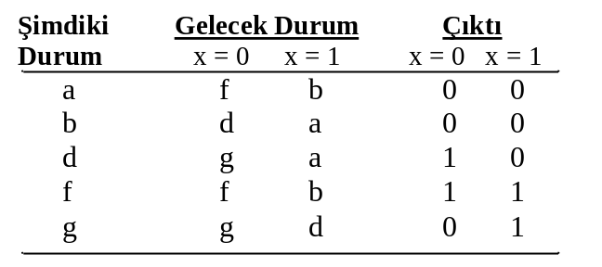

5) Design a sequential circuit as a Mealy machine, which detects the occurrence of each 0011 sequence, by using T type flip-flops as memory elements. First find the state diagram and use minimal number of states and combinational circuit elements. Show all of your design steps clearly. The machine must generate an output of 1, whenever the sequence received and 0 at all other times.
A
B
C
D
1/0
1/0
1/0
1/1
0/0
0/0
0/0
0/0

PS | NS |  | z
PS | x=0 | x=1 | x=0 | x=1
A | B | A | 0 | 0
B | C | A | 0 | 0
C | C | D | 0 | 0
D | B | A | 0 | 1

PS | NS |  | z
PS | x=0 | x=1 | x=0 | x=1
Q₂Q₁ | q₂q₁ | q₂q₁ | x=0 | x=1
00 | 01 | 00 | 0 | 0
01 | 10 | 00 | 0 | 0
10 | 10 | 11 | 0 | 0
11 | 01 | 00 | 0 | 1
PS | NS |  | z
PS | x=0 | x=1 | x=0 | x=1
Q₂Q₁ | T₂T₁ | T₂T₁ | x=0 | x=1
00 | 01 | 00 | 0 | 0
01 | 11 | 01 | 0 | 0
10 | 00 | 01 | 0 | 0
11 | 10 | 11 | 0 | 1
x\Q₂Q₁ | 00 | 01 | 11 | 10 | x\Q₂Q₁ | 00 | 01 | 11 | 10
0 | 1 | 1 | 0 | 0 | 0 | 0 | 1 | 1 | 0
1 | 0 | 1 | 1 | 1 | 1 | 0 | 0 | 1 | 0

T₁=(x’+Q₂+Q₁)(x+Q₂’) T₂=Q₁(x’+Q₂)
z=xQ₁Q₂

x\Q₂Q₁ | 00 | 01 | 11 | 10 | x\Q₂Q₁ | 00 | 01 | 11 | 10
0 | 1 | 1 | 0 | 0 | 0 | 0 | 1 | 1 | 0
1 | 0 | 1 | 1 | 1 | 1 | 0 | 0 | 1 | 0

T1=x’Q2’+xQ2+Q2’Q1 T2=x’Q1+Q2Q1
z=xQ1Q2

Points: Q1: 5p each, 30p total Q2: a) 10p b) 10p, 20p total
Q3: 20p Q4: 10p, Q5: 20p

Exam Duration : 100 minutes.

