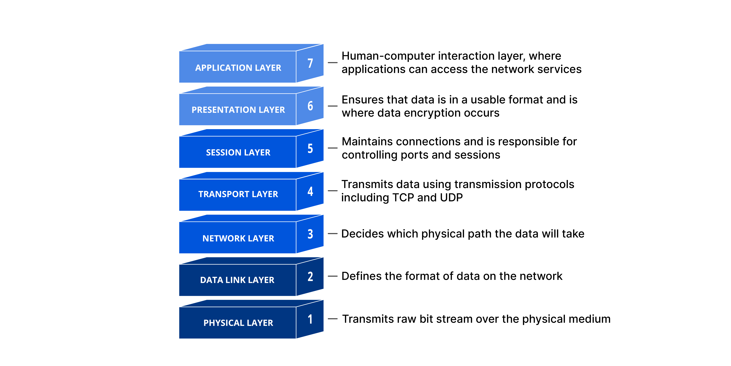**What is HTTP?**

- HTTP is a TCP/IP-based application layer communication protocal that standardizes how clients and server communicate with each other.

- It defines how content is requested and transmitted across the internet.

- TCP port 80 is used

- HTTPS used port 443

**Reverse Proxy**

A reverse proxy is a server that sits in front of web servers and forwards client (e.g web broswer) request to those web servers. Reverse proxies are typically implementes to help increase [security](https://www.cloudflare.com/learning/security/what-is-web-application-security/), [performance](https://www.cloudflare.com/learning/performance/why-site-speed-matters/), and reliability.

- The proxy server intercepts those requests and then communicates with web servers on behalf of those clients.

- The forward proxy sits in front of a client and ensures that no origin server ever communicates directly.

**Benefit:**

- **To avoid state or institutional browsing restrictions**

**- To block access to certain content**

**- To protect their identity online**

- The requests are intercepted at the [network edge](https://www.cloudflare.com/learning/serverless/glossary/what-is-edge-computing/) by the reverse proxy server.

- The reverse proxy sits in front of an origin server and ensures that no client ever communicates directly with that origin server.

**Benefit:**

- Load balancing

- Protection from attacks

- Global server load balancing

- Caching

- SSL encryption: Encrypting and Decrypting [SSL](https://www.cloudflare.com/learning/ssl/what-is-ssl/) (or [TLS](https://www.cloudflare.com/learning/ssl/transport-layer-security-tls/)) communications for each client can be computationally expensive for an origin server.