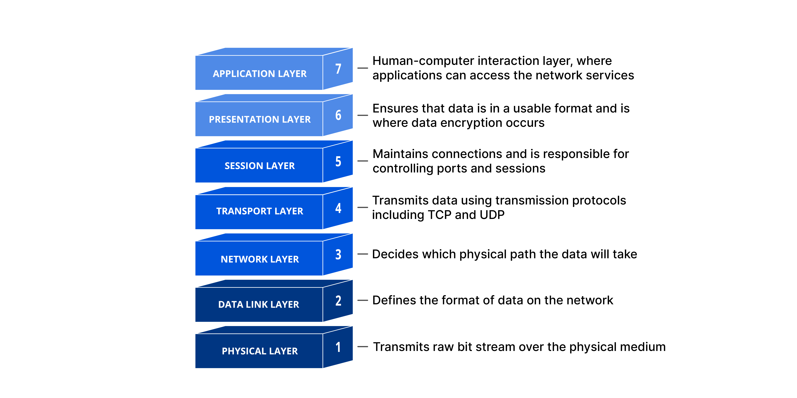**What is HTTP?**

- HTTP is a TCP/IP-based application layer communication protocal that standardizes how clients and server communicate with each other.

- It defines how content is requested and transmitted across the internet.

- TCP port 80 is used

- HTTPS used port 443

