Scenarios

* Car :

1. Car starts engine and goes to current target location (next gate or final target ).
2. Car reaches gate, waits and turns off the engine.

* Gate :

1. Car is enqueued, if car is emergency then it’s the first element of the queue.
2. If the first car in the queue is an emergency or the expected pollution of the car won’t make the next area exceeds its threshold then the car is admitted and dequeued.

Expected Pollution = Area_avg_speed* pollution of the car .

1. One car only enters/exits the gate queue at a time.
2. If there are N cars at different gates leading to the same area then they are admitted in the following order :

(Left, Up , Right , Down).

* Car Controller:

1. Once the car is admitted then the engine is on.
2. Sets its current area to the next area from the sequence.
3. Admitted car gets the location of either the next gate or the final point as the next target.

**Equations inside the Plant**

***Gas_Pollution_Dot($arⅇa_{i}$)*** *= $\sum{car_gas_pollution_{inside arⅇa_{i} }}$ $-\sum{car_gas_Pollution(Neigboring\left(arⅇa_{i}\right))}$-5*Pollution($arⅇa_{i})$*

***Noise_Pollution_Dot($arⅇa_{i}$)*** *= $\sum{car_noise_pollution_{inside arⅇa_{i} }}$– noise($arⅇa_{i}$)*

***Speed_Dot(${car}_{i}$)*** *= (average_speed(current_area)-speed(${car}_{i}$))+random; random $∈[-max_speed(current_area)/4,max_speed(current_area)/4]$*

***Location_Dot(${car}_{i}$)*** *= $\frac{current_target_location({car}_{i}) – current_location({car}_{i}) }{||current_target_location({car}_{i}) – current_location({car}_{i}) ||}$*speed(${car}_{i}$)*

***Pollution(${car}_{i}$)(per second)*** *= pollution(${car}_{i}$) (per meter) *speed(in meter/sec)*

***Horn(${car}_{i}$)*** *= random(1) < 0.5*

***Noise_Plus(${car}_{i}$)*** *= noise(${car}_{i}$) + horn_noise(${car}_{i}$)*horn(${car}_{i}$)*

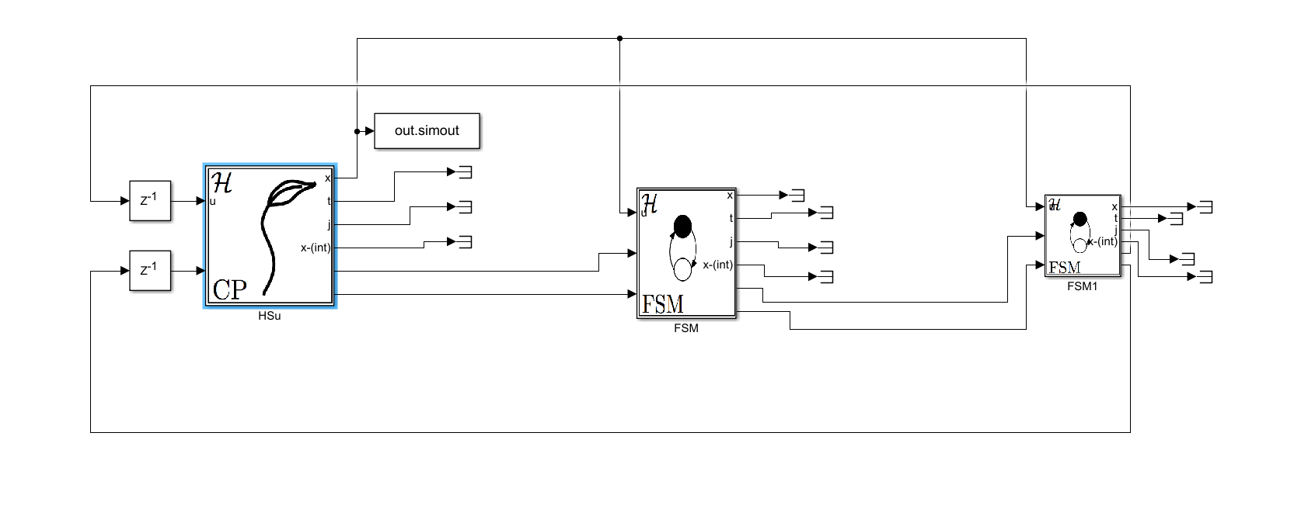

Plant handles the continous and jump parameters of the all the areas and cars,

The first FSM handles the gate queues,

The second FSM handles the car path control

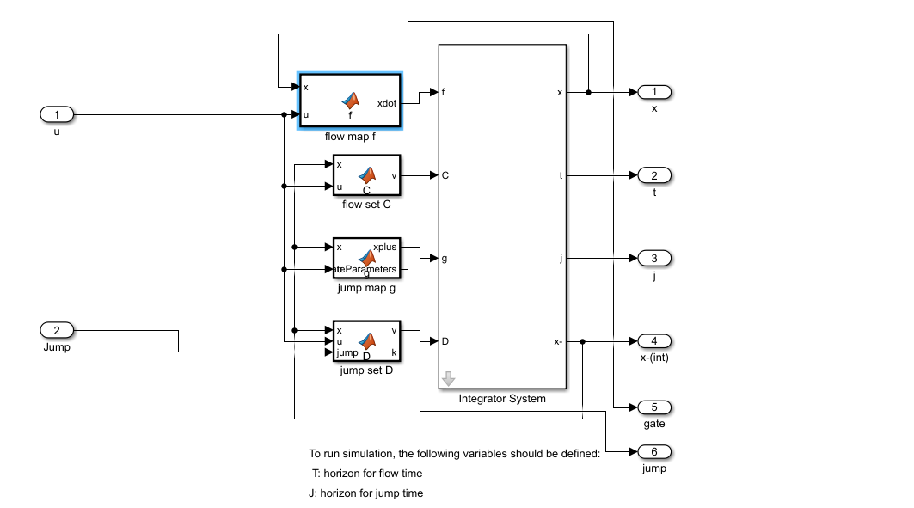

This is the inside of the plant and takes the imput from the car path control and it outputs the pending cars

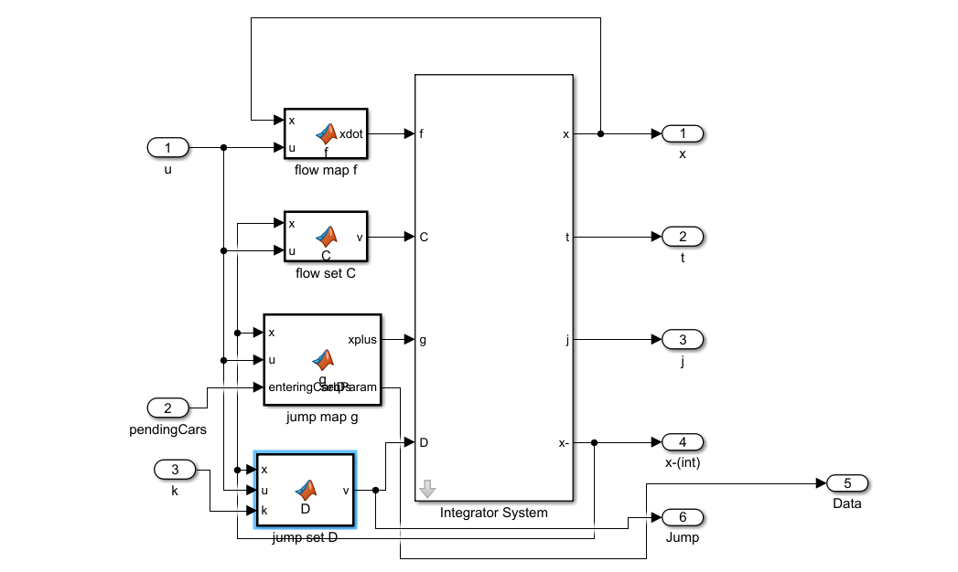

This the gate FSM control and it gets the pending cars as input and outputs the admitted cars

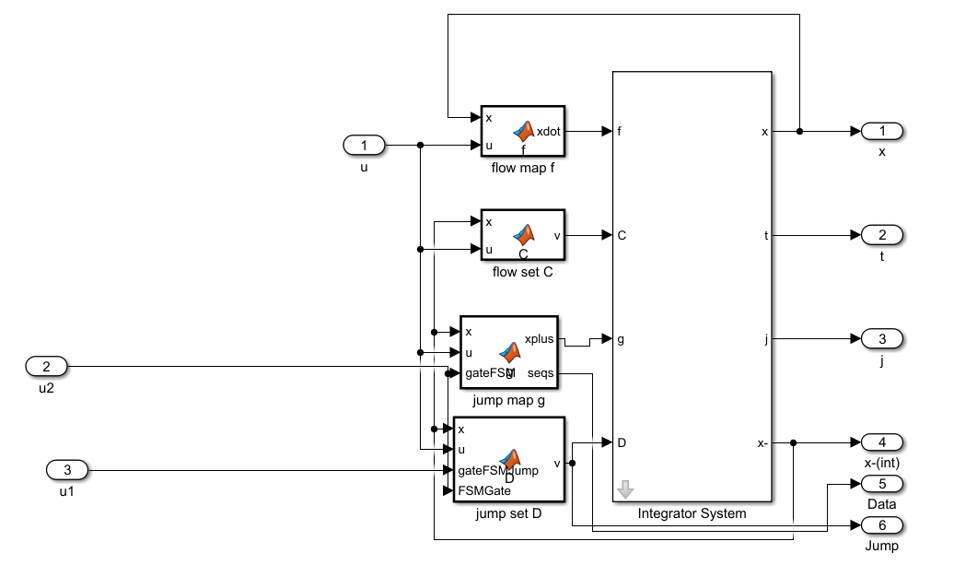

This is the FSM of the car control and it takes the admitted cars as input and outputs the new cars paths

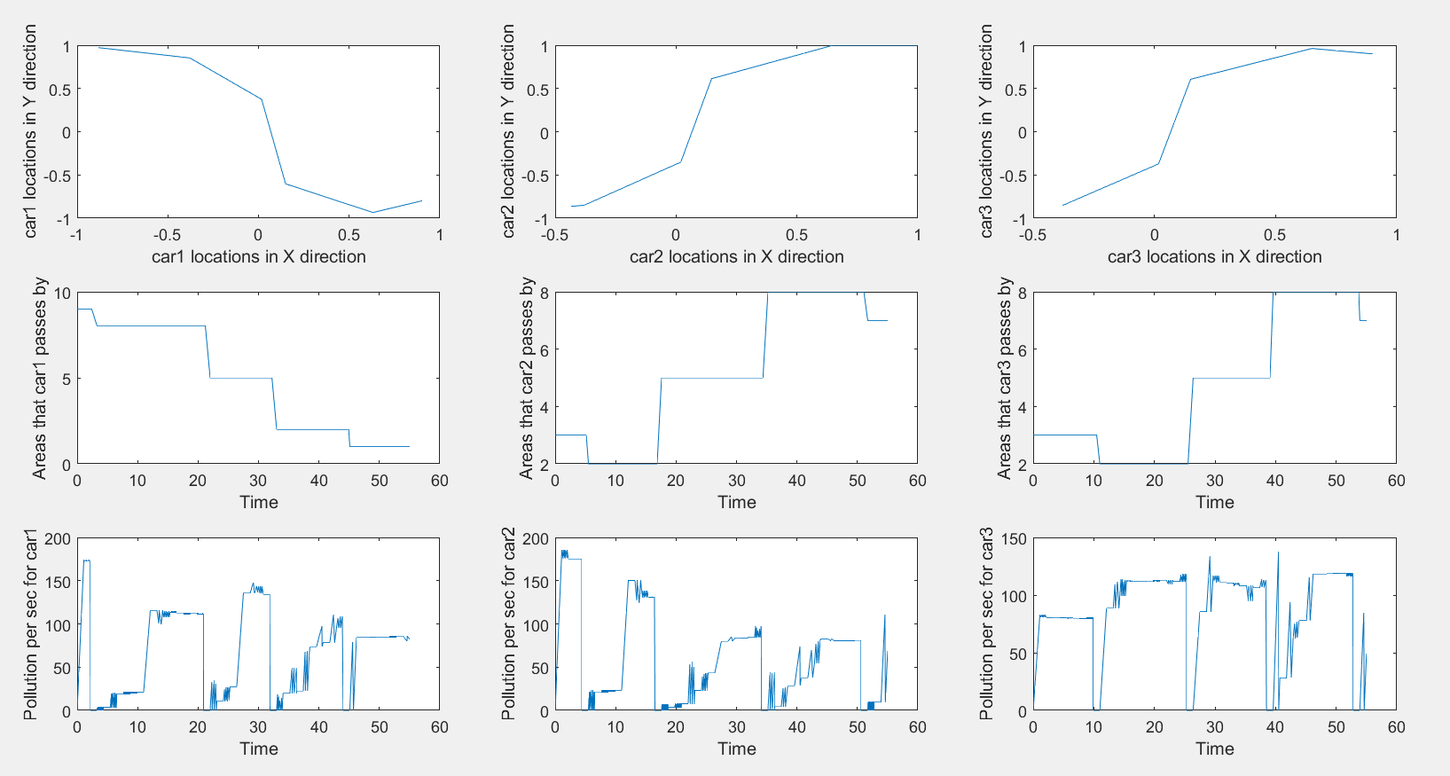

We chose to give the model 3 cars and these are the continuous paths, visited areas and the instantaneous gas pollutions through the simulation.

We chose the cars path to go through areas {car 1 : 9,8,5,2,1} , {car 2 : 3,2,5,8,7},and car3 takes the same path as car2 but it’s an emergency vehicle.

We can observe that the instantaneous gas pollutions are zero when the car is pending and between two areas (the car is waiting in the queue) .

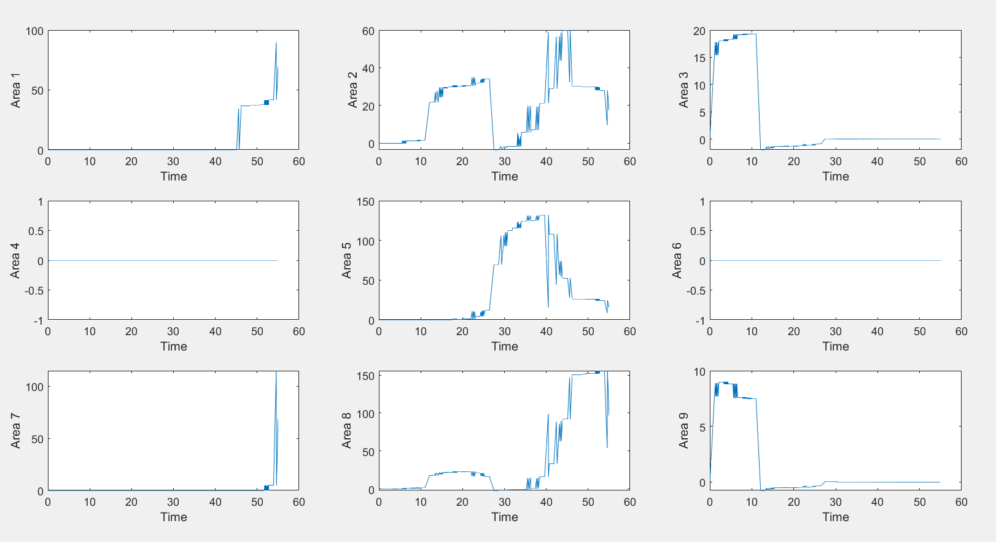

These correspond to the noise pollution of each area.

We can observe that areas 4 and 6 have no pollutions because no cars pass through them and our model does not have noise dissipations between areas.

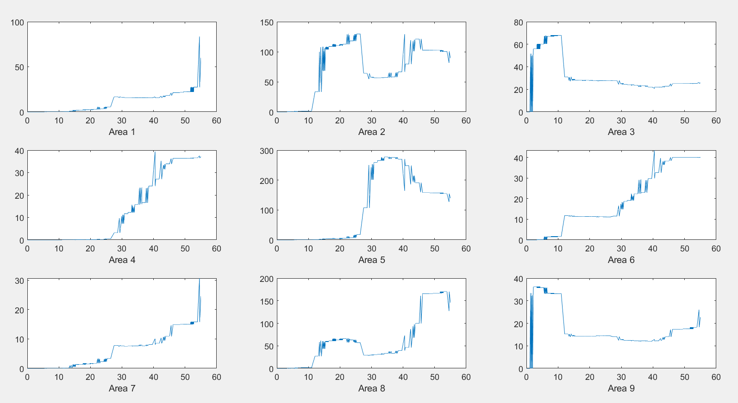

These are the gas pollution of each area.

We can observe that the area the cars pass through have more pollutions than other areas especially area in the middle while areas 4 and 6 are relatively low because they get dissipations from neighboring areas.

Furthermore, corner areas are more prone to dissipations to the outer atmosphere.