# Project One

# Taking on Fantasy Football

## Group Members

### Tanner Pedretti

### Ryan Hathaway

### Ismahan Adan

### Don Sargent

# Determined Project Scope

# Present Data

Fantasy Football scoring ; there are numerous scoring systems for Fantasy Football. This study will be using the PPR scoring system. We are not looking for specific players that have historically scored highest points but we are interested in which position is more important and what is the likelihood that after the draft our team will score above a certain point threshold.

Finding

Data from plots

# Established Questions

# Set up data requirements

**This will be the body of my presentation**

I will bring the data below into the body of the presentation first draft

I would like to base our statistics on how may points does it take week to week to win a 16 game season.

What I believe will be interesting is if we could display the data in a weekly format so instead of showing a cumulative score for the year just divide the score by 16 games.

I think we should include our original line graphs to shoe=w the progression that we went through to arrive at our conclusion. It will also be nice to have a combined line chart.

If our chart could look like this that would be great

Both of these charts are from this website

<http://fantasyoutliers.com/leagues/10Rec_League_Manager_12Team/the-basics.html>

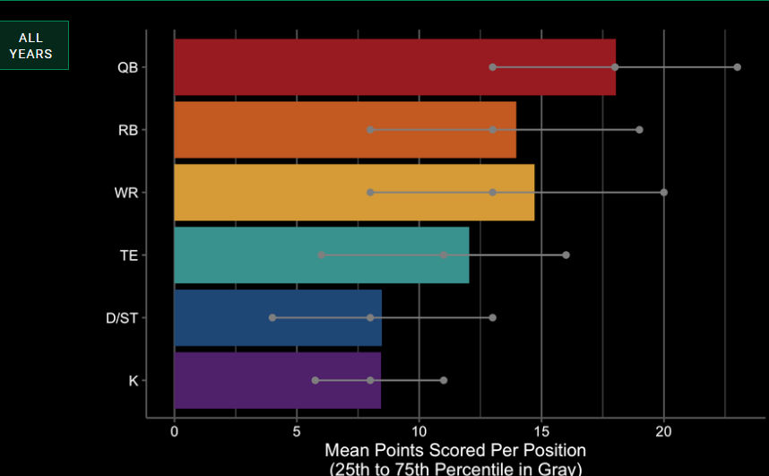

Figure our scores are slightly different than this

..

This chart can illustrate what we are shooting for= We will state that this chart was out side the scope of our project

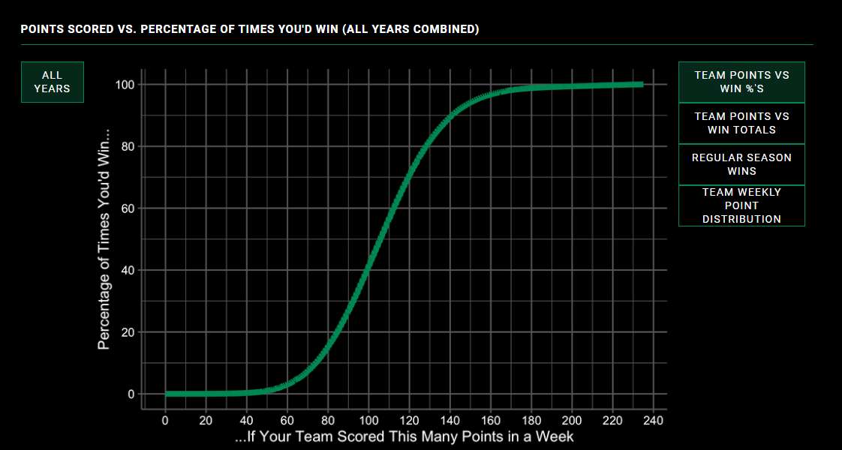

Figure

The second chart above shows that in a PPR league to be above 50% chance of winning you will need to score above 110 points.

Quaterback plot

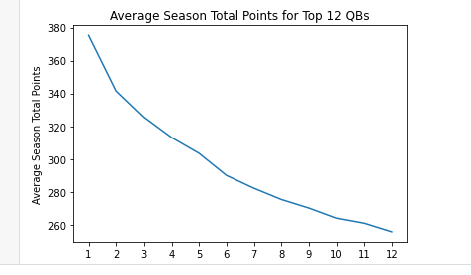



Figure median score 20 per week

Running back plot

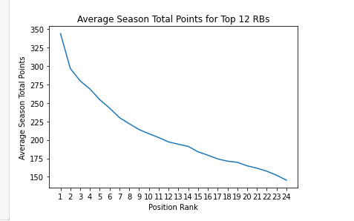



Figure median score 15.6 per week times 2 each team has 2 running backs

Wide receiver plot

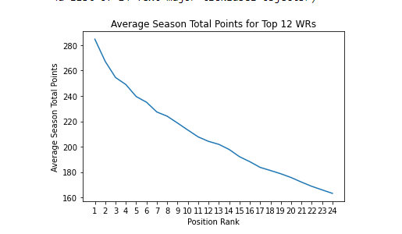



Figure median score 13.75 per week times 2 each team has 2 wide receivers

Tight End plot

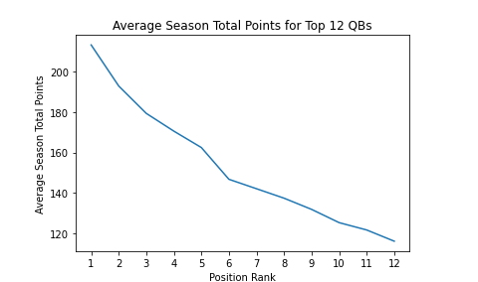



Figure median score 10.00 per week



A few things that I notice about the data

1. First the difference between the high and low scores
   1. 120 points for quarterbacks and wide receivers
   2. 100 point running backs
   3. 80 point difference for tight ends

So it appears that selecting 2 higher round running backs might be a good strategy. Quarterbacks are also very important, they do score the most points. Then wide receivers. Tight ends although they are important because the difference in the high and low scores is so narrow that a late round selection of a tight end should not be a huge liability. So it is simple all you have to do is select all players that perform and score median values each week you will win. Some of the articles that I read stated that winning in fantasy football is 60% skill and 40% luck. All that I say is that some one is pretty lucky because I do not win these kind of things very often

|  |  |  |
| --- | --- | --- |
| Quarter backs | 20 | 20 |
| Running backs | 15.6 | 31.2 |
| Wide receivers | 13.75 | 27.5 |
| Tight ends | 10 | 10 |
| Defense | 10 | 10 |
| Kicker | 10 | 10 |
|  |  | 108.7 |