**Object Recognition Tutorial Using PYNQ Z2 Board A detailed guide for object detection using a deep learning approach on the PYNQ Z2 board**

**Configuring the board setup: In the first phase take the memory card inserted into the SD card and plug in to your laptop.**

**Step1: Download the Win-32 Disk Imager setup from the provided link:** [**https://sourceforge.net/projects/win32diskimager/**](https://sourceforge.net/projects/win32diskimager/)

**Step2: To download the appropriate image go to the link** [**https://github.com/Xilinx/PYNQ/releases**](https://github.com/Xilinx/PYNQ/releases)

**Then download** [**https://bit.ly/pynq_z2_v3**](https://bit.ly/pynq_z2_v3)

**Step3:**

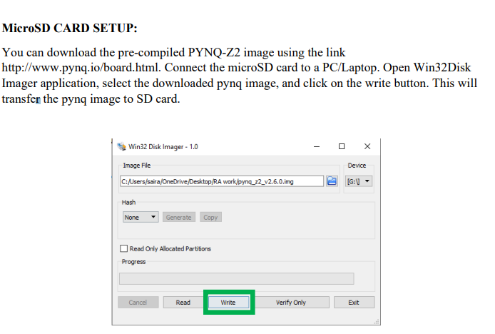

1. Set the boot jumper to SD card.

2. Set the power jumper to power the board from USB.

3. Insert the SD card loaded with pynq image.

4. Connect MicroUSB cable to PROG-UART port of the board and USB port to your PC/Laptop.

5. Connect Ethernet cable to a PC or to a Router.

6. Turn ON the board which will immediately glow the Red LED to indicate that the board has power and then the Done LED will turn ON to confirm that the device is working. Finally, 2 Blue LEDs and four Green LEDs will light up to show that the device is booted and ready to use.

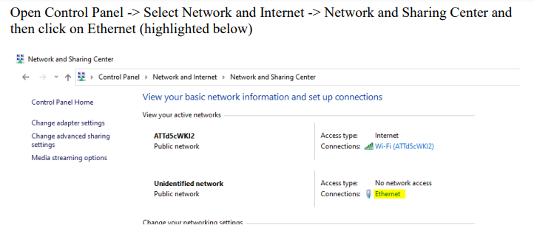

**Note: Connect your laptop and PYNQ-Z2 board to the LAN cable with the same network.**

**If the LAN is not connected/no-internet then try to troubleshoot the ethernet drivers and check the status of the internet access.**

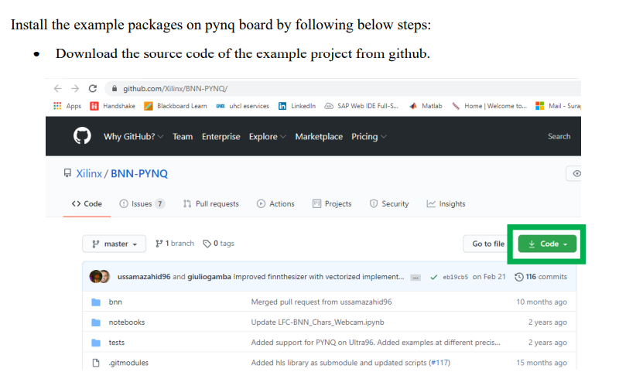

**WORKING EXAMPLES:**

**Once the installation is done, then try to open the jupyter notebooks which are pre-installed in the example: CNV-BNN_Cifar10.ipynb**

**Example2: CNV-BNN_Road-Signs.ipynb**

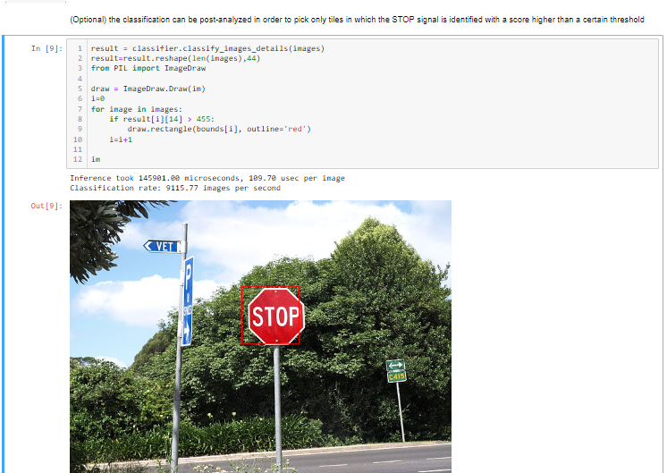

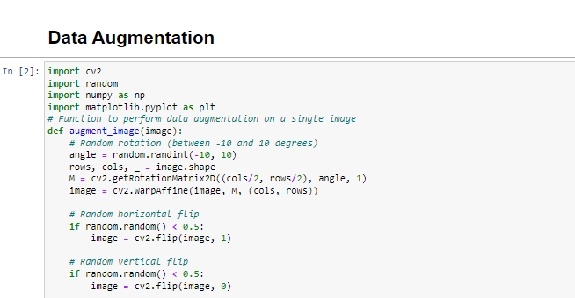

**Data Augmentation**

**Output:**

**Image processing**

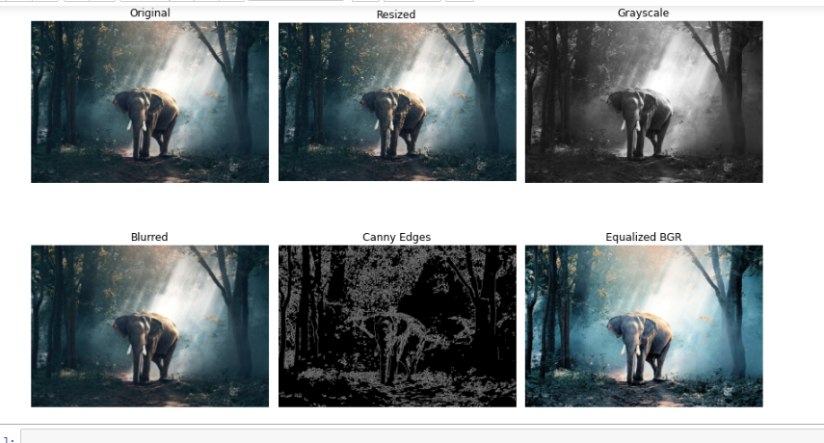

**Install a custom python package using CLI:**

**Open terminal form the jupyter notebook**

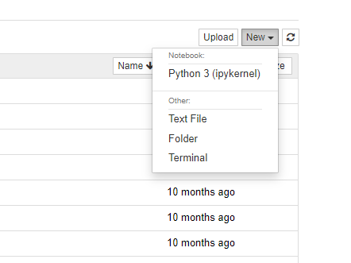

**While installing a python package using pip you will face the below described warnings. To resolve follow up the next process.**

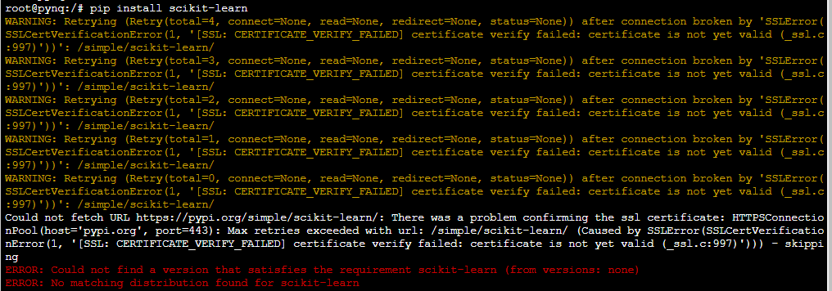

**Update the system by following the command**

**Then to configure package of python use the below mentioned command followed by the package name.**

sudo pip3 install --trusted-host pypi.org --trusted-host pypi.python.org --trusted-host=files.pythonhosted.org **package-name**

**if the above command doesn’t work follow the below-mentioned command**

**or**

Before installing any new package try to run the following **cmd: sudo apt-get update**

sudo apt-get install package-name

**To capture live video stream**

**Output:**



