PENTECOST UNIVERSITY
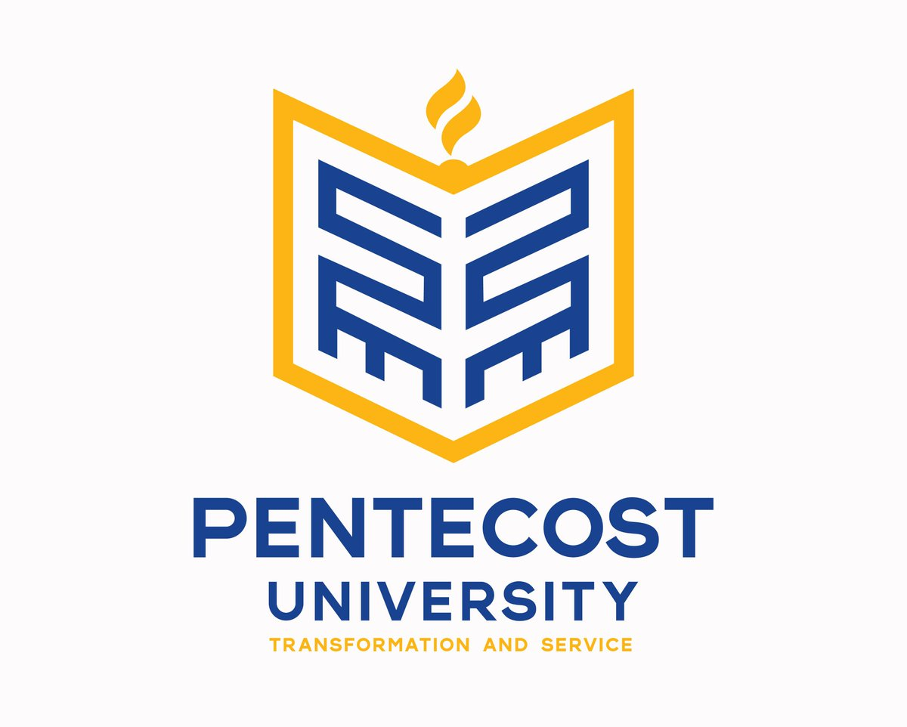

SOWUTUOM, ACCRA, GHANA

FACULTY OF HEALTH AND ALLIED SCIENCE

IT AND COMPUTER FUNDAMENTALS

COURSE OUTLINE

Course Lecturer:
Name: Harry Atieku-Boateng
Email: hatieku-boateng@pentvars.edu.gh
Phone: 0249663991

Course Description
This course serves as an introduction to the essential concepts of information and computer technology. Students will explore how information is created, stored, processed, and communicated in today's digital world. The course covers fundamental hardware and software components, network basics, and emerging technologies such as artificial intelligence (AI) and the Internet of Things (IoT). Students will gain hands-on experience using Microsoft Office applications, performing basic troubleshooting, and understanding the ethical, legal, and security considerations associated with technology. Emphasis is placed on practical skills and critical thinking to prepare students for technology use in diverse professional contexts.

Learning Outcomes
Upon successful completion of this course, students will be able to:
- Understand and describe the structure and function of computers, including hardware and software components.
- Explain the importance of information and technology in daily life and various professional sectors.
- Demonstrate knowledge of networking concepts and modern digital communication tools.
- Discuss the basics of AI and IoT, including their applications and potential impacts.
- Apply practical skills to use Microsoft Office applications effectively.
- Identify and troubleshoot basic computer hardware and software problems.
- Understand ethical, legal, and security issues related to technology use.

Course Content
1. Introduction to Information and Technology
- What is Data?
Explanation of raw facts and figures without context.
- What is Information?
Processed data that is meaningful and useful for decision-making.
- What is Technology?
Tools and methods used to solve problems or achieve objectives.
- What is Information Technology?
Integration of hardware, software, and networks to collect, store, and communicate information.
Students will explore real-life examples, such as how data is used in health records or banking transactions.

2. Overview of Computer Hardware and Software
- History of Computers
Brief evolution from early mechanical devices to modern digital systems.
- Functional Components of a Computer
Input, processing, output, and storage units, and how they work together.
- Internal Components
Motherboard, CPU, RAM, storage drives, and peripheral connections.
- Booting and Booting Process
Steps involved in starting up a computer and loading the operating system.
- Software
Difference between system software (e.g., operating systems) and application software (e.g., Word processors).
- Applications of Computers
Use in education, healthcare, business, and research.
Students will be introduced to disassembling a computer (virtually or physically) to identify key parts.

3. Applications of IT and Computing Technologies
- Use of IT in various industries: healthcare systems, e-learning platforms, e-commerce, and online banking.
- Case studies illustrating IT's transformative effects on efficiency, data management, and communication.

4. Introduction to Networking
- Networking Concepts
Importance of connecting devices to share resources and information.
- Types of Networks
LAN, WAN, MAN, PAN; examples of their practical uses.
- Digital Technologies
Overview of data transmission, switching, and wireless technologies.
- Introduction to IoT
Connecting devices and enabling smart systems in homes, healthcare, and industrial settings.
Students will examine common network setups and basic configurations.

5. Introduction to Artificial Intelligence
- What is AI?
The science of making machines perform tasks that typically require human intelligence.
- History of AI
From early algorithms to modern machine learning and neural networks.
- Applications of AI
In healthcare diagnostics, finance, autonomous vehicles, and virtual assistants.
- Ethical Considerations
Issues around privacy, bias, job displacement, and accountability.
Students will discuss AI tools they interact with daily and analyse potential risks.

6. Troubleshooting Techniques
- Hardware Troubleshooting
Identifying and fixing common issues like faulty RAM, overheating, or connectivity failures.
- Software Troubleshooting
Addressing problems like software crashes, malware infections, and update errors.
Students will perform guided exercises in diagnosing and resolving simulated faults.

7. Hands-on Training in Microsoft Office Suite
- Microsoft Word
Document creation, formatting, tables, and referencing.
- Microsoft Excel
Spreadsheet design, formulas, data analysis, and charts.
- Microsoft PowerPoint
Creating professional presentations, animations, and multimedia integration.
- Microsoft Publisher
Designing flyers, newsletters, and brochures.
Practical assignments will require students to create real-world documents and reports.

8. Supplementary Topics
- Introduction to Information Security
Basics of protecting data from unauthorized access and cyber threats.

- Numbering Systems
Binary, decimal, and hexadecimal systems and their importance in computing.
- Introduction to IoT Applications
Smart homes, wearables, and industrial automation.
- Malware
Types, infection methods, and preventive measures.
- Health Informatics
Use of IT to improve patient care, manage health data, and support medical research.

Mode of Delivery
- Expository lectures supported by visual aids and live demonstrations.
- Interactive tutorials and group discussions.
- Practical lab sessions using software tools.
- Reading assignments, multimedia resources, and case studies.
- Individual and group presentations to develop communication skills.

Assessment Criteria

Component | Weight (%) | Description
End-of-semester exam | 60% | Comprehensive test covering all theoretical and practical aspects of the course.
Mid-semester assessment | 20% | Could include quizzes, projects, term papers, or continuous group assignments.
Assignments | 15% | Regular assignments requiring written reports and in-class defense.
Attendance & participation | 5% | Based on consistent attendance and active involvement in class activities and discussions.

Additional Assessment Guidelines
- All softcopy submissions must go through Turnitin for similarity and AI-generated content checks.
- Adherence to IEEE referencing style is mandatory for all academic work, except agreed otherwise.
- Late submissions incur a 5% penalty per calendar day, with no acceptance after public release of solutions or results.

Academic Integrity
Students must avoid:
- Plagiarism: Using another person's work or ideas without acknowledgement.
- Collusion: Unauthorised collaboration or sharing of work.
Penalties include zero marks for the specific assessment, potential suspension, or expulsion. Students are also responsible for reporting any academic misconduct they witness.

Weekly Schedule
Week | Topic | Activities | Resources
1 | Introduction to Information/Tech | Lectures, tutorial, discussion | Recommended texts, online videos
2 | Computer Hardware & Software | Demonstrations, lab activities | Online resources, textbooks
3 | IT Applications | Case studies, group discussions | Journal articles, case videos
4 | Networking Basics | Lab setups, simulations | Practical guides, videos
5 | Introduction to AI | Group debates, mini projects | Articles, AI tool demos
6 | Information Security | Risk assessments, scenarios | Cybersecurity modules
7 | Numbering Systems | Exercises, quizzes | Lecture slides, online quizzes
8 | IoT Fundamentals | Hardware demos, project brainstorming | IoT kits, tutorials
9 | Malware | Case reviews, simulations | Security reports, articles
10 | Health Informatics | Guest lecture, case discussions | Research papers, videos
11 | One-on-One Consultations | Individual feedback sessions | —
12 | Revision & Exam Prep | Recaps, practice exams | Past questions, summary notes

Recommended Reading Materials
- Barnbrook, G. (2022). Language and computers. Edinburgh University Press.
- Burbules, N. (2018). Watch IT: The risks and promises of information technologies for education. Routledge.
- Eiben, A. E., & Smith, J. E. (2015). Introduction to evolutionary computing. Springer.
- Elahi, A. (2022). Introduction to computer architecture. Springer. https://doi.org/10.1007/978-3-030-93449-1_6
- Foulkes, L. (2020). Learn Microsoft Office 2019. Packt Publishing.
- Mueller, S. (2015). Upgrading and repairing PCs. Que Publishing.
- Rajaraman, V. (2018). Introduction to information technology. PHI Learning Pvt. Ltd.

Required Tools and Software
- Microsoft Office Suite (Word, Excel, PowerPoint, Publisher)
- Mendeley Reference Manager
- ChatGPT account (for guided research assistance)

