Tile:

Stock Market Analysis through big data

Key points of the project including area of application:

* It will take large amount of data per unit time from stock exchange of each listed companies. This data will include
  + Date
  + Open price
  + High
  + Low
  + Close price
  + Volume
* The taken data will be stored in a distributed file system in number of PC.
* The analysis of this large data set wil be performed through map-reduce algorithm.
* The technical and statisctical analysis will be performed by making charts and graph of the acquired data.
* Morever, the software can pedict the nature of market such as
  + Rally
  + Volatility
  + Volume
  + Yield etc
* The information will be taken as a input from the user to predict the share of his profitable companies. It will include:-
  + Exchange
  + Average Volume
  + Market Capital
  + Institutional Ownership
  + P/E ratio
  + Diluted EPS
  + Forward annual dividend yield
  + Quaterly Dividend Amount
  + Closing Price at year end.
  + 52 week High and Low Price
* The number of parameters which will be calculated are:-
* RSI (Relative Stength Index)
* Sensex
* Nifty
* Support and Resistance Lines
* It will provide an simpistic interface where the users can
* It will provide guidlence for proper investment strategies.

Technology of the project:

* Hadoop
* Hive
* Rhadoop
* Mahout
* Java
* Html
* CSS
* Javascript
* Bootstrap

Module Implementation Graph:

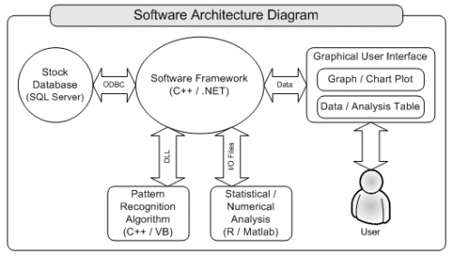

Group Member Details:

|  |  |  |  |  |
| --- | --- | --- | --- | --- |
| Name | Enrollment | Contact | E-mail id | Signature |
| Avani Sharma | 0812cs131021 | 9669166651 | avi4bulbul@gmail.com |  |
| Hatim Bohra | 0812cs131042 | 8349074222 | 786hatim53@gmail.com |  |
| Honey Jain | 0812cs131048 | 9425306877 | honeyj.jain@gmail.com |  |
| Hussain Jagirdar | 0812cs131049 | 8982290142 | Hussainjagirdar.hj@gmail.com |  |