Specifications for the development of the "Action Plans"
module of the QHSE Qualishare software

I. Objectives:

The "Action Plans" module aims to enable users of the QHSE Qualishare software to manage and monitor action plans associated with various QHSE-related activities, including quality, health, safety, and environment. The module must be capable of providing a synthetic view of the actions, generating Excel export reports for ongoing and unfinished actions, enabling the creation of meeting forms, displaying completed actions, and ensuring data security.

II. Features:

The "Action Plans" module must include the following features:

- Summary of actions:
The module must allow users to obtain a synthetic view of ongoing actions for each QHSE activity. This view must enable filtering actions by status (ongoing, pending, completed), creation date, responsible person, QHSE activity, priority, and risk level.

- Excel export (current year):
The module must enable users to generate Excel export reports for ongoing actions for the current year. These reports must include the following information for each action: year, action title, action origin, domain, process, site, action type, action manager, implementation deadline, status, effective measurement result, cost, and closing date.

- Safety actions:
The module must allow users to create and monitor safety-related actions. Safety actions must be clearly identified in the summary of actions.

- Excel export - Unfinished actions (current year):
The module must enable users to generate Excel export reports for unfinished actions for the current year.

- HSE actions:
The module must allow users to create and monitor actions related to health, safety, and environment (HSE). HSE actions must be clearly identified in the summary of actions.

- 8D form view:
The module must allow users to create 8D forms for identified non-compliant actions. 8D forms must include problem-solving steps and necessary corrective and preventive actions.

- Completed actions:
The module must allow users to display completed actions for each QHSE activity. This view must enable filtering actions by end date, responsible person, and QHSE activity.

- Meeting form view:
The module must allow users to create meeting forms for QHSE meetings. Meeting forms must include identified actions and associated responsible persons.

III. Development:

The development of the "Action Plans" module must include the following aspects:

- Angular frontend:
The front-end must be developed with Angular, an open-source JavaScript framework for web application development. It must be designed to be user-friendly and intuitive, with an attractive user interface and easy navigation. The front end must be adapted to all devices, including desktop computers, tablets, and mobile phones.

- Django backend:
The backend must be developed with Django, a Python web framework. It must be designed to handle the features of the "Action Plans" module, including data management, communication with the MySQL database, and data security. The backend must be designed to be scalable and to handle a large number of users.

- MySQL database:
The "Action Plans" module must be designed to work with a MySQL database. The database must be designed to manage action data, including information about actions, responsible persons, deadlines, and priority and risk levels. The database must be designed to be scalable and to handle a large number of users.

IV. Front-end and Back-end Security:
The "Action Plans" module must be designed to ensure data security on both the front-end and back-end. Front-end security should include user authentication, authorization and role management, and user input validation. Back-end security should include protection of sensitive data and error management. The module must be designed to be compliant with the strictest security standards.

V. Development Constraints:
The development of the "Action Plans" module must comply with the following constraints:

- Clear and Well-commented Code:
The code should be easy to read and understand. It should be logically and coherently organized to allow for easy maintenance and future scalability. The code should be well-commented to explain its functionalities and workings.

- No Malicious Code:
The code must not contain any malicious code or known security vulnerabilities. Developers should be aware of security practices and follow best development practices to avoid any potential vulnerabilities.

- Rigorous Testing:
The "Action Plans" module must be rigorously tested to ensure that it functions correctly and does not negatively affect other QHSE Qualishare software features. Testing should be done at every stage of development, including unit, integration, and system testing.

- Compliance with Coding Standards:
The code must comply with the coding standards defined by the QHSE Qualishare development team. Coding standards should include naming rules, style conventions, and coding practices.

- Comprehensive Documentation:
The code must be accompanied by comprehensive documentation that explains its functionalities and workings. The documentation should include specifications, requirements, installation instructions, user guides, and maintenance guides.

- VI. Module Interface Captures:
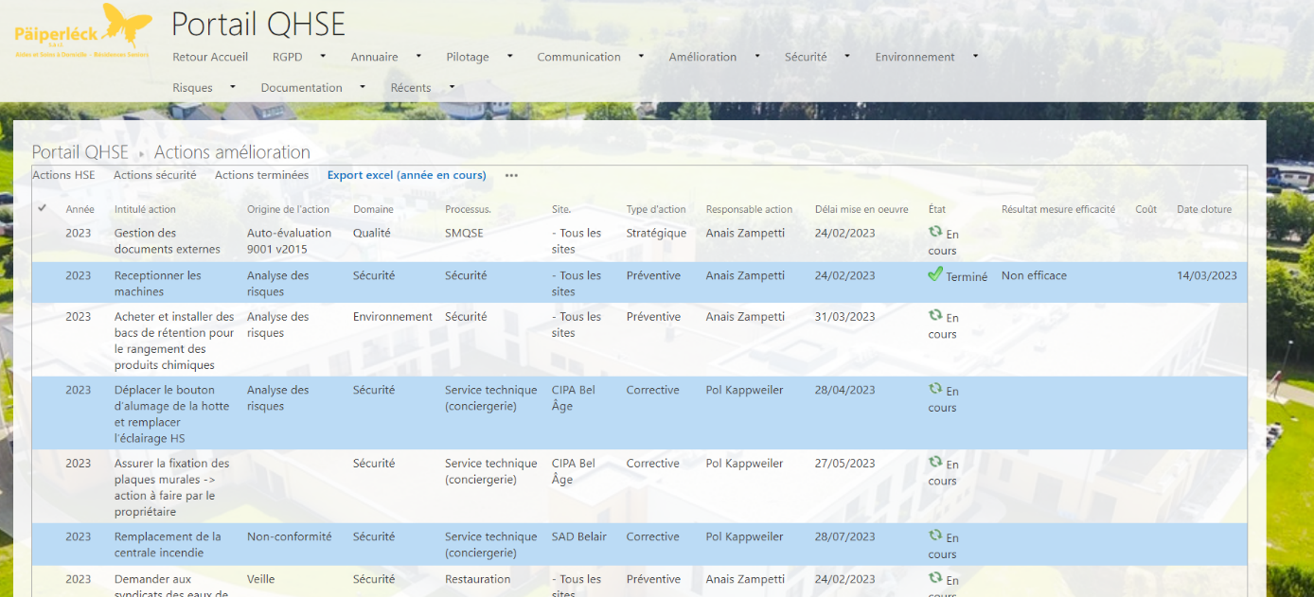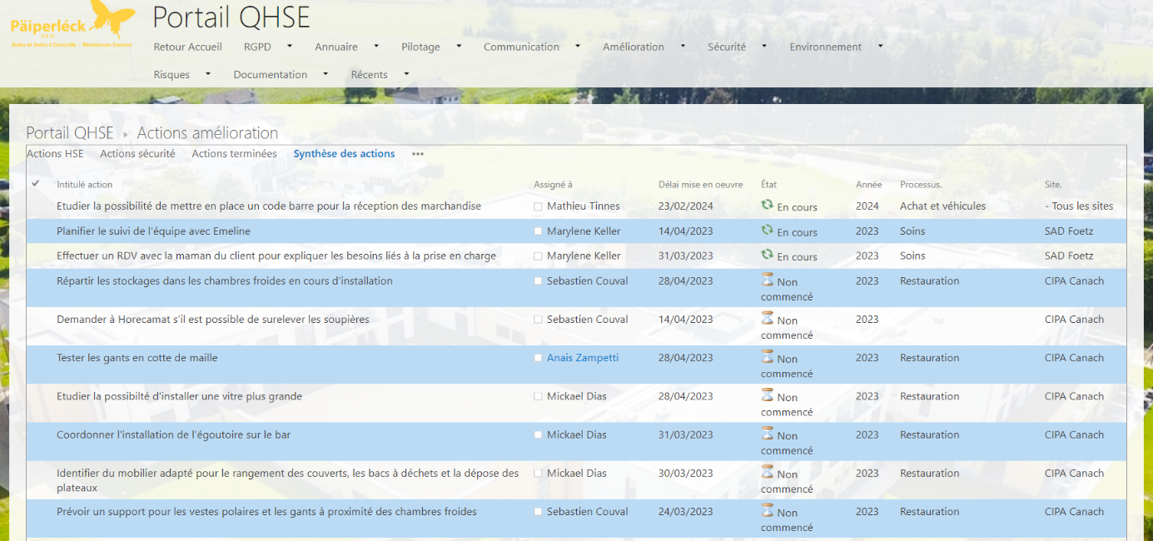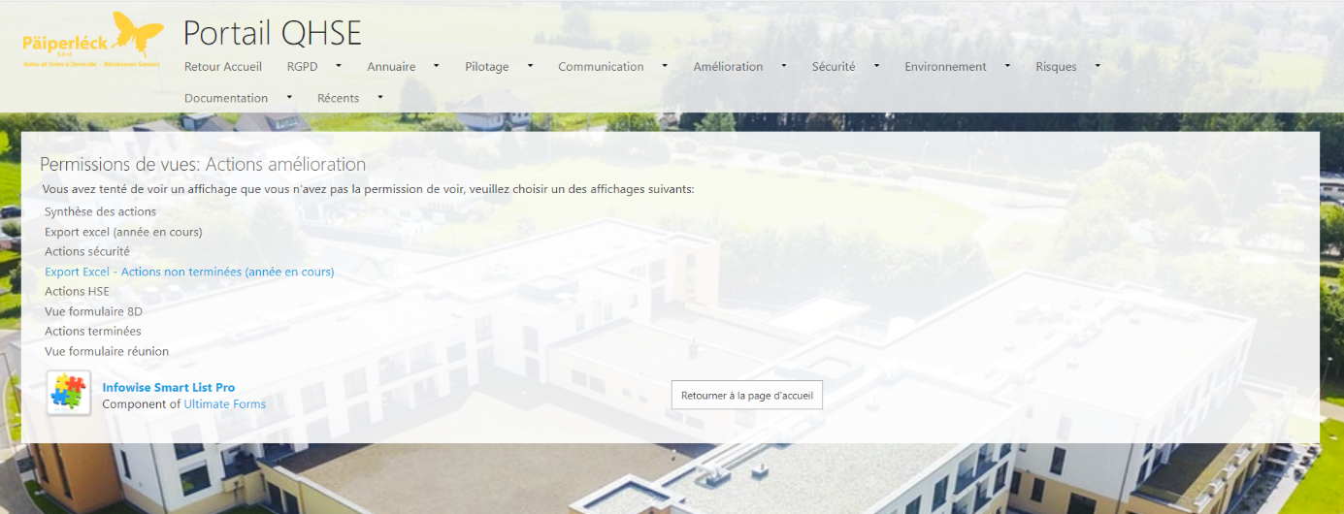
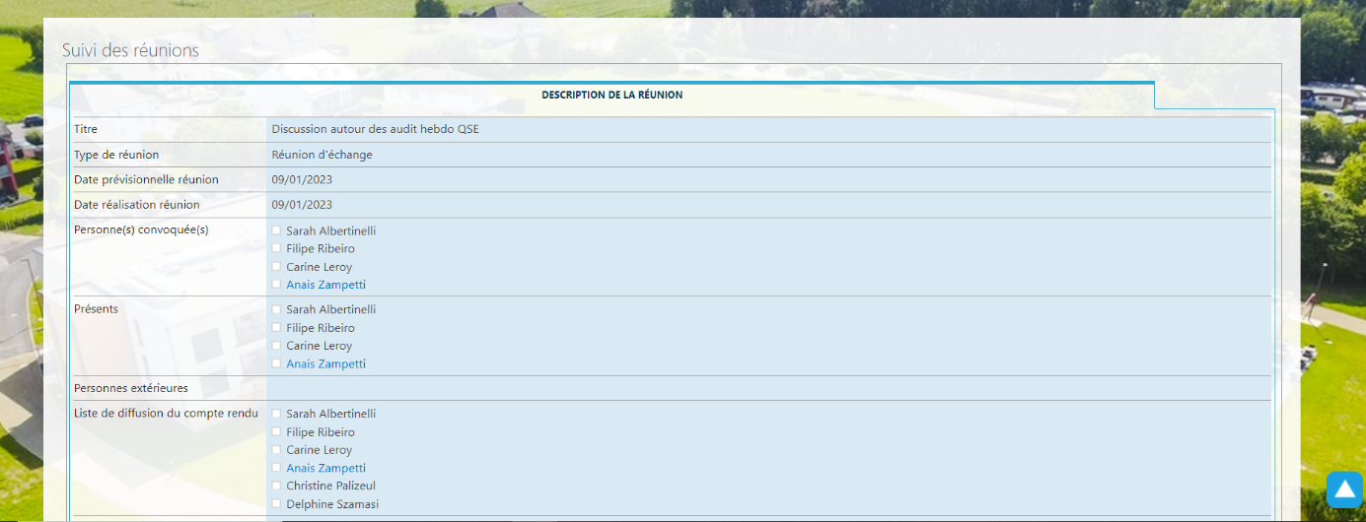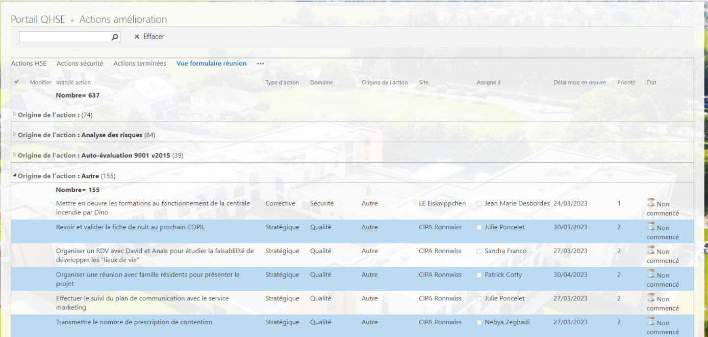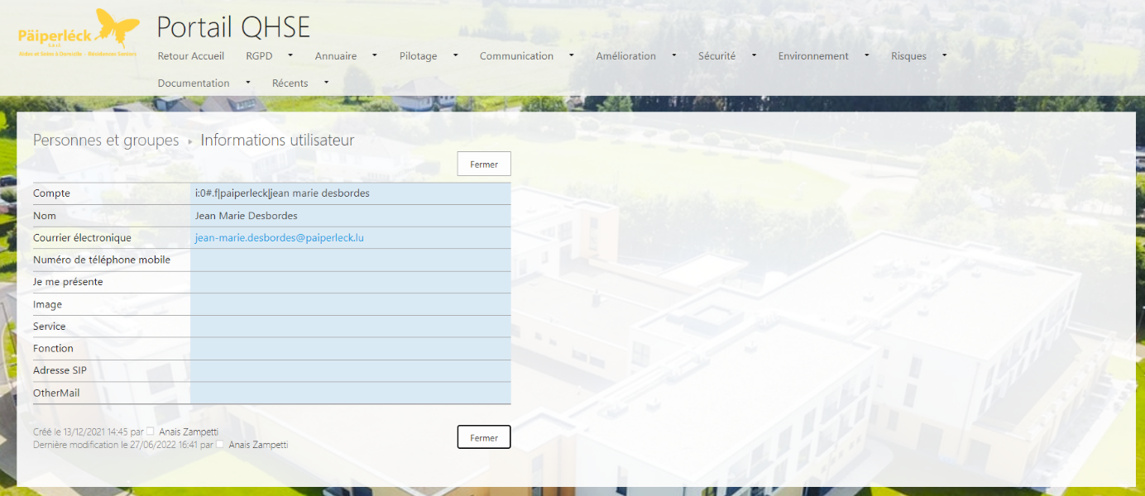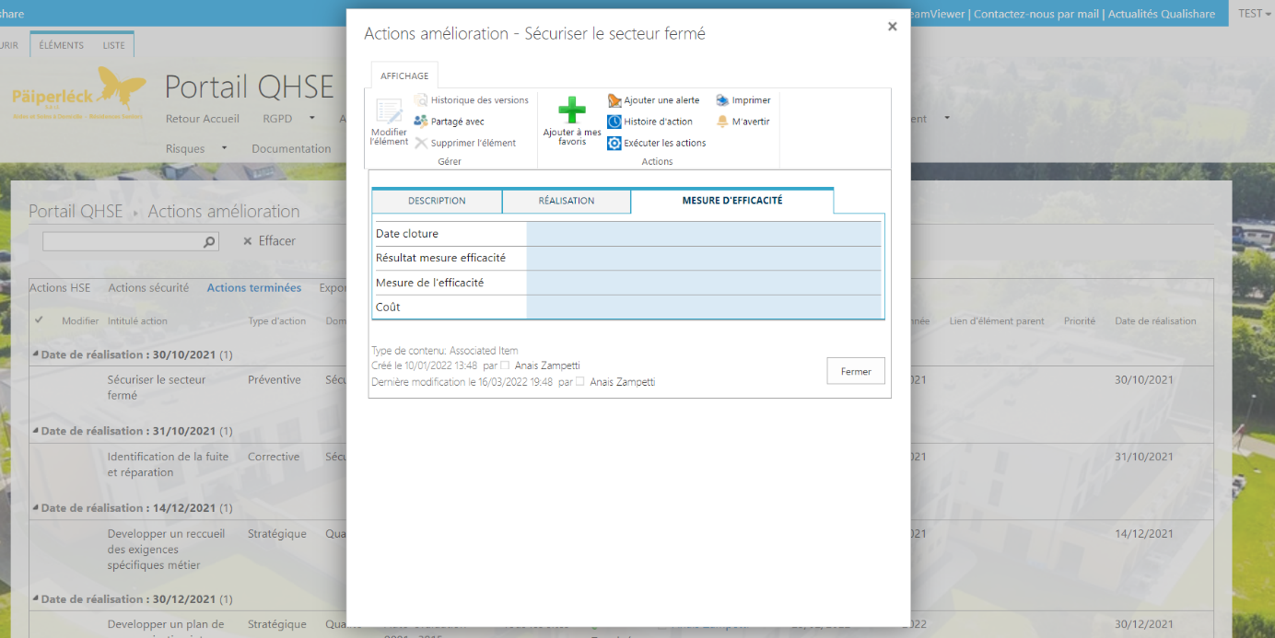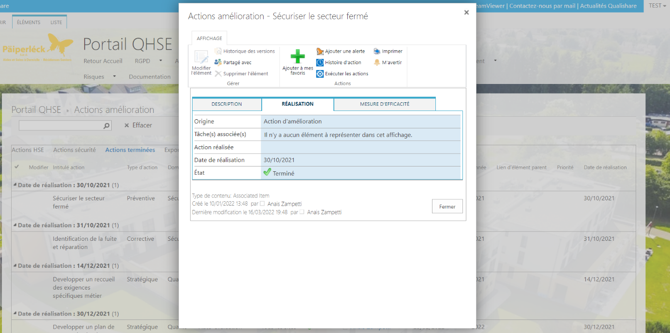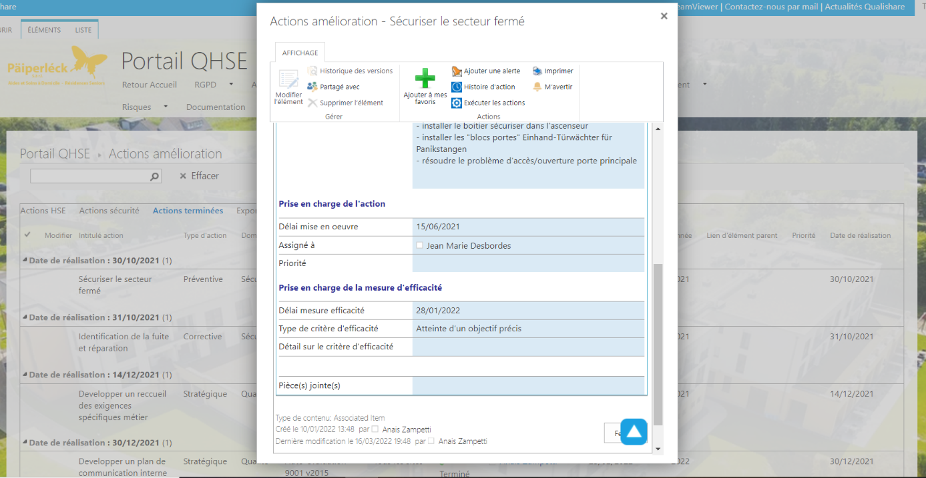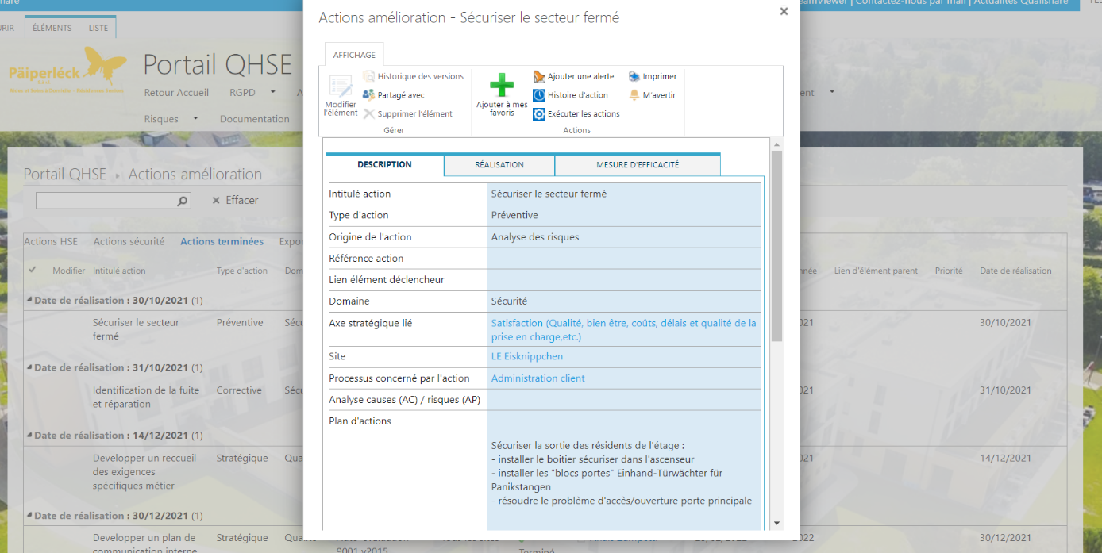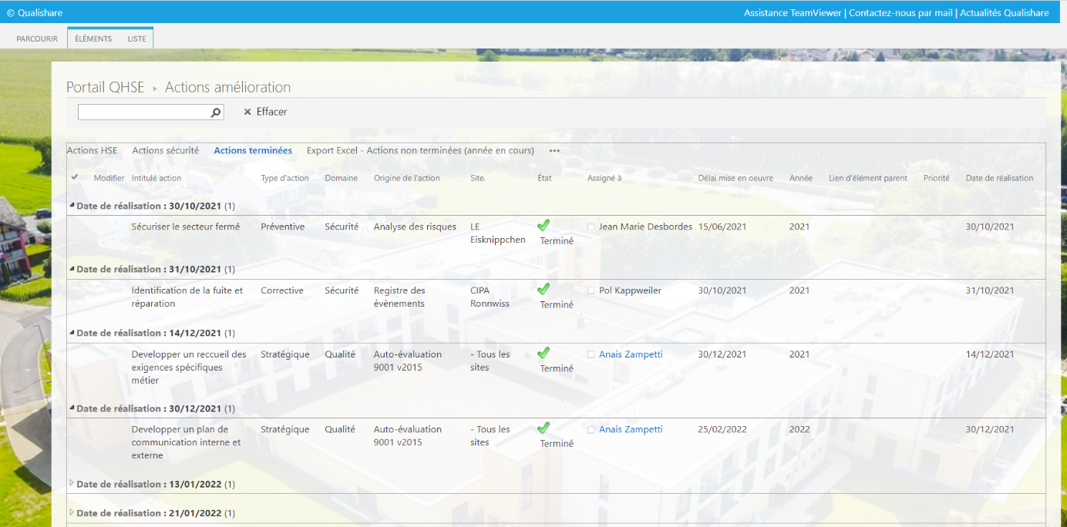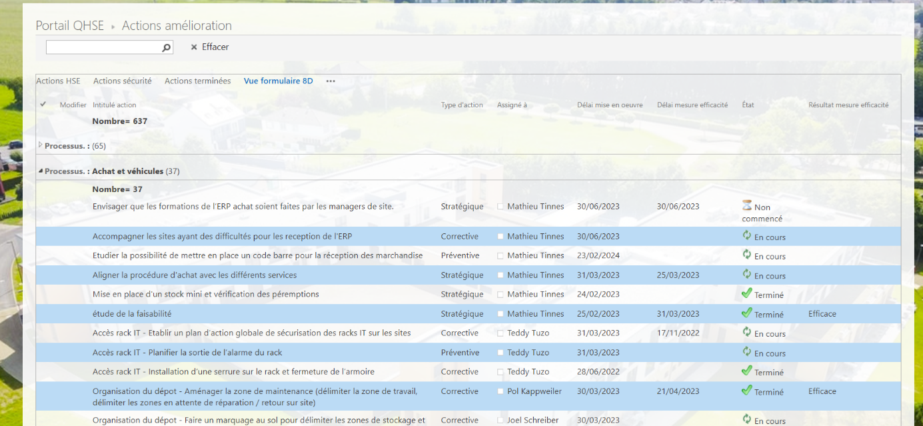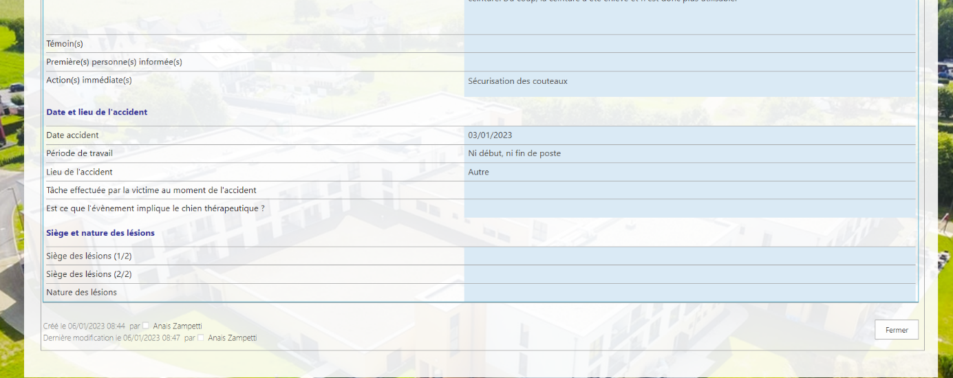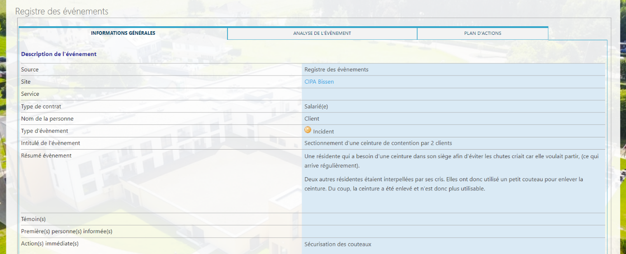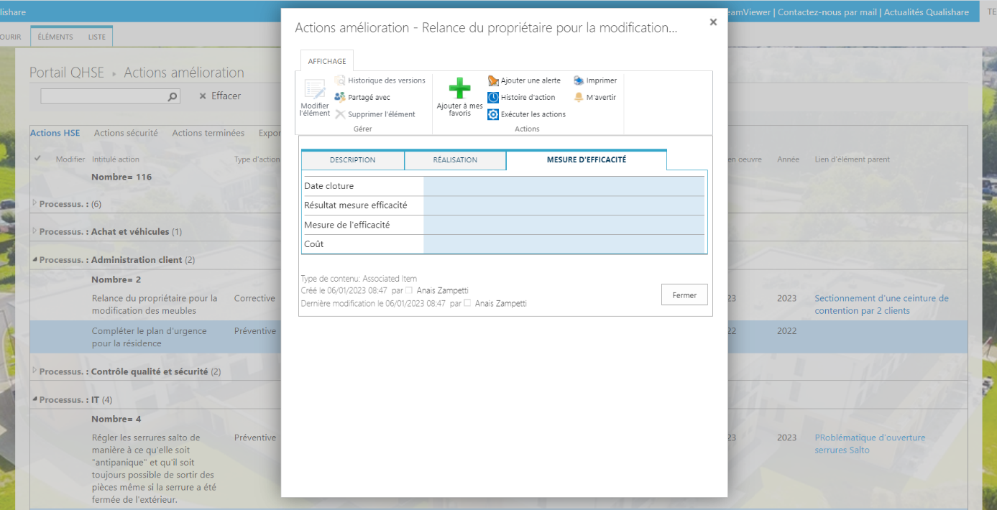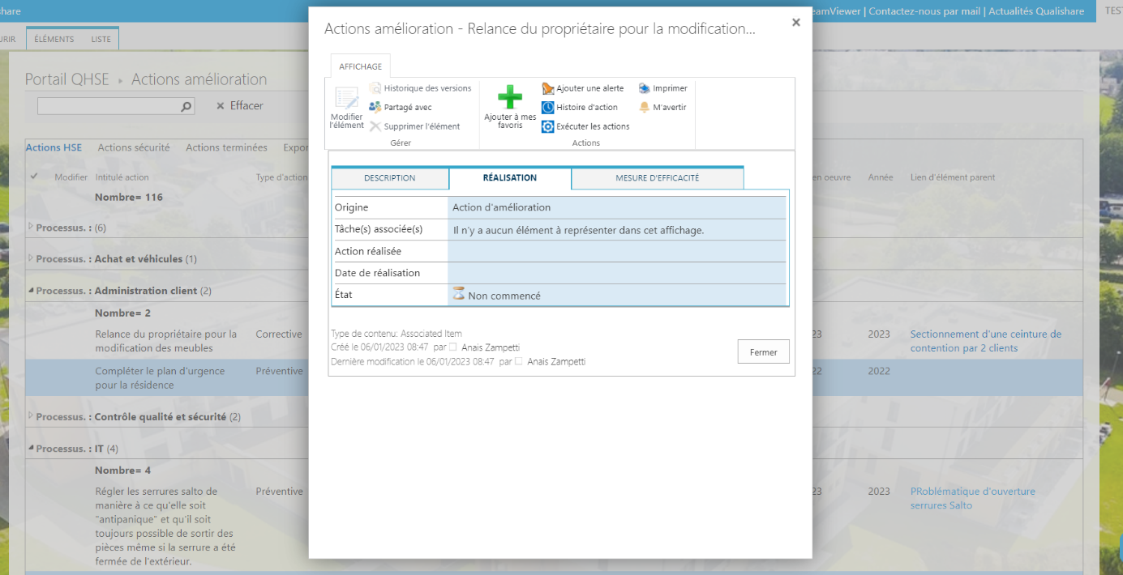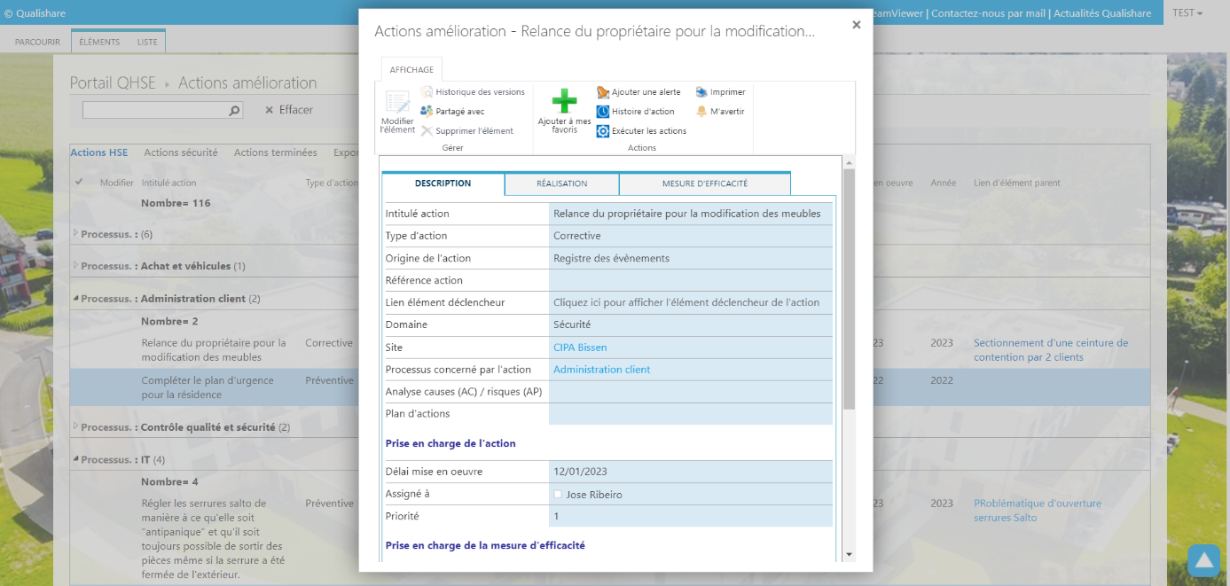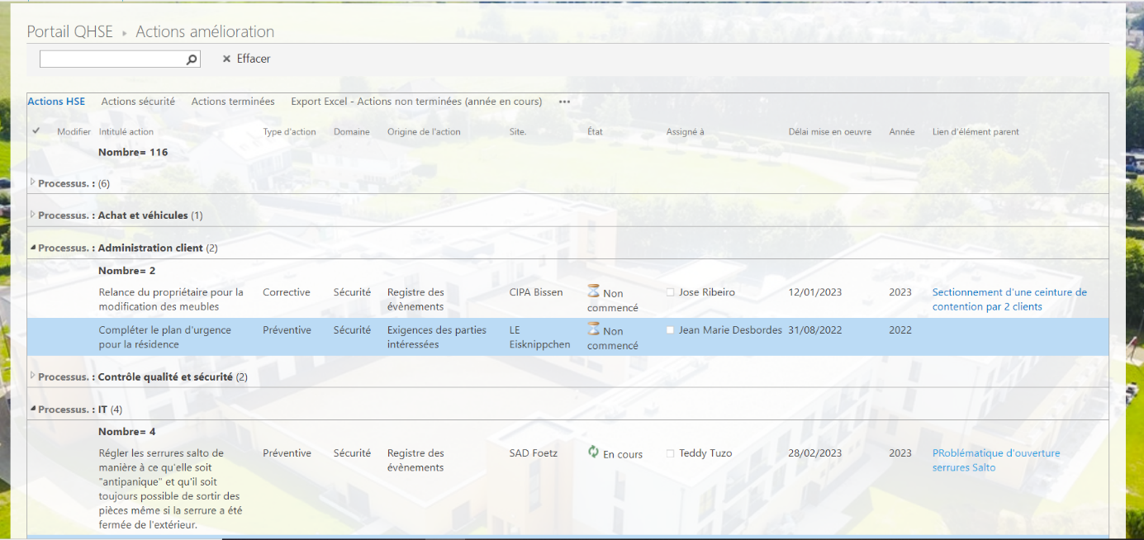
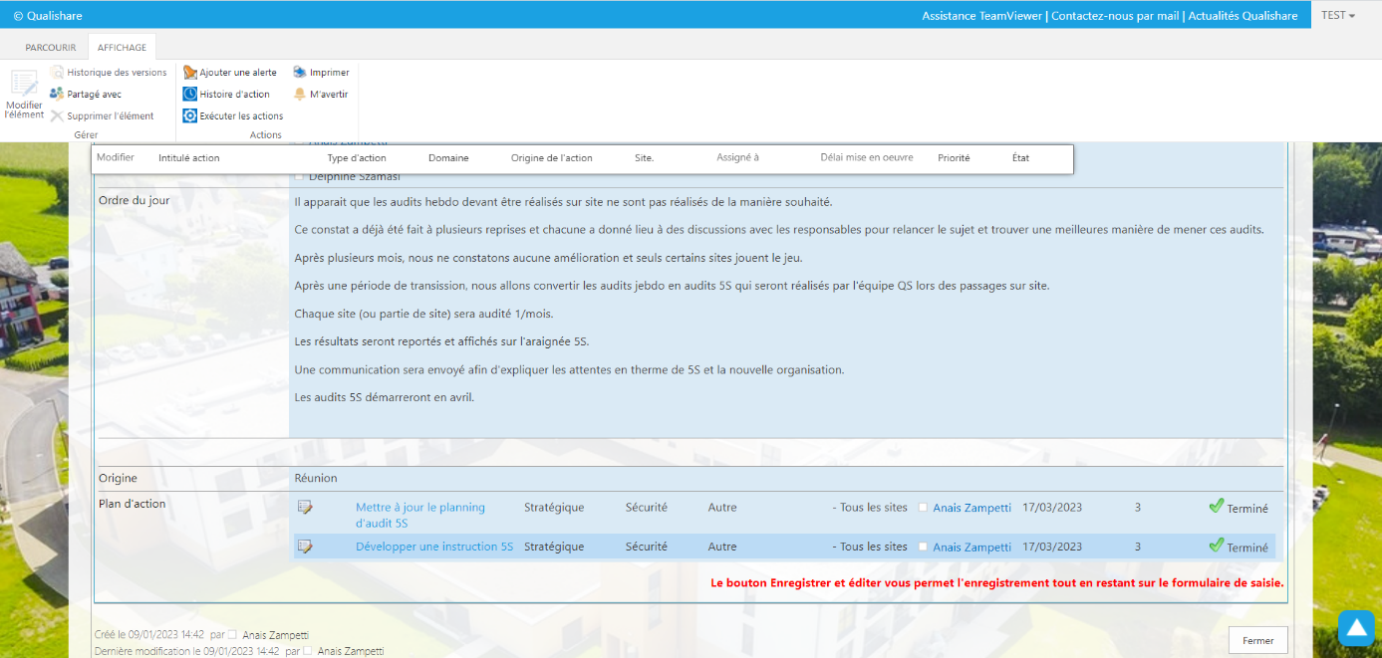

- Proposed design:


