YouTube Comment Sentiment Analyzer
Project Documentation
Name: Uzair Khan
ID: F2024376506
Python | YouTube Data API v3 | Transformers | Pandas | Matplotlib

1. Introduction
This project collects public comments from YouTube videos and classifies each comment as Positive, Neutral or Negative. It then produces exploratory data analysis (EDA) tables and charts that summarise how viewers reacted. The comments are written in English, Roman Urdu and Hinglish, with some Urdu and Hindi script, so a normal English-only sentiment tool is not enough.

1.1 Objectives
- Collect more than 2,000 real YouTube comments from a brand advertisement video.
- Keep data collection and sentiment analysis as two separate steps, so comments can be gathered once and analysed later.
- Classify sentiment for English, Roman Urdu and other languages.
- Remove spam and duplicates before analysis.
- Produce clear EDA outputs: distribution, score histogram, length analysis, time trend and distinctive words.
- Measure accuracy against manually labelled comments instead of assuming the model is correct.

2. Tools and Technologies
Tool / Library | Purpose
Python 3 | Main programming language
YouTube Data API v3 (google-api-python-client) | Fetching top-level comments from public videos
pandas, numpy | Data cleaning, grouping and statistics
matplotlib | All charts
transformers, torch, sentencepiece | Multilingual XLM-RoBERTa sentiment model (cardiffnlp/twitter-xlm-roberta-base-sentiment)
vaderSentiment | Optional English-only baseline engine
anthropic (optional) | Optional LLM engine (Claude) for sarcasm and stance
python-dotenv | Reads the API keys from a .env file
pytest | Automated tests

3. Project Structure
File | Description
fetch.py | Fetches comments from one or more videos and saves them to output/raw_comments.csv. Contains no sentiment analysis. New runs add to the file and skip duplicates.
main.py | Reads the comments CSV, cleans it, removes spam and duplicates, classifies sentiment, saves results and charts, and can evaluate accuracy.
sentiment.py | Sentiment engines (XLM-RoBERTa, VADER, Claude), the Roman Urdu/Hinglish/emoji lexicon, the stance rules and the thresholds.
eda.py | Summary tables, text summary and the four EDA charts, including the distinctive-words analysis.
demo_data.py | Synthetic English, Roman Urdu, Hindi and Urdu comments for testing the pipeline offline.
tests/test_basic.py | Unit tests for URL parsing, cleaning, spam detection, lexicon, rules and the pipeline.
review_sample_labeled.csv | 105 comments labelled by hand, used to measure accuracy.
requirements.txt | All Python dependencies.

4. System Workflow
The project runs in two independent stages.

Stage 1: Data collection (fetch.py)
- Extract the video ID from a YouTube URL or ID.
- Request top-level comments through the YouTube Data API in pages of 100, using both the relevance and the time order to get more variety.
- Save comment ID, video ID, text, author, publish time, like count and reply count.
- Merge with any existing raw_comments.csv and remove duplicate comment IDs, so the dataset grows safely across runs.

Stage 2: Analysis (main.py)
- Load raw_comments.csv.
- Clean the text: decode HTML entities, remove URLs and @mentions, collapse whitespace.
- Remove empty and duplicate comments.
- Detect and remove spam (for example crypto, WhatsApp numbers and "check my channel" comments) and save it to spam_comments.csv.
- Score and label each comment with the chosen engine.
- Save classified_comments.csv, review_sample.csv, eda_summary.txt, eda tables and five charts.

5. Data Collection
The dataset used for the results in this report was collected from one controversial brand advertisement video on YouTube (video ID UYaY2Kb_PKI).
Item | Value
Comments collected (raw file) | 2,631
Unique comments after cleaning and spam removal | 2,600
Required minimum | 2,000 (met)
Comment type | Top-level comments
Languages | Mostly English, with Roman Urdu, Hinglish, Hindi and Urdu script
Comment order requested | Relevance and time

6. Sentiment Methodology

6.1 Why a normal English model is not enough
The first version used VADER, which only understands English. On Roman Urdu comments it returned a score of about zero, so a large share of comments became falsely Neutral, and words such as "crying" were read as negative even when viewers meant it as praise. The brand names also appeared as top positive words. This showed that the first version was not reliable.

6.2 Engines
Engine | How it works
xlmr (default) | Multilingual XLM-RoBERTa model. The score is P(positive) minus P(negative), in the range -1 to 1. The confidence is the highest class probability.
vader | English-only baseline. Uses the VADER compound score.
claude (optional) | A Claude model reads batches of comments and returns the stance toward the advertisement and brand, with a confidence value. It handles sarcasm and Roman Urdu much better, and results are cached so a run can resume.

6.3 Roman Urdu, Hinglish and emoji lexicon
A small lexicon adds a signal on top of the model. It contains words such as mashallah, zabardast, acha, bakwas, ghatiya and bekar, handles stretched spelling (for example "loooove"), and handles negation such as "acha nahi". Emoji also count: positive emoji add to the score and negative emoji subtract. The lexicon contributes 35% of its value to the final score.

6.4 Stance rules for advertisement threads
In a brand-advertisement thread, a comment's sentiment is really its stance toward the advertisement or brand. A general model often misses this. The rules therefore detect:
- Boycott and purchase intent, for example "never buying again", "stopped using" and "switched to".
- References to the dislike button or thumbs down.
- Sarcasm about money lost, for example "great job" followed by billions lost.
- Comments that mention a competitor brand, which are treated as Negative toward the advertised brand.
- Memes, timestamps and emoji-only comments, which are treated as Neutral.
- Positive statements that are paired with laughter markers, which are treated as likely sarcasm and set to Neutral.
The rules can be switched off with --no-rules, and the competitor list can be edited in sentiment.py.

6.5 Labels
Label | Rule (local engines)
Positive | Final score is +0.15 or higher
Neutral | Final score is between -0.15 and +0.15
Negative | Final score is -0.15 or lower

7. Results and Exploratory Data Analysis

7.1 Sentiment distribution
Sentiment | Comments | Share | Mean score
Positive | 375 | 14.42% | 0.591
Neutral | 366 | 14.08% | -0.005
Negative | 1,859 | 71.50% | -0.718
Total | 2,600 | 100% | -0.429 (overall mean)

Negative comments make up almost three quarters of the data. This is consistent with a video that received a strong public backlash.
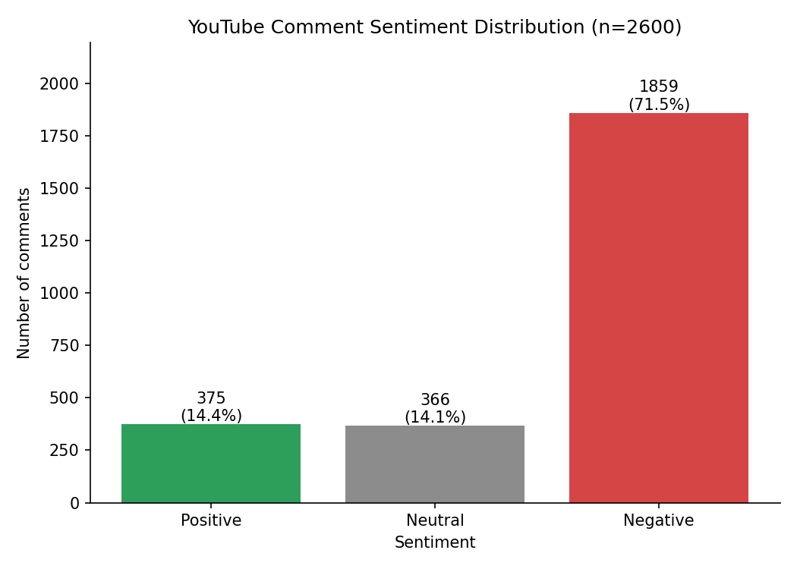
Figure 1: Sentiment distribution of 2,600 comments

7.2 Score distribution
The histogram shows the final score of every comment, coloured by label. The dashed lines mark the +/-0.15 thresholds. The tall bar near -0.6 is expected: the boycott and sarcasm rules set a minimum negative score of -0.6 for matching comments, so many comments land on that value. It is a property of the rules, not a natural cluster in the data.
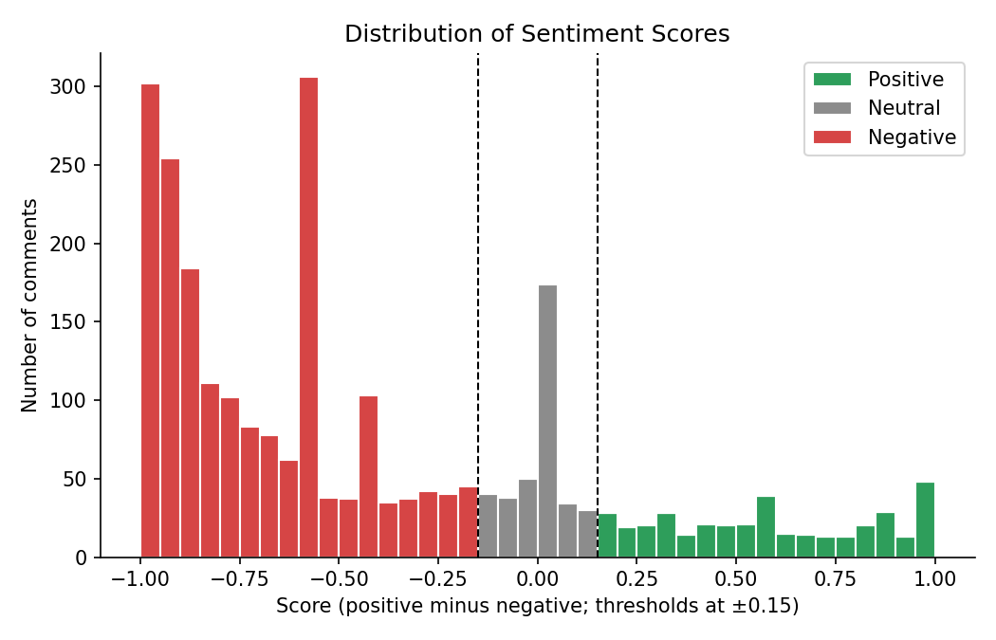
Figure 2: Distribution of sentiment scores

7.3 Comment length
Negative comments are longer than the others. The mean length is 17.9 words for Negative, 12.9 for Positive and 11.4 for Neutral. Viewers who disagree with the video tend to explain their reasons, while Neutral comments are often short memes, timestamps or questions.
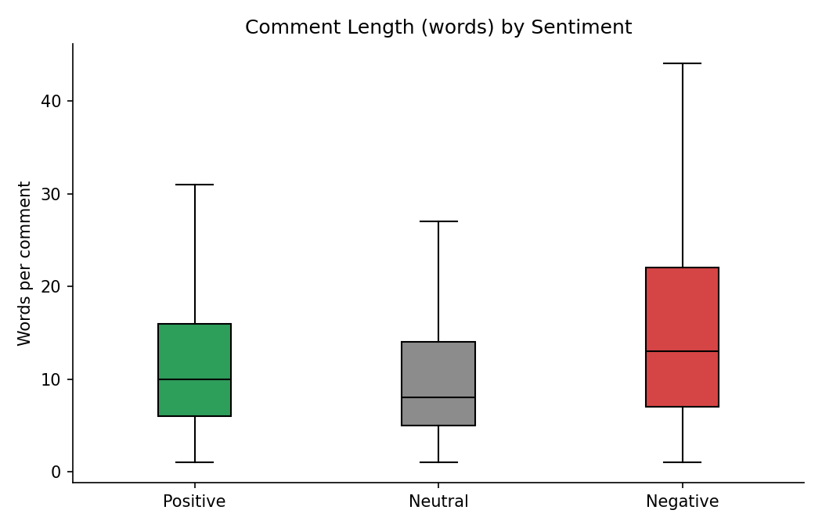
Figure 3: Comment length (words) by sentiment

7.4 Comments over time
The chart groups comments by quarter because the data spans several years. Most quarters are dominated by Negative comments. Comment volume peaks in the second quarter of 2023 and again in late 2025, and the Negative share stays high throughout.
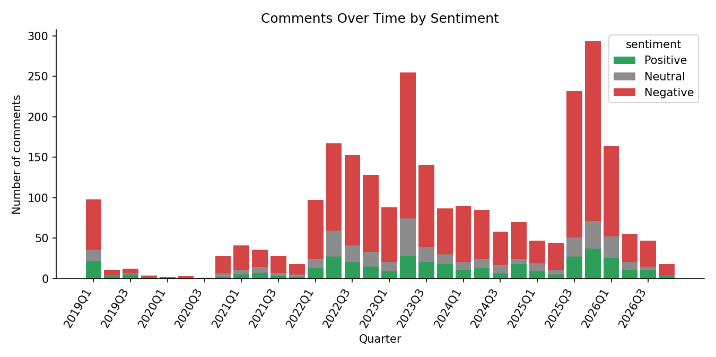
Figure 4: Comments over time by sentiment

7.5 Distinctive words
Instead of raw word counts, the chart ranks words by how much more often they appear in one sentiment class than in the whole dataset (count multiplied by log-lift). Words shared by all classes, English and Roman Urdu stopwords, and optional brand words given with --stopwords are removed.
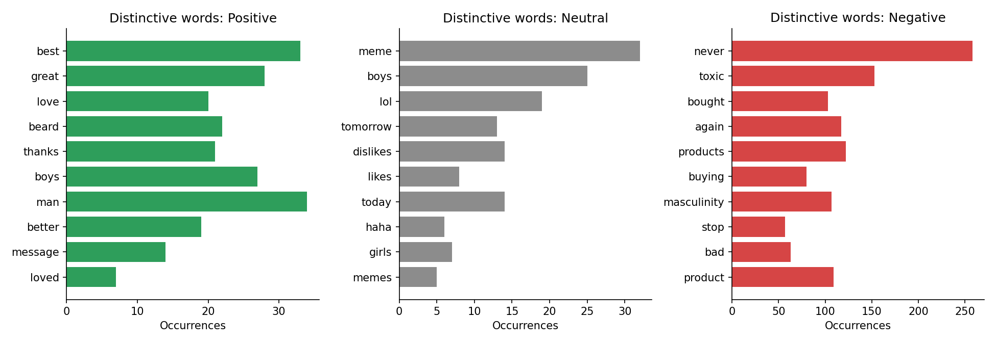
Figure 5: Distinctive words per sentiment
Sentiment | Distinctive words (count)
Positive | best (33), great (28), love (20), beard (22), thanks (21), boys (27), man (34), better (19), message (14), loved (7)
Neutral | meme (32), boys (25), lol (19), tomorrow (13), dislikes (14), likes (8), today (14), haha (6), girls (7), memes (5)
Negative | never (258), toxic (153), bought (103), again (117), products (122), buying (80), masculinity (107), stop (57), bad (63), product (109)

The Negative words (never, bought, again, buying, stop, products) show that many viewers talk about boycotting and no longer buying the product. Neutral words show memes, laughter and discussion of likes and dislikes.

7.6 Other statistics
Statistic | Value
Mean words per comment | 16.3 (median 12)
Mean likes per comment | 62.8 (median 4)
Most liked comment | 10,125 likes
Mean model confidence | 0.722

8. Accuracy Evaluation
Accuracy was not assumed. A stratified sample of 105 comments (35 per predicted label) was exported to review_sample.csv and each comment was labelled by hand as Positive, Neutral or Negative, based on its stance toward the advertisement and brand. The command python main.py --evaluate review_sample_labeled.csv compares these labels with classified_comments.csv by comment ID.
Version | Agreement with manual labels
First version (XLM-RoBERTa and lexicon, no stance rules) | 48%
With stance rules | about 69%
With stance rules and competitor rule | about 72%

Important note: the manual labels were created by the project author, and the rules were tuned while looking at the same 105 comments, so the 72% figure is likely optimistic. A fair estimate for the local engine on new comments is roughly 65% to 70%. The result is acceptable for exploratory analysis, but it is not above 80%.

8.1 Typical errors
- Sarcastic praise, for example thanking the brand for something that actually hurt it, can still be labelled Positive.
- The Positive class is the weakest, because many apparently positive comments are really mocking the video.
- Neutral comments with an implied stance, for example mentioning a competitor product, can be missed.

9. Limitations
- All results in this report come from one video, so they describe reaction to one advertisement and should not be generalised.
- The YouTube API returns top-level comments only. Replies are not included.
- The accuracy estimate is based on 105 comments labelled by one person.
- The stance rules and the competitor list were written for a brand-backlash thread and need to be edited for other brands.
- Chart labels in Urdu and Hindi script may not render with Arabic-style joining in matplotlib.
- The first run of the XLM-RoBERTa model downloads about 1 GB.

10. How to Run

10.1 Setup
pip install -r requirements.txt

# create a file named .env in the project folder
YOUTUBE_API_KEY=your_youtube_key
ANTHROPIC_API_KEY=your_key # only for --engine claude

10.2 Step 1: collect comments
python fetch.py --videos URL1 URL2 --max-comments 1500
The comments are saved to output/raw_comments.csv. Run the command again with other videos to add more comments without duplicates.

10.3 Step 2: analyse sentiment
python main.py --input output/raw_comments.csv --stopwords brandname razor

# best accuracy for sarcasm (needs ANTHROPIC_API_KEY)
python main.py --engine claude --target "the brand advertisement"

10.4 Step 3: measure accuracy
python main.py --evaluate review_sample_labeled.csv

10.5 Other options
Option | Meaning
--input | Comments CSV to analyse (default output/raw_comments.csv)
--engine | xlmr (default), vader or claude
--target | What the sentiment is about (used by the claude engine)
--no-rules | Turn off the stance rules
--stopwords | Words to hide from the word charts
--output-dir | Folder for results (default output)
--demo | Use synthetic comments, no API key needed
python -m pytest tests | Run the automated tests

11. Output Files
File | Content
raw_comments.csv | All fetched comments
classified_comments.csv | Cleaned comments with sentiment, score and confidence
spam_comments.csv | Comments removed as spam
review_sample.csv | Stratified sample for manual labelling
sentiment_distribution.png | Bar chart of the three classes
eda_score_histogram.png | Score histogram with thresholds
eda_length_by_sentiment.png | Box plot of comment length
eda_sentiment_over_time.png | Stacked bars per time period
eda_top_words.png | Distinctive words per class
eda_summary.txt and eda_*.csv | Summary statistics tables

12. Future Improvements
- Collect comments from several videos and compare sentiment between brands.
- Label 300 or more comments, split them into tuning and test sets, and report accuracy on the untouched test set.
- Fine-tune a multilingual model on labelled Roman Urdu data.
- Run the Claude engine on the full dataset and compare it with the local engine using the same labels.
- Include replies and analyse the like count as a measure of how much a comment is supported.

13. Conclusion
The project collects more than 2,000 YouTube comments, separates collection from analysis, removes spam, supports English and Roman Urdu text, and produces a complete set of EDA outputs. The analysis shows that 71.5% of the 2,600 analysed comments are negative toward the advertisement, 14.4% are positive and 14.1% are neutral. The local engine reaches an estimated 65% to 72% agreement with manual labels, and the optional Claude engine is provided for higher accuracy on sarcasm. The accuracy limits are reported openly, together with the tools to measure them again on new data.

