dateOfLastData "yyyy-MM-dd HH:mm:ss or yyyy.MM.dd HH:mm:ss"
设备最后返回保存数据的时间，第一次没有传null或者空“”
<string-array name="item_options">
<item>设置/获取设备时间</item> <item>Set/Get Device Time</item>
<item>基础信息</item> Basic Information
<item>恢复出厂设置</item> Restore factory settings
<item>电池电量</item> Battery level
<item>获取设备Mac</item> Get device Mac
<item>设备版本</item> Device version
<item>重置MCU</item> Reset MCU
<item>实时计步</item> Real time step counting
<item>自动区间</item> Automatic interval
<item>获得计步总数据</item> Obtain total step count data
<item>获得步数详细数据</item> Obtain detailed data on the number of steps
<item>睡眠数据</item> Sleep data
<item>心率历史数据</item> Historical heart rate data
<item>静态心率历史数据</item> Static heart rate historical data
<item>Hrv数据</item> Hrv data
<item>温度数据</item> Temperature data
<item>设备自动\n测试血氧数据</item> Obtain automatic measurement\n of blood oxygen data
<item>运动模式</item>sports mode
<item>设备名</item>device name
<item>运动历史</item> Get exercise data
<item>血糖</item> blood sugar
<item>Log</item>
</string-array>

updata: v6.0
0x66 加入设备返回的最后时间戳
0x78 与iOS统一方法名以及字段

- sdk使用说明（operation instructions）：
数据解析流程：Bluetooth 4.0 + byte [] data receiving - > Data Processing - > data return
蓝牙4.0+的 byte[]数据接收->数据处理->数据返回

蓝牙系统onCharacteristicChanged（）方法中接收数据->广播发送数据到BaseActivity->SDK处理数据->dataCallback()返回数据
Receive data in oncharacteristicchanged() method of Bluetooth system - > broadcast and send data to baseactivity - > SDK process data - > datacallback() return data

1：Receive data in oncharacteristicchanged() method of Bluetooth system
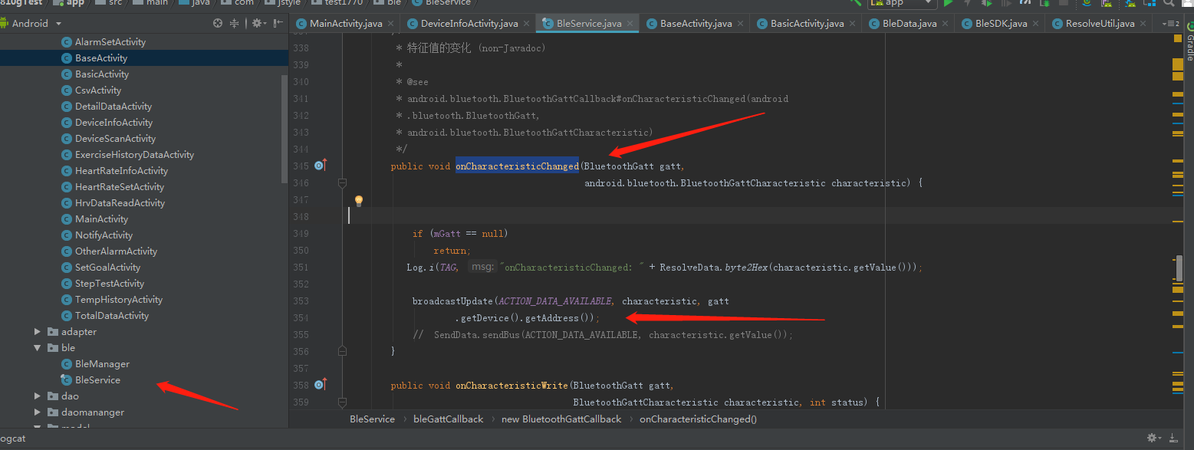
2：broadcast and send data to baseactivity
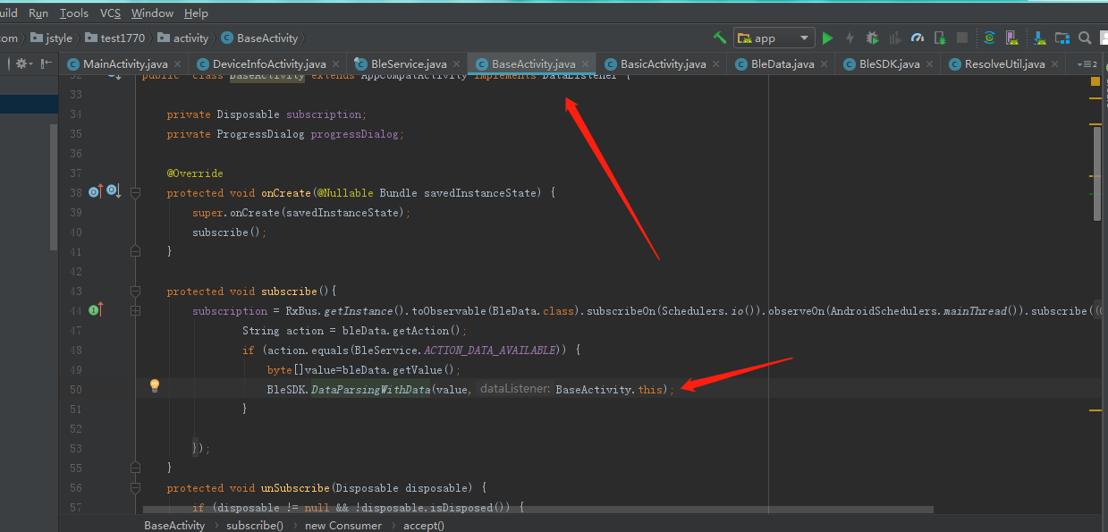

3：SDK process data - > datacallback() return data

Activity implements DataListener{}

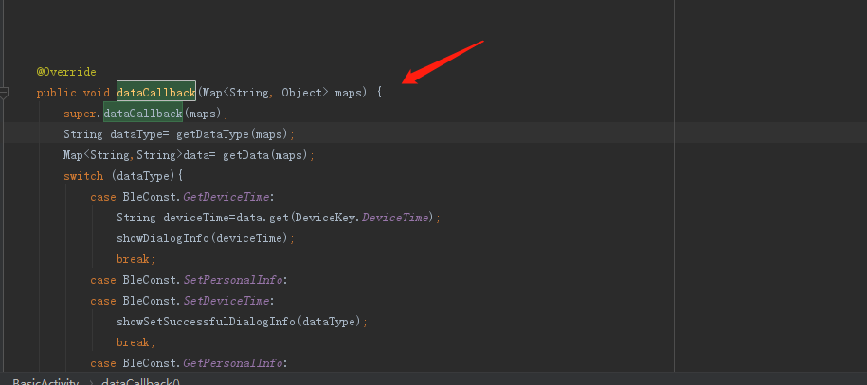

详细接口信息（Detailed interface information）

0： 设置时间（BLE Data Format）
Bluetooth instruction head | 0x01
Usage method | BleSDK.SetDeviceTime(MyDeviceTime )
Parameter | Calendar calendar=Calendar.getInstance();  int year=calendar.get(Calendar.YEAR);  int month=calendar.get(Calendar.MONTH)+1;  int day=calendar.get(Calendar.DAY_OF_MONTH);  int hour=calendar.get(Calendar.HOUR_OF_DAY);  int min=calendar.get(Calendar.MINUTE);  int second=calendar.get(Calendar.SECOND);  MyDeviceTime setTime=new MyDeviceTime();  setTime.setYear(year);  setTime.setMonth(month);  setTime.setDay(day);  setTime.setHour(hour);  setTime.setMinute(min);  setTime.setSecond(second);  sendValue(BleSDK.SetDeviceTime(setTime));
Data returned | {dataType=0, //Current 1th directive  dicData={},  dataEnd=true //End of data ( true or false)  }

1： 获取时间（Get device time）
Bluetooth instruction head | 0x41
Usage method | BleSDK.GetDeviceTime()
Data returned | {dataEnd=true,  dataType=1, dicData={  strDeviceTime=20-04-26 14:41:49,  GPSTime=00.00.00}}

2： 设置用户个人信息（Set user profile）
Bluetooth instruction head | 0x02
Usage method | BleSDK.SetPersonalInfo(MyPersonalInfo)
Parameter | MyPersonalInfo setPersonalInfo=new MyPersonalInfo();  setPersonalInfo.setAge(age);//1-220  setPersonalInfo.setHeight(height);  setPersonalInfo.setWeight(weight);  setPersonalInfo.setStepLength(stepLength);//step length  setPersonalInfo.setSex(gender); //Male 1, female 0  sendValue(BleSDK.SetPersonalInfo(setPersonalInfo));
Data returned | {dataEnd=true, dataType=3, dicData={}}

3： 获取用户个人信息（Get user's personal information）
Bluetooth instruction head | 0x42
Usage method | BleSDK.GetPersonalInfo()
parameter
Data returned | {dataEnd=true, dataType=2, dicData=  {MyStride=13,//step length  MyAge=30,  MyWeight=120,  MyGender=0,  MyHeight=38  }}

6： 设置设备的mac地址（Set the MAC address of the device）
Bluetooth instruction head | 0x05
Usage method | BleSDK.SetDeviceName(name)  name aabbccddffee
Data returned | {DataType=6,  Data=,  dataEnd=true}

9： 读取设备电量（Read device power）
Bluetooth instruction head | 0x13
Usage method | BleSDK.GetDeviceBatteryLevel()
Data returned | {dataType=9, dicData={batteryLevel=10  }, dataEnd=true}

10： 读取MAC地址（Read MAC address）
Bluetooth instruction head | 0x22
Usage method | BleSDK.GetDeviceMacAddress()
Data returned | {dataEnd=true, dataType=10, dicData={macAddress=FE:53:8C:0D:73:FB}}

11： 读取软件版本号（Read software version number）
Bluetooth instruction head | 0x27
Usage method | BleSDK.GetDeviceVersion()
Data returned | {dataType=11, dicData={deviceVersion=0.3.2.1}, dataEnd=true}

12： 恢复出厂设置（Restore factory settings）
Bluetooth instruction head | 0x12
Usage method | BleSDK.Reset()
Data returned | {dataType=12, dataEnd=true}

13： MCU软复位指令（MCU soft reset command）
Bluetooth instruction head | 0x2E
Usage method | BleSDK.MCUReset()
Data returned | {dataType=13, dataEnd=true}

16： 读取自动检测时段（Read auto detect heart rate period）
Bluetooth instruction head | 0x2B
Usage method | BleSDK.GetAutomatic(AutoMode type)
Data returned | {dataType=17, dicData={  heartStartMinter=00,  workModel=2, //0 ,1, 2 One of the three models  heartEndHour=23,  heartEndMinter=59,  heartStartHour=00,  workTime=5,//Indicates how many minutes to prompt  weekValue=1-1-1-1-1-1-1},  //Bit1 = 0 means Monday is not enabled, Bit1 = 1 means Monday is enabled.  Bit2 = 0 means Tuesday is not enabled, bit2 = 1 means Tuesday is enabled.  Bit3 = 0 means Wednesday is not enabled, bit3 = 1 means Wednesday is enabled.  Bit4 = 0 means Thursday is not enabled, bit4 = 1 means Thursday is enabled.  Bit5 = 0 means Friday is not enabled, bit5 = 1 means Friday is enabled.  Bit6 = 0 means Saturday is not enabled, bit6 = 1 means Saturday is enabled.  Bit7 = 0 means Sunday is not enabled, bit7 = 1 means Sunday is enabled.  dataEnd=true}

17： 设置自动检测时段（Set automatic heart rate detection period）
Bluetooth instruction head | 0x2A
Usage method | sendValue(BleSDK.SetAutomaticHRMonitoring(MyAutomaticHRMonitoring ,autoMode));  AutoMode :AutoHeartRate, AutoSpo2,AutoTemp,AutoHrv
Data returned | {dataType=17, dicData={}, dataEnd=true}
public class MyAutomaticHRMonitoring extends SendData{
int open;//1 开启整个时间段都测量 2时间段内间隔测量 0关闭
// 1. Enable measurement throughout the entire time period 2. Measure intervals within the time period 0. Close
int startHour;//开始小时 Starting hours
int startMinute;//开始分钟 Start minute
int endHour;//结束小时 End Hour
int endMinute;//结束分钟 End minute
int week;//星期一到星期日 开启选择 Monday to Sunday open selection
int time;//多少时间测试一次，单位是分钟。 How many times does it take to test, in minutes.

23：开始实时计步（Start real time step ）
Bluetooth instruction head | 0x09
Usage method | BleSDK.RealTimeStep(boolean enable,boolean tempEnable )
Parameter | enable //True turns counting on, false turns counting off  tempEnable //True opening temperature, false closing temperature
Data returned | {dataType=19, dicData={  heartRate=89,//Heart rate  distance=0.12, //distance  step=193, //Step number  ExerciseTime=0,  calories=11.3,  exerciseMinutes=1,  }, dataEnd=true}

24： 获得计步总数据(Get step total data）
Bluetooth instruction head | 0x51
Usage method | GetTotalActivityDataWithMode(Mode,String dateOfLastData  )  Mode 0: table ⽰ is read from the latest location (up to 50 groups of data) 2: table ⽰ then read (when the total data is ⼤ 50) 0x99: table ⽰ delete all the motion data
Data returned | {dataEnd=false, dataType=24, dicData=[{date=20.04.18, goal=0, distance=0.00, step=0, ExerciseTime=0, calories=0.00, exerciseMinutes=0}, {date=20.04.17, goal=26, distance=1.61, step=2647, ExerciseTime=19, calories=79.64, exerciseMinutes=1339}, {date=20.04.16, goal=0, distance=0.00, step=0, ExerciseTime=0, calories=0.00, exerciseMinutes=0}, {date=20.04.15, goal=46, distance=3.70, step=4689, ExerciseTime=23, calories=244.83, exerciseMinutes=1712}]}  {dataEnd=true, dataType=24, dicData=[]}

25： 获得步数详细数据（Get step details）
Bluetooth instruction head | 0x52
Usage method | GetDetailSleepDataWithMode(byte modeString dateOfLastData  )  *0x99: delete step details,  *0: read the latest step details.  *1: read the step details of the specified location.  *2: continue the next segment of data at the last read location
Data returned | {dataEnd=true, dataType=25, dicData=[{date=20.04.15 17:00:53, detailMinterStep=102, distance=0.05, calories=2.77, arraySteps=16 0 18 10 36 0 0 22 0 0}, {date=20.04.15 15:48:24, detailMinterStep=1175, distance=1.08, calories=75.99, arraySteps=196 192 194 193 195 183 22 0 0 0}, {date=20.04.15 15:38:19, detailMinterStep=1931, distance=1.77, calories=124.93, arraySteps=183 196 195 196 192 196 194 194 192 193}]}

26： 获得睡眠详细数据（Get sleep details）
Bluetooth instruction head | 0x53
Usage method | GetDetailSleepDataWithMode(byte modeString dateOfLastData)  *0x99: delete step details,  *0: read the latest step details.  *1: read the step details of the specified location.  *2: continue the next segment of data at the last read location  dateOfLastData: yyyy-MM-dd HH:mm:ss or yyyy.MM.dd HH:mm:ss
Data returned | {dataEnd=false, dataType=26, dicData=[{  date=2021-10-21 14:00:02,  sleepUnitLength=1, //1 for 1 minute sleep, 5 for 5 minutes sleep  arraySleepQuality=39 2 2 2 2 2 2 2 2 2 2 2 3 2 2 2 2 2 2 2 2 2 2 2 2 2 2 2 2 2 1 1 1 1 1 1 1 1 1 2 2 2 2 2 2 2 2 2 2 2 2 }]}  {DataType=26, Data=[], DataEnd=true}  DataEnd=true数据已经同步完成

27： 获得心率数据（Get heart rate data）
Bluetooth instruction head | 0x54
Usage method | GetDynamicHRWithMode(byte Number,String dateOfLastData  )  Number  0x99: delete all heart rate data,  0: read the latest heart rate data.  1: Read the heart rate data at the specified location.  2: Continue the next segment of data at the last read location.
Data returned | {dataEnd=false, dataType=27, dicData=[{date=20.04.15 19:19:59, arrayDynamicHR=84 89 94 86 86 87 89 87 86 87 90 83 81 81 80}, {date=20.04.15 18:27:59, arrayDynamicHR=75 77 0 0 0 0 0 0 0 0 0 0 0 0 0}, {date=20.04.15 17:15:59, arrayDynamicHR=78 75 79 0 0 0 0 0 0 0 0 0 0 0 0}, {date=20.04.15 16:52:59, arrayDynamicHR=79 80 85 85 81 90 83 77 79 80 74 72 75 76 81}, {date=20.04.15 16:09:59, arrayDynamicHR=70 72 0 0 0 0 0 0 0 0 0 0 0 0 0}]}  {dataEnd=true, dataType=27, dicData=[]}

28： 获得单次心率数据（间隔测试心率）（Obtain single heart rate data (interval test heart rate)
Bluetooth instruction head | 0x55
Usage method | GetStaticHRWithMode(byte mode,String dateOfLastData  )  )  mode  0x99: delete all single heart rate data,  0: read the latest single heart rate data.  1: Read the single heart rate data at the specified location.  2: Continue the next segment of data at the last read location
Data returned | {dataEnd=false, dataType=28, dicData=[{date=20.04.15 17:20:30, onceHeartValue=108}, {date=20.04.15 17:00:30, onceHeartValue=78}, {date=20.04.15 16:55:30, onceHeartValue=71}, {date=20.04.15 16:50:30, onceHeartValue=80}, {date=20.04.15 16:45:30, onceHeartValue=77}, {date=20.04.15 16:40:30, onceHeartValue=59}, {date=20.04.15 16:30:30, onceHeartValue=70}, {date=20.04.15 16:25:30, onceHeartValue=70}, {date=20.04.15 16:20:30, onceHeartValue=83}, {date=20.04.15 16:15:30, onceHeartValue=64}, {date=20.04.15 16:10:30, onceHeartValue=92}, {date=20.04.15 16:00:30, onceHeartValue=71}]}  {dataEnd=true, dataType=29, dicData=[]}

37： 获得/删除HRV测试数据（Set/Get HRV test data）
Bluetooth instruction head | 0x56
Usage method | GetHRVDataWithMode(byte mode, String dateOfLastData)  0x99: delete all motion data,  1: Read the movement data of the specified position.  2: Continue the next segment of data at the last read location
Data returned | {DataType=37, Data=[{hrvBloodValue=0, historyDate=20.04.10 09:10:30, heartValue=0, HighPressure=0, hrvValue=63, KHrvBreathRate=89, LowPressure=0, KHrvMoodValue=86, hrvTired=53}, {hrvBloodValue=55, historyDate=10.09.05 30:41:00, heartValue=0, HighPressure=86, hrvValue=0, KHrvBreathRate=32, LowPressure=90, KHrvMoodValue=0, hrvTired=0}, {hrvBloodValue=0, historyDate=00.30.6c 00:00:3a, heartValue=86, HighPressure=0, hrvValue=0, KHrvBreathRate=16, LowPressure=32, KHrvMoodValue=4, hrvTired=91}, {hrvBloodValue=92, historyDate=33.00.00 43:00:00, heartValue=0, HighPressure=4, hrvValue=86, KHrvBreathRate=80, LowPressure=16, KHrvMoodValue=8, hrvTired=32}, {hrvBloodValue=32, historyDate=00.3f.00 00:56:5d, heartValue=4, HighPressure=8, hrvValue=0, KHrvBreathRate=138, LowPressure=69, KHrvMoodValue=48, hrvTired=16}, {hrvBloodValue=16, historyDate=00.00.56 5e:00:20, heartValue=8, HighPressure=48, hrvValue=4, KHrvBreathRate=0, LowPressure=65, KHrvMoodValue=0, hrvTired=64}, {hrvBloodValue=9, historyDate=56.5f.00 20:03:28, heartValue=89, HighPressure=0, hrvValue=8, KHrvBreathRate=0, LowPressure=0, KHrvMoodValue=69, hrvTired=66}], DataEnd=false}  {DataType=37, Data=[{hrvBloodValue=0, historyDate=20.03.23 19:49:59, heartValue=0, HighPressure=0, hrvValue=83, KHrvBreathRate=97, LowPressure=0, KHrvMoodValue=86, hrvTired=69}, {hrvBloodValue=69, historyDate=20.14.59 59:53:00, heartValue=0, HighPressure=86, hrvValue=0, KHrvBreathRate=32, LowPressure=98, KHrvMoodValue=0, hrvTired=0}], DataEnd=true}
deletehrv | {dataEnd=true, dataType=72, dicData=[]}

59：自动测试温度数据（Automatic test temperature data）
Bluetooth instruction head | 0x62
Usage method | sendValue(BleSDK.GetTemperature_historyDataWithMode(mode,String dateOfLastData  )  ));  Mode：  0x99: delete all temperature data,  1: Read the temperature data of the specified position.  2: Continue to read the last location of the next piece of data
Data returned

60：健康测量控制（Health measurement control）
Bluetooth instruction head | 0x28
Usage method | SetDeviceMeasurementWithType(AutoTestMode dataType,long second, boolean open)  AutoTestMode ：AutoHeartRate/ AutoSpo2  Second：最少30秒 30 seconds minimum
Data returned | AutoHeartRate:  {dataEnd=true, dataType=74, dicData={stress=0, Type=2, lowPressure=0, heartRate=0, Blood_oxygen=0, hrv=0, highPressure=0}}  AutoSpo2  {dataEnd=true, dataType=75, dicData={stress=0, Type=3, lowPressure=0, heartRate=0, Blood_oxygen=0, hrv=0, highPressure=0}}

69：获得血氧数据（自动测试）（Obtaining blood oxygen data (automatic test)）
Bluetooth instruction head | 0x66
Usage method | Oxygen_data(byte Number,String dateOfLastData)  0x99: delete all motion data,  0：  1: Read the movement data of the specified position.  2: Continue the next segment of data at the last read location
Data returned | {dataEnd=false, dataType=68, dicData=[{date=2023.09.27 08:30:30, Blood_oxygen=94}, {date=2023.09.27 08:00:30, Blood_oxygen=95}, {date=2023.09.27 07:30:20, Blood_oxygen=100}, {date=2023.09.27 00:30:22, Blood_oxygen=99}, {date=2023.09.27 00:00:26, Blood_oxygen=96}, {date=2023.09.26 23:30:14, Blood_oxygen=99}, {date=2023.09.26 23:00:30, Blood_oxygen=96}, {date=2023.09.26 22:30:22, Blood_oxygen=99}, {date=2023.09.26 21:30:30, Blood_oxygen=94}, {date=2023.09.26 21:00:30, Blood_oxygen=95}, {date=2023.09.26 20:00:30, Blood_oxygen=94}, {date=2023.09.26 19:30:30, Blood_oxygen=95}, {date=2023.09.26 16:00:22, Blood_oxygen=100}, {date=2023.09.26 15:30:16, Blood_oxygen=100}, {date=2023.09.26 10:00:25, Blood_oxygen=100}, {date=2023.09.26 09:30:22, Blood_oxygen=100}, {date=2023.09.26 09:00:30, Blood_oxygen=98}, {date=2023.09.26 08:30:22, Blood_oxygen=100}, {date=2023.09.23 19:30:14, Blood_oxygen=100}, {date=2023.09.23 19:00:30, Blood_oxygen=95}, {date=2023.09.23 18:30:30, Blood_oxygen=96}, {date=2023.09.22 18:00:30, Blood_oxygen=93}, {date=2023.09.22 17:30:22, Blood_oxygen=100}, {date=2023.09.22 17:00:30, Blood_oxygen=100}]}  {dataEnd=true, dataType=68, dicData=[{date=2023.09.22 16:00:30, Blood_oxygen=96}, {date=2023.09.22 15:30:30, Blood_oxygen=93}, {date=2023.09.22 15:00:30, Blood_oxygen=98}, {date=2023.09.22 11:30:27, Blood_oxygen=100}, {date=2023.09.22 10:30:30, Blood_oxygen=93}, {date=2023.09.22 09:30:30, Blood_oxygen=98}, {date=2023.09.22 00:30:17, Blood_oxygen=100}, {date=2023.09.22 00:00:30, Blood_oxygen=93}, {date=2023.09.21 22:00:30, Blood_oxygen=96}, {date=2023.09.21 20:30:30, Blood_oxygen=96}, {date=2023.09.21 20:00:30, Blood_oxygen=95}, {date=2023.09.21 19:30:23, Blood_oxygen=99}, {date=2023.09.21 19:00:19, Blood_oxygen=100}, {date=2023.09.21 18:30:30, Blood_oxygen=98}, {date=2023.09.21 11:30:15, Blood_oxygen=99}, {date=2023.09.21 09:30:17, Blood_oxygen=100}]}  dataEnd=true/false;数据true读取完成，其他是未完成Data true read complete, others incomplete.

30： 运动模式控制开关（Sport mode control switch）
Bluetooth instruction head | 0x19
Usage method | EnterActivityMode(int activityMode, int WorkMode)  activityMode: 1 for start, 4 for end  WorkMode: 0：Run，  1：Cycling  2.Badminton  3.Football  4.Tennis  5.Yoga  6. Meditation  7.Dance  8.Basketball  9、Walk  10、Workout  11、Cricket  12、Hiking  13、 Aerobics  14、Ping-Pong  15、Rope Jump  16、Sit-ups
Data returned | {dataEnd=true, dataType=30, dicData={heartRate=69, step=0, calories=0.0}}
Usage method | 查询当前的运动模式  Query the current sports mode  FindActivityMode()
{dataEnd=true, dataType=120, dicData={Type=1}}

Type=1:开始 ， 2：暂停， 3：继续， 4结束。
1: Start, 2: Pause, 3: Continue, 4: End.

Status=WorkMode

当通过APP打开手环运动模式后，每秒会发送一个心跳数据包给手环。
命令格式： 0x17 D1 D2 D3 D4 MM SS GG 00 00 00 00 00 00 00 CRC
D1 D2 D3 D4:距离，浮点数。单位是KM。
MM SS：配速度，MM:分钟，SS秒钟。最小配速是255分59秒
When you open the bracelet movement mode through app, a heartbeat packet will be sent to the bracelet every second.
Command format: 0x17 D1 D2 D3 D4 mm SS GG 00 00 00 00 00 CRC
D1 D2 D3 D4: distance, floating point. The unit is km.

Mm SS: speed, mm: minute, SS second. The minimum speed is 255 minutes and 59 seconds

sendHeartPackage(float distance, int space, int rssi)

Distance:km
Space:Space represents the pace in the phone
Rssi:RSSI stands for satellite in mobile phone

31： 读取蓝牙设备名称（Read Bluetooth device name）
Bluetooth instruction head | 0x3d
Usage method | SetDeviceName(String strDeviceName)
Data returned | {dataEnd=true, dataType=116, dicData={}}

32： 读取蓝牙设备名称（Read Bluetooth device name）
Bluetooth instruction head | 0x3E
Usage method | BleSDK.GetDeviceName()
Data returned | {{dataEnd=true, dataType=117, dicData={deviceName=6C53}}

：

连接设备状态监听 Connected device status monitoring

BleManager.getInstance().connectDevice(address, true, new BleConnectionListener() {
@Override
public void BleStatus(int status, int newState) {//蓝牙4.0连接状态 Bluetooth 4.0 connection status
Log.e(TAG, "BleStatus: "+status+"***"+newState);
}
@Override
public void ConnectionSucceeded() {//连接设备成功 Successfully connected the device
Log.e(TAG, "ConnectionSucceeded");
}
@Override
public void Connecting() {//设备连接中 Device is connected
Log.e(TAG, "Connecting");
}
@Override
public void ConnectionFailed() {//设备连接失败 Device connection failed
Log.e(TAG, "ConnectionFailed");
}
@Override
public void OnReconnect() {//重新连接中 Reconnecting
Log.e(TAG, "OnReconnect");
}

@Override
public void BluetoothSwitchIsTurnedOff() {//蓝牙开关被关闭 Bluetooth switch is turned off
Log.e(TAG, "BluetoothSwitchIsTurnedOff");
}
});

手机蓝牙开关状态获取Mobile Bluetooth switch status acquisition

protected class ListenerReceiver extends BroadcastReceiver {
@Override
public void onReceive(Context context, Intent intent) {
if (Objects.requireNonNull(intent.getAction()).equals(BluetoothAdapter.ACTION_STATE_CHANGED)) {
int state = intent.getIntExtra(BluetoothAdapter.EXTRA_STATE, BluetoothAdapter.ERROR);
switch (state) {
case BluetoothAdapter.STATE_ON://Bluetooth on
if (TextUtils.isEmpty(address)) {
Log.i(TAG, "onCreate: address null ");
return;
}
BleManager.getInstance().connectDevice(address,true,null);
break;
case BluetoothAdapter.STATE_OFF://Bluetooth off
if(null!=mainAdapter){
mainAdapter.setEnable(false);
}
if(null!=btConnect){
btConnect.setEnabled(true);}
BleManager.getInstance().disconnectDevice();
break;

}
}
}
}

ADD:

血糖 Blood sugar

主要流程为：1.设备定时五分钟收集设备返回的ppg数据->数据上传到服务器后，服务按照数据给出结果。
The main process is as follows: 1. The device is scheduled to collect PPG data returned by the device for five minutes ->After uploading the data to the server, the server provides results based on the data.

步骤 step：

- 连接设备
- 开始血糖测试。
- 开始计时5分钟
- 计时进度下发给设备
- 关闭ppg/riss信号采集（设备处于等待状态，结果未知）
- 把收集到五分钟的ppg/riss数据等信息上传到服务器。
- 服务其给出结果后向设备发送结果的指令。
- 向设备发送关闭血糖测试指令。

1. Connecting devices
2. Start blood sugar testing.
3. Start timing for 5 minutes
4. Send the timing progress to the equipment
5. Turn off ppg/riss signal acquisition (device in waiting state, unknown result)
6. Upload the collected PPG/RISS data and other information for five minutes to the server.
7. The instruction to send the result to the device after the service provides it.
8. Send the command to turn off the blood glucose test to the device.

/*!
* @method ppgWithMode::
* @param ppgMode 1 表示开启ppg测量 2表示给设备发送测量结果 3表示停止ppg测量 4表示给设备发送ppg测量的进度 5表示退出ppg测量
* @param ppgStatus 当 ppgMode=2或者 ppgMode=4的时候才有效。当ppgMode=2时，0表示测量失败 1 表示测量结果偏低 2表示测量结果正常 3表示测量结果偏高 。 当ppgMode=4时，ppgStatus表示测量的进度值，范围是0-100
* @discussion Turn on ECG measurement 开启ECG测量
*
*/
ppgWithMode:(int)ppgMode ppgStatus:(int)ppgStatus;

使用方法 Usage：
- 开始血糖测量数据收集Start collecting blood glucose measurement data：
BleManager.getInstance().writeValue(BleSDK. ppgWithMode
(1，0));

{dataEnd=true, dataType=118, dicData={Type=0}}

Type=0//设备状态正常，这里可以开启一个五分钟的计时器。 The device status is normal, and a five minute timer can be activated here.
Type=2//电池电量过低，少于10% The battery level is too low, less than 10%
Type=3//在跑步模式，不能开始测试 Unable to start testing in running mode

- 向设备发送计时的进度Send the progress of timing to the device
BleManager.getInstance().writeValue(BleSDK. ppgWithMode (4，int Progress
);
Progress 0-100

- 血糖数据采集返回的数据Blood glucose data collection and return data：
{dataEnd=false, dataType=119, dicData={PPG=[926517, 929883, 930359, 931379, 933963, 934915, 928949, 920568, 915178, 913666, 914158, 914397, 912629, 909840, 907002, 905896, 905964, 905063, 904367, 903346, 901154, 899096, 897345, 895220, 894472, 893946, 893861, 892501, 892058, 891735, 892041, 892467, 892246, 892347, 892619, 892092, 892313, 892228, 892211, 891838, 892348, 892416, 892840, 892738, 892670, 893316, 893503, 893605, 893928, 894234]}}

3.停止ppg/riss数据采集 Stop ppg/riss data collection

BleManager.getInstance().writeValue(BleSDK. ppgWithMode (3，0));

- 发送服务器返回结果给设备Send server return result to device
/**
* 血糖测量结果
* Send blood glucose results to the device
* status 1低 2中 3高 0测试失败
* Status 1 low, 2 moderate, 3 high , 0 test failed
*/
ppgWithMode (2，int status)

- 关闭血糖测试功能Turn off blood glucose testing function

ppgWithMode (5，0)

