DevOps Technical Assessment – Pokémon API Scanner

Scenario 1

Output

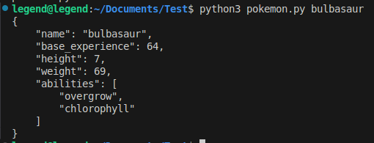
Link:- https://github.com/hatlageomkar/pokemon.git

Scenario 2

Link:- docker pull omkarhatlage17/pokemon-scanner:latest

