Software Design Specification

**Version 1.6**

Group 6 – Sales manager

**MODIFICATION HISTORY**

|  |  |  |  |  |
| --- | --- | --- | --- | --- |
| **Ngày** | **Phiên Bản** | **Mô Tả** | **Tác Giả** | **Sửa Bởi** |
| **10/10/2021** | **1.0** | **Database design** | Ngọc Trường | Ngọc Trường |
|  |  |  |  |  |
|  |  |  |  |  |
|  |  |  |  |  |

**TABLE OF CONTENTS**

# **INTRODUCE**

## **Overview**

* This application makes it easy for users to order the books they need. Suitable for those who like fast and convenient.
* Make it easy for administrators to use and manage.
* Order quickly and conveniently.
* Shiper is easy to handle delivery and delivery.

## **Limit**

* Operating System: Android 7.0
* Test device: Google Pixel 3
* Display: 1080 X 2160
* Only supports vertical screen
* An internet connection is required

# **SYSTEM DESCRIPTION**

1. **General Architectural Description**
   1. **Overview**

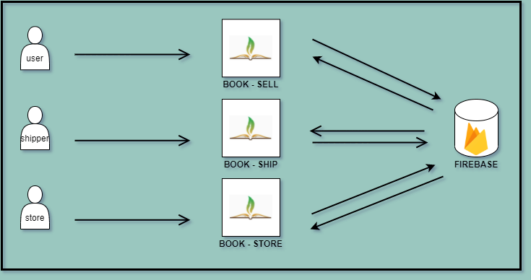

* 1. **Workflow**
* **Customer**

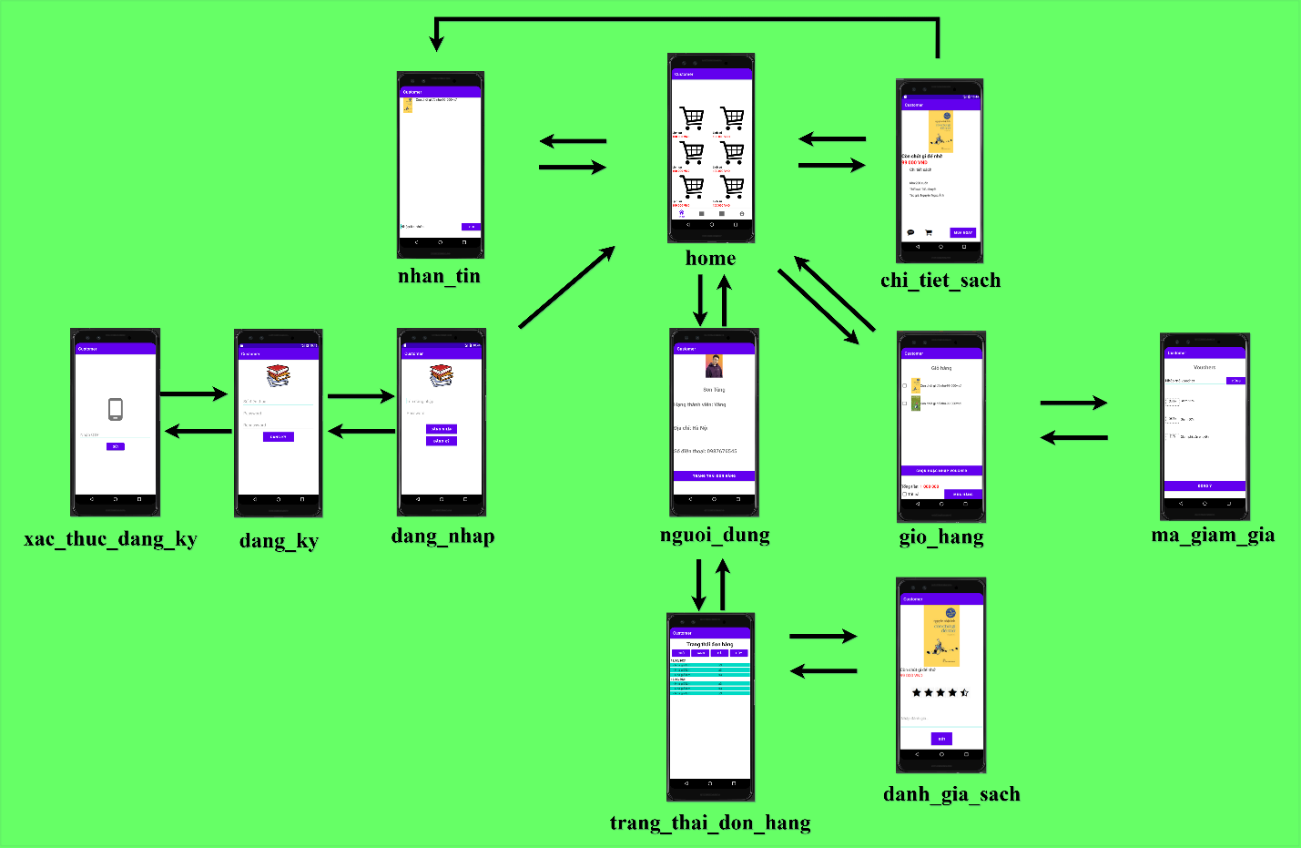

* **Store**
* **Shipper**

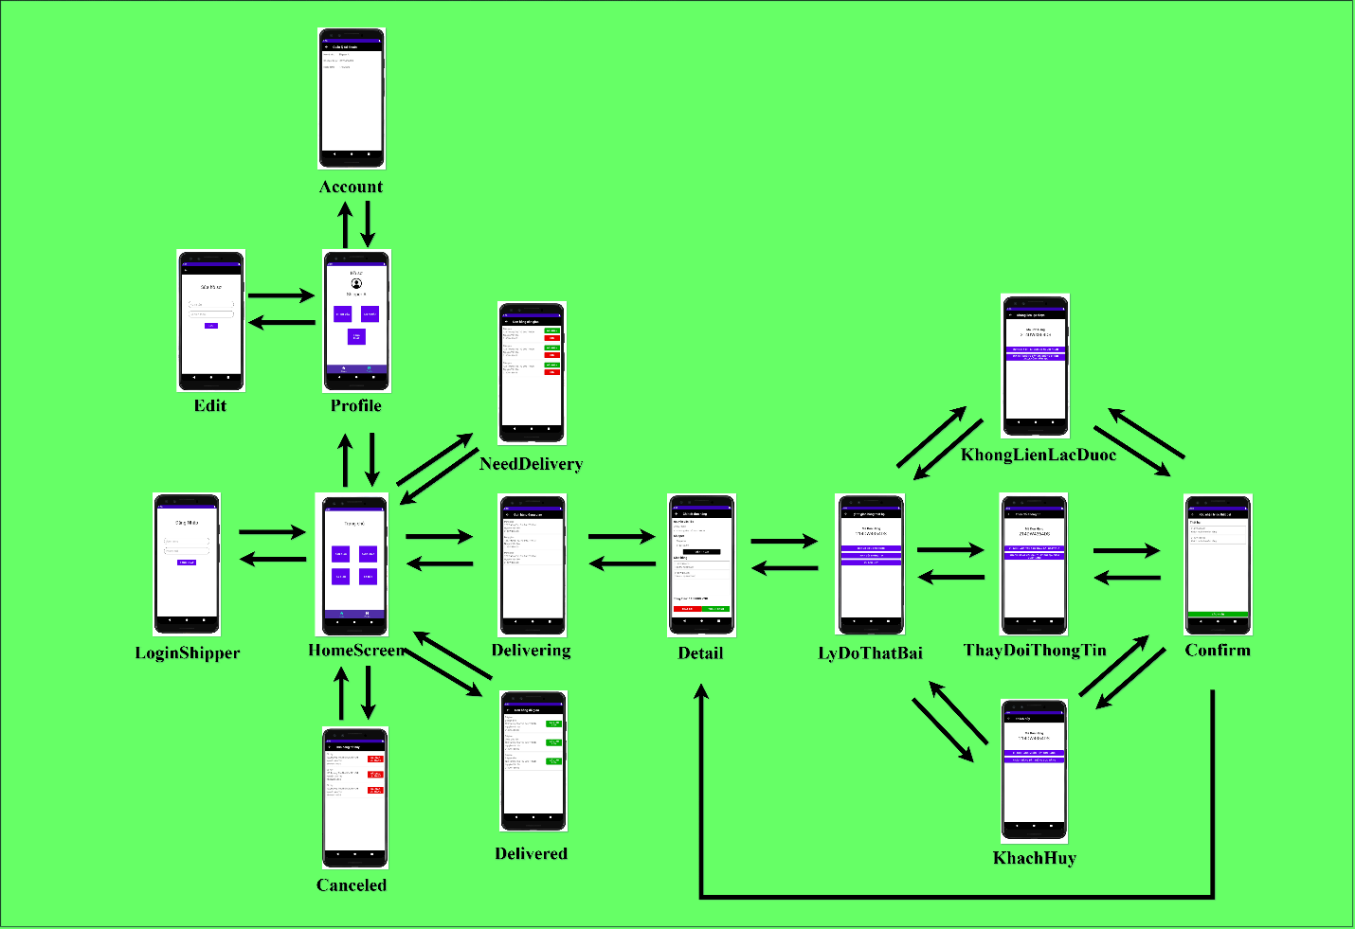

# **SYSTEM FUNCTION DESCRIPTION**

1. **Features / Components: Screen**

* **User interface**
* **Require function**