**Software Requirement Specification**

**Version 1.6**

Group 6 – Sales manager

**MODIFICATION HISTORY**

|  |  |  |  |  |
| --- | --- | --- | --- | --- |
| **Day** | **Version** | **Description** | **Author** | **Edit By** |
| September 22, 2021 | 1.1 | Storekeepers' work screens | Ngoc Truong | Ngoc Truong |
| September 23, 2021 | 1.2 | Screens of shop owners, bill handlers | Ngoc Nam | Ngoc Truong |
| September 24, 2021 | 1.3 | Managers and packers screens | Truong Vu | Ngoc Truong |
| September 27, 2021 | 1.4 | Fix the editor interface | Truong Vu | Ngoc Truong |
| September 27, 2021 | 1.4 | Client screens  + Login  + Sign up  + Main interface  + Details  + Texting | Cong Dang | Quoc Tri |
| September 27, 2021 | 1.5 | Client screens  + Shopping cart  + Purchase  + Voucher  + Customer information  + Status | Quoc Tri | Quoc Tri |
| September 27, 2021 | 1.6 | Screens for shippers | Le Ho | Quoc Tri |
| 04/10/2021 | 1.7 | The functions of the storekeeper | Ngoc Truong | Ngoc Truong |

**GROUP ACTIVITIES LOG**

|  |  |  |  |  |
| --- | --- | --- | --- | --- |
| **Stt** | **First and last name** | **The work has been finished** | **Review team** | **Signature** |
| **1** | **Nguyen Ngoc Truong** | 1. Write mockups, SRS, test cases for the cashier's interface screen | **16.66%** |  |
| **2** | **Tran Ngoc Nam** | 1. Write mockups, SRS, test cases for shop owner and invoice handler interface screens | **16.66%** |  |
| **3** | **Tran Quoc Tri** | 1. Write mockups, SRS, test cases for the user interface screen of purchasing | **16.66%** |  |
| **4** | **Le Ho** | 1. Write mockups, SRS, test cases for the shipper's interface screen | **16.66%** |  |
| **5** | **Nguyen Cong Dang** | 1. Write mockups, SRS, test cases for the user interface screen of purchasing | **16.66%** |  |
| **6** | **Nguyen Phi Truong Vu** | 1. Write mockups, SRSs, test cases for the screen editor and manager interface | **16.66%** |  |

**TABLE OF CONTENTS**

INTRODUCE 6

**1.** **Overview** 6

**2.** **Limit** 6

REQUIRE FUNCTION 7

**1.** **Features / Components: Login Screen** 7

**1.1.** **User interface** 7

**1.2.** **Require function** 7

**2.** **Features / Components: Home Screen** 10

**2.1.** **User interface** 10

**2.2.** **Require function** 10

**3.** **Features / Components: Orders to be delivered** 11

**3.1.** **User interface** 11

**3.2.** **Require function** 12

**4.** **Features / Components: Orders Being Delivered Screen** 14

**4.1.** **User interface** 14

**4.2.** **Require function** 14

**5.** **Features / Components: Order Details Screen** 15

**5.1.** **User interface** 15

**5.2.** **Require function** 15

**6.** **Features / Components: Delivered Order Screen** 18

**6.1.** **User interface** 18

**6.2.** **Require function** 18

**7.** **Features / Components: Canceled Order Screen** 20

**7.1.** **User interface** 20

**7.2.** **Require function** 20

**8.** **Features / Components: Profile Screen** 22

**8.1.** **User interface** 22

**8.2.** **Require function** 22

**9.** **Features / Components: Account Management Screen** 24

**9.1.** **User interface** 24

**9.2.** **Require function** 24

**10.** **Features / Components: Edit Profile Screen** 26

**10.1.** **User interface** 26

**10.2.** **Require function** 26

**11.** **Features / Components: Forgot Password Screen** 28

**11.1.** **User interface** 28

**11.2.** **Require function** 28

**12.** **Features / Components: Change Password Screen** 30

**12.1.** **User interface** 30

**12.2.** **Require function** 30

# INTRODUCE

## **Overview**

**•**                   This application makes it easy for users to order the books they need. Suitable for those who like fast and convenient.

**•**                   Make it easy for administrators to use and manage.

**•**                   Order quickly and conveniently.

**•**                   Shiper is easy to handle delivery and delivery.

## **Limit**

●     Operating System: Android 7.0

●     Test device: Google Pixel 3

●     Display: 1080 X 2160

●     Only supports vertical screen

●     An internet connection is required

# REQUIRE FUNCTION

## **Features / Components: Login Screen**

### **User interface**

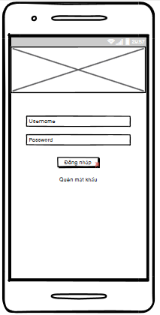

### **Require function**

|  |  |  |  |
| --- | --- | --- | --- |
| **Item** | **Description** | **Behavior** | **Response** |
| **Login Screen** | The login screen includes:  -         “username” edittext  -         “password” edittext  -        “login” button  -          “Forgot password” textview  - “Image” ImageView | N/A | N/A |
| **“Username” edittext** | Enter Username | Tap on | Display the keyboard and the user can input |
| **“Password” edittext** | Enter Password | Tap on | Display the keyboard and the user can input and show password as * |
| **“Forgot password” textview** | If the user forgot the password, tap Forgot Password | Tap on | Go to Forgot Password Screen |
| **“Login” button** | If Username and Password exist correctly in the database, it will go to the Home screen | Tap on | Go to Home Screen |
| If the Username and Password do not exist correctly in the database, a dialog box will be displayed with the content “Invalid Username or Password” and “Close” button. | Tap on | A pop up is showed |
| “Close” button closes a pop up | Tap on | Pop up is closed |
| “Image” ImageView | Show image on the login screen | N/A | N/A |

## **Features / Components: Home Screen**

### **User interface**

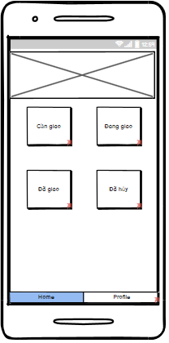

### **Require function**

|  |  |  |  |
| --- | --- | --- | --- |
| **Item** | **Description** | **Behavior** | **Response** |
| **Home Screen** | The Home screen includes:  -        “Need Delivery” button  -        “Delivering” button  -        “Delivered” button  -        “Canceled” button  -        “Home” tab  -        “Profile” tab  -        “Image” ViewFlipper | N/A | N/A |
| **“Need delivery” button** | “Need delivery” button go to the Orders to be delivered screen | Tap on | Go to the Orders to be delivered screen |
| **“Delivering” button** | “Delivering” button go to the Orders being delivered screen | Tap on | Go to the Orders being delivered screen |
| **“Delivered” button** | “Delivered” button go to the Delivered Orders screen | Tap on | Go to the Delivered Orders screen |
| **“Canceled” button** | “Cancelled” button go to Canceled Order screen | Tap on | Go to the Canceled Orders screen |
| **“Profile” tab** | “Profile” tab go to the profile screen | Tap on | Go to the profile screen |
| **“Home” tab** | “Home” tab go to the home screen | Tap on | Go to the home screen |
| **“Image” ViewFlipper** | Used to move images | N/A | N/A |

## **Features / Components: Orders to be delivered**

### **User interface**

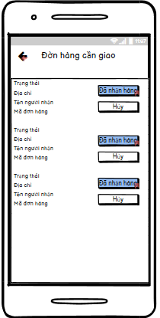

### **Require function**

|  |  |  |  |
| --- | --- | --- | --- |
| **Item** | **Description** | **Behavior** | **Response** |
| **"Order to be delivered" screen** | The "Order to be delivered" screen includes:  -        “icon arrow-left” button  -          Listview | N/A | N/A |
| **“icon arrow-left” button** | Back to the Home screen | Tap on | Back to the Home screen |
| **“Order to be delivered” listview** | Display order information to be delivered including:   * Status * Address * Recipient's name * Code orders * “Cancel” button * “Received” button | Tap on “Received” button | Go to the Orders being delivered screen.  The order will be removed from the list and The order goes to the Orders being delivered screen |
| Tap on “Cancel” button | Confirm that the Shipper is busy and the order will be removed from the list |

## **Features / Components: Orders Being Delivered Screen**

### **User interface**

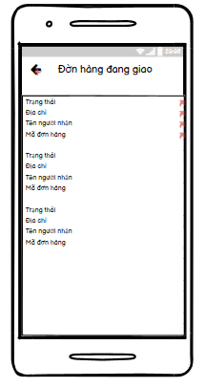

### **Require function**

|  |  |  |  |
| --- | --- | --- | --- |
| **Item** | **Description** | **Behavior** | **Response** |
| **Orders Being Delivered Screen** | The Orders being delivered screen includes:  -        “icon arrow-left” button  -        Listview | N/A | N/A |
| **“icon arrow-left” button** | Back to the Home screen | Tap on “Arrow-left” | Back to the Home screen |
| **'Orders being delivered' listview** | Display information about orders being delivered, including: “  -        Status  -        Address  -        Recipient's name  -        Code orders  " | N/A | N/A |
| Tap on an item will go to the Order Details screen | Tap on | Go to the Order Details screen |

## **Features / Components: Order Details Screen**

### **User interface**

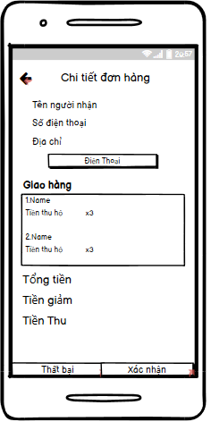

### **Require function**

|  |  |  |  |
| --- | --- | --- | --- |
| **Item** | **Description** | **Behavior** | **Response** |
| **Order Details screen** | The Order Details screen includes:  -        “icon arrow-left” button  -        “Recipient Name” label  -        “Phone number” label  -        “Address” label  -        “Phone” button  -        Listview  -        “Confirm” button  -        “Fail” button  - “Discount” label  - “Proceeds” label  -        “Delivery” textview  -    “Total amount” label | N/A | N/A |
| **“icon arrow-left” button** | Back to the Orders being delivered screen | Tap on | Back to the Orders being delivered screen |
| **“Recipient Name” label** | Display “recipient name” on the screen | N/A | N/A |
| **“Phone number” label** | Display “phone number” on the screen | N/A | N/A |
| **“Address” label** | Display “address” on the screen | N/A | N/A |
| **“Discount” label** | Show discount amount on the screen | N/A | N/A |
| **“Proceeds” label** | Proceeds = Total amount – Discount and show proceeds on screen | N/A | N/A |
| **“Phone” button** | Exit the app and show the phone number on the phone app | Tap on “Phone” | Exit the app and open the phone app |
| **“Delivery” listview** | Display the list of orders of the recipient including:  -        Name Product  -    Proceeds  - Quantity | N/A | N/A |
| **“Total amount” label** | Display the total amount of the orders of each recipient | N/A | N/A |
| **“Confirm” button** | The order is in transit, it has been delivered and it will go to the delivered order screen | Tap on | Go to the Delivered Orders screen |
| **“Fail” button** | Switch to the Failure Reason screen | Tap on | Go to the Failure Reason screen |
| **“Delivery” textview** | Display “Delivery” textview to the screen | N/A | N/A |

## **Features / Components: Delivered Order Screen**

### **User interface**

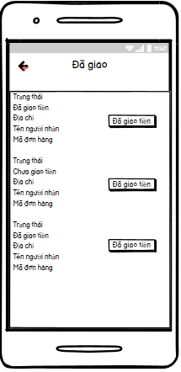

### **Require function**

|  |  |  |  |
| --- | --- | --- | --- |
| **Item** | **Description** | **Behavior** | **Response** |
| **Orders Delivered Screen** | The Delivered Orders screen includes:  -        “icon arrow-left” button  -        Listview | N/A | N/A |
| **“icon arrow-left” button** | Back to the Home screen | Tap on “Arrow-left” | Back to the Home screen |
| **'Order delivered' listview** | Displays information about orders that have been delivered, including the following information:   * Status * Money has/haven't been delivered * Address * Recipient's name * Code orders * Money delivered button | Tap on Money delivered button | Confirm that the Shipper has delivered the money to the store |

## **Features / Components: Canceled Order Screen**

### **User interface**

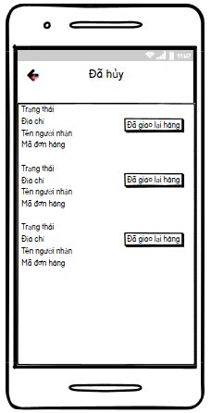s

### **Require function**

|  |  |  |  |
| --- | --- | --- | --- |
| **Item** | **Description** | **Behavior** | **Response** |
| **Canceled Orders screen** | The Canceled Orders screen includes:  -        “icon arrow-left” button  -        Listview | N/A | N/A |
| **“icon arrow-left” button** | Back to the Home screen | Tap on “Arrow-left” | Back to the Home screen |
| **'canceled order ' listview** | Displays information about orders that have been delivered, including the following information:   * Status * Address * Recipient's name * Code orders * redelivered button | Tap on redelivered button | The canceled order confirmation is returned to the store and the order will be deleted upon confirmation |

## **Features / Components: Profile Screen**

### **User interface**

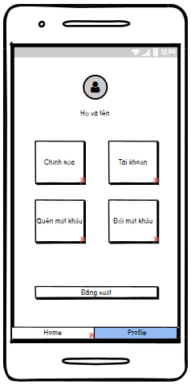

### **Require function**

|  |  |  |  |
| --- | --- | --- | --- |
| **Item** | **Description** | **Behavior** | **Response** |
| **Profile Screen** | The Profile screen includes:  -        “Shipper Name” label  -         “Log Out” button  -        “Edit” button  -        “Avatar” image  -        “Home” tab  -        “Profile” tab  -        “Account” button  -        “ForgotPassword” button  - “ChangePassword” button | N/A | N/A |
| **“Shipper Name” label** | Display “first and last name of shipper” on the screen | N/A | N/A |
| **“Log Out” button** | Tap on“Log Out” the account will exit and go to the Login screen | Tap on | Go to the Login screen |
| **“Avatar” image** | Show Shipper .'s profile photo | N/A | N/A |
| **“Edit” button** | Go to Edit Profile screen | Tap on | Go to Edit Profile screen |
| **“Home” tab** | Go to the Home screen | Tap on | Go to the Home screen |
| **“Profile” tab** | Go to Profile screen | Tap on | Go to Profile screen |
| **“Account” button** | Go to the Account Management screen | Tap on | Go to the Account Management screen |
| **“ForgotPassword” button** | if the email is sent successfully a pop up with message: “email sent successfully” and “Close” button | Tap on | A pop up is showed |
| if the email is sent fail a pop up with message: “Email sent failed” and “Close” button | Tap on | A pop up is showed |
| “Close” button closes a pop up | Tap on | A pop up is close |
| **“ChangePassword” button** | Go to the Change Password screen | Tap on | Go to the Change Password screen |

## **Features / Components: Account Management Screen**

### **User interface**

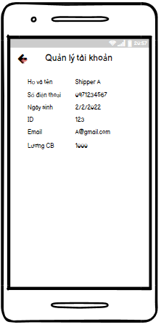

### **Require function**

|  |  |  |  |
| --- | --- | --- | --- |
| **Item** | **Description** | **Behavior** | **Response** |
| **Account Management screen** | The Account Management screen includes:  -        “icon arrow-left” button  -        “Full name” label  -        “Phone number” label  - “ID” label  - “Email” label  - “basic salary” label  -        “Date of Birth” label | N/A | N/A |
| **“Full name” label** | Show first and last name Shipper from database | N/A | N/A |
| **“Phone number” label** | Show Shipper's phone number from database | N/A | N/A |
| **“Date of Birth” label** | Show Shipper's date of birth from database | N/A | N/A |
| **“icon arrow-left” button** | Back to Profile screen | Tap on | Back to Profile screen |
| **“ID” label** | Show ID Shipper from database | N/A | N/A |
| **“Email” label** | Show Email Shipper from database | N/A | N/A |
| **“Basic salary” label** | Show Basic salary Shipper from database | N/A | N/A |

## **Features / Components: Edit Profile Screen**

### **User interface**

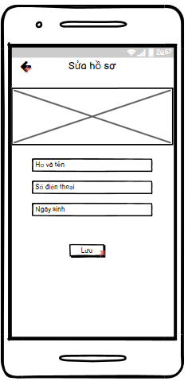

### **Require function**

|  |  |  |  |
| --- | --- | --- | --- |
| **Item** | **Description** | **Behavior** | **Response** |
| **Edit Profile Screen** | The Edit Profile screen includes:  -        “Full name” edittext  -        “Phone number” edittext  -        “Date of Birth” edittext  - “Image” ImageView  -        “Save” button  -        “icon arrow-left” button | N/A | N/A |
| **“Full name” edittext** | Enter Shipper's First and Last Name | Tap on | Display the keyboard and enter the shipper's name |
| **“Phone number” edittext** | Enter Shipper's Phone Number | Tap on | Display the keyboard and enter the shipper's phone number |
| **“Date of Birth” edittext** | Enter Date of Birth | Tap on | Display the keyboard and enter the date of brith |
| **“Save” button** | Used to save the information entered by the user in the edittext, change on database and Go to the Profile screen | Tap on | Go to the Profile screen |
| **“icon arrow-left” button** | Back to Profile screen | Tap on | Back to the Profile screen |
| **“Image” Imageview** | Show image on the Edit screen | N/A | N/A |

## **Features / Components: Forgot Password Screen**

### **User interface**

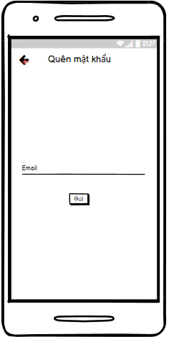

### **Require function**

|  |  |  |  |
| --- | --- | --- | --- |
| **Item** | **Description** | **Behavior** | **Response** |
| **Forgot Password Screen** | The Forgot Password screen includes:  -        “icon arrow-left” button  -         “Send” button  -        “Email” edittext | N/A | N/A |
| **“Send” button** | Used to send to email if email is right, a pop up with a message:" Email sent successfully please check your email" and “Close” button | Tap on | A pop up is showed |
| if email is wrong, a pop up with a message: “Email failed” and “Close” button |
| “Close” button closes pop up | Tap on | A pop up is closed |
| **“Email” edittext** | Enter email of shipper | Tap on | Display the keyboard and enter the email of the shipper |
| **“icon arrow-left” button** | If the user don’t log in then return the Login screen | Tap on | Back to the Login screen |

## **Features / Components: Change Password Screen**

### **User interface**

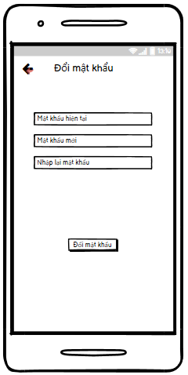

### **Require function**

|  |  |  |  |
| --- | --- | --- | --- |
| **Item** | **Description** | **Behavior** | **Response** |
| **Change Password Screen** | The Change Password screen includes:  -        “icon arrow-left” button  -         “current password” edittext  -        “new password” edittext  - “RePassword” edittext  - “change Password” button | N/A | N/A |
| **“Current Password” edittext** | Enter Current Password | Tap on | Display the keyboard and enter the current password and show CurrentPassword as * |
| **“New Password” edittext** | Enter New Password | Tap on | Display the keyboard and enter the new password and show New Password as * |
| **“RePassword” edittext** | Enter RePassword | Tap on | Display the keyboard and enter the RePassword and show RePassword as * |
| **“ChangePassword” button** | Used to update password | Tap on | A pop up with message: “Change password successfully” and “Close” button |
| **“Icon Arrow-left” button** | Used Back to Profile Screen | Tap on | Back to Profile Screen |