**Software Requirement Specification**

**Version 1.6**

Group 6 – Sales manager

**MODIFICATION HISTORY**

|  |  |  |  |  |
| --- | --- | --- | --- | --- |
| **Day** | **Version** | **Description** | **Author** | **Edit By** |
| 10/10/2021 | 1.1 | make product management interface | Ngoc Truong | Ngoc Truong |
| 10/10/2021 | 1.2 | Make product type management interface | Ngoc Nam | Ngoc Truong |
| 10/10/2021 | 1.3 | Making the interface to manage the type of manufacturer | Truong Vu | Ngoc Truong |
| 10/10/2021 | 1.4 | VIP customer interface | Truong Vu | Ngoc Truong |
| 20/10/2021 | 1.4 | Order management interface | Cong Dang | Quoc Tri |
| 25/10/2021 | 1.5 | Stats interface | Quoc Tri | Quoc Tri |
| 01/10/2021 | 1.6 | Login logout | Le Ho | Quoc Tri |

**GROUP ACTIVITIES LOG**

|  |  |  |  |  |
| --- | --- | --- | --- | --- |
| **Stt** | **First and last name** | **The work has been finished** | **Review team** | **Signature** |
| **1** | **Nguyen Ngoc Truong** | 1. Write mockups, SRS, test cases for the interface screen of product management | **16.7%** |  |
| **2** | **Tran Ngoc Nam** | 1. Write test cases for the interface of customer management | **16.66%** |  |
| **3** | **Tran Quoc Tri** | 1. Write test cases for the product type management screen and statistics | **16.66%** |  |
| **4** | **Le Ho** | 1. Write test cases for screen manufacturers and vip customers | **16.66%** |  |
| **5** | **Nguyen Cong Dang** | 1. Write test cases for the input screen | **16.66%** |  |
| **6** | **Nguyen Phi Truong Vu** | 1. Testcase for order screen and login logout | **16.66%** |  |

**TABLE OF CONTENTS**

**INTRODUCE 7**

**1. Overview 7**

**2. Limit 7**

**REQUIRE FUNCTION 8**

**1. Features / Ingredients: Order Management Screen 8**

**1.1. User interface 8**

**1.2. Require function 8**

**2. Features / Components: Pending Order Screen 9**

**2.1. User interface 9**

**2.2. Require function 10**

**3. Features / Components: Prepared Order Screen 11**

**3.1. User interface 11**

**3.2. Require function 11**

**4. Features / Ingredients: Orders Being Delivered Screen 13**

**4.1. User interface 13**

**4.2. Require function 13**

**5. Features / Ingredients: Delivered Order Screen 14**

**5.1. User interface 14**

**5.2. Require function 15**

**6. Features / Components: User Management Screen 16**

**6.1. User interface 16**

**6.2. Require function 16**

**7. Features / Components: Create User Account Screen 18**

**7.1. User interface 18**

**7.2. Require function 18**

**8. Features / Ingredients: Product Screen 20**

**8.1. User interface 20**

**8.2. Require function 21**

**9. Features / Components: Product Category Screen 23**

**9.1. User interface 23**

**9.2. Require function 23**

**10. Features / Components: Update Customer Screen 25**

**10.1. User interface 25**

**10.2. Require function 25**

**11. Features / Ingredients: Customer VIP Screen 27**

**11.1. User interface 27**

**11.2. Require function 27**

**12. Features / Ingredients: Statistics Screen 28**

**12.1. User interface 28**

**12.2. Require function 28**

**13. Features / Ingredients: Detail Screen 29**

**13.1. User interface 29**

**13.2. Require function 29**

**14. Features / Ingredients: Import Goods Screen 32**

**14.1. User interface 32**

**14.2. Require function 32**

**15. Features / Ingredients: Manufacture Screen 33**

**15.1. User interface 33**

**15.2. Require function 34**

**16. Features / Ingredients: Manufacture Screen 36**

**16.1. User interface 36**

**16.2. Require function 36**

**17. Features / Ingredients: Main Screen 37**

**17.1. User interface 37**

**17.2. Require function 38**

**18. Features / Ingredients: Home user screen 40**

**18.1. User interface 40**

**18.2. Require function 40**

**19. Features / Ingredients: Detai product 41**

**19.1. Interface: 41**

**19.2. Description 41**

**20. Features / Ingredients: Cart user 42**

**20.1. Interface: 42**

**20.2. Description: 43**

**21. Features / Ingredients: Detail bill order 44**

**21.1. Interface: 44**

**21.2. Description: 45**

**22. Features / Ingredients: User 46**

**22.1. Interface: 46**

**22.2. Description: 46**

**23. Features / Ingredients: Bill screen 47**

**23.1. Interface: 47**

**24. Description: 48**

# INTRODUCE

## **Overview**

App for warehouse managers and customers who need to order items

## **Limit**

●     Operating System: Android 7.0

●     Test device: Google Pixel 3

●     Display: 1080 X 2160

●     Only supports vertical screen

●     An internet connection is required

# REQUIRE FUNCTION

## **Features / Ingredients: Order Management Screen**

### **User interface**

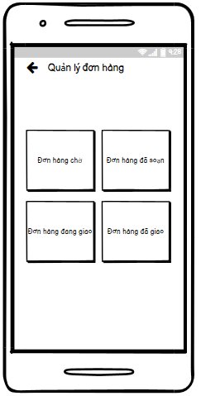

### **Require function**

|  |  |  |  |
| --- | --- | --- | --- |
| **Item** | **description** | **Behavior** | **Response** |
| **Order Management Screen** | Order Management Screen incluce:   * Pending order button * Prepared order button * Delivering button * Delived button * Arrow-left button | N/A | N/A |
| **Pending order button** | Used to view pending orders | Tap on | Go to Pending order screen |
| **Prepared order button** | Used to view Prepared orders | Tap on | Go to Prepared order screen |
| **Delivering button** | Used to view orders being delivered | Tap on | Go to Orders Being Delivered Screen |
| **Delived button** | used to view delivered orders | Tap on | Go to Delivered Order Screen |
| **Arrow-left button** | Used back to warehouse Management Screen | Tap on | Back to Warehouse Management Screen |

## **Features / Components: Pending Order Screen**

### **User interface**

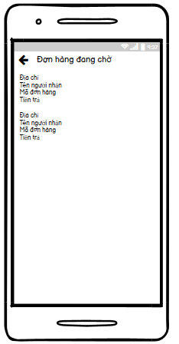

### **Require function**

|  |  |  |  |
| --- | --- | --- | --- |
| **Item** | **Description** | **Behavior** | **Response** |
| **Pending Order Screen** | **Pending Order Screen include:**   * Arrow-left button * Pending order listview | **N/A** | **N/A** |
| **Arrow-left button** | Used to return to order management screen | Tap on | Back to order management screen |
| **Pending order listview** | Get data from the database and display information about pending orders to the screen   * Address * Recipient's name * code orders * Money | Tap on item | Transfer data and go to detail bill screen |

## **Features / Components: Prepared Order Screen**

### **User interface**

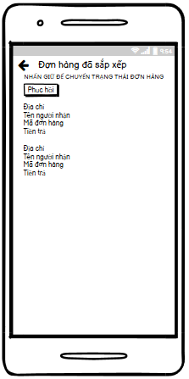

### **Require function**

|  |  |  |  |
| --- | --- | --- | --- |
| **Item** | **Description** | **Behavior** | **Response** |
| **Prepared Order Screen** | **Prepared Order Screen include:**   * Arrow-left button * Prepared order listview * Long press to change order status Text * Recovery button | **N/A** | **N/A** |
| **Arrow-left button** | Used to return to Order management screen | Tap on | Back to Order management screen |
| **Prepared order listview** | Get data from the database and display information about prepared orders to the screen   * Address * Recipient's name * code orders * Money | Press and hold | Order disappeared and Transfer data go to Orders Being Delivered Screen  Recovery button will appear |
| **Long press to change order status Text** | Display Long press to change order status Text on screen | N/A | N/A |
| **Recovery button** | if the press and hold on unwanted order then use for order recovery | Tap on | Order return to the prepared order screen |
| If there is no order or do not press and hold the order then  Recovery button will not appear | N/A | N/A |

## **Features / Ingredients: Orders Being Delivered Screen**

### **User interface**

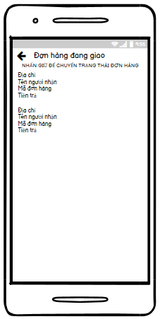

### **Require function**

|  |  |  |  |
| --- | --- | --- | --- |
| **Item** | **Description** | **Behavior** | **Response** |
| **Orders Being Delivered Screen** | Orders Being Delivered screen include:   * Arrow-left button * Orders Being Delivered listview * Long press to change order status Text | N/A | N/A |
| **Arrow-left button** | Used to return to Order management screen | Tap on | Back to Order management screen |
| **Orders Being Delivered listview** | Get data from the database and display information about orders being delivered to the screen   * Address * Recipient's name * code orders * Money | Press and hold | Order disappeared and Transfer data go to Delivered Order Screen |
| **Long press to change order status Text** | Display Long press to change order status Text on screen | N/A | N/A |

## **Features / Ingredients: Delivered Order Screen**

### **User interface**

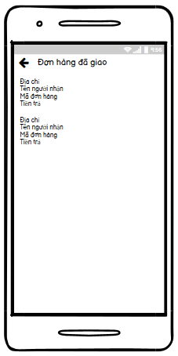

### **Require function**

|  |  |  |  |
| --- | --- | --- | --- |
| **Item** | **Description** | **Behavior** | **Response** |
| **Delivered Order Screen** | Delivered Order Screen include:   * Arrow-left button * Delivered order listview | **N/A** | **N/A** |
| **Arrow-left button** | Used to return to Order management screen | Tap on | Back to Order management screen |
| **Delivered order listview** | Get data from the database and display information about delivered order to the screen   * Address * Recipient's name * code orders * Money | Press and hold | Confirmed order delivered and the background turns green |

## **Features / Components: User Management Screen**

### **User interface**

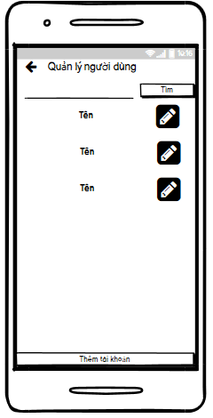

### **Require function**

|  |  |  |  |
| --- | --- | --- | --- |
| **Item** | **Description** | **Behavior** | **Response** |
| **User Management Screen** | User Management Screen include:   * Arrow-left button * Search TextInput * Search button * User listview * Add account button | N/A | N/A |
| **Arrow-left button** | Used back to warehouse Management Screen | Tap on | Back to Warehouse Management Screen |
| **Search TextInput** | Enter keywords to search | Tap on | Display the keyboard, can enter keywords and display the keywords just entered on TextInput |
| **Search button** | Used to search from textInput | Tap on | Display keywords to search below User listview |
| **User listview** | Get data from the database and display information about user to the screen:   * Name * Pen button | Tap on Pen button | Go to Update user information Screen |
| **Add account button** | Used to add account | Tap on | Go to create user account screen |

## **Features / Components: Create User Account Screen**

### **User interface**

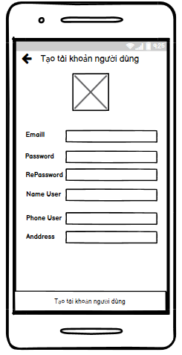

### **Require function**

|  |  |  |  |
| --- | --- | --- | --- |
| **Item** | **Description** | **Behavior** | **Response** |
| **Create User Account Screen** | Create User Account Screen include:   * Arrow-left button * Avatar Image * Email text * Password text * RePassword text * Name User text * Phone User text * Anddress text * Create user account button * Email TextInput * Password TextInput * RePassword TextInput * Name User TextInput * Phone User TextInput * Address TextInput | N/A | N/A |
| **Arrow-left button** | Used to return to User Management Screen | Tap on | Back to User Management Screen |
| **Email Text** | display email text on screen | N/A | N/A |
| **Password Text** | display password text on screen | N/A | N/A |
| **RePassword Text** | display RePassword text on screen | N/A | N/A |
| **Name User Text** | display Name User text on screen | N/A | N/A |
| **Phone User Text** | display Phone User text on screen | N/A | N/A |
| **Address Text** | display Address text on screen | N/A | N/A |
| **Avatar Image** | display avatar picture when selecting a photo from phone | Tap on | Go to photo gallery from phone |
| **Email TextInput** | Enter Email User | Tap on | show keyboard, enter email and display email just entered on TextInput |
| **Password TextInput** | Enter PassWord User | Tap on | show keyboard, enter Password and Display the characters “*” |
| **RePassword TextInput** | Enter RePassWord User | Tap on | show keyboard, enter RePassword and Display the characters “*” |
| **Name User TextInput** | Enter Name User | Tap on | show keyboard, enter Name and display Name just entered on TextInput |
| **Phone User TextInput** | Enter Phone User | Tap on | show keyboard, enter Phone and display Phone just entered on TextInput |
| **Address TextInput** | Enter Address User | Tap on | show keyboard, enter Address and display Address just entered on TextInput |
| **Create user account button** | used to create user accounts | Tap on | If the account is created successfully, it will show the pop-up message "Registration successful"  and save on the database |
| If the account is not created successfully, it will show the pop-up message "Registration failed |

## **Features / Ingredients: Product Screen**

### **User interface**

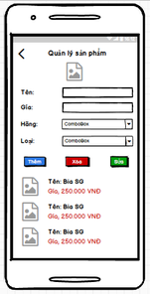

### **Require function**

|  |  |  |  |
| --- | --- | --- | --- |
| **Item** | **description** | **Behavior** | **Response** |
| Product Screen | Product Screen has:   * Icon back * Image * EditText “Name” * EditText “Price” * Combobox “Brand” * Combobox ”Category” * Button ”Add” * Button “Delete” * Button ”Update” * ListView | N/A | N/A |
| Icon Back | Back to Home | Tab | Back to Home |
| Image | Show photos of products | display | Show photos of products |
| EditText “Name product” | Used to enter the name of the product | Tab and enter | The entered product name will be displayed in the edittext |
| EditText ”Price” | Used to enter the price of the product | Tab and enter | The entered product price will be displayed in the edittext |
| Combobox ”Brand” | Used to select the brand for the product | Tab and select | The selected brand will be displayed on combobox |
| Combobox “Category” | Used to select the category for the product | Tab and select | The selected category will be displayed on combobox |
| Button “Add” | Used to add products | Tab | Show on the listview |
| Button “Delete” | Used to delete products | Tab | Delete from listview |
| Button “Update” | Used to update products | Tab | Update products |
| ListView | Display the product | Display | Display the product |

## **Features / Components: Product Category Screen**

### **User interface**

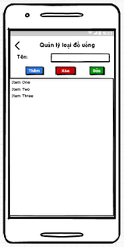

### **Require function**

|  |  |  |  |
| --- | --- | --- | --- |
| **Item** | **Description** | **Behavior** | **Response** |
| Product Category Screen | Product Category Screen has:   * Icon back * EditText “Name Category” * Button ”Add” * Button “Delete” * Button ”Update” * ListView | N/A | N/A |
| Icon Back | Back to Home | Tab | Back to Home |
| EditText “Name category” | Used to enter the name category | Tab and enter | The entered name category will be displayed in the edittext |
| Button “Add” | Used to add category | Tab | Show on the listview |
| Button “Delete” | Used to delete category | Tab | Delete from listview |
| Button “Update” | Used to update category | Tab | Update category |
| ListView | Display the category | Display | Display the category |

## **Features / Components: Update Customer Screen**

### **User interface**

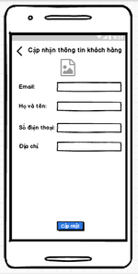

### **Require function**

|  |  |  |  |
| --- | --- | --- | --- |
| **Item** | **Description** | **Behavior** | **Response** |
| Update Customer Screen | Update Customer Screen has:   * Icon Back * Image * EditText “Email” * EditText ”Name” * EditText ”Phone Number” * EditText ”Address” * Button “Update” | N/A | N/A |
| Icon Back | Back to customer management screen | Tab | Back to customer management screen |
| Image | Display customer photos | Display | Display customer photos |
| EditText “Email” | Display email of customer, than tab and enter the email to update again | Display, tab and enter | Display the email that the customer has just updated |
| EditText “Name” | Display name of customer, than tab and enter the email to update again | Display, tab and enter | Display the name that the customer has just updated |
| EditText “Phone number” | Display phone number of customer, than tab and enter the email to update again | Display, tab and enter | Display the phone number that the customer has just updated |
| EditText “Address” | Display address of customer, than tab and enter the email to update again | Display, tab and enter | Display the address that the customer has just updated |
| Button “Update” | Used to update customer information | Tab | Save updated information |

## **Features / Ingredients: Customer VIP Screen**

### **User interface**

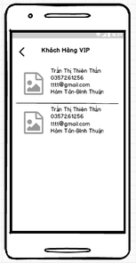

### **Require function**

|  |  |  |  |
| --- | --- | --- | --- |
| **Item** | **Description** | **Behavior** | **Response** |
| Customer VIP Screen | Customer VIP Screen has;   * Icon back * ListView | N/A | N/A |
| Icon back | Back to home | Tab | Back to home |
| ListView | Display list of VIP customers | Display | Display list of VIP customers |

## **Features / Ingredients: Statistics Screen**

### **User interface**

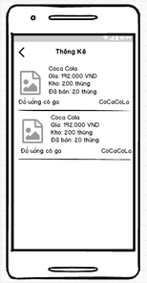

### **Require function**

|  |  |  |  |
| --- | --- | --- | --- |
| **Item** | **Description** | **Behavior** | **Response** |
| **Statistics screen** | **Statistics screen** has:   * Icon back * ListView | N/A | N/A |
| Icon back | Back to home | Tab | Back to home |
| ListView | Display list of products under statistics | Display | Display list of products under statistics |

## **Features / Ingredients: Detail Screen**

* 1. **User interface**

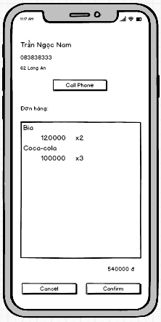

* 1. **Require function**

|  |  |  |  |
| --- | --- | --- | --- |
| **Item** | **Description** | **Action** | **Response** |
| **Order detail screen** | Order detail screen with 3 buttons, 5 TextView,1 Listview:   * Cancel button * Confirm button * Phone button * Product listview * Name textview * Phone textview * Address textview * Order textview * Total textview | N/A | N/A |
| **Cancel button** | Cancel the order, change the status of the canceled order. | Tap on Cancel button | Return to the order management screen |
| **Confirm button** | Confirm the order, change the status of the order being delivered. | Tap on Confirm button | Return to the order management screen |
| **Phone button** | Call phone for customer | Tap on Phone button | A pop up call phone screen |
| **Product listview** | Show list product item | N/A | N/A |
| **Name textview** | Show name of customer | N/A | N/A |
| **Phone textview** | Show number phone of customer | N/A | N/A |
| **Address textview** | Show address of customer | N/A | N/A |
| **Order textview** | Show text order | N/A | N/A |
| **Total textview** | Show total order | N/A | N/A |

## **Features / Ingredients: Import Goods Screen**

* 1. **User interface**

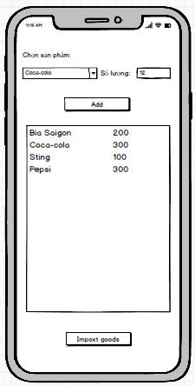

* 1. **Require function**

|  |  |  |  |
| --- | --- | --- | --- |
| **Item** | **Description** | **Action** | **Response** |
| **Import Goods screen** | Import Goods screen with 2 buttons, 2 TextView,1 Listview, 1 Spinner:   * Add button * Import Goods button * Product listview * Choose textview * Choose product spinner * Amount textview | N/A | N/A |
| **Add button** | Add a product item to listview | Tap on Add button | Add item in listview |
| **Import Goods button** | Import goods in listview | Tap on Import Goods button | Save to database |
| **Product listview** | Show list product item | N/A | N/A |
| **Choose textview** | Show text choose name | N/A | N/A |
| **Choose product spinner** | List of product in the database | Tap on item in spinner | Show name text seletect |
| **Quantity textview** | Show text quantity | N/A | N/A |

## **Features / Ingredients: Manufacture Screen**

* 1. **User interface**

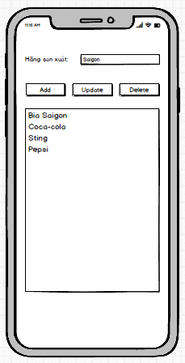

* 1. **Require function**

|  |  |  |  |
| --- | --- | --- | --- |
| **Item** | **Description** | **Action** | **Response** |
| **Import Goods screen** | Import Goods screen with 3 buttons, 1 TextView,1 Listview,1 Edittext:   * Add button * Update button * Delete button * Product listview * Name textview * Name edittext | N/A | N/A |
| **Add button** | Add a new manufacturer to listview | Tap on Add button | Add item in listview |
| **Update button** | Update manufacturer to listview | Tap on Update button | Update item in listview |
| **Product listview** | Show list item manufacturer | Tap on item in Listview | Select item in listview, Show name in Name edittext |
| **Name edittext** | Enter manufacturer name | N/A | N/A |
| **Name textview** | Show manufacturer name | N/A | N/A |
| **Delete button** | Delete manufacturer to listview | Tap on Delete button | Delete item in listview |

## **Features / Ingredients: Sign-in Screen**

### **User interface**

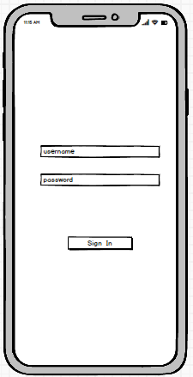

* 1. **Require function**

|  |  |  |  |
| --- | --- | --- | --- |
| **Item** | **Description** | **Action** | **Response** |
| **Sign-In screen** | Sign-In screen with 1 buttons, 2 Edittext:   * Sign-In button * Username edittext * Password edittext | N/A | N/A |
| **Sign-In button** | Move to main screen | Tap on Sign-In button | A pop up main screen |
| **Username textview** | Enter username | N/A | N/A |
| **Password textview** | Enter password | N/A | N/A |

## **Features / Ingredients: Main Screen**

* 1. **User interface**

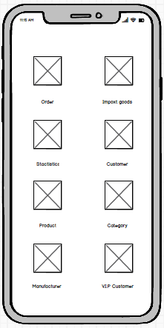

* 1. **Require function**

|  |  |  |  |
| --- | --- | --- | --- |
| **Item** | **Description** | **Action** | **Response** |
| **Main screen** | Main screen with 8 ImageView, 8 Textview:   * Order imageview * Import goods imageview * Stactistics imageview * Customer imageview * Product imageview * Category imageview * Manufacturer imageview * V.I.P imageview * Order textview * Import goods textview * Stactistics textview * Customer textview * Prduct textview * Category textview * Manufacturer textview * V.I.P textview | N/A | N/A |
| Order imageview | Move to order management screen | Tap on Order imageview | A pop up Order screen |
| Import goods imageview | Move to import goods management screen | Tap on Import goods imageview | A pop up Import goods screen |
| Stactistics imageview | Move to stactistics management screen | Tap on Stactistics imageview | A pop up Stactistics screen |
| Customer imageview | Move to customer management screen | Tap on Customer imageview | A pop up Customer screen |
| Product imageview | Move to product management screen | Tap on Product imageview | A pop up Product screen |
| Category imageview | Move to category management screen | Tap on Category imageview | A pop up Category screen |
| Manufacturer imageview | Move to manufacturer management screen | Tap on Manufacturer imageview | A pop up Manufacturer screen |
| V.I.P imageview | Move to V.I.P customer management screen | Tap on V.I.P imageview | A pop up V.I.P screen |
| Order textview | Show text name for imageview | N/A | N/A |
| Import goods textview | Show text name for imageview | N/A | N/A |
| Stactistics textview | Show text name for imageview | N/A | N/A |
| Customer textview | Show text name for imageview | N/A | N/A |
| Product textview | Show text name for imageview | N/A | N/A |
| Category textview | Show text name for imageview | N/A | N/A |
| Manufacturer textview | Show text name for imageview | N/A | N/A |
| V.I.P textview | Show text name for imageview | N/A | N/A |

## **Features / Ingredients: Home user screen**

* 1. **User interface**

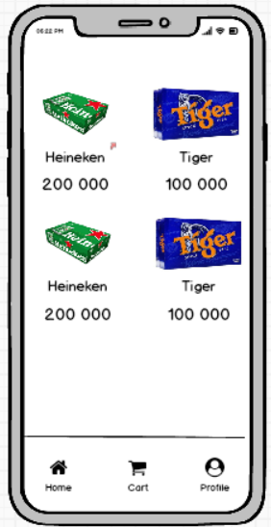

* 1. **Require function**

|  |  |  |  |
| --- | --- | --- | --- |
| **Item** | **Description** | **Action** | **Response** |
| Home user screen | Home screen, showing the products on sale | N/A | N/A |
| Image product | is an in stock product | Tab on | Go to that product detail page |
| Name product | Show that product name | Tab on | Go to that product detail page |
| Price product | Show the price of that product | Tab on | Go to that product detail page |

## **Features / Ingredients: Detai product**

* 1. **Interface:**

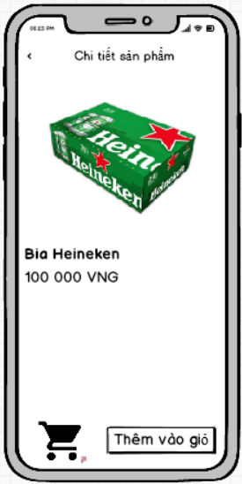

* 1. **Description**

|  |  |  |  |
| --- | --- | --- | --- |
| **Item** | **Description** | **Action** | **Response** |
| Screen | Show product details | N/A | N/A |
| Image | Show pictures of that product | N/A | N/A |
| Icon cart | Button to add products to cart | Tab on | The product will be added to the user's cart |
|  |  |  |  |

## **Features / Ingredients: Cart user**

* 1. **Interface:**

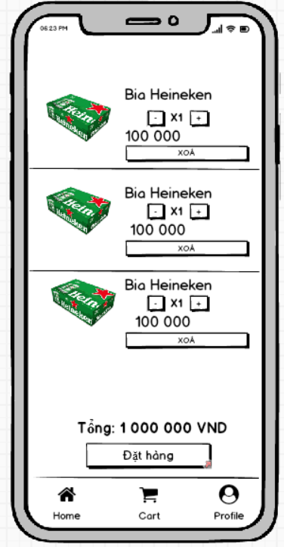

* 1. **Description:**

|  |  |  |  |
| --- | --- | --- | --- |
| **Item** | **Description** | **Action** | **Response** |
| Screen | Show all products in cart | N/A | N/A |
| Item product | Display that product and the price and quantity of that product | N/A | N/A |
| Button + | Increase product | Tab on | The number of existing products will be increased by 1 |
| Button - | Product discount | Tab on | The number of existing products will be discount by 1 |
| total money | Show total amount of all products in cart | N/A | N/A |
| Button ‘đặt hàng’ | Click to order | Tab on | Order will go to confirmation and order page |

## **Features / Ingredients: Detail bill order**

* 1. **Interface:**

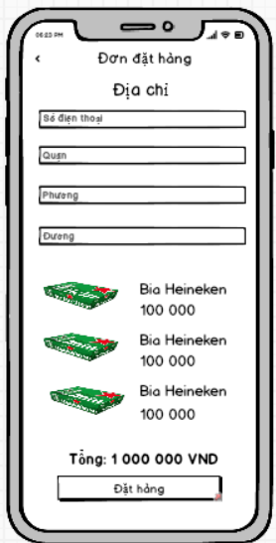

* 1. **Description:**

|  |  |  |  |
| --- | --- | --- | --- |
| **Item** | **Description** | **Action** | **Response** |
| Screen | Show all products in cart | N/A | N/A |
| Button đặt hàng | Orders will be placed | Tab on | Orders will be placed |

## **Features / Ingredients: User**

* 1. **Interface:**

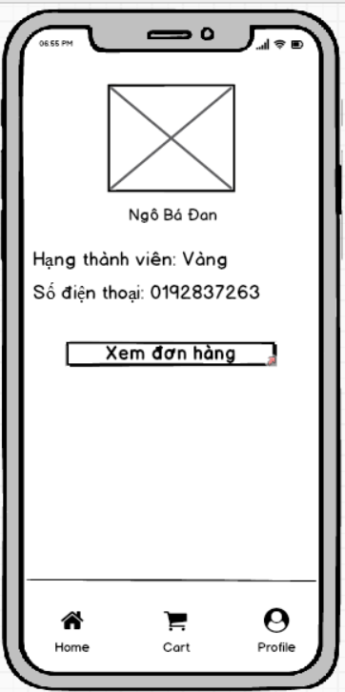

* 1. **Description:**

|  |  |  |  |
| --- | --- | --- | --- |
| **Item** | **Description** | **Action** | **Response** |
| Screen | Show info user | N/A | N/A |
| Image | Show user profile picture | Tab on | Go to the page to choose your profile picture |
| Rank | Show membership class | N/A | Show membership class |
| Button xem đơn hàng | Go to the order view page | Tab on | Go to the order view page |

## **Features / Ingredients: Bill screen**

* 1. **Interface:**

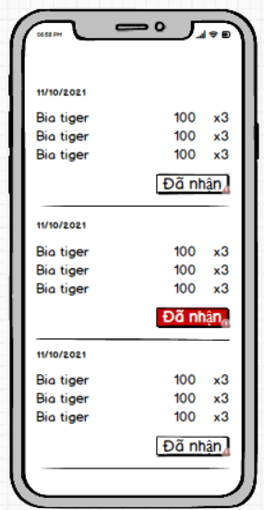

1. **Description:**

|  |  |  |  |
| --- | --- | --- | --- |
| **Item** | **Description** | **Action** | **Response** |
| Screen | Show full bill user | N/A | N/A |
| Item listview | Display the information of that order | N/A | N/A |