**Software Requirement Specification**

**Version 1.6**

Group 6 – Sales manager

**MODIFICATION HISTORY**

|  |  |  |  |  |
| --- | --- | --- | --- | --- |
| **Day** | **Version** | **Description** | **Author** | **Edit By** |
|  |  |  | Ngoc Truong | Ngoc Truong |
|  | 1.2 |  | Ngoc Nam | Ngoc Truong |
|  | 1.3 |  | Truong Vu | Ngoc Truong |
|  | 1.4 |  | Truong Vu | Ngoc Truong |
|  | 1.4 |  | Cong Dang | Quoc Tri |
|  | 1.5 |  | Quoc Tri | Quoc Tri |
|  | 1.6 |  | Le Ho | Quoc Tri |
|  | 1.7 | The functions of the storekeeper | Ngoc Truong | Ngoc Truong |

**GROUP ACTIVITIES LOG**

|  |  |  |  |  |
| --- | --- | --- | --- | --- |
| **Stt** | **First and last name** | **The work has been finished** | **Review team** | **Signature** |
| **1** | **Nguyen Ngoc Truong** |  | **16.66%** |  |
| **2** | **Tran Ngoc Nam** |  | **16.66%** |  |
| **3** | **Tran Quoc Tri** |  | **16.66%** |  |
| **4** | **Le Ho** |  | **16.66%** |  |
| **5** | **Nguyen Cong Dang** |  | **16.66%** |  |
| **6** | **Nguyen Phi Truong Vu** |  | **16.66%** |  |

**TABLE OF CONTENTS**

INTRODUCE 5

**1.** **Overview** 5

**2.** **Limit** 5

REQUIRE FUNCTION 6

**1.** **Features / Ingredients: Order Management Screen** 6

**1.1.** **User interface** 6

**1.2.** **Require function** 6

**2.** **Features / Components: Pending Order Screen** 7

**2.1.** **User interface** 7

**2.2.** **Require function** 8

**3.** **Features / Components: Prepared Order Screen** 9

**3.1.** **User interface** 9

**3.2.** **Require function** 9

**4.** **Features / Ingredients: Orders Being Delivered Screen** 11

**4.1.** **User interface** 11

**4.2.** **Require function** 11

**5.** **Features / Ingredients: Delivered Order Screen** 12

**5.1.** **User interface** 12

**5.2.** **Require function** 13

**6.** **Features / Components: User Management Screen** 14

**6.1.** **User interface** 14

**6.2.** **Require function** 14

**7.** **Features / Components: Create User Account Screen** 16

**7.1.** **User interface** 16

**7.2.** **Require function** 16

# INTRODUCE

## **Overview**

**•**                   This application makes it easy for users to order the books they need. Suitable for those who like fast and convenient.

**•**                   Make it easy for administrators to use and manage.

**•**                   Order quickly and conveniently.

**•**                   Shiper is easy to handle delivery and delivery.

## **Limit**

●     Operating System: Android 7.0

●     Test device: Google Pixel 3

●     Display: 1080 X 2160

●     Only supports vertical screen

●     An internet connection is required

# REQUIRE FUNCTION

## **Features / Ingredients: Order Management Screen**

### **User interface**

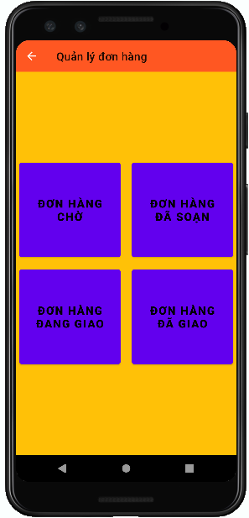

### **Require function**

|  |  |  |  |
| --- | --- | --- | --- |
| **Item** | **description** | **Behavior** | **Response** |
| **Order Management Screen** | Order Management Screen incluce:   * Pending order button * Prepared order button * Delivering button * Delived button * Arrow-left button | N/A | N/A |
| **Pending order button** | Used to view pending orders | Tap on | Go to Pending order screen |
| **Prepared order button** | Used to view Prepared orders | Tap on | Go to Prepared order screen |
| **Delivering button** | Used to view orders being delivered | Tap on | Go to Orders Being Delivered Screen |
| **Delived button** | used to view delivered orders | Tap on | Go to Delivered Order Screen |
| **Arrow-left button** | Used back to warehouse Management Screen | Tap on | Back to Warehouse Management Screen |

## **Features / Components: Pending Order Screen**

### **User interface**

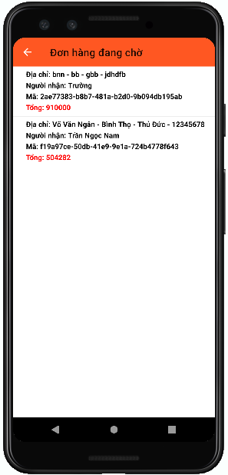

### **Require function**

|  |  |  |  |
| --- | --- | --- | --- |
| **Item** | **Description** | **Behavior** | **Response** |
| **Pending Order Screen** | **Pending Order Screen include:**   * Arrow-left button * Pending order listview | **N/A** | **N/A** |
| **Arrow-left button** | Used to return to order management screen | Tap on | Back to order management screen |
| **Pending order listview** | Get data from the database and display information about pending orders to the screen   * Address * Recipient's name * code orders * Money | Tap on item | Transfer data and go to detail bill screen |

## **Features / Components: Prepared Order Screen**

### **User interface**

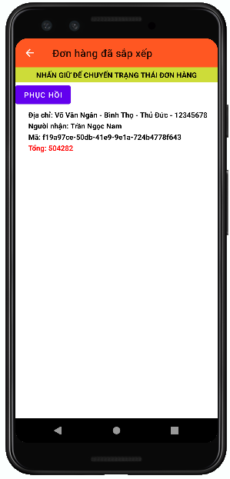

### **Require function**

|  |  |  |  |
| --- | --- | --- | --- |
| **Item** | **Description** | **Behavior** | **Response** |
| **Prepared Order Screen** | **Prepared Order Screen include:**   * Arrow-left button * Prepared order listview * Long press to change order status Text * Recovery button | **N/A** | **N/A** |
| **Arrow-left button** | Used to return to Order management screen | Tap on | Back to Order management screen |
| **Prepared order listview** | Get data from the database and display information about prepared orders to the screen   * Address * Recipient's name * code orders * Money | Press and hold | Order disappeared and Transfer data go to Orders Being Delivered Screen  Recovery button will appear |
| **Long press to change order status Text** | Display Long press to change order status Text on screen | N/A | N/A |
| **Recovery button** | if the press and hold on unwanted order then use for order recovery | Tap on | Order return to the prepared order screen |
| If there is no order or do not press and hold the order then  Recovery button will not appear | N/A | N/A |

## **Features / Ingredients: Orders Being Delivered Screen**

### **User interface**

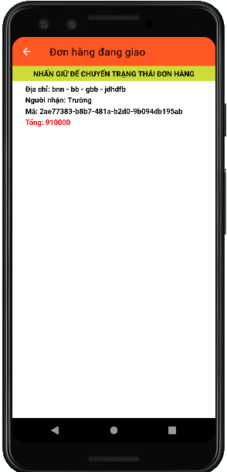

### **Require function**

|  |  |  |  |
| --- | --- | --- | --- |
| **Item** | **Description** | **Behavior** | **Response** |
| **Orders Being Delivered Screen** | Orders Being Delivered screen include:   * Arrow-left button * Orders Being Delivered listview * Long press to change order status Text | N/A | N/A |
| **Arrow-left button** | Used to return to Order management screen | Tap on | Back to Order management screen |
| **Orders Being Delivered listview** | Get data from the database and display information about orders being delivered to the screen   * Address * Recipient's name * code orders * Money | Press and hold | Order disappeared and Transfer data go to Delivered Order Screen |
| **Long press to change order status Text** | Display Long press to change order status Text on screen | N/A | N/A |

## **Features / Ingredients: Delivered Order Screen**

### **User interface**

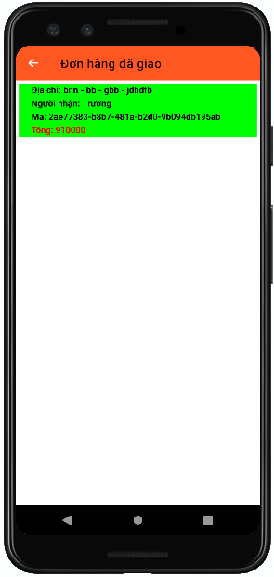

### **Require function**

|  |  |  |  |
| --- | --- | --- | --- |
| **Item** | **Description** | **Behavior** | **Response** |
| **Delivered Order Screen** | Delivered Order Screen include:   * Arrow-left button * Delivered order listview | **N/A** | **N/A** |
| **Arrow-left button** | Used to return to Order management screen | Tap on | Back to Order management screen |
| **Delivered order listview** | Get data from the database and display information about delivered order to the screen   * Address * Recipient's name * code orders * Money | Press and hold | Confirmed order delivered and the background turns green |

## **Features / Components: User Management Screen**

### **User interface**

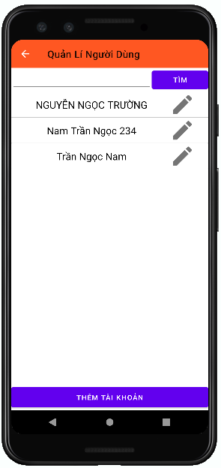

### **Require function**

|  |  |  |  |
| --- | --- | --- | --- |
| **Item** | **Description** | **Behavior** | **Response** |
| **User Management Screen** | User Management Screen include:   * Arrow-left button * Search TextInput * Search button * User listview * Add account button | N/A | N/A |
| **Arrow-left button** | Used back to warehouse Management Screen | Tap on | Back to Warehouse Management Screen |
| **Search TextInput** | Enter keywords to search | Tap on | Display the keyboard, can enter keywords and display the keywords just entered on TextInput |
| **Search button** | Used to search from textInput | Tap on | Display keywords to search below User listview |
| **User listview** | Get data from the database and display information about user to the screen:   * Name * Pen button | Tap on Pen button | Go to Update user information Screen |
| **Add account button** | Used to add account | Tap on | Go to create user account screen |

## **Features / Components: Create User Account Screen**

### **User interface**

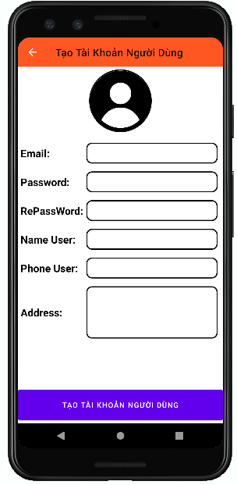

### **Require function**

|  |  |  |  |
| --- | --- | --- | --- |
| **Item** | **Description** | **Behavior** | **Response** |
| **Create User Account Screen** | Create User Account Screen include:   * Arrow-left button * Avatar Image * Email text * Password text * RePassword text * Name User text * Phone User text * Anddress text * Create user account button * Email TextInput * Password TextInput * RePassword TextInput * Name User TextInput * Phone User TextInput * Address TextInput | N/A | N/A |
| **Arrow-left button** | Used to return to User Management Screen | Tap on | Back to User Management Screen |
| **Email Text** | display email text on screen | N/A | N/A |
| **Password Text** | display password text on screen | N/A | N/A |
| **RePassword Text** | display RePassword text on screen | N/A | N/A |
| **Name User Text** | display Name User text on screen | N/A | N/A |
| **Phone User Text** | display Phone User text on screen | N/A | N/A |
| **Address Text** | display Address text on screen | N/A | N/A |
| **Avatar Image** | display avatar picture when selecting a photo from phone | Tap on | Go to photo gallery from phone |
| **Email TextInput** | Enter Email User | Tap on | show keyboard, enter email and display email just entered on TextInput |
| **Password TextInput** | Enter PassWord User | Tap on | show keyboard, enter Password and Display the characters “*” |
| **RePassword TextInput** | Enter RePassWord User | Tap on | show keyboard, enter RePassword and Display the characters “*” |
| **Name User TextInput** | Enter Name User | Tap on | show keyboard, enter Name and display Name just entered on TextInput |
| **Phone User TextInput** | Enter Phone User | Tap on | show keyboard, enter Phone and display Phone just entered on TextInput |
| **Address TextInput** | Enter Address User | Tap on | show keyboard, enter Address and display Address just entered on TextInput |
| **Create user account button** | used to create user accounts | Tap on | If the account is created successfully, it will show the pop-up message "Registration successful"  and save on the database |
| If the account is not created successfully, it will show the pop-up message "Registration failed |

## **Features / Ingredients: Product Screen**

### **User interface**

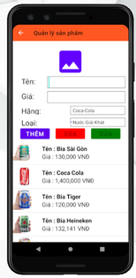

### **Require function**

|  |  |  |  |
| --- | --- | --- | --- |
| **Item** | **description** | **Behavior** | **Response** |
| Product Screen | Product Screen has:   * Icon back * Image * EditText “Name” * EditText “Price” * Combobox “Brand” * Combobox ”Category” * Button ”Add” * Button “Delete” * Button ”Update” * ListView | N/A | N/A |
| Icon Back | When the tab on the icon back, the screen will return to the home screen | Tab | Back to Home |
| Image | Show photos of products | display | Show photos of products |
| EditText “Name product” | Used to enter the name of the product | Tab and enter | The entered product name will be displayed in the edittext |
| EditText ”Price” | Used to enter the price of the product | Tab and enter | The entered product price will be displayed in the edittext |
| Combobox ”Brand” | Used to select the brand for the product | Tab and select | The selected brand will be displayed on combobox |
| Combobox “Category” | Used to select the category for the product | Tab and select | The selected category will be displayed on combobox |
| Button “Add” | * Used to add products * During the process of adding products, button “delete”, button “update” will be unenable. * Tab on the photos of product to select the photos from library * Enter information into the edittext, select the corresponding fields in the combobox. * Tab on the “Add” button to add to the listview below | Tab | Show new products added to listview |
| Button “Delete” | * Used to delete products * During the process of delete products, button “add” will be unenable. * Tab to any product below the listview, then tab on button “delete” to delete | Tab | Delete from listview |
| Button “Update” | * Used to update products * During the process of update products, button “add” will be unenable. * Tab to any product below the listview, then tab on button “update” to update | Tab | Update products |
| ListView | Display list information of the products: name, price, brand, category | Display | Display list information of the products |

## Features / Components: Product Category Screen

### **User interface**

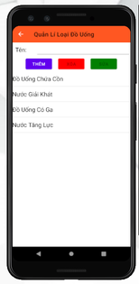

### **Require function**

|  |  |  |  |
| --- | --- | --- | --- |
| **Item** | **Description** | **Behavior** | **Response** |
| Product Category Screen | Product Category Screen has:   * Icon back * EditText “Name Category” * Button ”Add” * Button “Delete” * Button ”Update” * ListView | N/A | N/A |
| Icon Back | When the tab on the icon back, the screen will return to the home screen | Tab | Back to Home |
| EditText “Name category” | Used to enter the name category | Tab and enter | The entered name category will be displayed in the edittext |
| Button “Add” | * Used to add category * During the process of adding category, button “delete”, button “update” will be unenable. * Enter information into the edittext * Tab on the “Add” button to add to the listview below | Tab | Show new category added to listview |
| Button “Delete” | * Used to delete category * During the process of delete category, button “add” will be unenable. * Tab to any product below the listview, then tab on button “delete” to delete | Tab | Delete from listview |
| Button “Update” | * Used to update category * During the process of update category, button “add” will be unenable. * Tab to any product below the listview, then tab on button “update” to update | Tab | Update category |
| ListView | Display list the category | Display | Display list the category |

## Features / Components: Update Customer Screen

### **User interface**

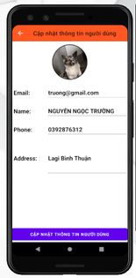

### **Require function**

|  |  |  |  |
| --- | --- | --- | --- |
| **Item** | **Description** | **Behavior** | **Response** |
| Update Customer Screen | Update Customer Screen has:   * Icon Back * Image * EditText “Email” * EditText ”Name” * EditText ”Phone Number” * EditText ”Address” * Button “Update” | N/A | N/A |
| Icon Back | Back to customer management screen | Tab | Back to customer management screen |
| Image | Display customer photos | Display | Display customer photos |
| EditText “Email” | Display email of customer, than tab and enter the email to update again | Display, tab and enter | Display the email that the customer has just updated |
| EditText “Name” | Display name of customer, than tab and enter the email to update again | Display, tab and enter | Display the name that the customer has just updated |
| EditText “Phone number” | Display phone number of customer, than tab and enter the email to update again | Display, tab and enter | Display the phone number that the customer has just updated |
| EditText “Address” | Display address of customer, than tab and enter the email to update again | Display, tab and enter | Display the address that the customer has just updated |
| Button “Update” | Used to update customer information | Tab | Save updated information |

## Features / Ingredients: Customer VIP Screen

### **User interface**

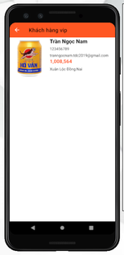

### **Require function**

|  |  |  |  |
| --- | --- | --- | --- |
| **Item** | **Description** | **Behavior** | **Response** |
| Customer VIP Screen | Customer VIP Screen has;   * Icon back * ListView | N/A | N/A |
| Icon Back | When the tab on the icon back, the screen will return to the home screen | Tab | Back to Home |
| ListView | Display list information of VIP customers:image, name customer, phone number, email, amount purchased, address, | Display | Display list of VIP customers |

## Features / Ingredients: Statistics Screen

### **User interface**

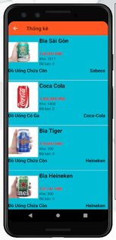

### **Require function**

|  |  |  |  |
| --- | --- | --- | --- |
| **Item** | **Description** | **Behavior** | **Response** |
| Statistics screen | Statistics screen has:   * Icon back * ListView | N/A | N/A |
| Icon Back | When the tab on the icon back, the screen will return to the home screen | Tab | Back to Home |
| ListView | Display list information of products under statistics: image of the product, name of the product, price, Quantity in stock, Quantity sold, brand, category. | Display | Display list of products under statistics |