## Features / Components: Home user screen

* **User interface**

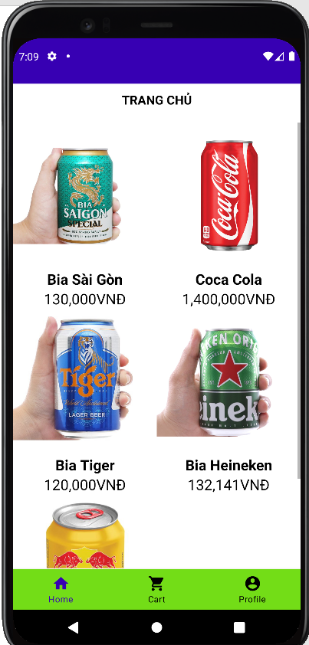

* **Require function**

|  |  |  |  |
| --- | --- | --- | --- |
| **Item** | **Description** | **Action** | **Response** |
| Home user screen | Home screen, showing the products on sale | N/A | N/A |
| Image product | is an in stock product | Tab on | Go to that product detail page |
| Name product | Show that product name | Tab on | Go to that product detail page |
| Price product | Show the price of that product | Tab on | Go to that product detail page |

## Features / Components: Detai product

* Interface:

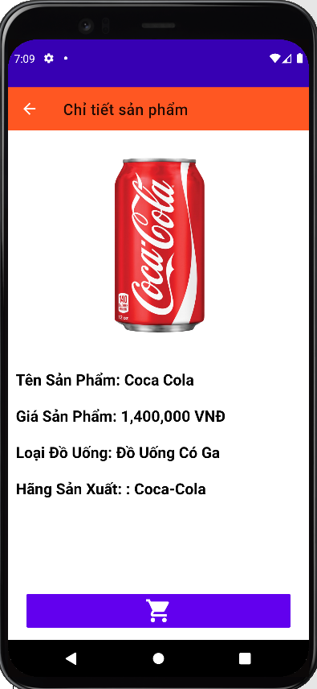

* Description

|  |  |  |  |
| --- | --- | --- | --- |
| **Item** | **Description** | **Action** | **Response** |
| Screen | Show product details | N/A | N/A |
| Image | Show pictures of that product | N/A | N/A |
| Icon cart | Button to add products to cart | Tab on | The product will be added to the user's cart |
|  |  |  |  |

## Features / Components: Cart user

* Interface:

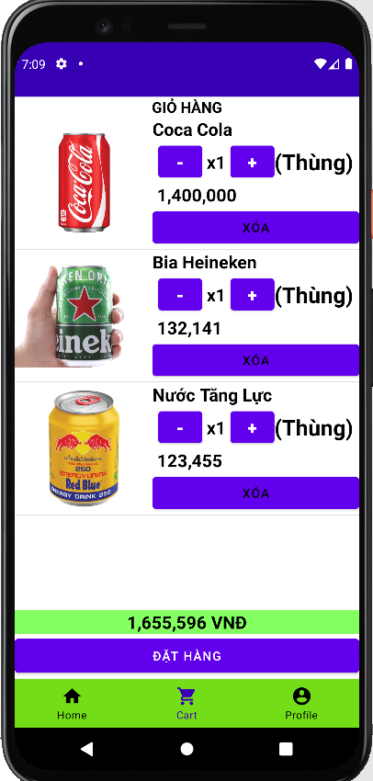

* Description:

|  |  |  |  |
| --- | --- | --- | --- |
| **Item** | **Description** | **Action** | **Response** |
| Screen | Show all products in cart | N/A | N/A |
| Item product | Display that product and the price and quantity of that product | N/A | N/A |
| Button + | Increase product | Tab on | The number of existing products will be increased by 1 |
| Button - | Product discount | Tab on | The number of existing products will be discount by 1 |
| total money | Show total amount of all products in cart | N/A | N/A |
| Button ‘đặt hàng’ | Click to order | Tab on | Order will go to confirmation and order page |

## Features / Components: Detail bill order:

* Interface:

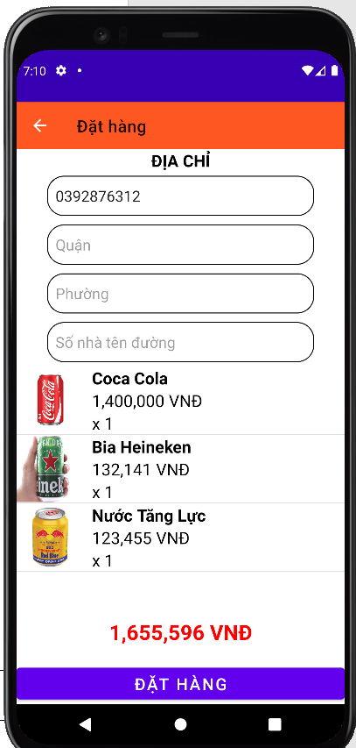

* Description:

|  |  |  |  |
| --- | --- | --- | --- |
| **Item** | **Description** | **Action** | **Response** |
| Screen | Show all products in cart | N/A | N/A |
| Button đặt hàng | Orders will be placed | Tab on | Orders will be placed |

## Features / Components: User

* Interface:

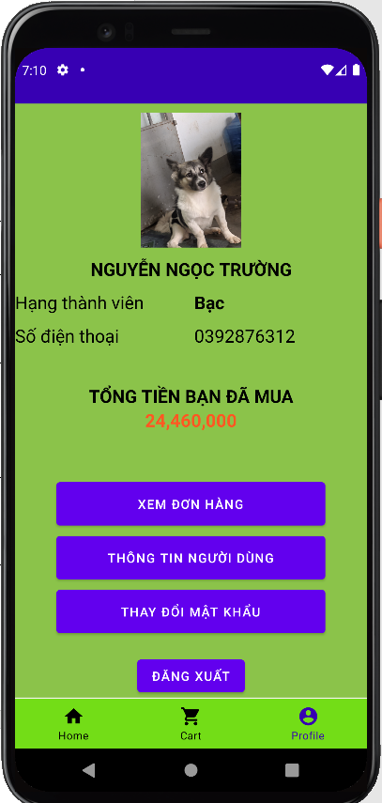

* Description:

|  |  |  |  |
| --- | --- | --- | --- |
| **Item** | **Description** | **Action** | **Response** |
| Screen | Show info user | N/A | N/A |
| Image | Show user profile picture | Tab on | Go to the page to choose your profile picture |
| Rank | Show membership class | N/A | Show membership class |
| Button xem đơn hàng | Go to the order view page | Tab on | Go to the order view page |

## Features / Components: Bill screen

* Interface:

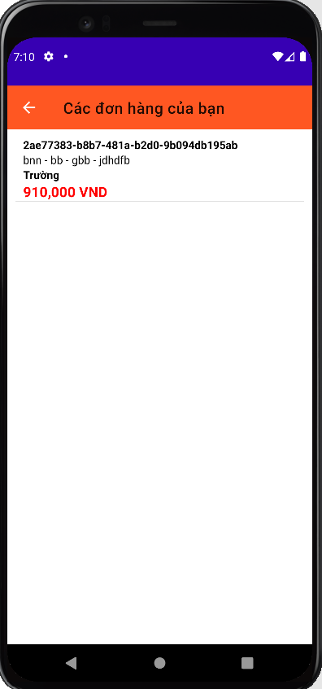

* Description:

|  |  |  |  |
| --- | --- | --- | --- |
| **Item** | **Description** | **Action** | **Response** |
| Screen | Show full bill user | N/A | N/A |
| Item listview | Display the information of that order | N/A | N/A |