Software Design Specification

**Version 1.6**

Group 6 – Sales manager

**MODIFICATION HISTORY**

|  |  |  |  |  |
| --- | --- | --- | --- | --- |
| **Ngày** | **Phiên Bản** | **Mô Tả** | **Tác Giả** | **Sửa Bởi** |
| **10/10/2021** | **1.0** | **Database design** | Ngọc Trường | Ngọc Trường |
|  |  |  |  |  |
|  |  |  |  |  |
|  |  |  |  |  |

**TABLE OF CONTENTS**

# **INTRODUCE**

## **Overview**

* This application makes it easy for users to order the books they need. Suitable for those who like fast and convenient.
* Make it easy for administrators to use and manage.
* Order quickly and conveniently.
* Shiper is easy to handle delivery and delivery.

## **Limit**

* Operating System: Android 7.0
* Test device: Google Pixel 3
* Display: 1080 X 2160
* Only supports vertical screen
* An internet connection is required

# **SYSTEM DESCRIPTION**

1. **General Architectural Description**
   1. **Overview**
   2. **Workflow**

# **SYSTEM FUNCTION DESCRIPTION**

## Features / Components: Orther Detail Screen

* **User interface**

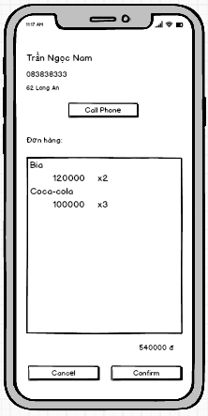

* **Require function**

|  |  |  |  |
| --- | --- | --- | --- |
| **Item** | **Description** | **Action** | **Response** |
| **Order detail screen** | Order detail screen with 3 buttons, 5 TextView,1 Listview:   * Cancel button * Confirm button * Phone button * Product listview * Name textview * Phone textview * Address textview * Order textview * Total textview | N/A | N/A |
| **Cancel button** | Cancel the order, change the status of the canceled order. | Tap on Cancel button | Return to the order management screen |
| **Confirm button** | Confirm the order, change the status of the order being delivered. | Tap on Confirm button | Return to the order management screen |
| **Phone button** | Call phone for customer | Tap on Phone button | A pop up call phone screen |
| **Product listview** | Show list product item | N/A | N/A |
| **Name textview** | Show name of customer | N/A | N/A |
| **Phone textview** | Show number phone of customer | N/A | N/A |
| **Address textview** | Show address of customer | N/A | N/A |
| **Order textview** | Show text order | N/A | N/A |
| **Total textview** | Show total order | N/A | N/A |

## Features / Components: Import Goods Screen

* **User interface**

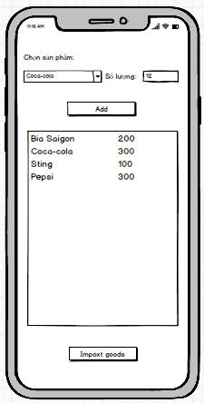

* **Require function**

|  |  |  |  |
| --- | --- | --- | --- |
| **Item** | **Description** | **Action** | **Response** |
| **Import Goods screen** | Import Goods screen with 2 buttons, 2 TextView,1 Listview, 1 Spinner:   * Add button * Import Goods button * Product listview * Choose textview * Choose product spinner * Amount textview | N/A | N/A |
| **Add button** | Add a product item to listview | Tap on Add button | Add item in listview |
| **Import Goods button** | Import goods in listview | Tap on Import Goods button | Save to database |
| **Product listview** | Show list product item | N/A | N/A |
| **Choose textview** | Show text choose name | N/A | N/A |
| **Choose product spinner** | List of product in the database | Tap on item in spinner | Show name text seletect |
| **Quantity textview** | Show text quantity | N/A | N/A |

## Features / Components: Manufacture **Screen**

* **User interface**

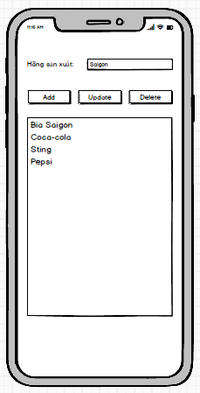

* **Require function**

|  |  |  |  |
| --- | --- | --- | --- |
| **Item** | **Description** | **Action** | **Response** |
| **Import Goods screen** | Import Goods screen with 3 buttons, 1 TextView,1 Listview,1 Edittext:   * Add button * Update button * Delete button * Product listview * Name textview * Name edittext | N/A | N/A |
| **Add button** | Add a new manufacturer to listview | Tap on Add button | Add item in listview |
| **Update button** | Update manufacturer to listview | Tap on Update button | Update item in listview |
| **Product listview** | Show list item manufacturer | Tap on item in Listview | Select item in listview, Show name in Name edittext |
| **Name edittext** | Enter manufacturer name | N/A | N/A |
| **Name textview** | Show manufacturer name | N/A | N/A |
| **Delete button** | Delete manufacturer to listview | Tap on Delete button | Delete item in listview |

## Features / Components: Sign-In Screen

* **User interface**

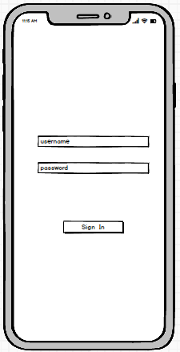

* **Require function**

|  |  |  |  |
| --- | --- | --- | --- |
| **Item** | **Description** | **Action** | **Response** |
| **Sign-In screen** | Sign-In screen with 1 buttons, 2 Edittext:   * Sign-In button * Username edittext * Password edittext | N/A | N/A |
| **Sign-In button** | Move to main screen | Tap on Sign-In button | A pop up main screen |
| **Username textview** | Enter username | N/A | N/A |
| **Password textview** | Enter password | N/A | N/A |

## Features / Components: Main Screen

* **User interface**

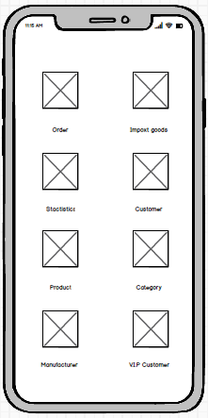

* **Require function**

|  |  |  |  |
| --- | --- | --- | --- |
| **Item** | **Description** | **Action** | **Response** |
| **Main screen** | Main screen with 8 ImageView, 8 Textview:   * Order imageview * Import goods imageview * Stactistics imageview * Customer imageview * Product imageview * Category imageview * Manufacturer imageview * V.I.P imageview * Order textview * Import goods textview * Stactistics textview * Customer textview * Prduct textview * Category textview * Manufacturer textview * V.I.P textview | N/A | N/A |
| Order imageview | Move to order management screen | Tap on Order imageview | A pop up Order screen |
| Import goods imageview | Move to import goods management screen | Tap on Import goods imageview | A pop up Import goods screen |
| Stactistics imageview | Move to stactistics management screen | Tap on Stactistics imageview | A pop up Stactistics screen |
| Customer imageview | Move to customer management screen | Tap on Customer imageview | A pop up Customer screen |
| Product imageview | Move to product management screen | Tap on Product imageview | A pop up Product screen |
| Category imageview | Move to category management screen | Tap on Category imageview | A pop up Category screen |
| Manufacturer imageview | Move to manufacturer management screen | Tap on Manufacturer imageview | A pop up Manufacturer screen |
| V.I.P imageview | Move to V.I.P customer management screen | Tap on V.I.P imageview | A pop up V.I.P screen |
| Order textview | Show text name for imageview | N/A | N/A |
| Import goods textview | Show text name for imageview | N/A | N/A |
| Stactistics textview | Show text name for imageview | N/A | N/A |
| Customer textview | Show text name for imageview | N/A | N/A |
| Product textview | Show text name for imageview | N/A | N/A |
| Category textview | Show text name for imageview | N/A | N/A |
| Manufacturer textview | Show text name for imageview | N/A | N/A |
| V.I.P textview | Show text name for imageview | N/A | N/A |