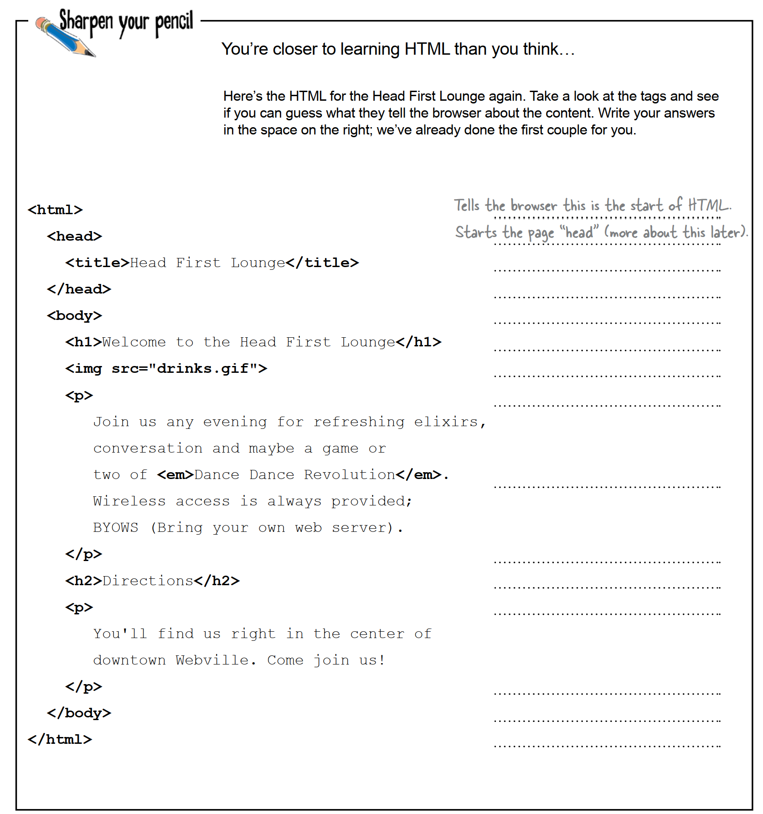

Second-level heading

Ends a paragraph

Emphasized content which will be rendered as italics in a paragraph

Starts the body of the page.

Ends the page “head”

Define title of the page

End of HTML

Ends the body

Ends a paragraph

Top-level heading

Starts a paragraph

Starts a paragraph

Display an image

## Giving content in the form of image below, determine HTML tag

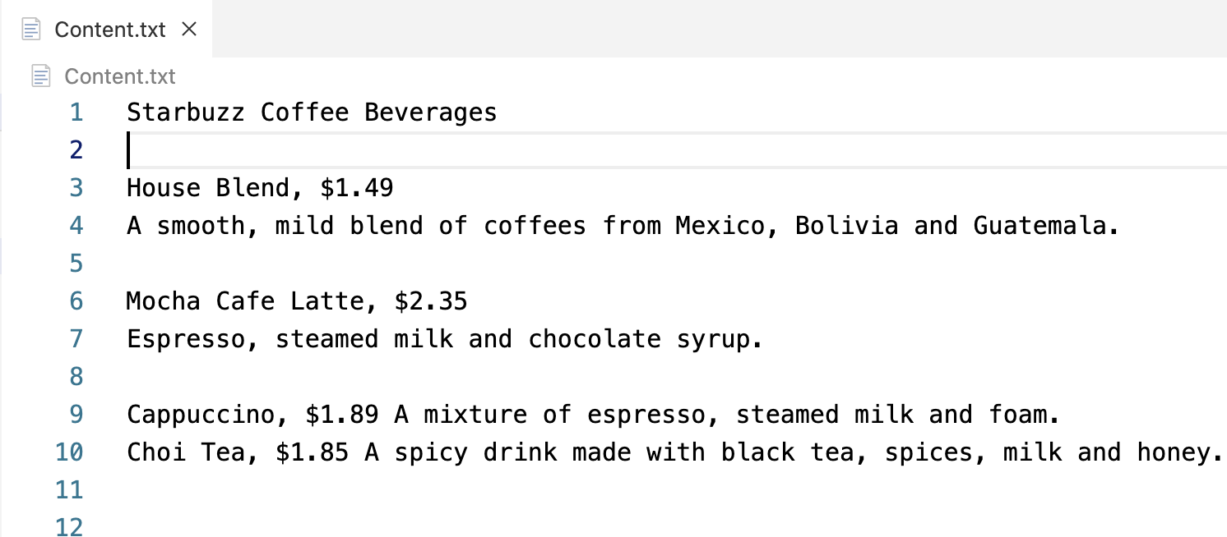

## Transform the content in Exercise 2 to HTML and display in Browser

## Upload content to Awardspace and enjoy your result

<http://21070239-vnuis.atwebpages.com/lecture3.html>