Nội dung
Hibernate One To Many (@OneToMany, @ManyToOne) 1
Cơ sở dữ liệu: 1
Công nghệ sử dụng: 1
Mô hình project: 2
Thư viện (pom.xml) 2
Cấu hình hibernateJPA với persistence.xml 3
Các thực thể tương ứng: 3
Company (Company.java) 3
Employee(Employee.java) 4
Chèn dữ liệu: 5
Truy xuất dữ liệu: 6

Hibernate One To Many (@OneToMany, @ManyToOne)
Mối quan hệ một-nhiều many-to-one và one-to-many trong Hibernate là loại kết hợp phổ biến nhất, nơi một đối tượng có thể được liên kết với nhiều đối tượng.
Ví dụ như: một công ty có nhiều nhân viên:
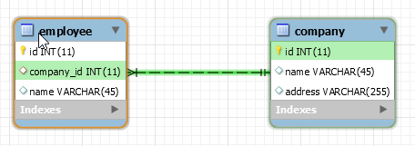

Cơ sở dữ liệu:
CREATE SCHEMA `hibernate-demo` ;
CREATE TABLE `hibernate-demo`.`company` (
`id` INT NOT NULL AUTO_INCREMENT,
`name` VARCHAR(45) NULL,
`address` VARCHAR(255) NULL,
PRIMARY KEY (`id`));
CREATE TABLE `hibernate-demo`.`employee` (
`id` INT NOT NULL AUTO_INCREMENT,
`company_id` INT NULL,
`name` VARCHAR(45) NULL,
PRIMARY KEY (`id`),
CONSTRAINT `emp-company`
FOREIGN KEY (`company_id`)
REFERENCES `hibernate-demo`.`company` (`id`));

Công nghệ sử dụng:
- MySQL
- Maven
- Hibernate JPA

Mô hình project:
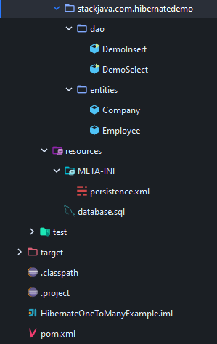

Thư viện (pom.xml)
<?xml version="1.0" encoding="UTF-8"?>
<project xmlns="http://maven.apache.org/POM/4.0.0"
xmlns:xsi="http://www.w3.org/2001/XMLSchema-instance"
xsi:schemaLocation="http://maven.apache.org/POM/4.0.0 http://maven.apache.org/xsd/maven-4.0.0.xsd">
<modelVersion>4.0.0</modelVersion>
<groupId>groupId</groupId>
<artifactId>viduHibernateJPA</artifactId>
<version>1.0-SNAPSHOT</version>
<properties>
<maven.compiler.source>1.11</maven.compiler.source>
<maven.compiler.target>1.11</maven.compiler.target>
</properties>
<dependencies>
<dependency>
<groupId>org.hibernate</groupId>
<artifactId>hibernate-core</artifactId>
<version>5.4.12.Final</version>
</dependency>
<dependency>
<groupId>org.hibernate</groupId>
<artifactId>hibernate-entitymanager</artifactId>
<version>5.4.12.Final</version>
</dependency>
<dependency>
<groupId>mysql</groupId>
<artifactId>mysql-connector-java</artifactId>
<version>8.0.19</version>
</dependency>
</dependencies>
</project>

Cấu hình hibernateJPA với persistence.xml
<?xml version="1.0" encoding="UTF-8"?>
<persistence xmlns="http://java.sun.com/xml/ns/persistence" version="2.0">
<persistence-unit name="persistence">
<description>Demo Hibernate Entity Manager</description>
<provider>org.hibernate.jpa.HibernatePersistenceProvider</provider>
<properties>
<property name="javax.persistence.jdbc.driver" value="com.mysql.jdbc.Driver" />
<property name="javax.persistence.jdbc.url"
value="jdbc:mysql://localhost:3306/hibernate-demo" />
<property name="javax.persistence.jdbc.user" value="root" />
<property name="javax.persistence.jdbc.password" value="Admin123" />
<property name="hibernate.show_sql" value="true" />
<property name="hibernate.connection.provider_disables_autocommit" value="true"/>
</properties>
</persistence-unit>
</persistence>

Các thực thể tương ứng:

Company (Company.java)
package stackjava.com.hibernatedemo.entities;
import java.util.HashSet;
import java.util.Set;
import javax.persistence.Column;
import javax.persistence.Entity;
import javax.persistence.FetchType;
import javax.persistence.GeneratedValue;
import javax.persistence.GenerationType;
import javax.persistence.Id;
import javax.persistence.OneToMany;
import javax.persistence.Table;
@Entity
@Table(name = "company")
public class Company {
@Id
@Column(name = "id")
@GeneratedValue(strategy = GenerationType.IDENTITY)
private Integer id;
@Column(name = "name")
private String name;
@OneToMany(fetch = FetchType.LAZY, mappedBy = "company")
private Set<Employee> listEmployee = new HashSet<>();
public Integer getId() {
return id;
}
public void setId(Integer id) {
this.id = id;
}
public String getName() {
return name;
}
public void setName(String name) {
this.name = name;
}
public Set<Employee> getListEmployee() {
return listEmployee;
}
public void setListEmployee(Set<Employee> listEmployee) {
this.listEmployee = listEmployee;
}
@Override
public String toString() {
return "Company [id=" + id + ", name=" + name + "]";
}
}

Employee(Employee.java)
package stackjava.com.hibernatedemo.entities;
import javax.persistence.Column;
import javax.persistence.Entity;
import javax.persistence.GeneratedValue;
import javax.persistence.GenerationType;
import javax.persistence.Id;
import javax.persistence.JoinColumn;
import javax.persistence.ManyToOne;
import javax.persistence.Table;
@Entity
@Table(name = "employee")
public class Employee {
@Id
@Column(name = "id")
@GeneratedValue(strategy = GenerationType.IDENTITY)
private Integer id;
@Column(name = "name")
private String name;
@ManyToOne
@JoinColumn(name = "company_id", nullable = false)
private Company company;
public Integer getId() {
return id;
}
public void setId(Integer id) {
this.id = id;
}
public String getName() {
return name;
}
public void setName(String name) {
this.name = name;
}
public Company getCompany() {
return company;
}
public void setCompany(Company company) {
this.company = company;
}
@Override
public String toString() {
return "Employee [id=" + id + ", name=" + name + ", company=" + company + "]";
}
}

Chèn dữ liệu:
package stackjava.com.hibernatedemo.dao;
import javax.persistence.EntityManager;
import javax.persistence.EntityManagerFactory;
import javax.persistence.Persistence;
import stackjava.com.hibernatedemo.entities.Company;
import stackjava.com.hibernatedemo.entities.Employee;
public class DemoInsert {
public static void main(String[] args) {
EntityManagerFactory entityManagerFactory = Persistence.createEntityManagerFactory("persistence");
EntityManager entityManager = entityManagerFactory.createEntityManager();
entityManager.getTransaction().begin();
Company company = new Company();
company.setName("Google");
entityManager.persist(company);
Employee emp1 = new Employee();
emp1.setName("kai");
emp1.setCompany(company);
Employee emp2 = new Employee();
emp2.setName("sena");
emp2.setCompany(company);
entityManager.persist(emp1);
entityManager.persist(emp2);
entityManager.getTransaction().commit();
System.out.println("--------- after insert -------------");
System.out.println(company);
System.out.println(emp1);
System.out.println(emp2);
entityManager.close();
entityManagerFactory.close();
}
}

Kết quả:
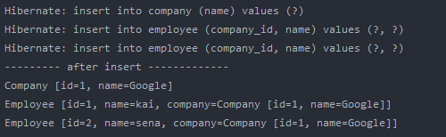

Truy xuất dữ liệu:
package stackjava.com.hibernatedemo.dao;
import javax.persistence.EntityManager;
import javax.persistence.EntityManagerFactory;
import javax.persistence.Persistence;
import stackjava.com.hibernatedemo.entities.Company;
public class DemoSelect {
public static void main(String[] args) {
EntityManagerFactory entityManagerFactory = Persistence.createEntityManagerFactory("persistence");
EntityManager entityManager = entityManagerFactory.createEntityManager();
entityManager.getTransaction().begin();
Company company = entityManager.find(Company.class, 1);
System.out.println(company);
company.getListEmployee().forEach(employee -> System.out.println(employee));
entityManager.getTransaction().commit();
entityManager.close();
entityManagerFactory.close();
}
}

Kết quả:
