Grid

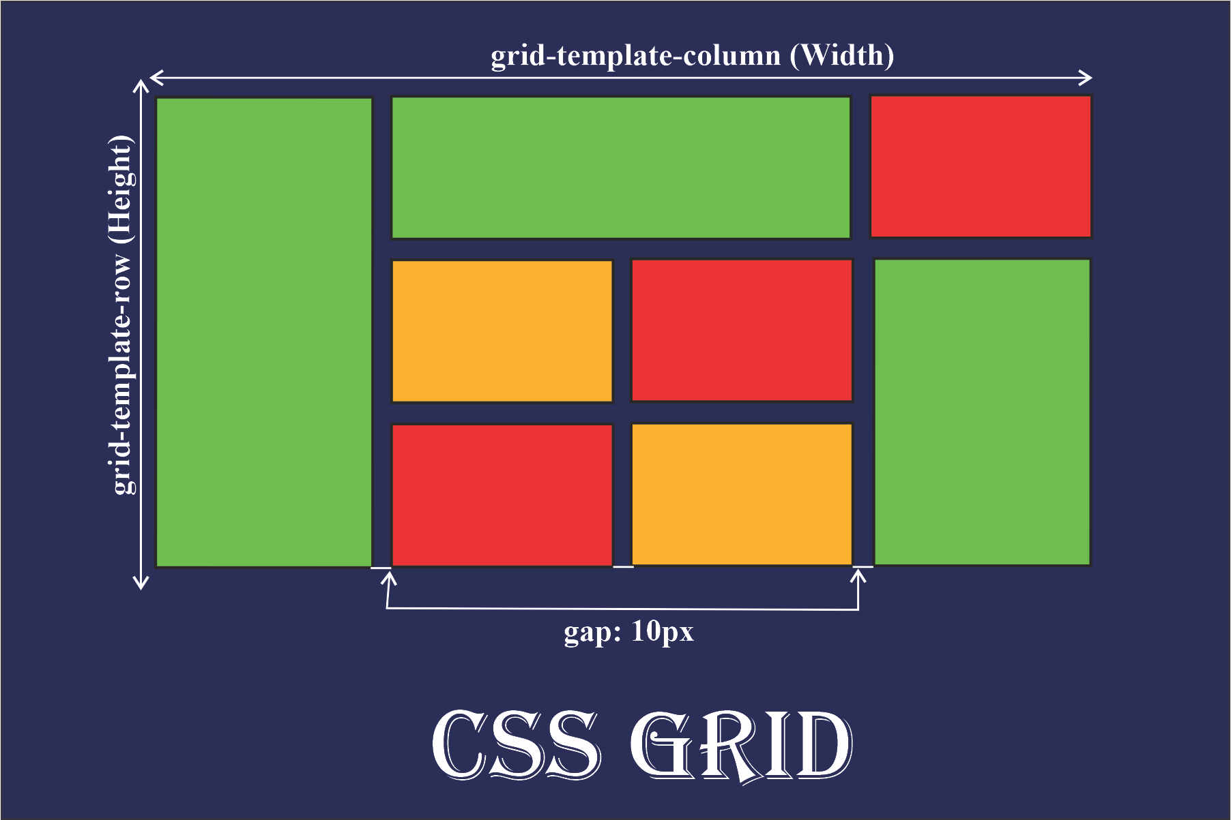

Index
1. Dividir en 2 columnas iguales: 3
2. Dividir en 3 columnas iguales: 4
3. Dividir en 4 columnas desiguales: 5
4. Disposición tipo galería: 6
5. Cabecera, contenido y pie de página: 8
6. Un diseño de 2x2: 10
7. Layout "sidebar": 12
8. Distribución flexible: 14
9. División asimétrica: 15
10. Superponer elementos: 16
11. Diseño tipo blog: 17
12. Grid responsivo: 19
13. Un mosaico desordenado: 21
14. Cuadrícula alineada: 23
15. Diseño de dashboard: 25
16. Diagrama de áreas: 27
17. Rejilla fija con espaciado: 29
18. Diseño tipo tablero de ajedrez: 31
19. Diseño complejo: 34
20. Grid anidado: 36

1. Dividir en 2 columnas iguales:

HTML:
<!DOCTYPE html>
<html lang="en">
<head>
<meta charset="UTF-8">
<meta name="viewport" content="width=device-width, initial-scale=1.0">
<title>Exercise 10 - Jose</title>
<link rel="stylesheet" href="style.css">
</head>
<body>
<div class="grid-container">
<div class="grid-item">1</div>
<div class="grid-item">2</div>
<div class="grid-item">2</div>
</div>
</body>
</html>

CSS:
body{
background-color: gray;
}

.grid-container {
display: grid;
grid-template-columns: auto auto;
background-color: #a51616;
padding: 10px;
}

.grid-item {
background-color: rgba(0, 0, 0, 0.8);
border: 1px solid white;
color: antiquewhite;
padding: 20px;
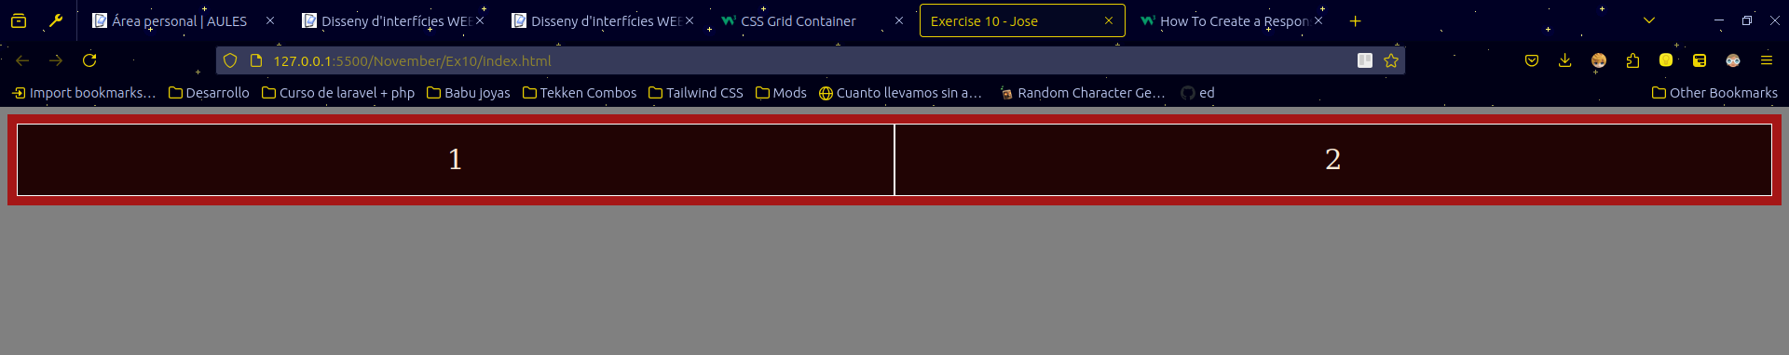
font-size: 30px;
text-align: center;
}

2. Dividir en 3 columnas iguales:

HTML:
<!DOCTYPE html>
<html lang="en">
<head>
<meta charset="UTF-8">
<meta name="viewport" content="width=device-width, initial-scale=1.0">
<title>Exercise 10 - Jose</title>
<link rel="stylesheet" href="style.css">
</head>
<body>
<div class="grid-container">
<div class="grid-item">1</div>
<div class="grid-item">2</div>
<div class="grid-item">3</div>
</div>
</body>
</html>

CSS:
body{
background-color: gray;
}

.grid-container {
display: grid;
grid-template-columns: auto auto auto;
background-color: #a51616;
padding: 10px;
}

.grid-item {
background-color: rgba(0, 0, 0, 0.8);
border: 1px solid white;
color: antiquewhite;
padding: 20px;
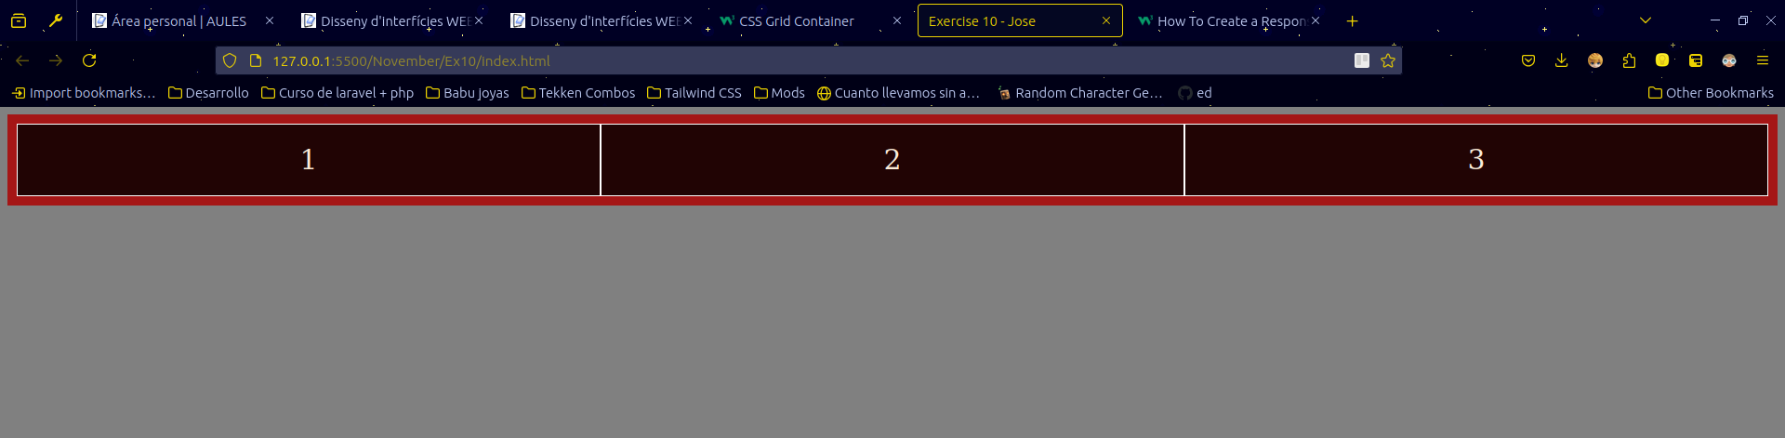
font-size: 30px;
text-align: center;
}

3. Dividir en 4 columnas desiguales:

HTML:
<!DOCTYPE html>
<html lang="en">
<head>
<meta charset="UTF-8">
<meta name="viewport" content="width=device-width, initial-scale=1.0">
<title>Exercise 10 - Jose</title>
<link rel="stylesheet" href="style.css">
</head>
<body>
<div class="grid-container">
<div class="grid-item">1</div>
<div class="grid-item">2</div>
<div class="grid-item">3</div>
<div class="grid-item">4</div>
</div>
</body>
</html>

CSS:
body{
background-color: gray;
}

.grid-container {
display: grid;
grid-template-columns: 10% 20% 30% 40%;
background-color: #a51616;
padding: 10px;
}

.grid-item {
background-color: rgba(0, 0, 0, 0.8);
border: 1px solid white;
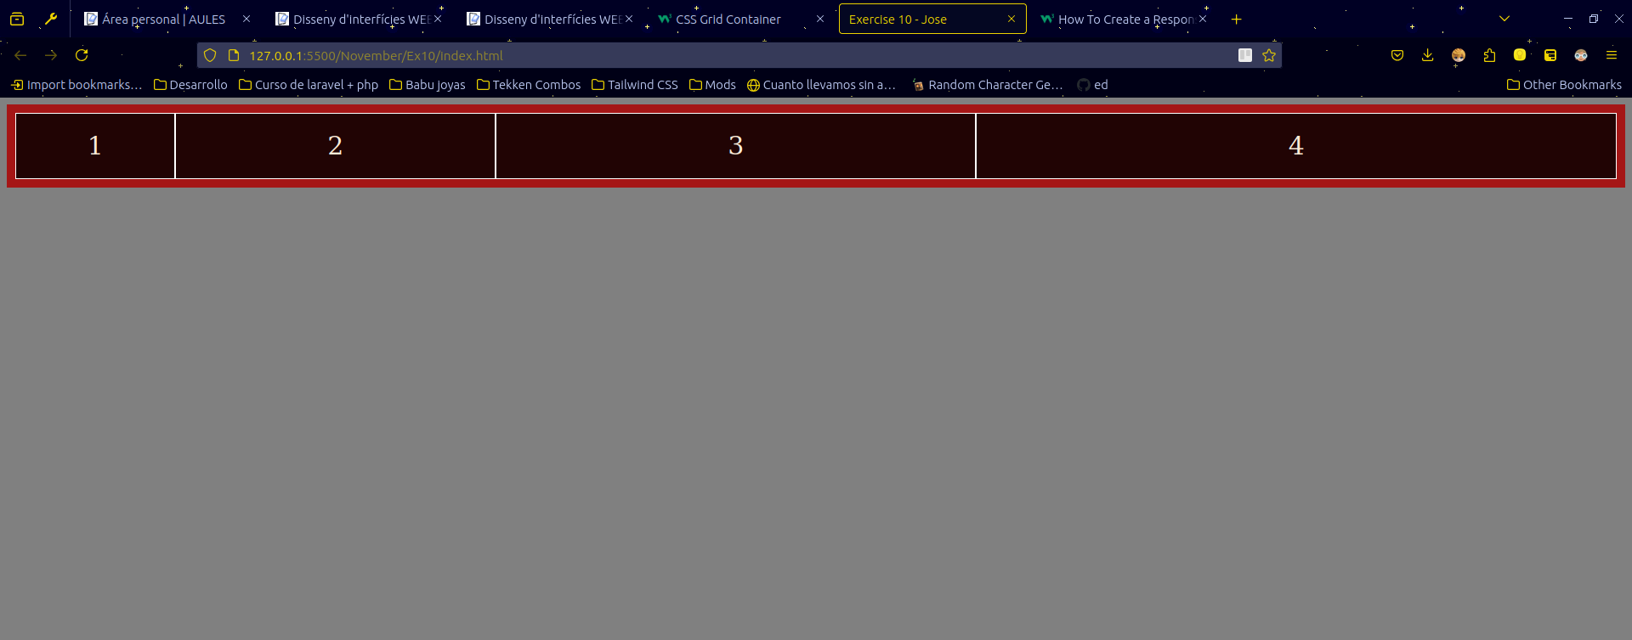
color: antiquewhite;
padding: 20px;
font-size: 30px;
text-align: center;
}

4. Disposición tipo galería:

HTML:
<!DOCTYPE html>
<html lang="en">
<head>
<meta charset="UTF-8">
<meta name="viewport" content="width=device-width, initial-scale=1.0">
<title>Exercise 10 - Jose</title>
<link rel="stylesheet" href="style.css">
</head>
<body>
<div class="grid-container">
<div class="grid-item">1</div>
<div class="grid-item">2</div>
<div class="grid-item">3</div>
<div class="grid-item">4</div>
<div class="grid-item">5</div>
<div class="grid-item">6</div>
<div class="grid-item">7</div>
<div class="grid-item">8</div>
<div class="grid-item">9</div>
</div>
</body>
</html>

CSS:
body{
display: flex;
background-color: gray;
justify-content: center;
margin-top: 10%;
}

.grid-container {
display: grid;
/* grid-template-columns: auto auto auto; */
/* Esto de acá abajo es lo mismo que la línea comentada de aquí, descubrí esto tonteando xD */
grid-template-columns: repeat(3, auto);
grid-gap: 10px;
background-color: #a51616;
padding: 10px;
width: fit-content;
}

.grid-item {
background-color: rgba(0, 0, 0, 0.8);
border: 1px solid white;
color: antiquewhite;
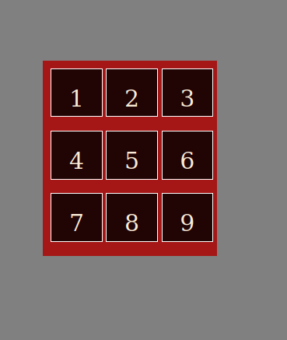
padding: 20px;
font-size: 30px;
text-align: center;
height: 40%;
width: 40%;
padding-bottom: 20%;
}

5. Cabecera, contenido y pie de página:

HTML:
<!DOCTYPE html>
<html lang="en">
<head>
<meta charset="UTF-8">
<meta name="viewport" content="width=device-width, initial-scale=1.0">
<title>Exercise 10 - Jose</title>
<link rel="stylesheet" href="style.css">
</head>
<body>
<header>
Header
<hr>
</header>

<main>
<p>Lorem ipsum dolor sit amet consectetur adipisicing elit. Accusamus adipisci amet vitae id ipsa temporibus quidem nam pariatur nulla quam nesciunt numquam animi beatae, aperiam atque aspernatur, tempore, laudantium quibusdam.</p>
<p>Lorem ipsum dolor sit amet consectetur adipisicing elit. Accusamus adipisci amet vitae id ipsa temporibus quidem nam pariatur nulla quam nesciunt numquam animi beatae, aperiam atque aspernatur, tempore, laudantium quibusdam.</p>
</main>

<footer>
Footer
</footer>
</body>
</html>

CSS:
body{
display: grid;
background-color: gray;
justify-content: center;
margin: 0;
grid-template-rows: auto 1fr auto;
min-height: 100vh;
}

header{
text-align: center;
font-size: 50px;
padding: 3px;
}

main{
padding: 30px;
}

footer{
background-color: black;
color: antiquewhite;
position: sticky;
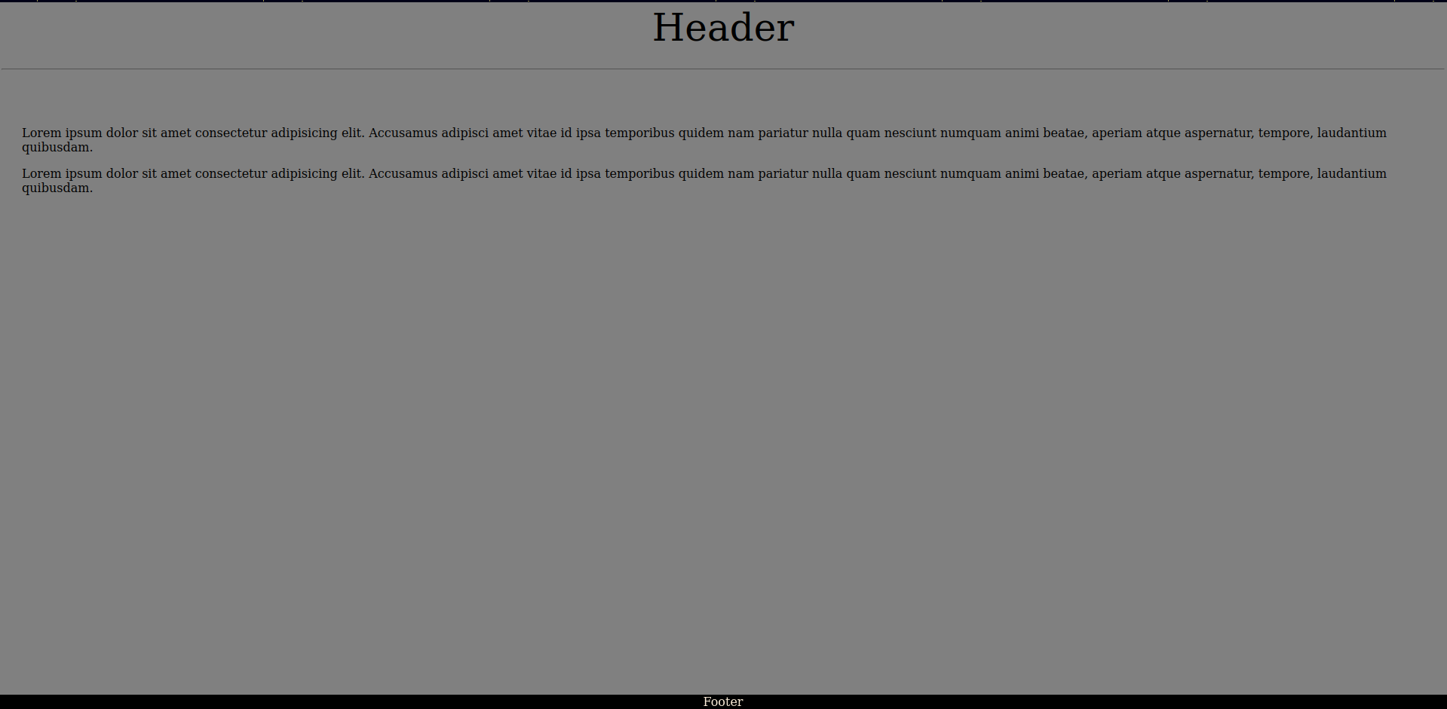
text-align: center;
bottom: 0;
}

6. Un diseño de 2x2:

HTML:
<!DOCTYPE html>
<html lang="en">
<head>
<meta charset="UTF-8">
<meta name="viewport" content="width=device-width, initial-scale=1.0">
<title>Exercise 10 - Jose</title>
<link rel="stylesheet" href="style.css">
</head>
<body>
<div class="grid-container">
<div class="grid-item">1</div>
<div class="grid-item">2</div>
<div class="grid-item">3</div>
<div class="grid-item">4</div>
</div>
</body>
</html>

CSS:
body{
display: flex;
background-color: gray;
justify-content: center;
margin-top: 10%;
}
.grid-container {
display: grid;
grid-template-columns: repeat(2, auto);
grid-template-rows: repeat(2, auto);
grid-gap: 10px;
background-color: #a51616;
padding: 10px;
width: fit-content;
}
.grid-item {
background-color: rgba(0, 0, 0, 0.8);
border: 1px solid white;
color: antiquewhite;
padding: 20px;
font-size: 30px;
text-align: center;
height: 40%;
width: 40%;
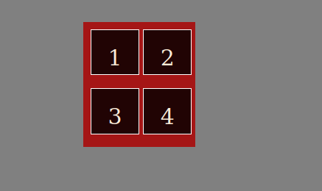
padding-bottom: 20%;
}

7. Layout "sidebar":

HTML:
<!DOCTYPE html>
<html lang="en">
<head>
<meta charset="UTF-8">
<meta name="viewport" content="width=device-width, initial-scale=1.0">
<title>Exercise 10 - Jose</title>
<link rel="stylesheet" href="style.css">
</head>
<body>
<!-- | Container | -->
<div class="container">

<!-- | Sidebar | -->
<div class="sidebar">
<ul>
<li>Home</li>
<li>Contacto</li>
<li>Abouto</li>
</ul>
</div>

<!-- | Contenido | -->
<div class="content">
<p>Lorem ipsum dolor sit amet consectetur adipisicing elit. Aperiam, aliquid sunt nulla dolore nobis, maxime nesciunt assumenda amet iste at magnam ullam, earum quasi alias deleniti. Beatae ipsam nam dolorum.</p>
</div>
</div>

</body>
</html>

CSS:
.container{
display: grid;
grid-template-columns: 25% 75%;
height: 100vh;
}
.content{
justify-content: center;
padding: 20px;
background-color: rgb(196, 196, 196);
}

.sidebar{
justify-content: center;
background-color: rgb(56, 56, 56);
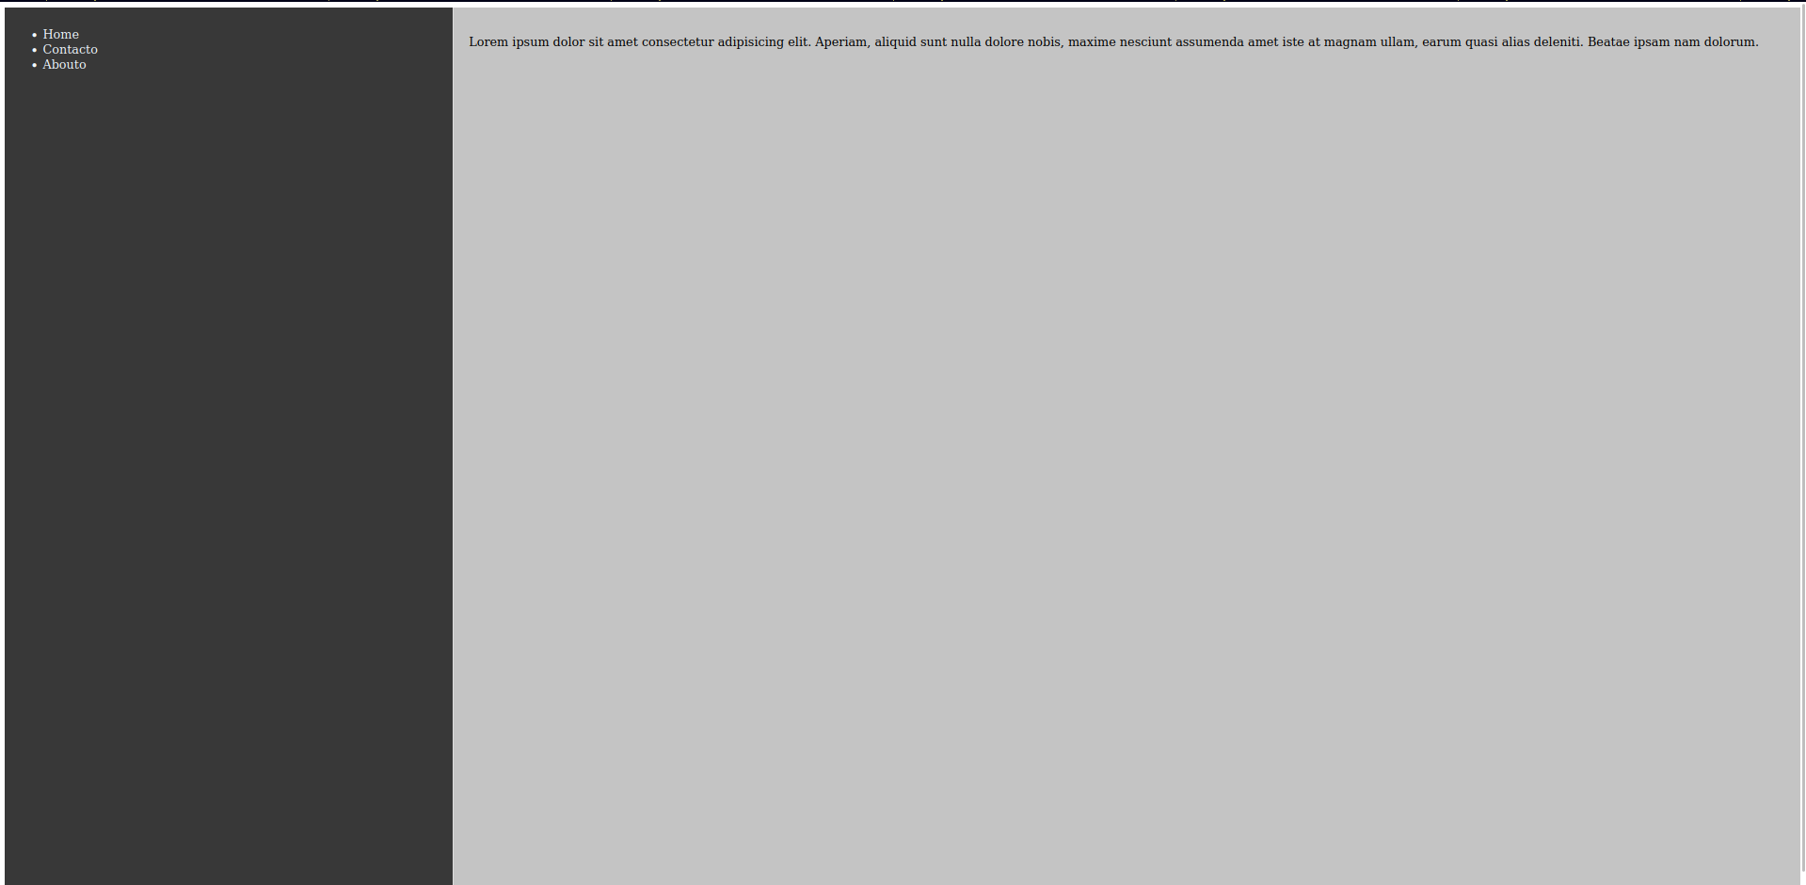
padding: 10px;
color: aliceblue;
border-right: 1px solid #ddd;
}

8. Distribución flexible:

HTML:
<!DOCTYPE html>
<html lang="en">
<head>
<meta charset="UTF-8">
<meta name="viewport" content="width=device-width, initial-scale=1.0">
<title>Exercise 10 - Jose</title>
<link rel="stylesheet" href="style.css">
</head>
<body>
<div class="grid-container">
<div class="grid-item">1</div>
<div class="grid-item">2</div>
<div class="grid-item">3</div>
<div class="grid-item">4</div>
</div>
</body>
</html>

CSS:
body{
display: flex;
background-color: gray;
justify-content: center;
margin-top: 10%;
}
.grid-container {
display: grid;
grid-template-columns: repeat( auto-fit, minmax(250px, 1px) );
grid-gap: 5px;
background-color: #a51616;
padding: 10px;
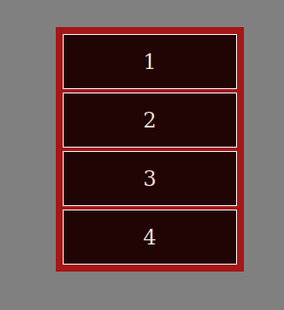
}
.grid-item {
background-color: rgba(0, 0, 0, 0.8);
border: 1px solid white;
color: antiquewhite;
padding: 20px;
font-size: 30px;
text-align: center;
}

9. División asimétrica:

HTML:
<!DOCTYPE html>
<html lang="en">
<head>
<meta charset="UTF-8">
<meta name="viewport" content="width=device-width, initial-scale=1.0">
<title>Exercise 10 - Jose</title>
<link rel="stylesheet" href="style.css">
</head>
<body>
<div class="grid-container">
<div class="grid-item">1</div>
<div class="grid-item">2</div>
<div class="grid-item">3</div>
</div>
</body>
</html>

CSS:
body{
display: flex;
background-color: gray;
justify-content: center;
margin-top: 10%;
}
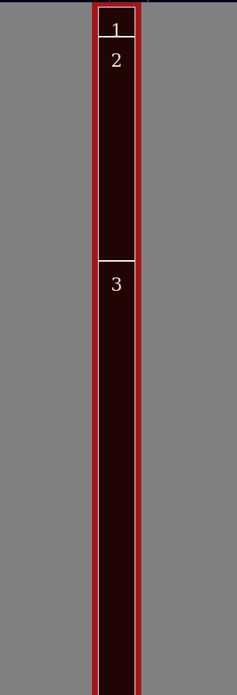
.grid-container {
display: grid;
grid-template-rows: 50px 1fr 2fr;
background-color: #a51616;
padding: 10px;
height: 100vh;
}
.grid-item {
background-color: rgba(0, 0, 0, 0.8);
border: 1px solid white;
color: antiquewhite;
padding: 20px;
font-size: 30px;
text-align: center;
}

10. Superponer elementos:

HTML:
<!DOCTYPE html>
<html lang="en">
<head>
<meta charset="UTF-8">
<meta name="viewport" content="width=device-width, initial-scale=1.0">
<title>Exercise 10 - Jose</title>
<link rel="stylesheet" href="style.css">
</head>
<body>
<div class="grid-container">
<div class="grid-item">
<div class="grid-item-small"></div>
</div>
</div>
</body>
</html>

CSS:
body{
display: flex;
background-color: gray;
justify-content: center;
margin-top: 10%;
}

.grid-container {
display: grid;
background-color: #a51616;
place-items: center;
padding: 10px;
}

.grid-item {
width: 200px;
height: 200px;
display: grid;
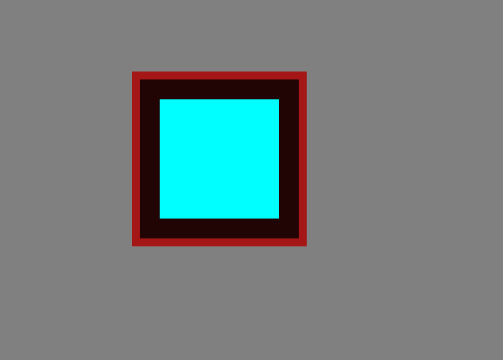
background-color: rgba(0, 0, 0, 0.8);
place-items: center;
}
.grid-item-small {
width: 150px;
height: 150px;
background-color: aqua;
}

11. Diseño tipo blog:
En este hice copia pega de lo que hice en el 7 porque fui imbecil y me puse a hacerlo antes de tiempo xD

HTML:
<!DOCTYPE html>
<html lang="en">
<head>
<meta charset="UTF-8">
<meta name="viewport" content="width=device-width, initial-scale=1.0">
<title>Exercise 10 - Jose</title>
<link rel="stylesheet" href="style.css">
</head>
<body>
<!-- | Container | -->
<div class="container">

<!-- | Sidebar | -->
<div class="sidebar">
<ul>
<li>Home</li>
<li>Contacto</li>
<li>Abouto</li>
</ul>
</div>

<!-- | Contenido | -->
<div class="content">
<p>Lorem ipsum dolor sit amet consectetur adipisicing elit. Aperiam, aliquid sunt nulla dolore nobis, maxime nesciunt assumenda amet iste at magnam ullam, earum quasi alias deleniti. Beatae ipsam nam dolorum.</p>
</div>
</div>

</body>
</html>

CSS:
.container{
display: grid;
grid-template-columns: 25% 75%;
height: 100vh;
}
.content{
justify-content: center;
padding: 20px;
background-color: rgb(196, 196, 196);
}

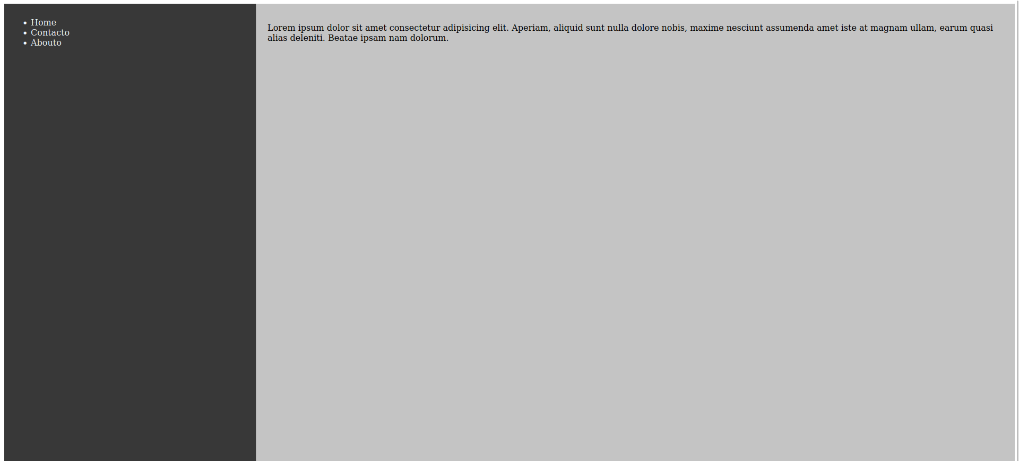
.sidebar{
justify-content: center;
background-color: rgb(56, 56, 56);
padding: 10px;
color: aliceblue;
border-right: 1px solid #ddd;
}

12. Grid responsivo:

HTML:
<!DOCTYPE html>
<html lang="en">
<head>
<meta charset="UTF-8">
<meta name="viewport" content="width=device-width, initial-scale=1.0">
<title>Exercise 10 - Jose</title>
<link rel="stylesheet" href="style.css">
</head>
<body>
<div class="grid-container">
<div class="grid-item">1</div>
<div class="grid-item">2</div>
<div class="grid-item">3</div>
<div class="grid-item">4</div>
<div class="grid-item">5</div>
<div class="grid-item">6</div>
<div class="grid-item">7</div>
<div class="grid-item">8</div>
<div class="grid-item">9</div>
</div>
</body>
</html>

CSS:
body{
display: flex;
background-color: gray;
justify-content: center;
margin-top: 10%;
}
.grid-container {
display: grid;
grid-template-columns: repeat(3, auto);
grid-gap: 10px;
background-color: #a51616;
padding: 10px;
width: fit-content;
}
.grid-item {
background-color: rgba(0, 0, 0, 0.8);
border: 1px solid white;
color: antiquewhite;
padding: 20px;
font-size: 30px;
text-align: center;
height: 40px;
width: 40px;
padding-bottom: 20%;
}

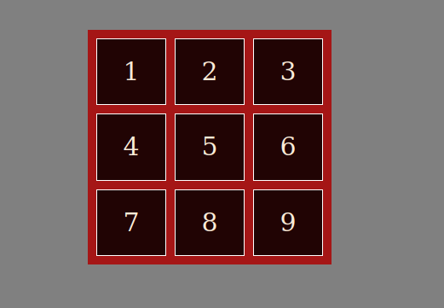
@media only screen and (max-width: 600px) {
.grid-container {
grid-template-columns: repeat(1, auto);
}
}

13. Un mosaico desordenado:

HTML:
<!DOCTYPE html>
<html lang="en">
<head>
<meta charset="UTF-8">
<meta name="viewport" content="width=device-width, initial-scale=1.0">
<title>Exercise 10 - Jose</title>
<link rel="stylesheet" href="style.css">
</head>
<body>
<div class="grid-container">
<div class="grid-item babu1">1</div>
<div class="grid-item babu2">2</div>
<div class="grid-item babu3">3</div>
<div class="grid-item">4</div>
<div class="grid-item">5</div>
</div>
</body>
</html>

CSS:
body{
background-color: gray;
justify-content: center;
margin-top: 10%;
}
.grid-container {
display: grid;
grid-template-columns: repeat(4, 1fr);
grid-template-rows: repeat(2, 100px);
background-color: red;
padding: 10px;
gap: 10px;
}
.grid-item {
background-color: rgba(0, 0, 0, 0.8);
border: 1px solid rgba(43, 39, 39, 0.8);
color: antiquewhite;
display: flex;
justify-content: center;
align-items: center;
}
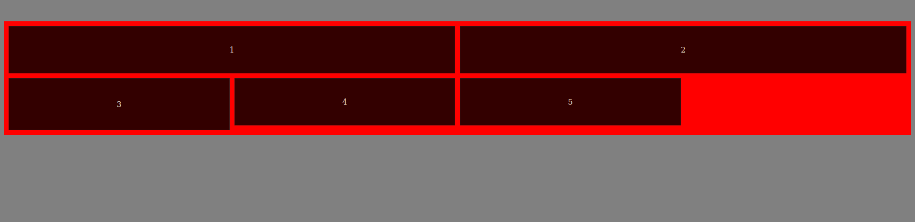
.babu1 { grid-column: span 2; }
.babu2 { grid-column: span 2; }
.babu3 { grid-row: span 2; }

14. Cuadrícula alineada:

HTML:
<!DOCTYPE html>
<html lang="en">
<head>
<meta charset="UTF-8">
<meta name="viewport" content="width=device-width, initial-scale=1.0">
<title>Exercise 10 - Jose</title>
<link rel="stylesheet" href="style.css">
</head>
<body>
<div class="grid-container">
<div class="grid-item">1</div>
<div class="grid-item">2</div>
<div class="grid-item">3</div>
<div class="grid-item">4</div>
<div class="grid-item">5</div>
<div class="grid-item">6</div>
<div class="grid-item">7</div>
<div class="grid-item">8</div>
<div class="grid-item">9</div>
</div>
</body>
</html>

CSS:
body{
display: flex;
background-color: gray;
justify-content: center;
margin-top: 10%;
}
.grid-container {
display: grid;
grid-template-columns: repeat(3, 80px);
grid-template-rows: repeat(3, 80px);
gap: 10px;
background-color: #a51616;
padding: 10px;
width: fit-content;
}
.grid-item {
background-color: rgba(0, 0, 0, 0.8);
border: 1px solid rgba(43, 39, 39, 0.8);
color: antiquewhite;
display: flex;
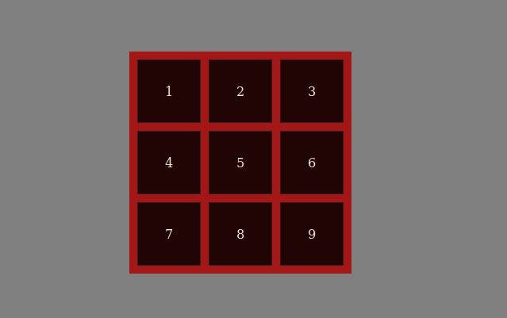
justify-content: center;
align-items: center;
}

15. Diseño de dashboard:
En este fui muy vago y lo pille muy fuerte del copilot haciendo mis modificaciones y entendiendolo, srry xD

HTML:
<!DOCTYPE html>
<html lang="en">
<head>
<meta charset="UTF-8">
<meta name="viewport" content="width=device-width, initial-scale=1.0">
<title>Exercise 10 - Jose</title>
<link rel="stylesheet" href="style.css">
</head>
<body>
<header>
<h1>SOCORRO BABU TÍO</h1>
</header>
<aside>
<h2>Sidebar</h2>
<ul>
<li><a href="#">Home</a></li>
<li><a href="#">Babu</a></li>
<li><a href="#">COntact</a></li>
<li><a href="#">About</a></li>
</ul>
</aside>
<main>
<h2>Yo folks</h2>
<p>Lorem ipsum dolor sit amet consectetur adipisicing elit. Nam, quidem rem error ducimus nemo laudantium eum sapiente maxime odit natus, doloremque, omnis laborum porro iusto debitis nostrum exercitationem dolore aliquid?</p>
<p>Lorem ipsum dolor sit amet consectetur adipisicing elit. Nam, quidem rem error ducimus nemo laudantium eum sapiente maxime odit natus, doloremque, omnis laborum porro iusto debitis nostrum exercitationem dolore aliquid?</p>
<p>Lorem ipsum dolor sit amet consectetur adipisicing elit. Nam, quidem rem error ducimus nemo laudantium eum sapiente maxime odit natus, doloremque, omnis laborum porro iusto debitis nostrum exercitationem dolore aliquid?</p>
<p>Lorem ipsum dolor sit amet consectetur adipisicing elit. Nam, quidem rem error ducimus nemo laudantium eum sapiente maxime odit natus, doloremque, omnis laborum porro iusto debitis nostrum exercitationem dolore aliquid?</p>

</main>
<div class="panel">
<h2>Extras</h2>
<img src="https://cdn.pixabay.com/photo/2019/01/25/15/31/smoking-3954750_640.jpg" width="60px">
</div>
</body>
</html>

CSS:
body {
display: grid;
/* Esto de acá es una fumada que vi que me hizo gracia :x */
/* En cada elemento defines con grid-area el nombre y te sirve para manejar después el grid-template xD */
background-color: gray;
grid-template-areas:
"header header header"
"mrbabu-navegation main panel";
grid-template-columns: 0.7fr 4fr 0.5fr;
grid-template-rows: auto 1fr;
height: 100vh;
margin: 0;
}
header {
grid-area: header;
padding: 20px;
background-color: rgb(110, 26, 26);
text-align: center;
}
aside {
grid-area: mrbabu-navegation;
background-color: #e9ecef;
border-right: black solid 1px;
padding: 20px;
}
main {
grid-area: main;
padding: 20px;

}
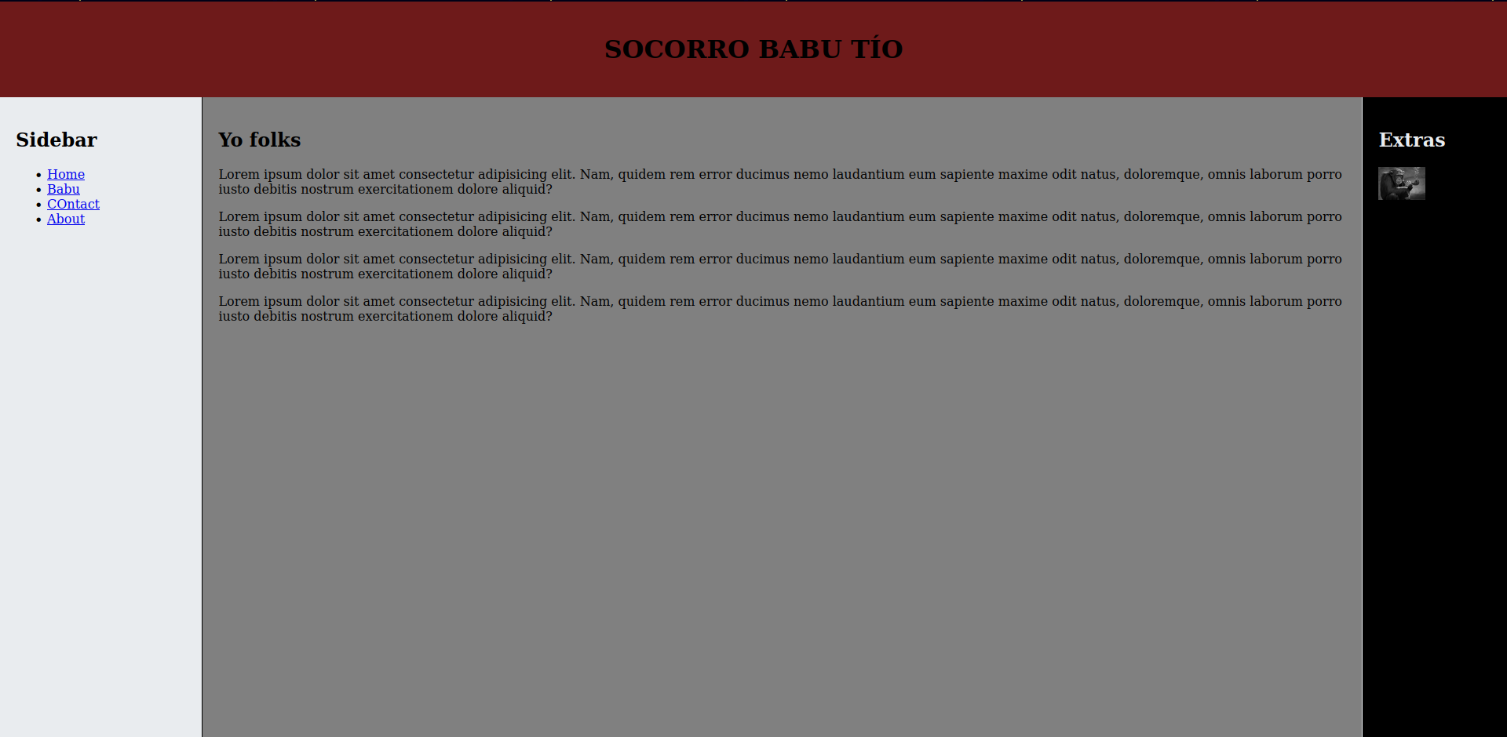
.panel {
grid-area: panel;
background-color: #000000;
color: #e9ecef;
border-left: #e9ecef solid 1px;
padding: 20px;
}

16. Diagrama de áreas:

HTML:
<!DOCTYPE html>
<html lang="en">
<head>
<meta charset="UTF-8">
<meta name="viewport" content="width=device-width, initial-scale=1.0">
<title>Exercise 10 - Jose</title>
<link rel="stylesheet" href="style.css">
</head>
<body>
<header>
<h1>SOCORRO BABU TÍO</h1>
</header>
<aside>
<h2>Sidebar</h2>
<ul>
<li><a href="#">Home</a></li>
<li><a href="#">Babu</a></li>
<li><a href="#">COntact</a></li>
<li><a href="#">About</a></li>
</ul>
</aside>
<main>
<h2>Yo folks</h2>
<p>Lorem ipsum dolor sit amet consectetur adipisicing elit. Nam, quidem rem error ducimus nemo laudantium eum sapiente maxime odit natus, doloremque, omnis laborum porro iusto debitis nostrum exercitationem dolore aliquid?</p>
<p>Lorem ipsum dolor sit amet consectetur adipisicing elit. Nam, quidem rem error ducimus nemo laudantium eum sapiente maxime odit natus, doloremque, omnis laborum porro iusto debitis nostrum exercitationem dolore aliquid?</p>
<p>Lorem ipsum dolor sit amet consectetur adipisicing elit. Nam, quidem rem error ducimus nemo laudantium eum sapiente maxime odit natus, doloremque, omnis laborum porro iusto debitis nostrum exercitationem dolore aliquid?</p>
<p>Lorem ipsum dolor sit amet consectetur adipisicing elit. Nam, quidem rem error ducimus nemo laudantium eum sapiente maxime odit natus, doloremque, omnis laborum porro iusto debitis nostrum exercitationem dolore aliquid?</p>

</main>

<footer>
Footer
</footer>
</body>
</html>

CSS:
body {
display: grid;
background-color: gray;
grid-template-areas:
"header header header"
"mrbabu-navegation main main"
"footer footer footer";
grid-template-columns: 0.7fr 4fr;
justify-content: center;
grid-template-rows: auto 1fr auto;
height: 100vh;
margin: 0;
}
header {
grid-area: header;
padding: 20px;
background-color: rgb(110, 26, 26);
text-align: center;
}
aside {
grid-area: mrbabu-navegation;
background-color: #e9ecef;
border-right: black solid 1px;
padding: 20px;
}
main {
grid-area: main;
padding: 20px;

}
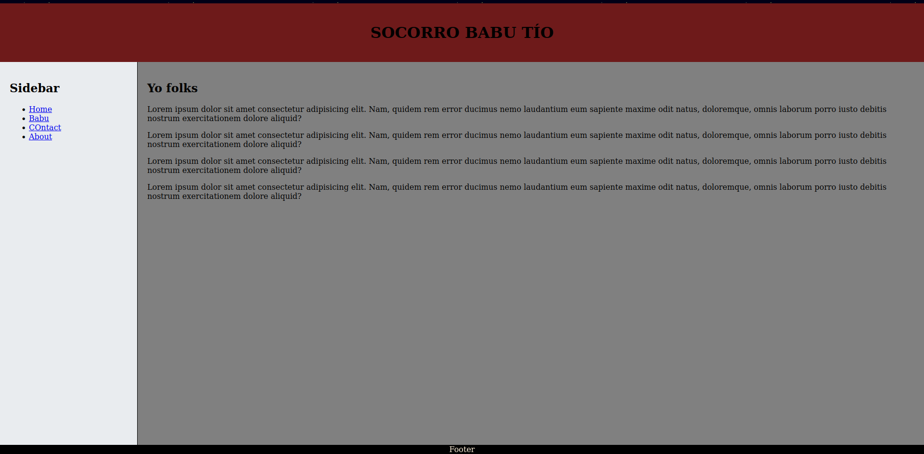
footer{
grid-area: footer;
background-color: black;
color: antiquewhite;
position: sticky;
text-align: center;
bottom: 0;
}

17. Rejilla fija con espaciado:

HTML:
<!DOCTYPE html>
<html lang="en">
<head>
<meta charset="UTF-8">
<meta name="viewport" content="width=device-width, initial-scale=1.0">
<title>Exercise 10 - Jose</title>
<link rel="stylesheet" href="style.css">
</head>
<body>
<div class="grid-container">
<div class="grid-item">1</div>
<div class="grid-item">2</div>
<div class="grid-item">3</div>
<div class="grid-item">4</div>
<div class="grid-item">5</div>
<div class="grid-item">6</div>
<div class="grid-item">7</div>
<div class="grid-item">8</div>
<div class="grid-item">9</div>
<div class="grid-item">10</div>
<div class="grid-item">11</div>
<div class="grid-item">12</div>
<div class="grid-item">13</div>
<div class="grid-item">14</div>
<div class="grid-item">15</div>
<div class="grid-item">16</div>
</div>
</body>
</html>

CSS:
body{
display: flex;
background-color: gray;
justify-content: center;
margin-top: 10%;
}

.grid-container {
display: grid;
grid-template-columns: repeat(4, 1fr);
grid-template-rows: repeat(4, 1fr);
gap: 10px;
background-color: #a51616;
padding: 10px;
width: fit-content;
}

.grid-item {
background-color: rgba(0, 0, 0, 0.8);
border: 1px solid white;
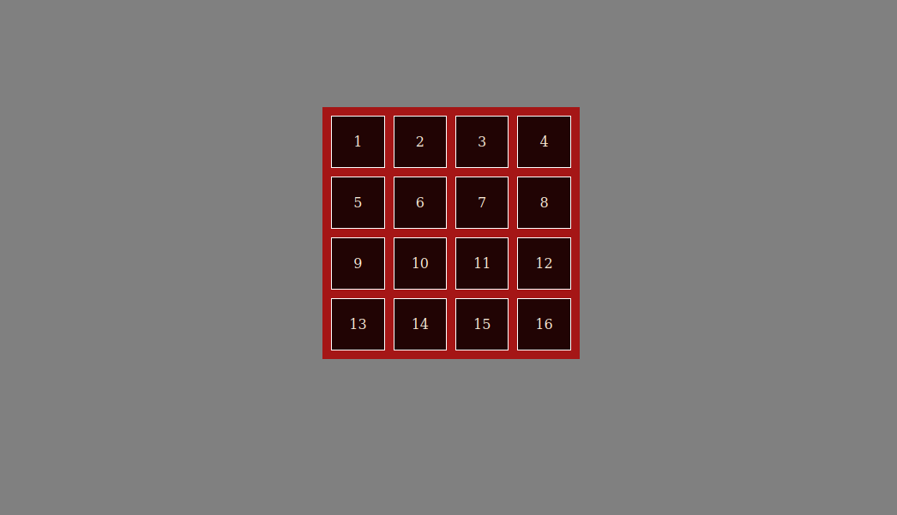
color: antiquewhite;
padding: 20px;
text-align: center;
}

18. Diseño tipo tablero de ajedrez:

HTML:
<!DOCTYPE html>
<html lang="en">
<head>
<meta charset="UTF-8">
<meta name="viewport" content="width=device-width, initial-scale=1.0">
<title>Exercise 10 - Jose</title>
<link rel="stylesheet" href="style.css">
</head>
<body>
<div class="tablerin">
<!-- Fila 1 -->
<div class="square-einx white"></div>
<div class="square-einx black"></div>
<div class="square-einx white"></div>
<div class="square-einx black"></div>
<div class="square-einx white"></div>
<div class="square-einx black"></div>
<div class="square-einx white"></div>
<div class="square-einx black"></div>
<!-- Fila 2 -->
<div class="square-einx black"></div>
<div class="square-einx white"></div>
<div class="square-einx black"></div>
<div class="square-einx white"></div>
<div class="square-einx black"></div>
<div class="square-einx white"></div>
<div class="square-einx black"></div>
<div class="square-einx white"></div>
<!-- Fila 3 -->
<div class="square-einx white"></div>
<div class="square-einx black"></div>
<div class="square-einx white"></div>
<div class="square-einx black"></div>
<div class="square-einx white"></div>
<div class="square-einx black"></div>
<div class="square-einx white"></div>
<div class="square-einx black"></div>
<!-- Fila 4 -->
<div class="square-einx black"></div>
<div class="square-einx white"></div>
<div class="square-einx black"></div>
<div class="square-einx white"></div>
<div class="square-einx black"></div>
<div class="square-einx white"></div>
<div class="square-einx black"></div>
<div class="square-einx white"></div>
<!-- Fila 5 -->
<div class="square-einx white"></div>
<div class="square-einx black"></div>
<div class="square-einx white"></div>
<div class="square-einx black"></div>
<div class="square-einx white"></div>
<div class="square-einx black"></div>
<div class="square-einx white"></div>
<div class="square-einx black"></div>
<!-- Fila 6 -->
<div class="square-einx black"></div>
<div class="square-einx white"></div>
<div class="square-einx black"></div>
<div class="square-einx white"></div>
<div class="square-einx black"></div>
<div class="square-einx white"></div>
<div class="square-einx black"></div>
<div class="square-einx white"></div>
<!-- Fila 7 -->
<div class="square-einx white"></div>
<div class="square-einx black"></div>
<div class="square-einx white"></div>
<div class="square-einx black"></div>
<div class="square-einx white"></div>
<div class="square-einx black"></div>
<div class="square-einx white"></div>
<div class="square-einx black"></div>
<!-- Fila 8 -->
<div class="square-einx black"></div>
<div class="square-einx white"></div>
<div class="square-einx black"></div>
<div class="square-einx white"></div>
<div class="square-einx black"></div>
<div class="square-einx white"></div>
<div class="square-einx black"></div>
<div class="square-einx white"></div>
</div>
</body>
</html>

CSS:
* {
box-sizing: border-box;
margin: 0;
padding: 0;
}

body, html {
height: 100%;
width: 100%;
display: flex;
justify-content: center;
align-items: center;
}

.tablerin {
display: grid;
grid-template-columns: repeat(8, 1fr);
grid-template-rows: repeat(8, 1fr);
width: 100vw;
height: 100vh;
}

.square-einx {
width: 100%;
height: 100%;
}

.black {

background-color: black;
}

.white {
background-color: white;
}

19. Diseño complejo:

HTML:
<!DOCTYPE html>
<html lang="en">
<head>
<meta charset="UTF-8">
<meta name="viewport" content="width=device-width, initial-scale=1.0">
<title>Exercise 10 - Jose</title>
<link rel="stylesheet" href="style.css">
</head>
<body>
<header>
<h1>SOCORRO BABU TÍO</h1>
</header>
<aside>
<h2>Sidebar</h2>
<ul>
<li><a href="#">Home</a></li>
<li><a href="#">Babu</a></li>
<li><a href="#">COntact</a></li>
<li><a href="#">About</a></li>
</ul>
</aside>
<main>
<h2>Yo folks</h2>
<p>Lorem ipsum dolor sit amet consectetur adipisicing elit. Nam, quidem rem error ducimus nemo laudantium eum sapiente maxime odit natus, doloremque, omnis laborum porro iusto debitis nostrum exercitationem dolore aliquid?</p>
<p>Lorem ipsum dolor sit amet consectetur adipisicing elit. Nam, quidem rem error ducimus nemo laudantium eum sapiente maxime odit natus, doloremque, omnis laborum porro iusto debitis nostrum exercitationem dolore aliquid?</p>
<p>Lorem ipsum dolor sit amet consectetur adipisicing elit. Nam, quidem rem error ducimus nemo laudantium eum sapiente maxime odit natus, doloremque, omnis laborum porro iusto debitis nostrum exercitationem dolore aliquid?</p>
<p>Lorem ipsum dolor sit amet consectetur adipisicing elit. Nam, quidem rem error ducimus nemo laudantium eum sapiente maxime odit natus, doloremque, omnis laborum porro iusto debitis nostrum exercitationem dolore aliquid?</p>

</main>
<div class="random">
<p>Lorem ipsum dolor sit amet consectetur adipisicing elit. Magni, enim aperiam praesentium quos ratione esse, dolorum in incidunt totam expedita tempora perspiciatis saepe molestias, natus temporibus labore officiis ipsum numquam?</p>
</div>

</body>
</html>

CSS:
body {
display: grid;
background-color: gray;
grid-template-areas:
"header header header"
"main random mrbabu-navegation";
grid-template-columns: 50% 50% 20%;
justify-content: center;
grid-template-rows: auto 1fr;
height: 100vh;
margin: 0;
}
header {
grid-area: header;
padding: 20px;
background-color: rgb(110, 26, 26);
text-align: center;
}
aside {
grid-area: mrbabu-navegation;
background-color: #e9ecef;
border-right: black solid 1px;
padding: 20px;
}
main {
grid-area: main;
padding: 20px;
}

.random{
grid-area: random;
}
footer{
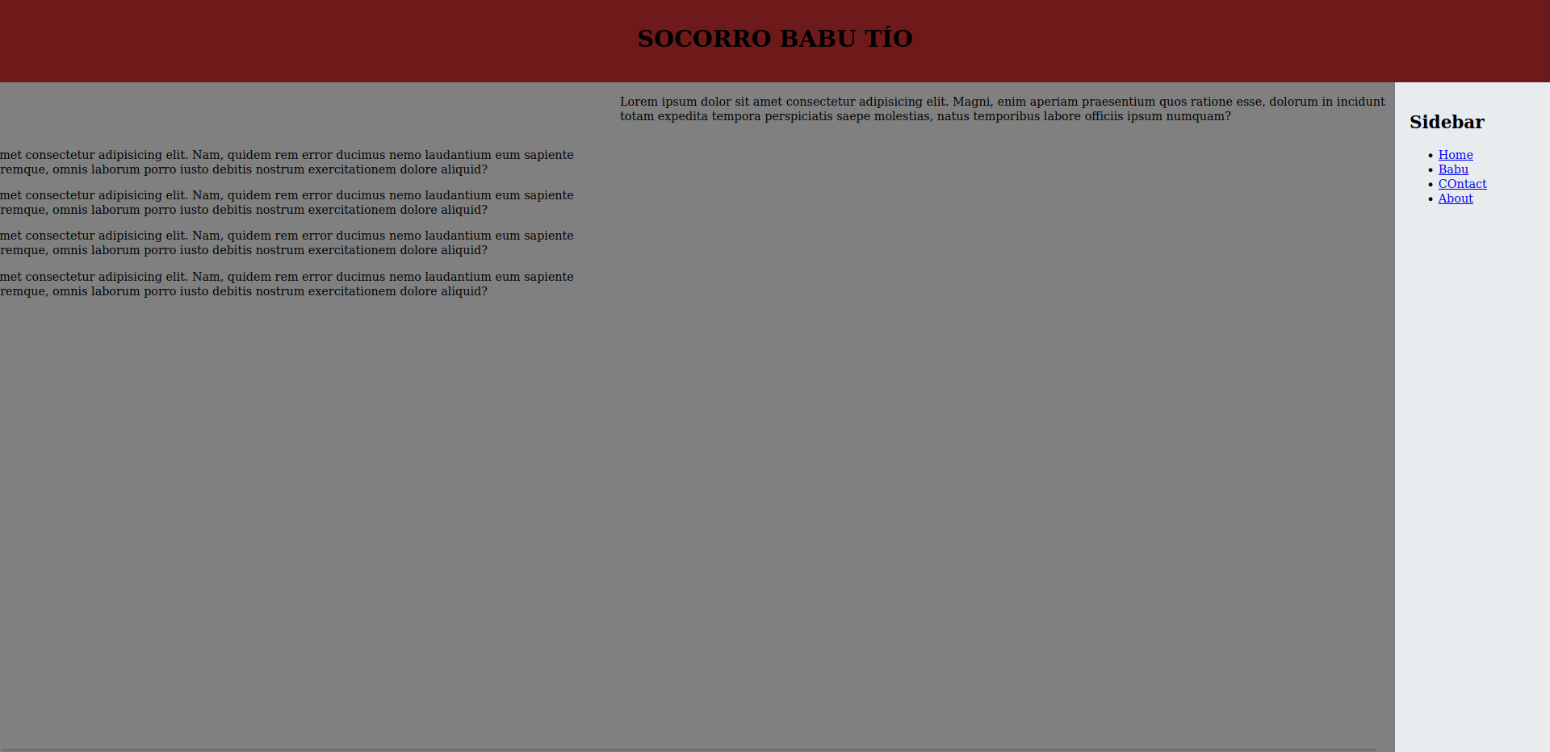
grid-area: footer;
background-color: black;
color: antiquewhite;
position: sticky;
text-align: center;
bottom: 0;
}

20. Grid anidado:

HTML:
<!DOCTYPE html>
<html lang="en">
<head>
<meta charset="UTF-8">
<meta name="viewport" content="width=device-width, initial-scale=1.0">
<title>Exercise 10 - Jose</title>
<link rel="stylesheet" href="style.css">
</head>
<body>
<div class="grid-container">
<div class="grid-item">1</div>
<div class="grid-item">2</div>
<div class="grid-item">
<div class="sub-container-item">
<div class="sub-grid-item">A</div>
<div class="sub-grid-item">B</div>
<div class="sub-grid-item">C</div>
<div class="sub-grid-item">D</div>
</div>
</div>
<div class="grid-item">4</div>
</div>
</body>
</html>

CSS:
body{
display: flex;
background-color: gray;
justify-content: center;
margin-top: 10%;
}

.grid-container {
display: grid;
grid-template-columns: 1fr 1fr;
grid-template-rows: 1fr 1fr;
gap: 5px;
background-color: #a51616;
padding: 10px;
width: fit-content;
}

.grid-item {
background-color: lightgray;
display: flex;
justify-content: center;
background-color: rgba(0, 0, 0, 0.8);
border: 1px solid white;
color: antiquewhite;
align-items: center;
border: 1px solid black;
}

.sub-container-item {
display: grid;
grid-template-columns: 1fr 1fr;
grid-template-rows: 1fr 1fr;
background-color: #a578167c;
gap: 10px;
width: 100%;
height: 100%;
}

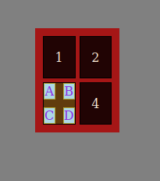
.sub-grid-item {
background-color: lightblue;
display: flex;
justify-content: center;
color: blueviolet;
align-items: center;
border: 1px solid rgb(175, 167, 54);
}

